Supplementary Information (SI)

Semi-natural habitat, ecotones and landscape-scale management enhance the occupancy, richness and fitness of cavity-nesting Hymenoptera
Christopher Wild^{1,2*}, Julia Zelychenko¹, Sebastian Hopfenmüller³, Robert J. Paxton^{1,4}, Panagiotis Theodorou^{1,4}
¹ General Zoology, Institute for Biology, Martin-Luther-University Halle-Wittenberg, Hoher Weg 8, 06120 Halle (Saale), Germany
²Naturkundemuseum Erfurt, Große Arche 14, 99084 Erfurt, Germany
³ Stiftung KulturLandschaft Günztal, Bahnhofstraße 38, 87724 Ottobeuren, Germany
⁴ German Centre for Integrative Biodiversity Research (iDiv) Halle-Jena-Leipzig, Deutscher Platz 5e, 04103 Leipzig, Germany

* Correspondence:
Christopher Wild, General Zoology, Institute for Biology, Martin Luther-University Halle-Wittenberg, Hoher Weg 8, 06120 Halle (Saale), Germany
Email: christopher_wild@hotmail.de

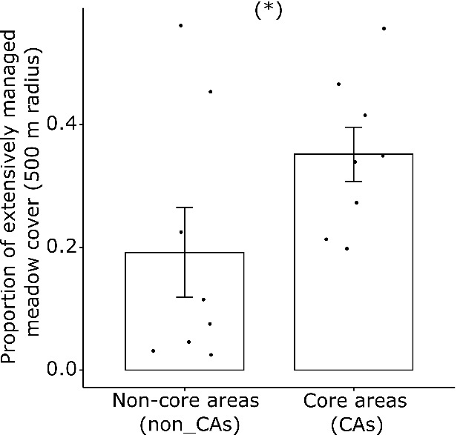
Fig. S1 Proportion of extensively managed meadow land cover (mean ± SE) in non-CAs versus CAs. *, P < 0.05.

Table S1 GPS-coordinates of all trap-nests.
Trap-Nest | Location | Site-Pair | Time of placing | Latitude | Longitude
H1I T1 | H1I | H1 | 24.03.2021 16:25 | 48.3230821283928 | 10.3160982251003
H1I T2 | H1I | H1 | 24.03.2021 16:48 | 48.3233292524339 | 10.3162408729747
H1I T3 | H1I | H1 | 24.03.2021 16:59 | 48.3237390201521 | 10.3175873448876
H1O T1 | H1O | H1 | 30.03.2021 10:10 | 48.3507485243307 | 10.3066822142654
H1O T2 | H1O | H1 | 30.03.2021 10:20 | 48.3499051503641 | 10.3050377410083
H1O T3 | H1O | H1 | 30.03.2021 10:32 | 48.3492561750284 | 10.3059480485305
H2I T1 | H2I | H2 | 22.03.2021 12:18 | 48.0709094497164 | 10.3401177425980
H2I T2 | H2I | H2 | 22.03.2021 12:25 | 48.0721625657346 | 10.3383367732532
H2I T3 | H2I | H2 | 22.03.2021 12:45 | 48.0717425103669 | 10.3376480640443
H2O T1 | H2O | H2 | 23.03.2021 13:21 | 48.0356771202302 | 10.3188314005408
H2O T2 | H2O | H2 | 23.03.2021 13:31 | 48.0363731701695 | 10.3187738178719
H2O T3 | H2O | H2 | 23.03.2021 13:46 | 48.0366832203484 | 10.3173776750277
H3I T1 | H3I | H3 | 23.03.2021 15:28 | 47.9880284626542 | 10.2871013884515
H3I T2 | H3I | H3 | 23.03.2021 15:37 | 47.9881854080233 | 10.2860687691538
H3I T3 | H3I | H3 | 23.03.2021 15:50 | 47.9873160405214 | 10.2858670690528
H3O T1 | H3O | H3 | 23.03.2021 12:31 | 47.9917787726647 | 10.3815315823202
H3O T2 | H3O | H3 | 23.03.2021 12:40 | 47.9913722859433 | 10.3810130247755
H3O T3 | H3O | H3 | 23.03.2021 12:52 | 47.9908475372444 | 10.3808301339808
H4I T1 | H4I | H4 | 23.03.2021 09:28 | 47.8960477743681 | 10.3614371353076
H4I T2 | H4I | H4 | 23.03.2021 09:39 | 47.8967408452515 | 10.3604278840798
H4I T3 | H4I | H4 | 23.03.2021 09:50 | 47.8975081707620 | 10.3599218185717
H4O T1 | H4O | H4 | 23.03.2021 11:32 | 47.9320976399016 | 10.3637071152315
H4O T2 | H4O | H4 | 23.03.2021 11:44 | 47.9305610582670 | 10.3654923021213
H4O T3 | H4O | H4 | 23.03.2021 11:52 | 47.9299956945954 | 10.3668903667760
H5I T1 | H5I | H5 | 22.03.2021 16:49 | 47.8848393990972 | 10.4098610762218
H5I T2 | H5I | H5 | 22.03.2021 16:58 | 47.8836116866409 | 10.4112865192842
H5I T3 | H5I | H5 | 22.03.2021 17:10 | 47.8834209097968 | 10.4089814593453
H5O T1 | H5O | H5 | 23.03.2021 10:47 | 47.9047139205261 | 10.3944773652511
H5O T2 | H5O | H5 | 23.03.2021 10:52 | 47.9041715712872 | 10.3939516657267
H5O T3 | H5O | H5 | 23.03.2021 11:10 | 47.9066278358920 | 10.3924508324410
H6I T1 | H6I | H6 | 22.03.2021 16:01 | 47.8615972712599 | 10.4079999919182
H6I T2 | H6I | H6 | 22.03.2021 16:10 | 47.8624236567384 | 10.4080683534411
H6I T3 | H6I | H6 | 22.03.2021 16:18 | 47.8629789798988 | 10.4078614035679
H6O T1 | H6O | H6 | 22.03.2021 14:59 | 47.8266601394871 | 10.4153081579061
H6O T2 | H6O | H6 | 22.03.2021 15:10 | 47.8266354115619 | 10.4159587798402
H6O T3 | H6O | H6 | 22.03.2021 15:25 | 47.8260925681314 | 10.4172254855638
H7I T1 | H7I | H7 | 24.03.2021 11:54 | 48.2164251175668 | 10.2752984308033
H7I T2 | H7I | H7 | 24.03.2021 12:09 | 48.2167454128582 | 10.2749709126078
H7I T3 | H7I | H7 | 24.03.2021 12:23 | 48.2164851652548 | 10.2741440633237
H7O T1 | H7O | H7 | 24.03.2021 13:23 | 48.1985846835334 | 10.3242072672127
H7O T2 | H7O | H7 | 24.03.2021 13:42 | 48.1990396122774 | 10.3256731502007
H7O T3 | H7O | H7 | 24.03.2021 13:57 | 48.1981018145176 | 10.3267130692038
H8I T1 | H8I | H8 | 24.03.2021 10:43 | 48.1899344440717 | 10.2432923275826
H8I T2 | H8I | H8 | 24.03.2021 10:53 | 48.1903147787427 | 10.2425238141186
H8I T3 | H8I | H8 | 24.03.2021 11:12 | 48.1887814699880 | 10.2417879272440
H8O T1 | H8O | H8 | 24.03.2021 14:39 | 48.1739872803792 | 10.3365761006812
H8O T2 | H8O | H8 | 24.03.2021 14:50 | 48.1734638139296 | 10.3367172138537
H8O T3 | H8O | H8 | 24.03.2021 15:03 | 48.1714931554788 | 10.3370162451990

Supplementary methods S1
DNA-extraction and species identification through barcoding
DNA was extracted from larvae using a Qiagen DNeasy Blood & Tissue Kit following the manufacturer’s recommendations while a Chelex (5%) extraction protocol was used for adult individuals. For Chelex DNA extraction, two mid-legs per sample were transferred into PCR plates with 100 µl of 5% Chelex solution and 5 µl of proteinase K (20 mg/ml). The PCR-plates were processed on a thermocycler (Biometra, Göttingen, Germany) using the following programme: 1h at 55 °C; 15 min at 99 °C; 1min at 37 °C and 15 min at 99 °C. Extracted DNA samples were stored at -20 ° C.

The ca. 650 bp region of the mitochondrial cytochrome c oxidase subunit I (COI) gene was amplified using the DNA extracts with the primers LCO-1490 (5'-GGTCAACAAATCATAAAGATATTGG-3') and HCO-2198 (5'- TAAACTTCAGGGTGACCAAAAAATCA-3') (Folmer et al., 1994). PCR reactions were carried out in 10 µL volumes consisting of 1 x PCR buffer containing 1.5 mM MgCl₂ (Promega, Madison, WI, USA), 200 µM of each dNTP, 0.4 µM of each primer, 1.5 U Taq-Polymerase (Promega) and 2 µL of template DNA (approximately 25-50 ng). PCRs were performed with a thermocycler (Biometra, Göttingen, Germany) using the following thermal regime: 3 min at 94 °C, followed by 35 cycles of 30 s at 94 °C, 45 s annealing at 50 °C and 1 min elongation at 72°C, then a final elongation step at 72 °C for 8 min.

PCR products were screened using agarose gel electrophoresis to confirm amplification of correct fragment size. The ExoSAP-IT PCR Product Cleanup kit (Affymetrix, Santa Clara, CA, USA; Bell, 2008) was used to purify PCR products and samples were Sanger sequenced with the forward primer (LCO-1490). Sequence reads were checked and trimmed using Geneious v.7.1.9. Trimmed sequences were BLASTed against the NCBI (GenBank) nucleotide database using a threshold of at least 98% identity for species identification. Additionally, the Barcode of Life (BOLD) database (Ratnasingham & Hebert, 2007) was used to confirm species identification.

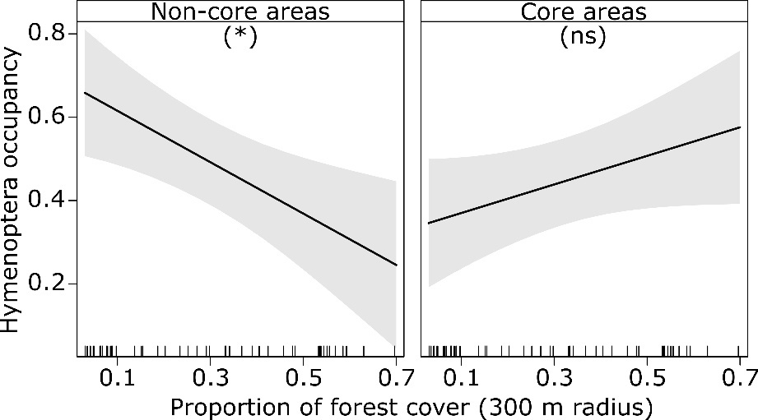
Fig. S2 Relationships between Hymenoptera occupancy (proportion of occupied stems) and the proportion of forest cover at the 300 m radius in non-CAs and CAs. Plotted lines show the predicted relationship and shaded areas indicate the 95% confidence intervals. *, P < 0.05; ns, not-significant.

Table S2 ANOVA table of the effect of CAs versus non-CAs, proportion of forest cover, edge density, and their interaction with CA/non-CA status on Hymenoptera occupancy, wild bee species richness, and wasp species richness.
 | F-value | P-value | Effect size (partial η²)
Hymenoptera occupancy
Core area vs non-core area | 0.866 | 0.357 | 0.17
Proportion of forest cover | 0.804 | 0.376 | 0.42
Edge density | 0.033 | 0.856 | 0.21
Core area vs non-core area: Proportion of forest cover | 12.318 | 0.001** | 0.59
Core area vs non-core area: Edge density | 5.963 | 0.018* | 0.36
Bee species richness
Core area vs non-core area | 0.577 | 0.451 | 0.12
Proportion of forest cover | 1.760 | 0.194 | 0.04
Edge density | 0.033 | 0.855 | 0.10
Core area vs non-core area: Proportion of forest cover | 0.087 | 0.768 | 0.009
Core area vs non-core area: Edge density | 2.996 | 0.091 | 0.21
Wasp species richness
Core area vs non-core area | 11.716 | 0.001** | 0.71
Proportion of forest cover | 0.419 | 0.524 | 0.11
Edge density | 0.449 | 0.509 | 0.03
Core area vs non-core area: proportion of forest cover | 7.819 | 0.008** | 0.37
Core area vs non-core area: edge density | 0.063 | 0.803 | 0.003

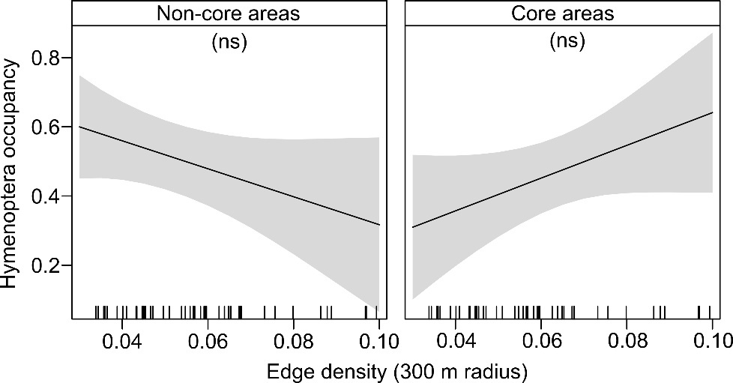
Fig. S3 Relationships between Hymenoptera occupancy (proportion of occupied stems) and edge density at the 300 m scale in non-CAs and CAs. Plotted lines show the predicted relationship and shaded areas indicate the 95% confidence intervals. ns, not-significant.

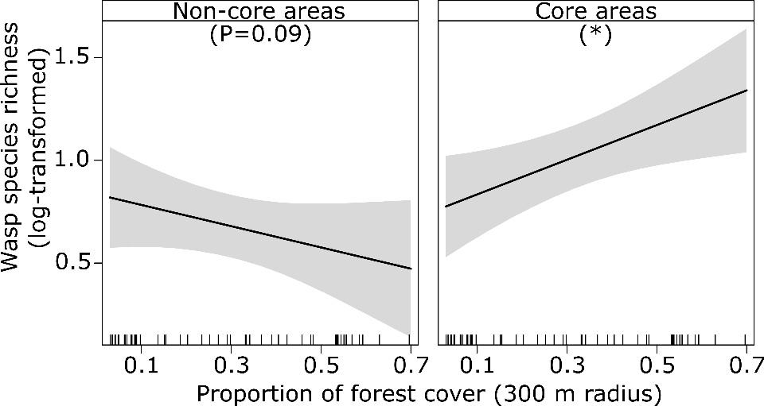
Fig. S4 Relationships between wasp species richness and the proportion of forest cover at the 300 m radius in non-CAs and CAs. Plotted lines show the predicted relationship and shaded areas indicate the 95% confidence intervals. *, P < 0.05.

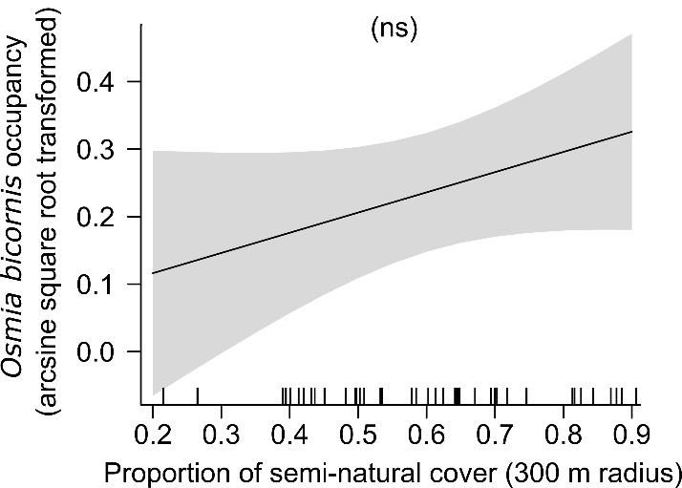
Fig. S5 Relationship between Osmia bicornis occupancy (proportion of occupied stems) and proportion of semi-natural land cover at the 300 m radius. Plotted line shows the predicted relationships and shaded areas indicate the 95% confidence intervals; ns, not-significant.

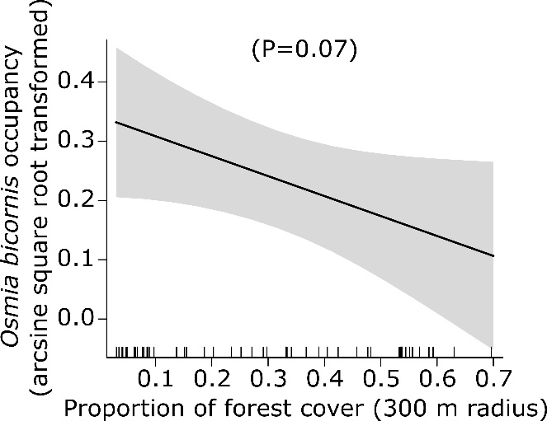
Fig. S6 Relationship between Osmia bicornis occupancy (proportion of occupied stems) and the proportion of forest cover at the 300 m radius. Plotted line shows the predicted relationship and shaded areas indicate the 95% confidence intervals.

Table S3 ANOVA table of the effect of CAs versus non-CAs, proportion of forest cover, edge density, and their interaction with CA/non-CA status on Osmia bicornis occupancy, brood cells per stem, number of female and male offspring, and survival.
 |  | F-value | P-value | Effect size (partial η²)
 | Osmia bicornis occupancy
 | Core area vs non-core area | 0.0004 | 0.984 | 0.00009
 | Proportion of forest cover | 3.815 | 0.073 | 0.27
 | Edge density | 0.105 | 0.750 | 0.02
 | Core area vs non-core area: proportion of forest cover | 2.900 | 0.126 | 0.19
 | Core area vs non-core area: edge density | 0.978 | 0.344 | 0.06
 | Osmia bicornis brood cells per stem
 | Core area vs non-core area | 0.562 | 0.457 | 0.10
 | Proportion of forest cover | 6.906 | 0.011* | 0.27
 | Edge density | 0.016 | 0.899 | 0.009
 | Core area vs non-core area: proportion of forest cover | 1.245 | 0.270 | 0.07
 | Core area vs non-core area: edge density | 0.418 | 0.521 | 0.02
 | Osmia bicornis number of female offspring
 | Core area vs non-core area | 1.400 | 0.243 | 0.22
 | Proportion of forest cover | 4.809 | 0.033* | 0.21
 | Edge density | 0.400 | 0.530 | 0.003
 | Core area vs non-core area: proportion of forest cover | 1.066 | 0.307 | 0.06
 | Core area vs non-core area: edge density | 0.097 | 0.756 | 0.005
 | Osmia bicornis number of male offspring
 | Core area vs non-core area | 0.237 | 0.668 | 0.05
 | Proportion of forest cover | 5.784 | 0.040* | 0.31
 | Edge density | 0.040 | 0.843 | 0.005
 | Core area vs non-core area: proportion of forest cover | 3.133 | 0.107 | 0.17
 | Core area vs non-core area: edge density | 0.388 | 0.544 | 0.02
Osmia bicornis survival
Core area vs non-core area |  | 1.711 | 0.206 | 0.32
Proportion of forest cover |  | 0.008 | 0.929 | 0.002
Edge density |  | 4.832 | 0.040* | 0.38
Core area vs non-core area: proportion of forest cover |  | 0.248 | 0.623 | 0.01
Core area vs non-core area: edge density |  | 1.100 | 0.307 | 0.07

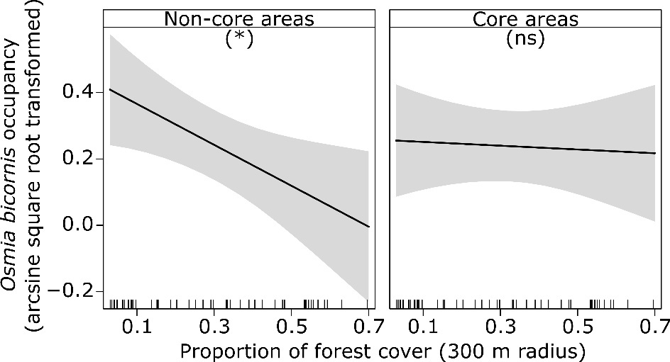
Fig. S7 Relationships between Osmia bicornis occupancy (proportion of occupied stems) and the proportion of forest cover at the 300 m radius in non-CAs and CAs. Plotted lines show the predicted relationship and shaded areas indicate the 95% confidence intervals. *, P < 0.05; ns, not-significant.

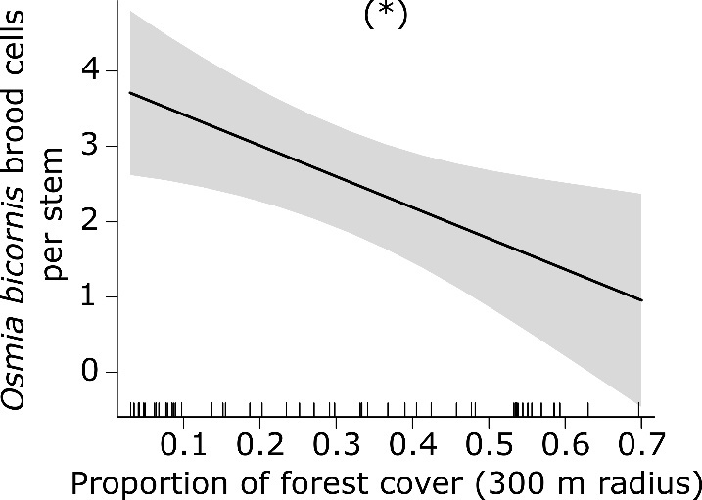
Fig. S8 Relationship between Osmia bicornis number of brood cells per stem and the proportion of forest cover at the 300 m radius. Plotted line shows the predicted relationship and shaded areas indicate the 95% confidence intervals. *, P < 0.05.

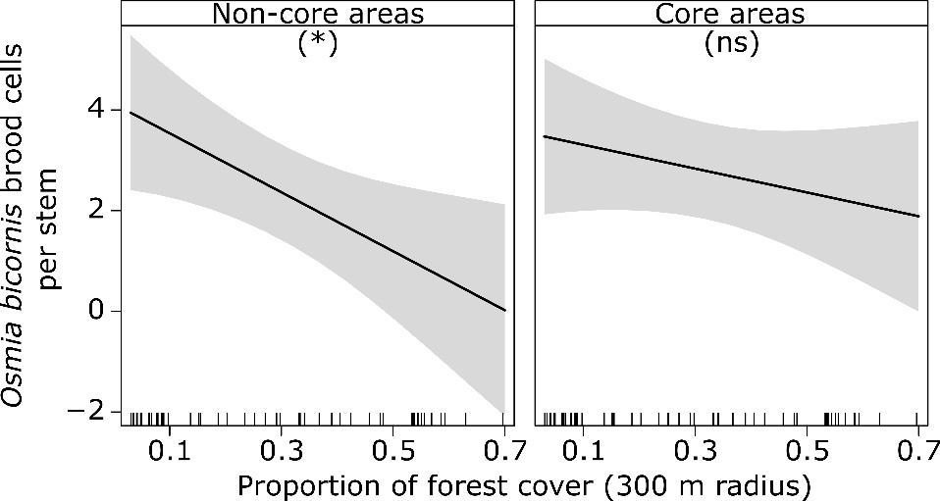
Fig. S9 Relationships between number of Osmia bicornis brood cells per stem and the proportion of forest cover at the 300 m radius in non-CAs and CAs. Plotted lines show the predicted relationship and shaded areas indicate the 95% confidence intervals. *, P < 0.05; ns, not-significant.

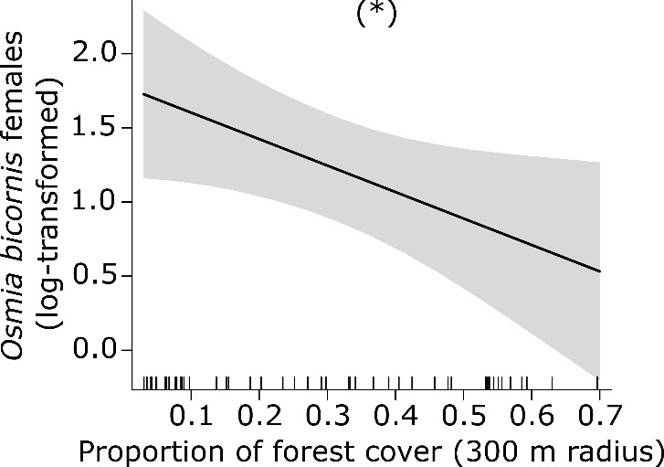
Fig. S10 Relationship between the number of Osmia bicornis female offspring and the proportion of forest cover at the 300 m radius. Plotted line shows the predicted relationship and shaded areas indicate the 95% confidence intervals. *, P < 0.05.

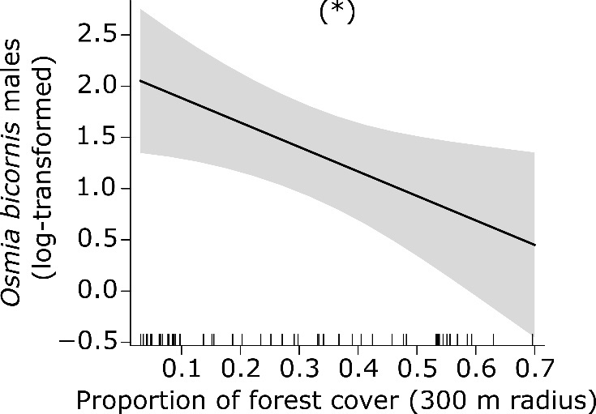
Fig. S11 Relationship between the number of Osmia bicornis male offspring and the proportion of forest cover at the 300 m radius. Plotted line shows the predicted relationship and shaded areas indicate the 95% confidence intervals. *, P < 0.05.

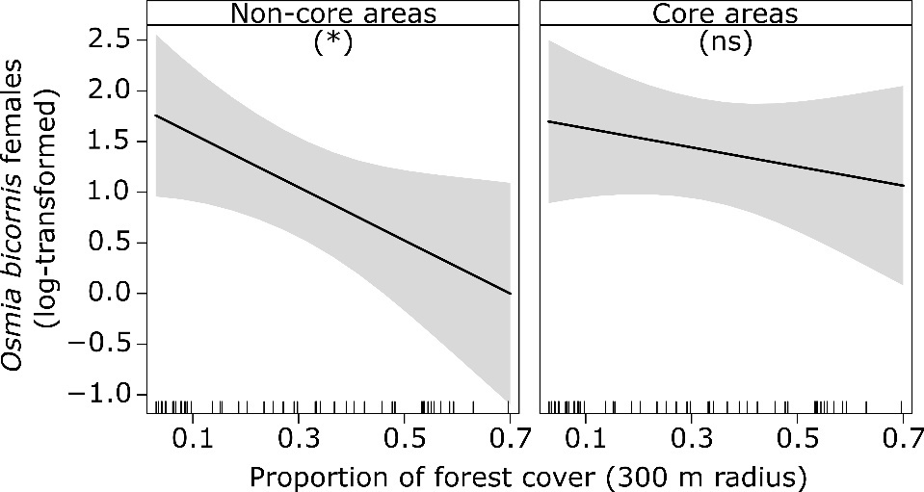
Fig. S12 Relationships between the number of Osmia bicornis female offspring and the proportion of forest cover at the 300 m radius in non-CAs and CAs. Plotted lines show the predicted relationship and shaded areas indicate the 95% confidence intervals. *, P < 0.05; ns, not-significant.

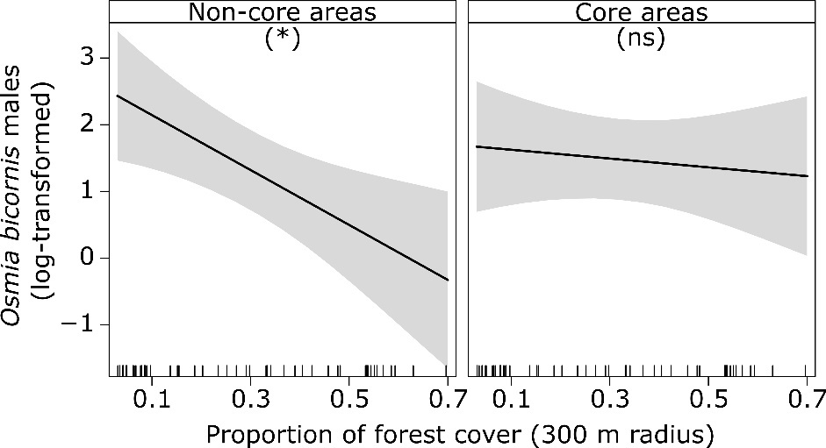
Fig. S13 Relationships between the number of Osmia bicornis male offspring and the proportion of forest cover at the 300 m radius in non-CAs and CAs. Plotted lines show the predicted relationship and shaded areas indicate the 95% confidence intervals. *, P < 0.05; ns, not-significant.

Table S4 All identified Hymenoptera species of the Günz valley (study area), including host and parasitic species.
Identified species
Bees | Wasps | Parasitic bees | Parasitic wasps
Chelostoma florisomne | Allodynerus rossii | Coelioxys alata | Coelopencyrtus arenarius
Heriades truncorum | Ancistrocerus antilope | Coelioxys inermis | Chrysis angustula
Hylaeus difformis | Ancistrocerus gazella | Coelioxys mandibularis | Omalus biaccinctus
Hylaeus sp. | Ancistrocerus nigricornis | Stelis breviuscula | Trichrysis cyanea
Megachile alpicola | Ancistrocerus parietinus |  | Sapyga_clavicornis
Megachile centuncularis | Ancistrocerus trifasciatus
Megachile ligniseca | Discoelius zonalis
Megachile versicolor | Euodynerus notatus
Megachile sp. | Euodynerus quadrifasciatus
Osmia bicornis | Passaloecus borealis
Osmia caerulescens | Passaloecus insignis
Osmia leaiana | Pemphredon cf. lethifer
 | Symmorphus bifasciatus
 | Symmorphus crassicornis
 | Symmorphus gracilis
 | Symmorphus murarius
 | Trypoxylon figulus

