Additional files

Table S1: GIAB cell lines overview

NIST ID | Corriell ID | Description
HG001 | NA12878 | UTAH CEPH female; Caucasian
HG002 | NA24385 | Ashkenazi Jewish son
HG003 | NA24149 | Ashkenazi Jewish father
HG004 | NA24143 | Ashkenazi Jewish mother
HG005 | NA24631 | Han Chinese son
HG006 | NA24694 | Han Chinese father
HG007 | NA24695 | Han Chinese mother

Table S2. Complete list of all candidate quality features for model training
Features/Variables | Definition
Read count | The number of 'countable' reads supporting the allele. Countable reads are defined based on the user-defined settings in the variant callers.
Coverage | The read coverage at this position. Only 'countable' reads are considered.
Frequency | 'Count' divided by 'Coverage'
Forward count | The number of 'countable' forward reads supporting the allele
Reverse count | The number of 'countable' reverse reads supporting the allele
Forward/Reverse ratio | ‘Forward count’ divided by ‘Reverse count’
Average quality | The average base quality score of the bases supporting a variant.
Probability | posterior probability of the particular site-type called.
Read position probability | The test probability for the test of whether the distribution of the read positions variant in the variant carrying reads is different from that of all the reads covering the variant position.
Read direction probability | The test probability for the test of whether the distribution among forward and reverse reads of the variant carrying reads is different from that of all the reads covering the variant position
Homopolymer | The column contains "1" if the variant is likely to be a homopolymer error and "0" if not. This is assessed by inspecting all variants in homopolymeric regions longer than 2. A variant will get the mark "1" if it is a homopolymeric length variation of the reference allele, or a length variation of another variant that is a homopolymeric variation of the reference allele.
Homopolymer length | homopolymer length
Complex region | region with known homology and/or low mappability

Figure S3. Density plots for eight selected key features between true positives and false positives
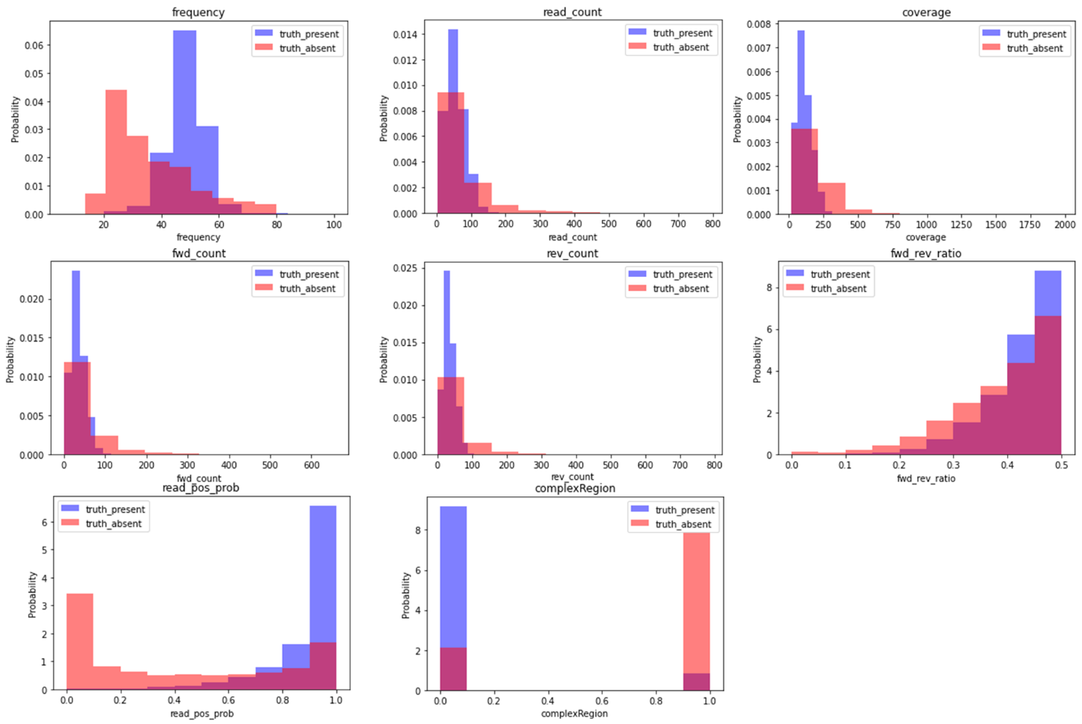

Table S4. Summary of metrics for combinations of features and datasets
features | data type | model name | model name | TPR | FPR | TNR | FNR | ROC | Thred | Ss | F1
all | imbalanced | imb_all | GB | 98.12 | 10.74 | 89.26 | 1.88 | 98.67 | 0.42 | 0.90 | 0.90
key | imbalanced | imb_key | GB | 98.06 | 10.44 | 89.56 | 1.94 | 98.66 | 0.47 | 0.90 | 0.90
key | SOS balanced | sos_key | GB | 97.84 | 9.76 | 90.24 | 2.16 | 98.66 | 12.77 | 0.87 | 0.89
all | SOS balanced | sos_all | GB | 97.80 | 9.77 | 90.23 | 2.20 | 98.63 | 13.07 | 0.87 | 0.88
key | SMOTE balanced | smote_key | GB | 98.35 | 17.96 | 82.04 | 1.65 | 98.40 | 6.39 | 0.93 | 0.87
key | SOS balanced | sos_key | LR | 98.69 | 28.66 | 71.34 | 1.31 | 98.30 | 4.91 | 0.97 | 0.82
all | SOS balanced | sos_all | LR | 98.77 | 29.95 | 70.05 | 1.23 | 98.30 | 4.64 | 0.97 | 0.82
all | SMOTE balanced | smote_all | GB | 96.21 | 8.77 | 91.23 | 3.79 | 98.25 | 11.47 | 0.69 | 0.79
all | imbalanced | imb_all | RF | 99.13 | 37.00 | 63.00 | 0.87 | 97.85 | 10.27 | 1.00 | 0.77
key | imbalanced | imb_key | LR | 98.63 | 35.69 | 64.31 | 1.37 | 98.07 | 0.30 | 0.96 | 0.77
all | imbalanced | imb_all | LR | 98.67 | 36.18 | 63.82 | 1.33 | 98.07 | 0.29 | 0.96 | 0.77
key | imbalanced | imb_key | RF | 99.05 | 38.23 | 61.77 | 0.95 | 97.94 | 10.21 | 1.00 | 0.76
all | SMOTE balanced | smote_all | LR | 98.85 | 38.82 | 61.18 | 1.15 | 98.18 | 4.55 | 0.98 | 0.75
key | SMOTE balanced | smote_key | LR | 98.83 | 38.84 | 61.16 | 1.17 | 98.18 | 4.48 | 0.98 | 0.75
all | SOS balanced | sos_all | RF | 99.23 | 39.58 | 60.42 | 0.77 | 97.88 | 10.44 | 1.00 | 0.75
all | SMOTE balanced | smote_all | RF | 99.17 | 41.31 | 58.69 | 0.83 | 97.73 | 12.01 | 1.00 | 0.74
key | SOS balanced | sos_key | RF | 99.05 | 42.06 | 57.94 | 0.95 | 97.90 | 10.16 | 1.00 | 0.73
key | SMOTE balanced | smote_key | RF | 99.48 | 58.59 | 41.41 | 0.52 | 97.83 | 11.04 | 1.00 | 0.59
smote: Synthetic Minority Oversampling; selected models with the best overall performances are highlighted.

Table S5. Summary of Sanger confirmation results of SNV calls that were classified as high-confidence by the two-tiered workflow
gene | nmid | cdot | chr | start | end | ref | alt | Exon # | Strand | Sanger confirm (Y/N)
APC | NM_000038 | c.3920T>A | 5 | 112175211 | 112175211 | T | A | 16 | + | Y
ERCC2 | NM_000400 | c.1847G>C | 19 | 45856059 | 45856059 | C | G | 20 | - | Y
ERCC6 | NM_000124 | c.2167C>T | 10 | 50690735 | 50690735 | G | A | 10 | - | Y
GLA | NM_000169 | c.427G>A | X | 100656740 | 100656740 | C | T | 3 | - | Y
GPD1L | NM_015141 | c.839C>T | 3 | 32200588 | 32200588 | C | T | 6 | + | Y
IL7R | NM_002185 | c.651G>A | 5 | 35873695 | 35873695 | G | A | 5 | + | Y
MYH7 | NM_000257 | c.2890G>C | 14 | 23893148 | 23893148 | C | G | 23 | - | Y
MYL3 | NM_000258 | c.530A>G | 3 | 46899903 | 46899903 | T | C | 5 | - | Y
NGLY1 | NM_018297 | c.1201A>T | 3 | 25775422 | 25775422 | T | A | 8 | - | Y
PKP2 | NM_004572 | c.1114G>A | 12 | 33021917 | 33021917 | C | T | 4 | - | Y
SLC26A4 | NM_000441 | c.1151A>G | 7 | 107330570 | 107330570 | A | G | 10 | + | Y
ABCB4 | NM_000443 | c.1529A>G | 7 | 87069546 | 87069546 | T | C | 13 | - | Y
ACADSB | NM_001609 | c.443C>T | 10 | 124800121 | 124800121 | C | T | 4 | + | Y
ALOX12B | NM_001139 | c.1562A>G | 17 | 7979005 | 7979005 | T | C | 12 | - | Y
ALOXE3 | NM_021628 | c.1889C>T | 17 | 8006708 | 8006708 | G | A | 15 | - | Y
BARD1 | NM_000465 | c.2137G>A | 2 | 215593597 | 215593597 | C | T | 11 | - | Y
BCHE | NM_000055 | c.1253G>T | 3 | 165547569 | 165547569 | C | A | 2 | - | Y
BCHE | NM_000055 | c.293A>G | 3 | 165548529 | 165548529 | T | C | 2 | - | Y
BTD | NM_001370658 | c.1270G>C | 3 | 15686693 | 15686693 | G | C | 4 | + | Y
BTD | NM_001370658 | c.1308A>C | 3 | 15686731 | 15686731 | A | C | 4 | + | Y
BTD | NM_001370658 | c.451G>A | 3 | 15685874 | 15685874 | G | A | 4 | + | Y
CLCN1 | NM_000083 | c.2680C>T | 7 | 143048771 | 143048771 | C | T | 23 | + | Y
DOCK8 | NM_203447 | c.54-1G>T | 9 | 271626 | 271626 | G | T | 2 | + | Y
FBN1 | NM_000138 | c.7412C>G | 15 | 48717607 | 48717607 | G | C | 60 | - | Y
FKRP | NM_024301 | c.1073C>T | 19 | 47259780 | 47259780 | C | T | 4 | + | Y
G6PD | NM_000402 | c.1058T>C | X | 153761240 | 153761240 | A | G | 9 | - | Y
GJB2 | NM_004004 | c.101T>C | 13 | 20763620 | 20763620 | A | G | 2 | - | Y
HFE | NM_000410 | c.187C>G | 6 | 26091179 | 26091179 | C | G | 2 | + | Y
HFE | NM_000410 | c.845G>A | 6 | 26093141 | 26093141 | G | A | 4 | + | Y
KCNE2 | NM_172201 | c.229C>T | 21 | 35743006 | 35743006 | C | T | 2 | + | Y
LDLRAP1 | NM_015627 | c.605C>A | 1 | 25889633 | 25889633 | C | A | 6 | + | Y
MSH6 | NM_000179 | c.893G>A | 2 | 48026015 | 48026015 | G | A | 4 | + | Y
MUTYH | NM_001128425 | c.1187G>A | 1 | 45797228 | 45797228 | C | T | 13 | - | Y
MYH7 | NM_000257 | c.11C>T | 14 | 23902931 | 23902931 | G | A | 3 | - | Y
NAGA | NM_000262 | c.973G>A | 22 | 42457056 | 42457056 | C | T | 8 | - | Y
OCA2 | NM_000275 | c.1327G>A | 15 | 28230247 | 28230247 | C | T | 13 | - | Y
PCSK9 | NM_174936 | c.1180G>A | 1 | 55523187 | 55523187 | G | A | 7 | + | Y
POMGNT1 | NM_017739 | c.1539+1G>A | 1 | 46657769 | 46657769 | C | T | 17 | - | Y
PTEN | NM_000314 | c.935A>G | 10 | 89720784 | 89720784 | A | G | 8 | + | Y
SERPINA1 | NM_000295 | c.1096G>A | 14 | 94844947 | 94844947 | C | T | 5 | - | Y
SOS1 | NM_005633 | c.755T>C | 2 | 39278394 | 39278394 | A | G | 6 | - | Y
TCIRG1 | NM_006019 | c.1674-1G>A | 11 | 67816547 | 67816547 | G | A | 15 | + | Y
USH2A | NM_206933 | c.6902T>C | 1 | 216144022 | 216144022 | A | G | 36 | - | Y
ABCB4 | NM_000443 | c.2800G>A | 7 | 87041333 | 87041333 | C | T | 23 | 1 | Y
ACADM | NM_000016 | c.799G>A | 1 | 76215194 | 76215194 | G | A | 9 | -3 | Y
ACADM | NM_000016 | c.985A>G | 1 | 76226846 | 76226846 | A | G | 11 | -3 | Y
ALDOB | NM_000035 | c.448G>C | 9 | 104189856 | 104189856 | C | G | 5 | -3 | Y
ATM | NM_000051 | c.4784A>G | 11 | 108165661 | 108165661 | A | G | 32 | 0 | Y
ATP7B | NM_000053 | c.3316G>A | 13 | 52516618 | 52516618 | C | T | 15 | -2 | Y
ATP7B | NM_000053 | c.2605G>A | 13 | 52524268 | 52524268 | C | T | 11 | -3 | Y
ATP7B | NM_000053 | c.1995G>A | 13 | 52534410 | 52534410 | C | T | 7 | 0 | Y
ATP7B | NM_000053 | c.347T>C | 13 | 52549009 | 52549009 | A | G | 2 | 0 | Y
BBS1 | NM_024649 | c.1169T>G | 11 | 66293652 | 66293652 | T | G | 12 | -3 | Y
BBS2 | NM_031885 | c.1895G>C | 16 | 56530894 | 56530894 | C | G | 15 | -3 | Y
BRCA2 | NM_000059 | c.4819A>G | 13 | 32913311 | 32913311 | A | G | 11 | 0 | Y
CAPN3 | NM_000070 | c.2257G>A | 15 | 42702858 | 42702858 | G | A | 21 | 0 | Y
CYP1B1 | NM_000104 | c.1405C>T | 2 | 38298092 | 38298092 | G | A | 3 | -3 | Y
DPYD | NM_000110 | c.2846A>T | 1 | 97547947 | 97547947 | T | A | 22 | -3 | Y
FAH | NM_000137 | c.782C>T | 15 | 80465431 | 80465431 | C | T | 9 | -3 | Y
GJB2 | NM_004004 | c.109G>A | 13 | 20763612 | 20763612 | C | T | 2 | -3 | Y
GJB2 | NM_004004 | c.35G>T | 13 | 20763686 | 20763686 | C | A | 2 | -3 | Y
GLA | NM_000169 | c.352C>T | X | 100658816 | 100658816 | G | A | 2 | 0 | Y
GLDC | NM_000170 | c.2216G>A | 9 | 6554768 | 6554768 | C | T | 19 | -3 | Y
HBB | NM_000518 | c.316-197C>T | 11 | 5247153 | 5247153 | G | A | i2 | -3 | Y
HLCS | NM_000411 | c.1519+5G>A | 21 | 38139514 | 38139514 | C | T | 8 | -3 | Y
HSD17B4 | NM_000414 | c.743G>A | 5 | 118829516 | 118829516 | G | A | 11 | 0 | Y
MEFV | NM_000243 | c.2177T>C | 16 | 3293310 | 3293310 | A | G | 10 | -3 | Y
MEFV | NM_000243 | c.2082G>A | 16 | 3293405 | 3293405 | C | T | 10 | -3 | Y
MPL | NM_005373 | c.305G>C | 1 | 43804305 | 43804305 | G | C | 3 | -3 | Y
NBN | NM_002485 | c.127C>T | 8 | 90994994 | 90994994 | G | A | 2 | -3 | Y
NDUFAF5 | NM_024120 | c.519+4A>G | 20 | 13779150 | 13779150 | A | G | 6 | 1 | Y
NPHS1 | NM_004646 | c.565G>T | 19 | 36341309 | 36341309 | C | A | 5 | -3 | Y
NPHS2 | NM_014625 | c.686G>A | 1 | 179526214 | 179526214 | C | T | 5 | -1 | Y
PAH | NM_000277 | c.1068C>G | 12 | 103237555 | 103237555 | G | C | 11 | -3 | Y
PAH | NM_000277 | c.688G>A | 12 | 103248932 | 103248932 | C | T | 6 | -3 | Y
PMM2 | NM_000303 | c.422G>A | 16 | 8905010 | 8905010 | G | A | 5 | -3 | Y
PMM2 | NM_000303 | c.713G>A | 16 | 8941654 | 8941654 | G | A | 8 | 0 | Y
RAG1 | NM_000448 | c.1566G>T | 11 | 36596420 | 36596420 | G | T | 2 | -3 | Y
RPGRIP1 | NM_020366 | c.3358A>G | 14 | 21811213 | 21811213 | A | G | 22 | 0 | Y
SMPD1 | NM_000543 | c.1550A>T | 11 | 6415491 | 6415491 | A | T | 6 | 1 | Y
USH2A | NM_206933 | c.12145G>A | 1 | 215853640 | 215853640 | C | T | 62 | -1 | Y
ABCC8 | NM_000352 | c.3976G>A | 11 | 17418752 | 17418752 | C | T | 32 | 0 | Y
ACSF3 | NM_174917 | c.1081G>A | 16 | 89180850 | 89180850 | G | A | 6 | 0 | Y
ASL | NM_000048 | c.571C>T | 7 | 65551777 | 65551777 | C | T | 8 | -3 | Y
CPT2 | NM_000098 | c.149C>A | 1 | 53662764 | 53662764 | C | A | 1 | -3 | Y
DHCR7 | NM_001360 | c.1342G>A | 11 | 71146507 | 71146507 | C | T | 9 | -3 | Y
FKRP | NM_024301 | c.826C>A | 19 | 47259533 | 47259533 | C | A | 4 | -3 | Y
GALK1 | NM_000154 | c.1036G>A | 17 | 73754362 | 73754362 | C | T | 7 | -2 | Y
GCDH | NM_000159 | c.262C>A | 19 | 13002779 | 13002779 | C | A | 4 | -2 | Y
LDLR | NM_000527 | c.682G>T | 19 | 11216264 | 11216264 | G | T | 4 | -3 | Y
MYBPC3 | NM_000256 | c.1468G>A | 11 | 47364285 | 47364285 | C | T | 16 | 0 | Y
MYL3 | NM_000258 | c.170C>A | 3 | 46902303 | 46902303 | G | T | 3 | 0 | Y
TSEN54 | NM_207346 | c.919G>T | 17 | 73518081 | 73518081 | G | T | 8 | -3 | Y

