Supplementary Information

Vitamin C administration by intravenous infusion increases tumour ascorbate content in patients with colon cancer: a clinical intervention study

Gabi U Dachs¹*, Jamish Gandhi²*, Christina Wohlrab¹, Anitra C Carr³, Helen R Morrin^{1,4}, Juliet M Pullar⁵, Simone B Bayer⁵, Tim W Eglinton², Bridget A Robinson^{1,6}, Margreet CM Vissers^{5#}
*These authors contributed equally
¹Mackenzie Cancer Research Group, Department of Pathology and Biomedical Science, University of Otago Christchurch, NZ.
²Department of Surgery, Christchurch Hospital, University of Otago Christchurch, NZ.
³Nutrition in Medicine Research Group, Department of Pathology and Biomedical Science, University of Otago Christchurch, NZ.
⁴Cancer Society Tissue Bank, University of Otago Christchurch, NZ.
⁵Centre for Free Radical Research, Department of Pathology and Biomedical Science, University of Otago Christchurch, NZ.
⁶ Canterbury Regional Cancer and Haematology Service, Canterbury District Health Board, and Department of Medicine, University of Otago Christchurch, NZ.
Supplementary Figure 1. Participant and recruitment flow chart.
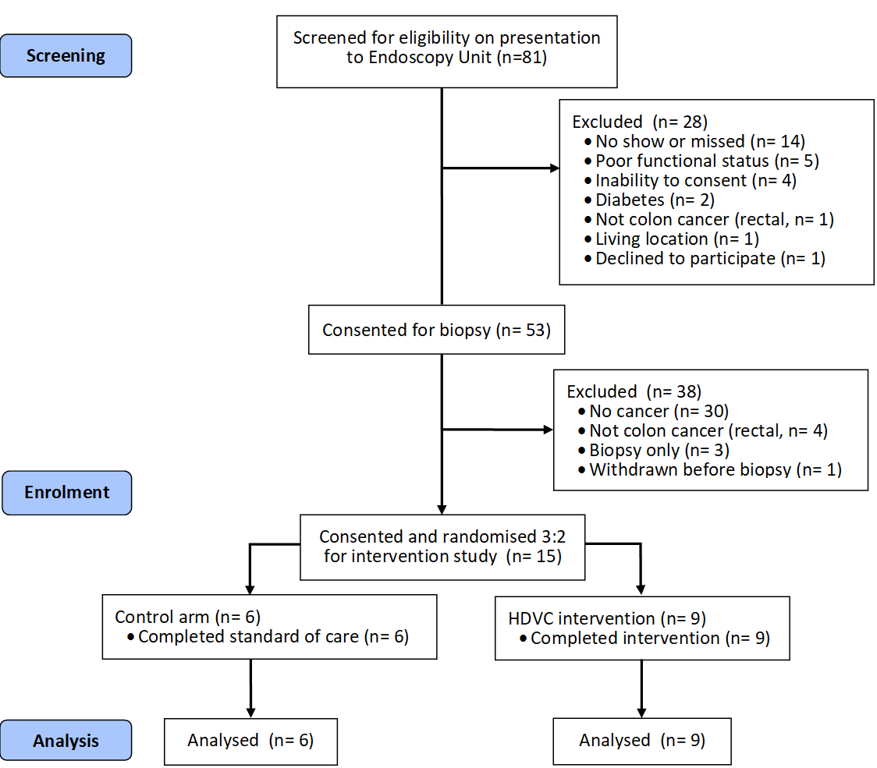

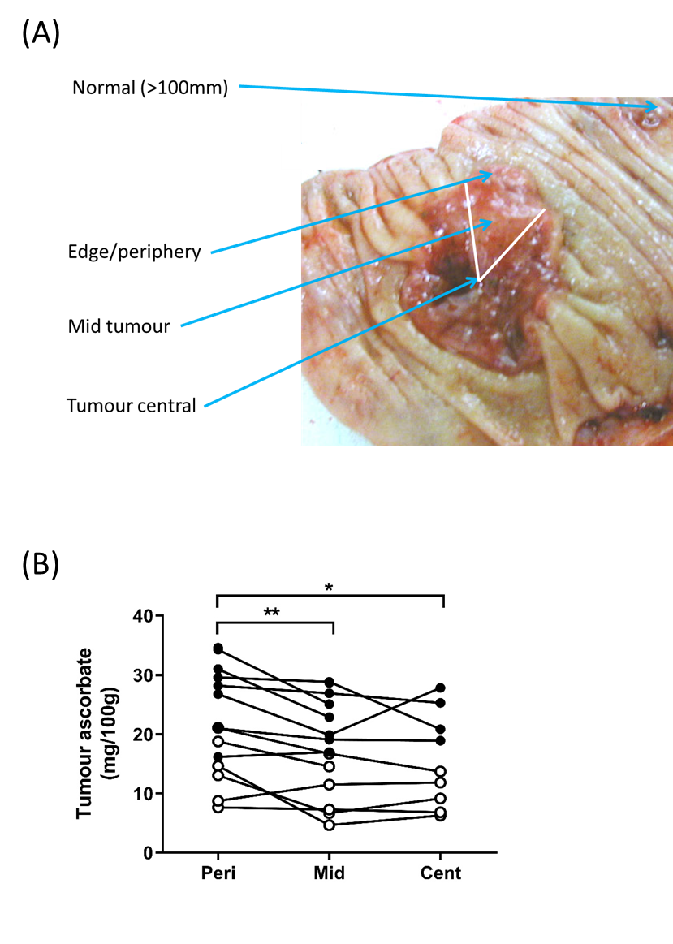
Supplementary Figure 2. (A) Schematic showing the regions sampled across a colon cancer lesion as well as sampling from normal mucosa. (B) Ascorbate levels in periphery, mid and central tumour regions. Levels were significantly lower in the mid and central regions than in the periphery for both control () and post-infusion () tumours. Results from individual patient tissues are shown. ** P<0.01, *p<0.05

2h
4+16h
4h
5 mM asc
2h
4+16h
4h
20 mM asc
-
yH2AX
β-actin
T
N
T
N
T
T
N
T
T
T
+
Control samples
CA9
β-actin
β-actin
Glut1
T
N
T
N
+
T
N
T
N
T
Infusion samples
T
T
N
T
N
+
T
N
T
N
T
β-actin
Glut1
T
CA9
β-actin
(A)
(C)
(B)
γH2AX
β-actin
T
N
N
T
T
T
T
N
N
T
+
T
N
T
N
T
T
N
T
T
+
γH2AX
β-actin
Control samples
Infusion samples
Supplementary Figure 3. Western blotting exemplars. (A) HIF-dependent proteins in tissue samples from control and ascorbate infusion patients with colon cancer. (B) DNA damage marker gH2AX in WiDr colon cell line following exposure to 5 mM or 20 mM ascorbate for 2 h or 4 h, or 4h followed by 16 h recovery. (C) γH2AX in tissue samples from control or infusion patients. + positive control, N normal mucosa, T tumour, b-actin was used as loading control.

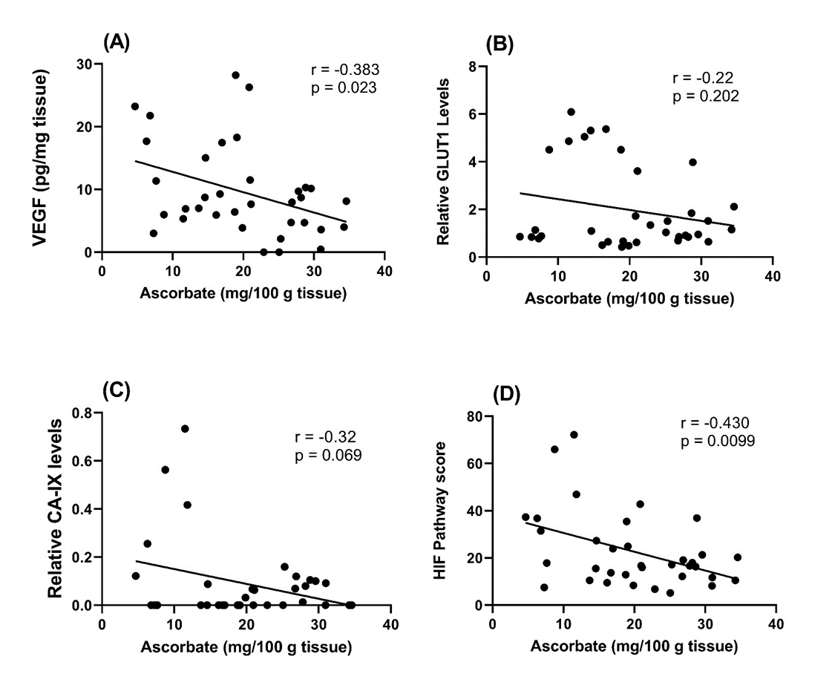

Supplementary Figure 4. Pearson’s correlations between expression of HIF-dependent proteins (A) VEGF, (B) GLUT1, (C) CA-IX) and (D) the derived HIF Pathway score with tumour ascorbate levels. All tumour data from control and infusion cohorts were included in this analysis.
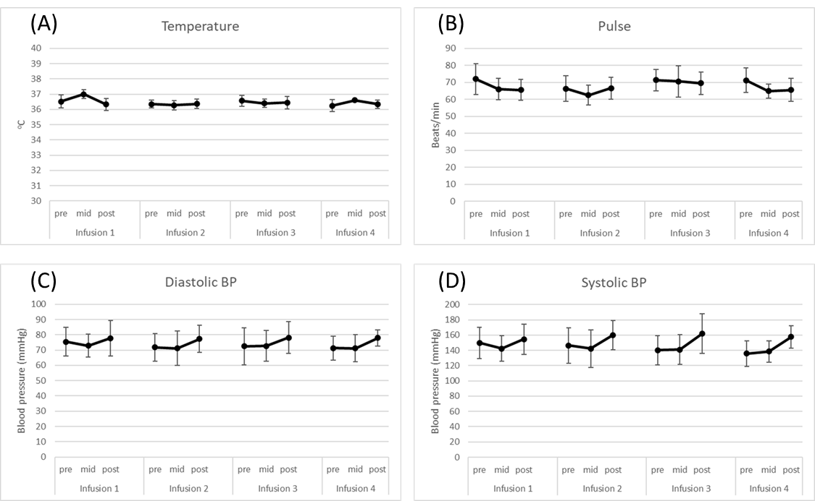

Supplementary Figure 5. Vital signs of patients with colon cancer during high dose ascorbate infusions, showing changes in average body temperature (A), pulse rate (B) and blood pressure (diastolic (C) and systolic (D)) at measurements at pre-infusion, at 10 min into infusion and after infusion with up to 1 g/kg ascorbate on days 1-4. Mean ± SEM, n=9.

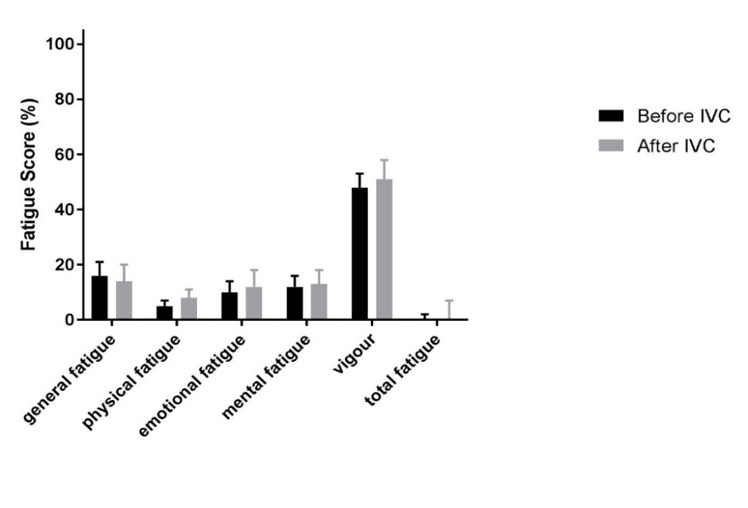
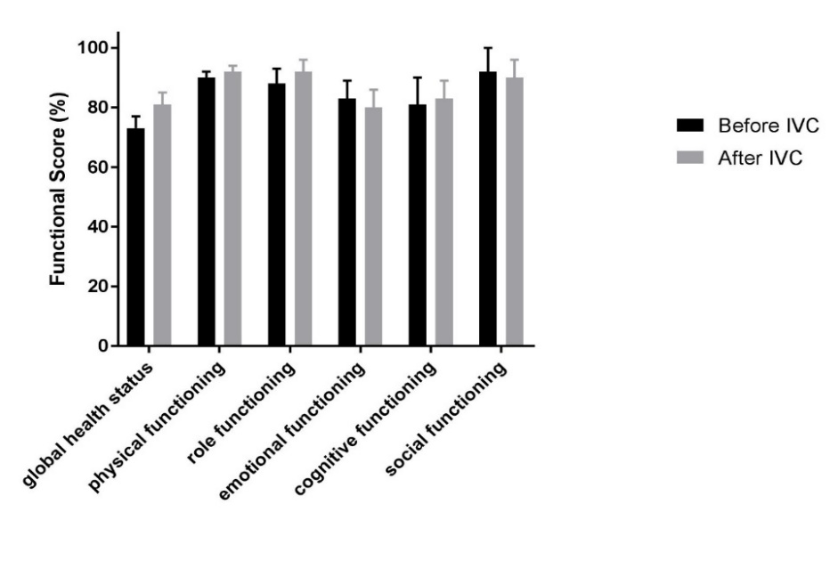
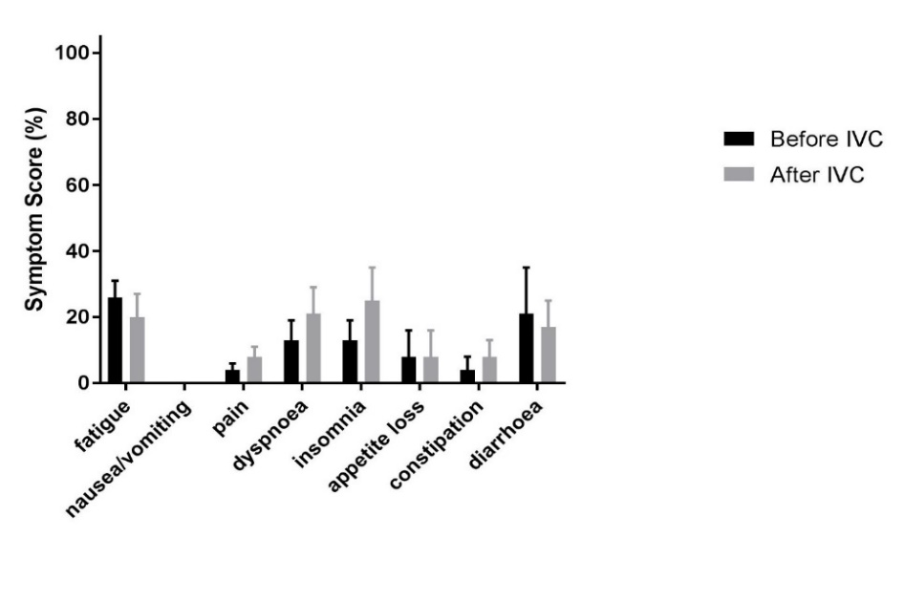
Supplementary Figure 6. Quality of life scores according to the EORTC QLQ-C30 and MFSI-SF questionnaires of patients with colon cancer in the infusion cohort. (A) Functional score, (B) symptom score and (C) fatigue score. Black bars are at baseline, grey bars before surgery, after all high dose ascorbate infusions; mean ± SD, n=9.
(A)
(B)
(C)
Supplementary Table 1. Protein expression levels in matched normal and tumour tissues from all study participants.

Sample | Normal mucosa | Tumour tissue | Significance
VEGF  (pg/mg tissue) | 0.823 ± 0.209 (14) | 1.534 ± 0.211 (14) | 0.0031**
GLUT1  (Relative protein levels | 1.176 ± 0.376 (15) | 1.687 ± 0.385 (15) | 0.023*
CA-IX  (Relative protein levels) | 0 ± 0 (14) | 0.073 ± .037 (14) | 0.0078**
γH2AX  (Relative protein levels) | 0.002 ± 0.001 (14) | 0.028 ± 0.013 (14) | 0.068
Results show means ± SE for samples from (n) individual patients. Significance levels are recorded for paired t-tests between data from the normal mucosa and tumour tissue from each individual patient.

