Dengue virus 3’ untranslated region regulates RNA genome translation

Kiven Kumar¹, Justin SG Ooi¹, Hwee Cheng Tan¹, Xudong Lyu¹, Wy Ching Ng¹, Kuan Rong Chan¹, Esteban Finol*¹, Eng Eong Ooi*^{1,2,3,4}

¹Programme in Emerging Infectious Diseases, Duke-NUS Medical School, 8 College Rd, Singapore 169857, Singapore.
²Viral Research and Experimental Medicine Centre, SingHealth Duke-NUS Academic Medical Centre, Singapore 169857, Singapore.
³Saw Swee Hock School of Public Health, National University of Singapore, Singapore 117549, Singapore.
⁴Department of Clinical Translational Research, Singapore General Hospital, Singapore 169608, Singapore.

*Correspondence to:
Eng Eong Ooi (engeong.ooi@duke-nus.edu.sg)
Esteban Finol (esteban.finol@duke-nus.edu.sg)

Contents
Supplementary Figures 1--6

Supplementary Table 1-5

Supplementary Figures

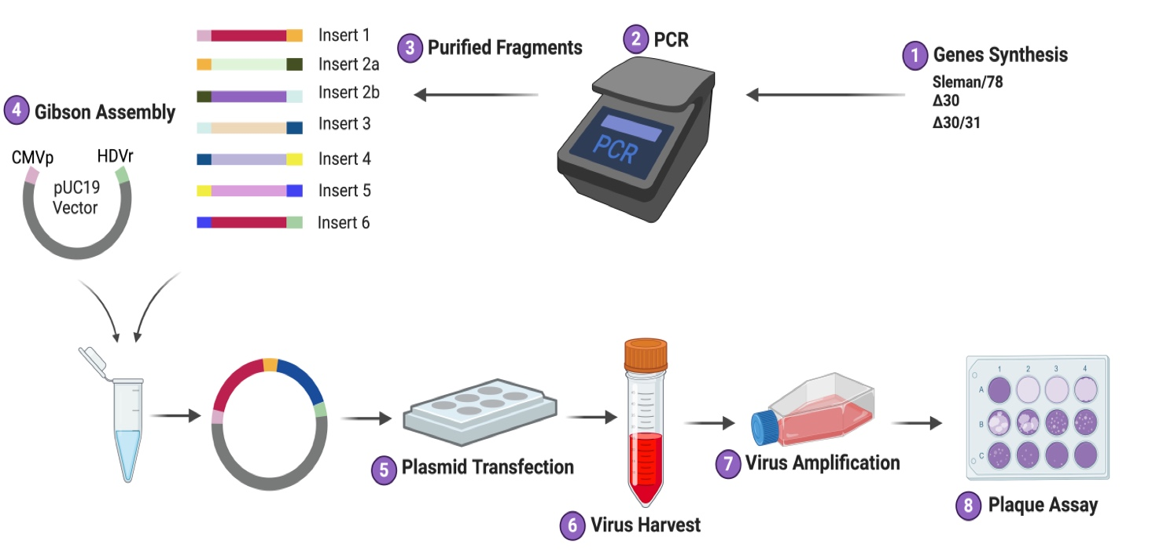

Supplementary Figure 1. Features of the preparation of the infectious clone of Sleman/78, ∆30, and ∆30/31. The complete sequences of the Sleman/78 (wild-type), ∆30, and ∆30/31 variants were divided into seven fragments and chemically synthesized. Each fragment was cloned into a holding vector and then amplified by PCR using flanking sequences. The PCR products were purified, and approximately 0.1 pmol of each fragment was assembled with the pUC19 vector. The assembled plasmid was transfected into HEK293T cells and incubated at 37°C for 72 hours. The supernatant was then harvested and used to infect C6/36 cells for virus amplification at 28°C. The resulting supernatant was collected and subjected to a viral plaque assay in BHK-21 cells to determine the virus titer.
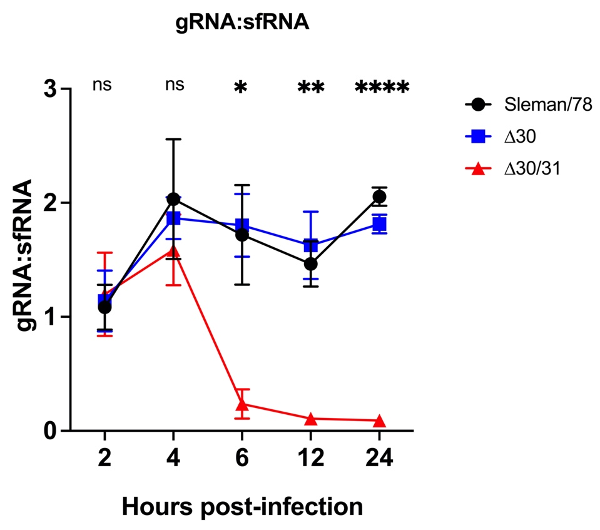
Supplementary Figure 2. Features of Sleman/78, ∆30, and ∆30/31 gRNA:sfRNA ratios in infected MoDCs. The gRNA and sfRNA levels were calculated as ratios. There was no significant difference in this ratio between the Sleman/78 and ∆30 compared to ∆30/31. Similar observations were made at 2 and 4 hpi. The gRNA:sfRNA ratio for ∆30/31 showed a significant reduction compared to Sleman/78 and ∆30 from 6 hpi onwards. These trends were similar to those of gRNA and sfRNA, suggesting that the nucleotide deletions in the 3’UTR did not affect sfRNA formation. Mean ± SEM values were compared using one-way ANOVA with Tukey’s post hoc test. Statistical significance was set at *p ≤ 0.05, **p ≤ 0.01, ***p ≤ 0.001, ****p ≤ 0.0001, and ns: nonsignificant.

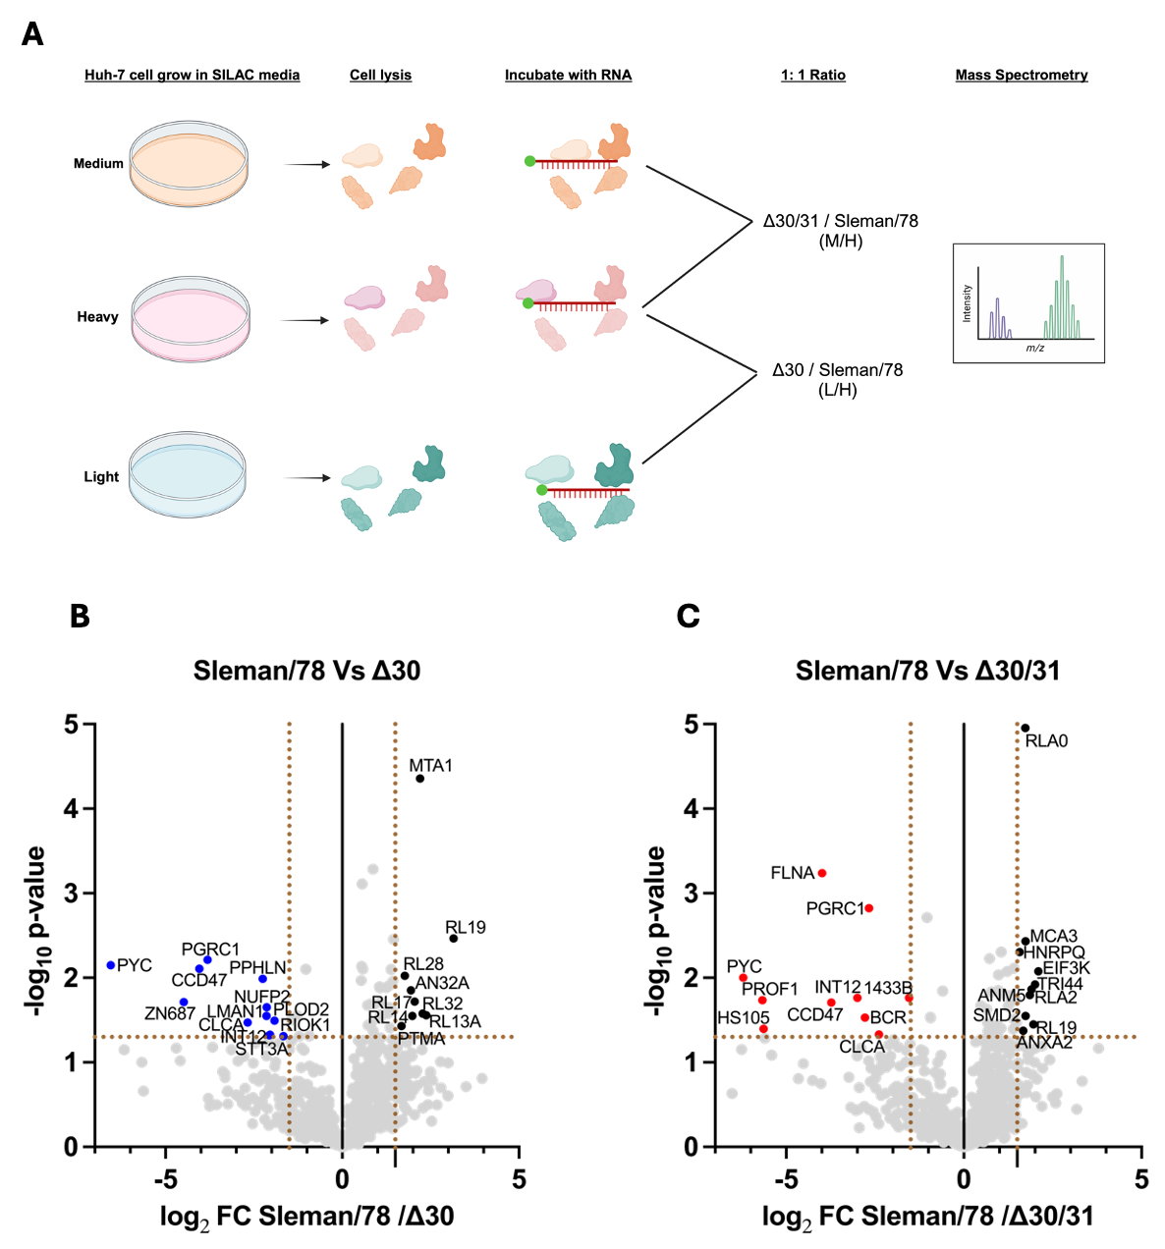
Supplementary Figure 3 Features of SILAC-qMS and binding partners of 3’UTR. (A) Huh-7 cells were labelled using a triple-SILAC approach with light (K₀R₀), medium (K₄R₆), and heavy (K₈R₁₀) isotopes. After seven passages in SILAC medium, cells were harvested and lysed using a lysis buffer. Crude lysates from each SILAC-labelled sample were used for RNA pulldown. The RNA of interest, tagged with tobramycin, was bound to a tobramycin matrix column. After adding the protein extract, samples were incubated at 4°C for 2 hours, then washed. RNA-protein complexes were eluted by introducing a higher concentration of tobramycin. The eluted proteins were mixed in a 1:1 ratio before being analysed by mass spectrometry. (B) Volcano plot of the cytoplasmic proteins that were enriched with Sleman/78 versus ∆30 3’UTR. Proteins with higher binding affinity for 3’UTR of Sleman/78 compared to ∆30 are shown in black and those with lower binding are shown in blue. (C) Volcano plot of the cytoplasmic proteins that that were enriched with Sleman/78 versus ∆30/31 3’UTR. Proteins with higher binding affinity for 3’UTR of Sleman/78 compared to ∆30/31 are shown in black and those with lower binding are shown in red. Each single point represents an individual protein, with the -log₁₀ P-value plotted on the y-axis and the log₂ fold-change in on the x-axis.

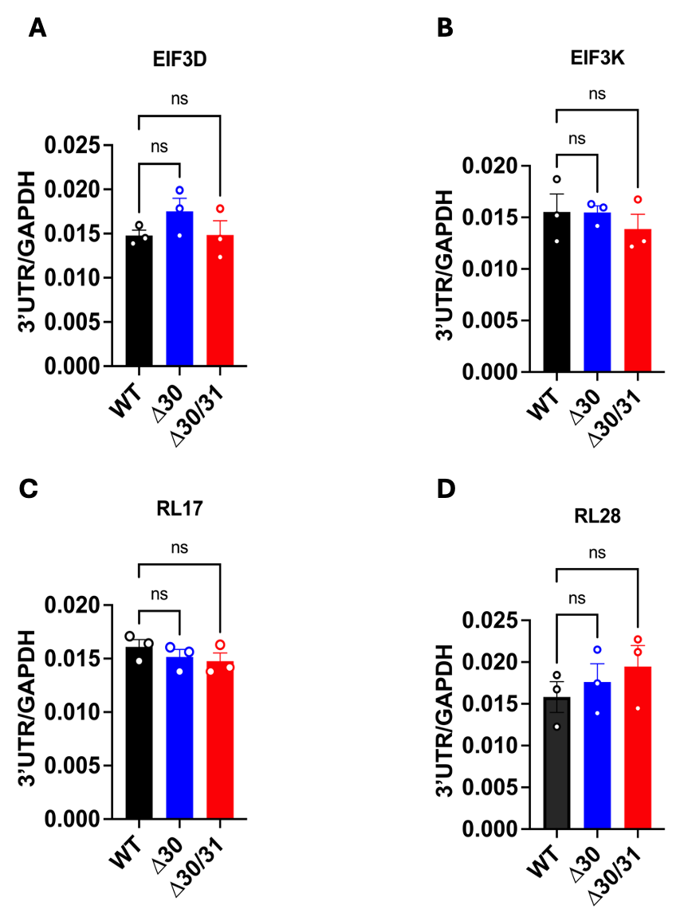
Supplementary Figure 4 Features of the 3′UTR RNA levels at 4 hours post-transfection. (A-D) Plasmids containing the 3′UTR from Sleman/78 (WT), ∆30, and ∆30/31 were separately transfected into Huh-7 cells for each of the four experiments that involved immunoprecipitation with mAbs specific for EIF3D, EIF3K, RL17 and RL28. Cells were harvested at the 4-hour post-transfection to determine the 3′UTR RNA levels before RNA immunoprecipitation. The RT-qPCR results for, showed no significant differences in transcription levels between WT, ∆30, and ∆30/31 in all four experiments. Mean ± SEM values for the fold enrichment were compared using one-way ANOVA with Tukey’s post-hoc test. Statistical significance was set at *p ≤ 0.05, **p ≤ 0.01, ***p ≤ 0.001, ****p ≤ 0.0001
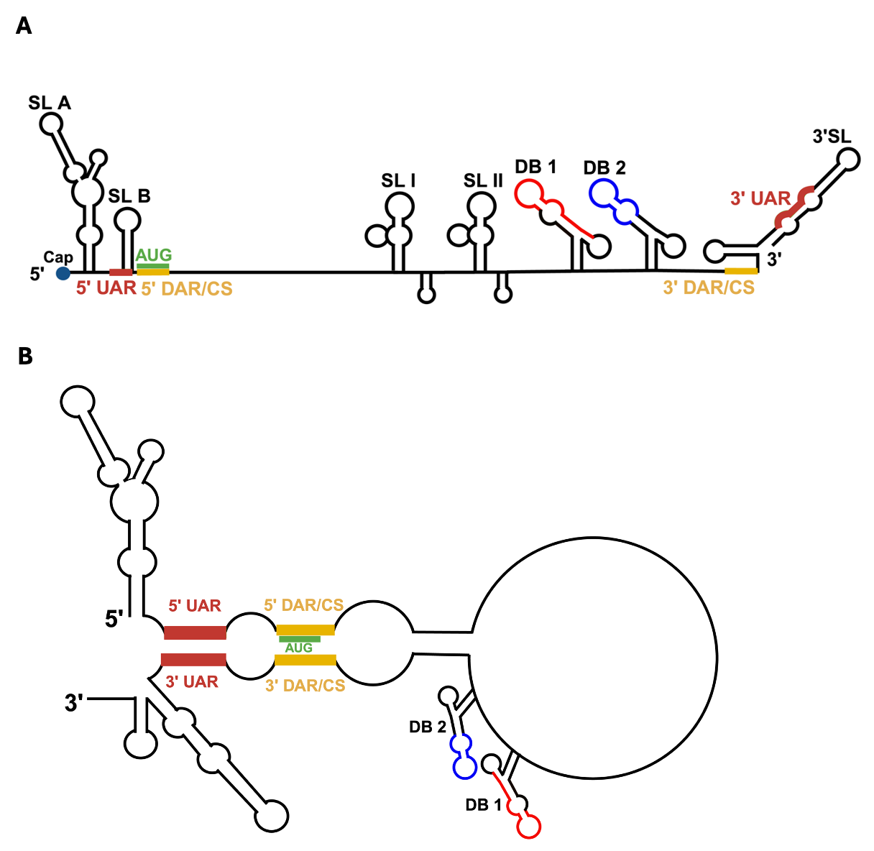
Supplementary Figure 5 Features of the cyclized DENV RNA genome. (A) A schematic representation of the DENV genome, along with the predicted RNA structures in the 5’ and 3’UTR. The 5' UTR has two stem-loop structures: stem-loop A (SLA) and stem-loop B (SLB), both located upstream of the AUG region (UAR), which consist of a hairpin structure and complementary sequences (CS) from the capsid coding region. The 3' UTR has two double stem-loop structures (SL-I and SL-II), followed by two dumbbell structures (DB-1 and DB-2) followed by a downstream AUG region (DAR) and a 3' stem-loop (3' SL). (B) In the circular form, long-range RNA-RNA interactions occur between elements in the 5' and 3' UTRs. These interactions involve in sequences of 5'-3' CS, 5'-3' DAR and 5'-3' UAR. These elements facilitate the cyclization of the viral RNA.

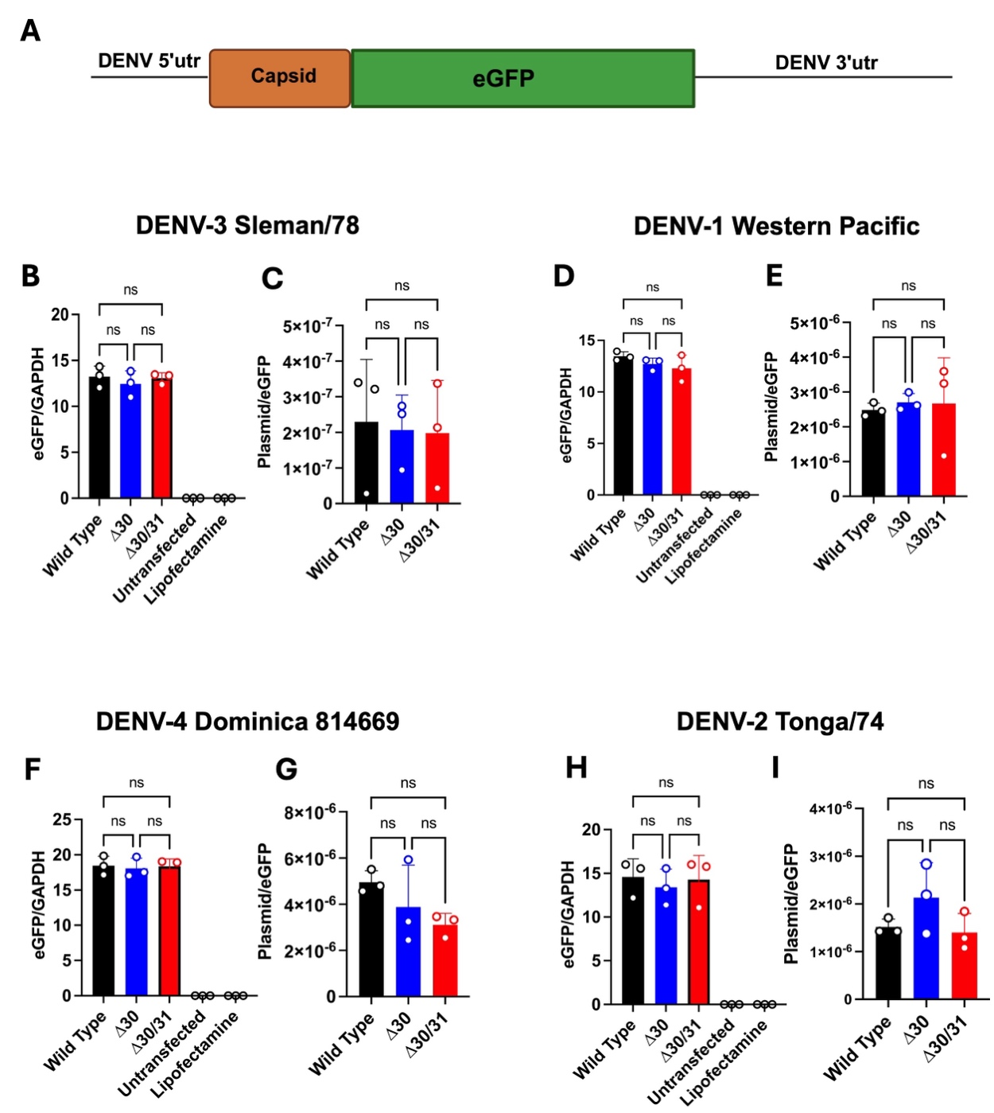
Supplementary Figure 6 Features of the DENV 5’ and 3’ UTR flanked eGFP plasmid transfection efficiency. (A) The construct was designed for the expression of eGFP, along with DENV-1 to -4 5' and 3' UTRs and 37 amino acids from the dengue capsid.
(B, D, F, and H) Transfection efficiency and plasmid transcription levels were measured using qPCR and RT-qPCR to ensure that the eGFP fluorescence data was not confounded by differences in transfection efficiency or eGFP mRNA levels. No significant differences in mRNA production were observed between the wildtype, ∆30, and ∆30/31 constructs. (C, E, G and I) To ensure that the RNA extraction was free from plasmid contamination, we also performed RT-qPCR targeting the plasmid sequence, normalizing it using eGFP. Mean ± SEM values were compared using one-way ANOVA with Tukey’s post hoc test. Statistical significance was set at *p ≤ 0.05, **p ≤ 0.01, ***p ≤ 0.001, ****p ≤ 0.0001, ns: nonsignificant.

Supplementary Tables
Supplementary Table 1. List of the primers used in Gibson assembly

Primer Name | Sequences
S_F1_F | AGAGCTCGTTTAGTGAACCGAGTTGTTAGTCTACGTGGACCGAC
S_F1_R | GCTGTGTCTCCCAAGATGGCCATGC
S_F2a_F | GCATGGCCATCTTGGGAGACACAGC
S_F2a_R | TATCACCCACAACTACCGTTAATTTGATGTTGTTTTC
S_F2b_F | AACGGTAGTTGTGGGTGATATAATTGGG
S_F2b_R | GAGGATTGCCAAACACAAGACTCCCATTG
S_F3_F | CAATGGGAGTCTTGTGTTTGGCAATCCTC
S_F3_R | ATAGGAGATCCTGAAGTCCCAGGCTTGAA
S_F4_F | TTCAAGCCTGGGACTTCAGGATCTCCTAT
S_F4_R | AGAGTTCTCTATGGTATGTCTTAACATTGGTGT
S_F5_F | ACACCAATGTTAAGACATACCATAGAGAACTCT
S_F5_R | CTGTCATTGCCATCTGTGTCACCATGGG
S_F6_F | CCCATGGTGACACAGATGGCAATGACAG
S_F6_R | GATGCCATGCCGACCCGAACCTGTTGATTCAACAGCACCA
pUC19_F | TGGTGCTGTTGAATCAACAGGTTCGGGTCGGCATGGCATCTCCAC
pUC19_R | GTCGGTCCACGTAGACTAACAACTCGGTTCACTAAACGAGCTCT

Supplementary Table 2. List of primers used in qPCR

Primer name | Sequences
gRNA_F | CGATGAAGAGATTCAGGAAGGAG
sfRNA_F | AAAGAAGAAGTCAGGCCCAAA
gRNA/sfRNA_R | CTGCGTTGTGTCATGGGA
Interferon-β_F | CAGCTCTTTCCATGAGCTACAA
Interferon-β_R | CAGTATTCAAGCCTCCCATTCA
GAPDH_F | GAGTCAACGGATTTGGTCGT
GAPDH_R | TTGATTTTGGAGGGATCTCG

Supplementary Table 3. List of the primers used for amplification of 3’UTR or NS2A with T7 and tobramycin tag

Primers name | Sequences
3’UTR F | AGA GCT CGT TTA GTG AAC CGT AAT ACG ACT CAC TAT AAG GG
3’UTR R | ATA TTT TAT TTG CTG TTA TTT GCG GGG GGT CTC CTC
NS2a F | AGA GCT CGT TTA GTG AAC CGT AAT ACG ACT CAC TAT AGG G
NS2a R | TAG CAT ATT TTA TTA TTT TTT CAA ATT GTG TTA ATT TAA GAG CCA T

Supplementary Table 4. List of the primers used for Gibson assembly of DENV 5’ and 3’UTR flanked eGFP mammalian expression vector, pUC19

Primer name | Sequences
Western Pacific_eGFP_F | TTT AGT GAA CCG TAG TTG TTA GTC TAC GTG GAC
Western Pacific_eGFP_R | GCC ATG CCG ACC CAG AAC CTG TTG ATT CAA CAG
Western Pacific_eGFP_Vactor_F | TCA ACA GGT TCT GGG TCG GCA TGG CAT CTC CA
Western Pacific_eGFP_Vactor_R | AGA CTA ACA ACT ACG GTT CAC TAA ACG AGC TCT GC
Tonga/74_eGFP_F | TTT AGT GAA CCG TAG TTG TTA GTC TAC GTG GAC
Tonga/74_eGFP_R | GCC ATG CCG ACC CAG AAC CTG TTG ATT CAA CAG
Tonga/74_eGFP_Vac_F | TCA ACA GGT TCT GGG TCG GCA TGG CAT CTC CA
Tonga/74_eGFP_Vac_R | AGA CTA ACA ACT ACG GTT CAC TAA ACG AGC TCT GC
Sleman/78_eGFP_F | GAA TCA ACA GGT TCT GGG TCG GCA TGG CAT CTC CAC CTC CTC GAC
Sleman/78_eGFP_R | ATG CCA TGC CGA CC AGA ACC TGT TGA TTC AAC AGC ACC ATT CCA
Sleman/78_eGFP_Vector_F | CGT TTA GTG AAC CGT AGT TGT TAG TCT ACG TGG ACC GAC AAG AAC
Sleman/78_eGFP_Vector_R | CGT AGA CTA ACA ACT ACG GTT CAC TAA ACG AGC TCT GCT TAT ATA GAC CTC CCA CCG TA
Dominica_eGFP_F | TTT AGT GAA CCG TAG TTG TTA GTC TGT GTG GAC
Dominica_eGFP_R | GCC ATG CCG ACC CAG AAC CTG TTG GAT CAA CAA C
Dominica_eGFP_Vac_F | CCA ACA GGT TCT GGG TCG GCA TGG CAT CTC CA
Dominica_eGFP_Vac_R | AGA CTA ACA ACT ACG GTT CAC TAA ACG AGC TCT GC

Supplementary Table 5. List of the primers used to measure transcription of eGFP

Primer name | Sequence
eGFP F | CTACAACTCCCACAACGTCTAC
eGFP_R | CGTCTTCGATATTGTGTCGTATCT
GFP Vec qPCR F | ACTGGTCCACCTACAACAAAG
GFP Vec qPCR R | AGAAGGTGTTGCTGACTCATAC

