Theoretical investigation on the complexation characteristics and spectral properties of CdTe QDs with four capping agents
Qinghong Yang. Xujiang Wan .Yang Chen .Hui Luo . Yan Zheng* . Laicai Li*
College of Chemistry and Material Science, Sichuan Normal University, Chengdu, 610068, China.
E-mail: zhengyanchem@163.com; lilcmail@163.com

Table of Contents
Fig. S1. The stable complexation configurations of GSH、TG and MES on (CdTe)_{n(n=6,9)} respectively
Fig. S2. The electron density maps of stable complexation structures of MPA、GSH、TG and MES
on (CdTe)_{n(n=6,9)}
Table S1. The milliken charge values of MPA、GSH、TG、MES、(CdTe)_{n(n=6,9)} before complexation and the stable configurations after complexation

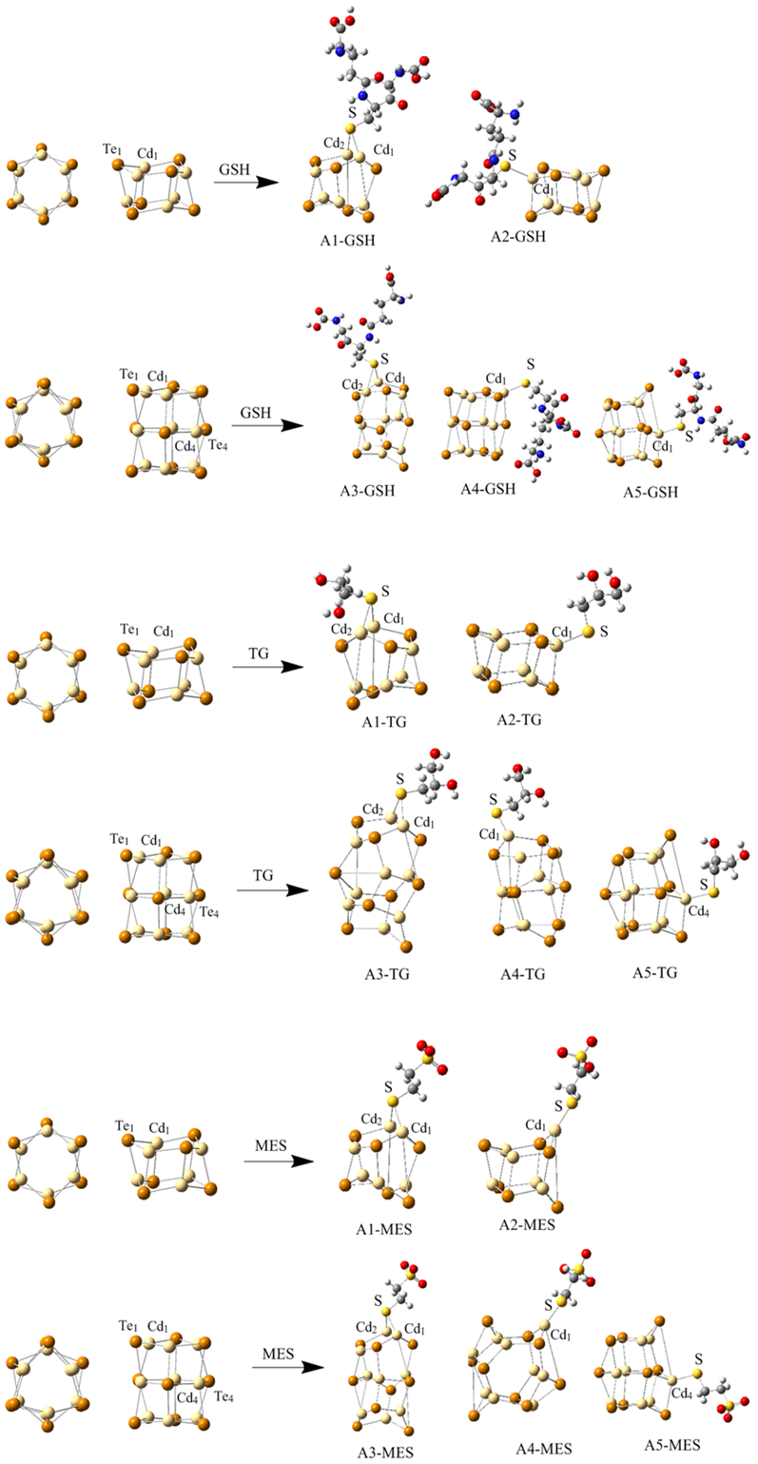
Fig. S1 The stable complexation configurations of GSH、TG and MES on (CdTe)n(n=6,9) respectively

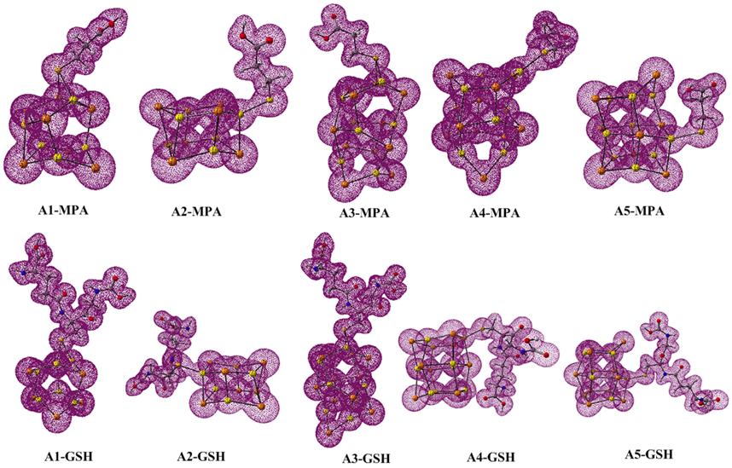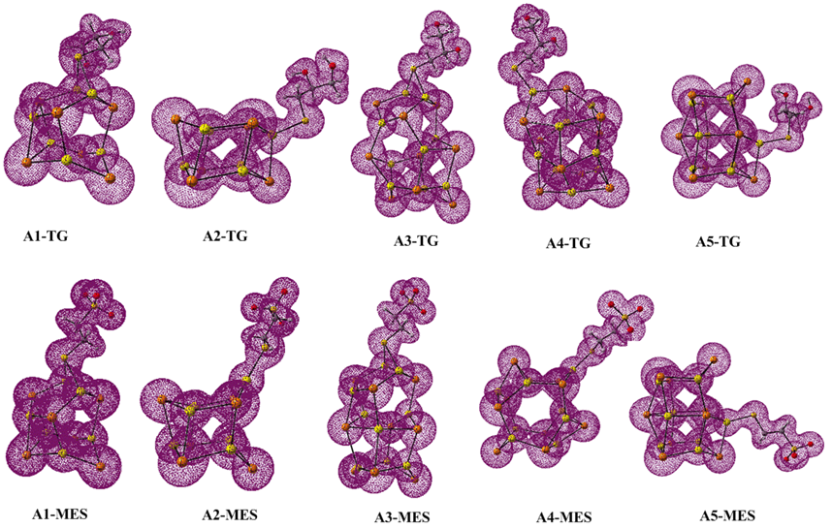
Fig. S2. The electron density maps of stable complexation structures of MPA、GSH、TG and MES on (CdTe)n (n = 6, 9)
Table S1. The Milligan charge values of MPA、GSH、TG、MES、(CdTe)_{n(n=6,9)} before complexation and the stable configurations after complexation
complexes | q/e | complexes | q/e | complexes | q/e | complexes | q/e
(CdTe)₆ | Cd₁₌0.24  Te₁=-0.24 | MPA | S₁=-0.82 | TG | S₁=-0.77
(CdTe)₉ | Cd₁₌0.10  Cd₄₌0.37  Te₁=-0.24  Te₄=-0.33 | GSH | S₁=-0.64 | MES | S₁=-0.95
A1-MPA | S₁=0.23  Cd₁=0.22  Cd₂=0.19 | A1-GSH | S₁=0.43  Cd₁=0.18  Cd₂=0.20 | A1-TG | S₁=0.09  Cd₁=0.35  Cd₂=0.23 | A1-MES | S₁=0.39  Cd₁=0.19  Cd₂=0.19
A2-MPA | S₁=-0.20  Cd₁=0.47 | A2-GSH | S₁=-0.21  Cd₁=0.40 | A2-TG | S₁=-0.22  Cd₁=0.52 | A2-MES | S₁=-0.20  Cd₁=0.38
A3-MPA | S₁=0.19  Cd₁=0.17  Cd₂=0.19 | A3-GSH | S₁=0.30  Cd₁=0.18  Cd₂=0.23 | A3-TG | S1=0.22  Cd1=0.21  Cd2=0.15 | A3-MES | S1=0.38  Cd1=0.17  Cd2=0.18
A4-MPA | S₁=-0.14  Cd₁=0.36 | A4-GSH | S=-0.17  Cd₁=0.39 | A4-TG | S1=-0.16  Cd1=0.36 | A4-MES | S1=-0.21  Cd1=0.42
A5-MPA | S₁=-0.06  Cd₄=0.42 | A5-GSH | S=-0.23  Cd₁=0.47 | A5-TG | S1=-0.08  Cd4=0.44 | A5-MES | S1=-0.37  Cd4=0.50

