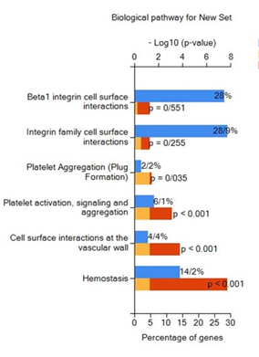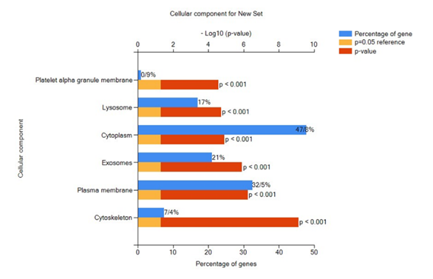
(b)
(a)
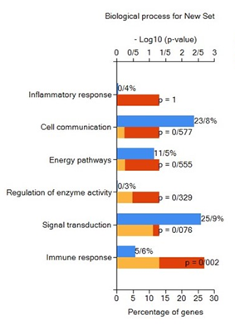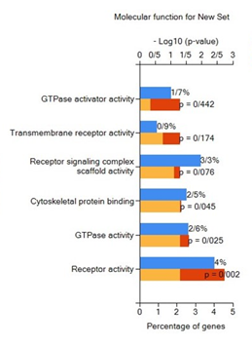
(d)
(c)
Figure S1. Diagrams obtained from the FunRich program illustrating various aspects of gene enrichment analysis: (a) Biological pathway diagram. (b) Cellular component diagram. (c) Biological process diagram. (d) Molecular function diagram.

Table S1. List of the top 10 hub genes identified from the Protein-Protein Interaction (PPI) network using Cytoscape software via the Maximum Clique Centrality (MCC) pathway analysis.
Pdb code | UNIPRUT CODE | Full name | GENE symbol
3ZCW | P52732 | Kinesin Family Member 11 | KIF11
1FIN | P20248 | Cyclin A2 | CCNA2
4YC6 | P06493 | Cyclin Dependent Kinase 1 | CDK1
4QPM | O43683 | MitoticCheckpoint Serine/Threonine Kinase | BUB1
2RAW | Q53HL2 | Cell Division Cycle Associated 8 | CDCA8
7ZX4 | Q15398 | DLG Associated Protein 5 | DLGAP5
6YIP | O95235 | Kinesin Family Member 20A | KIF20A
1OL5 | Q9ULW0 | TPX2 Microtubule Nucleation Factor | TPX2

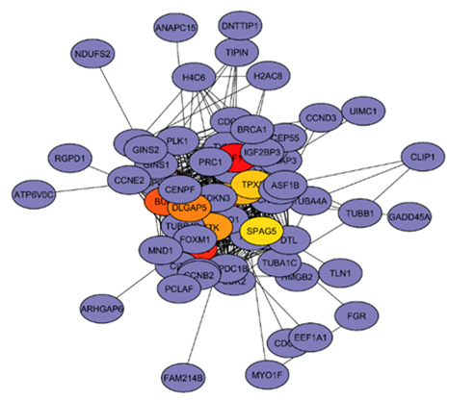
Figure S2. Gene interaction network based on Maximum Clique Centrality (MCC) analysis through the Cytohubba plugin in Cytoscape. This network illustrates the interactions among the top hub genes identified in the study.
Table S2. Comparison of the expression levels of hub genes between the drug-treated group and the MS group. The table highlights the differences in expression for each hub gene, showcasing their potential roles in the context of multiple sclerosis treatment.
MS.Treat- MS.UnTreat |  |  | MS.UnTreat-Control
adj.P.Val | P.Value | logFC | adj.P.Val | P.Value | logFC | Gene Symbol
0/294195 | 0/020366 | -0/31613 | 0/39678 | 0/002991 | 0/425092 | KIF11
0/195604 | 0/005532 | -0/33578 | 0/536509 | 0/01111 | 0/317227 | CCNA2
0/360281 | 0/03732 | 0/138399 | 0/644179 | 0/02534 | 0/281647 | CDK1
0/23779 | 0/010545 | -0/28409 | 0/312688 | 0/000879 | 0/38992 | BUB1
0/293963 | 0/02027 | -0/21322 | 0/467592 | 0/005229 | 0/268461 | CDCA8
0/238131 | 0/010952 | -0/35405 | 0/461864 | 0/005105 | 0/406252 | DLGAP5
0/397266 | 0/049055 | -0/20131 | 0/584877 | 0/015704 | 0/258167 | TTK
0/092305 | 0/000619 | -0/34313 | 0/258899 | 0/000193 | 0/390777 | KIF20A
0/303161 | 0/022291 | -0/25045 | 0/316761 | 0/00098 | 0/382744 | TPX2
0/343688 | 0/032656 | -0/21534 | 0/530014 | 0/010505 | 0/269498 | SPAG5

Table S3. List of drugs assessed for pharmacokinetic properties using Lipinski's rule of five, obtained from the SwissADME database. This table includes the compounds that meet the criteria for drug-likeness, highlighting their potential suitability for therapeutic applications.
Drug  Names | Protein Names
5-(3-AMINOPROPYL)-3-(2,5-DIFLUOROPHENYL)-N-ETHYL-5-PHENYL-4,5-DIHYDRO-1H-PYRAZOLE-1-CARBOXAMIDE | P52732
Monastrol | P52732
(4R)-4-(3-HYDROXYPHENYL)-N,N,7,8-TETRAMETHYL-3,4-DIHYDROISOQUINOLINE-2(1H)-CARBOXAMIDE | P52732
N,N-DIETHYL-2-[(2-THIENYLCARBONYL)AMINO]-4,5,6,7-TETRAHYDRO-1-BENZOTHIOPHENE-3-CARBOXAMIDE | P52732
(5R)-N,N-DIETHYL-5-METHYL-2-[(THIOPHEN-2-YLCARBONYL)AMINO]-4,5,6,7-TETRAHYDRO-1-BENZOTHIOPHENE-3-CARBOXAMIDE | P52732
(2S)-4-(2,5-difluorophenyl)-N-[(3R,4S)-3-fluoro-1-methylpiperidin-4-yl]-2-(hydroxymethyl)-N-methyl-2-phenyl-2,5-dihydro-1H-pyrrole-1-carboxamide | P52732
[(4R)-4-(3-HYDROXYPHENYL)-1,6-DIMETHYL-2-THIOXO-1,2,3,4-TETRAHYDROPYRIMIDIN-5-YL](PHENYL)METHANONE | P52732
(2S)-4-(2,5-DIFLUOROPHENYL)-N-METHYL-2-PHENYL-N-PIPERIDIN-4-YL-2,5-DIHYDRO-1H-PYRROLE-1-CARBOXAMIDE | P52732
(1S)-1-CYCLOPROPYL-2-[(2S)-4-(2,5-DIFLUOROPHENYL)-2-PHENYL-2,5-DIHYDRO-1H-PYRROL-1-YL]-2-OXOETHANAMINE | P52732
(2S)-4-(2,5-DIFLUOROPHENYL)-N,N-DIMETHYL-2-PHENYL-2,5-DIHYDRO-1H-PYRROLE-1-CARBOXAMIDE | P52732
(5S)-5-(3-AMINOPROPYL)-3-(2,5-DIFLUOROPHENYL)-N-ETHYL-5-PHENYL-4,5-DIHYDRO-1H-PYRAZOLE-1-CARBOXAMIDE | P52732
4-(2,4-Dimethyl-Thiazol-5-Yl)-Pyrimidin-2-Ylamine | P20248
6-O-Cyclohexylmethyl Guanine | P20248
[4-(2-Amino-4-Methyl-Thiazol-5-Yl)-Pyrimidin-2-Yl]-(3-Nitro-Phenyl)-Amine | P20248
4-(2,4-Dimethyl-Thiazol-5-Yl)-Pyrimidin-2-Yl]-(4-Trifluoromethyl-Phenyl)-Amine | P20248
4-[(7-OXO-7H-THIAZOLO[5,4-E]INDOL-8-YLMETHYL)-AMINO]-N-PYRIDIN-2-YL-BENZENESULFONAMIDE | P20248
N-(3-cyclopropyl-1H-pyrazol-5-yl)-2-(2-naphthyl)acetamide | P20248
O6-CYCLOHEXYLMETHOXY-2-(4'-SULPHAMOYLANILINO) PURINE | P20248
N-cyclopropyl-4-pyrazolo[1,5-b]pyridazin-3-ylpyrimidin-2-amine | P20248
6-CYCLOHEXYLMETHOXY-2-(3'-CHLOROANILINO) PURINE | P20248
5-[5,6-BIS(METHYLOXY)-1H-BENZIMIDAZOL-1-YL]-3-{[1-(2-CHLOROPHENYL)ETHYL]OXY}-2-THIOPHENECARBOXAMIDE | P20248
4-{5-[(Z)-(2-IMINO-4-OXO-1,3-THIAZOLIDIN-5-YLIDENE)METHYL]-2-FURYL}-N-METHYLBENZENESULFONAMIDE | P20248
4-{5-[(Z)-(2-IMINO-4-OXO-1,3-THIAZOLIDIN-5-YLIDENE)METHYL]FURAN-2-YL}BENZENESULFONAMIDE | P20248
4-{5-[(Z)-(2-IMINO-4-OXO-1,3-THIAZOLIDIN-5-YLIDENE)METHYL]FURAN-2-YL}-2-(TRIFLUOROMETHYL)BENZENESULFONAMIDE | P20248
4-{5-[(Z)-(2-IMINO-4-OXO-1,3-THIAZOLIDIN-5-YLIDENE)METHYL]FURAN-2-YL}BENZOIC ACID | P20248
N-[4-(2,4-DIMETHYL-THIAZOL-5-YL)-PYRIMIDIN-2-YL]-N',N'-DIMETHYL-BENZENE-1,4-DIAMINE | P20248
4-{[5-(CYCLOHEXYLOXY)[1,2,4]TRIAZOLO[1,5-A]PYRIMIDIN-7-YL]AMINO}BENZENESULFONAMIDE | P20248
1-(3,5-DICHLOROPHENYL)-5-METHYL-1H-1,2,4-TRIAZOLE-3-CARBOXYLIC ACID | P20248
4-(4-methoxy-1H-pyrrolo[2,3-b]pyridin-3-yl)pyrimidin-2-amine | P20248
4-(4-propoxy-1H-pyrrolo[2,3-b]pyridin-3-yl)pyrimidin-2-amine | P20248
HYDROXY(OXO)(3-{[(2Z)-4-[3-(1H-1,2,4-TRIAZOL-1-YLMETHYL)PHENYL]PYRIMIDIN-2(5H)-YLIDENE]AMINO}PHENYL)AMMONIUM | P20248
4-Methyl-5-[(2Z)-2-{[4-(4-morpholinyl)phenyl]imino}-2,5-dihydro-4-pyrimidinyl]-1,3-thiazol-2-amine | P20248
6-CYCLOHEXYLMETHYLOXY-2-(4'-HYDROXYANILINO)PURINE | P20248
4-(6-CYCLOHEXYLMETHOXY-9H-PURIN-2-YLAMINO)--BENZAMIDE | P20248
3-(6-CYCLOHEXYLMETHOXY-9H-PURIN-2-YLAMINO)-BENZENESULFONAMIDE | P20248
(2R)-2-{[4-(benzylamino)-8-(1-methylethyl)pyrazolo[1,5-a][1,3,5]triazin-2-yl]amino}butan-1-ol | P20248
3-({2-[(4-{[6-(CYCLOHEXYLMETHOXY)-9H-PURIN-2-YL]AMINO}PHENYL)SULFONYL]ETHYL}AMINO)PROPAN-1-OL | P20248
1-methyl-8-(phenylamino)-4,5-dihydro-1H-pyrazolo[4,3-h]quinazoline-3-carboxylic acid | P20248
(2R)-2-({9-(1-methylethyl)-6-[(4-pyridin-2-ylbenzyl)amino]-9H-purin-2-yl}amino)butan-1-ol | P20248
1-[4-(AMINOSULFONYL)PHENYL]-1,6-DIHYDROPYRAZOLO[3,4-E]INDAZOLE-3-CARBOXAMIDE | P20248
4-{[4-AMINO-6-(CYCLOHEXYLMETHOXY)-5-NITROSOPYRIMIDIN-2-YL]AMINO}BENZAMIDE | P20248
9-amino-5-(2-aminopyrimidin-4-yl)pyrido[3',2':4,5]pyrrolo[1,2-c]pyrimidin-4-ol | P20248
Indirubin-3'-Monoxime | P06493
Olomoucine | P06493
Hymenialdisine | P06493
SU9516 | P06493
Flavopiridol | P06493
Alsterpaullone | P06493
AT7519 | P06493

Table S4. Docking results of the top 5 compounds against KIF11. The table includes binding energies and key interacting amino acids, illustrating the interaction profiles of each compound with the KIF11 protein.
Ligad Name | Binding Affinity (kj/mol) | H-bond and length(Å) | Hydrophobic interaction
99443535 | -9.50 | Tyr104(3.04), Arg355(3.00) | Ala356, Thr300, Ile299, Gly296, Ile332, Ser269, Leu292, Leu293, Tyr352
6102824 | -9.30 | Thr300(2.90), Gly296(3.02) | Ala356, Arg355, Ile299, Ile332, Tyr104, Tyr352, Ala355, Leu293
5288685 | -9.00 | Thr300(2.90), Leu292(2.09) | Arg355, Leu299, Gly296, Tyr352, Leu293, Leu295, Tyr104, Ala356
11840968 | -8.80 | - | Ile288, Leu293, Arg297, Tyr352, Gly296, Tyr104, Ile299, Leu292, Asn289
1190625 | -8.50 | Thr300(2.90), Gly296(3.02) | Ala356, Arg355, Ile299, Glu304, Ile332, Val303, Tyr104, Tyr352
Filanesib | 8.00 | - | Leu293, Leu292, Leu266, Tyr352, Tyr104, Ala356, Ala355, Arg355, Ile332, Thr300, Ile299, Gly296, Thr49

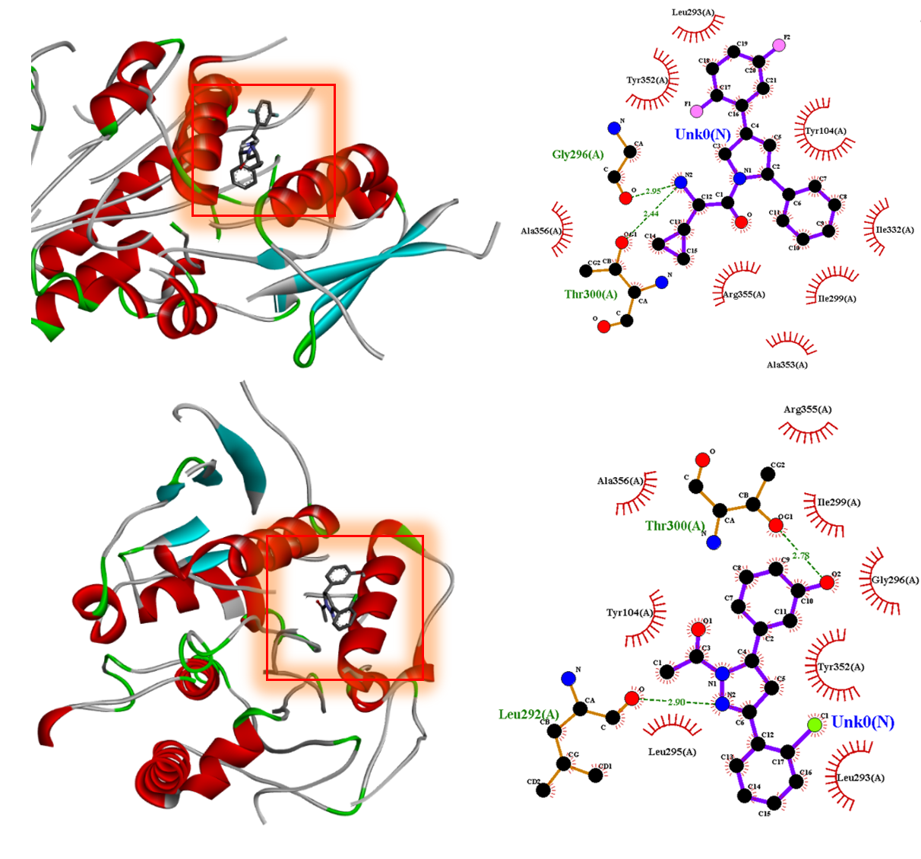
(a)
(b)

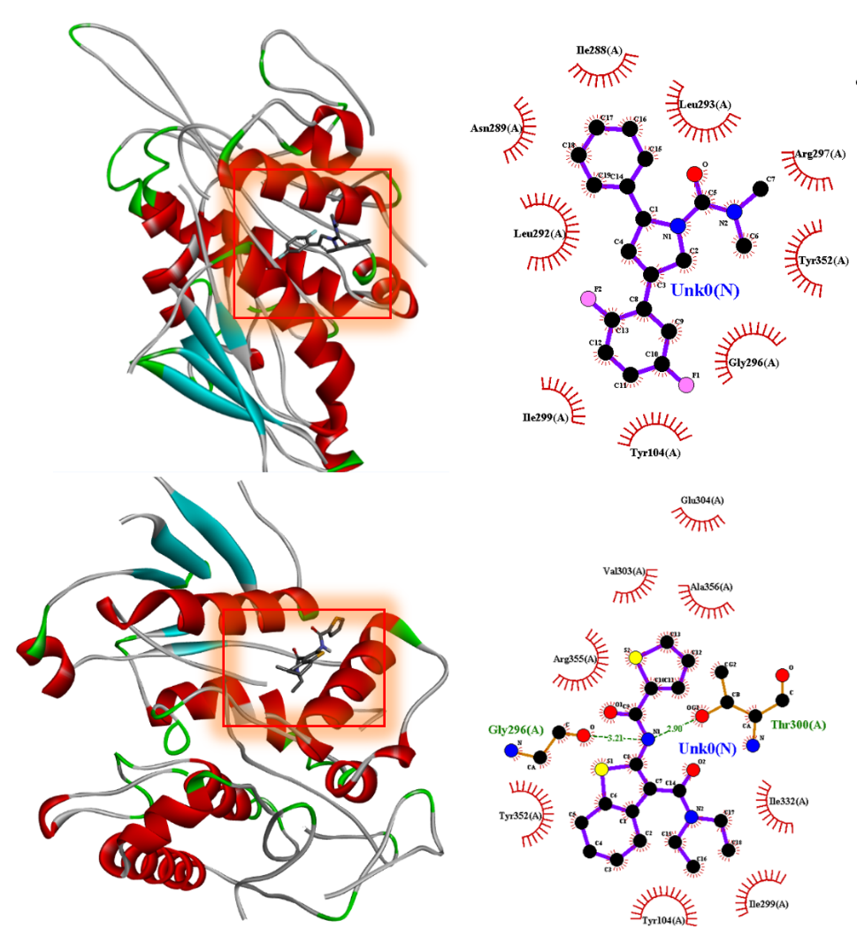
(d)
(c)
(e)
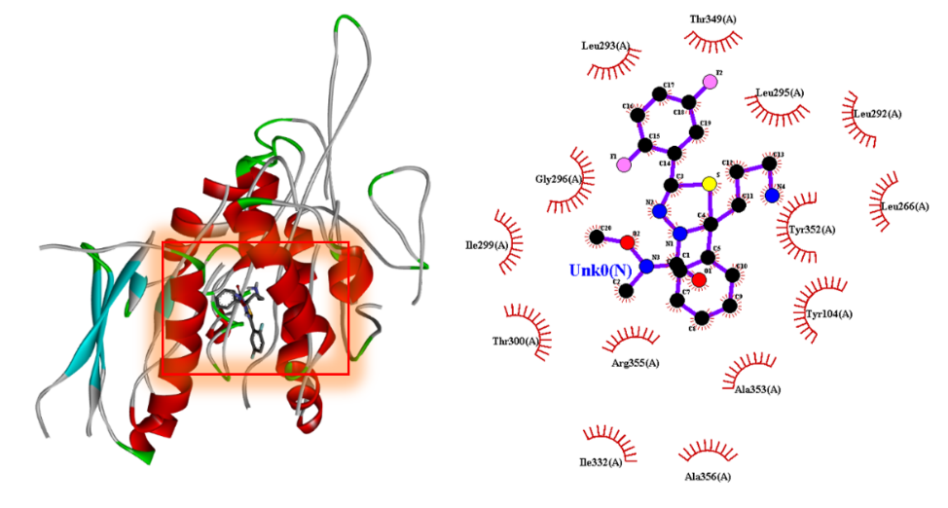

Figure S3. 2D and 3D views of the interactions of the remaining top compounds with KIF11 after docking. (a) Compound 6102824, (b) Compound 5288685, (c) Compound 11840968, (d) Compound 1190625, and (e) Filanesib. Each panel illustrates the binding interactions and conformations of the compounds with the KIF11 protein.
Table S5. Docking results for the top 5 compounds against CCNA2. This table includes the binding energies and key interaction details for each compound, highlighting their potential as inhibitors of the CCNA2 protein.
Ligad Name | Binding Affinity (kj/mol) | H-bond and length(Å) | Hydrophobic interaction
4566 | -8.60 | Thr316(2.98), Tyr197(3.03) | Ile182, Glu317, Tyr180, Ser181, Phe152, Val157, Glu174, Gly153, Asn173, Leu320, Phe319
4564 | -8.50 | Glu190(3.04), Tyr350(2.97) | Lys194, Pro195, Leu348, Tyr347, Leu341, Ile355, Val131, Val236, Ser340, Asn273, Pro352, Cys193
449087 | -8.40 | Asn173(2.84) | His179, Phe152, Gln317, Gly153, Thr316, Pro155, Tyr197, Leu320, Val157, Glu174, Ile182
23727982 | -8.3 | Ser340(2.97), Asn237 (3.23), Tyr350(2.96) | Pro195, Gln190, Pro352, Cys193, Lys194, Leu341, Arg211, Leu348, Asp240, Ile355, Pro309, Tyr347, Glu190, Val236, His233
23727981 | -8.10 | Ser340(3.01), Asn237 (3.17), Tyr350(2.90) | Pro195, Gln190, Pro352, Cys193, Lys194, Leu341, Arg211, Leu348, Asp240, Ile355, Pro309
Omacetaxine_Mepesuccinate | -7.30 | Glu230(2.05), Asn312(3.05), Tyr197(3.13) | Ala135, Phe319, Thr316, Pro155, Val154, Asn229, Glu288, Met334, Glu330, Leu320

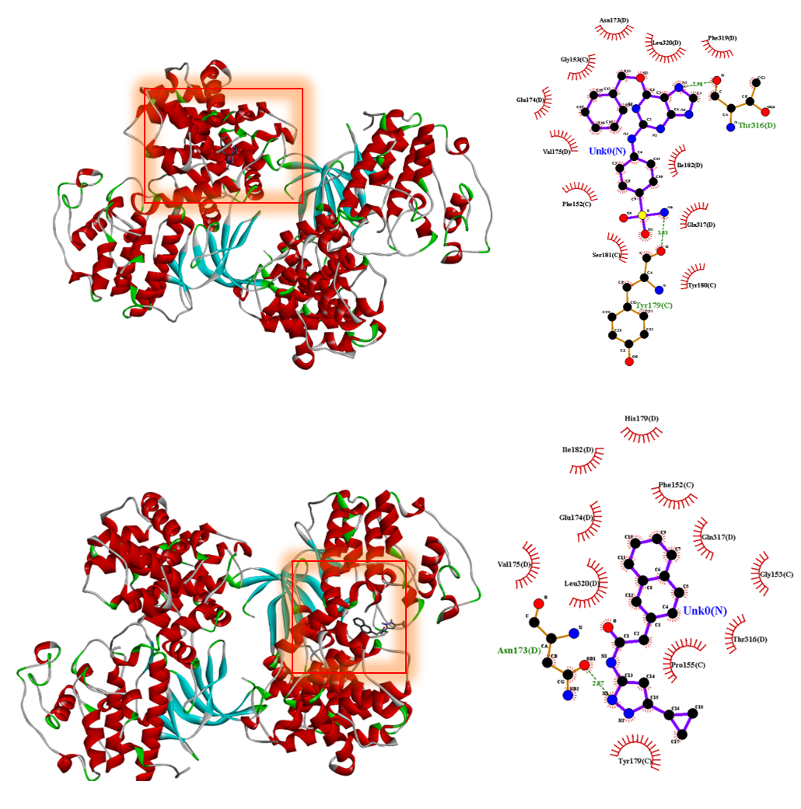
(c)
(a)
(b)

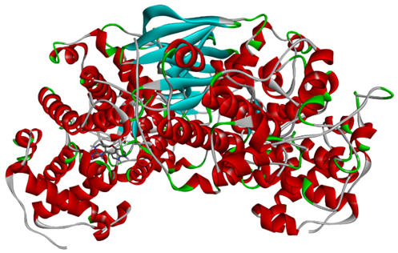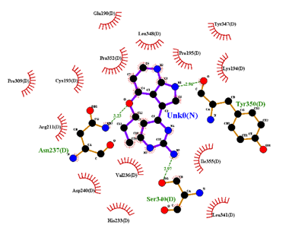

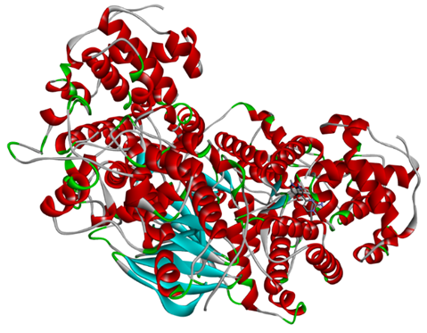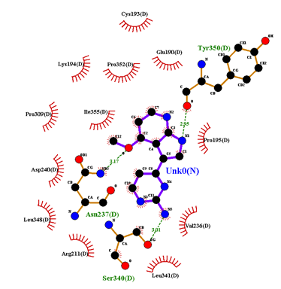
(e)
(d)
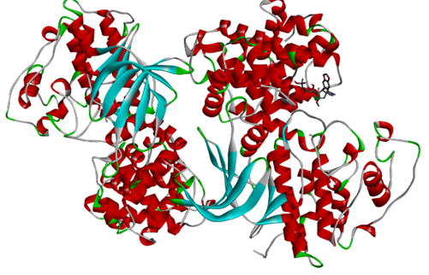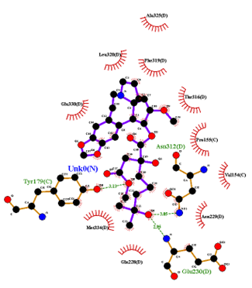

Figure S4. 2D and 3D views of the remaining top compounds docked with CCNA2. (a) Compound 4564. (b) Compound 449087. (c) Compound 23727982. (d) Compound 23727981. (e) Control compound Omacetaxine Mepesuccinate.

Table S6. Docking results of the top 5 compounds against CDK1, including binding energy and interaction details.
Ligad Name | Binding Affinity (kj/mol) | H-bond and length(Å) | Hydrophobic interaction
5005498 | -9.00 | - | Gln192, Gly13, Ala154, Asp146, Val64, Phe80, Ala31, Leu135, Val18, Lys33, Asn133
Flavopiridol | -8.50 | Lys33(2.8), Asp146(2.70), Glu81(2.70), Leu83(2.80) | Phe82, Val64, Phe80, Leu135, Ala31, Ala145, Gly13, Asn133, Gln132, Ile10, Met85, Asp86
5287969 | -8.2 | Ile10(2.85), Lys33(2.96), Lys33(2.97) | Asp154, Leu135, Ala31, Leu83, Ser84, Lys89, Asp86, Glu132, Asp146, Gly13
3707 | -8.00 | Leu135(2.70), Leu135(3.10), Ile10(2.98) | Lys33, Asp146, Ala154, Val64, Phe80, Ala31, Leu135, Ser84, Asp86, Lys89, Met85
11338033 | -7.50 | Lys33(3.03) | His162, Gln132, Gly13, Asp146, Leu135, Val118, Ile10, Ala31, Glu12
135413546 | -7.00 | Asn133(3.05), Asp146(2.93) | Leu135, Lys33, Leu135, Gln132

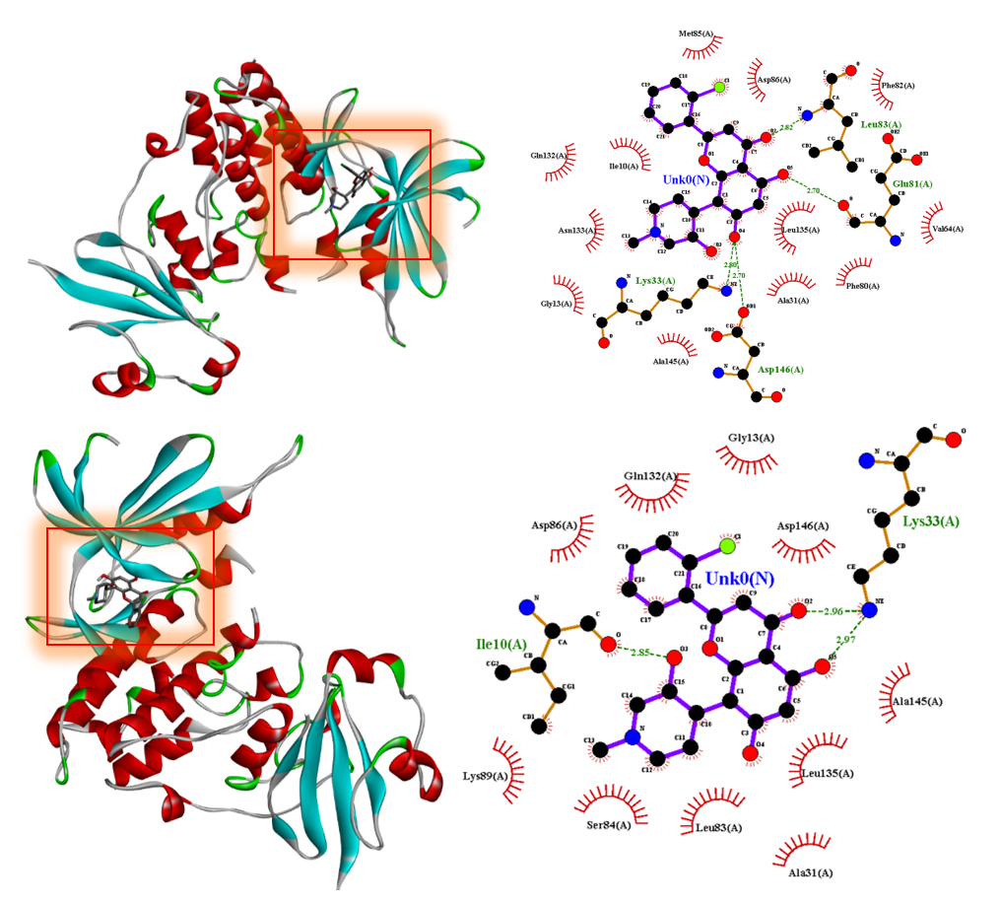
(b)
(a)
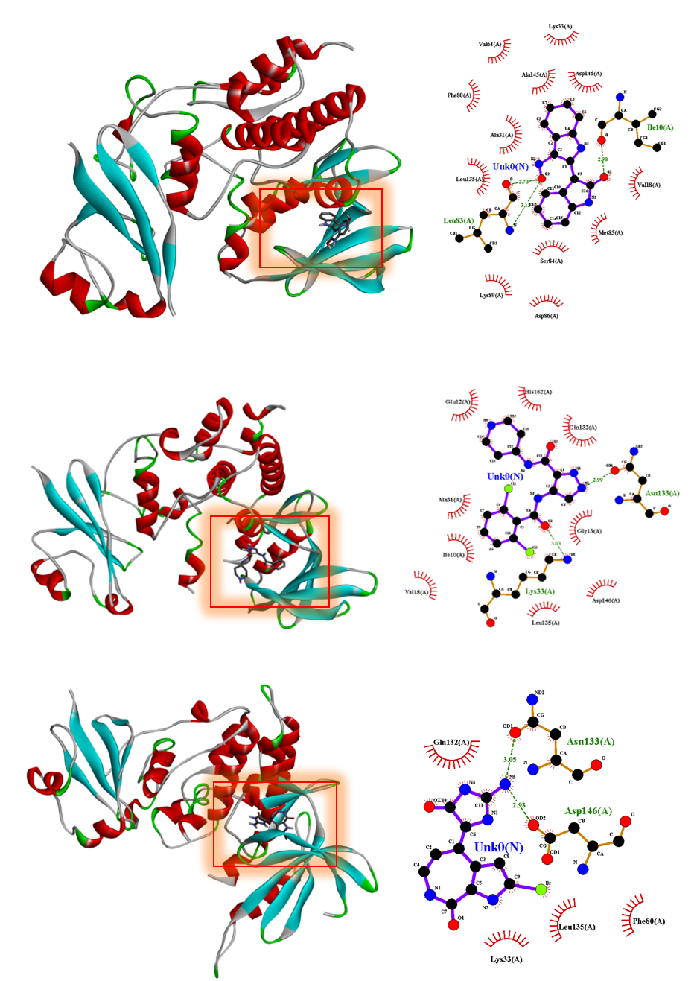
(e)
(d)
(c)

Figure S5. 2D and 3D views of the interactions of the top compounds with CDK1 after docking. (a) Flavopiridol. (b) Compound 5287969. (c) Compound 3707. (d) Compound 11338033. (e) Compound 135413546.

List of Abbreviations

Abbreviation | Definition
KIF11 | kinesin family member 11
CCNA2 | cyclin A2
CDK1 | Cyclin-dependent kinase 1
BUB1 | budding uninhibited by benzimidazoles 1
CDCA8 | Cell Division Cycle Associated 8
DLGAP5 | Disks large-associated protein 5
TTK | threonine tyrosine kinase
KIF20A | Kinesin Family Member 20A
TPX2 | Targeting protein for Xklp2
SPAG5 | Sperm-associated Antigen 5
Ala356 | Alanine 356
Thr300 | Tyrosine 300
Ile299 | Isoleucine 299
Gly296 | Glycine 269
Ile332 | Isoleucine 332
Ser269 | Serine 269
Leu292 | Leucine 292
Leu293 | Leucine 293
Tyr104 | Tyrosine 104
Arg355 | Arginine 355
Ile182 | Isoleucine 182
Glu317 | Glutamic acid 317
Tyr180 | Tyrosine 180
Ser181 | Serine 181
Phe152 | Phenylalanine 152
Val157 | Valine 157
Glu174 | Glutamic acid 174
Gly153 | Glycine 153
Asn173 | Asparagine 173
Leu320 | Leucine 320
Phe319 | Phenylalanine 319
Thr316 | Threonine 316
Tyr197 | Tyrosine 197
Gln192 | Glutamine 192
Gly13 | Glycine 13
Ala154 | Alanine 154
Asp146 | Aspartic acid 146
Val64 | Valine 164
Phe80 | Phenylalanine 80
Ala31 | Alanine 31
Leu135 | Leucine 135
Val18 | Valine 18
Lys33 | Lysine 33
Asn133 | Asparagine 133

