Supplementary Material
Differential tear fluid miRNAs in patients with Parkinson’s disease and atypical Parkinsonian syndromes
Antonia F. Demleitner¹*, Lucas Caldi Gomes¹, Lara Wenz¹, Laura Tzeplaeff¹, Dominik Pürner¹, Elena Luib¹, Lea H. Kunze¹, Paul Lingor^{1,2,3}

¹Department of Neurology, Klinikum rechts der Isar, TUM Universitätsklinikum, School of Medicine and Health, Technical University of Munich, Munich, Germany
² DZNE, German Center for Neurodegenerative Diseases, Munich, Germany
³ Munich Cluster for Systems Neurology (SyNergy), Munich Germany

*Corresponding Author: Antonia F. Demleitner, antonia.demleitner@tum.de, Department of Neurology, Klinikum rechts der Isar, TUM Universitätsklinikum, School of Medicine and Health, Technical University of Munich, Ismaninger Str. 22, 81675 Munich

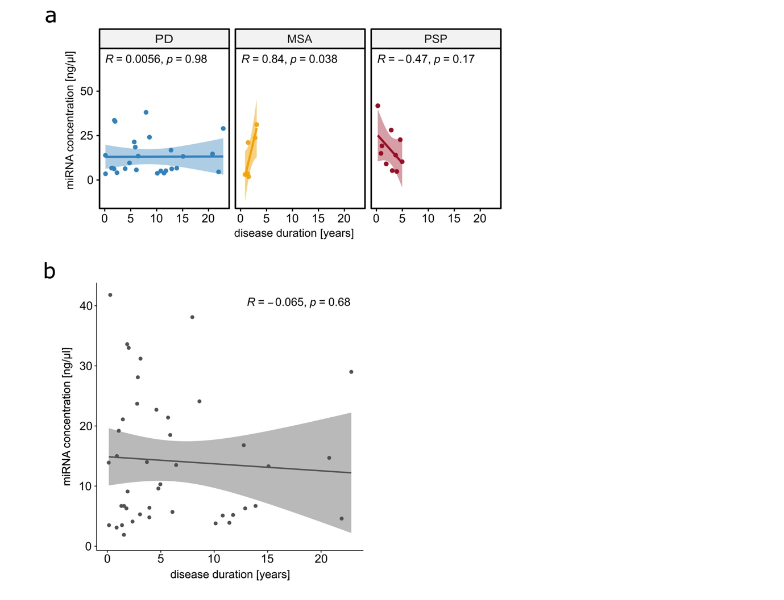
Supplementary Figure S1:
Correlation of miRNA concentration in tear fluid with disease duration. a) Correlation of miRNA concentration and disease duration within the subgroups of PD (blue), MSA (green) and PSP (red). b) Correlation of miRNA concentration and disease duration in a cohort of all disease groups. PD = Parkinson’s disease, MSA = multiple system atrophy, PSP = progressive supranuclear palsy. Pearson’s correlation (Coefficient = R) was used for analyses. Data are depicted as a regression line with 95% confidence interval and individual data points.
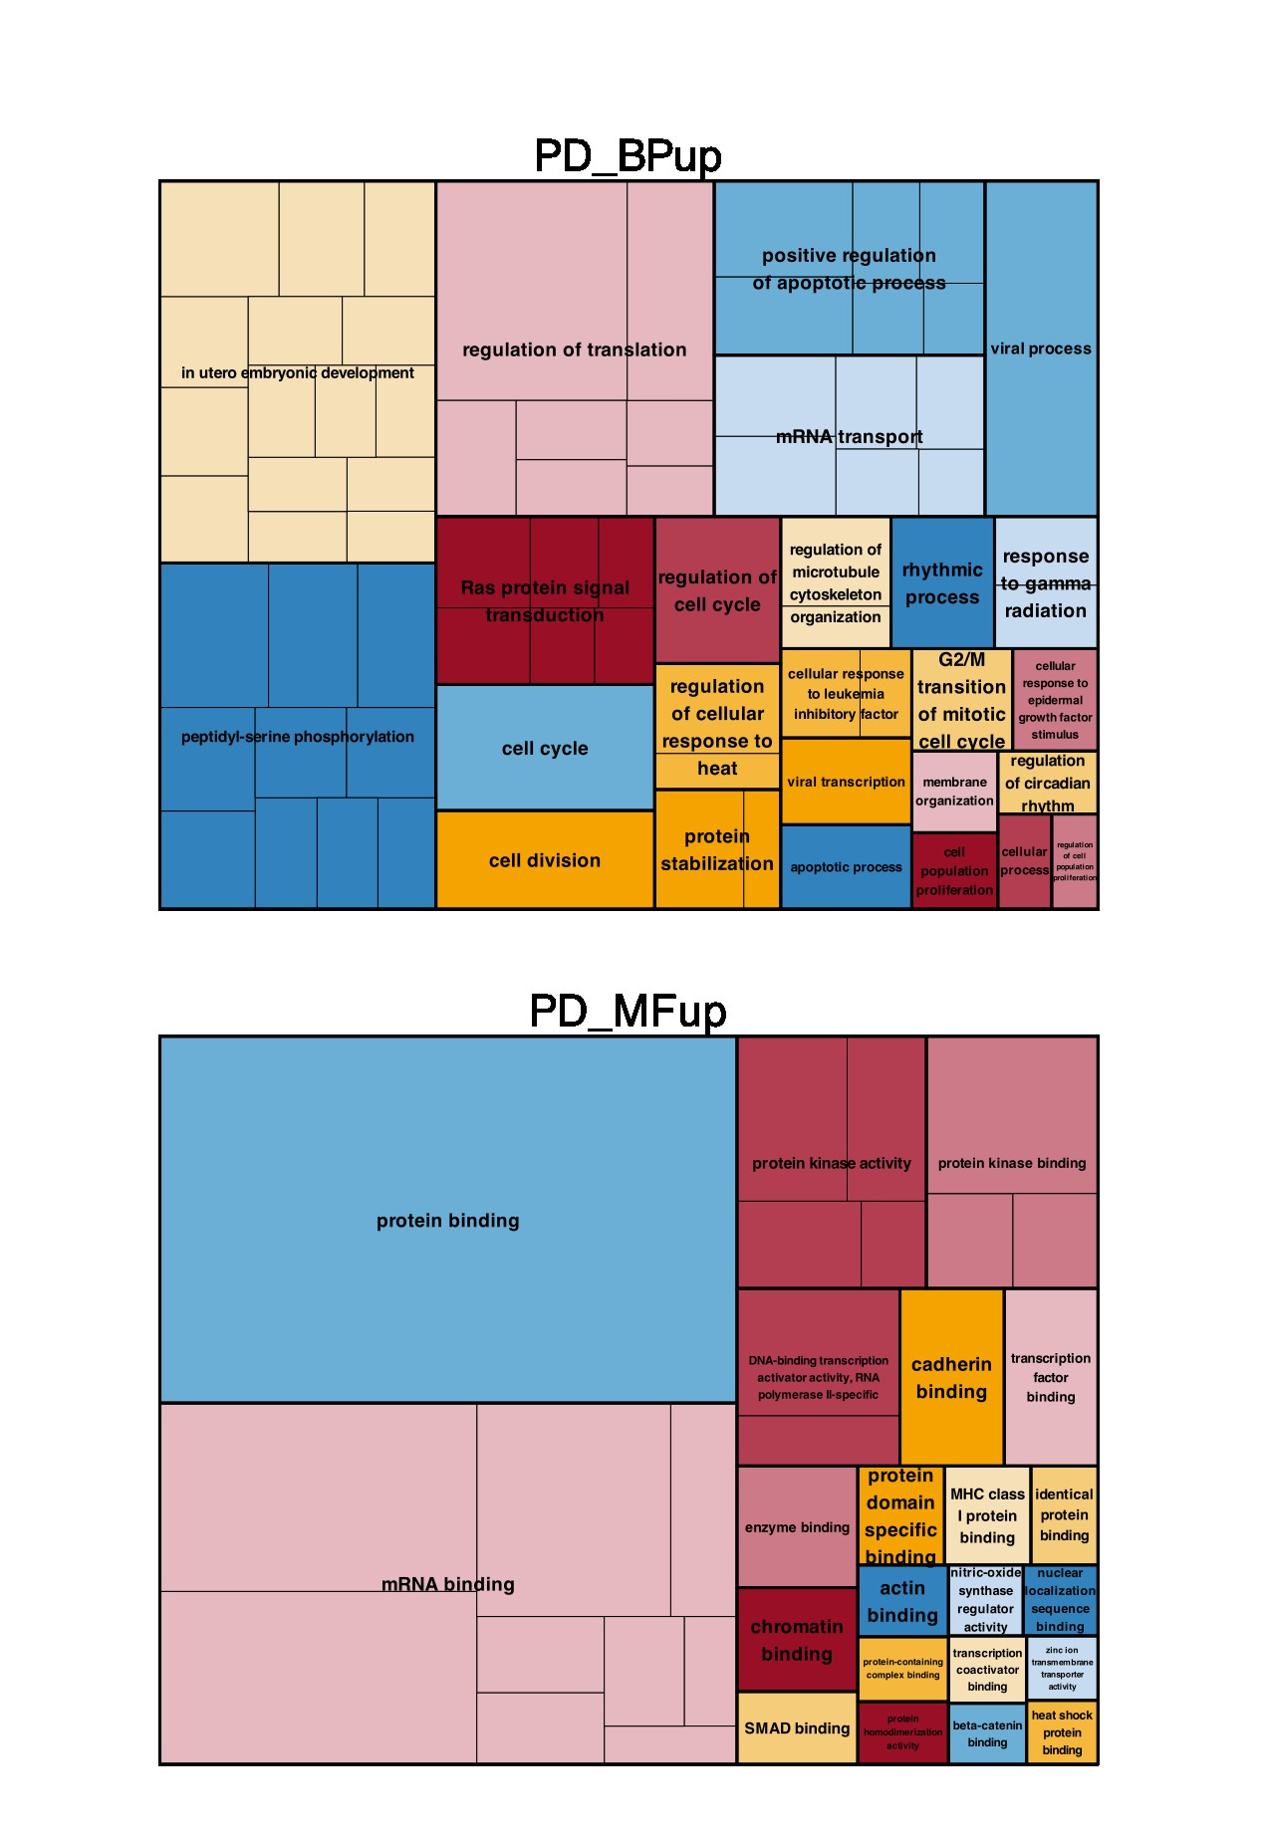
Supplementary Figure 2:
REVIGO Treemap Plots of all significant GO terms for the PD intersections. Labeling was determined by semantic similarity analysis. These representatives are combined into "superclusters", representing loosely related terms and visualized using different colors. The size of the clusters is adjusted to reflect the P-value and frequency of the GO term in the Homo sapiens GOA database. BP = Biological process, MF = Molecular function, PD = Parkinson’s disease.

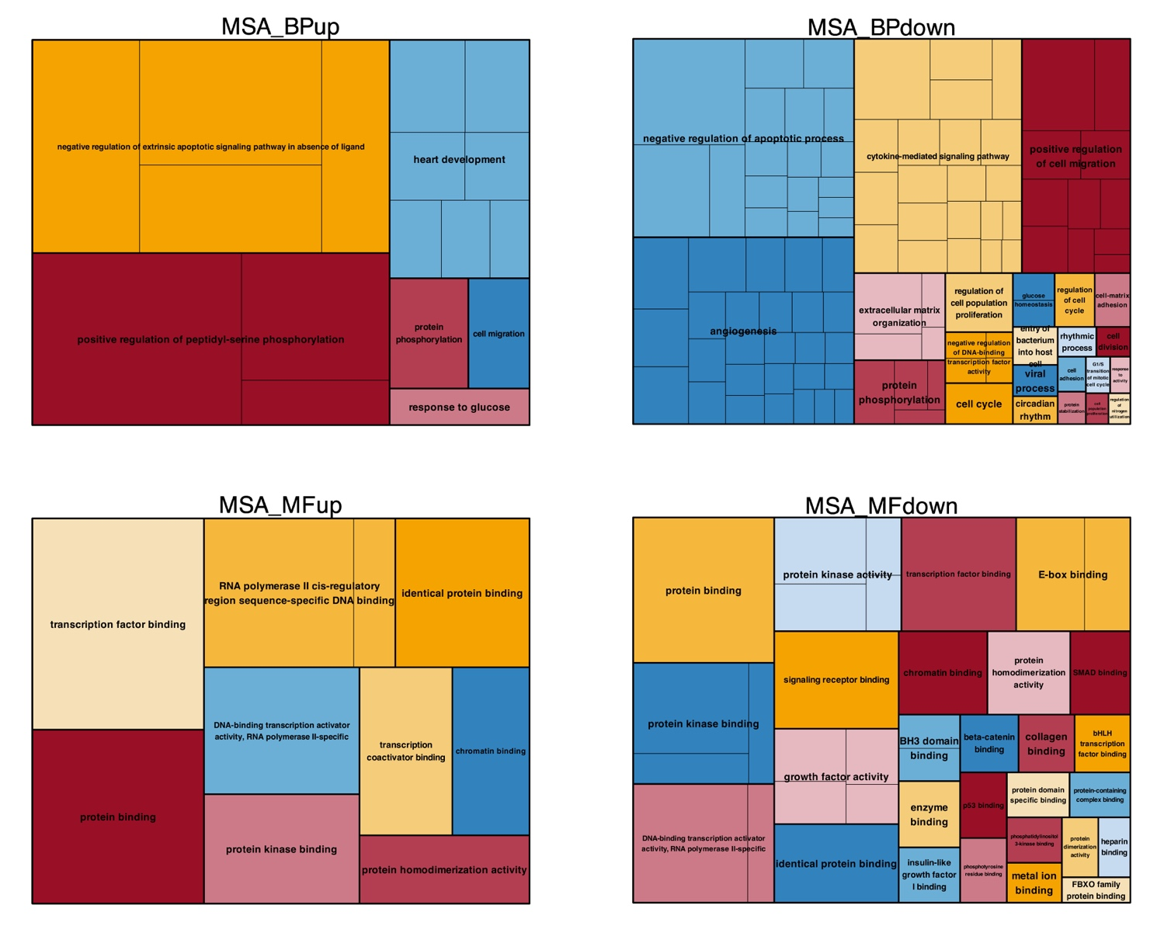
Supplementary Figure 3:
REVIGO Treemap Plots of all significant GO terms for the MSA intersections. Labeling was determined by semantic similarity analysis. These representatives are combined into "superclusters", representing loosely related terms and visualized using different colors. The size of the clusters is adjusted to reflect the P-value and frequency of the GO term in the Homo sapiens GOA database. BP = Biological process, MF = Molecular function, MSA = multiple system atrophy.

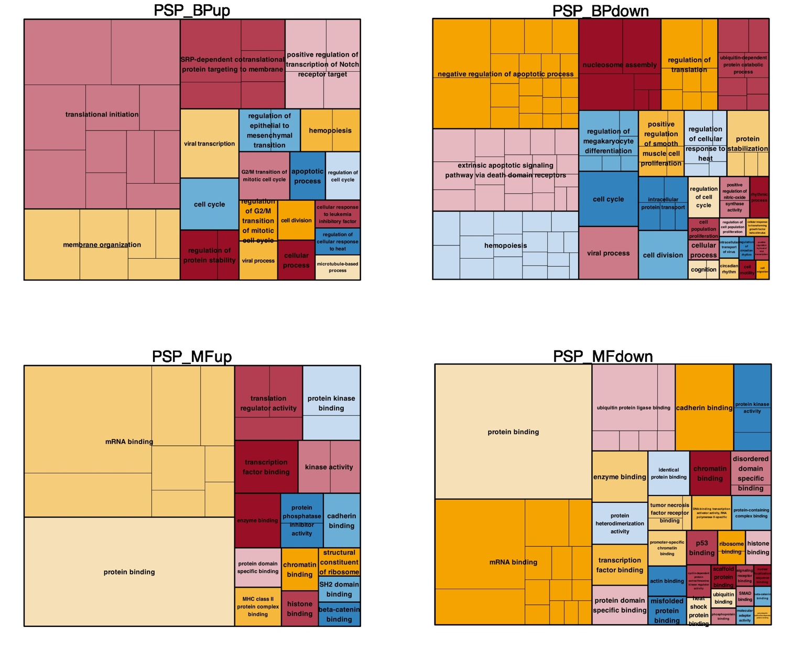
Supplementary Figure 4:
REVIGO Treemap Plots of all significant GO terms for the PSP intersections. Labeling was determined by semantic similarity analysis. These representatives are combined into "superclusters", representing loosely related terms and visualized using different colors. The size of the clusters is adjusted to reflect the P-value and frequency of the GO term in the Homo sapiens GOA database. BP = Biological process, MF = Molecular function, PSP = progressive supranuclear palsy.

Intersection | Name in QuantiMir Screen | Accession number | miRBase v22 Name
found in PD | hsa-miR-517c-5p | not listed | not listed
found in PD | hsa-miR-130a-5p | MIMAT0004593 | hsa-miR-130a-5p
found in PD | hsa-miR-20b-3p | MIMAT0004752 | hsa-miR-20b-3p
found in PD | hsa-miR-182-3p | MIMAT0000260 | hsa-miR-182-3p
found in PD | hsa-miR-192-3p | MIMAT0004543 | hsa-miR-192-3p
found in PD | hsa-miR-106b-3p | MIMAT0004672 | hsa-miR-106b-3p
found in PD | hsa-miR-30d-3p | MIMAT0004551 | hsa-miR-30d-3p
found in PD | hsa-miR-454-5p | MIMAT0003884 | hsa-miR-454-5p
found in PD | hsa-let-7d-3p | MIMAT0004484 | hsa-let-7d-3p
found in PD | hsa-miR-377 | MIMAT0000730 | hsa-miR-377-3p
found in PD | hsa-miR-516a-5p | MIMAT0004770 | hsa-miR-516a-5p
found in PD | hsa-miR-410 | MIMAT0002171 | hsa-miR-410-3p
found in PD | hsa-miR-567 | MIMAT0003231 | hsa-miR-567
found in PD | hsa-miR-573 | MIMAT0003238 | hsa-miR-573
found in PD | hsa-miR-500b | MIMAT0016925 | hsa-miR-500b-5p
found in PD | hsa-miR-27a-5p | MIMAT0004501 | hsa-miR-27a-5p
found in PD | hsa-miR-517b | MIMAT0002857 | hsa-miR-517b-3p
found in PD | hsa-miR-3191 | MIMAT0015075 | hsa-miR-3191-3p
found in PD | hsa-miR-505 | MIMAT0002876 | hsa-miR-505-3p
found in PD | hsa-miR-3124 | MIMAT0014986 | hsa-miR-3124-5p
found in PD | hsa-miR-524-5p | MIMAT0002849 | hsa-miR-524-5p
found in PD | hsa-miR-518d-3p | MIMAT0002864 | hsa-miR-518d-3p
found in PD | hsa-miR-196b | MIMAT0001080 | hsa-miR-196b-5p
found in PD | hsa-miR-103 | MIMAT0000101 | hsa-miR-103a-3p
found in PD | hsa-miR-3198 | MIMAT0015083 | hsa-miR-3198
found in PD | hsa-miR-4288 | MIMAT0016918 | hsa-miR-4288
found in PD | hsa-miR-298 | MIMAT0004901 | hsa-miR-298
found in PD | hsa-miR-199a-5p | MIMAT0000231 | hsa-miR-199a-5p
found in PD | hsa-miR-542-5p | MIMAT0003340 | hsa-miR-542-5p
found in PD | hsa-miR-328 | MIMAT0000752 | hsa-miR-328-3p
found in PD | hsa-miR-188-3p | MIMAT0004613 | hsa-miR-188-3p
found in PD | hsa-miR-374a | MIMAT0000727 | hsa-miR-374a-5p
found in PD | hsa-miR-654-5p | MIMAT0003330 | hsa-miR-654-5p
found in PD | hsa-miR-597 | MIMAT0003265 | hsa-miR-597-5p
found in PD | hsa-miR-596 | MIMAT0003264 | hsa-miR-596
found in PD | hsa-miR-3172 | not listed | not listed
found in PD | hsa-miR-193a-3p | MIMAT0000459 | hsa-miR-193a-3p
found in PD | hsa-miR-670 | MIMAT0010357 | hsa-miR-670-5p
found in PD | hsa-miR-508-5p | MIMAT0004778 | hsa-miR-508-5p
found in PD | hsa-miR-4260 | MIMAT0016881 | hsa-miR-4260
found in PD | hsa-miR-548v | MIMAT0015020 | hsa-miR-548v
found in PD | hsa-miR-671-5p | MIMAT0003880 | hsa-miR-671-5p
found in PD | hsa-miR-1909 | MIMAT0007883 | hsa-miR-1909-3p
found in PD | hsa-miR-3149 | MIMAT0015022 | hsa-miR-3149
found in PD | hsa-miR-183 | MIMAT0000261 | hsa-miR-183-5p
found in PD | hsa-miR-455-3p | MIMAT0004784 | hsa-miR-455-3p
found in PD | hsa-miR-522 | MIMAT0002868 | hsa-miR-522-3p
found in PD | hsa-miR-363 | MIMAT0000707 | hsa-miR-363-3p
found in PD | hsa-miR-142-5p | MIMAT0000433 | hsa-miR-142-5p
found in PD | hsa-miR-487b | MIMAT0003180 | hsa-miR-487b-3p
found in PD | hsa-miR-938 | MIMAT0004981 | hsa-miR-938
found in PD | hsa-miR-4290 | MIMAT0016921 | hsa-miR-4290
found in PD | hsa-miR-4279 | MIMAT0016909 | hsa-miR-4279
found in PD | hsa-miR-128 | MIMAT0000424 | hsa-miR-128-3p
found in PD | hsa-miR-876-5p | MIMAT0004924 | hsa-miR-876-5p
not found in PD | hsa-miR-193b-5p | MIMAT0004767 | hsa-miR-193b-5p
not found in PD | hsa-miR-95 | MIMAT0000094 | hsa-miR-95-3p
not found in PD | hsa-miR-886-5p | not listed | not listed
not found in PD | hsa-miR-934 | MIMAT0004977 | hsa-miR-934
found in PSP | hsa-miR-488-5p | MIMAT0002804 | hsa-miR-488-5p
found in PSP | hsa-miR-18a-3p | MIMAT0002891 | hsa-miR-18a-3p
found in PSP | hsa-miR-380-5p | MIMAT0000734 | hsa-miR-380-5p
found in PSP | hsa-miR-148a-5p | MIMAT0004549 | hsa-miR-148a-5p
found in PSP | hsa-miR-33a-3p | MIMAT0004506 | hsa-miR-33a-3p
found in PSP | hsa-miR-432 | MIMAT0002814 | hsa-miR-432-5p
found in PSP | hsa-miR-29c-5p | MIMAT0004673 | hsa-miR-29c-5p
found in PSP | hsa-miR-27b-5p | MIMAT0004588 | hsa-miR-27b-5p
found in PSP | hsa-miR-2117 | MIMAT0011162 | hsa-miR-2117
found in PSP | hsa-miR-558 | MIMAT0003222 | hsa-miR-558
found in PSP | hsa-miR-423-5p | MIMAT0004748 | hsa-miR-423-5p
found in PSP | hsa-miR-138-2* | MIMAT0004596 | hsa-miR-138-2-3p
found in PSP | hsa-miR-4311 | MIMAT0016863 | hsa-miR-4311
found in PSP | hsa-miR-1302 | MIMAT0005890 | hsa-miR-1302
found in PSP | hsa-let-7f-1* | MIMAT0004486 | hsa-let-7f-1-3p
found in PSP | hsa-miR-1293 | MIMAT0005883 | hsa-miR-1293
found in PSP | hsa-let-7 | not listed | not listed
found in PSP | hsa-miR-517a | MIMAT0002852 | hsa-miR-517a-3p
found in PSP | hsa-miR-532-5p | MIMAT0002888 | hsa-miR-532-5p
found in PSP | hsa-miR-643 | MIMAT0003313 | hsa-miR-643
found in PSP | hsa-miR-521 | MIMAT0002854 | hsa-miR-521
found in PSP | hsa-miR-4301 | MIMAT0016850 | hsa-miR-4301
found in PSP | hsa-miR-1272 | MIMAT0005925 | hsa-miR-1272
found in PSP | hsa-miR-3121 | MIMAT0014983 | hsa-miR-3121-3p
found in PSP | hsa-miR-1248 | MIMAT0005900 | hsa-miR-1248
found in PSP | hsa-miR-1227 | MIMAT0005580 | hsa-miR-1227-3p
found in PSP | hsa-let-7-2* | not listed | not listed
found in PSP | hsa-miR-502-3p | MIMAT0004775 | hsa-miR-502-3p
found in PSP | hsa-miR-2116 | MIMAT0011160 | hsa-miR-2116-5p
found in PSP | hsa-miR-425 | MIMAT0003393 | hsa-miR-425-5p
found in PSP | hsa-miR-764 | MIMAT0010367 | hsa-miR-764
found in PSP | hsa-miR-340 | MIMAT0004692 | hsa-miR-340-5p
found in PSP | hsa-miR-181a-2* | MIMAT0004558 | hsa-miR-181a-2-3p
found in PSP | hsa-miR-4291 | MIMAT0016922 | hsa-miR-4291
found in PSP | hsa-miR-194 | MIMAT0000460 | hsa-miR-194-5p
not found in PSP | hsa-miR-10b-3p | MIMAT0004556 | hsa-miR-10b-3p
not found in PSP | hsa-miR-223 | MIMAT0000280 | hsa-miR-223-3p
not found in PSP | hsa-miR-132 | MIMAT0000426 | hsa-miR-132-3p
not found in PSP | hsa-miR-27b | MIMAT0000419 | hsa-miR-27b-3p
not found in PSP | hsa-miR-202 | MIMAT0002811 | hsa-miR-202-3p
not found in PSP | hsa-miR-23b | MIMAT0000418 | hsa-miR-23b-3p
not found in PSP | hsa-miR-151-3p | MIMAT0000757 | hsa-miR-151a-3p
not found in PSP | hsa-miR-23a | MIMAT0000078 | hsa-miR-23a-3p
not found in PSP | hsa-let-7c | MIMAT0000064 | hsa-let-7c-5p
not found in PSP | hsa-miR-523 | MIMAT0002840 | hsa-miR-523-3p
not found in PSP | hsa-miR-488 | MIMAT0004763 | hsa-miR-488-3p
not found in PSP | hsa-miR-222 | MIMAT0000279 | hsa-miR-222-3p
not found in PSP | hsa-miR-206 | MIMAT0000462 | hsa-miR-206
not found in PSP | hsa-miR-3164 | MIMAT0015038 | hsa-miR-3164
not found in PSP | hsa-miR-559 | MIMAT0003223 | hsa-miR-559
not found in PSP | hsa-miR-618 | MIMAT0003287 | hsa-miR-618
not found in PSP | hsa-miR-219-1-3p | MIMAT0004567 | hsa-miR-219a-1-3p
not found in PSP | hsa-miR-520d-3p | MIMAT0002856 | hsa-miR-520d-3p
not found in PSP | hsa-miR-192 | MIMAT0000222 | hsa-miR-192-5p
not found in PSP | hsa-miR-4266 | MIMAT0016892 | hsa-miR-4266
not found in PSP | hsa-miR-1270 | MIMAT0005924 | hsa-miR-1270
not found in PSP | hsa-miR-490-5p | MIMAT0004764 | hsa-miR-490-5p
not found in PSP | hsa-miR-34a | MIMAT0000255 | hsa-miR-34a-5p
not found in PSP | hsa-miR-524-3p | MIMAT0002850 | hsa-miR-524-3p
not found in PSP | hsa-miR-503 | MIMAT0002874 | hsa-miR-503-5p
not found in PSP | hsa-miR-539 | MIMAT0003163 | hsa-miR-539-5p
not found in PSP | hsa-miR-99b | MIMAT0000689 | hsa-miR-99b-5p
not found in PSP | hsa-miR-10b-3p | MIMAT0004556 | hsa-miR-10b-3p
not found in PSP | hsa-miR-223 | MIMAT0000280 | hsa-miR-223-3p
not found in PSP | hsa-miR-132 | MIMAT0000426 | hsa-miR-132-3p
not found in PSP | hsa-miR-27b | MIMAT0000419 | hsa-miR-27b-3p
not found in PSP | hsa-miR-202 | MIMAT0002811 | hsa-miR-202-3p
not found in PSP | hsa-miR-23b | MIMAT0000418 | hsa-miR-23b-3p
not found in PSP | hsa-miR-151-3p | MIMAT0000757 | hsa-miR-151a-3p
not found in PSP | hsa-miR-23a | MIMAT0000078 | hsa-miR-23a-3p
not found in PSP | hsa-let-7c | MIMAT0000064 | hsa-let-7c-5p
not found in PSP | hsa-miR-523 | MIMAT0002840 | hsa-miR-523-3p
not found in PSP | hsa-miR-488 | MIMAT0004763 | hsa-miR-488-3p
not found in PSP | hsa-miR-222 | MIMAT0000279 | hsa-miR-222-3p
not found in PSP | hsa-miR-206 | MIMAT0000462 | hsa-miR-206
not found in PSP | hsa-miR-3164 | MIMAT0015038 | hsa-miR-3164
not found in PSP | hsa-miR-559 | MIMAT0003223 | hsa-miR-559
not found in PSP | hsa-miR-618 | MIMAT0003287 | hsa-miR-618
not found in PSP | hsa-miR-219-1-3p | MIMAT0004567 | hsa-miR-219a-1-3p
not found in PSP | hsa-miR-520d-3p | MIMAT0002856 | hsa-miR-520d-3p
not found in PSP | hsa-miR-192 | MIMAT0000222 | hsa-miR-192-5p
not found in PSP | hsa-miR-4266 | MIMAT0016892 | hsa-miR-4266
not found in PSP | hsa-miR-1270 | MIMAT0005924 | hsa-miR-1270
not found in PSP | hsa-miR-490-5p | MIMAT0004764 | hsa-miR-490-5p
not found in PSP | hsa-miR-34a | MIMAT0000255 | hsa-miR-34a-5p
not found in PSP | hsa-miR-524-3p | MIMAT0002850 | hsa-miR-524-3p
not found in PSP | hsa-miR-503 | MIMAT0002874 | hsa-miR-503-5p
not found in PSP | hsa-miR-539 | MIMAT0003163 | hsa-miR-539-5p
not found in PSP | hsa-miR-99b | MIMAT0000689 | hsa-miR-99b-5p
found in MSA | hsa-miR-374b-3p | MIMAT0004956 | hsa-miR-374b-3p
found in MSA | hsa-miR-129-3-3p | not listed | not listed
found in MSA | hsa-miR-3142 | MIMAT0015011 | hsa-miR-3142
found in MSA | hsa-miR-4330 | MIMAT0016924 | hsa-miR-4330
found in MSA | hsa-miR-22 | MIMAT0000077 | hsa-miR-22-3p
found in MSA | hsa-miR-130a | MIMAT0000425 | hsa-miR-130a-3p
found in MSA | hsa-miR-1182 | MIMAT0005827 | hsa-miR-1182
found in MSA | hsa-miR-532-3p | MIMAT0004780 | hsa-miR-532-3p
found in MSA | hsa-miR-608 | MIMAT0003276 | hsa-miR-608
found in MSA | hsa-miR-323-3p | MIMAT0000755 | hsa-miR-323a-3p
found in MSA | hsa-miR-4320 | MIMAT0016871 | hsa-miR-4320
found in MSA | hsa-miR-15a | MIMAT0000068 | hsa-miR-15a-5p
found in MSA | hsa-miR-765 | MIMAT0003945 | hsa-miR-765
found in MSA | hsa-miR-566 | not listed | not listed
not found in MSA | hsa-miR-1226-5p | MIMAT0005576 | hsa-miR-1226-5p
not found in MSA | hsa-miR-1914-3p | MIMAT0007890 | hsa-miR-1914-3p
not found in MSA | hsa-miR-1909-5p | MIMAT0007882 | hsa-miR-1909-5p
not found in MSA | hsa-miR-24-1* | MIMAT0000079 | hsa-miR-24-1-5p
not found in MSA | hsa-miR-3138 | MIMAT0015006 | hsa-miR-3138
not found in MSA | hsa-miR-1537 | MIMAT0007399 | hsa-miR-1537-3p
not found in MSA | hsa-miR-429 | MIMAT0001536 | hsa-miR-429
not found in MSA | hsa-miR-211 | MIMAT0000268 | hsa-miR-211-5p
not found in MSA | hsa-miR-342-3p | MIMAT0000753 | hsa-miR-342-3p
not found in MSA | hsa-miR-29c-3p | MIMAT0000681 | hsa-miR-29c-3p
not found in MSA | hsa-miR-4313 | MIMAT0016865 | hsa-miR-4313
not found in MSA | hsa-miR-204 | MIMAT0000265 | hsa-miR-204-5p
not found in MSA | hsa-miR-382 | MIMAT0000737 | hsa-miR-382-5p
not found in MSA | hsa-miR-216a | MIMAT0000273 | hsa-miR-216a-5p
not found in MSA | hsa-miR-34b | MIMAT0004676 | hsa-miR-34b-3p
not found in MSA | hsa-miR-3183 | MIMAT0015063 | hsa-miR-3183
not found in MSA | hsa-miR-1180 | MIMAT0005825 | hsa-miR-1180-3p
not found in MSA | hsa-miR-1275 | MIMAT0005929 | hsa-miR-1275
not found in MSA | hsa-miR-502-5p | MIMAT0002873 | hsa-miR-502-5p
not found in MSA | hsa-miR-93 | MIMAT0000093 | hsa-miR-93-5p
not found in MSA | hsa-miR-4309 | MIMAT0016859 | hsa-miR-4309
not found in MSA | hsa-miR-4274 | MIMAT0016906 | hsa-miR-4274
not found in MSA | hsa-miR-330-3p | MIMAT0000751 | hsa-miR-330-3p
not found in MSA | hsa-miR-3137 | MIMAT0015005 | hsa-miR-3137
not found in MSA | hsa-miR-661 | MIMAT0003324 | hsa-miR-661
not found in MSA | hsa-miR-631 | MIMAT0003300 | hsa-miR-631
not found in MSA | hsa-miR-152 | MIMAT0000438 | hsa-miR-152-3p
not found in MSA | hsa-miR-622 | MIMAT0003291 | hsa-miR-622
not found in MSA | hsa-miR-1258 | MIMAT0005909 | hsa-miR-1258
not found in MSA | hsa-miR-1253 | MIMAT0005904 | hsa-miR-1253
not found in MSA | hsa-miR-4315 | MIMAT0016866 | hsa-miR-4315
not found in MSA | hsa-miR-3135 | MIMAT0015001 | hsa-miR-3135a
not found in MSA | hsa-let-7e | MIMAT0000066 | hsa-let-7e-5p
not found in MSA | hsa-miR-1281 | MIMAT0005939 | hsa-miR-1281
not found in MSA | hsa-miR-632 | MIMAT0003302 | hsa-miR-632
not found in MSA | hsa-miR-214-3p | MIMAT0000271 | hsa-miR-214-3p
not found in MSA | hsa-miR-448 | MIMAT0001532 | hsa-miR-448
not found in MSA | hsa-miR-1265 | MIMAT0005918 | hsa-miR-1265
not found in MSA | hsa-miR-1203 | MIMAT0005866 | hsa-miR-1203
not found in MSA | hsa-miR-3175 | MIMAT0015052 | hsa-miR-3175
not found in MSA | hsa-miR-92a-1* | MIMAT0004507 | hsa-miR-92a-1-5p

Supplementary Table S1:
Overview over the miRNAs in the intersections of Figure 2B with their annotation in the QuantiMir kit as well as their respective accession number and their annotation in the v22 version of miRBase. miRNA names were converted using the miRBaseConverter package within the BiocManager package (v1.30.0) in R. PD = Parkinson’s disease, MSA = multiple system atrophy, PSP = progressive supranuclear palsy.
Supplementary Data S2:
Overview over the GO terms summarized by REVIGO using LogSize, Frequency, Uniqueness and Dispensability measures. Separate sheets show data for each condition: exclusively found (“-UP”) or exclusively absent (“-DOWN”) miRNAs of the different disease groups for the BP and MF terms. BP = Biological process, MF = Molecular function, PD = Parkinson’s disease, MSA = multiple system atrophy, PSP = progressive supranuclear palsy.

