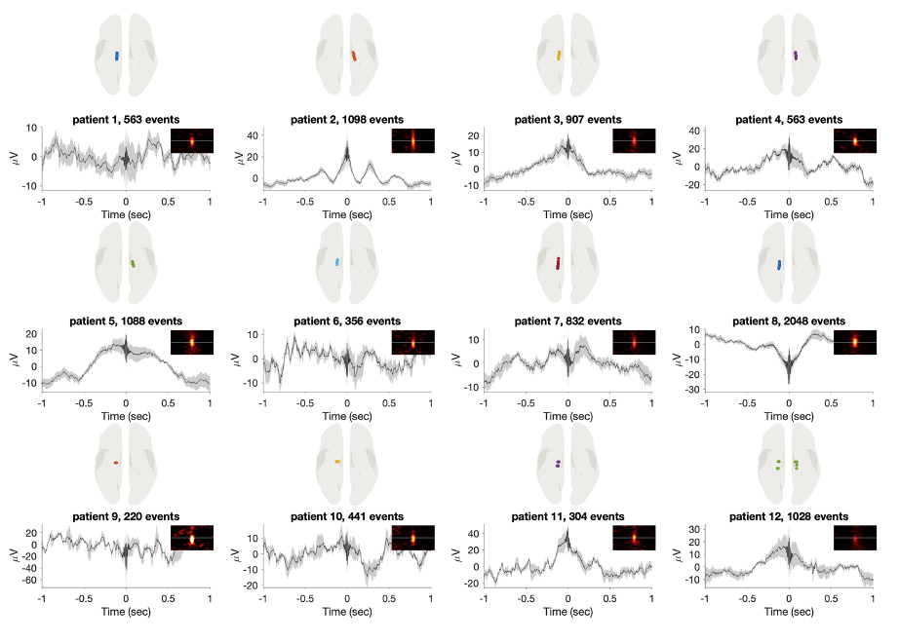
Extended Data Figure 1. Electrode implantation, ripple counts, and spectral characteristics per participant. Each panel displays data from a single participant. The top row illustrates electrode implantation sites within the hippocampus. The middle row shows the number of detected ripple events. The bottom row presents the average ripple waveform alongside the corresponding spectral power profile.
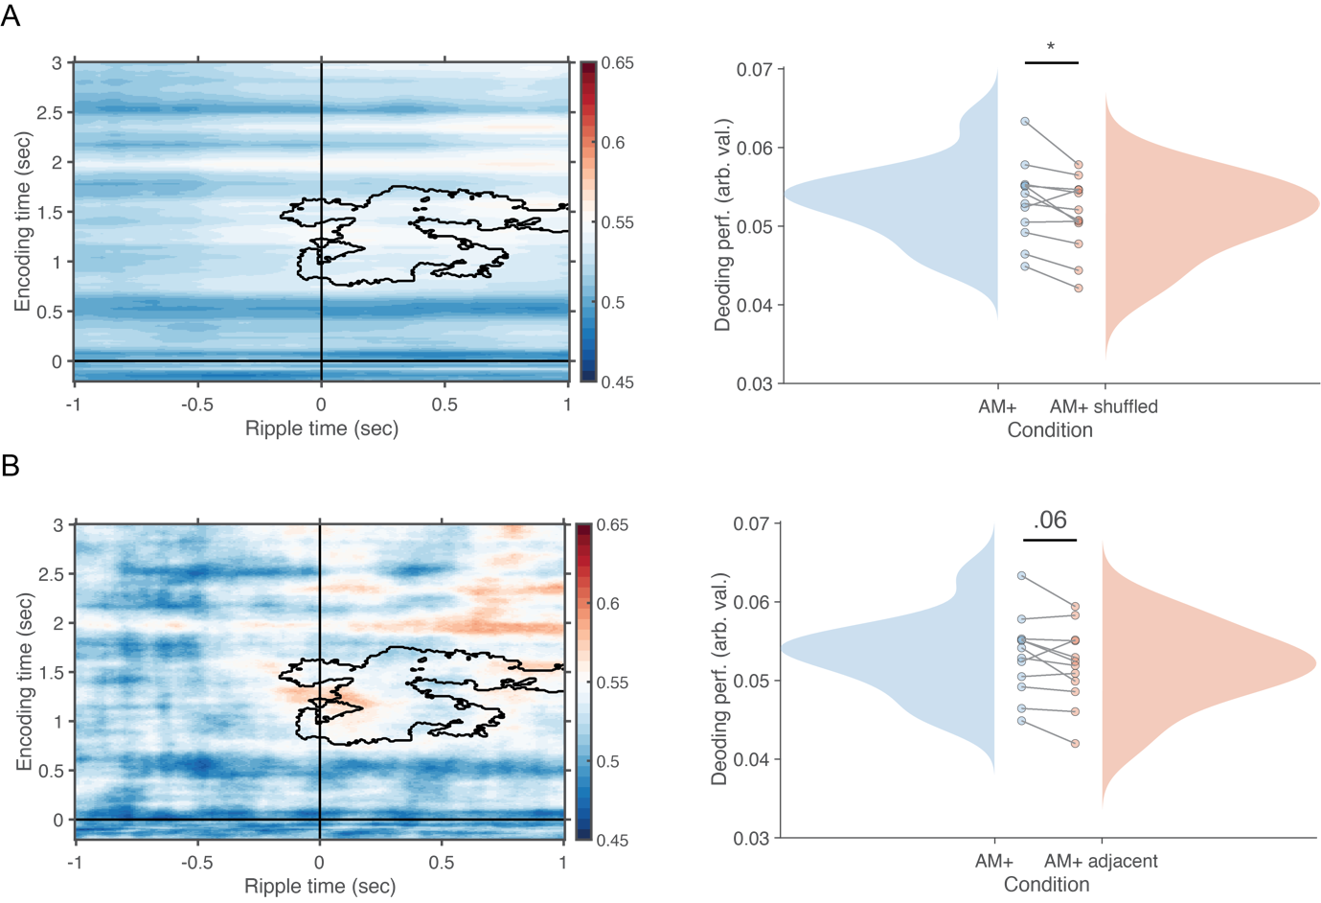
Extended Data Figure 2. Control Analyses Confirming Ripple-Triggered Reinstatement Specificity. (A) When AM+ trials were shuffled 1000 times, decoding accuracy within the significant cluster identified in Figure 2a (highlighted in black, left) was significantly higher for the empirical AM+ data compared to the shuffled data. Individual participant values are shown on the right. (B) A similar analysis was performed using a stricter control in which ripple times were swapped with those of adjacent trials (i.e., neighbouring trial shuffling). This revealed a trend towards higher decoding in the empirical AM+ condition compared to the adjacent-trial control.
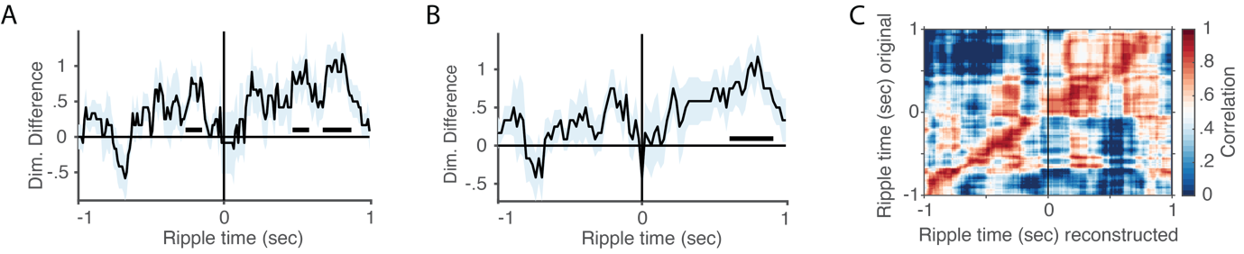
Extended Data Figure 3. Robustness of Dimensionality and Reconstruction Analysis
(A, B) Using a 100 ms (A) or 200 ms (B) sliding window for dimensionality estimation produced results highly similar to those obtained with a 60 ms window, demonstrating the robustness of the approach. (C) Correlation between original and reconstructed data, using the same number of components as in the PCA analysis, revealed a strong diagonal pattern—indicating a high-fidelity reconstruction of the original data structure.
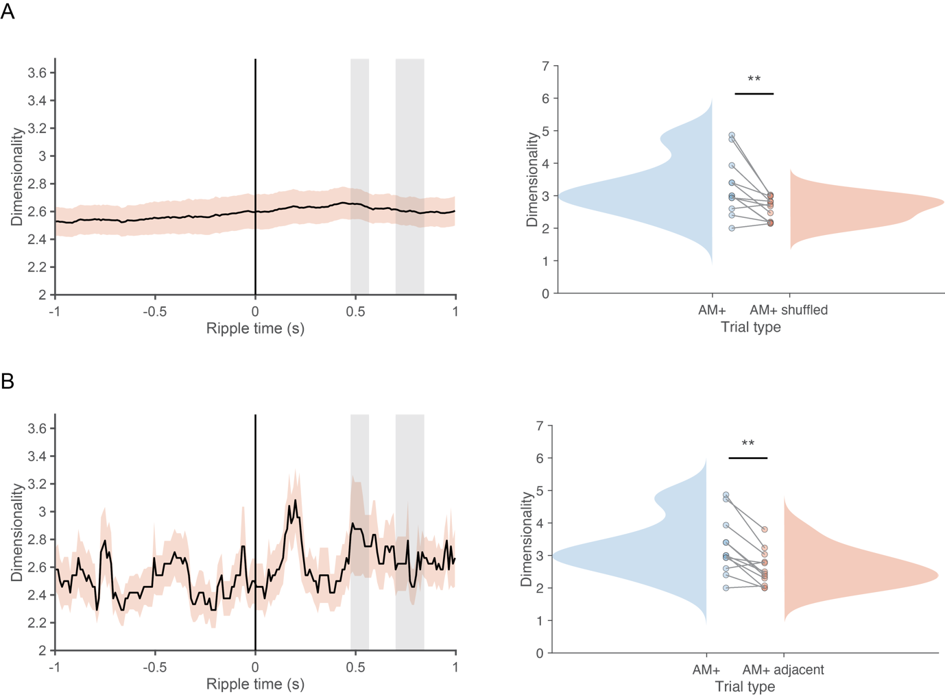
Extended Data Figure 4. Control Analyses Confirming Specificity of Dimensionality Expansion (A) Shuffling AM+ trials 1000 times revealed significantly greater dimensionality for empirical AM+ trials compared to the shuffled distribution, when averaging across the significant time points identified in Figure 2b (highlighted as grey bars, left). (B) A similar contrast between empirical AM+ and adjacent trials (i.e. temporally shifted controls) also yielded a significant difference, further supporting the specificity of ripple-linked dimensionality expansion. Each participant shown in right panels.
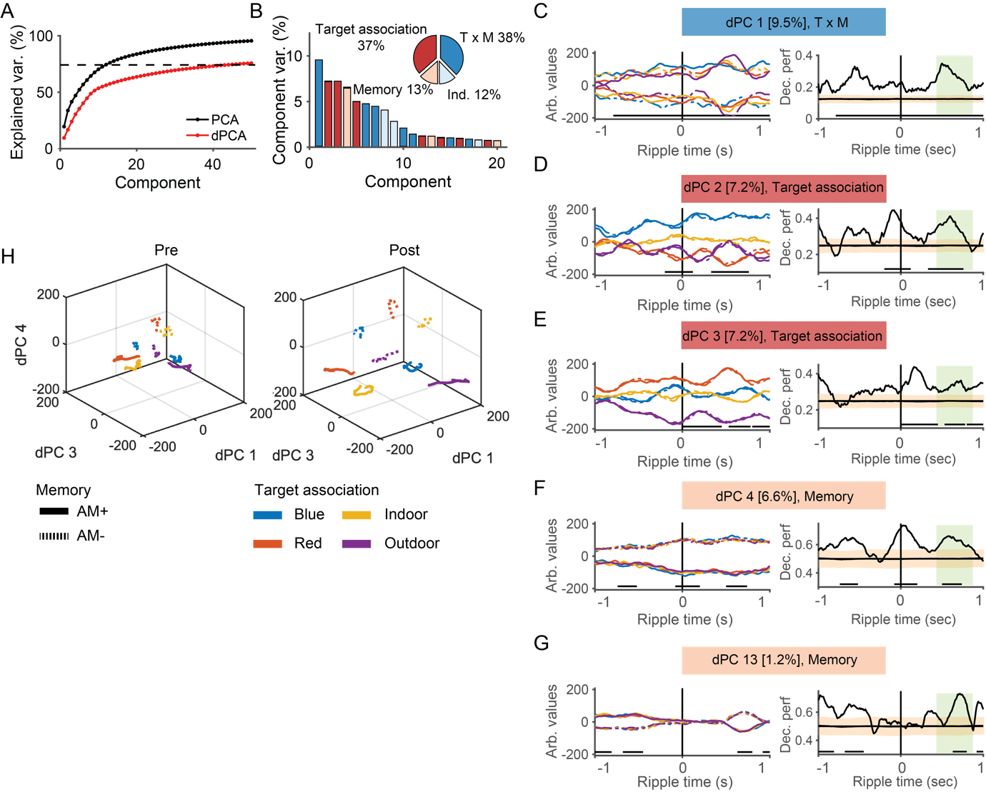 Extended Data Figure 5. Demixed Principal Component Analysis (dPCA). (A) Cumulative variance explained by the first 50 components exceeded the estimated signal variance (dashed line). Standard PCA (black) accounted for more total variance than dPCA. (B) The first four dPCs primarily reflected a mixture of “target association” and “memory” (dark blue), “target association only” (red), and “memory only” (beige). (C-G) Decoding accuracy for individual components, shown only for those with significant decoding between 400–800 ms post-ripple peak (highlighted by green bars). Left panels display component activation; right panels show decoding performance. Significant decoding intervals are marked with black horizontal lines. Orange shaded areas represent the shuffled distributions, with their mean indicated in black. (H) Neural state space plots of dPCs 1, 3, and 4 show that pre-ripple representations were more overlapping (left), whereas post-ripple activity exhibited greater separation between experimental conditions (right), indicating increased representational differentiation.

Extended Data Table 1. Linear mixed-effects model of dimensionality transformation.
Name | Estimate | SE | t | df | p | 95% CI  (lower) | 95% CI  (upper)
Intercept | 2.28 | .07 | 32.47 | 19,988 | <.001 | 2.14 | 2.42
Trial Type | .09 | .03 | 2.82 | 19,988 | .005 | .03 | .16
Half | .14 | .03 | 4.39 | 19,988 | <.001 | .08 | .21
Trial Type x Half | -.09 | .02 | -4.16 | 19,988 | <.001 | -.13 | -.05

