Table S1 The effect of plant species richness and plant species composition on above-ground, plant N uptake, N use efficiency, Ndfa, complementarity effects, soil NH₄⁺-N and soil NO₃⁻-N. Significant effect (P < 0.05) are shown in bold.
 |  | Above-ground biomass | Plant N uptake | N use efficiency | Ndfa | Complementarity effects | Soil NH₄⁺-N | Soil NO₃⁻-N
 |  | g m⁻² | g N m⁻² | % | % | g m⁻² | mg kg⁻¹ | mg kg⁻¹
Plant species richness | F | 5.8 | 5.4 | 91.1 | 21.6, | -- | 1.2 | 3.6
Plant species richness | P | 0.006 | 0.008 | <0.0001 | <0.0001 | -- | 0.30 | 0.03
Plant species composition | F | 26.5, | 135.4 | 174.5 | -- | 10.1 | 2.9 | 30.7
Plant species composition | P | <0.0001 | <0.0001 | <0.0001 | -- | <0.0001 | 0.0087 | <0.0001

Table S2 Plant community composition effects on overyielding (observed biomass-expected biomass), complementarity, and selection effects, in relation to above-ground biomass at T0 (first harvest), T1 (second harvest) and T2 (final harvest) and plant N uptake (at T2). Results from Experiment 1 and its three consecutive harvests. Data are mean ± SE (n= 5). Lolium perenne (Lp), Festuca arundinacea (Fa), Lotus corniculatus (Lc), Trifolium pratense (Tp). Significant effects (P < 0.05) are shown in bold. Letters indicate significant differences for each harvest based on a Tukey posthoc test.
 | Above-ground biomass (g m⁻²) |  |  | Plant N uptake (g N m⁻²)
 | Overyielding net effect | Complementarity | Selection | Overyielding net effect | Complementarity | Selection
 | Overyielding net effect | effect | effect | Overyielding net effect | effect | Effect
a) first harvest-T0
Fa_Lp | 1.4 ± 11 | 4.6 ± 10 | -3.2 ± 3 ª | -- | -- | --
Fa_Lc | 32.1 ± 13 | 23.6 ± 10 | 8.4 ± 8 ^{ab} | -- | -- | --
Fa_Tp | 55.0 ± 18 | 68.3 ± 19 | -13.3 ± 5 ª | -- | -- | --
Lp_Lc | 46.0 ± 9 | 12.5 ± 9 | 33.5 ± 3 ^{b} | -- | -- | --
Lp_Tp | 10.2 ± 13 | 20.7 ± 17 | -10.5 ± 5 ª | -- | -- | --
Tp_Lc | 34.0 ± 23 | 28.8 ± 24 | 5.2 ± 7 ª | -- | -- | --
Fa_Lp_Tp_Lc | 50.4 ± 16 | 62.8 ± 23 | -12.4 ± 19 ^{ab} | -- | -- | --
b) second harvest-T1
Fa_Lp | 37.2 ± 19 ^{b} | 32.4 ± 16 ª | 4.8 ± 6 ^{b} | -- | -- | --
Fa_Lc | -95.0 ± 15 ª | 25.7 ± 31 ª | -120.7 ± 26 ª | -- | -- | --
Fa_Tp | 189.3 ± 42 ^{b} | 259.5 ± 32 ^{bc} | -70.2 ± 47 ^{ab} | -- | -- | --
Lp_Lc | -47.0 ± 31 ª | 95.8 ± 37 ^{ab} | -142.8 ± 21 ª | -- | -- | --
Lp_Tp | 63.1 ± 53 ^{ab} | 250.5 ± 47 ^{bc} | -187.4 ± 24 ª | -- | -- | --
Tp_Lc | 66.7 ± 21 ^{b} | 19.4 ± 24 ª | 47.2 ± 19 ^{b} | -- | -- | --
Fa_Lp_Tp_Lc | 110.7 ± 44 ^{b} | 284.4 ± 66 ^{c} | -173.7 ± 34 ª | -- | -- | --
c) final harvest-T2
Fa_Lp | -36.8 ± 16 ^{ab} | -12.0 ± 20 ª | -24.8 ± 14 ^{ab} | -0.6 ± 0.2 ^{ab} | -0.01 ± 0.4 ª | -0.62 ± 0.3
Fa_Lc | -101.4 ± 54 ª | -34.5 ± 59 ^{ab} | -66.9 ± 35 ª | -4.3 ± 1.5 ª | -1.5 ± 1.4 ª | -3.1 ± 1.1
Fa_Tp | 160.1 ± 23 ^{c} | 137.8 ± 27 ^{b} | 22.3 ± 31 ^{ab} | 5.2 ± 1.2 ^{c} | 5.9 ± 1.0 ^{bc} | -0.7 ± 1.5
Lp_Lc | -44.5 ± 25 ^{ab} | 86.2 ± 67 ^{ab} | -130.8 ± 69 ^{ab} | -3.8 ± 1.3 ª | 0.97 ± 2.2 ^{ab} | -4.6 ± 1.9
Lp_Tp | 147.2 ± 60 ^{c} | 285.6 ± 96 ^{b} | -138.4 ± 81 ^{ab} | 5.2 ± 1.9 ^{c} | 12.7 ± 2.6 ^{c} | -7.5 ± 3.1
Tp_Lc | -32.8 ± 60 ^{ab} | -45.7 ± 50 ª | 12.8 ± 18 ^{b} | -1.8 ± 2.2 ^{ab} | -1.1 ± 1.4 ª | 0.2 ± 1.0
Fa_Lp_Tp_Lc | 63.7 ± 51 ^{bc} | 199.5 ± 84 ^{ab} | -135.8 ± 86 ^{ab} | 2.7 ± 1.2 ^{bc} | 10.8 ± 2.8 ^{bc} | -8.4 ± 3.5
First harvest - T0 | F=1.7, P=0.15 | F=2.1, P=0.1 | F=16, P<0.0001 | -- | -- | --
Second harvest - T1 | F=26.4, P<0.0001 | F=9.8, P<0.0001 | F=29, P<0.0001 | -- | -- | --
Final harvest - T2 | F=9.5, P<0.0001 | F=11.4, P<0.0001 | F=6.3, P=0.0004 | F=10.5, P<0.0001 | F=14, P<0.0001 | F=2.6, P=0.05

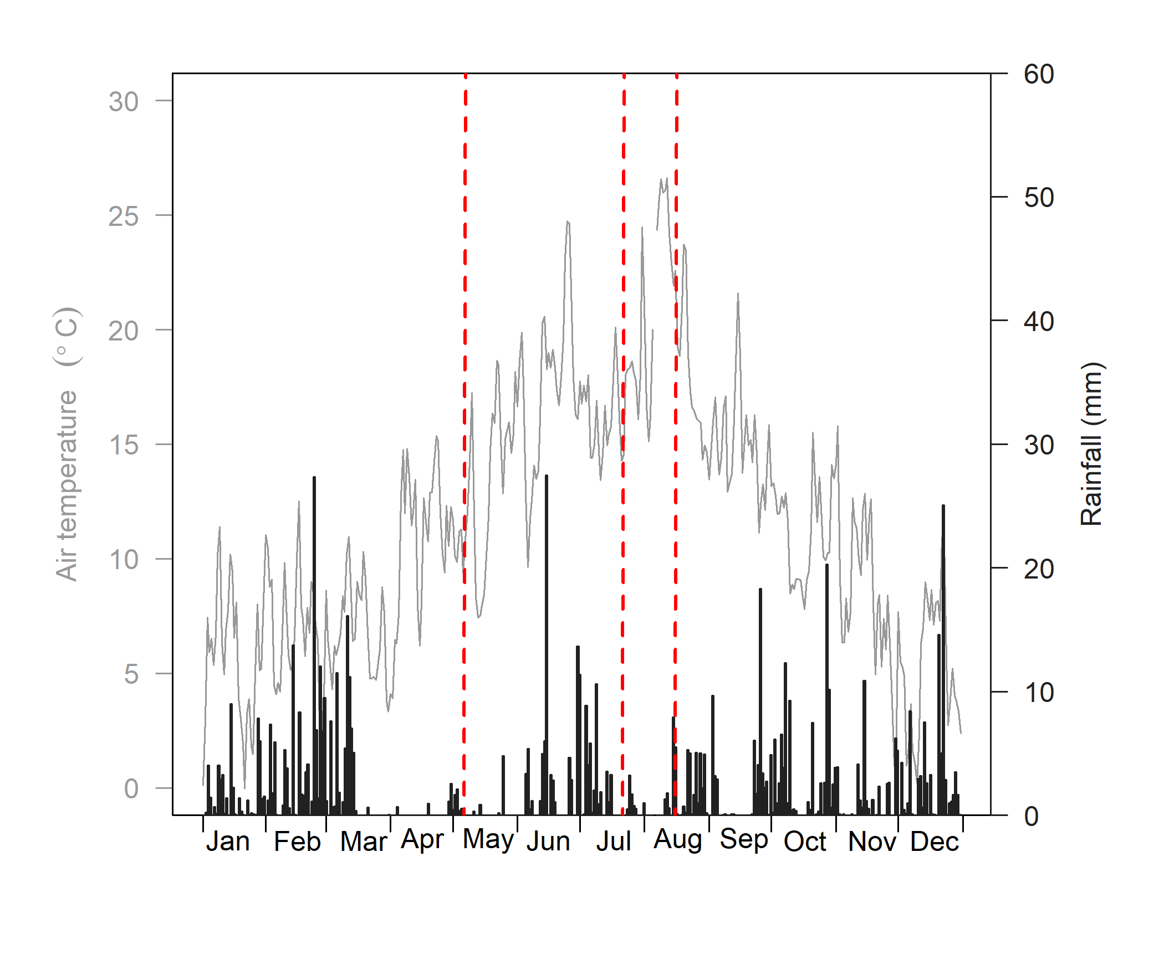
Fig. S1 Mean daily air temperature (grey lines) and daily rainfall total (black bars) at the field site (51° 59' 43.3" N, 5° 39' 17.6 "E) in 2020. Red dashed lines represent the dates of harvest (May, July and August 2020).

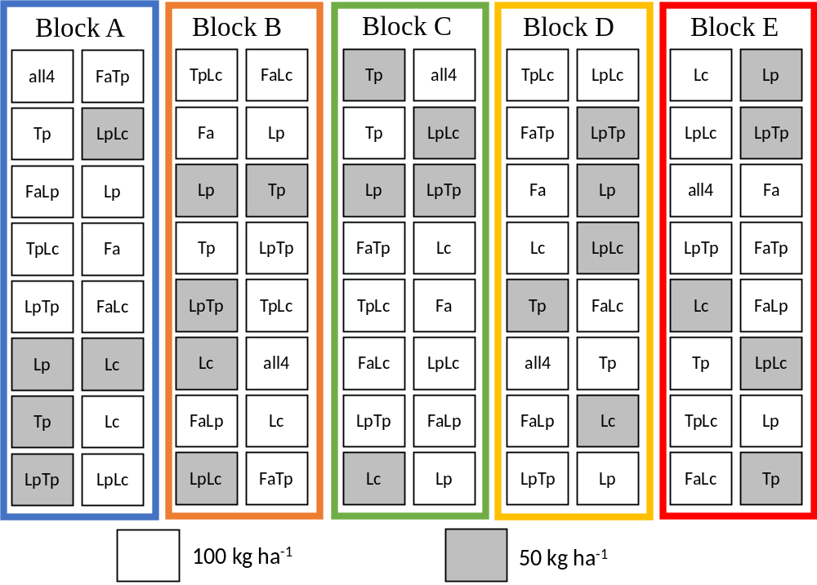
Fig. S2 Field experiment with 80 plots, laid out in randomised block design consisting of 5 blocks (A-E) at Nergena, Wageningen, the Netherlands (51° 59' 43.3" N, 5° 39' 17.6 "E). Experiment 1) full-factorial design to test the effects of different plant community composition, fertilised with 100 kg N ha⁻¹, and Experiment 2) full-factorial design to test the interactive effects of plant community composition (five different community composition) and N fertilisation levels (50 and 100 kg N ha⁻¹) with five replicates (one within each block). Lp= Lolium perenne, Fa= Festuca arundinacea, Tp= Trifolium pratense and Lc= Lotus corniculatus, all4= FaLpTpLc.

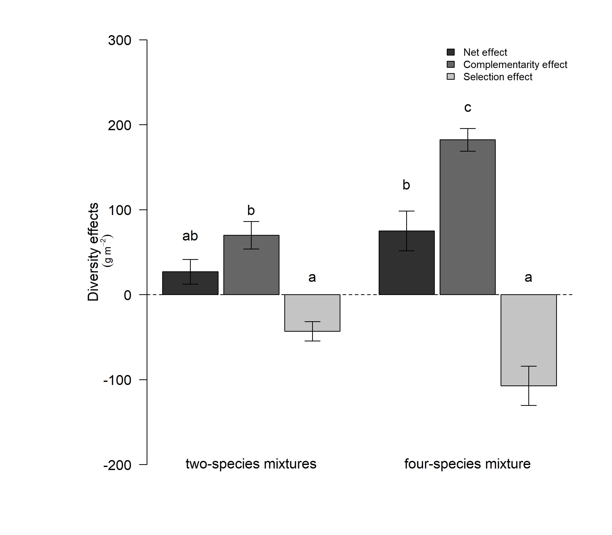
Fig. S3 Diversity effects (net, complementarity, and selection effect) on above-ground plant community productivity for the two and four-species mixtures of Experiment 1. Bars are mean ± SE (n= 30 for two-species and n=5 for four-species mixture). Different letters indicate significant differences between the treatments and effect types (P < 0.05) based on a Tukey posthoc test.
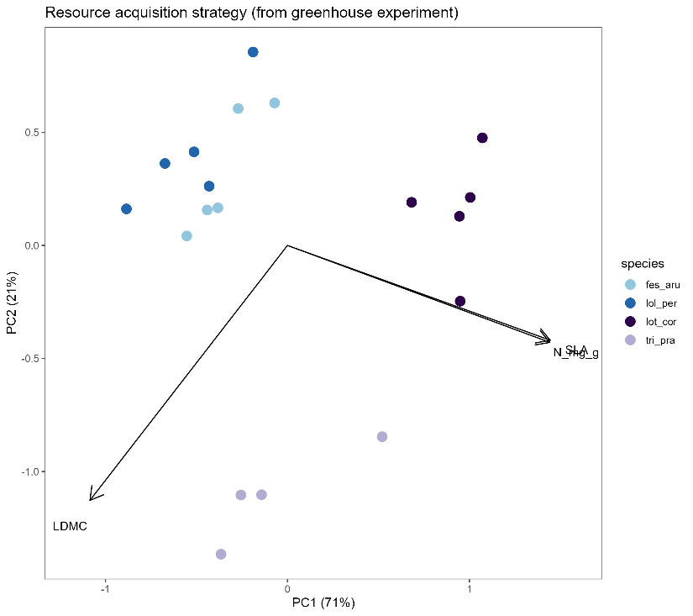

Fig. S4 Leaf economic spectrum from greenhouse experiment (monocultures grown in control conditions at T2/end of the experiment). PC1 scores were extracted and the mean per species was calculated and used as that plant species ‘strategy’. A lower value is more conservative (higher LMDC, lower SLA/N) and a higher value is more acquisitive (higher SLA/N, lower LDMC).

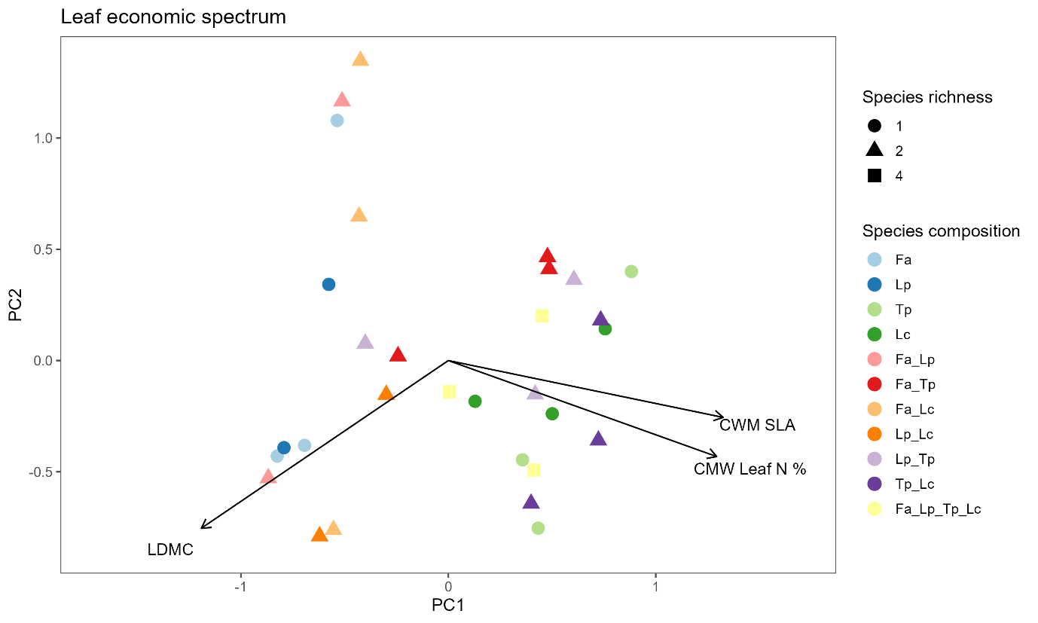
Fig. S5 Leaf economic spectrum based on traits from the field experiment at T2. Lolium perenne (Lp), Festuca arundinacea (Fa), Lotus corniculatus (Lc), Trifolium pratense (Tp). n = 30.

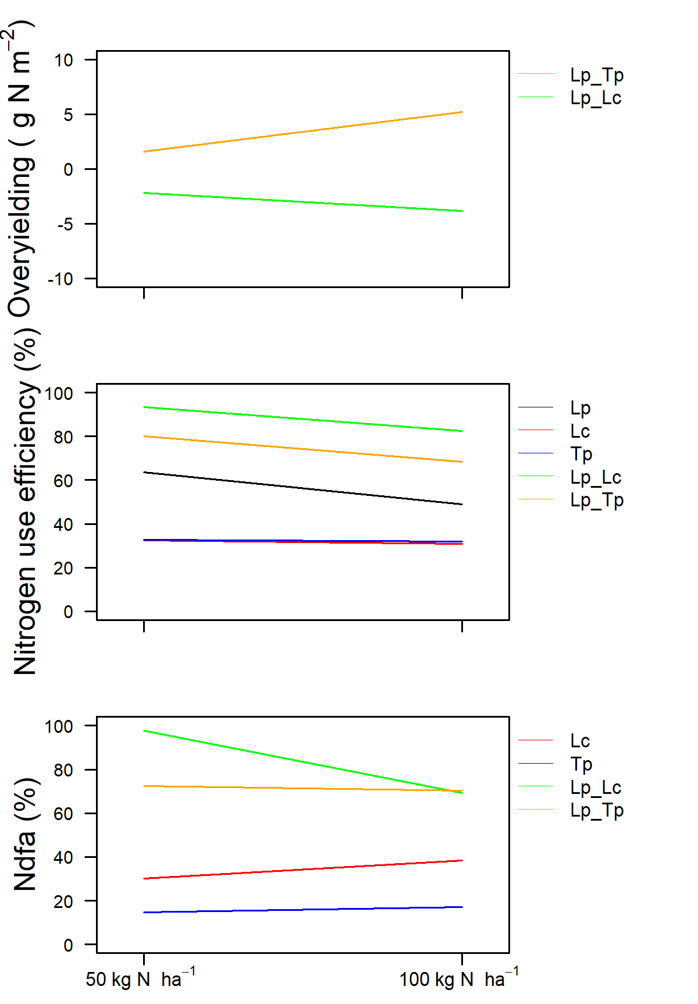
Fig. S6 Interaction between fertilisation level (50 and 100 kg N ha⁻¹) and plant community composition on overyielding-N (g N m⁻²), N use efficiency (%) and Ndfa (%). Lolium perenne (Lp); Lotus corniculatus (Lc); Trifolium pratense (Tp) of Experiment 2.

