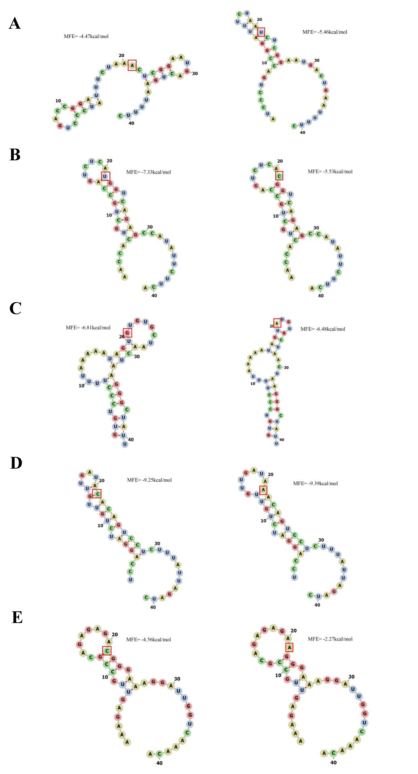
Figure S1 Predicted secondary structure of YTHDC1/2 mRNA affected by SNPs. (A) rs17592288 A/T affected the secondary structure of YTHDC1; (B) rs3813832 T/C affected the secondary structure of YTHDC1; (C) rs9552 G/A affected the secondary structure of YTHDC2; (D) rs2416282 C/A affected the secondary structure of YTHDC2;(E) rs6594732 C/A affected the secondary structure of YTHDC2.
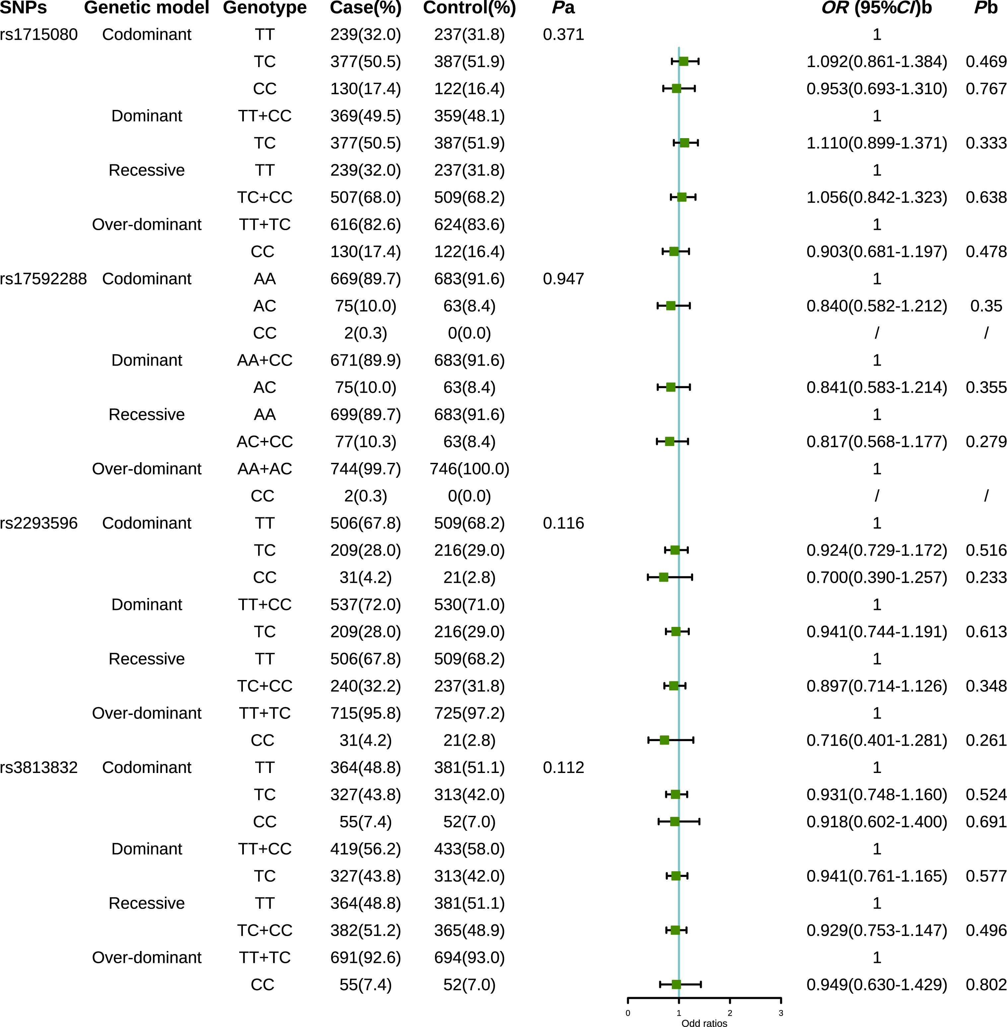
Figure S2 Association analysis of YTHDC1 SNPs genotype and breast cancer susceptibility. ª P value of Hardy-Weinberg equilibrium in controls. ^{b} Multivariate Logistic regression model adjusted by age, age of menarche, number of pregnancy, number of abortion, breast-feeding history, menopausal status and family history of tumors. Bold values mean significant results with P<0.05.
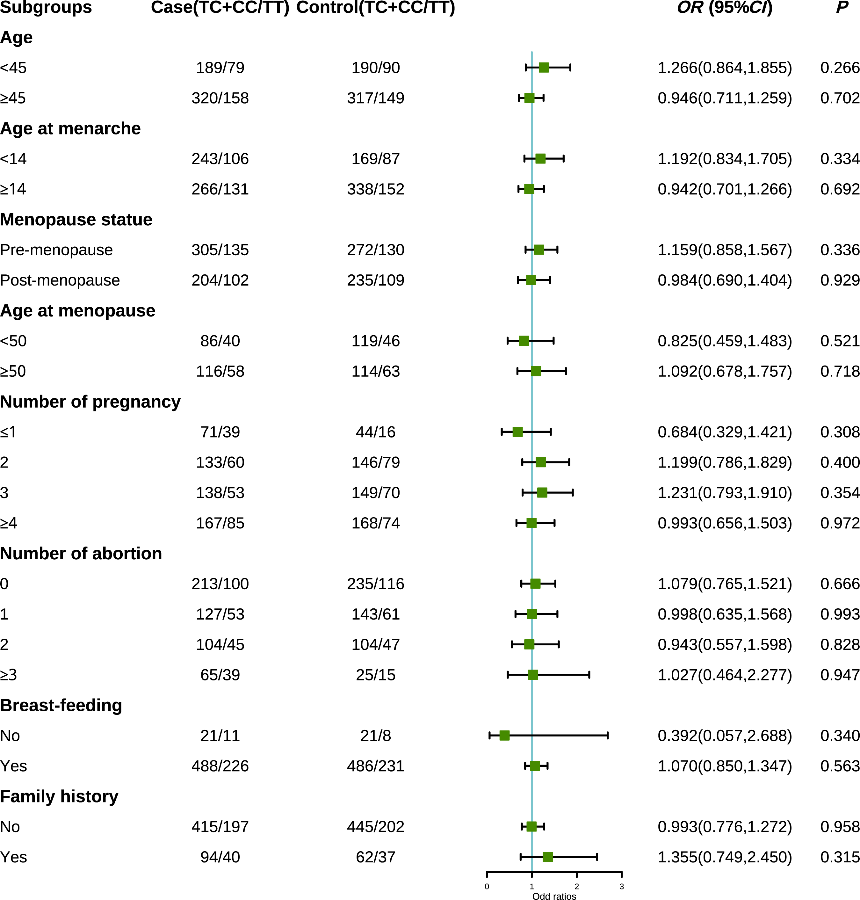
Figure S3 Stratified analysis of YTHDC1 rs1715080 and breast cancer risk in dominant model
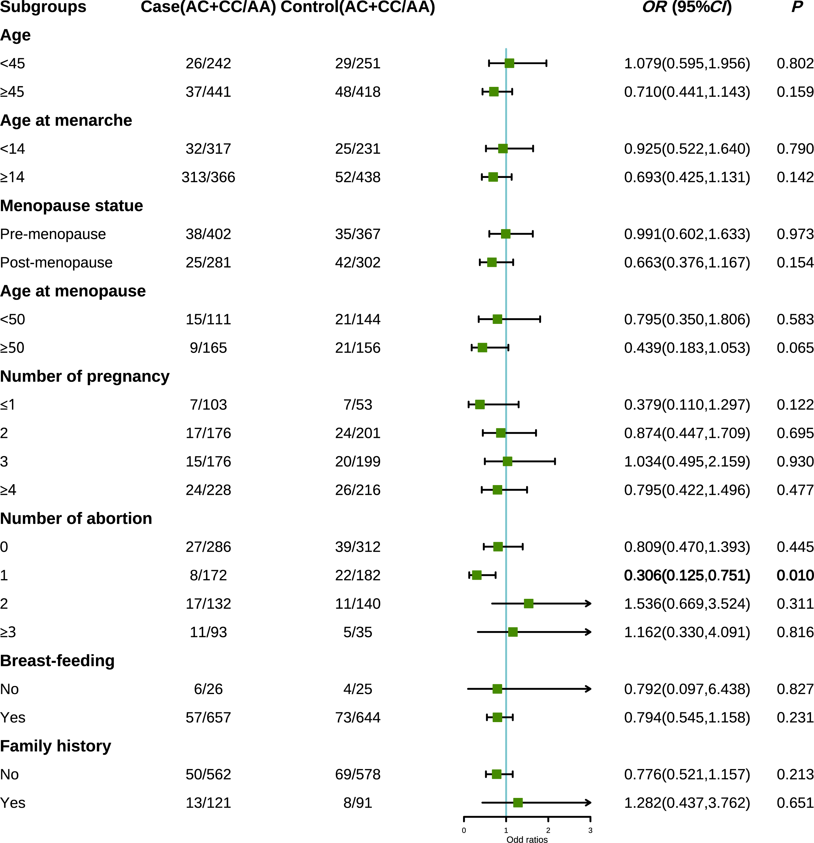
Figure S4 Stratified analysis of YTHDC1 rs17592288 and breast cancer risk in dominant model
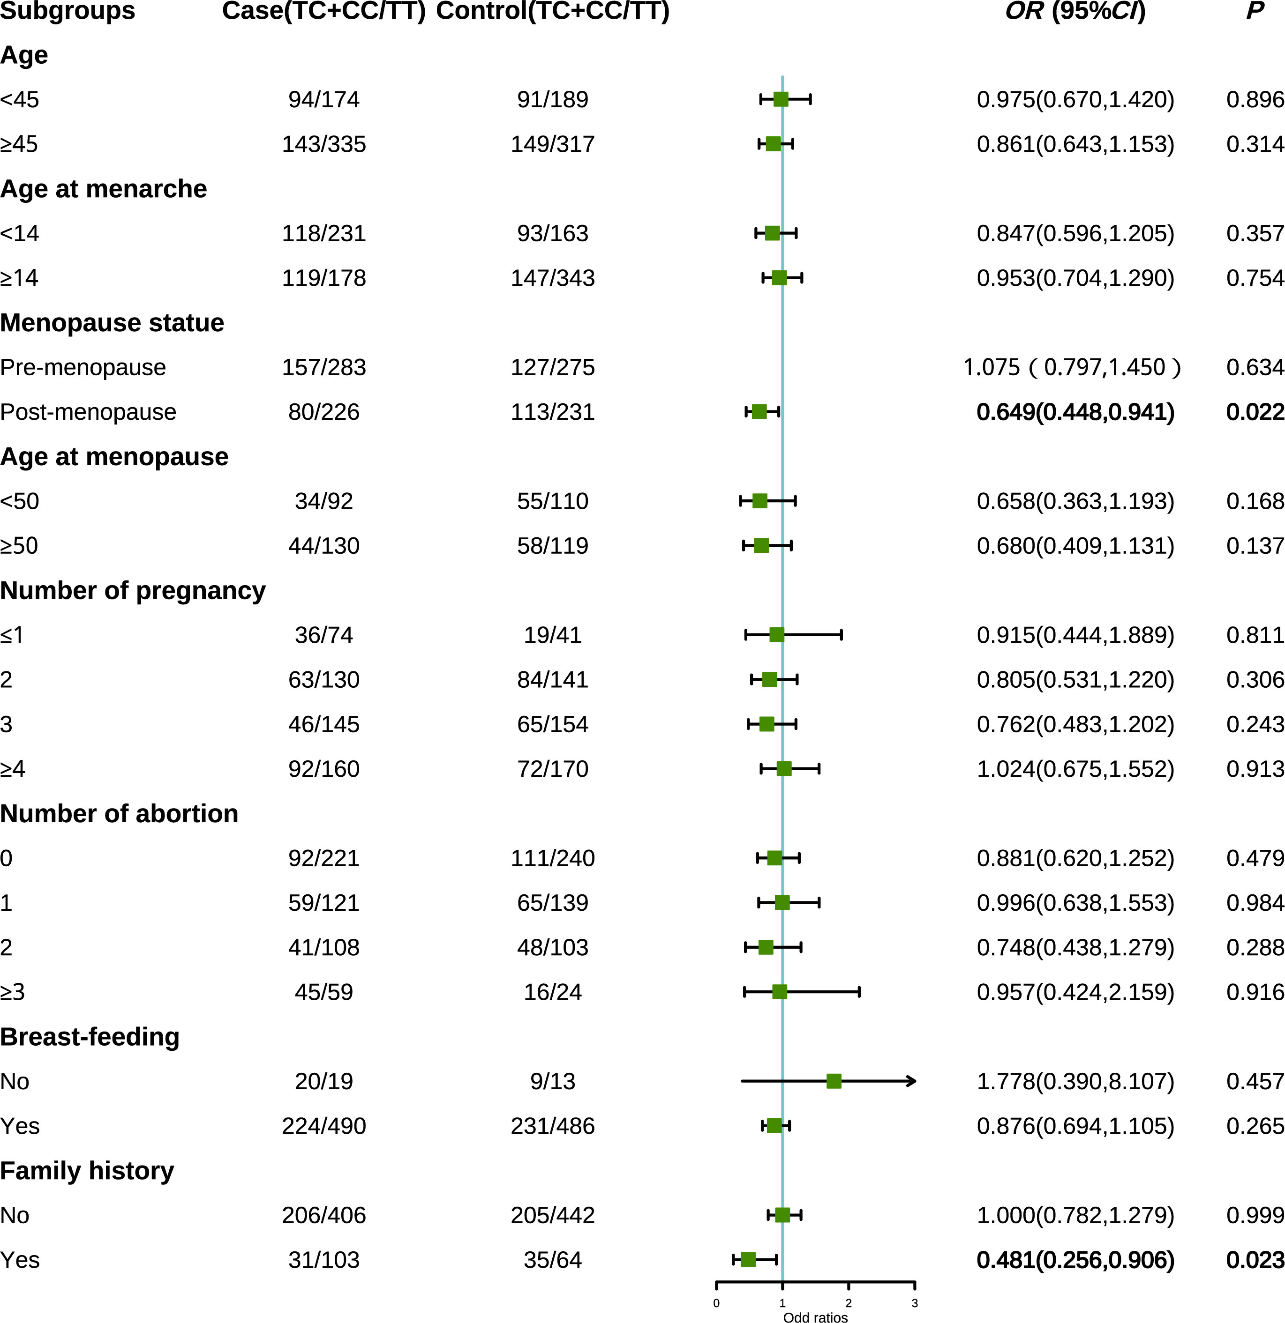
Figure S5 Stratified analysis of YTHDC1 rs2293596 and breast cancer risk in dominant model
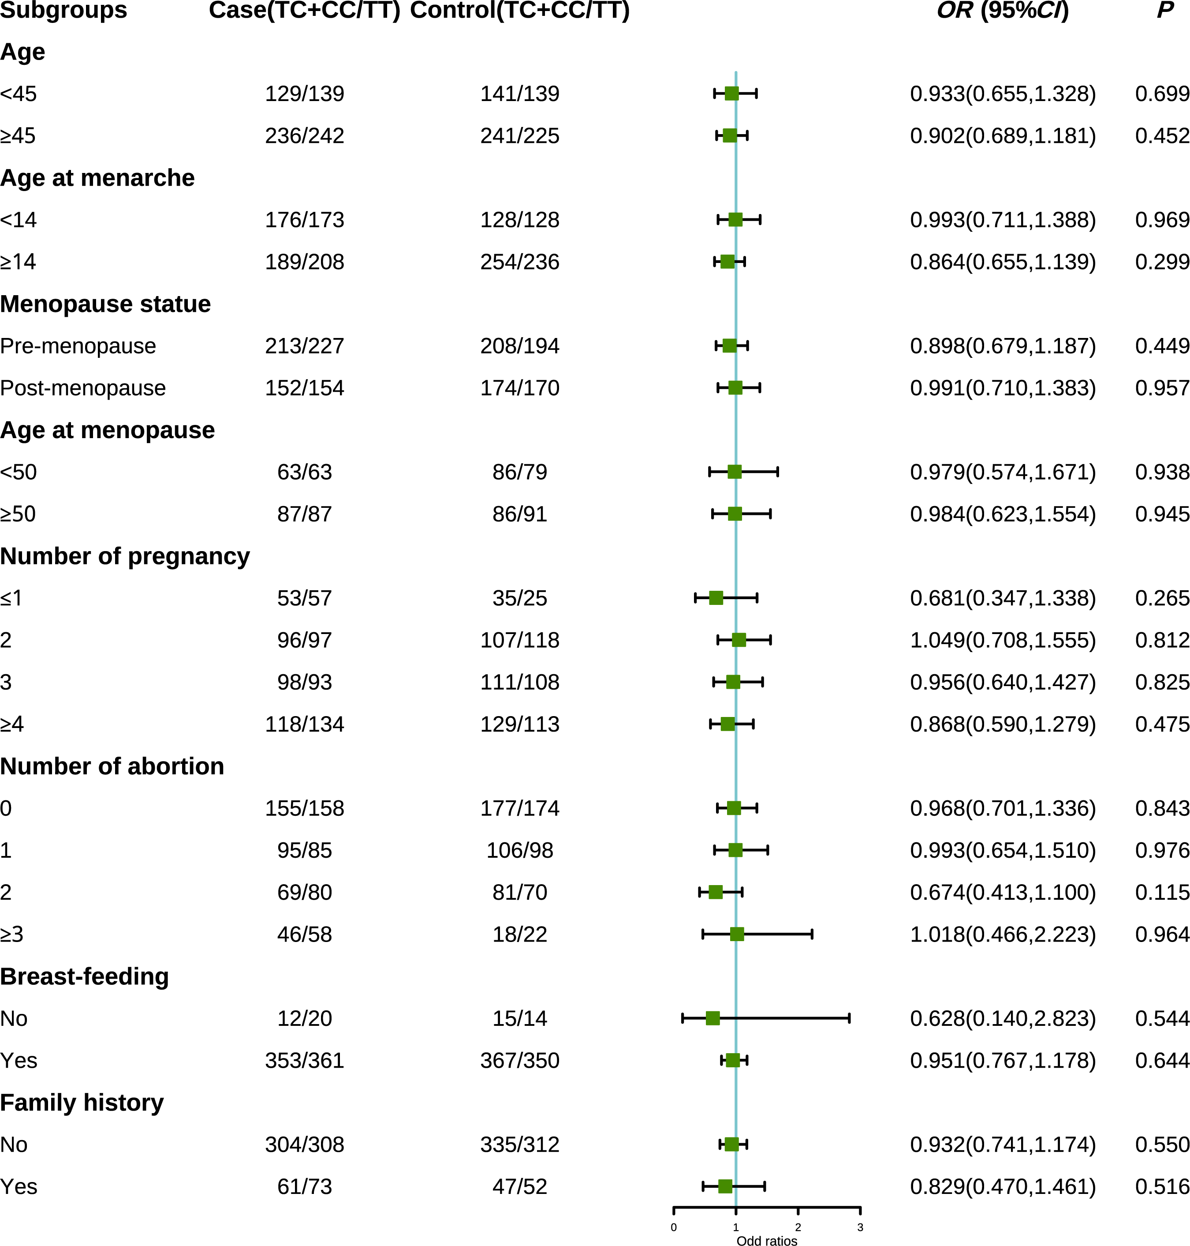Figure S6 Stratified analysis of YTHDC1 rs3813832 and breast cancer risk in dominant model
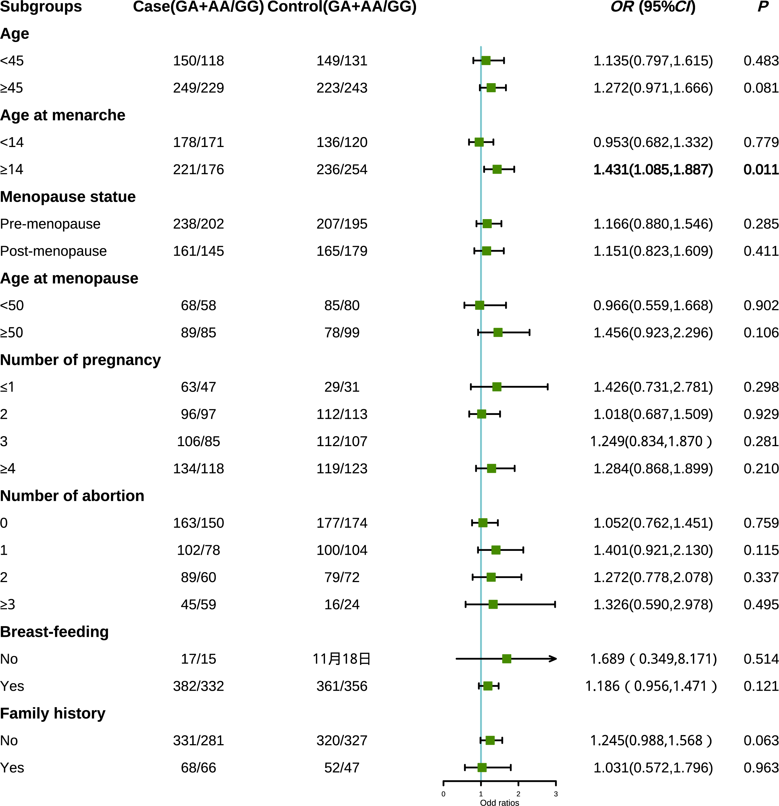Figure S7 Stratified analysis of YTHDC2 rs9552 and breast cancer risk in dominant model
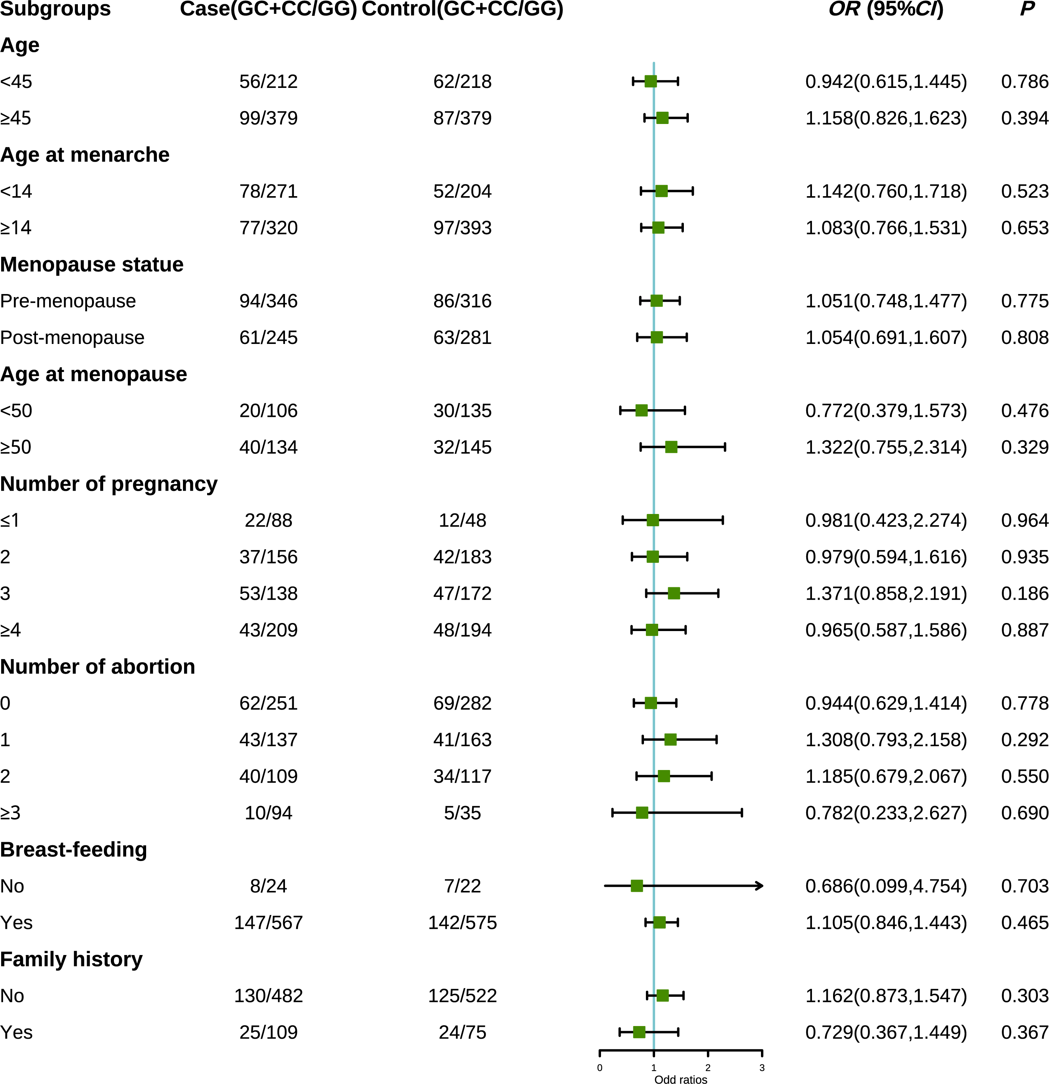Figure S8 Stratified analysis of YTHDC2 rs17135754 and breast cancer risk in dominant mode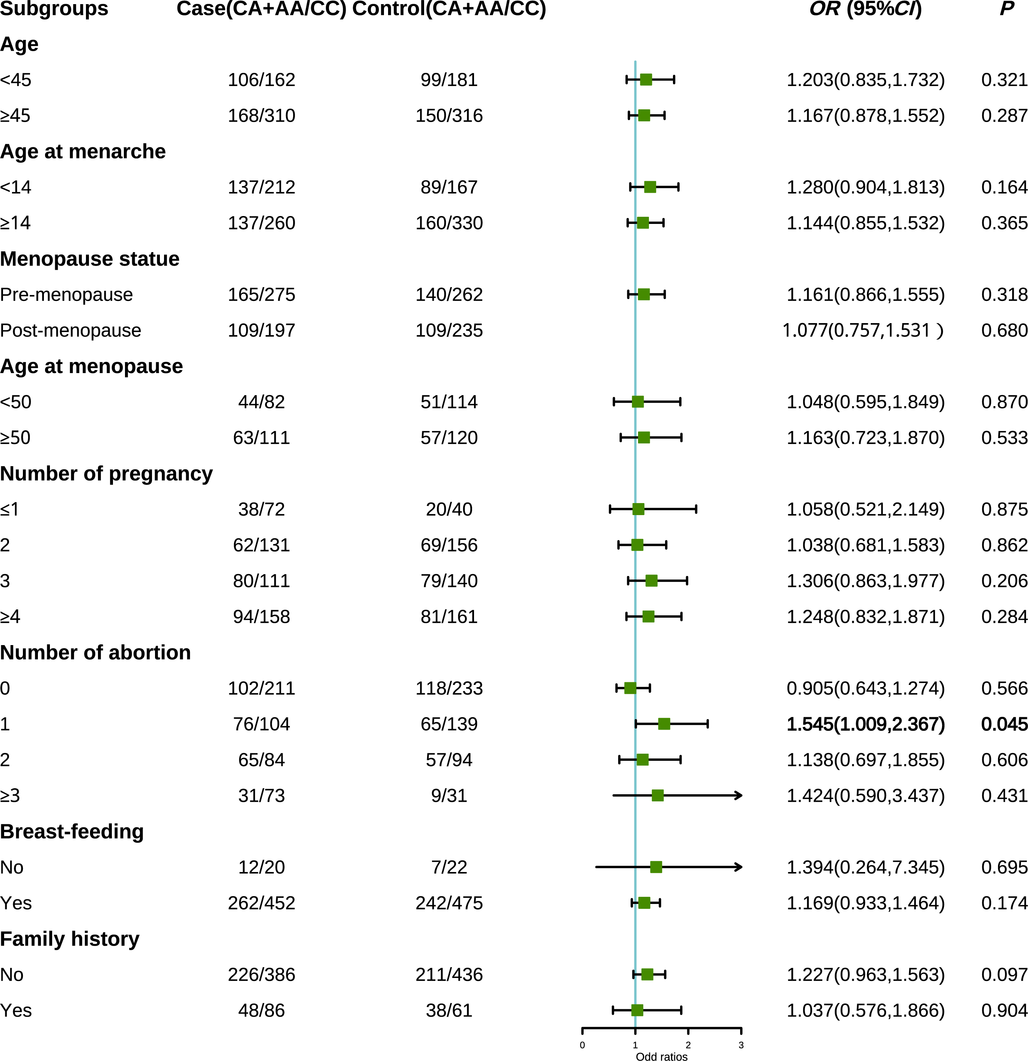Figure S9 Stratified analysis of YTHDC2 rs6594732 and breast cancer risk in dominant model
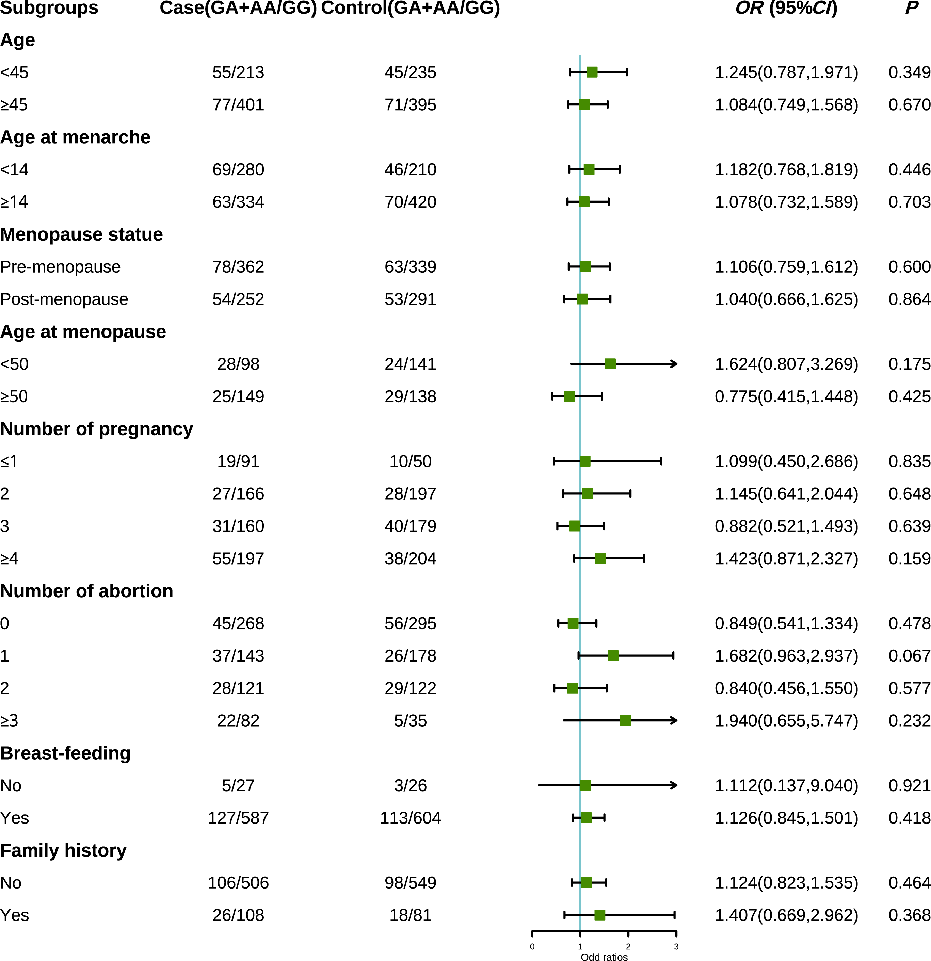Figure S10 Stratified analysis of YTHDC2 rs2303718 and breast cancer risk in dominant model
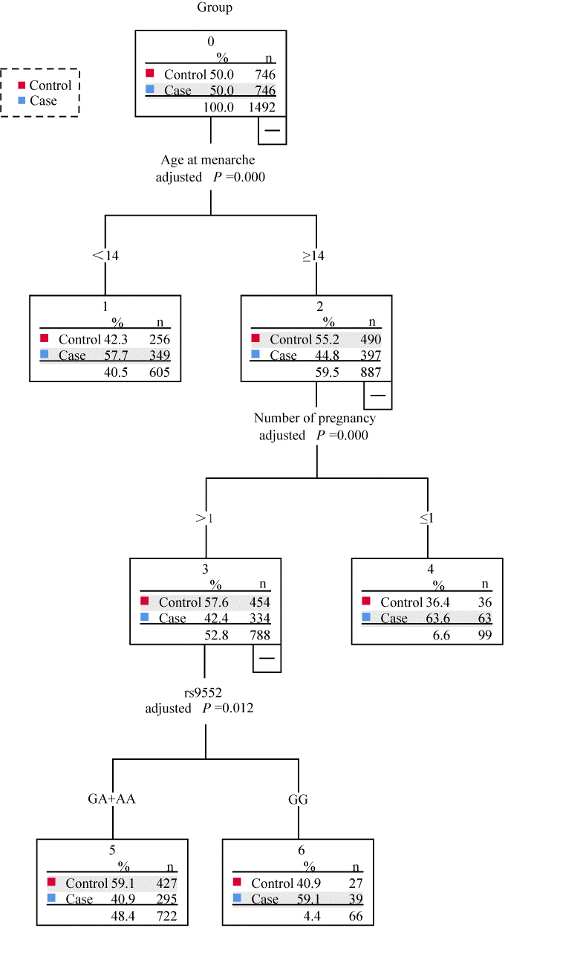
Figure S11 Classification and regression tree model of gene-reproductive factors of BC risk.
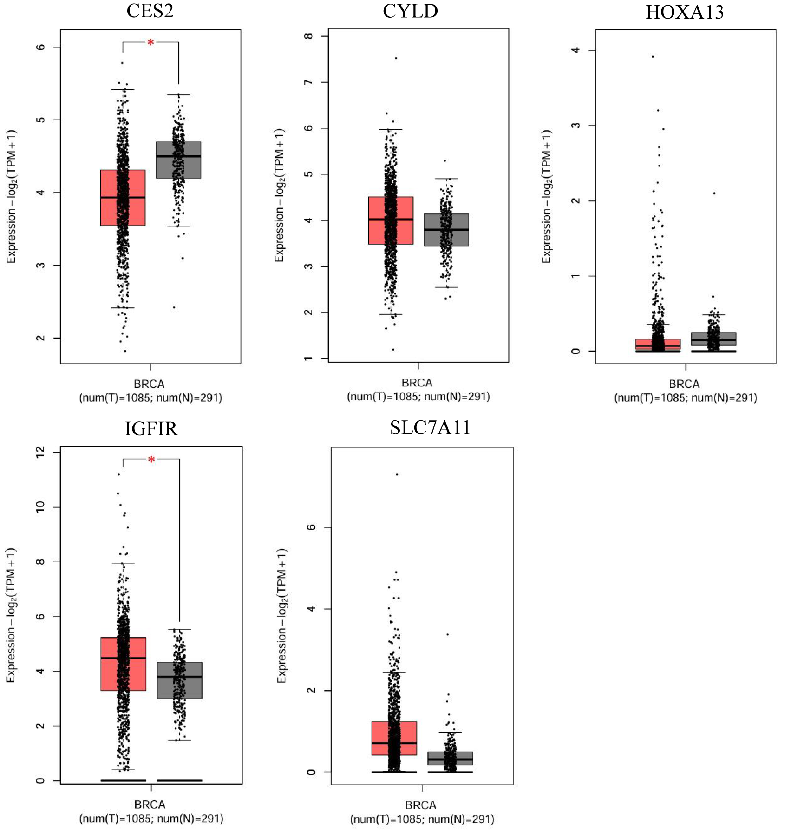
Figure S12 Expression analysis of target genes in breast cancer and normal tissues based on the GEPIA database
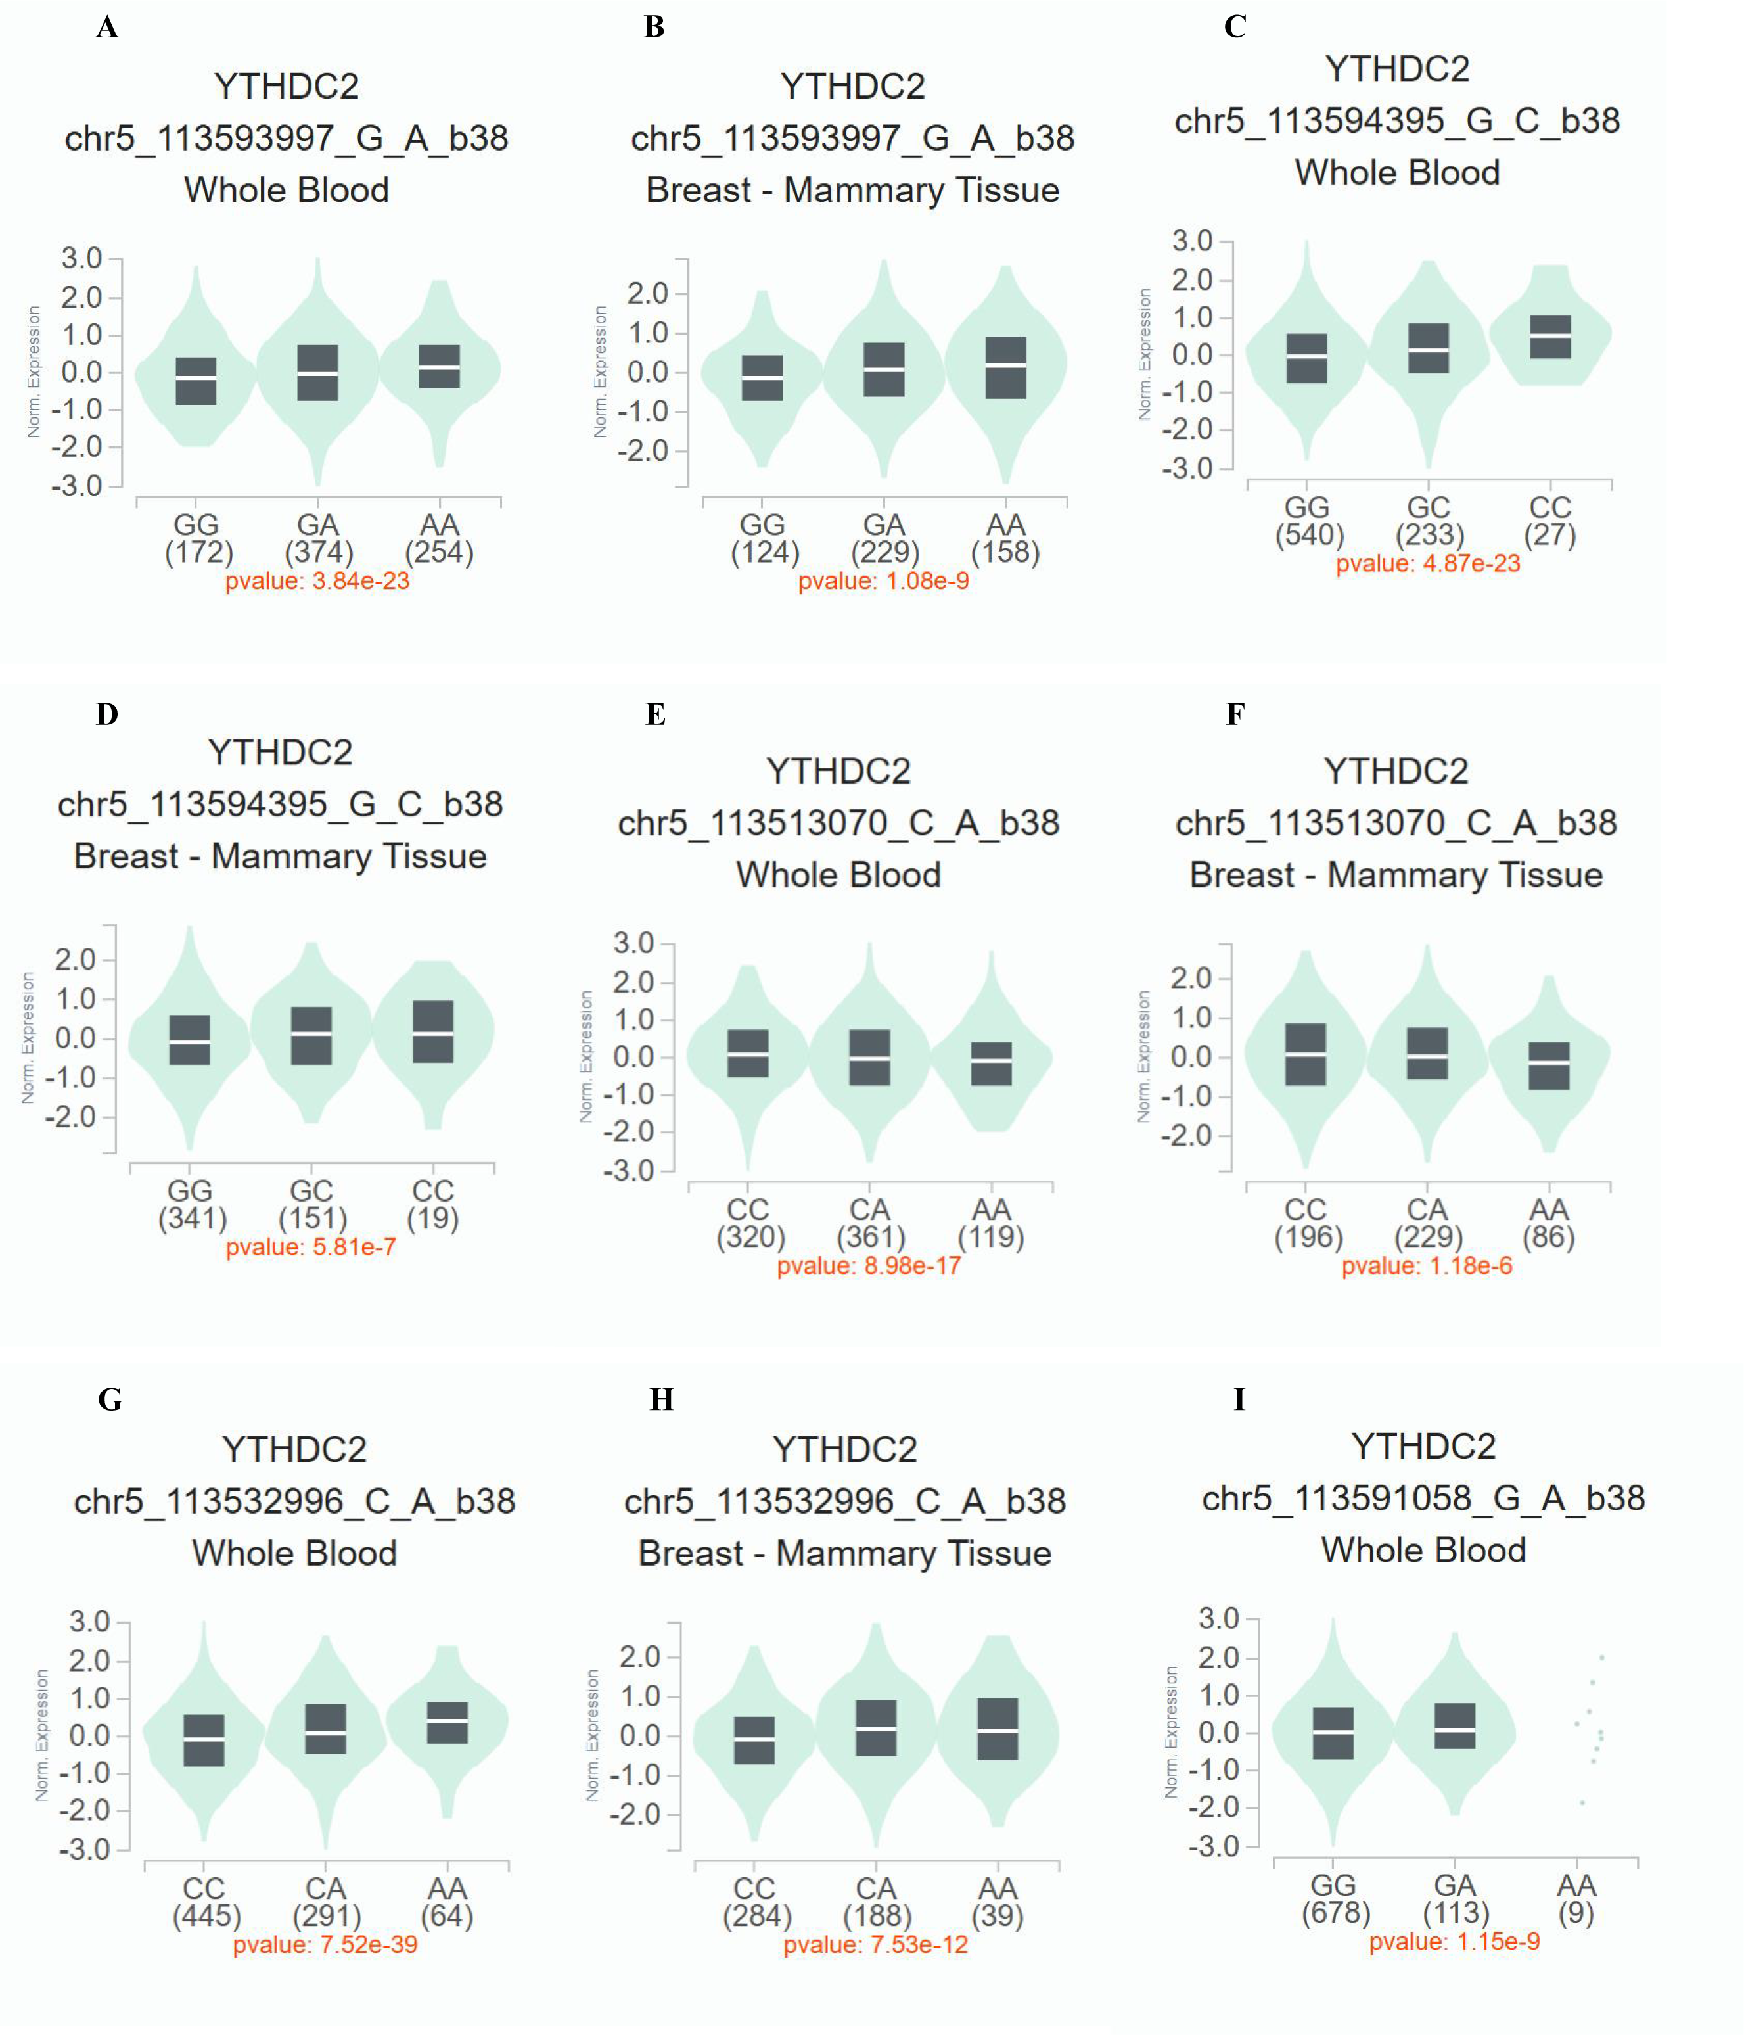
Figure S13 eQTL analysis of YTHDC2 SNPs. (A,B: rs9552; C,D: rs17135754; E,F: rs2416282; G,H: rs6594732; I: rs2303718)
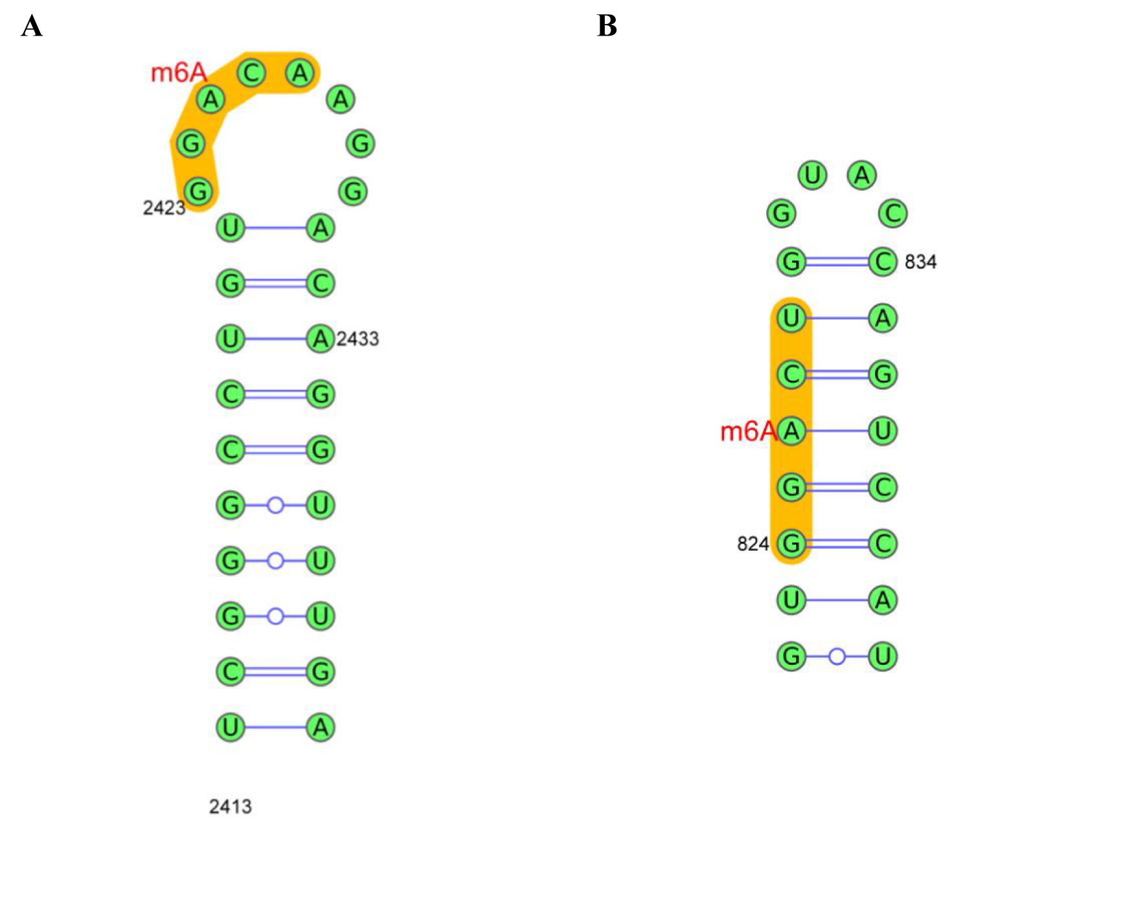
Figure S14 Predicted RNA secondary structures of the most credible m6A modification sites in target genes. (A: CES2; B: BIGFIR)

