Table 1. Concentrations of isoxanthohumol and 8-prenylnaringenin in beer, quantified by LC-MS/MS based on data reported by Stevens et al. (1999) unless otherwise specified.
Highly hopped beers | Isoxanthohumol (µM) | 8-prenylnaringenin (µM)
American porter | 3.75 | 0.705
Strong ale | 9.706 | 0.323
Organic beer* | 5.22 | 0.073
Low hopped beers
European lager | 0.112 | 0.0029
European pilsner | 1.608 | 0.061
Alcohol-free beer | 0.31 | 0.0088
*obtained from Golubovic et al. (2021)

16s rRNA data analysis
Aliquots of fecal samples were sent to Microsynth AG (Balgach, Switzerland), where DNA was extracted and the V4 region of 16s rRNA genes was amplified and sequenced. The analysis was conducted with QIIME2 (version 2024.5). Cutadapt was used to remove the forward and reverse primers. Denoising and chimera filtering were performed with the DADA2 algorithm, and the reads were truncated at base 226 for forward reads and at 182 for reverse reads. The pretrained Greengenes2 20240926 classifier from the 515F/806R region was used to assign the taxonomy.

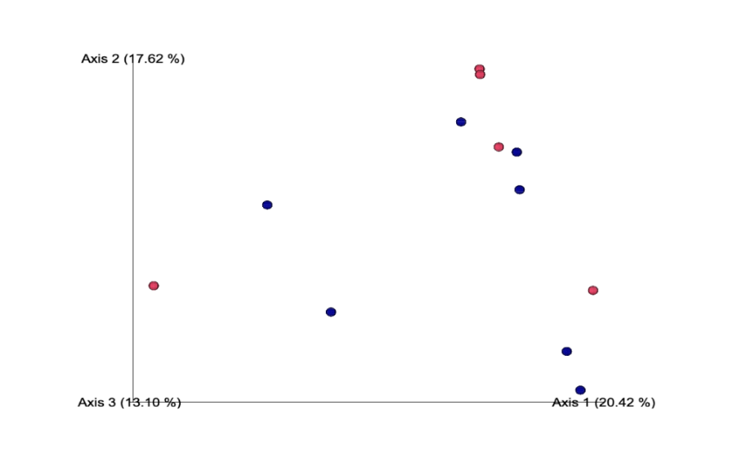
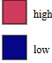

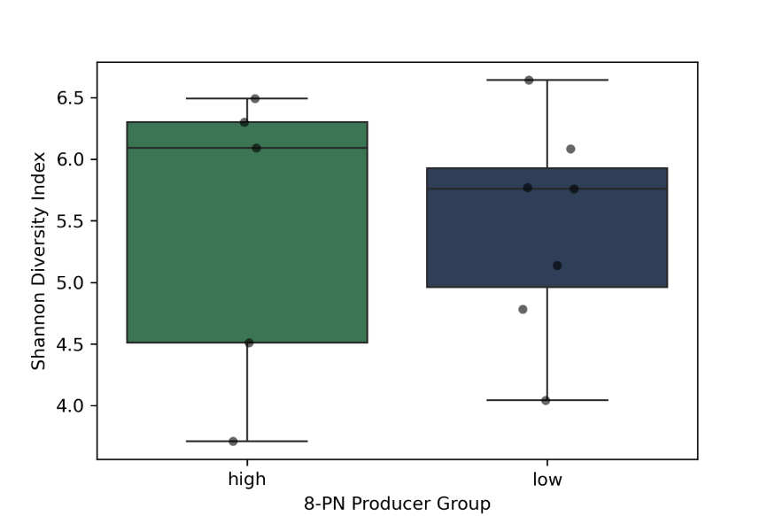
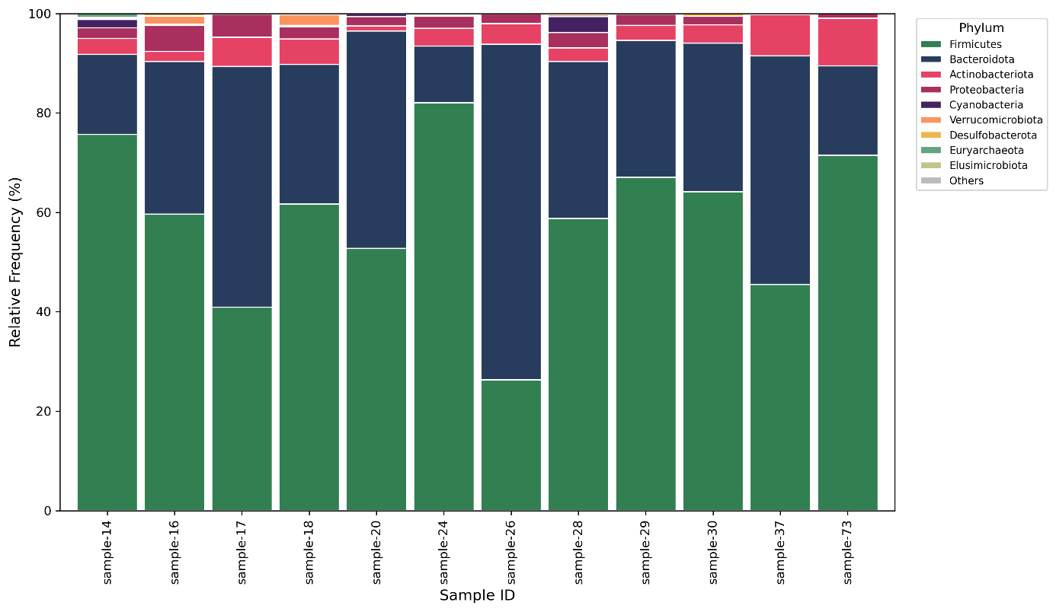
Figure 1. Principal coordinate analysis based on Bray-Curtis dissimilarity matrix to evaluate differences in community composition. Samples were color coded based on two different groups of high and low 8-PN producers.
Figure 3. Shannon diversity index of gut microbiome in 8-PN high and low producers. Alpha diversity was assessed using the Shannon entropy metric. Boxplots display the distribution of Shannon diversity values for each group (high: n = 5; low: n = 7), with individual samples overlaid as black dots.
Figure 2. Relative abundance of bacterial taxa at the phylum level across all samples. Barplots represent the taxonomic composition of gut microbiota, based on 16S rRNA gene sequencing and classification using the Greengene database. Each bar corresponds to an individual sample, and colors indicate different bacterial phyla. Only taxa with a relative abundance ≥1% in at least one sample are shown; all others are grouped under “Others.”

Table 2. MacFarlane media composition

Ingredient | Amount for 1 L | Vendor
Cellobiose | 1.0 g | Alfa Aesar
Xylan (oat spelts) | 1.0 g | Apollo
Arabinogalactan (larch wood) | 1.0 g | Sigma
Inuline (Raftiline® HP) | 0.5 g | Sigma
Soluble starch (potato) | 1.0 g | Sigma
Amicase | 3.0 g | Sigma
Bacto™ Tryptone | 5.0 g | Thermo Scientific
Meat extract | 1.5 g | Sigma
Yeast extract | 4.5 g | Sigma
Mucine | 4.0 g | Sigma
Bile salt | 0.4 g | Sigma
KH₂PO₄ | 3.0 g | Sigma
NaHCO₃ | 9.0 g | Sigma
NaCl | 4.5 g | Sigma
KCl | 4.5 g | Sigma
Mineral solution | 200 mL | see below
Tween 80 | 1.0 mL | Sigma
Volatile fatty acid mix | 5.7 mL | see below
0.05 g/mL hemin | 1.0 mL | see below
ddH₂O | 792 mL | /
Vitamin solution | 1.0 mL | see below
L-cysteine | 1.0 g | Sigma
Mineral solution
Components | g/L | Vendor
MgSO₄ anhydrous. (M: 120.37) | 3.05 g | Sigma
CaCl₂∙2H₂O (M: 147.02) | 0.5 g | Labguard
MnCl₂∙4H₂O (M: 197.91) | 1.0 g | Across Organics
FeSO₄∙7H₂O (M: 278.02) | 0.025 g | Sigma
ZnSO₄∙7H₂O (M: 287.56) | 0.5 g | Sigma
ddH₂O | 1 L | /
0.05 g/mL Hemin stock solution
Components | g/25 mL | Vendor
Hemin | 1.25 g | Across Organics
3M NaOH | 5 ml | Fisher Chemicals
Milli-Q | 20 ml

Volatile fatty acid mix
Components | For 100 mL | Vendor
Acetic acid | 32.8 mL | Merck
Propionic acid | 11.6 mL | Sigma
Isovaleric acid | 2 mL | Across Organics
Isobutyric acid | 1.6 mL | Across Organics
Valeric acid | 1.8 mL | Thermo Scientific
5N NaOH | 50 mL | Fisher Chemicals
10x concentrated vitamin solution
Components | g/100mL | Vendor
Biotin | 10 mg | Sigma
Cobalamin | 10 mg | Sigma
p-Aminobenzoic acid (PABA) | 30 mg | Sigma
Folic acid | 50 mg | Sigma
Pyridoxamine | 150 mg | Sigma
ddH₂O | Fill up to 100 mL | /

