SUPPLEMENTARY INFORMATION

A Function-Driven Single-Cell Approach to Unveiling and Cultivating Hidden Microplastic-Degrading Microbes from Insect Gut Microbiota

Hong-Qin Guo^{1,2}, Kai Yang¹, Xin-Yu Xing^{1,2}, Yu-Nan Yang¹, Long-Ji Zhu¹, Xiao-Xi Kang³, Feng Ju³, Rong Ji⁴, Philippe Francois-Xavier Corvini^{4,5}, Yong-Guan Zhu^{1,6}, Li Cui^{1, *}

¹State Key Laboratory of Regional and Urban Ecology, Institute of Urban Environment, Chinese Academy of Sciences, Xiamen, 361021, China
²University of Chinese Academy of Sciences, Beijing, 100049, China
³Research Center for Industries of the Future, School of Engineering, Westlake University, Hangzhou, 310024, China
⁴State Key Laboratory of Pollution Control and Resource Reuse, School of the Environment, Nanjing University, Nanjing, 210023, China
⁵Institute for Ecopreneurship, School of Life Sciences, University of Applied Sciences and Arts Northwestern Switzerland, Gründenstrasse 40, 4132 Muttenz, Switzerland
⁶State Key Lab of Urban and Regional Ecology, Research Center for Eco-Environmental Sciences, Chinese Academy of Sciences, Beijing, 100085, China

*Corresponding author at: State Key Laboratory of Regional and Urban Ecology, Institute of Urban Environment, Chinese Academy of Sciences, 1799 Jimei Road, Xiamen, 361021, China.
Email: lcui@iue.ac.cn; Tel./Fax: +86-592-6190560

Number of pages: 20
Number of tables: 3
Number of texts: 10
Number of figures: 19
Supplemental tables:

Table S1. Growth indexes of Tenebrio molitor larvae fed with wheat bran (Bran-fed), PS (PS-fed), and starved (Starvation)

Growth index | Starvation | Bran-fed | PS-fed
Survavial rate | 0.3981±0.1260 b | 0.6441±0.0491 a | 0.6145±0.1215 a
Putation rate | 0±0 b | 0.0869±0.0235 a | 0±0 b
Length gain rate | -0.1438±0.0557 c | 0.1579±0.0667 a | 0.0835±0.0926 b
Width gain rate | -0.2001±0.0825 c | 0.8562±0.0693 a | 0.2335±0.0466 b
Weight gain rate | -0.0809±0.0504 c | 0.2129±0.0246 a | -0.0194±0.0456 b

Table S2. 16S rRNA gene amplicon sequencing data statistics

Groups | Sample | Seq_num | Base_num (bp) | Sobs | Ace | Chao | Shannon | Simpson
Bran-fed | HBR1 | 165538 | 42327157 | 8 | 30.2102 | 10 | 1.1534 | 0.4620
Bran-fed | HBR2 | 88060 | 22457948 | 4 | 4.6944 | 4 | 0.5388 | 0.7428
Bran-fed | HBR3 | 83110 | 21206816 | 4 | 7.0000 | 4.5 | 0.3619 | 0.8457
PS-fed | HPS1 | 86070 | 21977706 | 6 | 7.2182 | 7 | 0.9047 | 0.5834
PS-fed | HPS2 | 104946 | 26783841 | 12 | 13.3428 | 13.5 | 2.2047 | 0.1216
PS-fed | HPS3 | 80683 | 20585032 | 17 | 37.0696 | 35 | 2.4213 | 0.1061
Starvation | HTA1 | 100956 | 25764884 | 9 | 11.3952 | 9.6 | 1.2422 | 0.4694
Starvation | HTA2 | 95671 | 24431910 | 5 | 5.8250 | 5 | 1.1184 | 0.3918
Starvation | HTA3 | 116776 | 29805686 | 8 | 8.4470 | 8 | 1.7678 | 0.1910

Table S3. Reported enzymes and types of plastics they can degrade

Enzymes | Plastics
Esterase | PS、PU、PET、PCL、PLA
Laccase | PS、PE
Lipase | PET、PCL
Hydrolase | PS、PET、PCL、PLA、Nylon、PES
Protease | PS、PLA

Supplemental texts:

Experiment S1. Feedstocks, Laboratory Cultivation, and Measurement of Growth Indexes of Larvae
The T. molitor larvae measuring approximately 2.09 ± 0.162 cm in length, 2.7 ± 0.156 mm in width, and weighed 0.07 ± 0.002 g each were selected for this study. Wheat bran was sourced from Jinhua Organic Feed Company. The polystyrene (PS) foams were cut into pieces (dimensions: 10 cm × 5 cm × 2 cm), cleaned with ethanol and distilled water, dried, and exposed to ultraviolet light before testing.¹ The larvae were reared indoors, fed with wheat bran in a dark, temperature-controlled environment at 26 °C with 60% humidity for 72 hours, and then starved for 48 hours prior to the experiments. Each group consisting of 100 larvae was placed in an incubation box (dimensions: 15 cm × 10 cm × 5 cm) to maintain consistent initial biomass and environmental conditions. The experiments spanned 42 days, during which 1 g of PS foam or wheat bran was added to each group at the start and supplemented as needed. Every seven days, PS pieces and plastic debris were collected and weighed to assess plastic consumption. Additionally, the growth indices of the larvae (including survival rates, pupation rates, and measurements of length, width and weight) were recorded. Dead larvae, pupae, and any shed exoskeletons were checked daily and removed to prevent infection from pathogenic microorganisms.
Experiment S2. Characterization of Residual PS Fragments from Larvae Frass
The larvae frass was collected at seven-day intervals and stored at -20 °C for further analysis. Plastic fragments that were not fully degraded were recovered from the frass. The characterization of the frass extracts was conducted using pristine PS foam plastics as a control, with three replicates for accuracy.
Changes in the functional groups of PS polymers were examined using FTIR spectrometer (VERTEX70, Brock Instruments, Germany) over the wavenumbers ranging from 4000 to 550 cm⁻¹ after the samples were laminated and dried. Peaks were identiﬁed using OMNIC software (Thermo Fisher Scientiﬁc Inc., Pittsburgh, PA). The thermal stability was characterized by TGA (SDT Q600, TA Instruments, USA) with the samples heated from 0 to 600 °C at the rate of 10 °C/min under high-purity argon ambience at a flow of 10 mL/min.²⁻⁴ Temperature for 5% loss of mass was the temperature at which the thermal decomposition or thermogravimetry of samples began and could be used to assess the thermal stability of the polymers.^{2,3} The molecular weight changes of PS polymer were analyzed using GPC (Agilent 1260, Waters, USA). The THF solution is mixed with the sample and heated at 60 °C gently, then settled and filtered through a 0.22 μm PVDF filter.¹ 20 μL of the extracts were injected for GPC analysis at the rate of 0.8 mL/min.
Experiment S3. Gut Microbiome Analysis
At the end of the 42-day experiment, the larvae were sterilized in 75% ethanol for 5 minutes and rinsed twice with phosphate-buffered saline (PBS). Under sterile conditions, the guts were extracted using medical dissection needles on a wax tray. The extracted guts were then shaken for 5 minutes on a vortex oscillator and stored at -20 °C for further gut microbiome analysis.⁵ The gut DNA was extracted with DNeasy Blood and Tissue Kit following the manufacturer’s directions (QIAGEN, Germany).⁶ The quality and quantity of gut DNA were evaluated by using agarose gel electrophoresis and a Qubit 3.0 fluorometer (Thermo Fisher, Waltham, USA). Then, the hypervariable V4 region of the 16S rRNA gene were amplified using primer pairs 515 F (5′-GTGYCAGCMGCCGCGGTAA-3′) and 806 R (5′-GGACTACNVGGGTWTCTAAT-3′).⁷ The amplicon products from each sample were evenly mixed and sequenced using a paired-end sequencing strategy (PE250) on the Illumina HiSeq2500 platform. Subsequently, the analysis of the gut microbial community was conducted using the online Majorbio Cloud Platform (Shanghai, China).
Experiment S4. Measurement of Gut Enzyme Activities
After the 42-day experiment, the guts of each sample were extracted and homogenized in PBS for further enzyme activity measurements. The activity of carboxylesterase was assessed using the Carboxylesterase Activity Test Kit following the manufacturer’s instructions (Jiancheng Co., China). Laccase activity was measured using the Laccase Activity Test Kit (ACMEC, China). All enzyme activities were reported in units of U/mg protein.
Experiment S5. Characterization of PS Microplastics Biodegradation by Strain P. aeruginosa-IUE
Multiple physicochemical characterizations were conducted to evaluate the biodegradation of PS after 30 days of incubation with the isolated strain P. aeruginosa-IUE, including FTIR, SEM, GPC, water contact angle (WCA) measurements, and TGA. To monitor the growth of the strain, optical density at 600 nm (OD600) was measured every 10 days using a Thermo Scientific Microplate Reader (SpectraMAX M5, Molecular Devices). At the end of the 30-day incubation period, the residual PS was recovered, sterilized through ultrasonic cleaning in ethanol and distilled water, and dried for further characterization. The morphology of the biofilms developed on PS was examined using SEM (Hitachi S4800, Japan). The samples were rinsed three times with 0.1 M PBS and fixed in 2.5% glutaraldehyde for 12 hours at 4 °C. Following fixation, the samples were dehydrated through a series of cold ethanol solutions (30%, 50%, 70%, 90%, and 100% v/v) for 10 minutes each. After dehydration, the samples were covered with filter paper and critical point dried overnight using an Autosamdri 815 automatic critical point dryer (Tousimis, USA). The dried samples were then adhered to conductive tapes (SPI, USA) mounted on copper stubs and sputter-coated with gold for SEM analysis. Water contact angles (θw) of the PS were measured with a contact angle instrument (DSA 100, KRUSS, Germany). A droplet of ultrapure water (5 μL) was placed on the surface of the plastic sheet, and the shape of the droplet was recorded for 10 seconds using a high-speed camera at room temperature. The water contact angles were subsequently calculated using ImageJ software (version 1.50i, Wayne Rasband, USA). Additionally, FTIR, GPC, and TGA analyses were performed as detailed in Experiment S2.
Experiment S6. Single-Cell Raman Spectra Acquisition
Single-cell Raman spectroscopy was acquired using LabRAM Aramis Confocal Raman microscope (Horiba Jobin-Yvon, Japan) equipped with a 300 grooves/mm grating. A 532 nm Nd:YAG laser (Laser Quantum, USA) with power of 3.5 mW and a 100 × objective (Olympus, NA = 0.90) were used for sample detection. The acquisition time for each spectrum was 25 s in the range of 400-3,200 cm⁻¹. More than 50 individual bacteria of each sample were randomly selected for Raman measurements. After the baseline correction and normalization preprocessed via LabSpec5 software (Horiba, Jobin-Yvon, Japan), the C-D ratios of CD / (CD + CH) were calculated according to the intensities of C-H peak (2800-3100 cm⁻¹) and C-D peak (2040-2300 cm⁻¹).⁸
Experiment S7. Response of Gut Microbes to Potential Plastic Additives.
To investigate whether the highly D-labeled cells respond to the potential PS plastic additives, 20 mg of PS microplastics were incubated with 5 mL of mineral salt medium (MSM) for 7 days at 30 °C. Following the incubation, the potential PS additives in the liquid supernatant were separated from the PS particles by centrifuging at 3,000 rpm for 5 minutes. This separation process was repeated three times, and the supernatant was filtered through a 0.22 μm filter to ensure effective removal of any remaining PS particles. Then the harvested cells were distributed into glass vials containing liquid MSM medium with potential additives and amended with 50% (v/v) D₂O. Detailed experimental groups were designed as below: (1) 2 mL MSM liquid medium + 2 mL D₂O + PS-fed gut cells + 100 μL potential additives; (2) 2 mL MSM liquid medium + 2 mL D₂O + E. coli DH5α+ 100 μL potential additives; (3) 2 mL MSM liquid medium + 2 mL D₂O + S. aureus RN4220 + 100 μL potential additives; (4) 2 mL MSM liquid medium + 2 mL D₂O + isolated strain P. aeruginosa-IUE +100 μL potential additives. Vials were incubated for 7 days at 30 °C. At the same time, group sets that incubated with PS microplastics or none as described in 2.5 were also repeated.
Experiment S8. Raman-D₂O Capturing of Active PE and PU Microbes in Gut Microbiota of Plastics-fed Larvae
T. molitor larvae were fed with polystyrene (PE) foams and polyurethane (PU) foams in triplicates for 42 days, following previously described protocols. The PE foams (Mn = 1,736 Da, Mw = 2,176 Da, 98% purity, density of 8 kg/m³) and PU foams (Mn = 64,127 Da, Mw = 95,661 Da, 98% purity, density of 8 kg/m³) were sourced from Liboshi Plastics Company in Zhejiang Province, China. To isolate microbes capable of degrading PE and PU, the extracted gut contents were suspended in PBS and vortexed. This mixture was then transferred to 100 mL of MSM containing 50 mg of sterile microplastics: PE (200 μm, Mn = 2,715 Da, Mw = 25,703 Da, 99% purity) and PU (200 μm, Mn = 11,992 Da, Mw = 26,043 Da, 99% purity). After 90 days of incubation, a PE-degrading bacterium, Staphylococcus sp.-IUE, and a PU-degrading bacterium, Pseudomonas aeruginosa-IUE2, were successfully isolated. The gut microbes from larvae fed with PE and PU for 42 days were then harvested and prepared for further Raman-D₂O detection. Several groups of positive and negative controls were established, including PE/PU-degrading bacteria and non-degrading bacteria, with plastic serving as the sole carbon source. These samples were incubated for 7 days at 30 °C. At the end of the incubation period, the cells were harvested and washed three times for subsequent single-cell Raman measurements, as previously detailed.

Result S1. Ingestion and Biodegradation of PS by T. molitor larvae
T. molitor larvae were found to be actively foraging on PS foam plastics. After 42 days of feeding trials, plentiful hollows were formed with the larvae chewing and digging into PS foam plastics as the sole diets (Fig. S3). The consumption of plastics increased throughout the feeding trials with a total mass loss of 78.97 ± 15.69 mg/g-larvae, indicating the good appetite of larvae to ingest PS foam plastics (Fig. S4A). Growth index of T. molitor larvae in the PS-fed groups, including survival rate, pupation rate, length/width/weight gain, were similar to or a little lower than that in the bran-fed groups, but much higher than that in the starvation groups (Table S1, Fig. S4B, Fig. S4C), demonstrating that the T. molitor larvae could gain necessary energy for normal growth through ingesting PS foam plastics.^{1,9} However, it was difficult for the T. molitor larvae to pupate when just fed on plastics, in contrast to the extra addition of wheat bran which enhances the pupation rate, survival rate, and degradation efficiency of plastics as previously reported.¹⁰⁻¹²
Biodegradation of PS foam plastics by T. molitor larvae was investigated by characterizing the residual plastic fragments recovered from the frass of larvae via GPC, FT-IR, and TGA. GPC results showed that the number-average molecular weight (Mn) of PS residuals was slightly decreased compared to raw PS feedstocks (ANOVA, p > 0.05), and the weight-average of molecular weight (Mw) was significantly decreased (ANOVA, p < 0.05, Fig. S4D). In addition, FTIR spectra of the residual PS showed new functional groups of O-H bending vibration (1390 cm⁻¹) and O-H stretching vibration (3550 cm⁻¹), and the peak of C-O stretching (1014 cm⁻¹) and C=O stretching (1710 cm⁻¹) were broader than the raw PS (Fig. S4E). These results suggested the occurrence of depolymerization and oxidation of PS during the ingestion progress, consistent with previous finding that the addition of oxygen functional groups into the polymer chain was a preliminary and indispensable step in plastic biodegradation.^{9,13-15} In addition, TGA analysis found that PS residual recovered from the frass of T. molitor larvae displayed a much lower thermal stabilities than raw PS based on the much lower temperature (214.1 °C vs 353 °C) at which 5% loss of mass occurred (Fig. S4F), corroborating PS degradation and formation of new organic degradation product.^{12,13,16}
Result S2. Gut Microbial Communities Responsive to Different Diets
Gut microbial communities were subjected to 16S rRNA gene amplicon sequencing and a total of 921,810 high-quality sequences were obtained following quality control (Table S2). A principal coordinate analysis (PCoA) of the PS-fed groups based on Bray-Curtis distances at the ASV level displayed remarkably distinct clustering features from that of Bran-fed groups and starvation groups after 42-day incubation (Adonis, R² = 0.4359, p = 0.005, 999 permutations) (Fig. S5A). Some species in the PS-fed groups become dominant, including Enterococcus sp., Pseudomonas sp., Chryseobacterium sp., Spiroplasma sp., and Staphylococcus sp. (Fig. S5B). LEfSe analyses based on all-against-all strategy showed that the distinct genus in gut microbiome of PS-fed groups was Pseudomonas compared to that of bran-fed and starvation groups (Fig. S5C, Fig. S5D). These findings indicated that the sole fed diets of PS enriched the specific functional gut microbes that could be conductive to the biodegradation of PS.
Supplemental figures:
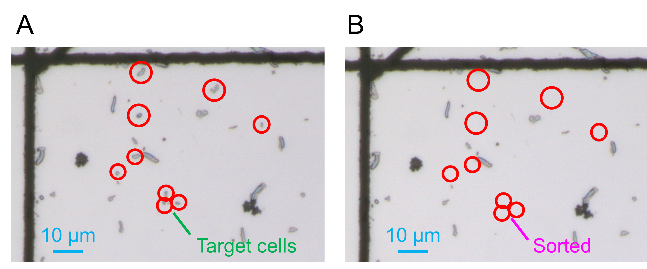Fig. S1 Targeted gut cells that were highly labeled by D after incubation with polystyrene microplastics were sorted by Raman-activated cell ejection. Red circles indicate target cells pending (A) and posting sorting (B).

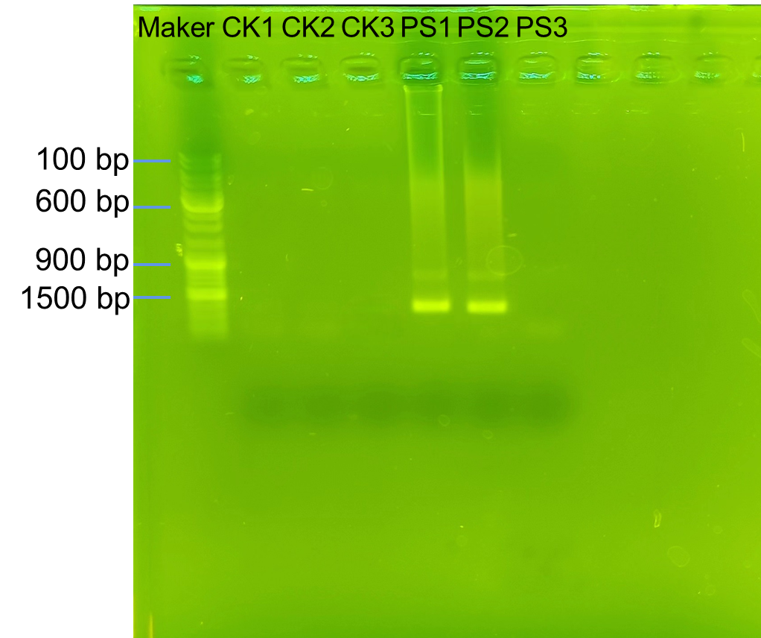
Fig. S2 Agarose gel images of MDA products of Raman-sorted cells. CK1-3: “No sort cells” control; PS1-3: the amplified DNA products from the sorted active PS-degrading cells.
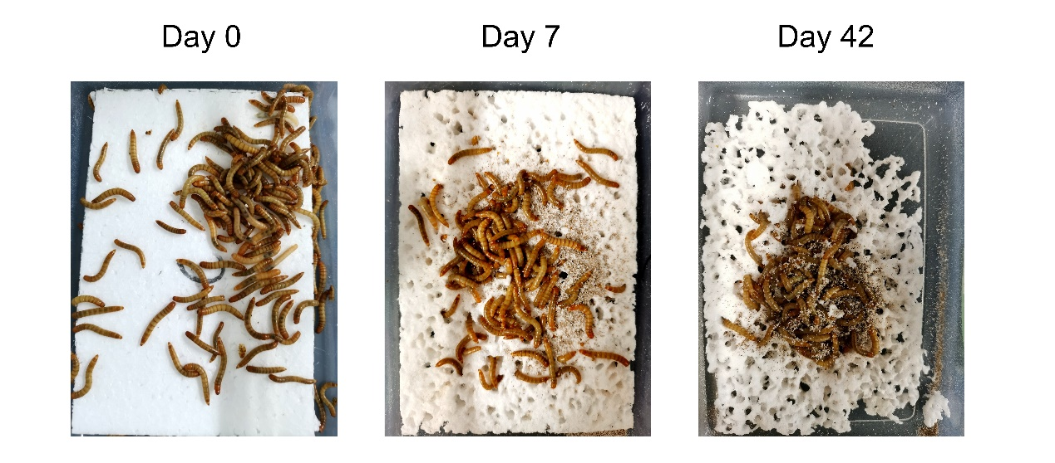
Fig. S3 Ingestion of polystyrene foam plastics by T. molitor larvae through the 42 days of feeding trials.

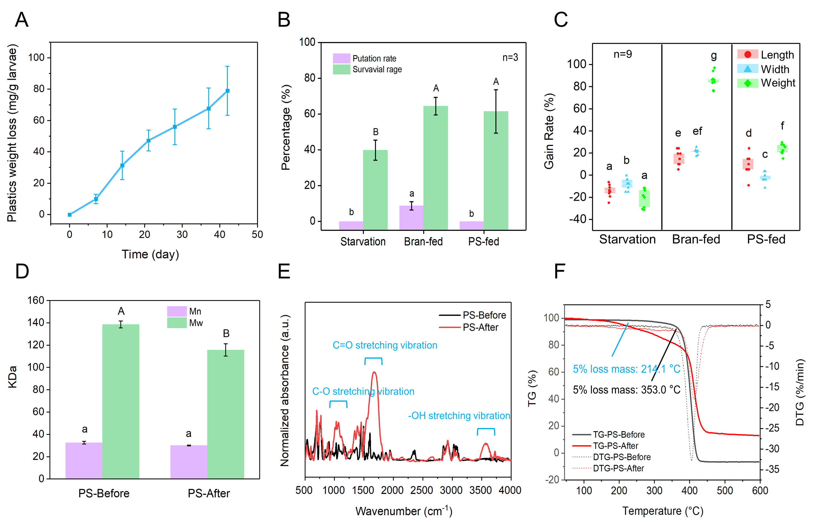
Fig. S4 Ingestion, biodegradation of PS foam plastics by T. molitor larvae. (A) Consumption of PS foam plastics increased throughout the 42 days of feeding trials. Changes of the survival rates, pupation rates (B), and the length/width/weight gain rates (C) of T. molitor larvae in different groups. The molecular weight (Mn, Mw) (D), FTIR spectra (E) and TGA curve (F) of residual PS foam plastics after ingestion by T. molitor larvae (PS-After) compared to raw PS (PS-Before). Distinct letters assigned to different groups in Fig. S4 indicated significant differences (ANOVA, p < 0.05). Starvation: larvae without food; Bran-fed: larvae fed with wheat bran; PS-fed: larvae fed with PS foams.

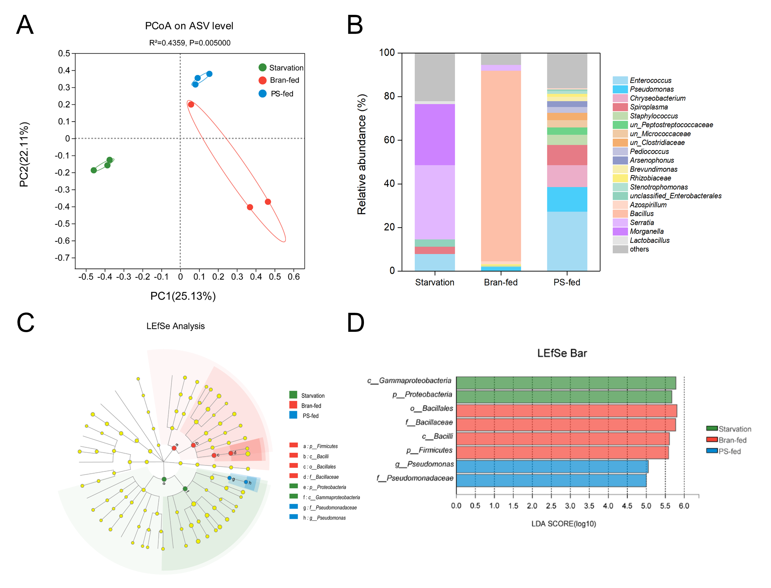
Fig. S5 Responses of T. molitor gut microbiome to different diets. (A) PCoA analysis of gut microbial community based on Bray-Curtis distances at ASV level displayed distinct clustering features in PS-fed groups. (B) Relative abundance of larval gut microbes at the genus level. (C) Taxonomic cladogram by LEfSe analysis of gut microbial community at the genus level. (D) LDA score of LEfSe analysis of gut microbial community based on all-against-all strategy showed that the distinct genus in gut microbiome of PS-fed groups was Pseudomonas compared to bran-fed and starvation groups. Starvation: larvae without food; Bran-fed: larvae fed with wheat bran; PS-fed: larvae fed with PS foams.

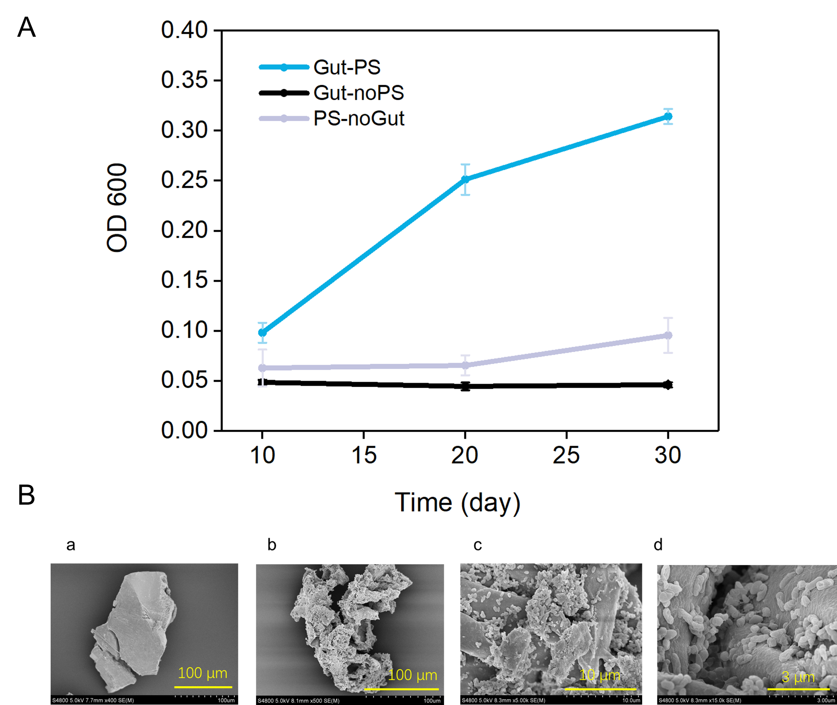
Fig. S6 Cultivation and enrichment of PS-degrading microbes. (A) OD 600 optical density curve of culture-enriched PS-degrading strain. Gut-PS: gut cells incubated with PS; Gut-noPS: gut cells incubated without PS; PS-noGut: sole PS in media without any gut cells. (B) SEM images of PS microplastics before (a) and after (b, c, d) incubation with PS-degrading microbes.
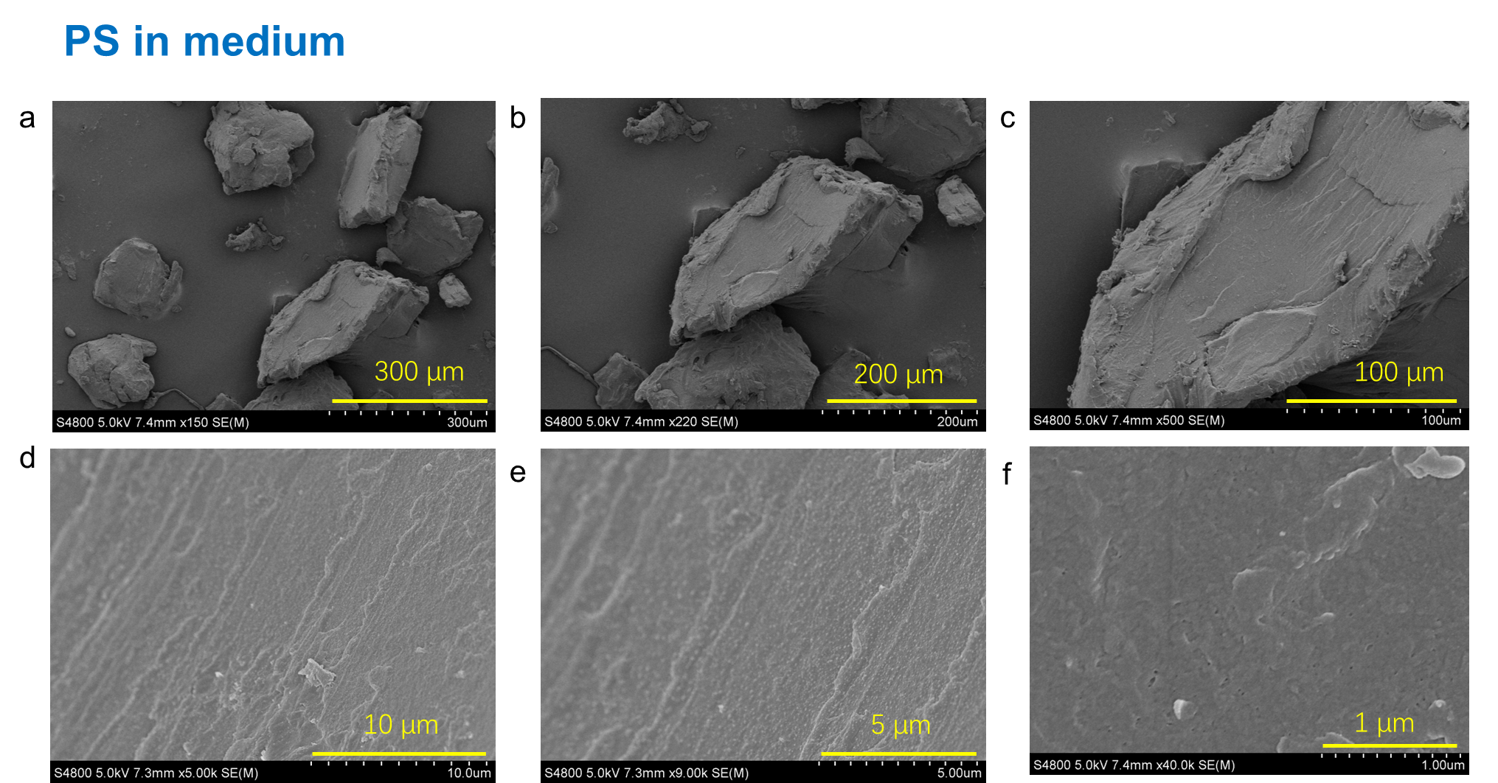
Fig. S7 SEM images of the sole PS microplastics in medium at day 30.

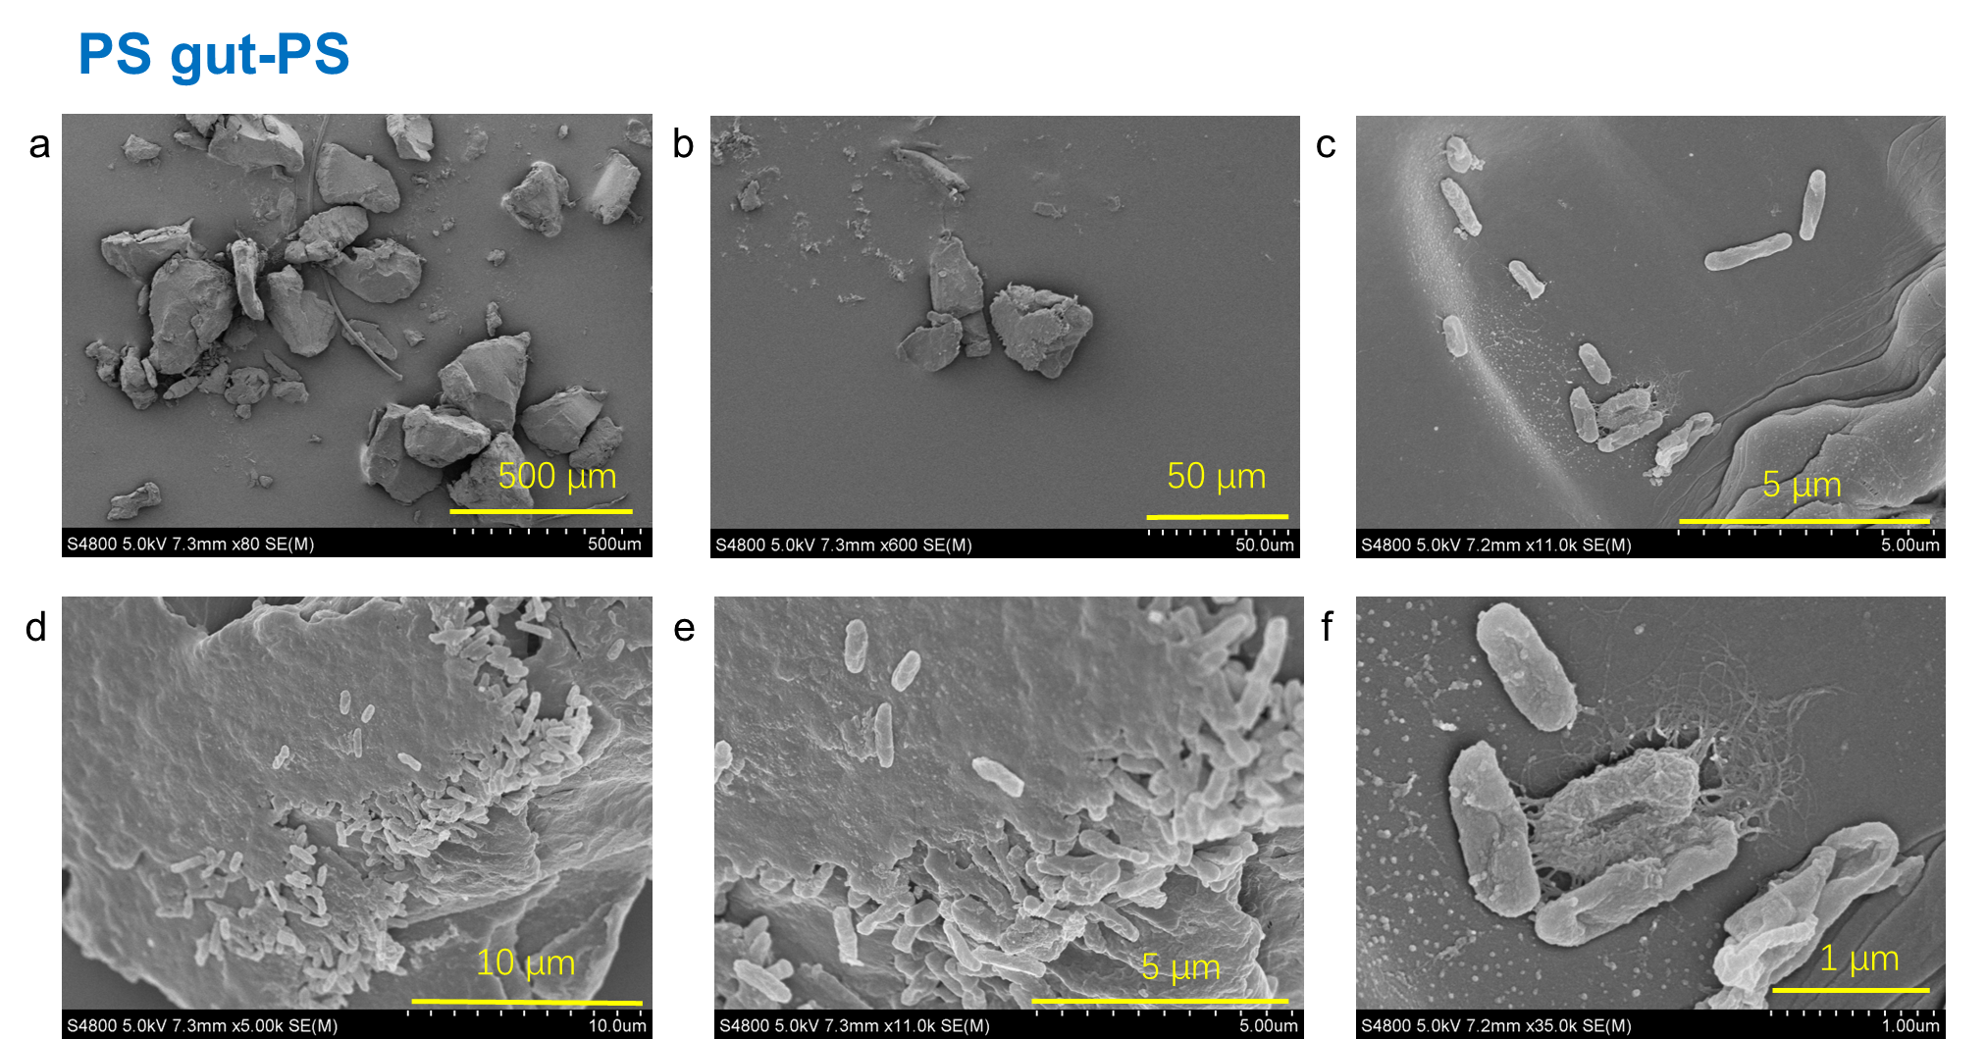
Fig. S8 SEM images of biofilm formed by PS-fed gut cells after incubation at the presence of PS microplastics for 30 days.
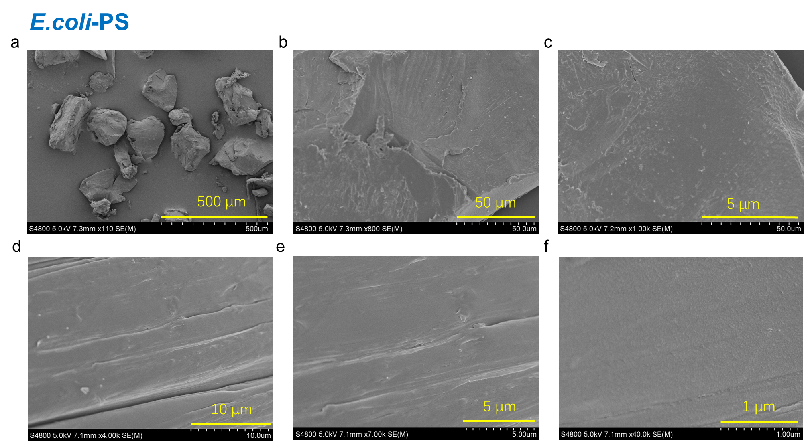
Fig. S9 SEM images of the PS microplastics after incubation with E. coli DH5α at day 30.
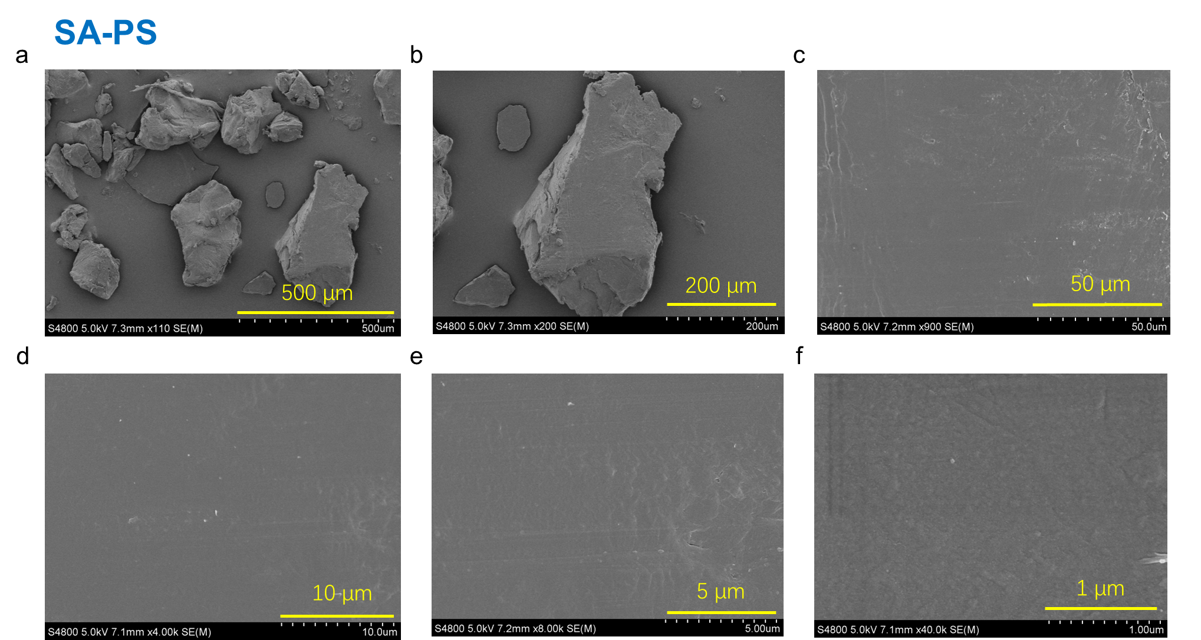
Fig. S10 SEM images of the PS microplastics after incubation with S. aureus RN4220 at day 30.
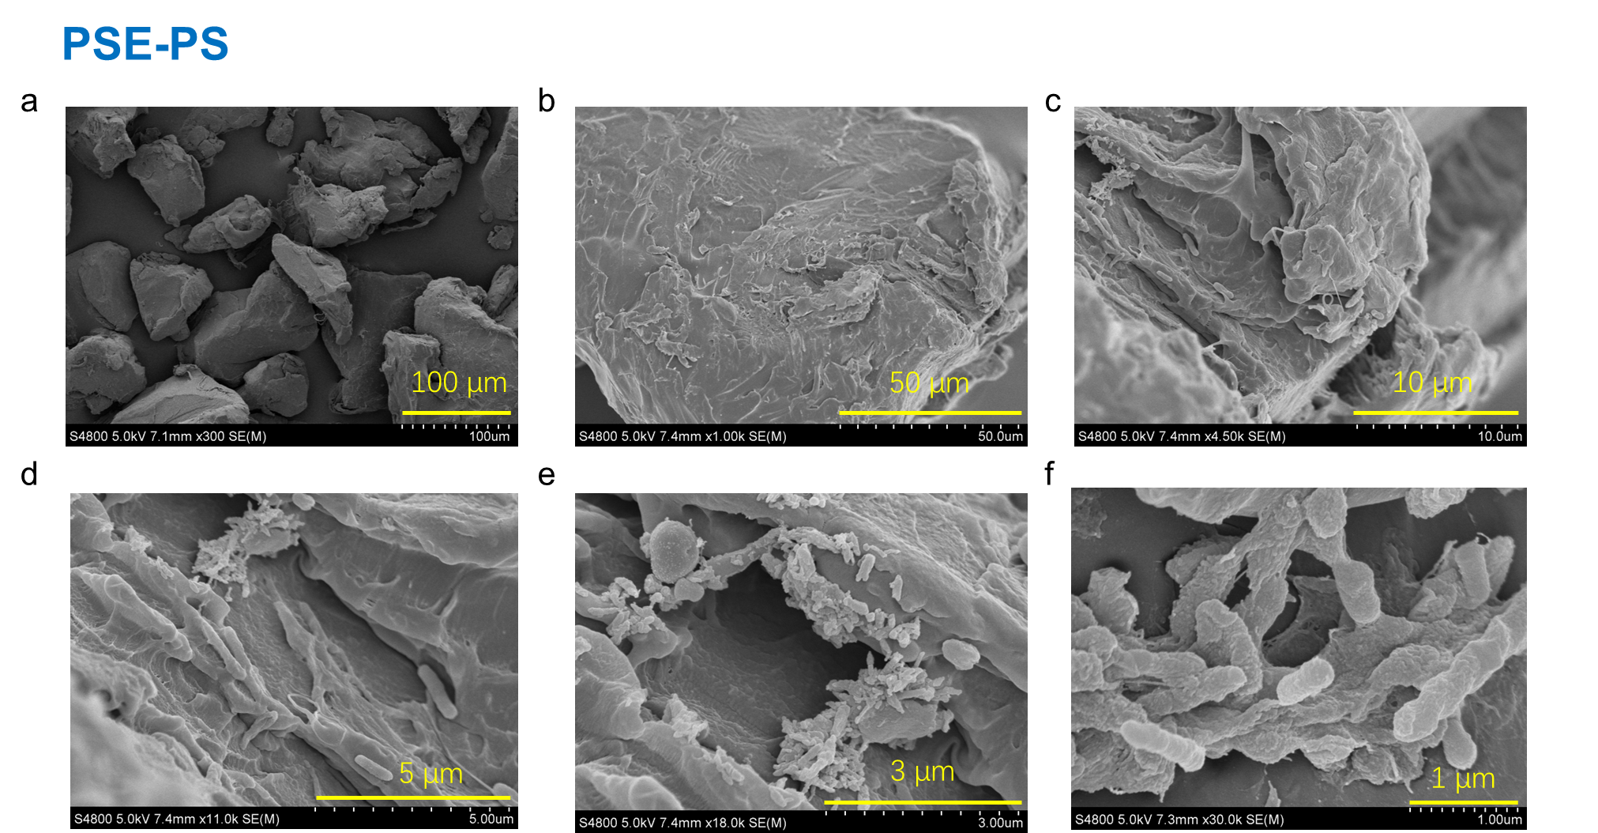
Fig. S11 SEM images of the biofilm formed by the isolated strain P. aeruginosa-IUE after the incubation at the presence of PS microplastics at day 30.

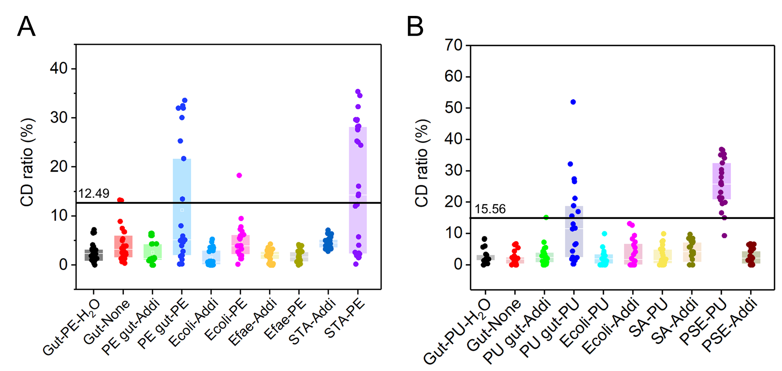
Fig. S12 Raman-D₂O detecting of active PE and PU microplastics-degrading microorganisms. Highly D-labelled cells’ response differences to the PE plastic, the potential PE additives (A) and to the PU plastic, the potential PU additives (B). Gut-PE-H₂O: gut cells of PE-fed T. molitor larvae incubated with PE and H₂O; Gut-PU-H₂O: gut cells of PU-fed T. molitor larvae incubated with PU and H₂O; Gut-None: gut cells incubated in D₂O without plastics and the potential additives; PE gut-PE (Addi), E. coli-PE (Addi), Efae-PE (Addi), STA-PE (Addi): gut cells of PE-fed T. molitor larvae, Escherichia coli DH5α, Enterococcus faecalis and Staphylococcus sp.-IUE incubated with PE or the potential PE additives. PU gut-PU (Addi), E. coli-PU (Addi), SA-PU (Addi), PSE-PU (Addi): gut cells of PU-fed T. molitor larvae, E. coli DH5α, Staphylococcus aureus RN4220, and Pseudomonas aeruginosa-IUE2 incubated with PU or the potential PU additives.

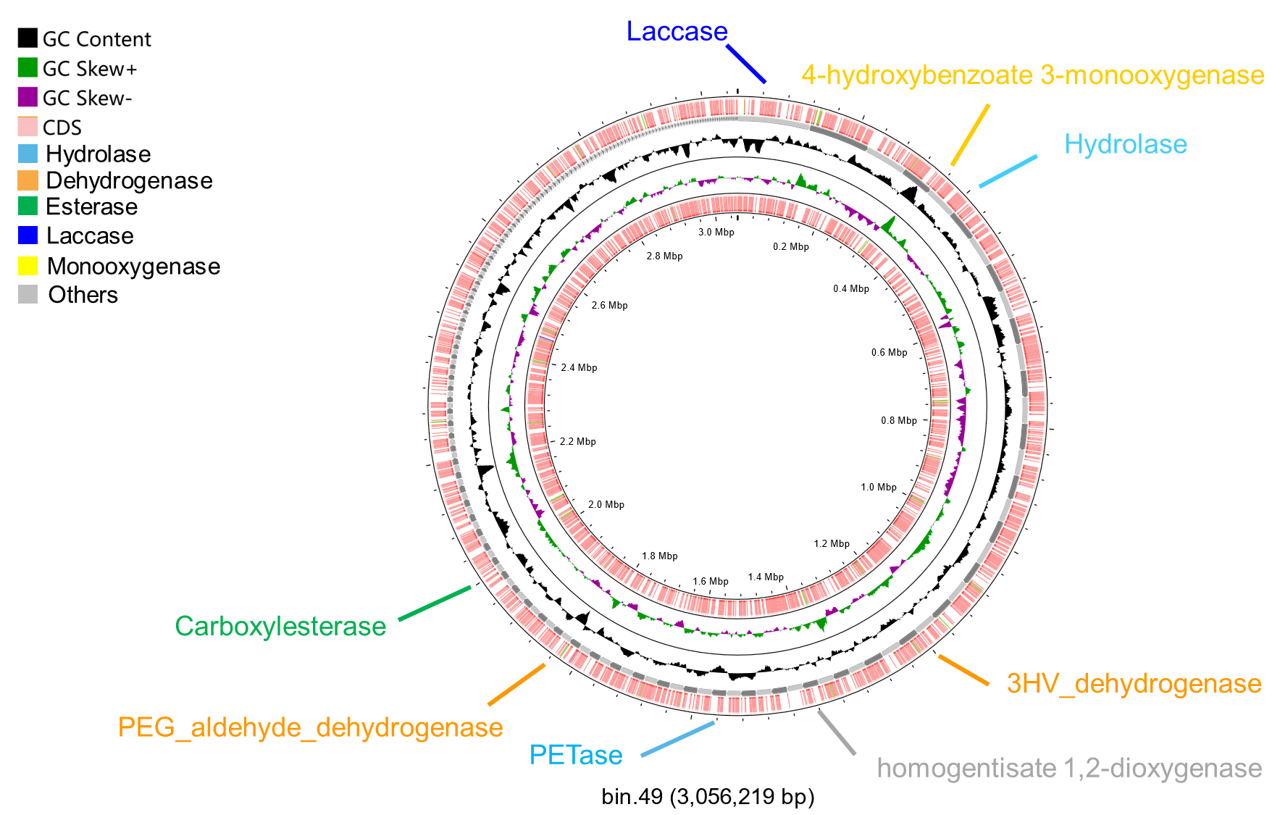
Fig. S13 Single circular genome map of bin 49 from Raman sorted active PS-degrading bacteria.
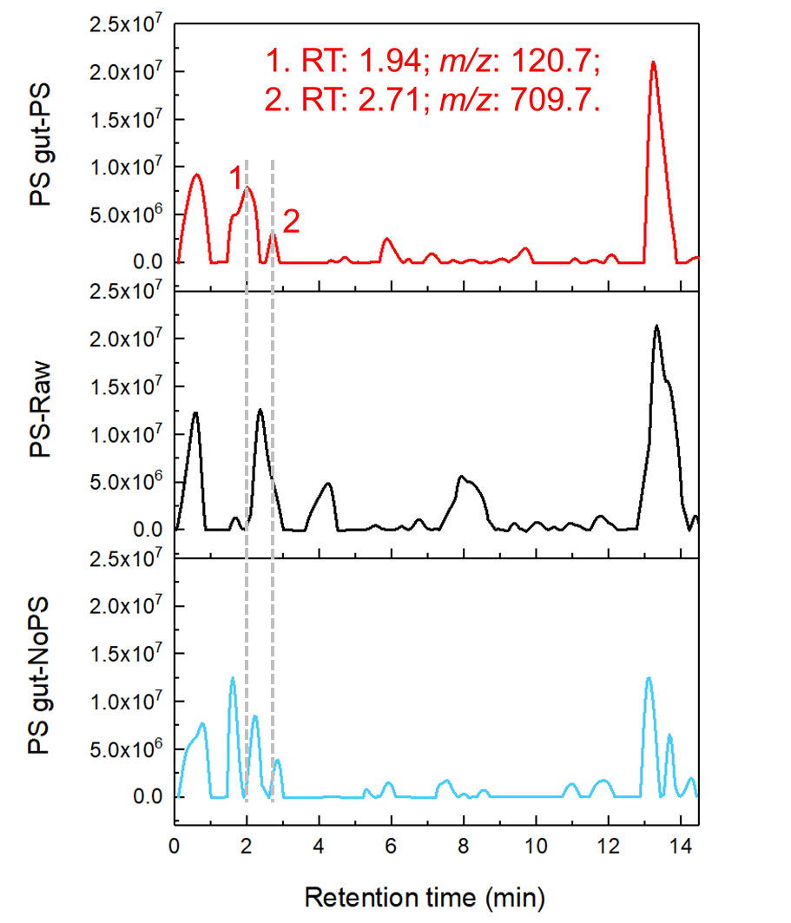
Fig. S14 HPLC-MS analysis of biodegradation products in different groups. PS gut-PS: gut cells of larvae fed with PS incubated with PS in MSM media for 30 days; PS-Raw: sole PS incubated in MSM media without any gut cells for 30 days; PS gut-NoPS: gut cells of larvae fed with PS incubated without PS in MSM media for 30 days.

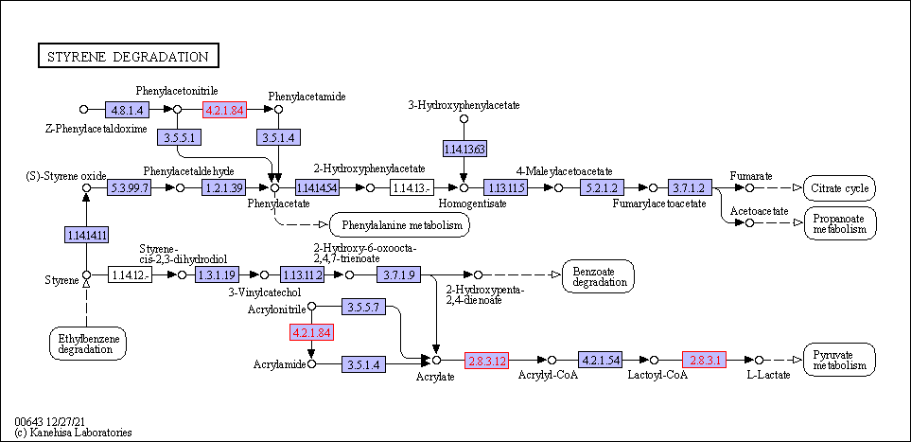
Fig. S15 Detected KEGG pathways in the genome of the sorted active PS degraders: styrene degradation. The detected enzymes were marked in red.

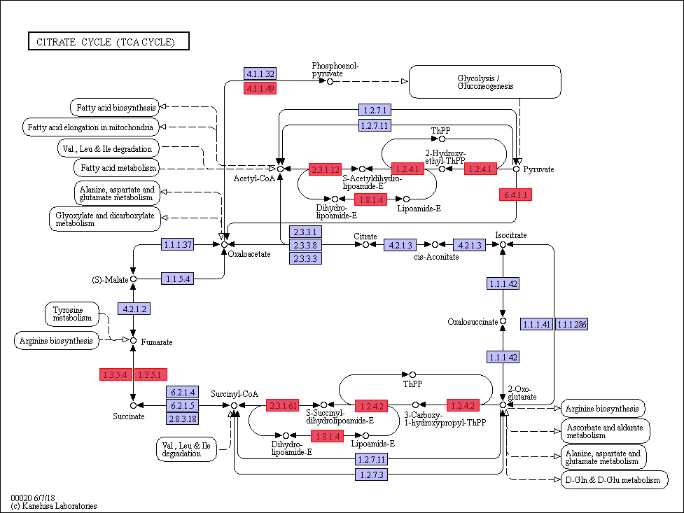
Fig. S16 Detected KEGG pathways in the genome of the sorted active PS degraders: TCA cycle. The detected enzymes were marked in red.

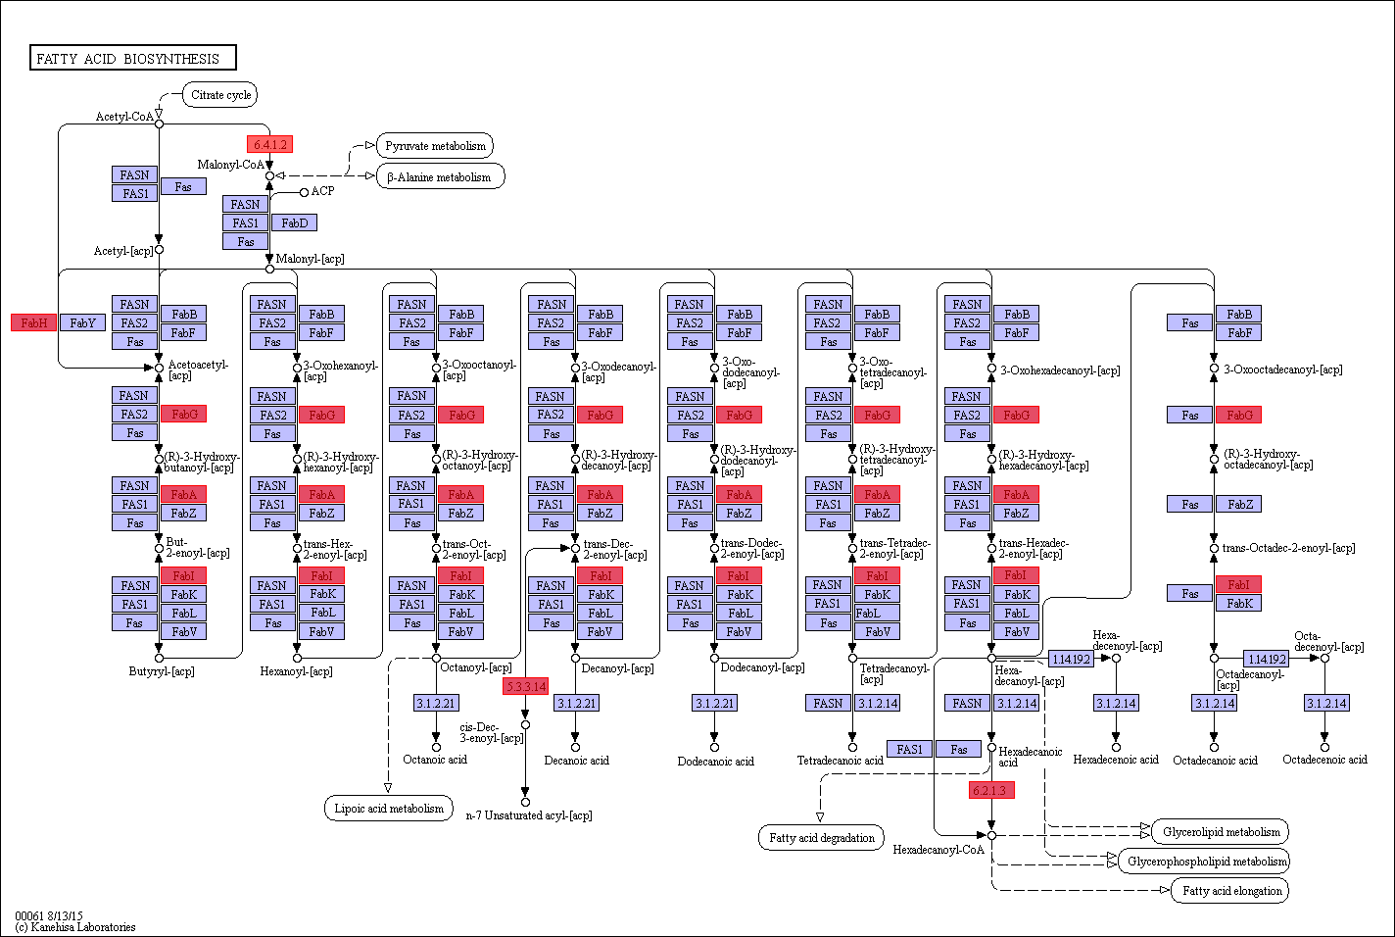
Fig. S17 Detected KEGG pathways in the genome of the sorted active PS degraders: fatty acid biosynthesis. The detected enzymes were marked in red.

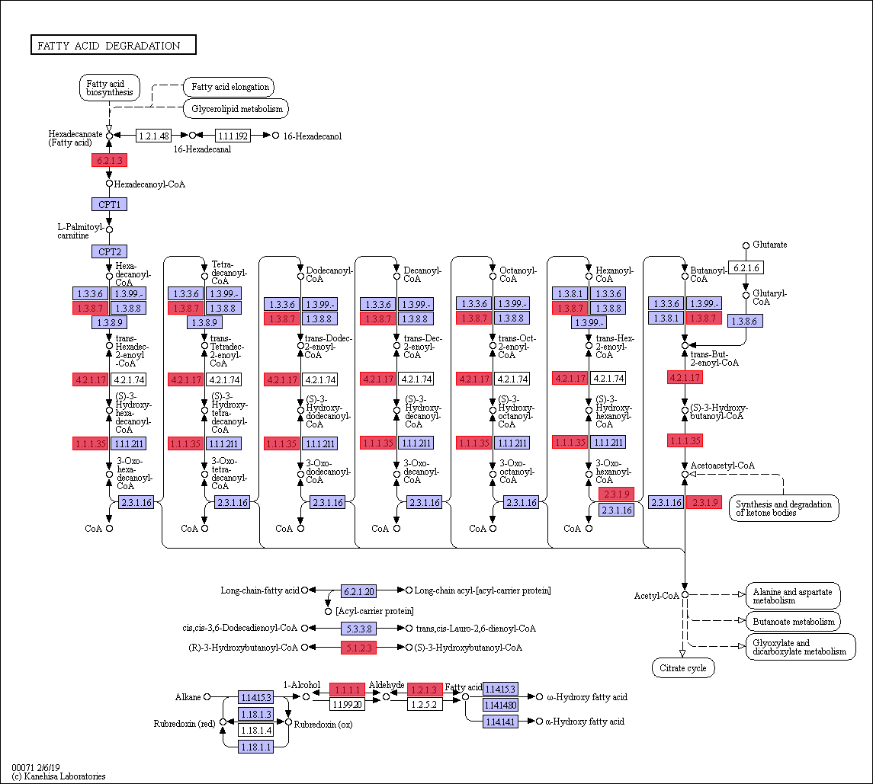
Fig. S18 Detected KEGG pathways in the genome of the sorted active PS degraders: fatty acid degradation. The detected enzymes were marked in red.
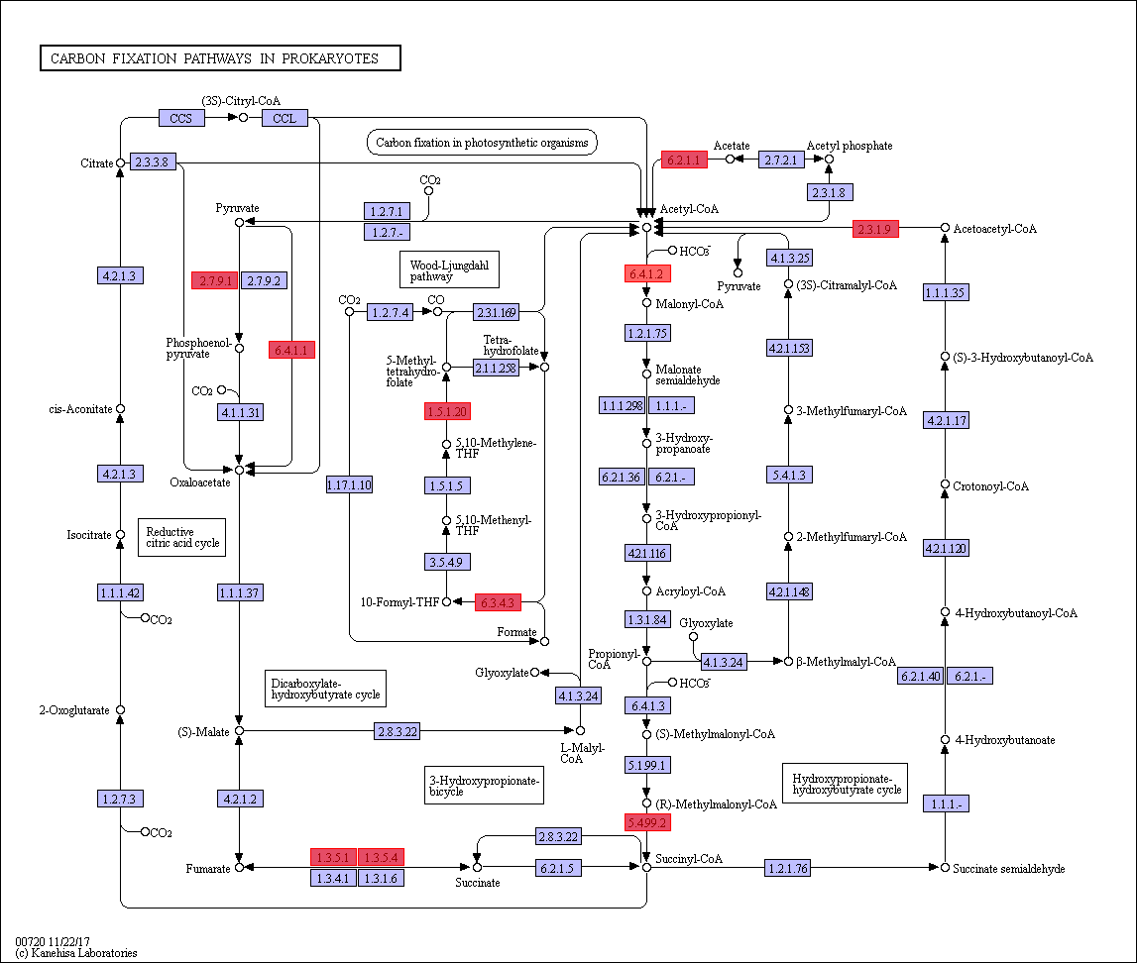
Fig. S19 Detected KEGG pathways in the genome of the sorted active PS degraders: carbon fixation pathways in prokaryotes. The detected enzymes were marked in red.

References:
1 Yang, Y. et al. Biodegradation and Mineralization of Polystyrene by Plastic-Eating Mealworms: Part 1. Chemical and Physical Characterization and Isotopic Tests. Environ. Sci. Technol. 49, 12080-12086, (2015).
2 Jeske, H., Schirp, A. & Cornelius, F. Development of a thermogravimetric analysis (TGA) method for quantitative analysis of wood flour and polypropylene in wood plastic composites (WPC). Thermochim. Acta 543, 165-171, (2012).
3 Gornicka, B. & Gorecki, L. TGA/DTG/DSC investigation of thermal ageing effects on polyamide–imide enamel. J. Therm. Anal. Calorim. 101, 647-650, (2010).
4 Gałka, P., Kowalonek, J. & Kaczmarek, H. Thermogravimetric analysis of thermal stability of poly(methyl methacrylate) films modified with photoinitiators. J. Therm. Anal. Calorim. 115, 1387-1394, (2013).
5 Yang, Y. et al. Biodegradation and Mineralization of Polystyrene by Plastic-Eating Mealworms: Part 2. Role of Gut Microorganisms. Environ. Sci. Technol. 49, 12087-12093, (2015).
6 Jin, M.-K. et al. Lipid Metabolites as Potential Regulators of the Antibiotic Resistome in Tetramorium caespitum. Environ. Sci. Technol. 58, 4476–4486, (2024).
7 Jin, M. K. et al. Exposure to cypermethrin pesticide disturbs the microbiome and disseminates antibiotic resistance genes in soil and the gut of Enchytraeus crypticus. J. Hazard. Mater. 449, 131026, (2023).
8 Yang, K. et al. Temporal Dynamics of Antibiotic Resistome in the Plastisphere during Microbial Colonization. Environ. Sci. Technol. 54, 11322-11332, (2020).
9 Wang, Y. et al. Different plastics ingestion preferences and efficiencies of superworm (Zophobas atratus Fab.) and yellow mealworm (Tenebrio molitor Linn.) associated with distinct gut microbiome changes. Sci. Total Environ. 837, 155719, (2022).
10 Yang, S. S. et al. Biodegradation of polystyrene wastes in yellow mealworms (larvae of Tenebrio molitor Linnaeus): Factors affecting biodegradation rates and the ability of polystyrene-fed larvae to complete their life cycle. Chemosphere 191, 979-989, (2018).
11 Brandon, A. M. et al. Biodegradation of Polyethylene and Plastic Mixtures in Mealworms (Larvae of Tenebrio molitor) and Effects on the Gut Microbiome. Environ. Sci. Technol. 52, 6526-6533, (2018).
12 Mamtimin, T. et al. Gut microbiome of mealworms (Tenebrio molitor Larvae) show similar responses to polystyrene and corn straw diets. Microbiome 11, 98, (2023).
13 Peng, B. Y. et al. Biodegradation of Polyvinyl Chloride (PVC) in Tenebrio molitor (Coleoptera: Tenebrionidae) larvae. Environ. Int. 145, 106106, (2020).
14 Singh, B. & Sharma, N. Mechanistic implications of plastic degradation. Polym. Degrad. Stab. 93, 561-584, (2008).
15 R Gautam , A. S. B., E K Yanful. A review of biodegradation of synthetic plastic and foams. Appl. Biochem. Biotechnol. (2007).
16 Luo, L. et al. Biodegradation of foam plastics by Zophobas atratus larvae (Coleoptera: Tenebrionidae) associated with changes of gut digestive enzymes activities and microbiome. Chemosphere 282, 131006, (2021).

