Supplementary Materials
This document serves as the supplementary material for the article titled “Symptoms of atrial fibrillation and sleep quality in atrial fibrillation: A network analysis.” It includes comprehensive information on the simple mediation model, as well as the estimation of network accuracy and stability.
A mediation analysis was conducted to investigate the mediating role of sleep disturbances (P5) in the relationship between atrial fibrillation (AF) symptoms and sleep quality. Detailed descriptions of the mediation model and the corresponding effect size analysis are provided in Figure S1 and Table S1.To assess the accuracy of the network edges, we calculated the 95% confidence interval (CI) for the bootstrapped edge weights, as illustrated in Figure S2. Subsequently, we evaluated the stability of node centrality through subset bootstrapping and determined the centrality stability coefficient (CS coefficient) as a benchmark for network stability, as depicted in Figure S3. The CS coefficient was found to be 0.596, exceeding the threshold of 0.5, which suggests that the ASTA-PSQI network exhibits robust stability. The results of the node difference and edge difference tests are presented in Figures S4 and S5, respectively.

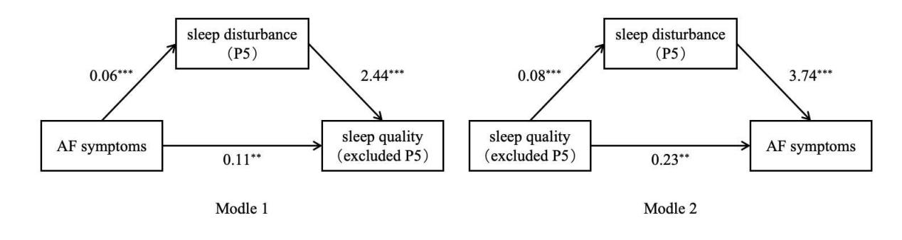
Figure S1. Simple mediation model diagram.

Table S1
Simple Mediation Effect Analysis
 |  | Effect size | se | LLCI | ULCI
Model 1 | Total Effect | 0.25 | 0.04 | 0.18 | 0.32
Model 1 | Direct Effect | 0.11 | 0.04 | 0.03 | 0.19
Model 1 | Mediated Effect | 0.14 | 0.02 | 0.09 | 0.19
Model 2 | Total Effect | 0.54 | 0.08 | 0.38 | 0.69
Model 2 | Direct Effect | 0.23 | 0.08 | 0.07 | 0.40
Model 2 | Mediated Effect | 0.31 | 0.05 | 0.21 | 0.41

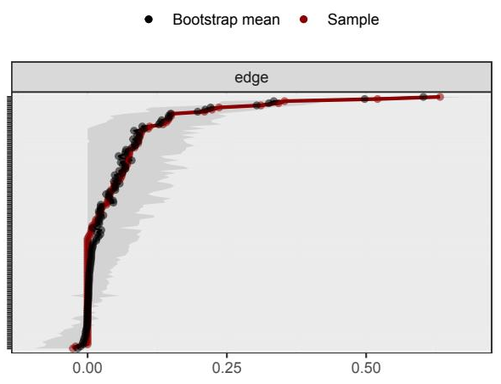
Figure S2. Bootstrapped confidence intervals (CIs) of estimated edge
weights for estimated network.

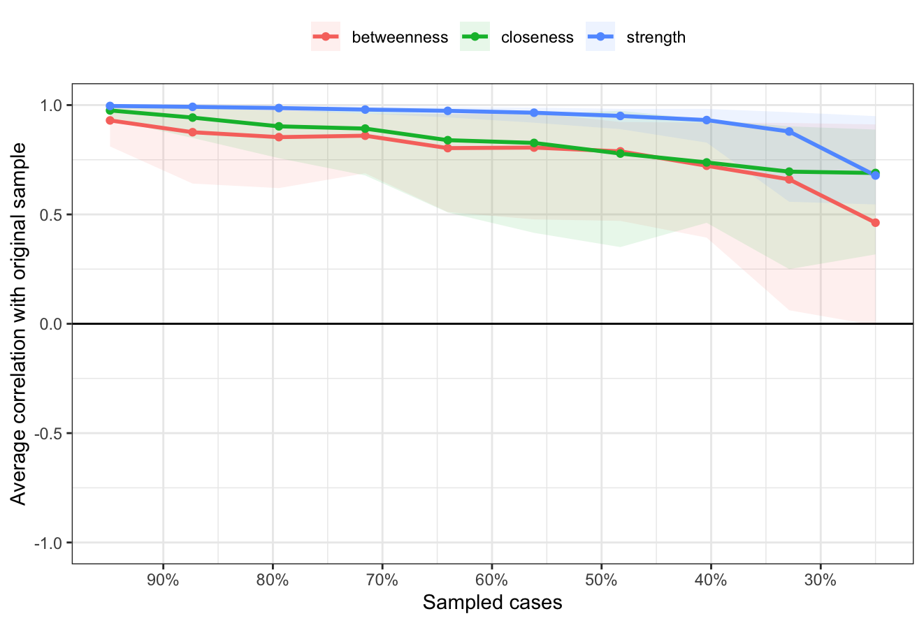
Figure S3. Bootstrapped stability for the graphical least absolute shrinkage and selection operator networks.

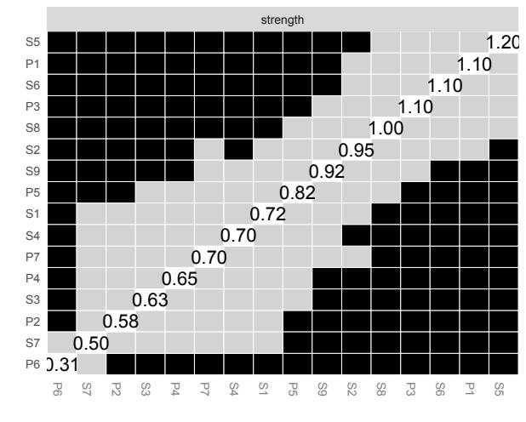
Figure S4. Node difference test results.

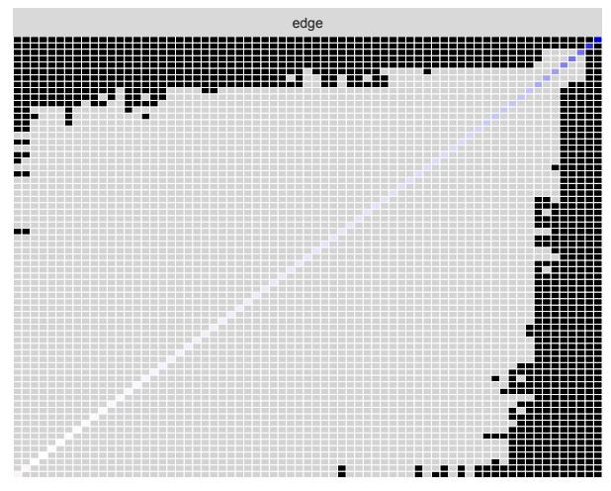
Figure S5: Edge difference test results.

