Supplementary materials

Sheet music for classical and original compositions study 1.

Nocturne op. 9 no 2. In E flat major by Frédéric Chopin.
Audiofile downloaded from Youtube 17th of February 2020 at 08:48.
https://www.youtube.com/watch?v=YGRO05WcNDk
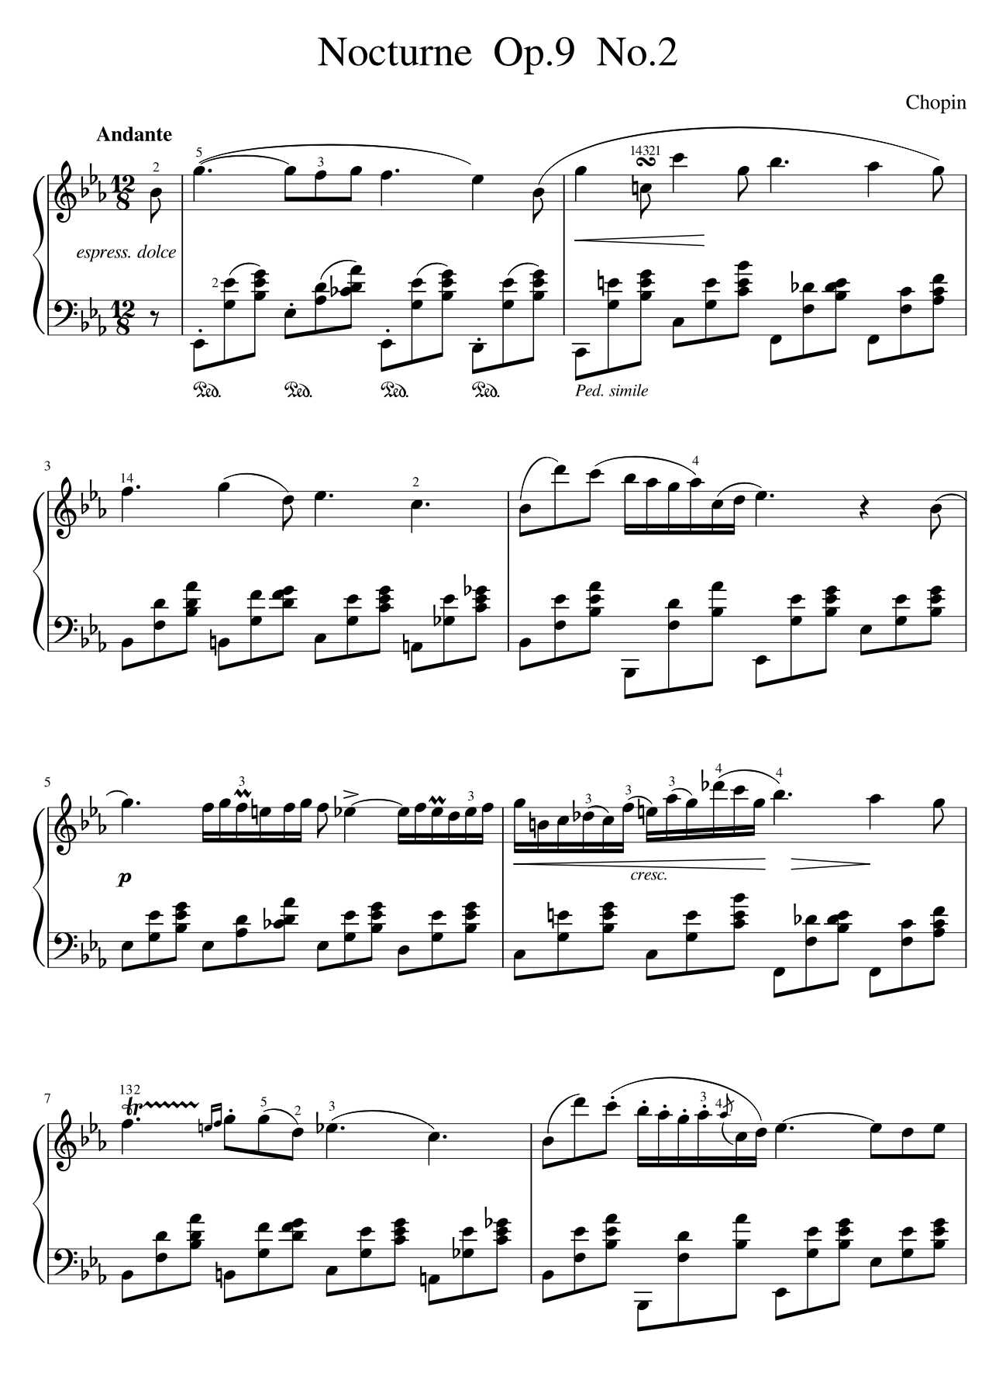

Original sublime composition, study 1.

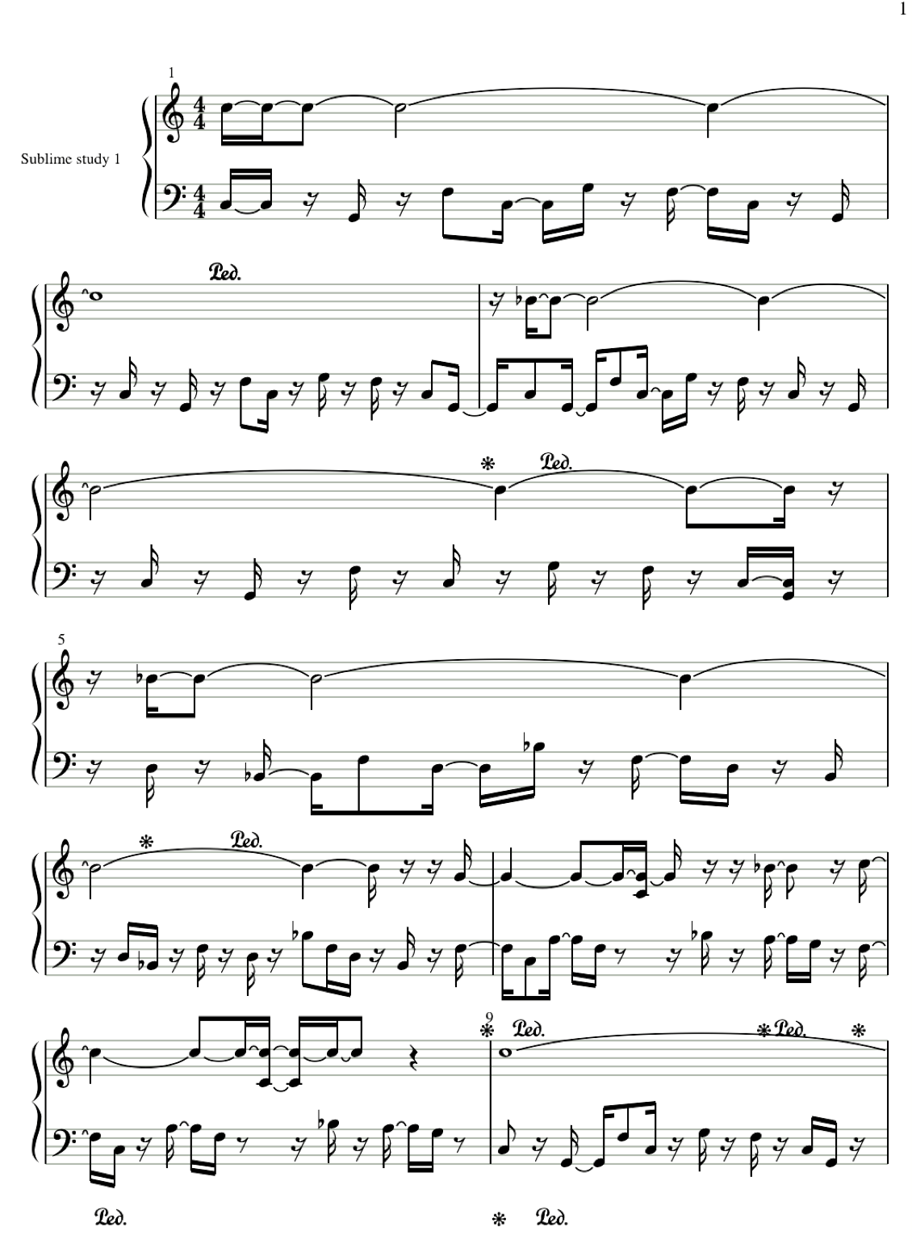

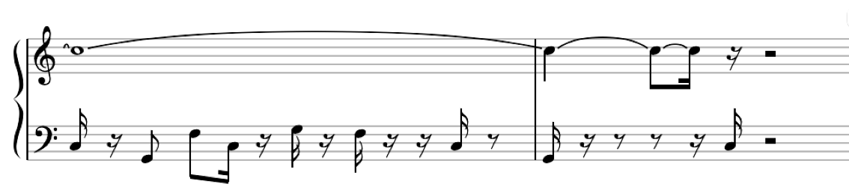

The Miraculous Mandarin, in A minor by Béla Bartók.

Audio file downloaded from YouTube 17th of February 2020 at 11:32.
https://www.youtube.com/watch?v=QJXe2gYcNlM&t=556s
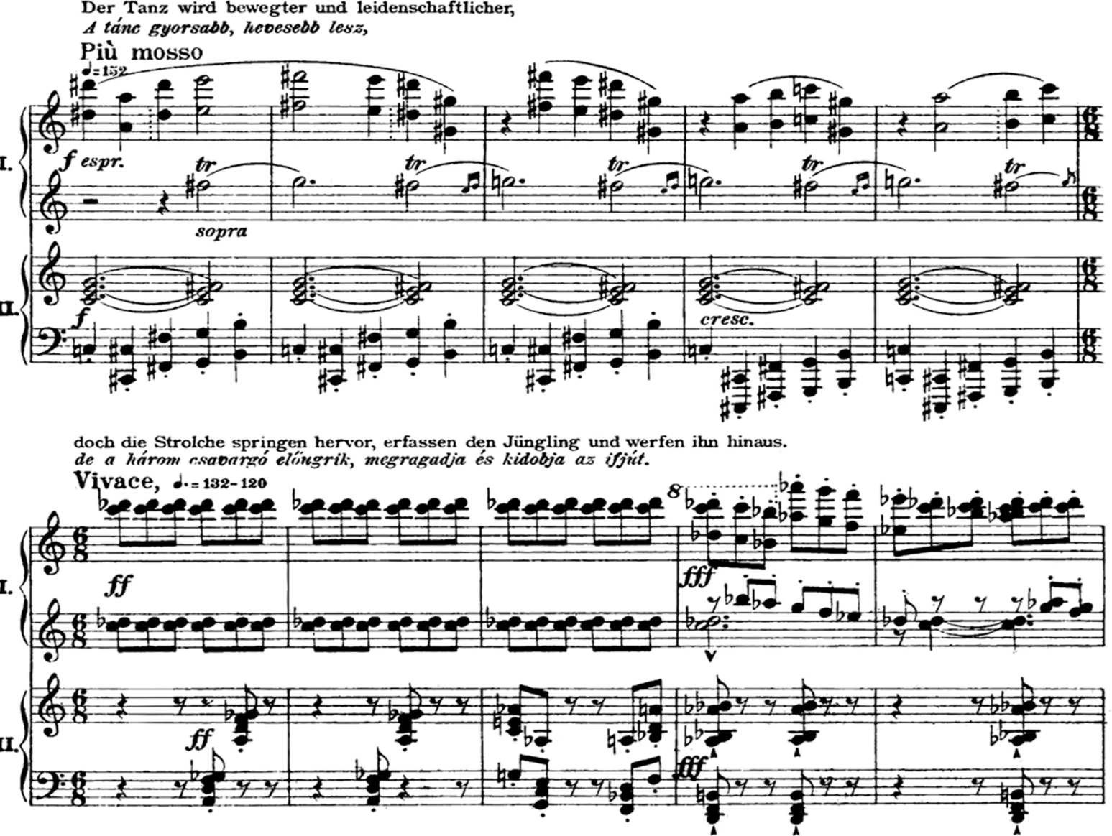
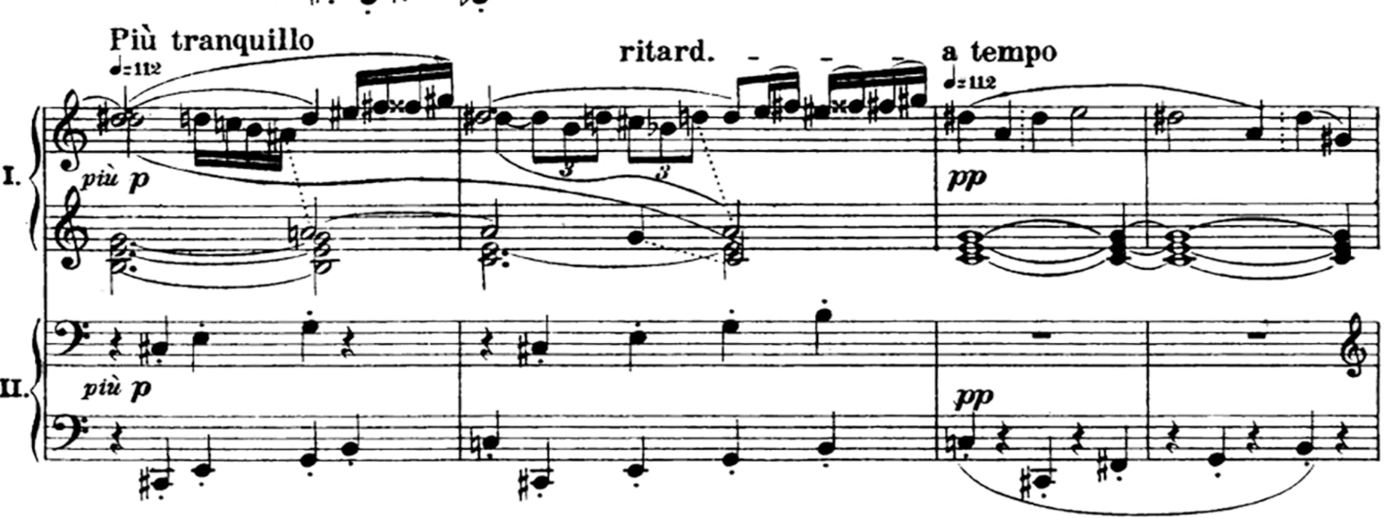

Original uneasy composition, study 1.
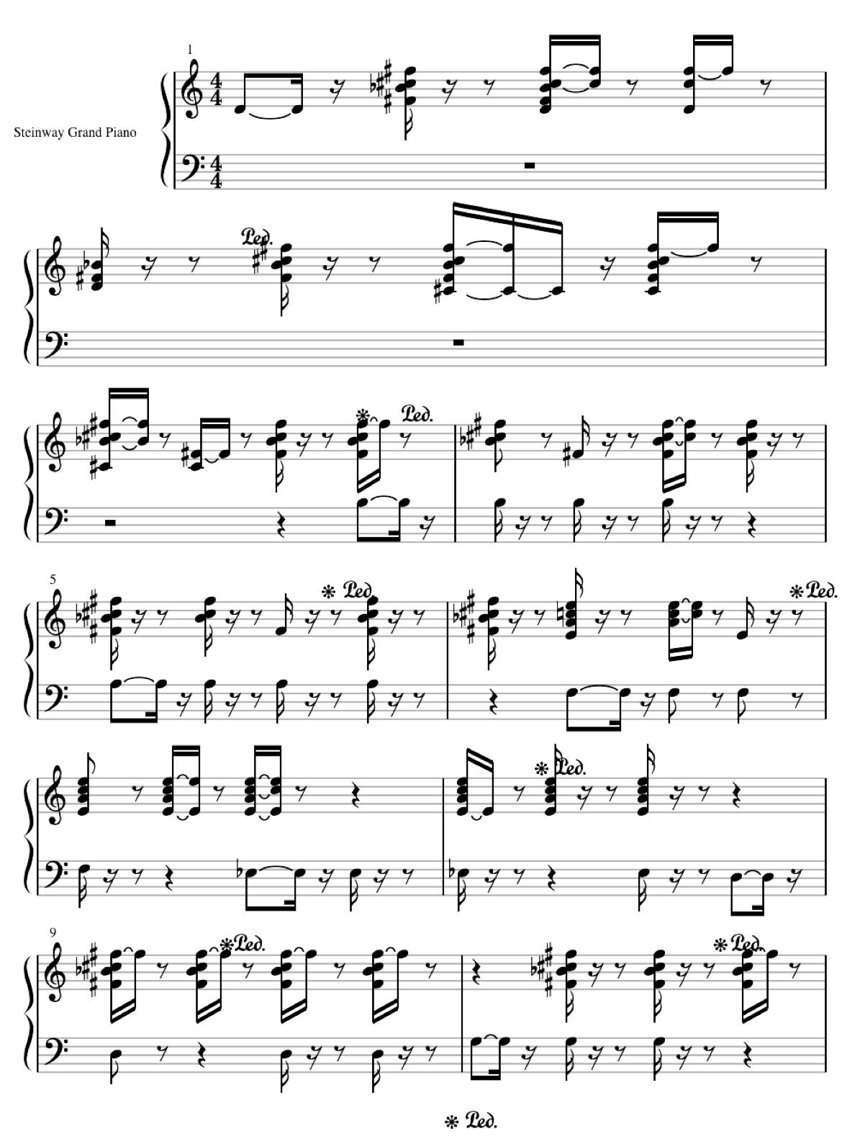
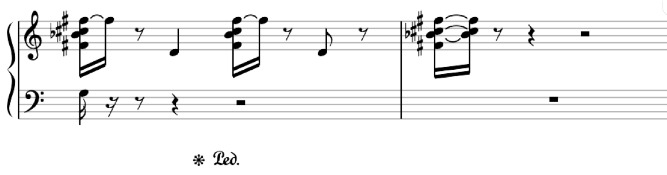

Valse Op 64. No 1. Waltz in D flat Major by Frédéric Chopin.
Audiofile downloaded from Youtube on 17th of February 2020 at 08:50.
https://www.youtube.com/watch?v=X-_SORD0YXM
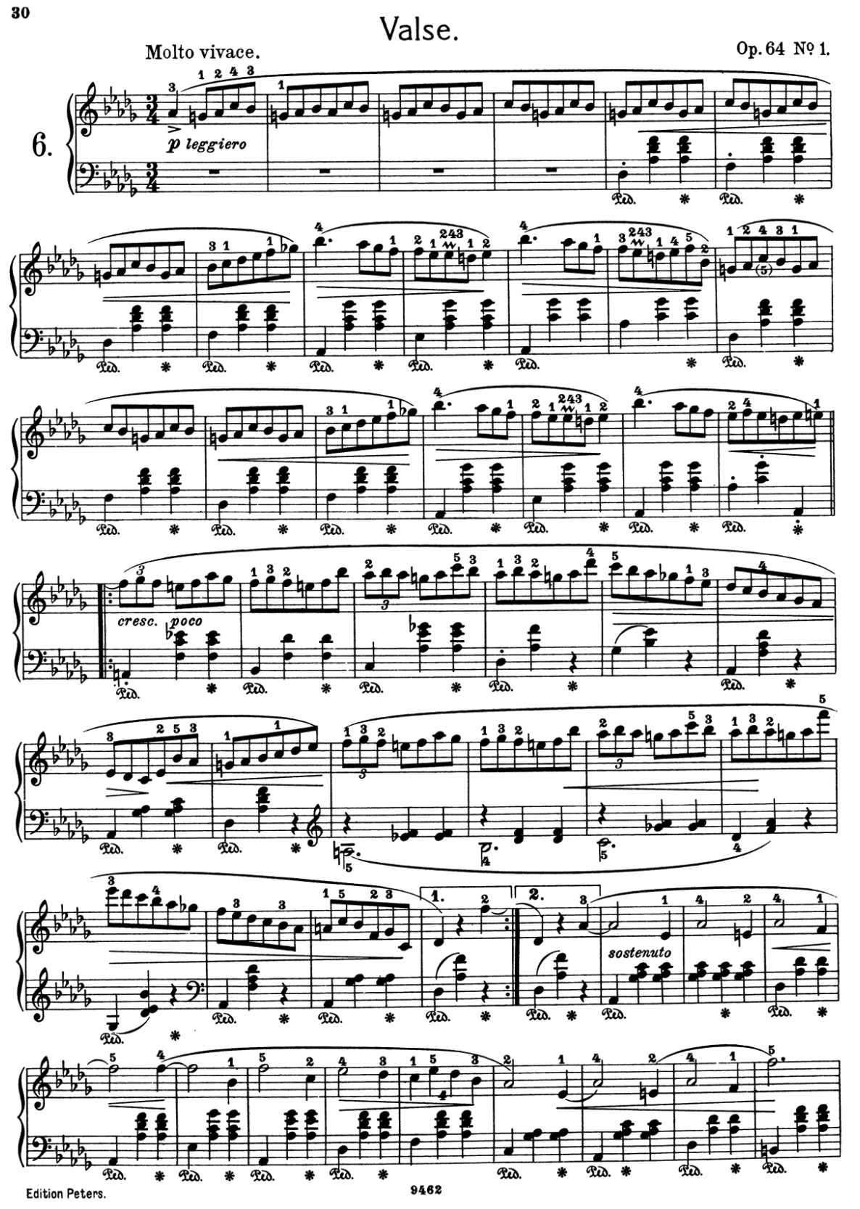
Original vital composition, study 1.

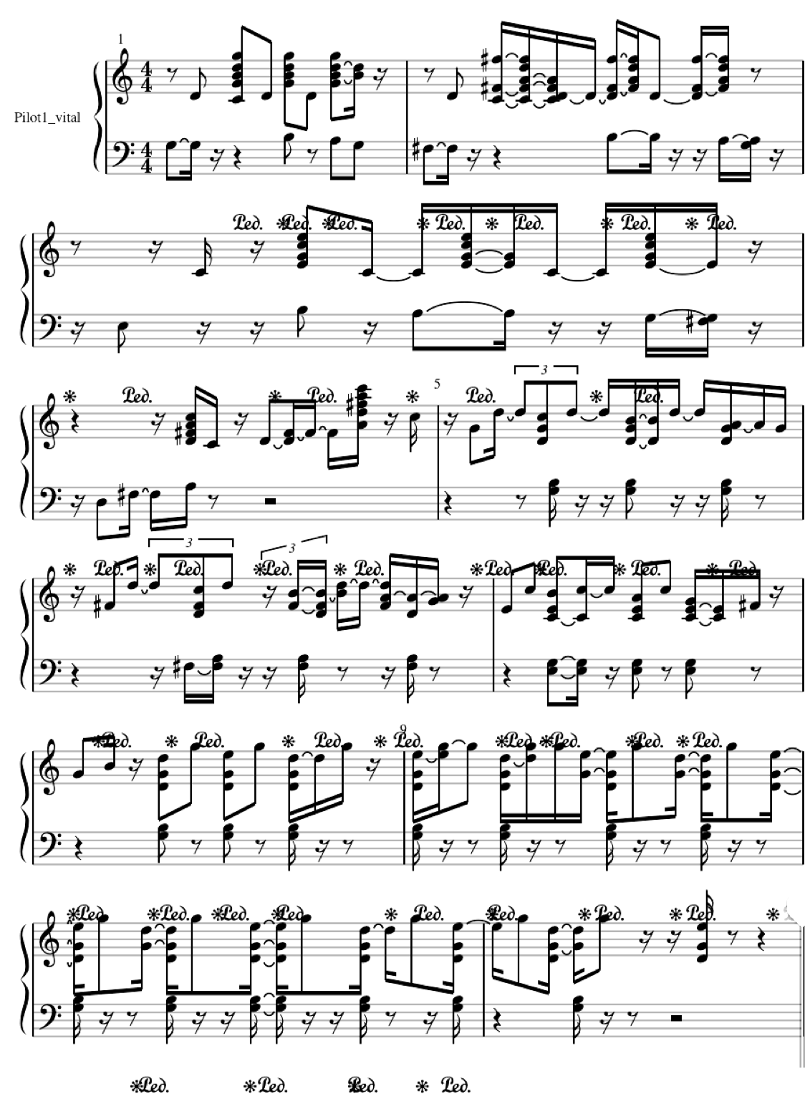

Instructions for participants – in Norwegian and English

Norwegian:
Vi vil vite hvilke følelser ulike typer musikk utløser i deg, ved at du skal lytte til noen lydeksempler og så besvare noen enkle spørsmål i denne spørreundersøkelsen.
Vi ber om at du leser og besvarer alle spørsmålene nøye. Det er best å fullføre hele spørreskjema i én økt (istedenfor å ta pauser og fortsette senere). Det er ingen riktige eller gale svar, vi vil vite din personlige mening.
English translation – not distributed

We would like to know which emotions different types of music trigger in you. You will be listening to some music examples and answer a few simple questions in this survey.

We ask that you read the questions carefully. It is best to do the whole survey in one go, rather than taking breaks and continuing later. There are no right or wrong answers, we just want to know your opinion.

Sheet music for original compositions study 2.

Original sublime composition, study 2.

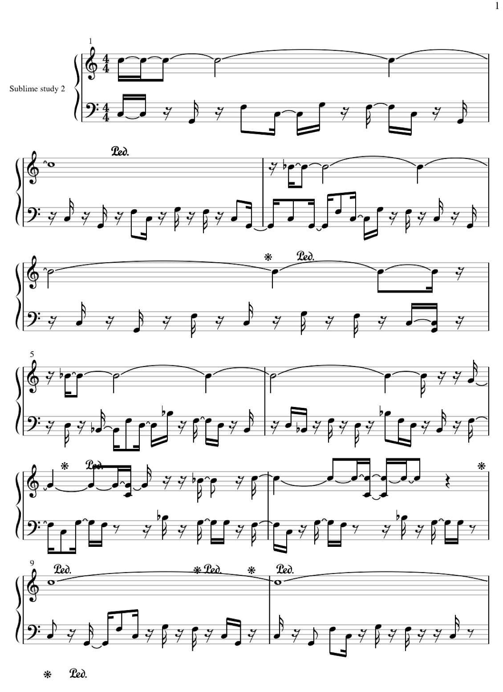

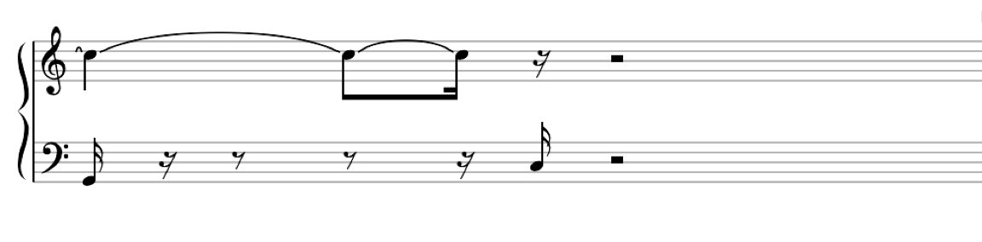

Original uneasy composition, study 2.
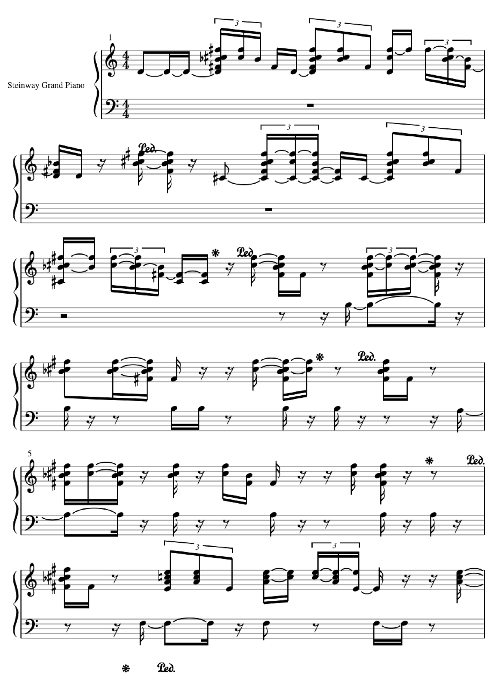
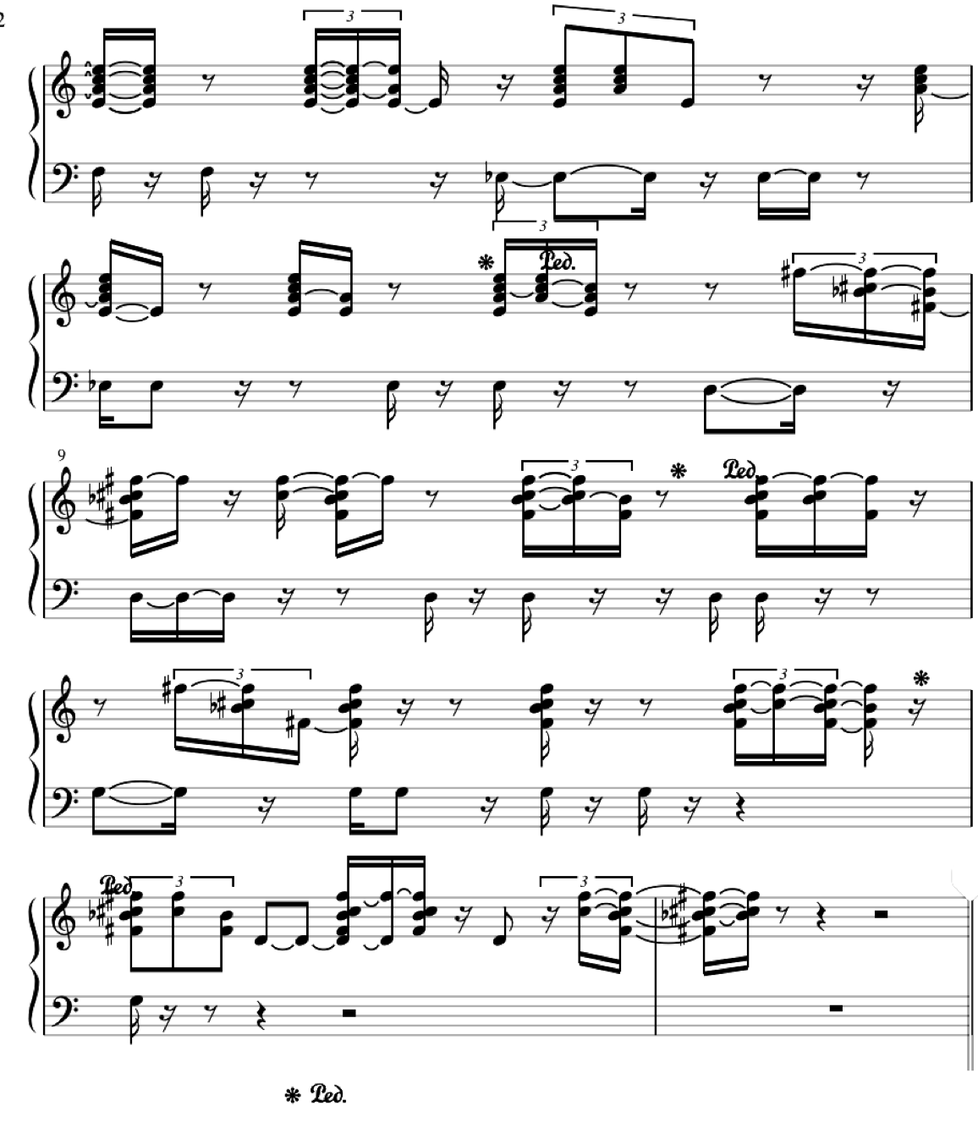

Original vital composition, study 2.

