Coal waste: A Potential Source for the Alumina Enrichment
Seyed Ali Akbar Sajadiª∗, Zeynab Khorablouª, Abbas Jafari^{b}
ª Sharif University of Technology, Sharif Energy, Water and Environment Institute (SEWEI)
P.O.Box 11155-8639 Tehran, Iran
^{b}Impasco, Tehran, Iran

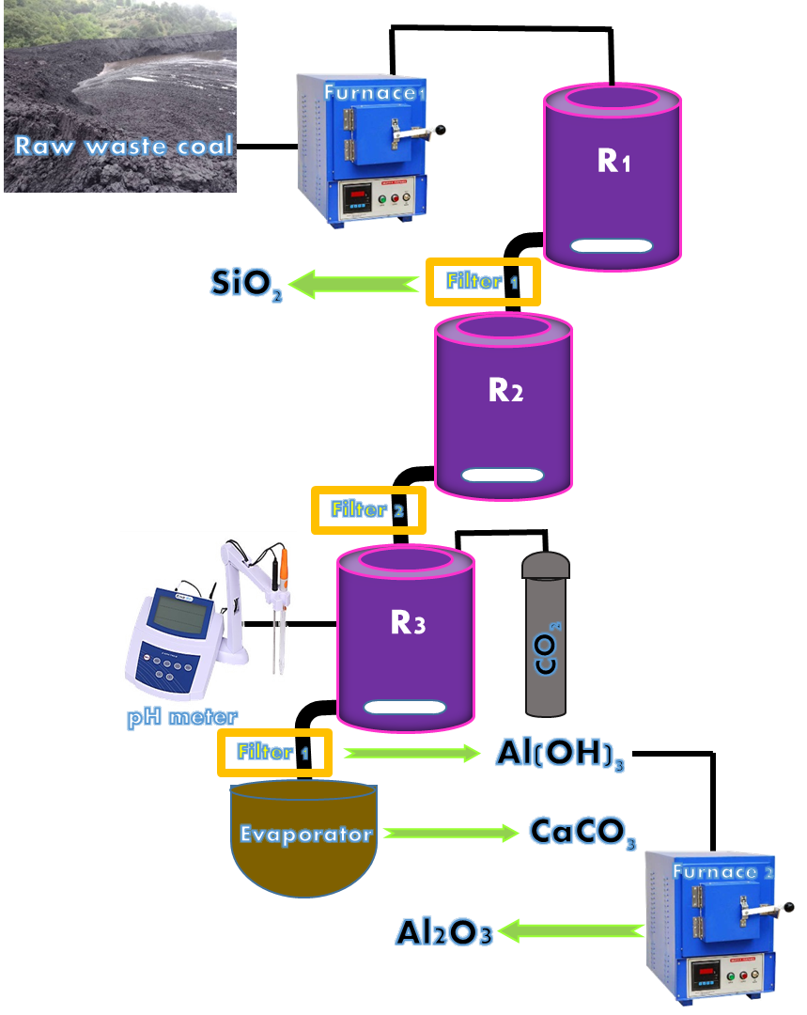
Scheme 1. Flow diagram of the new "selected method" for alumina extraction from coal waste.

* Corresponding author. Tel-Fax: +9821-66005118 E-mail address: sajadi@sharif.ac.ir

