Supplementary information for

Extraordinary Radiation Resistance in Metals via
Adaptive Martensitic Transformation

S. Zhang, Y. B. Dong, Y. T. Sun, Y. Liu, L. T. Sun, H. W. Zhao, N. Gao, Z. B. Wang
Corresponding authors: N. Gao, ning.gao@sdu.edu.cn;
Z. B. Wang, zbwang@imr.ac.cn.

The PDF file includes:

Supplementary Note 1: MD simulations of AMT mechanism
Supplementary Figs. 1-14
Supplementary Tables 1-3
Captions for Supplementary Videos 1-4

Other Supplementary Materials for this manuscript include the following:

Supplementary Video 1 to Video 5

Supplementary Note 1: MD simulations of AMT mechanism
An atomistic model of 304NG stainless steel with GNS (Supplementary Fig. 10) was set up to address the AMT mechanism for extraordinary radiation resistance. By choosing this atomic model, we used a semiempirical potential model developed with the EAM¹ for a Fe-Cr-Ni system and carried out MD simulations, as shown in Extended Data Fig. 9a. After position and volume relaxations, numerous SFs and DNs are introduced in the material. It is noted that SFs and Σ3 GBs are further characterized according to PTM method. The simulated configuration results (Extended Data Fig. 9b) are consistent with the experimental ones (Fig. 1) in this work. Then, the displacement cascade simulations were introduced into the model to simulate irradiation process. The displacement cascades could cause structural damages and then form various radiation defects (Supplementary Fig. 11), such as interstitials, vacancies, loops, and voids. Considering the effects induced by residual stress introduced by SMRT and stresses induced by phase transformation and ion implantation, we applied external stress for further simulations after cascade process to accelerate the whole system evolution, and investigated how the radiation induced defects affect the phase transformation². The shear deformation simulation is also carried out for comparison. It is clear that martensitic transformation occurs widely in the system after cascade and tensile or shear stress acceleration simulations (Extended Data Fig. 9a, 9c, 9d). The role of applying the external tensile or shear stress was to accelerate the simulation process because of the timescale limitation of classical MD but without affecting the underlying physics. According to transition state theory^{3,4}, increasing temperature or applying external stress could increase the jumping frequency to induce the system to overcome the state transition barrier to a lower state, as did in this work.
The radiation defects are absorbed by interfaces and DNs in GNS 304NG (Supplementary Fig. 12), as revealed theoretically^{5,6} and experimentally⁷ previously. This is one of the crucial mechanisms of the extraordinary irradiation tolerance for GNS 304NG. Furthermore, the present simulations also confirm that the grain size in GNS samples does not significantly increase after irradiation, being different to cases after the same cascade simulations in the normal NC model (Supplementary Video 2). Meanwhile, the phase transition occurs mainly at the junctions of SFs (Extended Data Fig. 9c, 9d), which conforms to the classical Kurdjumov-Sachs relationship (see Fig. 3, Supplementary Fig. 13, and Supplementary Video 3). Further analysis indicates that the phase transition goes on while the radiation induced defects are absorbed by the SFs (Supplementary Video 4), confirming that the radiation induced phase transformation is firstly induced by the interaction between SFs and radiation defects. The mechanism of large-scale AMT was further analyzed by building a small MD model (Supplementary Fig. 14a) with cross SFs around the newly formed BCC phase. Under the interaction of SFs and irradiation defects, the phenomenon that martensite extends along these interactions to both sides (Supplementary Fig. 14b, Supplementary Video 5) is confirmed. By analyzing the displacement of interstitial atoms, it is found that the displacement of defects near the interface between SFs and martensite is more significant, and finally martensite occurs at the intersection of SFs and extends to both sides (Supplementary Fig. 14c). Meanwhile, the corresponding phase transformation also promotes atomic displacements after the formation of new BCC phase, resulting in continuous phase transformation and related defect absorption from the damage peak to the surrounding regions. Therefore, it is concluded that the martensitic transformation related with a high density of SFs plays an important role to induce the extraordinary radiation resistance in GNS 304NG.
In fact, numerous MD studies have been performed to explore the radiation damages in single crystals^{8,9} and different types of grain boundaries¹⁰ in FCC Fe-Cr-Ni alloys. For example, Ustrzycka et al.⁸ demonstrated that DLs and voids form in the lattice due to overlap collision cascades under irradiation at room temperature. And Gao et al.¹⁰ revealed that four typical GBs in austenitic stainless steels all exhibit better self-healing performance than single crystals, while their absorption capacities for radiation induced defects (both interstitial and vacancy) depend on the lattice mismatch near grain boundaries. However, we noticed that no martensite transformation has been observed in FCC Fe-Cr-Ni systems by simulations previously.

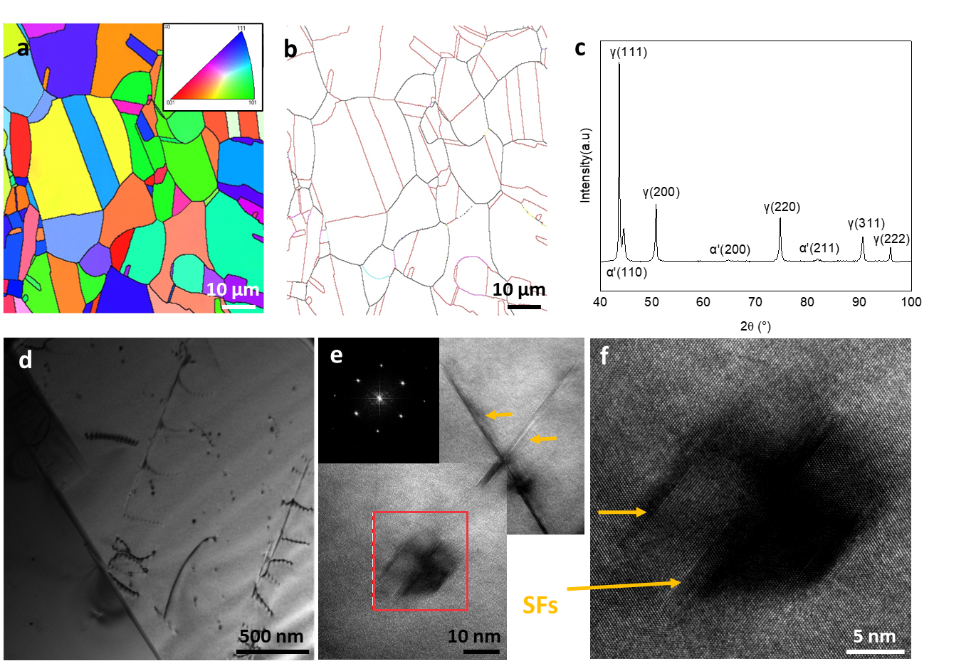

Supplementary Fig. 1. Microstructure of CG 304NG. a, b, The EBSD analysis, an inverse pole figure (IPF) image (a), a sketch map of GBs distribution (b), Red lines, Σ3 GBs; Black lines, high angle GBs (>15°); Other colored lines, other CSL boundaries. c, The XRD pattern. d, A BF TEM image. e, f, High-resolution TEM images with SFs pointed by arrows, and (f) is a magnified view of the boxed zone in (e). The inset in (e) shows the FFT pattern.

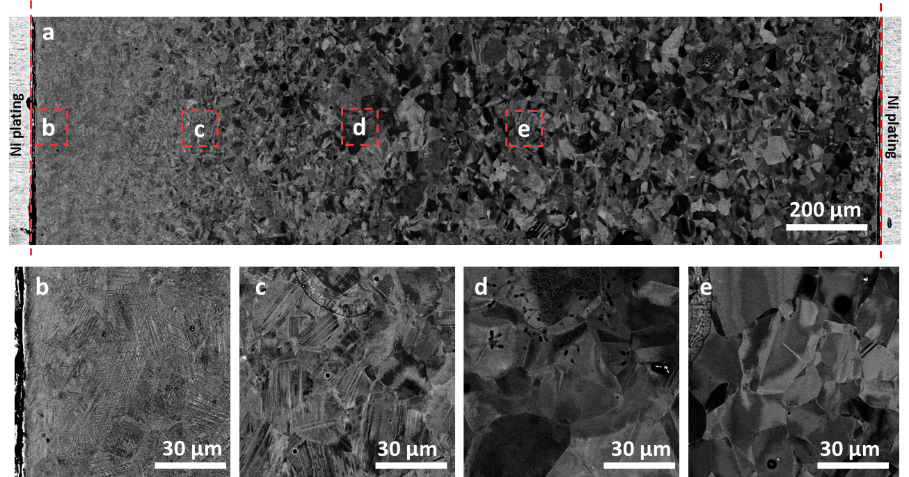

Supplementary Fig. 2. SEM images of SMRT 304NG sample. a, A cross-sectional morphology. b-e, The magnified views of the corresponding zones marked in (a).

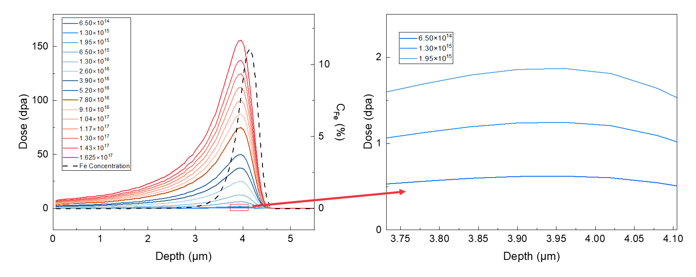

Supplementary Fig. 3. Profiles of irradiation dose and Fe concentration along depth under different ion fluences applied in this work.

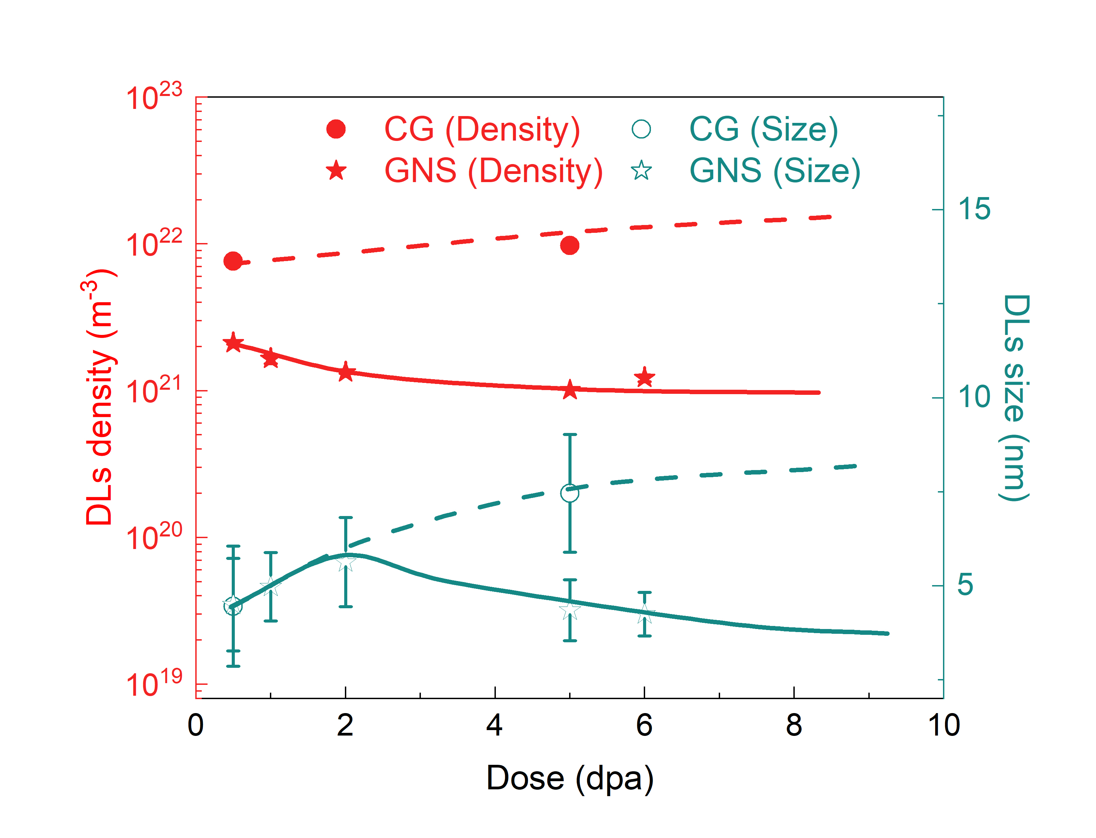

Supplementary Fig. 4. Variations of DLs density and size with radiation dose at room temperature in CG and GNS samples. This is an enlarged view of Fig. 2c showing the situation at low doses.

Supplementary Fig. 5. Comparisons of irradiation DLs densities in different nanostructured materials and their CG counterparts after ion irradiation. All the materials were irradiated at low temperatures except that 304L was irradiated at 500 °C and G91 was irradiated at 300 °C (Refs. (11-16)). UFG: ultra-fine grained, NP: nano-porous; NT: nano-twinned.

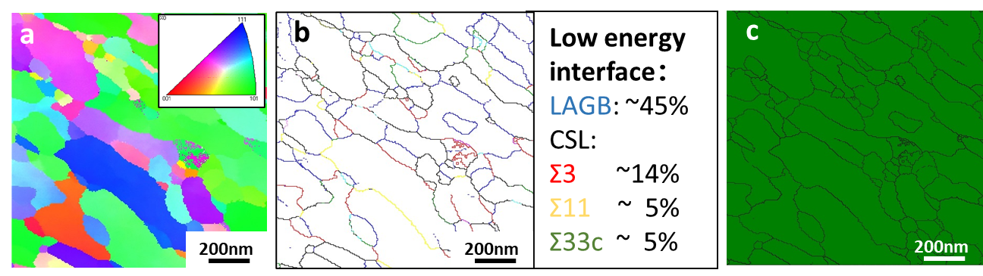

Supplementary Fig. 6. Microstructure of GNS 304NG irradiated at room temperature with an ion fluence of 1.625 × 10¹⁷ cm⁻² (also a part in Extended Data Fig. 8). a-c, The TKD analysis results, an IPF image (a), a sketch map of GB distribution (b), and a phase distribution image (c). In (b): Red lines, Σ3 interfaces; Blue lines, low-angle GBs (5 to 15°); Black lines, high-angle GBs (>15°); and other colored lines, other CSL boundaries. In (c): Red, γ; Green, α'.

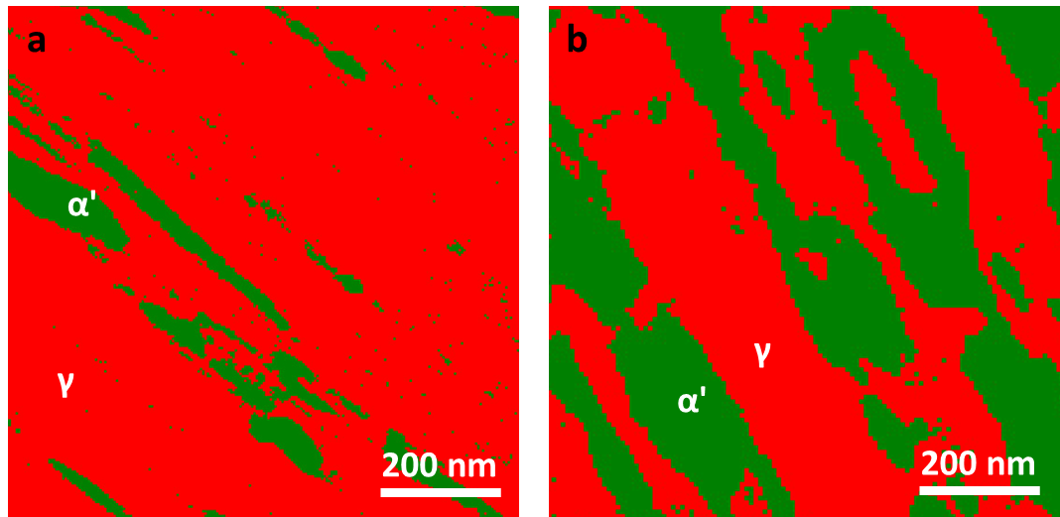

Supplementary Fig. 7. Phase distribution images characterized by TKD at a depth of ~4.0 μm in GNS samples. Before irradiation (a) and after irradiation (b) at room temperature for ~5 dpa. Red, γ; Green, α’.

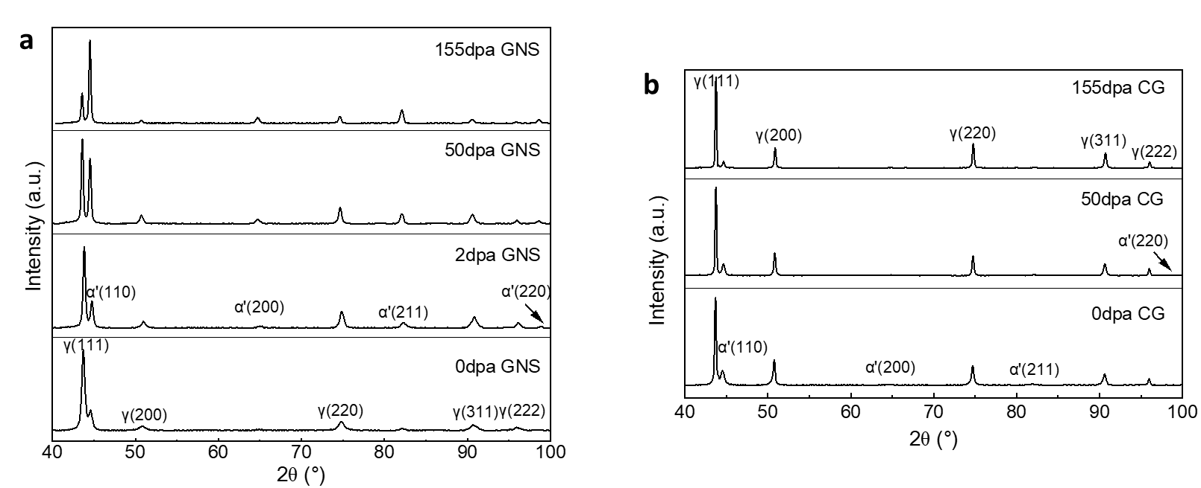

Supplementary Fig. 8. XRD patterns of different samples irradiated at room temperature. GNS samples (a) and CG samples (b) with the corresponding doses marked.

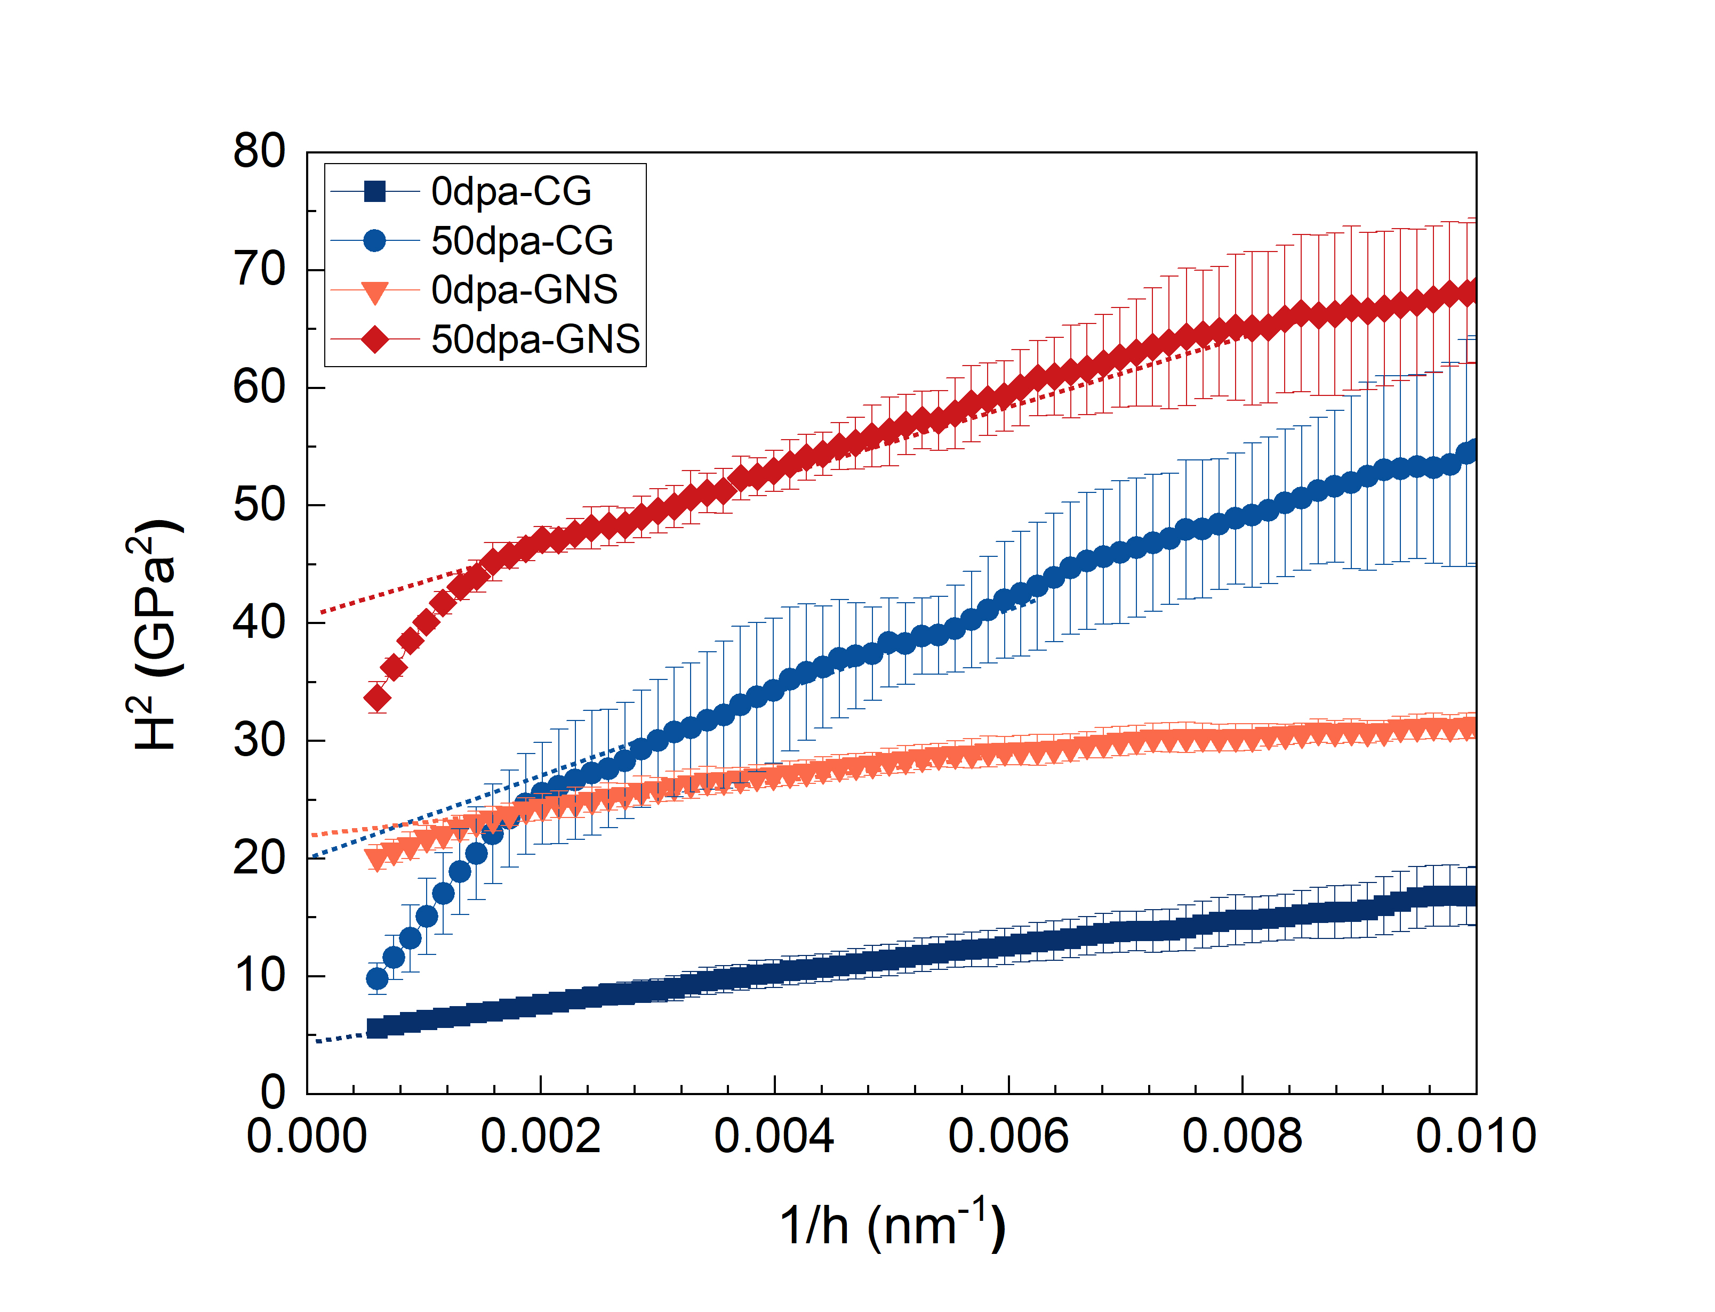

Supplementary Fig. 9. Indentation displacement dependence of hardness of GNS and CG samples before and after irradiation (~50 dpa at room temperature). The plots were taken from Fig. 4A according to the Nix-Gao correction model (17), i.e., (H/H₀)² =1+h*/h, where H is the obtained hardness at the indentation displacement h, H₀ is the hardness at infinite h, and h* is a characteristic length depending on the properties of indented material and geometry of indenter tip. The values of H₀ are derived from the dotted fitting lines for 50dpa-CG, 0dpa-GNS, and 50dpa-GNS, since the sections with low 1/h values (i.e. large indentation displacement) should be influenced by the substrate with a lower hardness. The surface hardness values were estimated to be 2.31±0.10, 4.37±0.45, 4.93±0.13, and 6.45±0.29 GPa for 0dpa-CG, 50dpa-CG, 0dpa-GNS, and 50dpa-GNS, respectively.

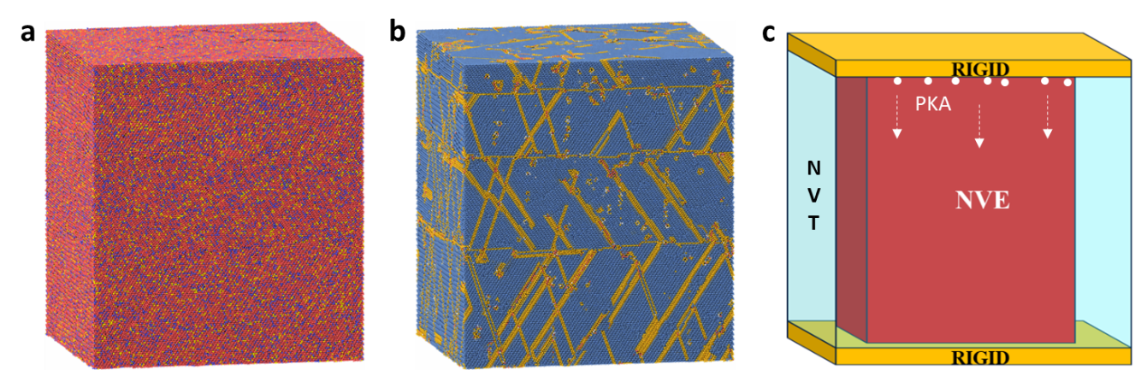

Supplementary Fig. 10. Atomic model of GNS 304NG. a, The element distribution of the model. The red, blue, and yellow balls represent Fe, Cr, and Ni atoms, respectively. b, The phase distribution identified by PTM method: the blue balls represent the atoms in FCC phase, the orange balls represent the atoms in GB or SF phase, the red balls represent the atoms in BCC phase, and the grey atoms represent the atoms unrecognized by PTM method. c, The ensemble of the model in MD simulations.

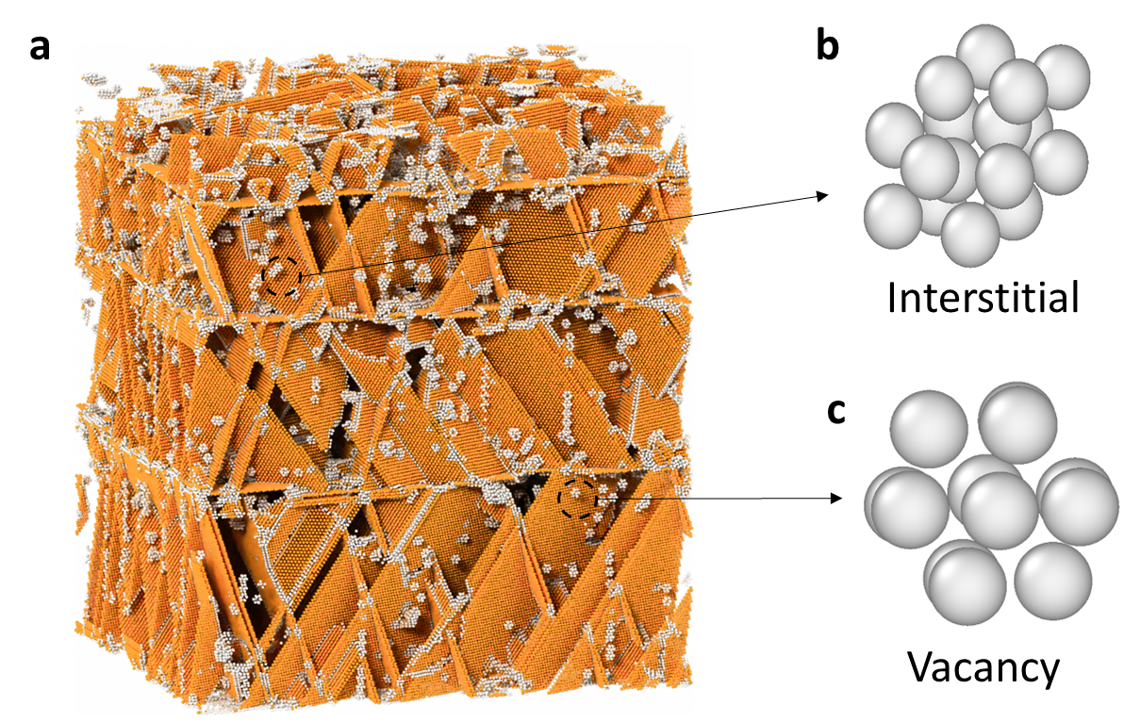

Supplementary Fig. 11. Defects formation in the GNS 304NG under irradiation. a, The defect distribution in GNS 304NG after radiation cascade recognized by PTM method, in which the orange balls represent atoms in SFs and the grey balls represent atoms in other defects, such as interstitial (b) and vacancy (c), which would be trapped or annihilated through trapping in GBs, SFs, DNs, and by the AMT mechanism.

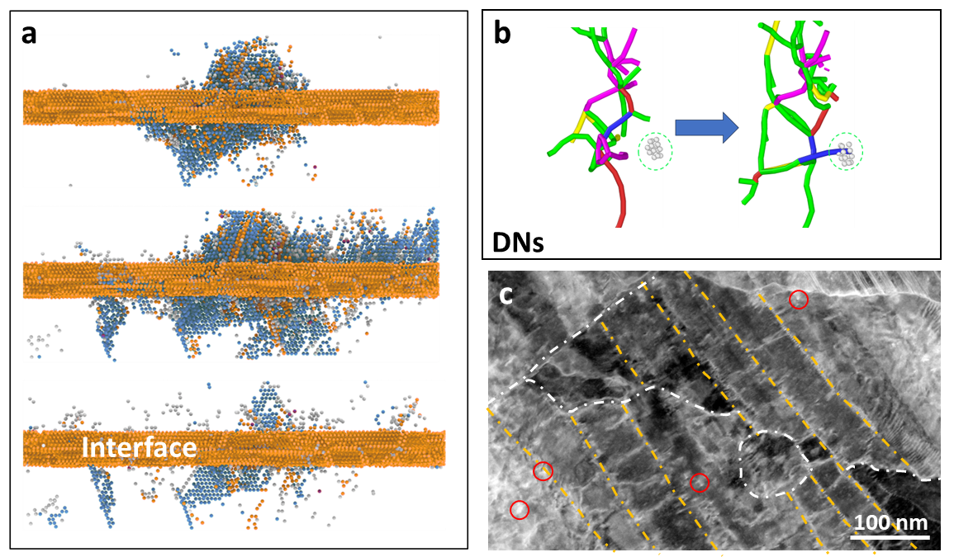

Supplementary Fig. 12. Defect absorption in irradiated GNS 304NG. a, b, Defects (grey balls) are absorbed by interface (a) and DNs (b), respectively, in MD simulations. c, The STEM image of irradiated GNS sample under a dose of 2 dpa, presenting defect absorption by interfaces and DNs.

Supplementary Fig. 13. Atomic migration trajectories of martensitic transformation induced by irradiation defect.

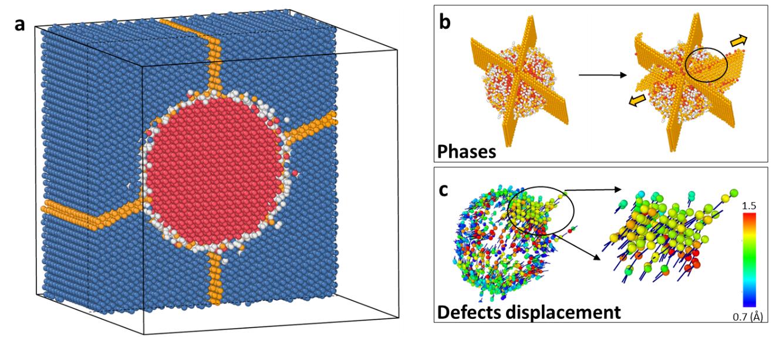

Supplementary Fig. 14. Extending process of AMT mechanism. a, Small SFs-BCC model. b, The phases extend process. c, Defects enrichment process. Blue (FCC), yellow (HCP), red (BCC) and grey (other types) atoms are determined according to the different lattice arrangements in (a) and (b). The color in (c) represents the atomic displacement magnitude as shown in the color-bar.

2. Supplementary Tables

Supplementary Table 1. SMRT parameters. The parameters used in SMRT for 304NG plate samples.

v_{y}  (mm s⁻¹) | P_{x}  (mm) | L_{x}  (mm) | L_{y}  (mm) | a_{p}  (μm) | Repeated times
33.3 | 0.03 | 30 | 150 | 40 | 2

Supplementary Table 2. Radiation parameters. The radiation parameters of pre-experiments and high temperature experiments.

 | Pre-experiment |  |  | High temperature (450 °C) experiment
Incident particle energy (MeV U⁻¹) | 0.69 |  |  | 0.65
Radiation range  (μm) | 0 – 5.0 |  |  | 0 – 4.8
Peak damage  (μm) | 4.25 |  |  | 4.11
Ion fluence  (ions cm⁻²) | 5.0×10¹⁵ | 1.0×10¹⁶ | 5.0×10¹⁶ | 8.0×10¹⁶
Peak damage dose  (dpa) | 5 | 10 | 50 | 80

Supplementary Table 3. Distributions of DLs in different samples. Statistics of the density and size of radiation DLs in all the irradiated GNS and CG samples after validation experiments at room temperature. Arithmetic mean value and uncertainty were obtained from 3-5 TEM observations for each sample as illustrated in Extended Data Fig. 4.

GNS 304NG
Dose (dpa) | 0.5 | 1 | 2 | 5 | 6 | 12 | 25
DL density (m⁻³) | 2.11×10²¹ | 1.65×10²¹ | 1.33×10²¹ | 1.01×10²¹ | 1.22×10²¹ | 7.39×10²⁰ | 8.42×10²⁰
DL size (nm) | 4.50±1.24 | 4.97±0.91 | 5.63±1.18 | 4.35±0.81 | 4.25±0.58 | 4.48±0.59 | 4.49±0.73
Dose (dpa) | 40 | 50 | 75 | 85 | 100 | 155
DL density (m⁻³) | 7.03×10²⁰ | 7.66×10²⁰ | 8.36×10²⁰ | 6.66×10²⁰ | 7.04×10²⁰ | 5.96×10²⁰
DL size (nm) | 4.14±0.59 | 4.23±0.85 | 4.49±1.04 | 4.41±0.69 | 4.29±0.79 | 4.69±0.78
CG 304NG
Dose (dpa) | 0.5 | 5 | 12 | 50 | 155
DL density (m⁻³) | 7.63×10²¹ | 9.78×10²¹ | 9.92×10²¹ | 1.17×10²² | 1.57×10²²
DL size (nm) | 4.45±1.60 | 7.46±1.57 | 7.74±2.90 | 7.61±2.16 | 7.44 ± 1.93

Supplementary Video 1. Process of the micro-pillar compression test of irradiated GNS sample (~50 dpa at room temperature).

Supplementary Video 2. Process of GBs evolution under irradiation in NC model and GNS model, respectively.

Supplementary Video 3. Process of AMT in GNS 304NG.

Supplementary Video 4. Process of irradiation defects vanishment during the martensitic transformation due to the structure rearrangement (orange balls: SFs; blue balls: FCC; red balls: BCC; and grey balls circled in red mean a vacancy existing).

Supplementary Video 5. Process of large-scale AMT (Color ball is consistent with Supplementary Video 4).

Supplementary References
1 Bonny, G., Castin, N. & Terentyev, D. Interatomic potential for studying ageing under irradiation in stainless steels: the FeNiCr model alloy. Modell. Simul. Mater. Sci. Eng. 21, 085004 (2013). https://doi.org:10.1088/0965-0393/21/8/085004
2 Yang, C., Pachaury, Y., El-Azab, A. & Wharry, J. Molecular dynamics simulation of vacancy and void effects on strain-induced martensitic transformations in Fe-50 at.% Ni model concentrated solid solution alloy. Scr. Mater. 209, 114394 (2022). https://doi.org:10.1016/j.scriptamat.2021.114394
3 Vineyard, G. H. Frequency factors and isotope effects in solid state rate processes. J. Phys. Chem. Solids 3, 121-127 (1957). https://doi.org:10.1016/0022-3697(57)90059-8
4 Kocks, U. F., Argon, A. S. & Ashby, M. F. Thermodynamics and kinetics of slip. Vol. 19 (Pergamon Press Ltd, 1975).
5 Zhao, S., Osetsky, Y. & Zhang, Y. Atomistic simulation of defect-dislocation interactions in concentrated solid-solution alloys. Phys. Rev. Mater. 3, 103602 (2019). https://doi.org:10.1103/PhysRevMaterials.3.103602
6 Bai, X. M., Voter, A. F., Hoagland, R. G., Nastasi, M. & Uberuaga, B. P. Efficient annealing of radiation damage near grain boundaries via interstitial emission. Science 327, 1631-1634 (2010). https://doi.org:10.1126/science.1183723
7 Han, W. et al. Design of radiation tolerant materials via interface engineering. Adv. Mater. 25, 6975-6979 (2013). https://doi.org:10.1002/adma.201303400
8 Ustrzycka, A., Dominguez-Gutierrez, F. J. & Chromiński, W. Atomistic analysis of the mechanisms underlying irradiation-hardening in Fe–Ni–Cr alloys. Int. J. Plast. 182, 104118 (2024). https://doi.org:10.1016/j.ijplas.2024.104118
9 Hesterberg, J., Smith, R. & Was, G. S. Atomistic simulation of the obstacle strengths of radiation-induced defects in an Fe–Ni–Cr austenitic stainless steel. Modell. Simul. Mater. Sci. Eng. 27, 085004 (2019). https://doi.org:10.1088/1361-651X/ab40f9
10 Gao, J. et al. Effects of grain boundary structures on primary radiation damage and radiation-induced segregation in austenitic stainless steel. J. Appl. Phys. 128, 105304 (2020). https://doi.org:10.1063/5.0016404
11 Sun, C. et al. Superior radiation-resistant nanoengineered austenitic 304L stainless steel for applications in extreme radiation environments. Sci. Rep. 5, 7801 (2015). https://doi.org:10.1038/srep07801
12 Li, J., Fan, C., Li, Q., Wang, H. & Zhang, X. In situ studies on irradiation resistance of nanoporous Au through temperature-jump tests. Acta Mater. 143, 30-42 (2018). https://doi.org:10.1016/j.actamat.2017.09.054
13 Li, J. et al. Superior twin stability and radiation resistance of nanotwinned Ag solid solution alloy. Acta Mater. 151, 395-405 (2018). https://doi.org:10.1016/j.actamat.2018.03.052
14 Shang, Z. et al. He ion irradiation response of a gradient T91 steel. Acta Mater. 196, 175-190 (2020). https://doi.org:10.1016/j.actamat.2020.06.019
15 Sun, C. et al. In situ evidence of defect cluster absorption by grain boundaries in Kr ion irradiated nanocrystalline Ni. Metall. Mater. Trans. A 44, 1966-1974 (2013). https://doi.org:10.1007/s11661-013-1635-9
16 Duan, J. et al. Effect of grain size on the irradiation response of grade 91 steel subjected to Fe ion irradiation at 300 °C. J. Mater. Sci. 57, 13767-13778 (2022). https://doi.org:10.1007/s10853-022-07480-6
17 Nix, W. D. & Gao, H. Indentation size effects in crystalline materials: A law for strain gradient plasticity. Journal of the Mechanics and Physics of Solids 46, 411-425 (1998). https://doi.org:10.1016/s0022-5096(97)00086-0

