EXPERIENCES ACCESSING AND RECEIVING TUMOUR GENETIC PROFILING IN VICTORIA: A CONSUMER-LED CROSS-SECTIONAL SURVEY STUDY

Victorian Comprehensive Cancer Centre (VCCC) Alliance Personalised Cancer Care Consumer Reference Group: Kathleen Minas¹*, Melissa Sheldon¹*, Sonja Ilievska¹*, Naveena Nekkalapudi¹*, Kenneth Young¹*, Jonathan Ashley Granek¹*, Victoria Sharp¹*, Beth Doggett¹*
Victorian Comprehensive Cancer Centre (VCCC) Alliance staff: Genevieve Dall¹, Joanne M Britto¹, Nonie Chan¹, Michelle Barrett¹, Mark Buzza ¹. Research Support Team (University of Melbourne): Tamara Jones², Sarah Stratulate,^{2,3} Camille E Short.^{2,3}
*Equal first author

Supplementary file 1. Consumer Reference Group Workshops and Responsibilities

Background
The work undertaken by the Consumer Reference Group (CRG) was a project under the VCCC Alliance Strategic Program Plan 2021 – 2024, Program 2 – Personalised Cancer Care.

An overall goal of the Personalised Cancer Care program is to speed up the translation of promising personalised tests closer to the clinic and improve patient access to personalised treatment and the best chance of a good outcome.

5 Projects were established under Program 2 - they were:

1 Multi-disciplinary Connections
Connecting disciplines to accelerate research progress, for example, chemists and structural
biologists.
2 Translational Research Hub
Accelerating fundamental immunotherapy discoveries to the clinic by supporting access to
the Centre for Cancer Immunotherapy – Translational Research Hub.
3 Multi-site Research Coordination
Creating a framework to deliver personalised cancer care across the VCCC Alliance by
reducing research governance and tissue access barriers.
4 Molecular Testing
Providing molecular testing and curation for patients most in need – PRECISION study and
Creating a pathway to long-term sustainability for molecular testing.
5 Consumer-led Research Project

Key Milestones :

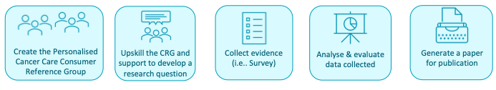

The Consumer Led Research Group (CRG) received strong support, with the work informed by earlier research into the key requirements for successful consumer-led research. Terms of Reference were established and endorsed by the CRG and then by the Program Steering Committee. The CRG Co-Chairs were members of the overall Program Steering Committee and provided regular updates on the Project progress and had the opportunity to comment on the progress, risks and issues impacting the other four Projects in the program.

The purpose of the CRG was to utilise lived experience, research, and expertise to support planned research activities of the Personalised Cancer Program.

In addition, members were involved in identifying approaches for continuous improvement in molecular testing, focusing on improving equity of clinical access. With guidance from the VCCC Alliance, they led the identification of research questions and conduct of aspects of consumer-led research. CRG members actively participated in the dissemination of the research, for example, through publication.

The CRG was well supported through education and engagement practices, both key to enabling effective contribution and completion of the Project.

VCCC alliance staff-led activities:
An initial workshop was undertaken with CRG members involved to gain a clear understanding of the entire program and to establish the ongoing ‘clarity and education’ requirements needed. Subsequent workshops were as follows:
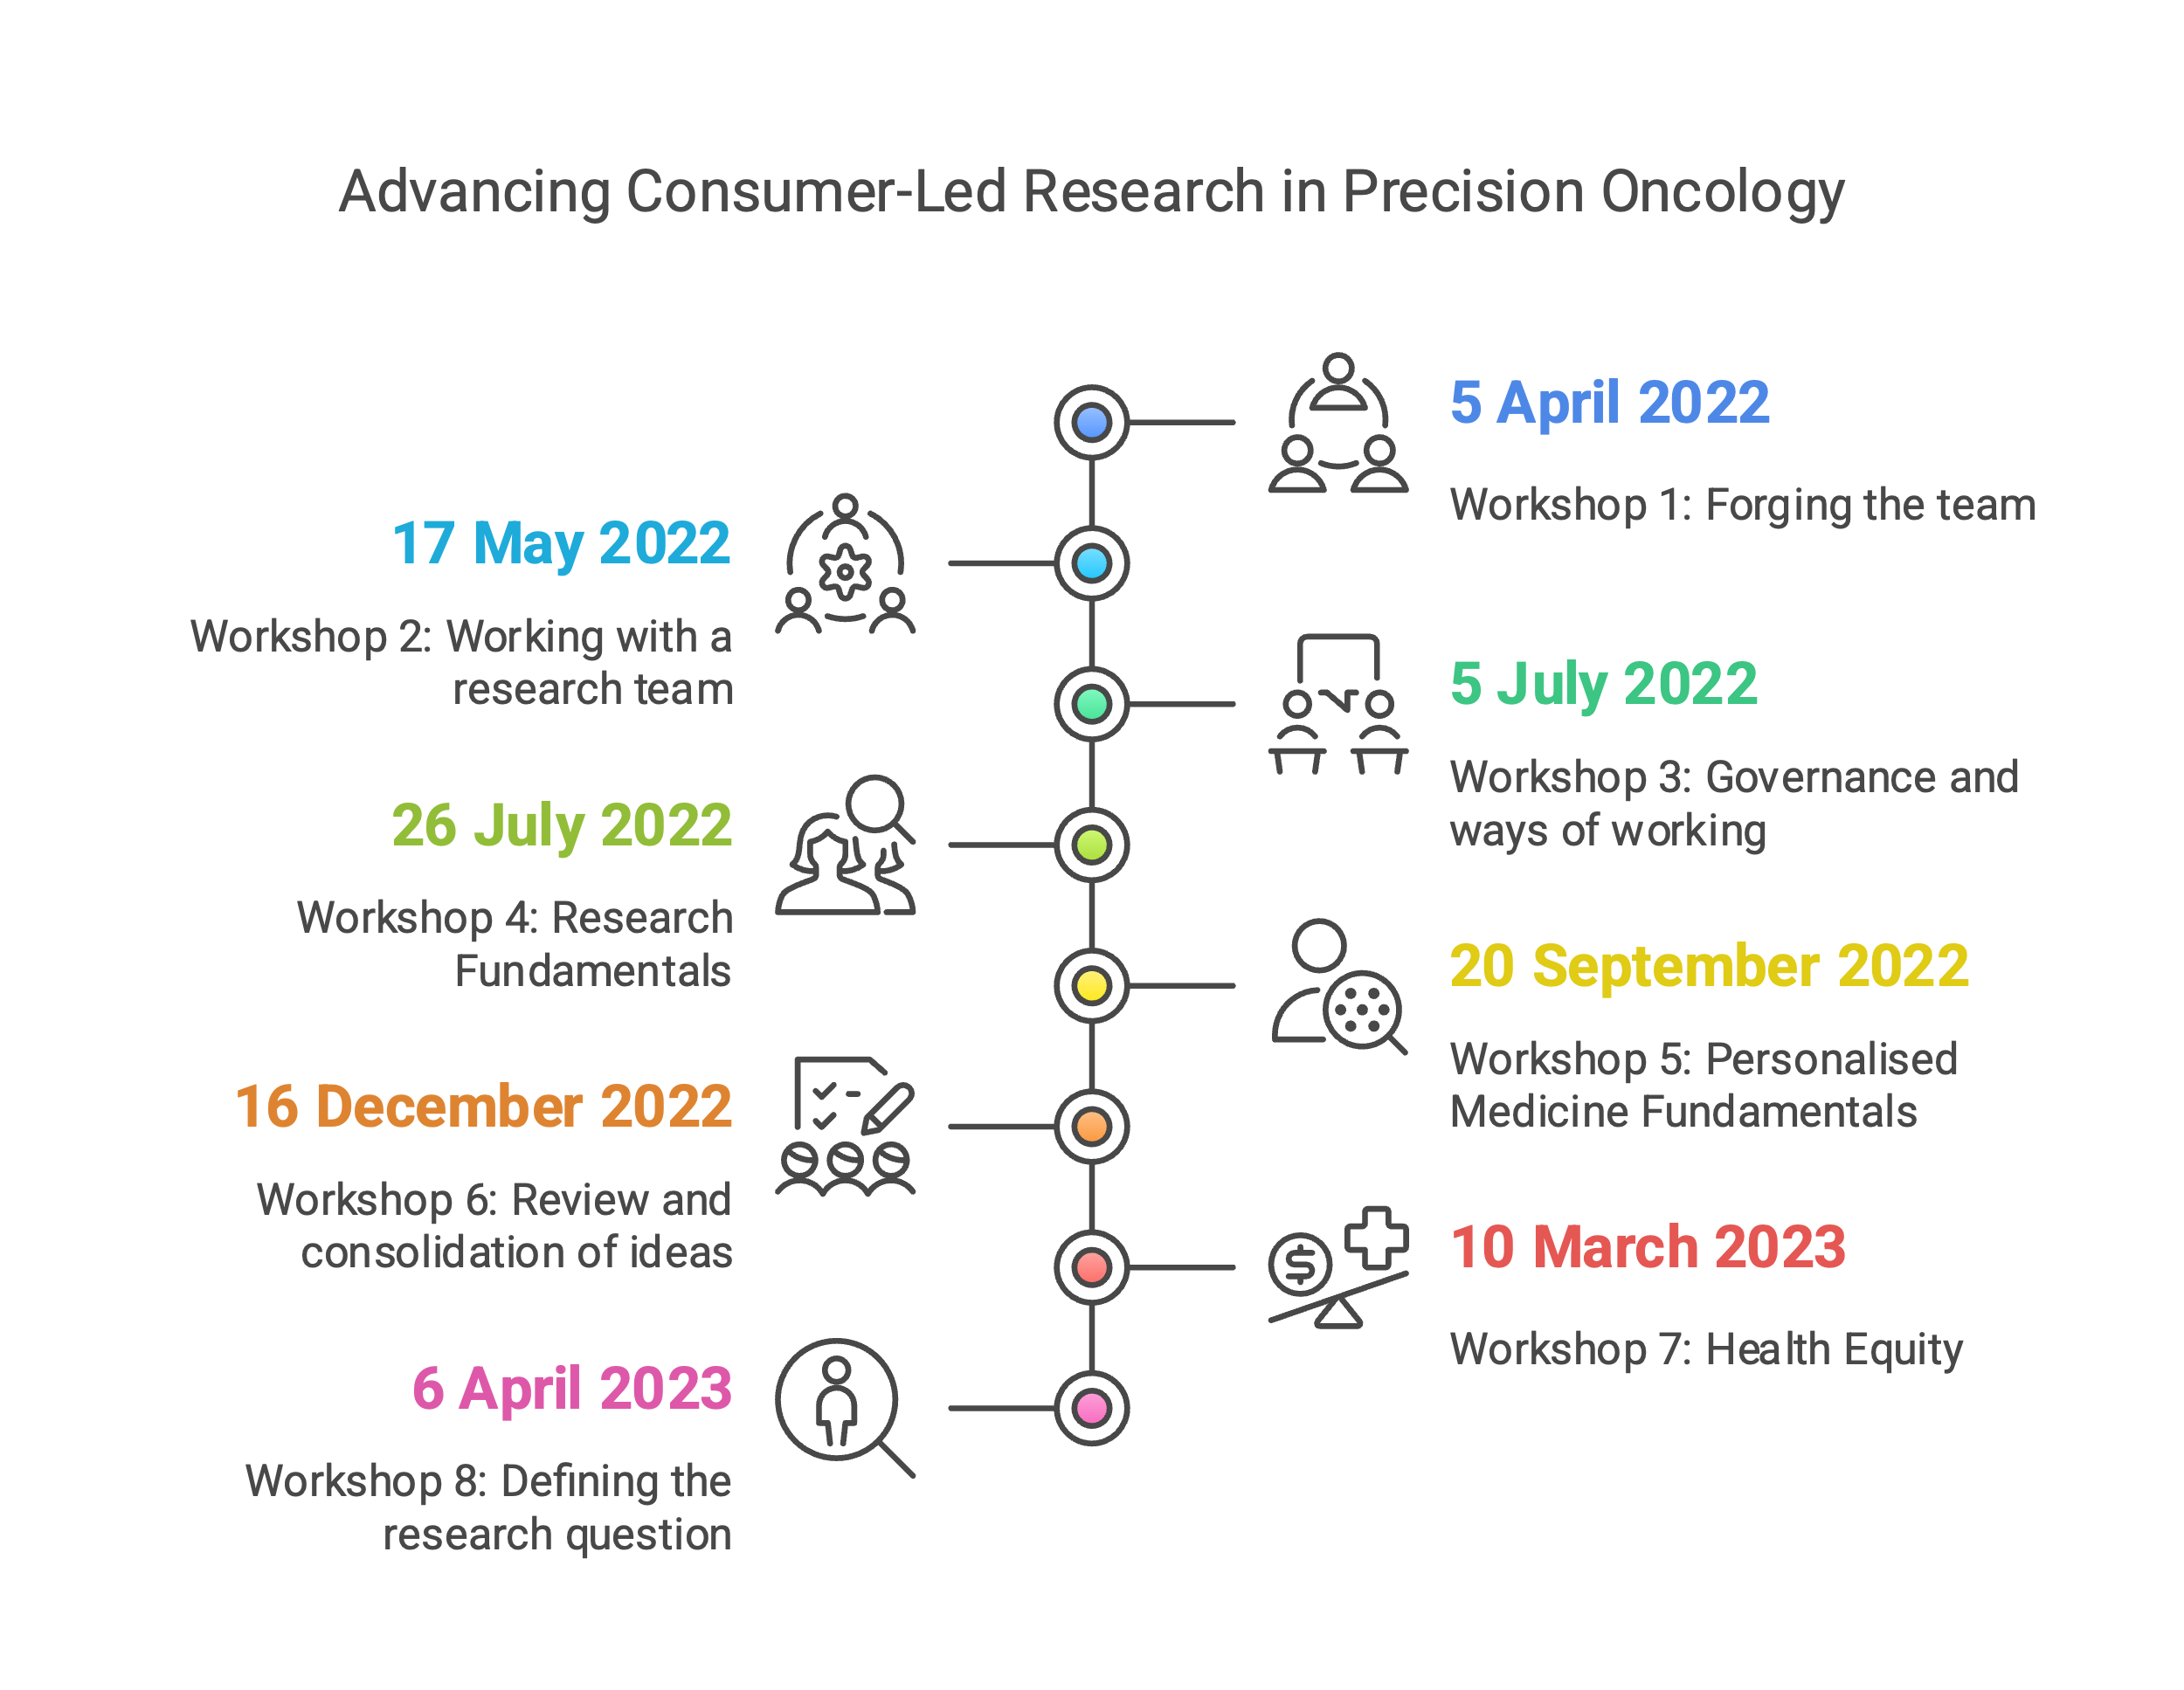
WORKSHOP 1 | Forging the team
Date | 5 April 2022
Aim | Orientate and explore the context and dynamics of developing a research program led by consumers, with a researcher team.
Objectives | - Outline personalised cancer care and consumer led research in the VCCC Alliance and broader sector.  - Build relationships between members of the Consumer Reference Group and VCCC Alliance project team.  - Explore the definition, expectations, supports and understanding of Consumer-led Research.  - Demonstrate VCCC Alliance Executive and Precision Cancer Care Program Co-Chair support for the consumer led research project.
Presenters | - CEO, VCCC Alliance  - Chair, Cancer Consumer Advisory Committee, VCCC Alliance  - Co-Chair VCCC Alliance Precision Cancer Care Program, University of Melbourne Bertalli Chair in Cancer Medicine, Centre for Cancer Research  - Medical Oncologist, Peter MacCallum Cancer Centre  - Director of Research, VCCC Alliance  - Director of Education, VCCC Alliance  - Chair, Personalised Cancer Care Consumer-led Research Project  - Chair, Personalised Cancer Care Consumer-led Research Project  - Senior Manager, Consumer Involvement, VCCC Alliance  - Program Manager, Personalised Cancer Care
Synopsis | The first workshop of the Personalised Cancer Care Consumer-led Research Project provided an in-depth introduction to the principles and practices of developing research led by consumers with researchers. Participants explored the current and future landscape of personalised cancer care and consumer-led research within the VCCC Alliance and the broader sector. The session facilitated relationship-building between the Consumer Reference Group and VCCC Alliance project team, outlined the roles, expectations, and support mechanisms necessary for collaboration, and addressed potential enablers and barriers to success. Through presentations, discussions, and interactive activities, the workshop established a shared understanding of consumer-led research and set the foundation for the project's ongoing development.
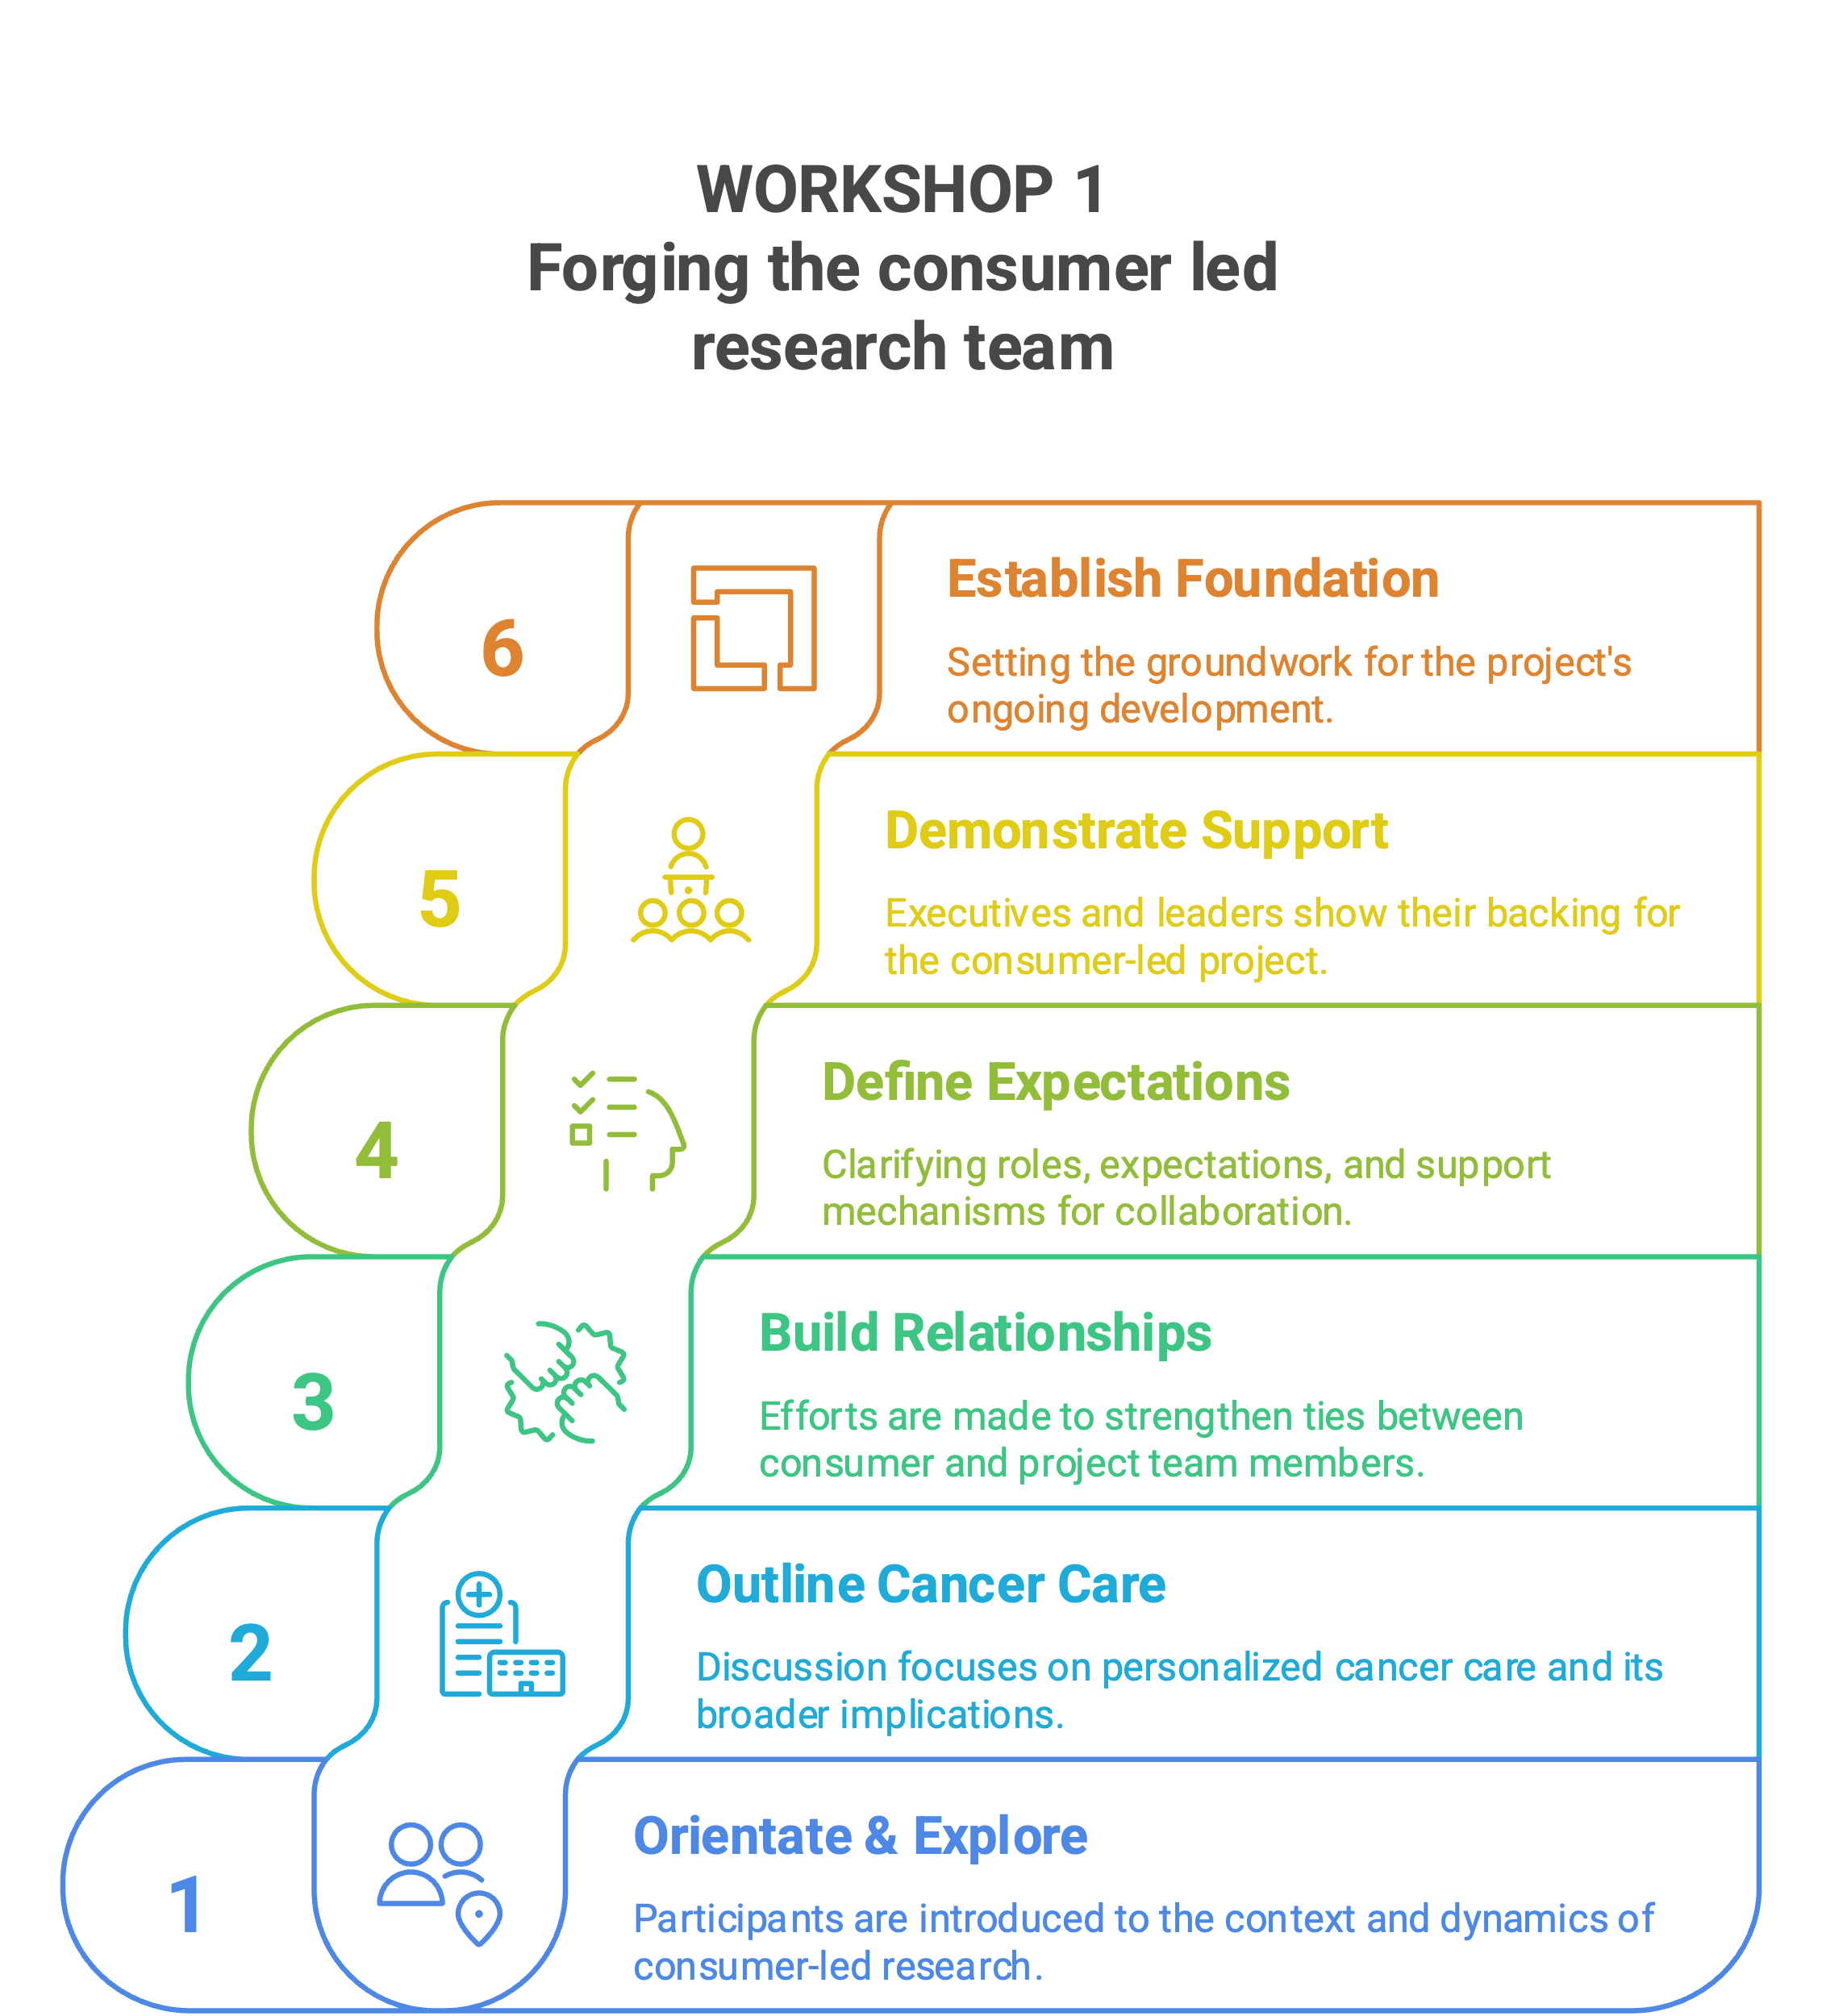

WORKSHOP 2 | Working with a research team
Date | 17 May 2022
Aim | Explore the dynamics of working with a research team.
Objectives | - Develop an agreed behavioural framework to frame ways of working together as a Consumer Reference Group.  - Outline the process of working with a research team.  - Further the understanding of consumer led research in practice.
Presenters | - Chair, Personalised Cancer Care Consumer-Led Research Project  - Senior Manager, Consumer Involvement, VCCC Alliance  - National Consumer Advocate  - Leadership Consultant
Synopsis | The second workshop of the Personalised Cancer Care Consumer Reference Group focused on working effectively within a research team. Participants developed a shared behavioural framework to guide interactions, emphasising effective communication, teamwork, and trust-building. The session provided practical insights into consumer-led research, highlighted key tips, common pitfalls, and collaboration strategies, and included discussions on rules of engagement and creating a supportive environment. Reflections and feedback reinforced collective learning, advancing the group’s understanding and laying the groundwork for constructive collaboration with research teams.

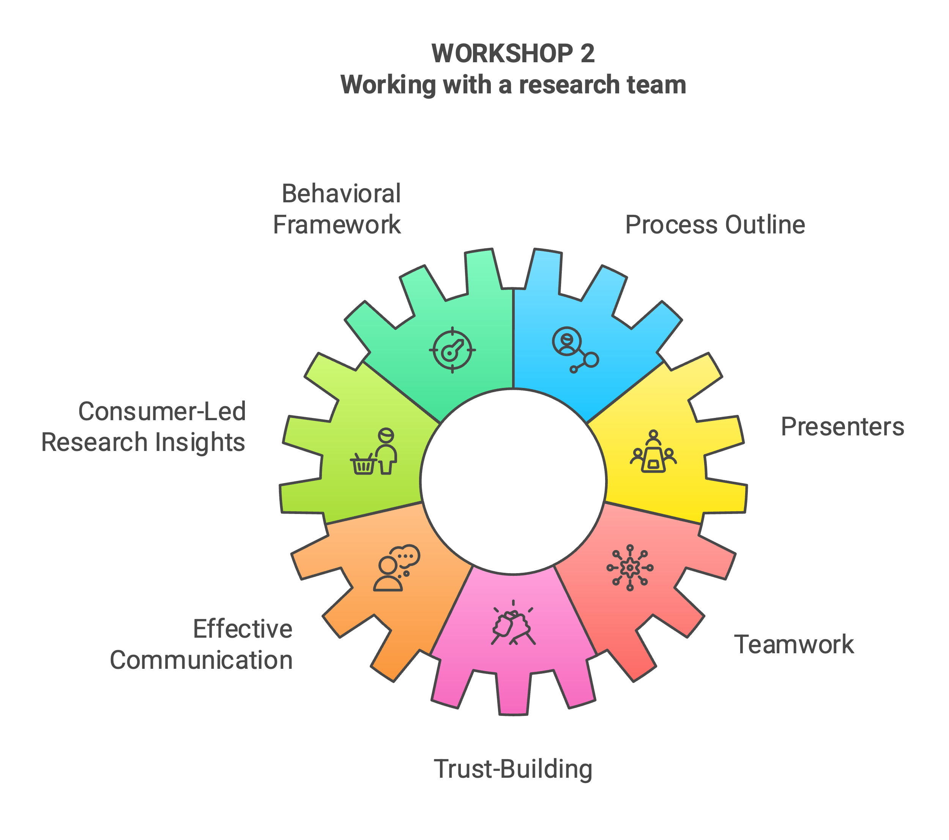

WORKSHOP 3 | Governance and ways of working
Date | 5 July 2022
Aim | Update the governance of the Precision Cancer Care Consumer Reference Group (CRG).
Objectives | - Seek an expression of interest for a co-chair to lead the Precision Cancer Care CRG  - Outline the evaluation data feedback from workshop 2  - Finalise the behavioural framework for the CRG  - Articulate the roles and responsibilities of the project team, consumers and researchers in a consumer led research process (RACI matrix)
Presenters | - Chair, Personalised Cancer Care Consumer-led Research Project  - Director of Education, VCCC Alliance  - Senior Manager, Consumer Involvement, VCCC Alliance
Synopsis | The third workshop of the Precision Cancer Care Consumer Reference Group (CRG) focused on updating the group’s governance framework and strengthening its foundation for collaboration. Key activities included calling for expressions of interest for a Co-chair to lead the CRG and reviewing evaluation feedback from the previous workshop. Participants finalised the agreed behavioural framework, outlining principles for effective collaboration within the group. The session also introduced a RACI matrix to clearly define the roles and responsibilities of the project team, consumers, and researchers in the consumer-led research process. The workshop provided practical tools and insights to ensure the CRG operates effectively and transparently.

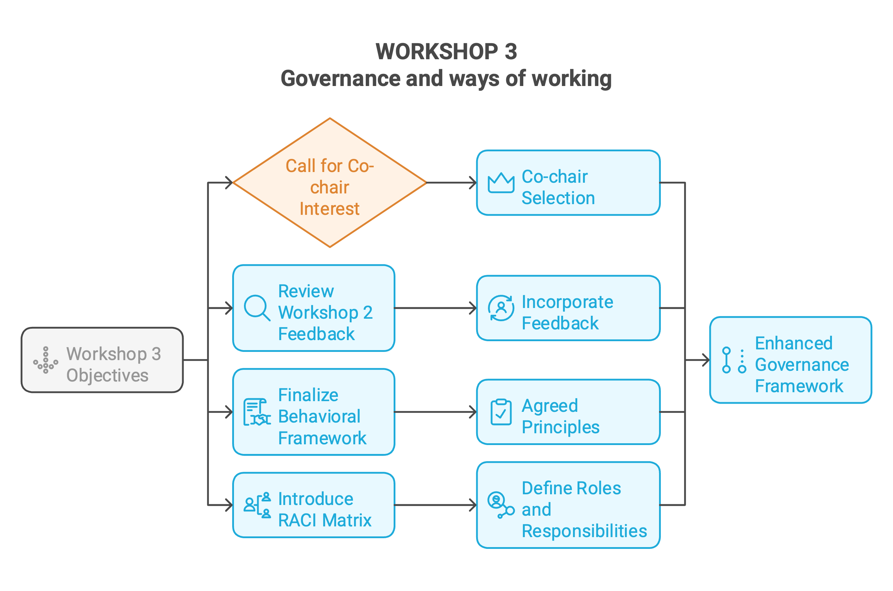

WORKSHOP 4 | Research Fundamentals
Date | 26 July 2022
Aim | Outline the various roles and responsibilities that consumers play in the consumer led research process.
Objectives | - Articulate what constitutes research  - Understand basic research terminology  - Outline the research process and the roles that both researchers and consumers play in consumer led research
Presenters | - Chair, Personalised Cancer Care Consumer-led Research Project  - Chair, Value Based Healthcare Consumer-led Research Project  - Chair, Value Based Healthcare Consumer-led Research Project  - Director of Research, VCCC Alliance  - National Program Manager, Primary Care Collaborative Cancer Clinical Trials Group (PC4)
Synopsis | The fourth workshop of the Precision Cancer Care Consumer Reference Group focused on outlining consumer roles in the research process and introduced foundational research concepts, including types of studies and approaches. Participants learned about collaboration opportunities between researchers and consumers across all research stages, from problem identification to dissemination, with an emphasis on the importance of consumer involvement. The session included practical resources and concluded with a recap of key learnings and a preview of the next steps.

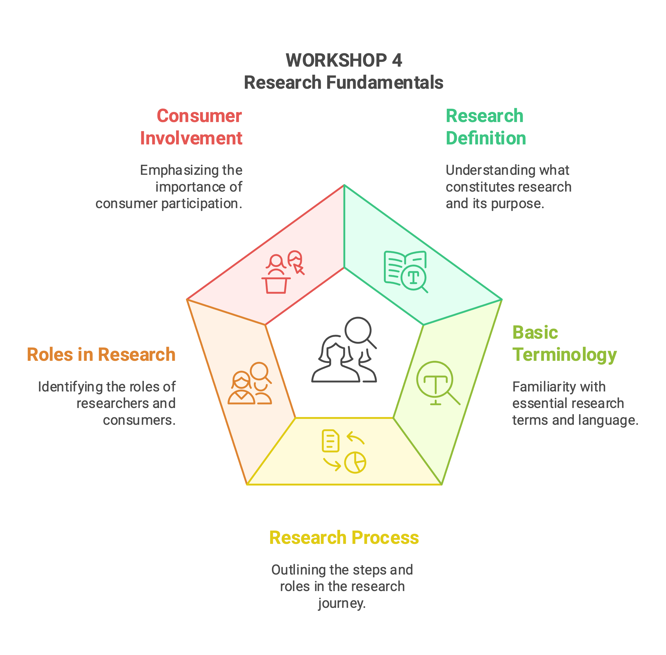

WORKSHOP 5 | Personalised Medicine Fundamentals
Date | 20 September 2022
Aim | Provide an overview of the status of personalised oncology, specifically molecular testing, in Victoria.
Objectives | - Outline molecular testing methods for precision oncology  - Explore the role of consumers in molecular testing and the gaps and opportunities to participation  - Understand how a patient gains access to molecular testing in the clinical setting, research, process, flow, communications, and application  - Discuss the system level challenges and opportunities that consumer involvement may present
Presenters | - Chair, Personalised Cancer Care Consumer-Led Research Project  - Director of Research, VCCC Alliance  - Co-Chair VCCC Alliance Precision Cancer Care Program, University of Melbourne Bertalli Chair in Cancer Medicine, Centre for Cancer Research  - Medical Oncologist, Peter MacCallum Cancer Centre  - Senior Genomics Consultant, Monash Partners Comprehensive Cancer Consortium  - Senior Cancer Genomics Curation Scientist and Senior Research Fellow, Peter MacCallum Cancer Centre  - Medical Oncologist, Peter MacCallum Cancer Centre
Synopsis | The fifth workshop of the Personalised Cancer Care Consumer Reference Group provided an in-depth overview of personalised oncology, focusing on molecular testing in Victoria. Participants explored testing methods, consumer roles, and patient access through clinical and research pathways. Expert presentations covered personalised medicine, molecular testing programs, tumour boards, advancements in patient communication, lab processes, and the clinical use of testing results, highlighting system-level challenges and opportunities for consumer involvement. Discussions allowed participants to reflect on gaps and opportunities, and the session concluded with project updates, the introduction of a new Program Manager, and collaboration with an academic partner.
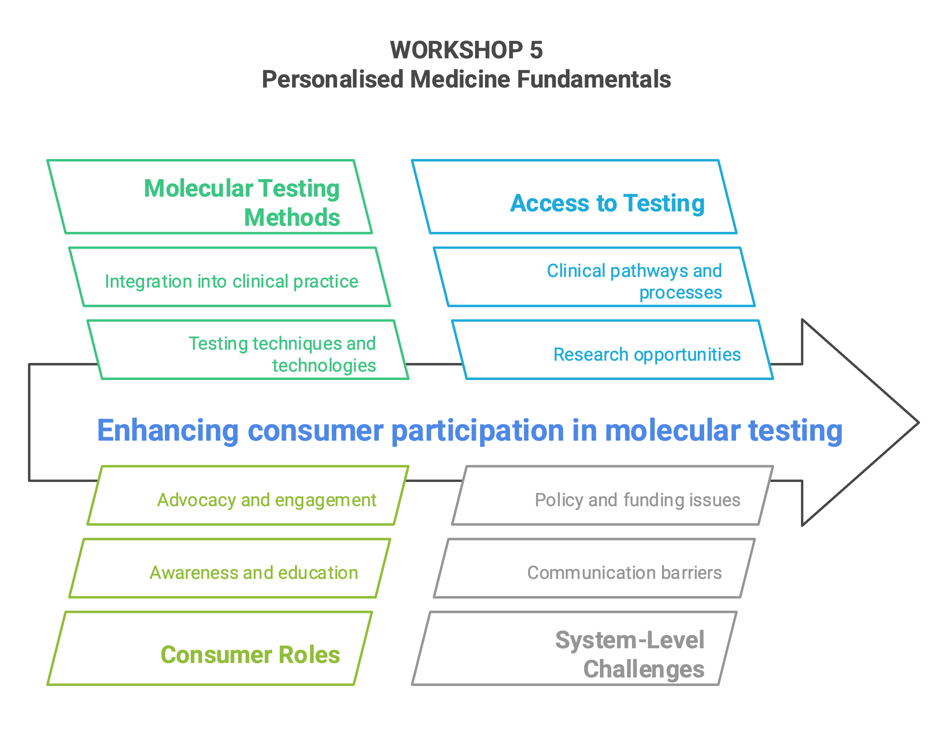

WORKSHOP 6 | Review and consolidation of ideas
Date | 16 December 2022
Aim | Review and consolidate insights from previous workshops, ensuring alignment on key frameworks, ideas, and next steps for the Consumer-led Research Project.
Objectives | - Reflect on the progress and key outputs from earlier workshops, including the Agreed Behavioural Framework and the RACI Matrix, to ensure clarity and alignment among group members.  - Discuss survey results to identify successes, gaps, and areas for improvement in the Consumer-led Research process.  - Foster team collaboration and engagement through interactive activities, setting the foundation for next steps in the project.
Presenters | - Chair, Personalised Cancer Care Consumer-led Research Project  - Chair, Personalised Cancer Care Consumer-led Research Project  - Director of Education, VCCC Alliance  - Program Manager, Personalised Cancer Care, VCCC Alliance
Synopsis | The sixth workshop of the Consumer-led Research Project focused on reviewing and consolidating ideas from previous sessions. It began with a welcome, acknowledgment of country, introductions of new members, and reminders about confidentiality and conflict of interest protocols. Icebreaker activities set a collaborative tone, followed by a review of key outputs like the Agreed Behavioural Framework and RACI Matrix. A detailed discussion of survey results provided insights, highlighted progress, and identified areas for further development. The session concluded with a summary of discussions, next steps, and a reminder of shared resources to support ongoing collaboration.

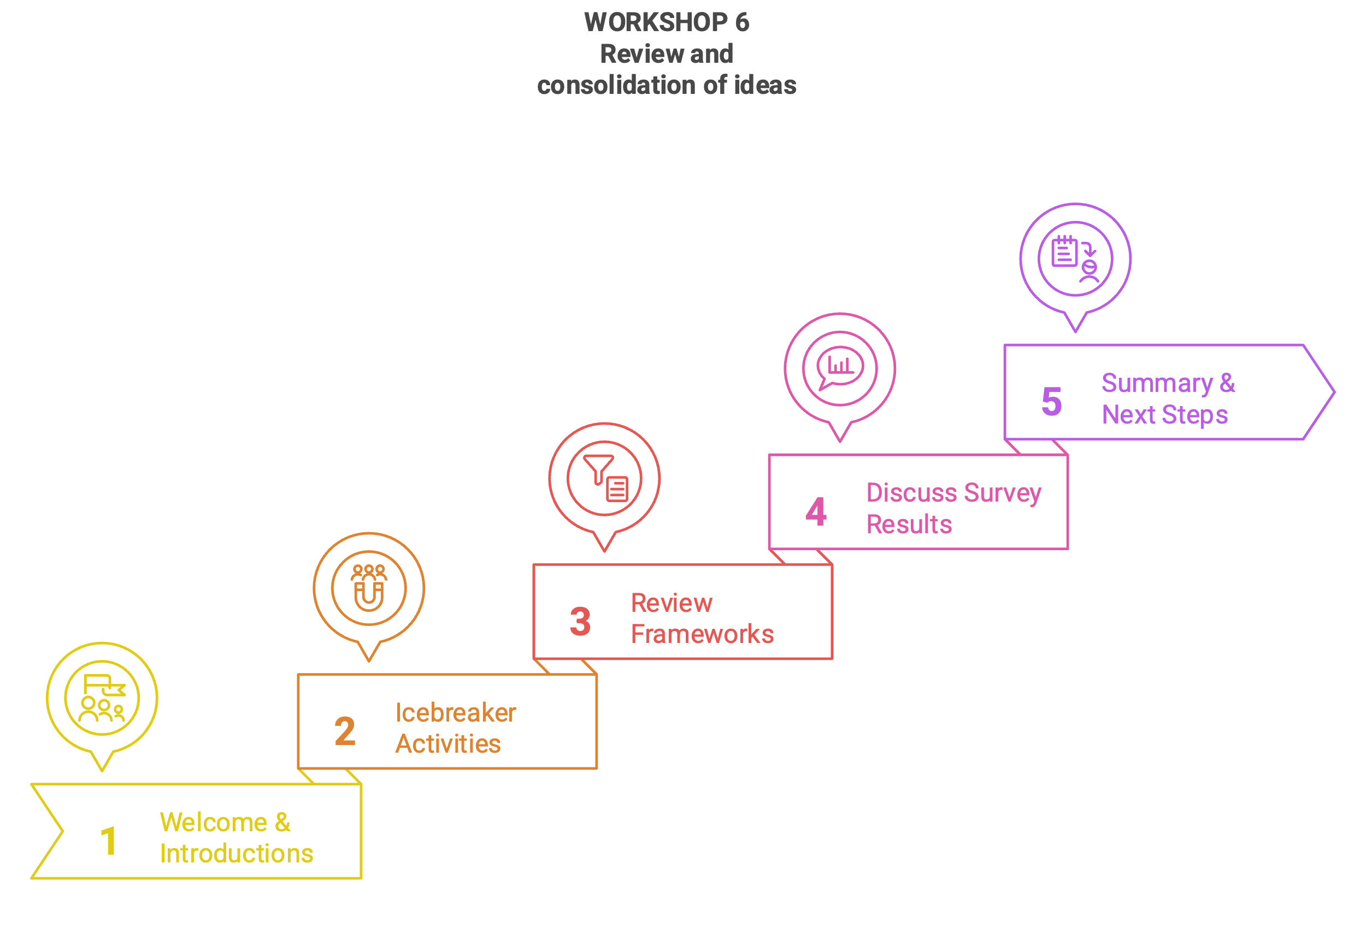
WORKSHOP 7 | Health Equity
Date | 10 March 2023
Aim | To ensure that consumer-led precision cancer care research incorporates accessibility and inclusivity by addressing health equity challenges, refining governance, and aligning with the Precision Oncology Summit program.
Objectives | - Identify key barriers and enablers to equitable access to precision cancer care.  - Review and update the project’s Terms of Reference to ensure alignment with consumer-led principles and project goals.  - Review the forthcoming program of the Precision Oncology Summit, identifying alignment with the principles of accessibility, inclusivity, and consumer-led research priorities.
Presenters | - Chair, Personalised Cancer Care Consumer-led Research Project  - Director of Health Equity and Strategic Programs  - Chair, Personalised Cancer Care Consumer-led Research Project  - Program Manager, Personalised Cancer Care
Synopsis | Workshop 7 of the Precision Cancer Care Consumer-led Research Project centred on the critical topic of health equity, ensuring any research questions factored in the important perspectives of accessibility and inclusivity. Participants engaged in interactive discussions to explore equity challenges, reviewed the project's governance framework, and reviewed the forthcoming program of the Precision Oncology Summit. This session empowered participants with knowledge, tools, and a clear path forward for advancing consumer-led precision cancer care initiatives.

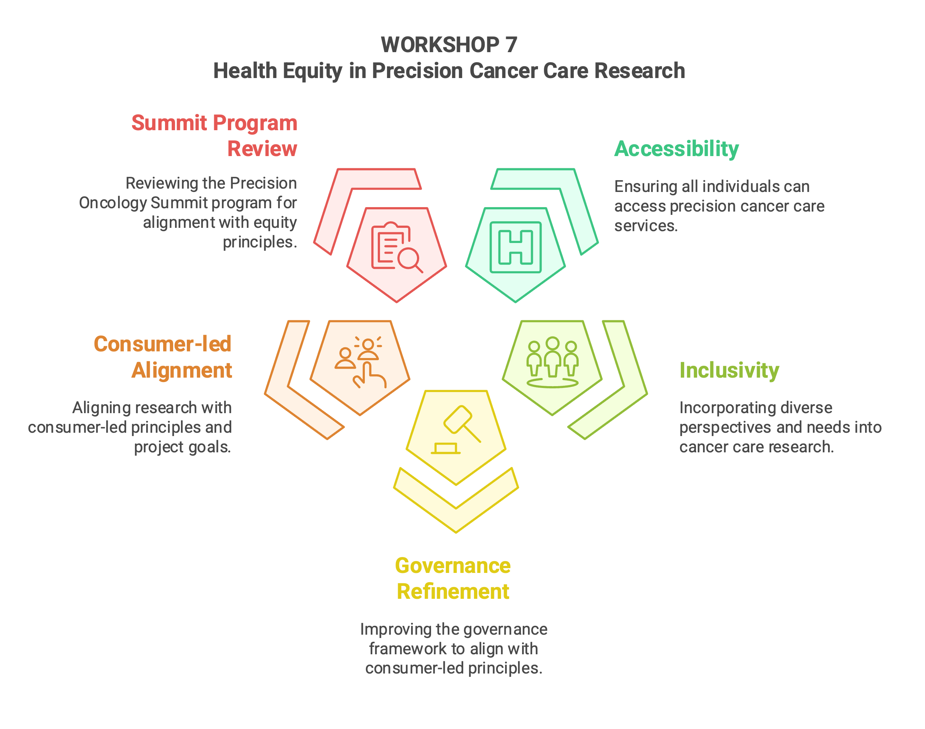
WORKSHOP 8 | Defining the research question
Date | 6 April 2023
Aim | Strengthen the foundation of collaborative, consumer-led research in precision oncology by fostering alignment on research principles, refining the research question, and exploring the current landscape of genomic testing for equity and impact.
Objectives | - Establish a shared Code of Collaboration that promotes inclusivity, respect, transparency, and consent-driven decision-making in consumer-led research.  - Critically examine the current state of genomic testing in precision oncology, identifying systemic inequities, dominant attitudes, and the lived experiences of patients and families.  - Refine and prioritise research questions by leveraging structured frameworks such as PICO and Finer criteria, ensuring relevance, feasibility, and alignment with the project's objectives.
Presenters | - Principal Research Fellow, Melbourne School of Psychological Sciences
Synopsis | This workshop focused on fostering collaborative research practices and advancing precision oncology research through consumer leadership. Participants co-developed a Code of Collaboration to ensure respectful, transparent, and inclusive interactions. The group explored the current landscape of genomic testing, examining systemic attitudes, equity challenges, and lived experiences to understand who benefits, who misses out, and why. Through guided activities, the consumers refined their research question using structured frameworks, identifying feasible and impactful topics around interventions, outcomes, and populations. This session empowered consumers to shape a meaningful, consumer-driven research question that addressed patient-needs.
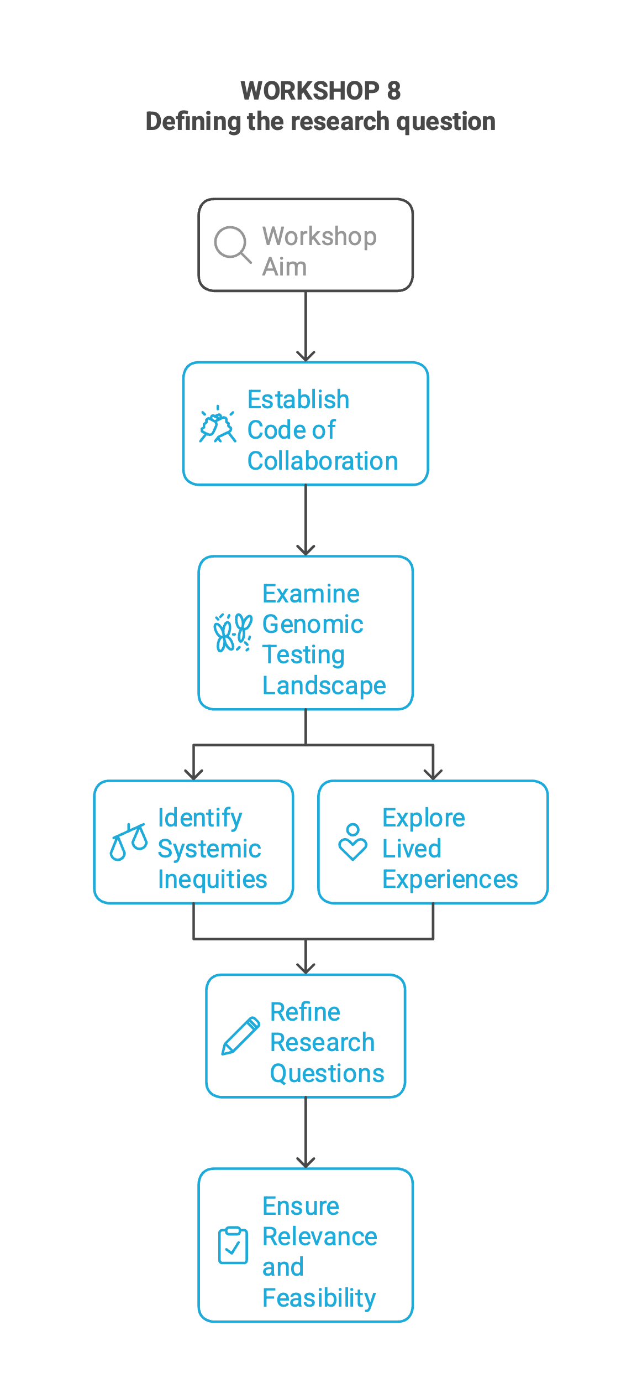

RACI Matrix:
Early in the project, the CRG, with support from the VCCC Alliance staff, worked on developing the Project RACI (Responsible, Accountable, Consulted, Informed) Matrix to clarify specific roles and responsibilities throughout the project's lifecycle. This helped identify the necessary support and education for success. The RACI was reviewed multiple times as detailed deliverables and activities emerged. It was considered essential to success, and all CRG members took ownership of the outcomes as they were involved in reaching an agreement. The latest version of the RACI, updated in April 2024, is presented below.

Researcher-led activities: The workshop slides, pre workshop recording and logic model are available via the studies open science page: https://osf.io/uc9t4/



