EXPERIENCES ACCESSING AND RECEIVING TUMOUR GENETIC PROFILING IN VICTORIA: A CONSUMER-LED CROSS-SECTIONAL SURVEY STUDY

Victorian Comprehensive Cancer Centre (VCCC) Alliance Personalised Cancer Care Consumer Reference Group: Kathleen Minas¹*, Melissa Sheldon¹*, Sonja Ilievska¹*, Naveena Nekkalapudi¹*, Kenneth Young¹*, Jonathan Ashley Granek¹*, Victoria Sharp¹*, Beth Doggett¹*
Victorian Comprehensive Cancer Centre (VCCC) Alliance staff: Genevieve Dall¹, Joanne M Britto¹, Nonie Chan¹, Michelle Barrett¹, Mark Buzza ¹. Research Support Team (University of Melbourne): Tamara Jones², Sarah Stratulate,^{2,3} Camille E Short.^{2,3}

*Equal first author

Supplementary file 3. Study Survey

EXPERIENCES ACCESSING AND RECEIVING TUMOUR GENETIC PROFILING IN VICTORIA:

A CONSUMER-LED CROSS-SECTIONAL SURVEY STUDY

Version 1 – 28th November (Revised in Response to Ethics).
Your responses indicate that you are eligible to participate in this study. Please read the information below and then answer the questions as accurately as you can. A few questions are optional, but for most, you will need to answer before you can move to the next section.
This survey will take approximately 15-30 minutes to complete, depending on your situation and if you have any comments you would like to make.
You can stop the survey at any time and return at a later date if you wish.
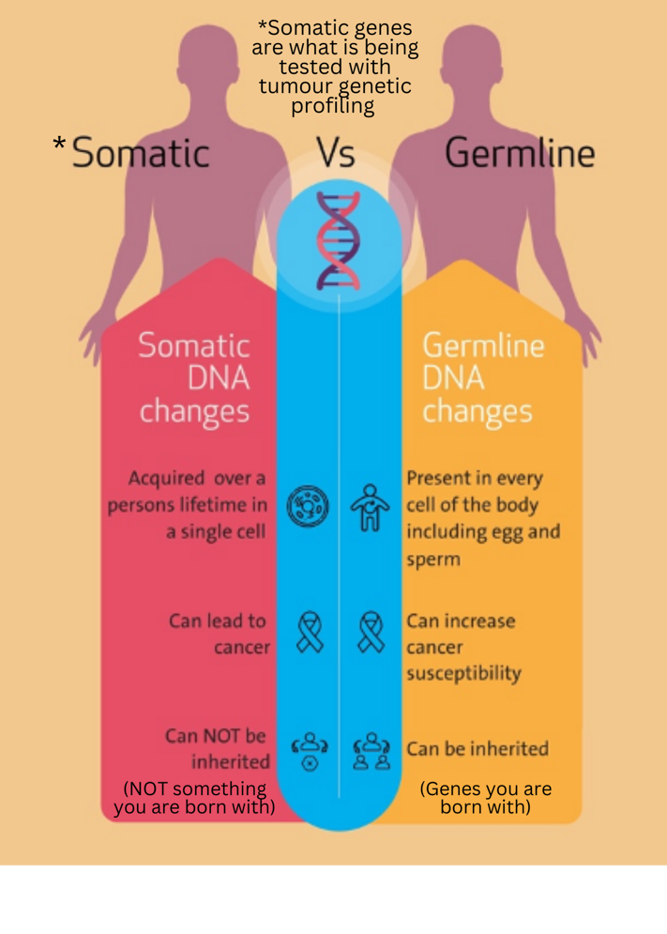
//Introduction
- We are interested in your experience receiving or being offered tumour genetic profiling as part of your cancer diagnosis and treatment.
- This includes understanding if tumour genetic profiling was not something you were offered or have ever heard of.
Version for carers:
- We are interested in your experience of the person you care/cared for receiving or being offered tumour genetic profiling as part of their cancer diagnosis and treatment.
- This includes understanding if tumour genetic profiling was not something they were offered or have ever heard of.
What is tumour genetic profiling?
Tumour genetic profiling (also called somatic testing) is a type of genetic test.
- It identifies gene mutations that occur within cancer cells, and sometimes requires a biopsy.
- It provides information on a person’s specific cancer profile so that the best method of treatment can be selected.
- It has great potential to improve patient’s chances of survival and reduce exposure to negative effects (e.g., by avoiding chemotherapy if it is unlikely to be helpful).

Tumour genetic profile testing is different to testing the genes a person is born with. Testing genes a person is born with is a type of genetic testing called germline testing.
- Germline testing is more commonly available and is usually done to find out if someone has inherited mutations from their parents that make them more likely to get cancer (e.g., the BRCA1 or BRCA2 genes, which may lead to increased risk of breast, ovarian, pancreatic and prostate cancers).

SECTION ONE - Experiences of tumour genetic profiling

These questions ask about your experiences during cancer treatment planning. If you have had
Question 1: Did anyone in your treatment team discuss tumour genetic profiling with you as part of your cancer treatment planning? (Did anyone in the treatment team discuss tumour genetic profiling as part of cancer treatment planning for the person you care or cared for?)
- Yes
- No
- Not that I remember

Question 2: Prior to commencing this survey, how familiar were you with the concept of tumour genetic profiling?
- Not at all (Skip to question 4).
- A little
- Somewhat
- Very
- Extremely

Question 3: From where have you learned most about tumour genetic profiling? (Select one): // From Sylvia (1)
- From a health care professional
- From participating in research studies
- Reading research papers
- Through searches on the internet
- From advertising on the internet
- Other forms of advertising
- Through social media
- From films, television or other media (eg, newspaper or magazine articles)
- Friends or family
- Other (If ticked, proceed to Q3.2a)
  - Q3.2a If other, please specify (open text box)
Question 4: From where would you trust to receive information about tumour genetic profiling? (Select all that apply): // From Sylvia (1)
- 1 From a health care professional
- 2 From participating in research studies
- 3 Reading research papers
- 4 Through searches on the internet
- 5 From advertising on the internet
- 6 Other forms of advertising
- 7 Through social media
- 8 From films, television or other media (eg, newspaper or magazine articles)
- 9 Friends or family
- Other (If ticked, proceed to Q4.2a)
  - Q4.2a If other, please specify (open text box)
Question 5: Have you ever had a test for tumour genetic profiling? (Did the person you care/cared for ever have a test for tumour genetic profiling?)
- No – go to question 6
- Yes - go to question 7
- I’m not sure – go to question 16.

//Outcome for Research question 1: We will explore predictors of answering yes or no to this question. E.g., Are those in metropolitan areas more likely to answer yes?

Question 6: Which of the following best explain why you have not had testing for tumour genetic profiling (select all that apply). (Which of the following best explain why the person you care/cared for has not had testing for tumour genetic profiling (select all that apply).)
- I was not aware of testing for tumour genetic profiling / We/they were not aware of testing for tumour genetic profiling
- I do not understand it / We/they do not understand it
- I did not feel tumour genetic profiling would benefit me / We/ they did not feel tumour genetic profiling would be of benefit
- My treatment team did not feel that tumour genetic profiling would benefit me / The treatment team did not feel tumour genetic profiling would be of benefit
- I felt tumour genetic profiling would cause me worry or stress / We/they felt tumour genetic profiling would cause worry or stress
- I could not afford to access tumour genetic profiling / We/they could not afford to access tumour genetic profiling
- I had privacy concerns / We/they had privacy concerns
- COVID-19
- I could not access tumour genetic profiling through Medicare / We/they could not access tumour genetic profiling through Medicare
- There were no clinical trials available.
- I would have had to travel too far / We/they would have had to travel too far
- Views of friends or family
- Faith-based or religious reasons
- Other (please specify).
  - If other, please specify. (open text box)

// PEOPLE WHO HAVE NOT HAD TESTING WILL NOW GO TO NEXT SECTION (Q16).
Question 7: (If yes Q5). Please provide details of the tumour genetic profiling that you have/the person you care/cared for has had by completing the table below. If you/they have undergone tumour profiling more than once, please provide details for each test.
Year | Access | Estimated amount paid out of pocket for the test | Travel required to access testing | Cancer type | Cancer stage at time of testing | Timing of test
2000-2023/4 | How was the test arranged?  - Arranged on your own through private pathology  - Through your treatment team  - Through a research project or clinical trial  - By GP/primary care/family physician  - By a medical specialist  - Other | 0-10,000 | 0km-4000kms | - Breast cancer  - Prostate cancer  - Lung cancer  - Melanoma  - Colorectal (bowel) cancer  - Head and neck cancer  - Pancreatic cancer  - Thyroid cancer  - Ovarian  - Cervical  - Leukemia  - Lymphoma  - Myeloma  - Sarcoma  - Cancer of unknown primary  - Other | Stage 1  Stage 2  Stage 3  Stage 4  I don’t know | - At diagnosis or soon after  - During initial treatment review  -During watchful waiting  -With  progression  - After relapse  - After not responding to treatment

Question 8: (If yes Q5). How did your physician present the tumour genetic profiling test results? If you have had more than one test, please answer based on the most rece test you had. (Select all that apply) // Tzeng custom and was specific to breast cancer [1] (2).
- Using numbers (ie. 6% chance)
- Using words (ie. ‘low risk’ or ‘high risk’)
- Using graphics (ie. charts)
- Other ___

Question 9: (If yes Q5). How much did you understand what you were told about your treatment choices based on the tumour genetic profiling test? If you have had more than one test, please answer based on the most recent test you had. // (2)

- Nothing at all
- Some things
- Most things
- Everything

Question 10: (If yes Q5). Please think about what happened when you talked with health care providers including doctors, nurses and other health care professionals about tumour genetic profiling for your cancer. / Please think about what happened when you / the person you care or cared for talked with health care providers including doctors, nurses and other health care professionals about tumour genetic profiling for cancer. // Shared decision making process scale (3). Used in (4)
How much did you and your health care providers: / How much did yourselves and your health care providers:
a) talk about the reasons you might want to have tumour genetic profiling? / talk about the reasons the person you care or cared for might want to have tumour genetic profiling?
□ A lot □ Some □ A little □ Not at all □ I don’t know
b) talk about the reasons you might not want to have tumour genetic profiling? talk about the reasons the person you care or cared for might not want to have tumour genetic profiling?
□ A lot □ Some □ A little □ Not at all □ I don’t know
Did any of your health care providers
c) explain that there were choices in what you could do to treat your cancer? / explain that there were choices in what the person you care or cared for could do to treat the cancer?
□Yes □ No □ I don’t know
d) ask if you wanted to have tumour genetic profiling? ask if the person you care or cared for wanted to have tumour genetic profiling?
□ Yes □ No□ I don’t know

Hypothesis: High levels of shared decision making will be associated with positive outcomes (lower distress, lower regret).

We are interested in the positive and negative impacts on people after receiving tumour genetic profiling results. If you have had more than one test, please consider your most recent test when answering these questions. / We are interested in the positive and negative impacts on people after receiving tumour genetic profiling results. If the person you care/cared for has had more than one test, please consider the most recent test when answering these questions.

Questions 11: (If yes Q5). Thinking about the decision to have tumour genetic profiling, please show how strongly you agree or disagree with these statements.

By ticking the number from 1 (strongly disagree) to 5 (strongly agree) which best fits your view about that decision // Decision Regret Scale (5 items) (5). Used in (6).
 | Strongly disagree | Disagree | Neither agree or disagree | Agree | Strongly agree
- It was the right decision | q1 | q2 | q3 | q4 | q5
- I regret the choice that was made | q1 | q2 | q3 | q4 | q5
- I would go for the same choice if I had to do it over again I would support the same choice if they had to do it over again. | q1 | q2 | q3 | q4 | q5
- The choice did me a lot of harm The choice did them a lot of harm | q1 | q2 | q3 | q4 | q5
- The decision was a wise one | q1 | q2 | q3 | q4 | q5

QUESTION 12. How useful were the test results to you? (4) / How useful do you believe the test results were to the person you care or cared for?

  - Extremely useful
  - Useful
  - Somewhat useful
  - Not at all useful

QUESTION 13. What do you feel you have gained from your test results? (Select all that apply)(4) / What do you think was gained from the test results?

  - Increased knowledge and understanding
  - Relief from uncertainty about the future
  - More personalized treatment options
  - Information relevant to life planning
  - Improved mental health
  - Other benefits not listed above.
(Please describe): ______________________________________________________
  - Not applicable-test results are not useful

QUESTION 14. What do you feel were the drawbacks from your test and/or test results? (Select all that apply) // What do you feel were the drawbacks from the test and/or test results? (Select all that apply)
MoST included open ended question. Adapted from Jamal L, Robinson J, Lupo P, et al. Perceptions of next generation sequencing, results and plans to use non-actionable findings. Am Soc Hum Genet. 2015. Conference abstract.
- Financial burden
- Increased uncertainty
- Psychological Distress
- Confusion
- Other drawbacks not listed above.
(Please describe): ______________________________________________________
- Not Applicable-No drawbacks experienced

QUESTION 15. Overall, how would you rate the impact of tumour genetic profiling on you personally. // Place an X on the line to indicate your overall experience (Visual Analogue Scale).
Extremely Negative Extremely Positive
0-----------------------------------------------------------------------------------------------------------------100

QUESTION 16. Overall, how would you rate the impact of tumour genetic profiling on the person you care or cared for? // Place an X on the line to indicate their overall experience (Visual Analogue Scale).
Extremely Negative Extremely positive
0-----------------------------------------------------------------------------------------------------------------100

Outcome for research question two: This question will allow us to explore predictors of more positive or more negative experience.

SECTION TWO – IMPROVING EXPERIENCE OF TUMOUR GENETIC PROFILING IN VIC

//All respondents answer these questions
QUESTION 17. How important do you think each of these strategies are to help improve tumour genetic profiling for cancer patients in Victoria? (Not at all – Extremely, I don’t know).
    - Tests subsidised by the government
    - Education to understand genomic testing, including differences between tumour genetic profiling and germline testing
    - Access to research studies
    - Improving the consent process in research studies
    - Access to health professionals with improved knowledge of genomic testing
    - Access to genetic counsellors

QUESTION 18. Which of these strategies do you think is MOST important to improve tumour genetic profiling for cancer patients in Victoria? (Choose one)
    - Tests subsided by the government.
    - Education to understand genomic testing, including differences with genetic testing
    - Access to research studies
    - Improving the consent process in research studies
    - Access to health professionals with improved knowledge of genomic testing
    - Access to genetic counsellors

QUESTION 19. Who would you prefer to receive test results for tumour genetic profiling from?
    - Your treatment team
    - A centralised service with expertise in tumour profiling

Question 20. We know that trust in the health care system might impact on people’s preferences and needs. Please indicate the degree to which you agree with each of these statements. (7) (8)
- “I trust my healthcare providers”
- “I always believe someone when they say that their healthcare provider hasn’t been nice to them”
- “In general, the healthcare system is not sensitive to the patients’ needs”
- “I’ve been treated poorly by healthcare providers more often than I’ve been treated with respect.”
4-point Likert-type scale (strongly agree to strongly disagree).

Question 21: Do you have any comments you would like to make about tumour genetic profiling? Please share anything you think might be important for advocating for future patients and carers.
___________________________________________________________________________
SECTION THREE - PARTICIPANT DEMOGRAPHICS

Because we are interested in understanding who is likely to be offered and receive tumour genetic profiling, we will also ask you questions about yourself, including demographic and medical history information. This will allow us to examine if things like where people live, how much money they have, and their diagnosis impact on access. The findings of this research will be used to advocate for fairer access to tumour genetic profiling in Victoria.
Question 22: Current age in years (drop down list).
Question 23: What is your home postcode? Nb. We can calculate remoteness from postcode.
Question 24: What gender do you identify as?
- Female
- Male
- Prefer not to say
- Other, please specify

Question 25: What is your current relationship status?
- Married, de-facto or living with partner
- Separated or divorced
- Widowed
- Single
- Prefer not to say

Question 26: What is your highest level of education?
- Primary school (Year 6)
- High school (Year 10 or 12)
- Certiﬁcate or diploma (e.g. TAFE or college)
- University degree
- Other, please specify

Question 27: What best describes your employment at this time?
- Full-time
- Part-time
- Casual
- Retired
- Household/caring duties
- Volunteer
- On leave without pay
- On leave with pay
- Unable to work due to diagnosis/treatment, receiving pension
- Unemployed
- Other, please specify

Question 28: What is your present gross family income each week (that is, before tax)?
1 Less than $300 per week
2 Between $300- $499 per week
3 Between $500- $799 per week
4 Between $800- $1000 per week
5 More than $1000 per week
6 Prefer not to answer

Question 29: Which of the following do you identify with? (Check as many as apply)
- Australian
- Aboriginal
- Torres Strait Islander
- New Zealander
- Maori/Pacific Islander
- North American
- Central/South American
- Northern European
- Southern European
- Eastern European
- African
- Middle Eastern
- Central Asian
- South Asian
- South East Asian
- East Asian
- Other, please specify

Question 30: Do you speak any language at home other than English?
- No
- Yes, please specify

SECTION FOUR – CANCER HISTORY AND HEALTH

This section of the survey asks your questions about your general health, cancer diagnosis and treatments.
Question31: //Global health status/ Qol from EORTC- QLQ-C30

- How would you rate your overall health during the past week
1(very poor) – 7 (excellent)

- How would you rate your overall quality of life during the past week?
1(very poor) – 7 (excellent)

Question 32: What type(s) of cancer have you/the person you cared for/are caring for been diagnosed with (select all that apply)?
- Breast cancer
- Prostate cancer
- Lung cancer
- Melanoma
- Colorectal (bowel) cancer
- Head and neck cancer
- Pancreatic cancer
- Thyroid cancer
- Ovarian
- Cervical
- Leukemia
- Lymphoma
- Myeloma
- Sarcoma
- Cancer of unknown primary
- Other (please provide)

//List based on European Society of Medical Oncology-ESCAT Taxonomy (ESMO Scale of Clinical Actionability for molecular Targets) https://oncologypro.esmo.org/tumour-sites
Question 33: When were you/the person you care or cared for first diagnosed with cancer? Month/Year

Question 34: What stage was your/their cancer when ﬁrst diagnosed? Please select a response //custom
- Stage 1
- Stage 2
- Stage 3
- Stage 4
- Unsure
Question 35: Which of the following best describes your/ the person you care or cared for current circumstances? Please select a response //custom
- Diagnosis, staging and treatment planning
- Currently undergoing curative treatment
- Care after initial treatment and recovery
- Managing recurrent, residual or metastatic disease
- End-of-life care
- Deceased

Question 36: Have you ever had a germline test? (Did the person you care/cared for ever have a germline test?)
- No – go to question 38
- Yes - go to next question (q37)
- I’m not sure – go to question 38

Question 37: Was the germline test result positive? A positive result means that a genetic variant associated with inherited cancer risk (e.g., BRAC2) was found.
- No
- Yes (please specify variant found if known _____).

Question 38: What type of cancer treatments are (/were) part of your/their treatment plan? Please select all that apply //custom

- Chemotherapy
- Surgery
- Immunotherapy
- Radiation therapy
- Bone marrow transplant
- Hormone therapy
- Targeted drug therapy
- Other, please specify
- I don’t know

Question 39: What type of hospital is managing/managed your/their cancer care? Please select a response //custom
- Public
- Private
- Both public and private

40. What types of allied health services have you engaged with as part of your cancer recovery or management? / What types of allied health services have the person you care/cared for engaged with as part of their cancer recovery or management?
- Physiotherapy
- Exercise Physiology
- Psychology
- Dietetics/ Nutrition
- Occupational Therapy
- Social Work
- Genetic counselling
- Other (please specify)

Thank you for completing this survey. It will help to direct our research eﬀorts in this area. If you are interested in being contacted for further research or events, receiving a summary of the survey ﬁndings, or entering the draw to win one of five $50 Giftpay vouchers, please leave your contact details on the next page.
If you do not want to be contacted or sent results, please exit the survey.
If you wish to contact the research team, please email [PI Email].
If this survey has caused you any distress, you can contact the research team by phone or email (_____). You can also talk to your doctor or call the Cancer Council Helpline (13 11 20, available 9am-5pm, Mon-Friday ) or Lifeline (13 11 14, available 24 hours a day) to speak to a trained support worker.

--------------------------------------------------------------------------------------------------------------------------

---END SURVEY---

References
1. Savard J, Hickerton C, Tytherleigh R, Terrill B, Turbitt E, Newson AJ, et al. Australians’ views and experience of personal genomic testing: survey findings from the Genioz study. European Journal of Human Genetics. 2019;27(5):711-20.
2. Tzeng JP, Mayer D, Richman AR, Lipkus I, Han PK, Valle CG, et al. Women's experiences with genomic testing for breast cancer recurrence risk. Cancer. 2010;116(8):1992-2000.
3. Valentine KD, Vo H, Fowler FJ, Jr., Brodney S, Barry MJ, Sepucha KR. Development and Evaluation of the Shared Decision Making Process Scale: A Short Patient-Reported Measure. Med Decis Making. 2021;41(2):108-19.
4. Ahmed K, Siegel JJ, Morgan-Linnell SK, LiPira K. Attitudes of patients with cutaneous melanoma toward prognostic testing using the 31-gene expression profile test. Cancer Medicine. 2023;12(2):2008-15.
5. Brehaut JC, O'Connor AM, Wood TJ, Hack TF, Siminoff L, Gordon E, et al. Validation of a decision regret scale. Med Decis Making. 2003;23(4):281-92.
6. Best M, Newson AJ, Meiser B, Juraskova I, Goldstein D, Tucker K, et al. The PiGeOn project: protocol for a longitudinal study examining psychosocial, behavioural and ethical issues and outcomes in cancer tumour genomic profiling. BMC Cancer. 2018;18(1):389.
7. Katapodi MC, Pierce PF, Facione NC. Distrust, predisposition to use health services and breast cancer screening: Results from a multicultural community-based survey. International Journal of Nursing Studies. 2010;47(8):975-83.
8. Ozawa S, Sripad P. How do you measure trust in the health system? A systematic review of the literature. Soc Sci Med. 2013;91:10-4.

