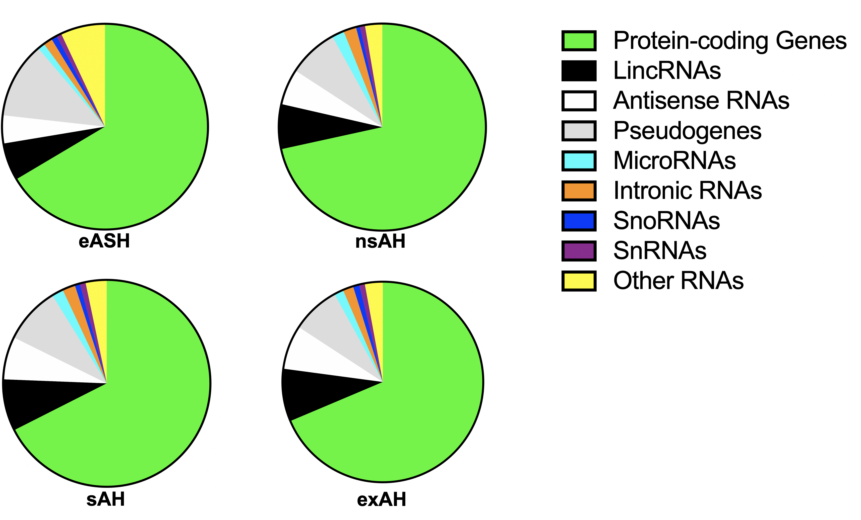

Supplementary Figure 1. Distribution of altered transcripts in AUD. eASH – early alcoholic steatohepatitis, nsAH – non-severe alcoholic hepatitis, sAH – severe alcoholic hepatitis, exAH – explants from patients who underwent hepatic transplantation due to liver failure.

Supplementary Figure 2. Blood alcohol concentrations in rats exposed to alcohol vapor (N=12 in each group). * – P < 0.05.

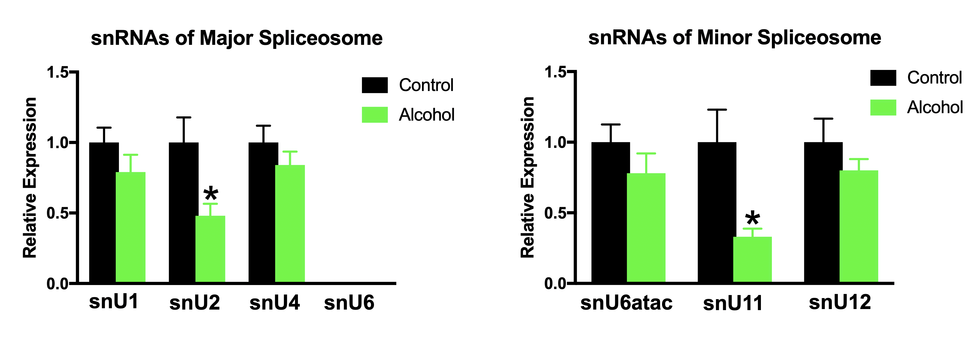

Supplementary Figure 3. Expression of snRNAs in the lung of rats exposed to alcohol vapor. * – P < 0.05.

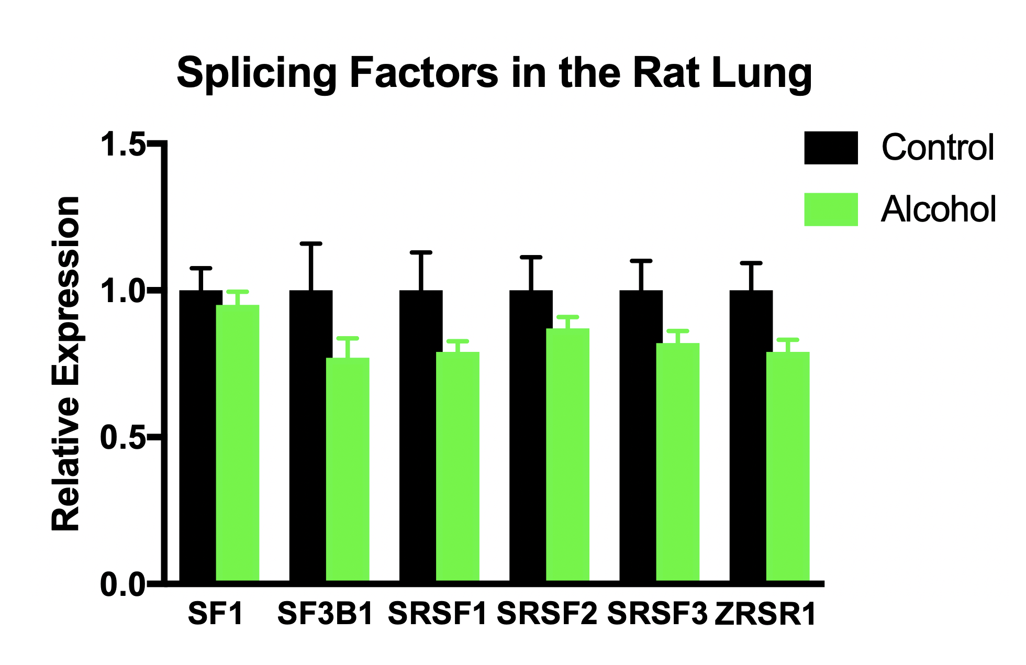

Supplementary Figure 4. Expression of cancer-related splicing-factors in the lung of rats.

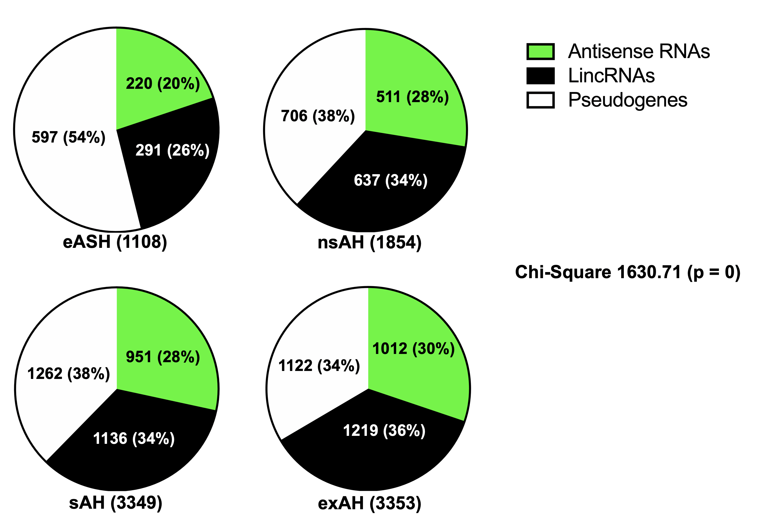

Supplementary Figure 5. Distribution of altered hepatic lncRNAomes in AUD. eASH – early alcoholic steatohepatitis, nsAH – non-severe alcoholic hepatitis, sAH – severe alcoholic hepatitis, exAH – explants from patients who underwent hepatic transplantation due to liver failure. LincRNAs – long intergenic non-coding RNAs. Difference in proportion of affected lncRNAs between groups was calculated using chi-square test.
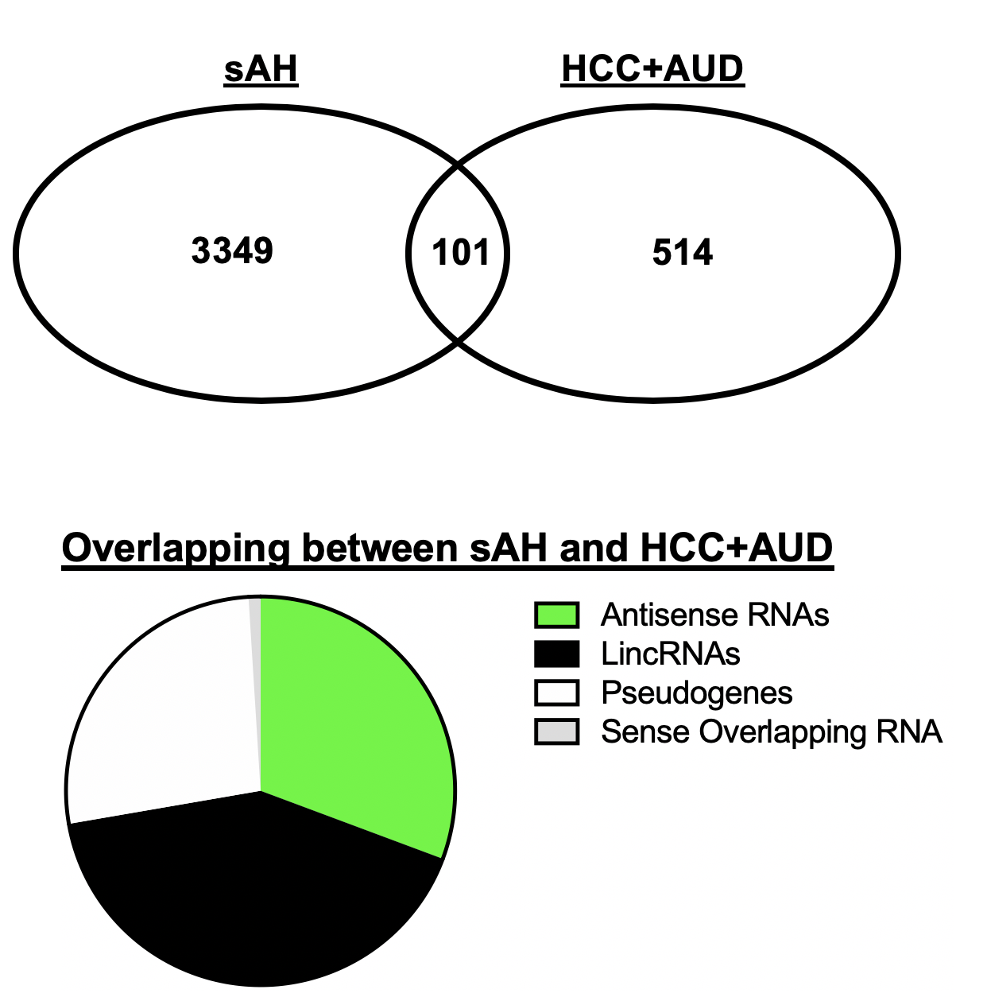

Supplementary Figure 6. LncRNAs overlapping in severe alcoholic hepatitis (sAH) and hepatocellular carcinoma in patients with alcohol use disorder (HCC+AUD). LincRNAs – long intergenic non-coding RNAs.

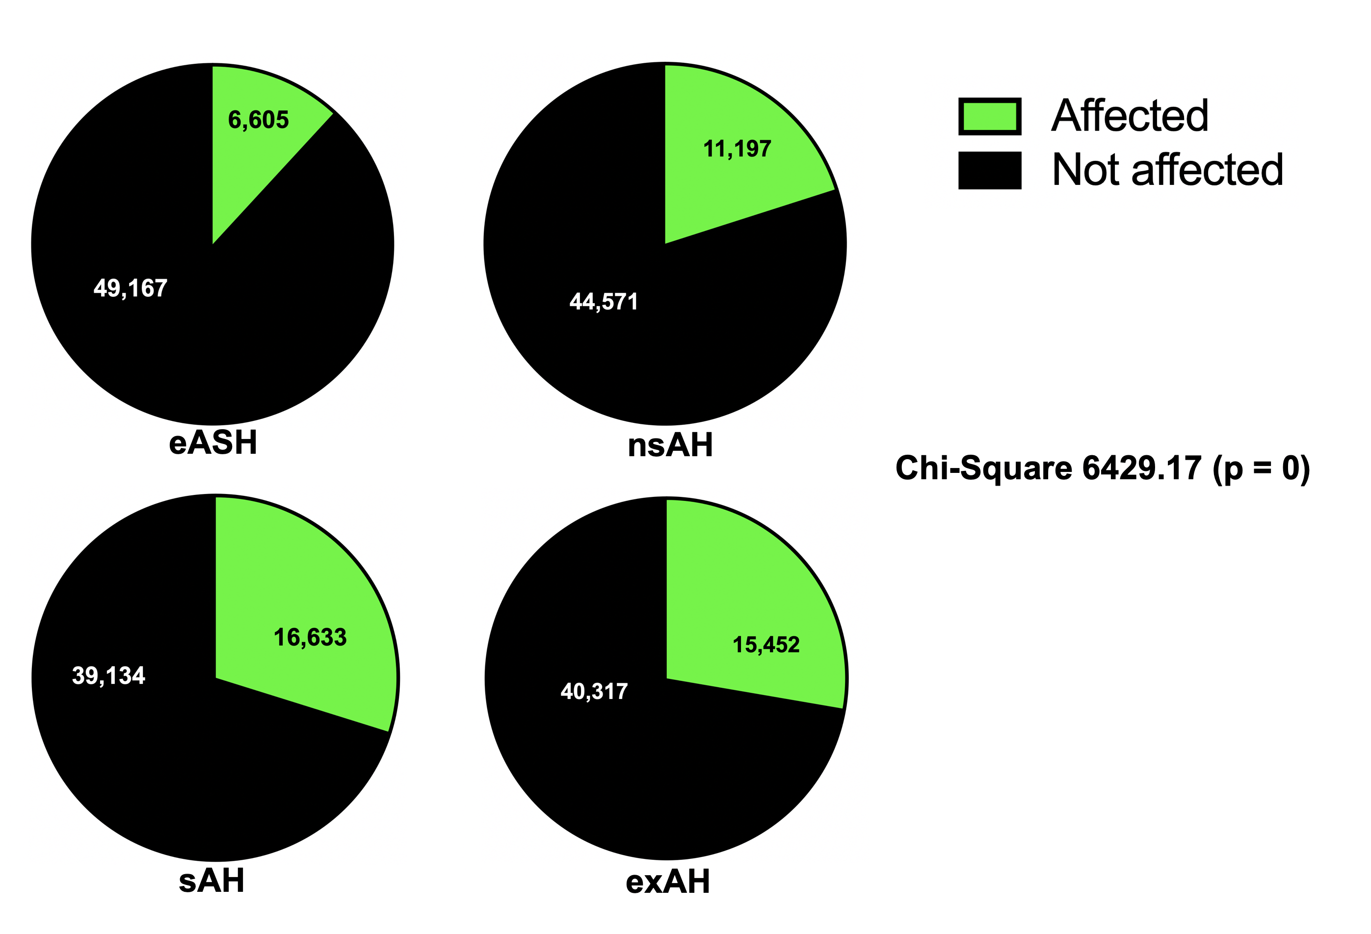

Supplementary Figure 7. Differentially expressed and misspliced genes in AUD. eASH – early alcoholic steatohepatitis, nsAH – non-severe alcoholic hepatitis, sAH – severe alcoholic hepatitis, exAH – explants from patients who underwent hepatic transplantation due to liver failure. Difference in proportion of affected genes between groups was calculated using chi-square test.

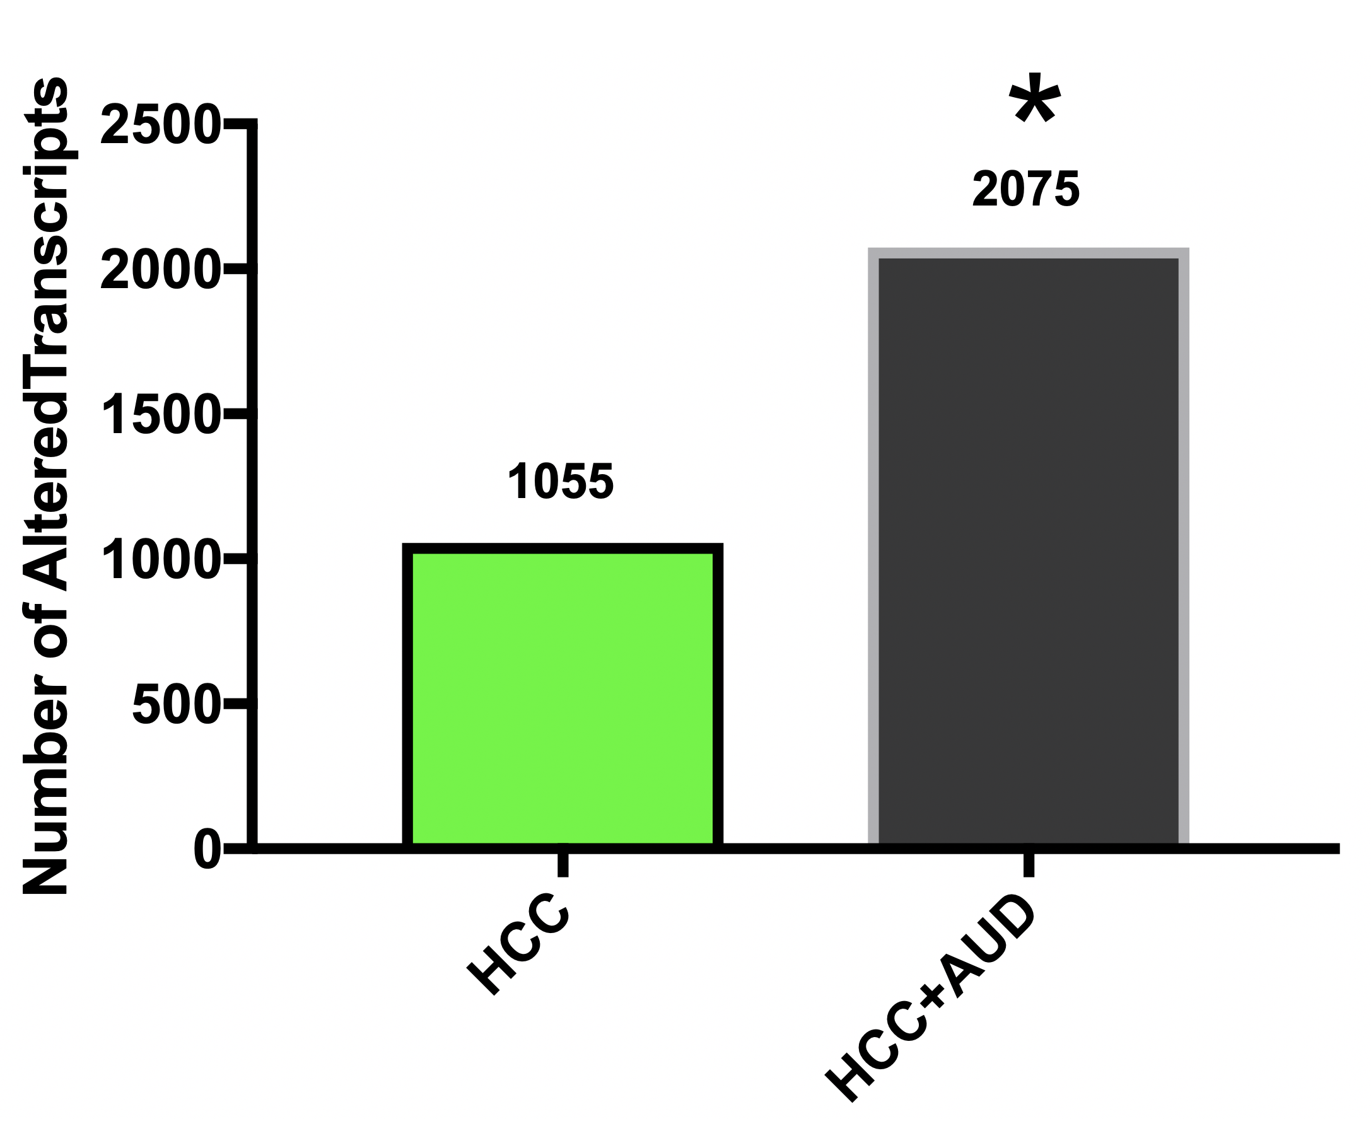

Supplementary Figure 8. Gene expression in hepatocellular carcinoma in patients with and without alcohol use disorder. HCC – hepatocellular carcinoma, AUD – alcohol use disorder. Difference in proportion of affected transcripts between groups was calculated using chi-square test.

