Supplemetary data
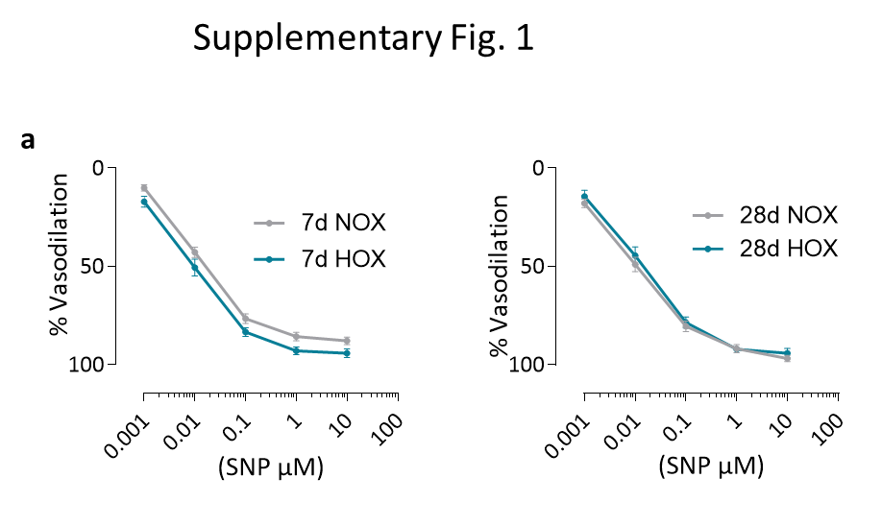

Figure S1 Sodium nitroprusside (SNP) response of mice in normoxia vs hypoxia at 7 days and 28 days a-b) Effect of sodium nitroprusside (SNP) at cumulative doses on Phenylephrine (PE) (1µM) preconstricted mouse pulmonary artery rings a) 7 days under normoxia and hypoxia (n=16 rings in NOX and n=18 rings in HOX) b) 28 days under normoxia and hypoxia (n=16 rings in NOX and n=13 rings in HOX).
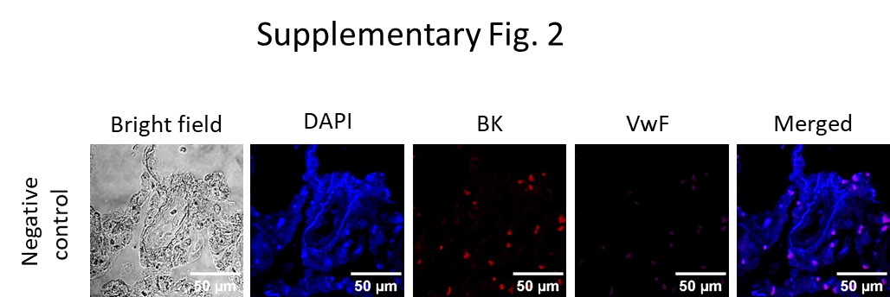

Figure S2 BK staining of human donor PAs. Negative control for BK staining in human donor PAs showing the background signal in the absence of primary antibodies.

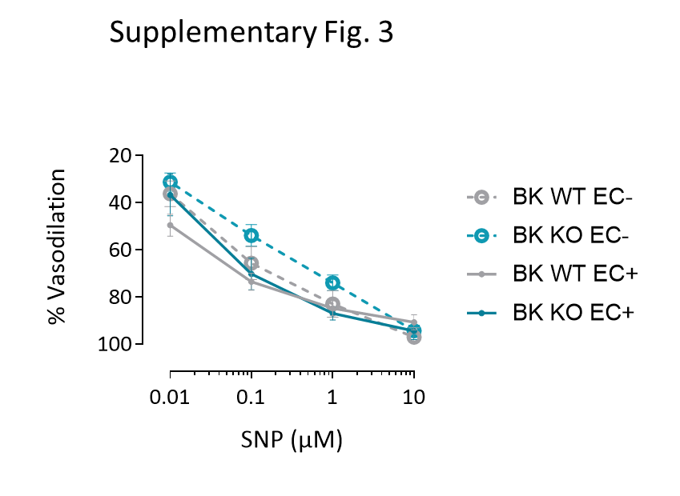

Figure S3 Sodium nitroprusside (SNP) response of BK WT vs BK KO mice PA rings. Effect of sodium nitroprusside (SNP) at cumulative doses on Phenylephrine (PE) (1µM) preconstricted mouse pulmonary artery rings with intact endothelium (n=8 for WT and n=7 for KO) and endothelium denuded (n=11 for WT and n=15 for KO).

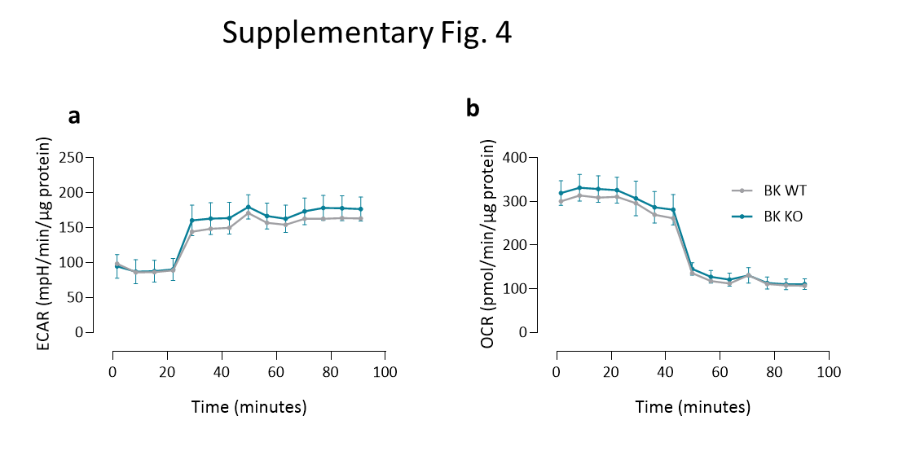

Figure S4 Disrupted bioenergetics due to lack of BK a) Glycolytic ability under mitostress condition represented by ECAR curve (n=6). b) Mitochondrial respiration under glycolytic stress condition represented by OCR curve (n=6).

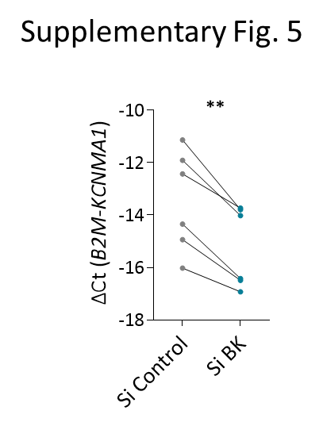
Figure S5 Silencing of KCNMA1 qPCR of hPAECs proving the decreased expression of KCNMA1 after siRNA treatment compared to siControl in the same donor cells (n=6). ** p < 0.01 paired t-test, data are presented as mean ± SEM.
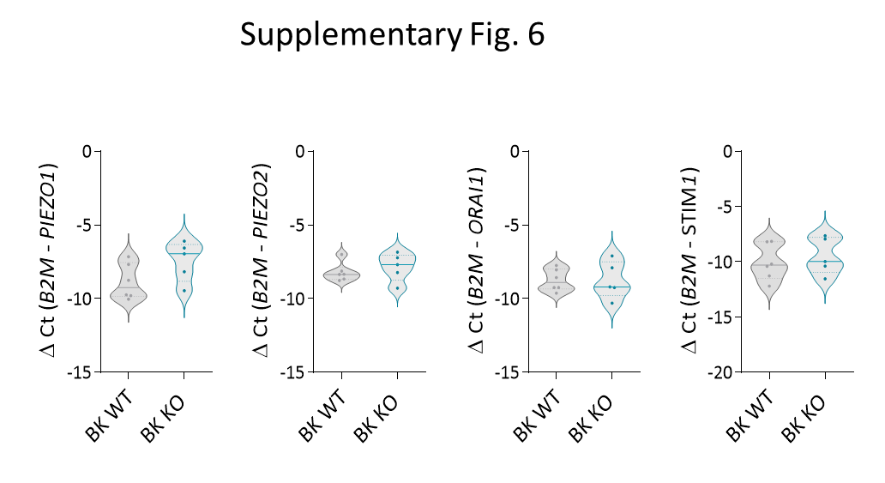

Figure S6 Expression of calcium influx channels in BK WT vs BK KO mice qPCR showing similar mRNA expression levels of piezo-1, piezo-2, STIM and ORAI channels in BK WT (n=6) vs BK KO mice (n=5).

