Risk-stratification of febrile African children at risk of sepsis using sTREM-1 as basis for a rapid triage test

Supplementary Information

Supplementary Information Table of Contents
I. Supplementary methods 3
Sample size consideration 3
Patient enrolment 3
Blood sample processing 3
Biomarker quantification 3
Literature review 4
Diagnostic definitions 4
a. Malaria 4
b. HIV 4
c. Pneumonia 4
II. Supplementary Tables 5
Table 1: Baseline characteristics for derivation and validation cohort 5
Table 2: Treatments reported at time of presentation 6
Table 3: Baseline characteristics between derivation and validation cohorts 7
Table 4: Baseline characteristics for children who absconded after 7 days 8
Table 5: Baseline characteristics for children who were transferred after 7 days 9
Table 6: Biomarker geometric means in cohorts combined and derivation and validation cohorts separately. 10
Table 7: Performance of 4 biomarkers quantified in all children with available plasma in derivation, internal validation, and external validation cohorts 11
Table 8: Performance of 4 biomarkers quantified in all children with available plasma in the derivation, internal validation, and external validation cohorts in children with and without malaria 12
Table 9: Likelihood ratios based on sTREM-1 cut-offs from the 10th to the 99th percentile of distribution in 0·1 natural logarithm increments of sTREM-1 in derivation, internal validation, and external validation cohorts 13
Table 10: Studies evaluating plasma sTREM-1 for sepsis diagnosis or outcome 14
Table 11: Coefficient of variance for intra-assay performance of 11 plasma biomarkers 16
III. Supplementary Figures 17
Fig. 1: Distribution of sTREM-1 and probabilities of death for: 17
a. Derivation Cohort 17
b. Validation Cohort 18
Fig. 2 Calibration plots for Log sTREM-1 values with multiple imputations from: 19
a. Internal Validation 19
b. External Validation 19
Fig. 3: Calibration plots for sTREM-1 Zones with multiple imputations from: 20
a. Internal Validation 20
b. External Validation 20
Fig. 4: Time-to-event analyses by sTREM-1 zones in the derivation cohort for: 21
a. Whole derivation cohort 21
b. Subgroup of derivation cohort with malaria 21
c. Subgroup of derivation cohort without malaria 21
Fig. 5: Time-to-event analyses by sTREM-1 zones in the validation cohort for: 22
a. Whole validation cohort 22
b. Subgroup of validation cohort with malaria 22
c. Subgroup of validation cohort without malaria 22
IV. References 23

Supplementary methods

Sample size consideration

The original sample size consideration assumed a nested case-control design, defining in-hospital deaths as cases and using 3 survivors per case as matching controls. The recruitment of 2,475 children would result in 99 in-hospital deaths and more than 80% power to detect a standardized difference between cases and controls of 0.45 standard deviations using a Bonferroni correction that allowed this difference to be tested simultaneously for 13 biomarkers at a two-sided alpha of 0.0038 (0.05/13). The difference of 0.45 standard deviation units would correspond to a 40% difference in mean values of Ang-2, between a mean of 11,000 pg/mL in survivors and 15,600 pg/mL in children who died in-hospital, with a common standard deviation of 9,600 pg/mL.¹ The current analysis reflects the original prospective cohort design rather than a nested case-control design, using in-hospital mortality from any cause up to 7 days as pre-specified primary outcome.

Patient enrolment

Patient enrolment occurred between 08:00 and 20:00. Patients presenting after 20:00 had a sample collected on the next day. Of 2,502 enrolled children, 11 presented after working hours, 8 of whom had follow-up to hospital discharge and were included in the analysis. The median time from presentation to sample collection in children who were included in analysis was 2.6 hours (interquartile range (IQR) 1.0, 4.1).

Blood sample processing

A venipuncture blood sample was collected at the time of presentation to the emergency room into a BD Microtainer® blood collection tube with EDTA (Becton, Dickinson and Company) and processed within 4 hours. Microtainer tubes were centrifuged for 20 minutes at 1360g and the plasma layer was aspirated and stored in a cryovial at +4°C until transport from Jinja, Uganda to Kampala, Uganda. Sample transport to Kampala, Uganda was done on ice and occurred once a day. In Kampala, cryovials were stored in a -80°C freezer and all samples were frozen within 24-hours of sample collection. Cryopreserved samples were shipped to Toronto, Canada on dry ice, where the cryovials were stored at -80°C without freeze-thaw until batch analyte quantification.

Biomarker quantification

Plasma analyte quantification was performed using reagents from the same lot (R&D Systems) and was completed within three weeks. A detailed protocol for sample quantification has been described by our group previously.²

The following 11 biomarkers were quantified: sTREM-1, Interleukin-6 (IL-6), Interleukin-8 (IL-8), Soluble Tumour Necrosis Factor Receptor-1 (sTNFR1), Chitinase-3-like protein 1 (CHI3L1), Interferon Gamma-Induced Protein 10 (IP10), Soluble fms-like tyrosine kinase-1(sFlt-1), Angiopoietin 1 (Ang-1), Angiopoietin 2 (Ang-2), Soluble Intercellular Adhesion Molecule 1 (sICAM-1), and Soluble Vascular Cell Adhesion Molecule 1 (sVCAM-1). An additional biomarker, Granzyme B, was also quantified, but omitted from statistical analyses, as its values were below the detection limit in 838 of the 2084 children (40·2%).

Literature review

We searched PubMed without date restrictions for publications until June 26, 2020 with the search terms “strem-1”, “strem 1”, “trem-1”, “trem 1”, “strem1”, “trem1”, “strem”, “trem”, OR (soluble AND triggering AND receptor AND myeloid), restricted to humans in the infant and child age group and to publications in English. Among 51 articles, 15 reported on diagnostic or prognostic studies assessing sTREM-1 plasma levels in children at risk of sepsis (Table S1). Our study is the largest prospective study to date to evaluate the ability of sTREM-1 to predict mortality, and the only study performed in unselected febrile children between 2 months and 5 years of age presenting to a referral hospital in a low-resource setting.

Diagnostic definitions

Malaria
Malaria diagnosis was based on both the detection of P. falciparum histidine rich protein 2 (HRP2) and pan-malaria lactate dehydrogenase (pLDH) by a rapid diagnostic test (RDT) (First Response Malaria Ag. HRP2/pLDH Combo Rapid Diagnostic Test, Premier Medical Corporation Limited, India) and visualization of parasites using light microscopy of Field’s stained thick peripheral blood smear.³

HIV
HIV diagnosis was confirmed by two antibody-based RDTs and quantitative polymerase chain reaction (PCR). A sample was considered seronegative if the Alere Determine® RDT (Waltham, MA, USA) was negative. Positive results were confirmed with a second RDT from a different manufacturer (Chembio, Medford, NY, USA). The sample was considered seropositive if both results were positive. Samples were considered indeterminate if the antibody tests were discordant. All seropositive and indeterminate samples were tested by PCR (Abbott Laboratories Ltd.). Children >24 months old were considered HIV infected if they were seropositive, or if they had indeterminate serology and detectable HIV RNA. Infants ≤24 months old were considered HIV infected if they had either seropositive or indeterminate serology and had detectable HIV RNA.

Pneumonia
Pneumonia was classified according to the World Health Organization (WHO) Integrated Management of Childhood Illness (IMCI) definition.⁴ The definition included a history of cough or difficulty breathing, and if present, respiratory rate >50 breaths/minute if ≤12 months or >40 breaths/minute if >12 months old. Severe pneumonia was defined as presence of pneumonia and any general danger sign.

Supplementary Tables

Table 1: Baseline characteristics for derivation and validation cohort

Characteristic at baseline* |  | Derivation Cohort |  |  |  |  | Validation Cohort
Characteristic at baseline* |  | Dead  (n=43) | Alive  (n=1390) | Odds ratio  (95% CI) | P value |  | Dead  (n=52) | Alive  (n=1017) | Odds ratio  (95% CI) | P value
Age, days |  | 18.1 (13.8) | 19.2 (12.9) | 0.84 (0.45 to 1.59) | 0.59 |  | 18.3 (12.1) | 20.4 (12.9) | 0.70 (0.39 to 1.28) | 0.25
Male (n, %) |  | 25 (58) | 760 (55) | 1.15 (0.62 to 2.13) | 0.65 |  | 29 (55.8) | 562 (55.3) | 0.99 (0.56 to 1.74) | 0.97
Time to MD, hr |  | 1.5 (1.6) | 3.0 (2.5) | 0.14 (0.05 to 0.37) | <0.001 |  | 1.7 (1.8) | 2.9 (2.1) | 0.20 (0.09 to 0.45) | <0.001
Temperature |  | 37.5 (1.5) | 37.9 (1.2) | 0.50 (0.27 to 0.93) | 0.029 |  | 37.2 (1.1) | 37.8 (1.1) | 0.33 (0.18 to 0.60) | <0.001
SpO2% |  | 91.9 (9.5) | 97.2 (3.9) | 0.37 (0.26 to 0.53) | <0.001 |  | 89.8 (12.5) | 96.9 (4.2) | 0.33 (0.22 to 0.50) | <0.001
Heart rate |  | 156 (32) | 161 (24) | 0.70 (0.38 to 1.27) | 0.24 |  | 164 (33) | 161 (24) | 1.29 (0.73 to 2.28) | 0.39
LODS (n, %) |  |  |  |  | <0.001 |  |  |  |  | <0.001
0 |  | 1 (2.3) | 846 (60.9) | 1.0 (reference) | - |  | 2 (3.8) | 666 (65.5) | 1.0 (reference) | -
1 |  | 4 (9.3) | 272 (19.6) | 12.5 (1.4 to 112.2) |  |  | 3 (5.8) | 165 (16.2) | 6.0 (1.0 to 36.5)
2 |  | 11 (25.6) | 169 (12.2) | 55.1 (7.0 to 430.4) |  |  | 14 (26.9) | 118 (11.6) | 39.5 (8.8 to 176.3)
3 |  | 27 (62.8) | 103 (7.4) | 221.0 (29.7 to 1647.4) |  |  | 33 (63.5) | 68 (6.7) | 161.5 (37.9 to 689.0)
Lactate, mmol/L |  | 7.1 (1.2 to 41.0) | 3.3 (0.8 to 14.2) | 6.41 (3.53 to 11.64) | <0.001 |  | 7.7 (1.4 to 41.7) | 3.3 (0.8 to 13.9) | 7.40 (4.16 to 13.17) | <0.001
Malaria (n, %) |  | 13 (30.2) | 746 (53.7) | 0.37 (0.19 to 0.72) | 0.004 |  | 24 (46.2) | 546 (53.7) | 0.74 (0.42 to 1.29) | 0.29
HIV (n, %) |  | 4 (9.3) | 29 (2.1) | 4.89 (1.63 to 14.67) | 0.005 |  | 1 (1.9) | 13 (1.3) | 1.55 (0.20 to 12.26) | 0.68

Displayed are means (SD) or numbers (%).

Table 2: Treatments reported at time of presentation

Intervention |  | Cohorts combined |  | Derivation cohort |  | Validation cohort
All children |  | 2502 (100%) |  | 1433 (100%) |  | 1069 (100%)
Any antimalarial |  | 2003 (81.5%) |  | 1133 (81.3%) |  | 870 (81.8%)
Any antibiotic |  | 1891 (76.7%) |  | 1091 (77.9%) |  | 800 (75.1%)
Whole blood transfusion |  | 868 (34.7%) |  | 531 (37.1%) |  | 337 (31.5%)
IV fluids |  | 298 (12.2%) |  | 213 (15.4%) |  | 85 (8.0%)
IV glucose |  | 564 (23.0%) |  | 341 (24.6%) |  | 223 (21.0%)
Malaria positive |  | 1329 (100%) |  | 759 (100%) |  | 570 (100%)
Any antimalarial |  | 1275 (97.0%) |  | 726 (97.3%) |  | 549 (96.7%)
IV Quinine only |  | 1034 (78.8%) |  | 657 (88.2%) |  | 377 (66.4%)
Other antimalarial* only |  | 171 (13.0%) |  | 27 (3.6%) |  | 144 (25.4%)
IV Quinine and other antimalarial |  | 69 (5.3%) |  | 41 (5.5%) |  | 28 (4.9%)
IMCI pneumonia |  | 1004 (100%) |  | 611 (100%) |  | 393 (100%)
Supplemental O₂ |  | 110 (11.2%) |  | 55 (9.4%) |  | 55 (14.0%)
Time to antibiotics (hours) |  | 14.5 (12.7, 17.8) |  | 15.0 (12.3, 18.0) |  | 14.5 (12.8, 17.5)
Any antibiotic |  | 838 (84.5%) |  | 500 (83.5%) |  | 338 (86.0%)
Ceftriaxone only |  | 229 (23.1%) |  | 141 (23.5%) |  | 88 (22.4%)
Other antibiotic# only |  | 342 (34.5%) |  | 220 (36.7%) |  | 122 (31%)
Ceftriaxone and other antibiotic |  | 267 (26.9%) |  | 139 (23.2%) |  | 128 (32.6%)

Data missingness for intervention variables ranged from 0.02% for whole blood transfusion to 2.4% for IV fluids.
*Antimalarials: Artesunate, Coartem, Artesunate/Coartem combination, Artemether, Sulfadoxine/Pyrimethamine (Fansidar)
#Antibiotics: Ampicillin, Amoxicillin, Penicillin, Cloxacillin, Ampiclox, Cephalexin, Gentamicin, Trimethoprim-Sulfamethoxazole, Chloramphenicol, Metronidazole, Ciprofloxacin

Table 3: Baseline characteristics between derivation and validation cohorts

Characteristic at baseline* | Derivation  (n=1433) | Validation  (n=1069) | Odds ratio  (95% CI) | P value
Age, months | 19.2 (12.9) | 20.3 (12.9) | 1.18 (1.01 to 1.39) | 0.038
Male (n, %) | 784 (54.7) | 591 (55.3) | 1.02 (0.87 to 1.20) | 0.79
Time to MD, hr | 3.0 (2.5) | 2.9 (2.1) | 0.88 (0.75 to 1.04) | 0.13
Temperature | 37.9 (1.2) | 37.8 (1.1) | 0.84 (0.72 to 0.99) | 0.033
SpO2% | 97.1 (4.2) | 96.6 (5.2) | 0.80 (0.68 to 0.95) | 0.009
Heart rate | 160.4 (24.4) | 160.8 (24.7) | 1.04 (0.88 to 1.22) | 0.66
LODS (n, %) |  |  |  | 0.14
0 | 847 (59.1) | 668 (62.5) | 1.00 (reference)
1 | 276 (19.3) | 168 (15.7) | 0.77 (0.62 to 0.96)
2 | 180 (12.6) | 131 (12.3) | 0.92 (0.72 to 1.18)
3 | 130 (9.1) | 101 (9.4) | 0.98 (0.74 to 1.30)
Lactate, mmol/L | 3.4 (0.8 to 14.9) | 3.4 (0.8 to 15.4) | 1.04 (0.88 to 1.22) | 0.64
Malaria (n, %) | 759 (53.0) | 570 (53.3) | 1.01 (0.87 to 1.19) | 0.86
HIV (n, %) | 35 (2.4) | 15 (1.4) | 0.56 (0.29 to 1.08) | 0.082

Displayed are means (SD) or numbers (%). Odds ratios are for the comparison of children in derivation and validation cohorts in case of binary or categorical characteristics, and per 2 standard deviations in case of continuous characteristics to allow direct comparison of odds ratios.⁵ An odds ratio <1.0 indicates that averages or percentages were lower in the validation cohort.

Table 4: Baseline characteristics for children who absconded after 7 days

Characteristic at baseline* | Absconded  (n=337) |  | Discharged  (n=2039) | Odds ratio  (95% CI) | P value
Age, months |  | 18.1 (12.3) | 20.0 (13.0) | 0.74 (0.58 to 0.95) | 0.017
Male (n, %) |  | 183 (54.3) | 1122 (55.0) | 0.97 (0.77 to 1.23) | 0.83
Time to MD, hr |  | 3.0 (2.5) | 3.0 (2.4) | 1.00 (0.79 to 1.26) | 0.99
Temperature |  | 37.7 (1.2) | 37.9 (1.2) | 0.74 (0.58 to 0.94) | 0.012
SpO2% |  | 97.3 (4.0) | 97.1 (4.0) | 1.10 (0.82 to 1.48) | 0.51
Heart rate |  | 161.2 (24.3) | 160.5 (24.2) | 1.06 (0.84 to 1.35) | 0.62
LODS (n, %) |  |  |  |  | 0.020
0 |  | 201 (59.6) | 1298 (63.7) | 1.00 (reference)
1 |  | 53 (15.7) | 379 (18.6) | 0.91 (0.66 to 1.26)
2 |  | 49 (14.5) | 232 (11.4) | 1.36 (0.96 to 1.91)
3 |  | 34 (10.1) | 130 (6.4) | 1.70 (1.13 to 2.55)
Lactate, mmol/L |  | 3.7 (0.8 to 16.8) | 3.2 (0.8 to 13.3) | 1.51 (1.19 to 1.91) | 0.001
Malaria (n, %) |  | 172 (51.0) | 1106 (54.2) | 0.88 (0.70 to 1.11) | 0.27
HIV (n, %) |  | 3 (0.9) | 38 (1.9) | 0.47 (0.15 to 1.45) | 0.20

Displayed are means (SD) or numbers (%). Odds ratios are for the comparison of children who absconded with children who were regularly discharged from hospital or survived up to 7 days in case of binary or categorical characteristics, and per 2 standard deviations in case of continuous characteristics to allow direct comparison of odds ratios.⁵ An odds ratio <1.0 indicates that averages or percentages were lower in children who absconded.

Table 5: Baseline characteristics for children who were transferred after 7 days

Characteristic at baseline* | Transferred  (n=31) | Discharged  (n=2039) | Odds ratio  (95% CI) | P value
Age, months | 19.9 (15.4) | 20.0 (13.0) | 0.99 (0.49 to 2.01) | 0.98
Male (n, %) | 17 (54.8) | 1122 (55.0) | 0.99 (0.49 to 2.03) | 0.98
Time to MD, hr | 2.0 (2.0) | 3.0 (2.4) | 0.33 (0.13 to 0.83) | 0.019
Temperature | 37.5 (0.9) | 37.9 (1.2) | 0.52 (0.25 to 1.08) | 0.079
SpO2% | 95.9 (5.7) | 97.1 (4.0) | 0.68 (0.43 to 1.08) | 0.099
Heart rate | 163.7 (21.3) | 160.5 (24.2) | 1.32 (0.63 to 2.76) | 0.46
LODS (n, %) |  |  |  | 0.004
0 | 13 (41.9) | 1298 (63.7) | 1.00 (reference)
1 | 5 (16.1) | 379 (18.6) | 1.32 (0.47 to 3.72)
2 | 6 (19.4) | 232 (11.4) | 2.58 (0.97 to 6.86)
3 | 7 (22.6) | 130 (6.4) | 5.37 (2.10 to 13.71)
Lactate, mmol/L | 6.0 (1.0 to 34.5) | 3.2 (0.8 to 13.3) | 4.59 (2.26 to 9.32) | <0.001
Malaria (n, %) | 14 (45.2) | 1106 (54.2) | 0.69 (0.34 to 1.42) | 0.32
HIV (n, %) | 0 (0.0) | 38 (1.9) | NE | 0.44

Displayed are means (SD) or numbers (%). Odds ratios are for the comparison of children who were transferred with children who were regularly discharged from hospital or survived up to 7 days in case of binary or categorical characteristics, and per 2 standard deviations in case of continuous characteristics to allow direct comparison of odds ratios.⁵ An odds ratio <1.0 indicates that averages or percentages were lower in children who were transferred.

Table 6: Biomarker geometric means in cohorts combined and derivation and validation cohorts separately.

 |  | Cohorts combined |  |  | Derivation cohort |  |  | Validation cohort
Biomarker  (pg/mL) |  | Alive  (n=1989) | Dead  (n=95) |  | Alive  (n=984) | Dead  (n=42) |  | Alive  (n=1005) | Dead  (n=53)
 |  | Geometric mean  (95% RR) | Geometric mean  (95% RR) |  | Geometric mean  (95% RR) | Geometric mean  (95% RR) |  | Geometric mean  (95% RR) | Geometric mean  (95% RR)
sTREM-1 |  | 231 (64 to 829) | 792 (187 to 3360) |  | 237 (65 to 861) | 864 (181 to 4136) |  | 222 (63 to 785) | 736 (194 to 2802)
sFIt1 |  | 394 (53 to 2911) | 1499 (138 to 16328) |  | 413 (56 to 3046) | 1793 (189 to 16998) |  | 369 (50 to 2719) | 1292 (108 to 15423)
IL-8 |  | 13 (1 to 273) | 172 (2 to 18748) |  | 13 (1 to 285) | 234 (2 to 25175) |  | 14 (1 to 257) | 134 (1 to 14478)
Ang-2 |  | 8004 (1954 to 32787) | 20221 (4522 to 90428) |  | 8093 (1979 to 33098) | 23264 (5101 to 106108) |  | 7884 (1920 to 32372) | 18007 (4202 to 77165)
CHI3L1 |  | 44 (4 to 490) | 234 (10 to 5454) |  | 46 (4 to 486) | 303 (13 to 7102) |  | 42 (4 to 493) | 189 (8 to 4233)
sTNFR1 |  | 3171 (821 to 12254) | 7698 (1349 to 43925) |  | 3427 (914 to 12847) | 8341 (1417 to 49120) |  | 2853 (729 to 11165) | 7204 (1289 to 40266)
IL-6 |  | 34 (1 to 1260) | 471 (2 to 95973) |  | 35 (1 to 1237) | 745 (4 to 138289) |  | 32 (1 to 1288) | 322 (2 to 66095)
sICAM-1 |  | 556 (49 to 6275) | 898 (67 to 12114) |  | 584 (51 to 6631) | 1062 (83 to 13547) |  | 522 (47 to 5807) | 782 (56 to 10950)
sVCAM-1 |  | 3910 (805 to 19004) | 6042 (973 to 37525) |  | 4107 (885 to 19057) | 7059 (925 to 53894) |  | 3664 (716 to 18744) | 5313 (1061 to 26605)
IP-10 |  | 13 (1 to 273) | 172 (2 to 18748) |  | 13 (1 to 285) | 234 (2 to 25175) |  | 14 (1 to 257) | 134 (1 to 14478)
Ang-1 |  | 2606 (241 to 28204) | 1300 (130 to 12963) |  | 2793 (265 to 29473) | 1433 (111 to 18566) |  | 2378 (215 to 26312) | 1200 (151 to 9508)

Data displayed for children with complete follow up and available plasma (n=2084) without imputed data.
RR: Reference range

Table 7: Performance of 4 biomarkers quantified in all children with available plasma in derivation, internal validation, and external validation cohorts

Biomarker |  | Derivation  (n=1406) |  | Internal validation  (n=1406) |  | External validation  (n=1054)
Biomarker |  | AUROC (95% CI) |  | AUROC (95% CI) |  | AUROC (95% CI)
sTREM-1 |  | 0.875 (0.826 to 0.924) |  | 0.876 (0.825 to 0.928) |  | 0.885 (0.841 to 0.929)
sFIt1 |  | 0.848 (0.780 to 0.917) |  | 0.846 (0.783 to 0.908) |  | 0.786 (0.718 to 0.853)
Ang-2 |  | 0.832 (0.775 to 0.889) |  | 0.836 (0.776 to 0.896) |  | 0.778 (0.711 to 0.844)
sTNFR1 |  | 0.777 (0.690 to 0.863) |  | 0.771 (0.696 to 0.846) |  | 0.784 (0.707 to 0.861)
AUROC: Area under the receiver operating characteristic curve; CI: confidence interval. Analyses based on multiple imputation to account for missing vital status in children who were transferred or absconded before 7 days, with all baseline characteristics and in-hospital death up to 7 days as variables in the imputation model to create 20 imputed datasets.

Table 8: Performance of 4 biomarkers quantified in all children with available plasma in the derivation, internal validation, and external validation cohorts in children with and without malaria

Biomarker |  | Derivation |  | Internal validation |  | External validation
Biomarker |  | AUROC (95% CI) |  | AUROC (95% CI) |  | AUROC (95% CI)
 |  | n=746 |  | n=746 |  | n=565
  Malaria positive
sTREM-1 |  | 0.924 (0.850 to 0.998) |  | 0.924 (0.849 to 0.998) |  | 0.931 (0.898 to 0.964)
sFIt1 |  | 0.948 (0.884 to 1.011) |  | 0.948 (0.886 to 1.010) |  | 0.875 (0.821 to 0.928)
Ang-2 |  | 0.849 (0.754 to 0.944) |  | 0.851 (0.757 to 0.944) |  | 0.857 (0.807 to 0.907)
sTNFR1 |  | 0.846 (0.736 to 0.956) |  | 0.844 (0.733 to 0.954) |  | 0.851 (0.791 to 0.910)
Malaria negative |  | n=660 |  | n=660 |  | n=489
sTREM-1 |  | 0.876 (0.812 to 0.939) |  | 0.876 (0.816 to 0.937) |  | 0.871 (0.821 to 0.922)
sFIt1 |  | 0.860 (0.789 to 0.932) |  | 0.861 (0.794 to 0.928) |  | 0.826 (0.767 to 0.884)
Ang-2 |  | 0.831 (0.757 to 0.904) |  | 0.833 (0.762 to 0.904) |  | 0.781 (0.719 to 0.843)
sTNFR1 |  | 0.806 (0.716 to 0.895) |  | 0.805 (0.719 to 0.892) |  | 0.789 (0.720 to 0.857)
AUROC: Area under the receiver operating characteristic curve; CI: confidence interval. Analyses based on multiple imputation to account for missing vital status in children who were transferred or absconded before 7 days, with all baseline characteristics and in-hospital death up to 7 days as variables in the imputation model to create 20 imputed datasets.

Table 9: Likelihood ratios based on sTREM-1 cut-offs from the 10th to the 99th percentile of distribution in 0·1 natural logarithm increments of sTREM-1 in derivation, internal validation, and external validation cohorts

Interval (pg/mL) |  | Positive Likelihood Ratio |  |  |  | Negative Likelihood Ratio
 |  | Derivation  (n=1406) | Internal validation  (n=1406) | External validation  (n=1054) |  | Derivation  (n=1406) | Internal validation  (n=1406) | External validation  (n=1054)
108 |  | 1.2 (1.1 to 1.2) | 1.1 (1.1 to 1.1) | 1.2 (1.1 to 1.2) |  | 0.13 (0.02 to 0.92) | 0.04 (0.00 to 0.20) | 0.15 (0.02 to 1.19)
119 |  | 1.2 (1.2 to 1.2) | 1.2 (1.1 to 1.2) | 1.2 (1.2 to 1.3) |  | 0.12 (0.02 to 0.92) | 0.03 (0.00 to 0.14) | 0.14 (0.02 to 0.90)
132 |  | 1.3 (1.2 to 1.3) | 1.2 (1.1 to 1.3) | 1.3 (1.2 to 1.4) |  | 0.10 (0.01 to 0.72) | 0.13 (0.00 to 0.39) | 0.11 (0.02 to 0.63)
146 |  | 1.4 (1.3 to 1.4) | 1.3 (1.2 to 1.3) | 1.4 (1.4 to 1.5) |  | 0.09 (0.01 to 0.57) | 0.11 (0.00 to 0.32) | 0.09 (0.02 to 0.49)
161 |  | 1.5 (1.4 to 1.6) | 1.4 (1.3 to 1.4) | 1.6 (1.5 to 1.7) |  | 0.08 (0.01 to 0.55) | 0.10 (0.00 to 0.27) | 0.07 (0.01 to 0.41)
178 |  | 1.6 (1.5 to 1.7) | 1.5 (1.4 to 1.6) | 1.7 (1.6 to 1.9) |  | 0.08 (0.01 to 0.44) | 0.09 (0.00 to 0.25) | 0.12 (0.02 to 0.59)
197 |  | 1.8 (1.7 to 2.0) | 1.6 (1.5 to 1.7) | 2.0 (1.8 to 2.1) |  | 0.07 (0.01 to 0.40) | 0.08 (0.00 to 0.22) | 0.12 (0.03 to 0.40)
217 |  | 2.1 (1.9 to 2.2) | 1.8 (1.7 to 2.0) | 2.2 (2.0 to 2.5) |  | 0.06 (0.01 to 0.34) | 0.08 (0.00 to 0.20) | 0.13 (0.04 to 0.38)
240 |  | 2.3 (2.1 to 2.5) | 2.1 (1.9 to 2.3) | 2.6 (2.3 to 2.9) |  | 0.12 (0.02 to 0.56) | 0.07 (0.00 to 0.18) | 0.11 (0.04 to 0.32)
266 |  | 2.7 (2.4 to 3.0) | 2.3 (2.1 to 2.6) | 3.1 (2.8 to 3.5) |  | 0.14 (0.05 to 0.41) | 0.12 (0.00 to 0.26) | 0.13 (0.05 to 0.35)
293 |  | 3.0 (2.7 to 3.4) | 2.7 (2.3 to 3.0) | 3.7 (3.2 to 4.2) |  | 0.18 (0.07 to 0.43) | 0.15 (0.01 to 0.28) | 0.17 (0.07 to 0.39)
324 |  | 3.5 (3.0 to 4.0) | 3.0 (2.6 to 3.4) | 4.5 (3.8 to 5.2) |  | 0.20 (0.09 to 0.42) | 0.18 (0.05 to 0.32) | 0.18 (0.09 to 0.36)
358 |  | 3.8 (3.2 to 4.4) | 3.5 (3.0 to 4.1) | 5.1 (4.3 to 6.0) |  | 0.31 (0.16 to 0.61) | 0.20 (0.06 to 0.34) | 0.28 (0.14 to 0.52)
396 |  | 4.2 (3.4 to 5.2) | 3.8 (3.0 to 4.5) | 5.9 (4.8 to 7.3) |  | 0.38 (0.23 to 0.63) | 0.32 (0.16 to 0.48) | 0.27 (0.17 to 0.44)
438 |  | 5.4 (4.3 to 6.8) | 4.2 (3.3 to 5.2) | 7.0 (5.6 to 8.7) |  | 0.37 (0.24 to 0.56) | 0.39 (0.23 to 0.55) | 0.32 (0.20 to 0.51)
484 |  | 6.7 (5.2 to 8.5) | 5.4 (4.1 to 6.7) | 7.6 (5.9 to 9.7) |  | 0.40 (0.27 to 0.60) | 0.37 (0.22 to 0.53) | 0.39 (0.26 to 0.59)
535 |  | 8.0 (6.1 to 10.5) | 6.7 (4.9 to 8.5) | 9.9 (7.5 to 13.2) |  | 0.41 (0.28 to 0.60) | 0.41 (0.26 to 0.56) | 0.40 (0.28 to 0.57)
591 |  | 10.2 (7.6 to 13.7) | 8.0 (5.7 to 10.3) | 11.4 (8.3 to 15.7) |  | 0.41 (0.28 to 0.59) | 0.42 (0.27 to 0.57) | 0.43 (0.31 to 0.61)
653 |  | 11.2 (8.2 to 15.3) | 10.2 (7.0 to 13.3) | 10.9 (7.7 to 15.5) |  | 0.48 (0.34 to 0.68) | 0.41 (0.27 to 0.56) | 0.55 (0.40 to 0.75)
722 |  | 12.2 (8.6 to 17.4) | 11.4 (7.4 to 15.4) | 12.6 (8.4 to 18.9) |  | 0.54 (0.39 to 0.73) | 0.48 (0.33 to 0.63) | 0.56 (0.44 to 0.72)
798 |  | 12.7 (8.5 to 18.8) | 12.3 (7.6 to 17.1) | 12.8 (8.3 to 19.8) |  | 0.59 (0.45 to 0.78) | 0.54 (0.39 to 0.68) | 0.58 (0.45 to 0.74)
882 |  | 16.4 (10.6 to 25.3) | 13.0 (7.4 to 18.6) | 12.5 (7.9 to 19.6) |  | 0.61 (0.48 to 0.77) | 0.59 (0.45 to 0.73) | 0.68 (0.54 to 0.86)
974 |  | 20.5 (12.7 to 33.1) | 17.1 (8.9 to 25.3) | 13.0 (7.6 to 22.4) |  | 0.62 (0.49 to 0.78) | 0.60 (0.47 to 0.74) | 0.78 (0.65 to 0.94)
1077 |  | 23.1 (13.8 to 38.8) | 21.8 (9.5 to 34.1) | 15.4 (7.8 to 30.4) |  | 0.67 (0.53 to 0.83) | 0.62 (0.48 to 0.76) | 0.82 (0.71 to 0.94)
1190 |  | 26.0 (14.5 to 46.3) | 24.9 (9.1 to 40.7) | 16.6 (7.5 to 36.4) |  | 0.72 (0.59 to 0.88) | 0.66 (0.53 to 0.79) | 0.85 (0.74 to 0.96)
1315 |  | 17.3 (8.9 to 33.7) | 28.4 (7.6 to 49.2) | 18.9 (7.6 to 46.9) |  | 0.82 (0.69 to 0.97) | 0.72 (0.59 to 0.84) | 0.88 (0.78 to 0.99)
1454 |  | 22.7 (10.7 to 48.3) | 19.0 (3.6 to 34.4) | 22.3 (7.7 to 64.7) |  | 0.87 (0.76 to 0.99) | 0.81 (0.70 to 0.92) | 0.88 (0.79 to 0.97)

Table 10: Studies evaluating plasma sTREM-1 for sepsis diagnosis or outcome
Study | Study type | Country | Entry criteria | Number of children | Age group | Mortality | sTREM-1 cut-off (pg/mL) | Sepsis AUROC (95% CI) | Mortality AUROC (95% CI) | sTREM-1 assay
Pontrelli, 2016⁶ | SR | N/A | Variable | 961 | Neonates and children | N/A | N/A | - | - | N/A
Bellos, 2018⁷ | MA | N/A | Variable | 667 | Neonates | N/A | N/A | 0.95  (0.81–0.99) | - | N/A
Saldir, 2015⁸* | PCS | Turkey | Deterioration due to possible sepsis in NICU | 60 | Neonates >34wk GA | 0% | 450 | 0.97  (0.93-1.0) | - | Quantikine ELISA, R&D
Stein, 2015⁹* | PCS | Israel | ER presentation with suspected SBI | 112 | Neonates (<3 months) | Not reported | 600 | 0.61  (0.47-0.74) | - | Quantikine ELISA, R&D
Mazzucchelli, 2013¹⁰* | PCS | Italy | NICU, d5-15 of life, 16 children with and 16 without LONS d16-25 | 32 | Preterm infants  <32wk GA | Not reported | N/A | 0.80  (0.63-0.92) | - | Flow cytometry, ELISA, R&D
Schlapbach, 2013¹¹* | POS | Switzerland | NICU admission with suspected EOS | 137 | Neonates >34wk GA | 0% | 1250 | 0.54  (0.41-0.67) | - | Duoset ELISA, R&D
Sarafidis, 2010¹²* | PCS | Greece | Suspected LONS in NICU | 52 | Neonates | 15.4% | 143.35 | 0.73  (0.59-0.88) | - | Quantikine ELISA, R&D
Chen, 2008¹³ | PCS | Taiwan | Hospital admission with suspected SBI | 44 | Neonates (<3 months) | Not reported | 24400 | 0.88 | - | Not reported
Carrol, 2009¹⁴ | PCS | Malawi | ER presentation with pneumonia or meningitis | 377 | 2 months-16 years | 22.0% | 25000 | 0.52  (0.43-0.61) | 0.54  (0.44-0.64) | Quantikine ELISA, R&D
Kevan, 2011¹⁵ | PCS | USA | Gastrointestinal  disease requiring TPN/CVC | 24 | 3 months-4 years | 16.7% | N/A | - | - | Quantikine ELISA, R&D
Miedema, 2011¹⁶ | PCS | Holland | Oncology patients on chemotherapy with fever and ANC <500/mm³ | 29 | 1-15 years | Not reported | N/A | - | - | ELISA, unknown manufacturer
Arzanian, 2011¹⁷ | PCS | Iran | Hematology ward admission with malignancy, fever and ANC <500/mm³ | 65 | 15 months-15 years | 4.6% | 525 | 0.97 | - | Duoset ELISA, R&D
Arizaga-Ballesteros, 2015¹⁸ | PCS | Mexico | Suspected LONS in NICU | 71 | Neonates | 7.0% | 300 | - | 0.88  (0.73-1.00) | ELISA, ab100659, Abcam
Adly, 2014¹⁹* | PCS | Egypt | 112 confirmed sepsis in NICU, 40 healthy newborns | 152 | Neonates | 24.1% | 310 (diagnosis)  1100 (mortality) | 1.00  (0.70-1.02) | 0.98  (0.85-1.13) | Quantikine ELISA, R&D
Erdman, 2011¹ | CCS | Uganda | ER presentation with severe malaria | 103 | 6 months-12 years | 22.3% | 289·9 | - | 0·76  (0.66-0.84) | Duoset ELISA, R&D

*Considered for inclusion in meta-analysis by Bellos, et al.⁷ Sequence of studies corresponds to the sequence presented in the Research in Context section. SR: Systematic Review; MA: Meta-analysis; PCS: Prospective cohort study; CCS: Case-control study; NICU: Neonatal Intensive Care Unit; LONS: Late onset neonatal sepsis (>72h after birth); ER: Emergency room; SBI: Serios bacterial infection; EOS: Early onset sepsis (<72h of birth); GA: Gestational Age; N/A: not applicable; TPN: Total Parenteral Nutrition; CVC: Central Venous Catheter; ANC: Absolute Neutrophil Count

Table 11: Coefficient of variance for intra-assay performance of 11 plasma biomarkers

Biomarker | N | Coefficient of Variation  (95% CI)
sTREM-1 | 156 | 2.77 (2.42 to 3.12)
sFIt1 | 156 | 2.34 (2.00 to 2.68)
IL-8 | 153 | 2.61 (2.08 to 3.14)
Ang-2 | 176 | 2.24 (1.98 to 2.50)
CHI3L1 | 152 | 3.03 (2.51 to 3.55)
sTNFR1 | 177 | 2.75 (2.24 to 3.26)
IL-6 | 156 | 3.02 (2.38 to 3.66)
sICAM-1 | 177 | 3.40 (2.98 to 3.82)
sVCAM-1 | 177 | 2.24 (1.98 to 2.50)
IP-10 | 176 | 2.84 (2.41 to 3.27)
Ang-1 | 176 | 1.77 (1.53 to 2.01)

Displayed are mean coefficients of variation with 95% confidence intervals. Biomarkers were measured using the Luminex multiplex platform in samples from 152 to177 patients; biomarker values outside the dynamic range of the assays were excluded for each biomarker.

Supplementary Figures

Fig. 1: Distribution of sTREM-1 and probabilities of death for:

Derivation Cohort
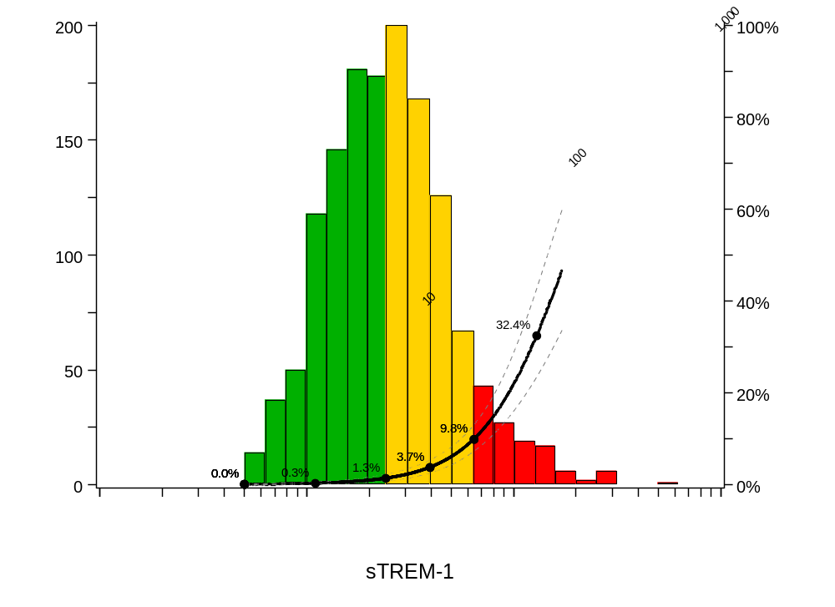

Validation Cohort
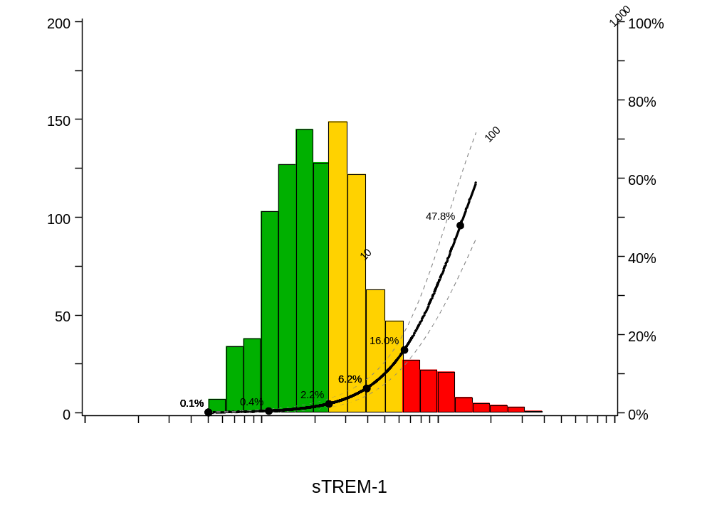

Fig. 2 Calibration plots for Log sTREM-1 values with multiple imputations from:

Internal Validation
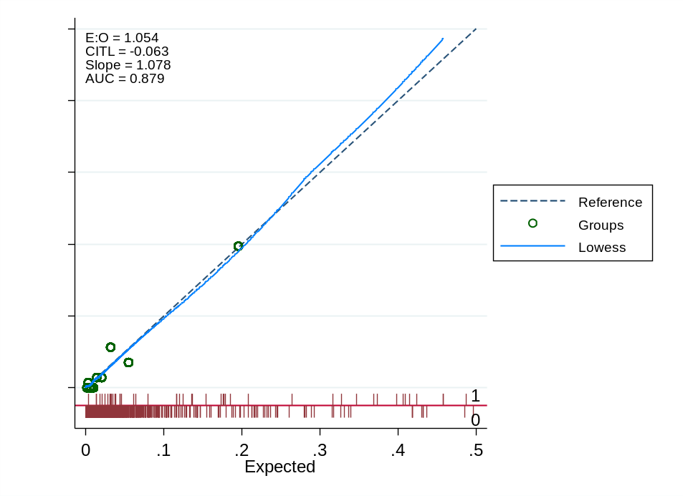

External Validation
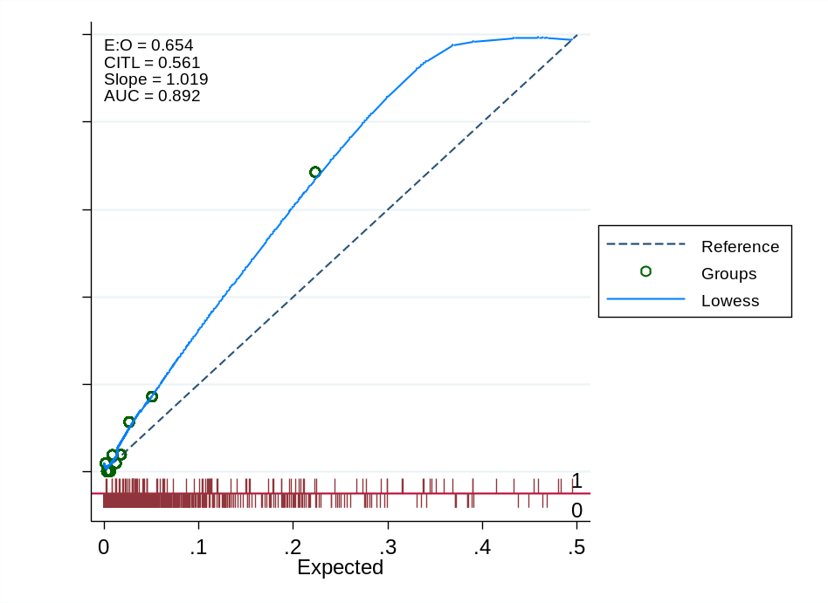

Abbreviations: E:O, ratio of expected to observed events for model calibration; CITL, calibration-in-the-large; AUC, Area under the curve

Fig. 3: Calibration plots for sTREM-1 Zones with multiple imputations from:

Internal Validation
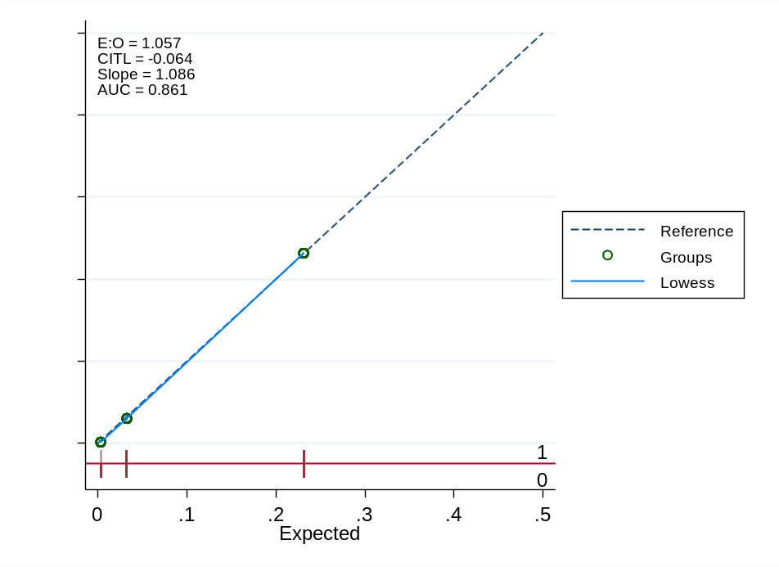

External Validation
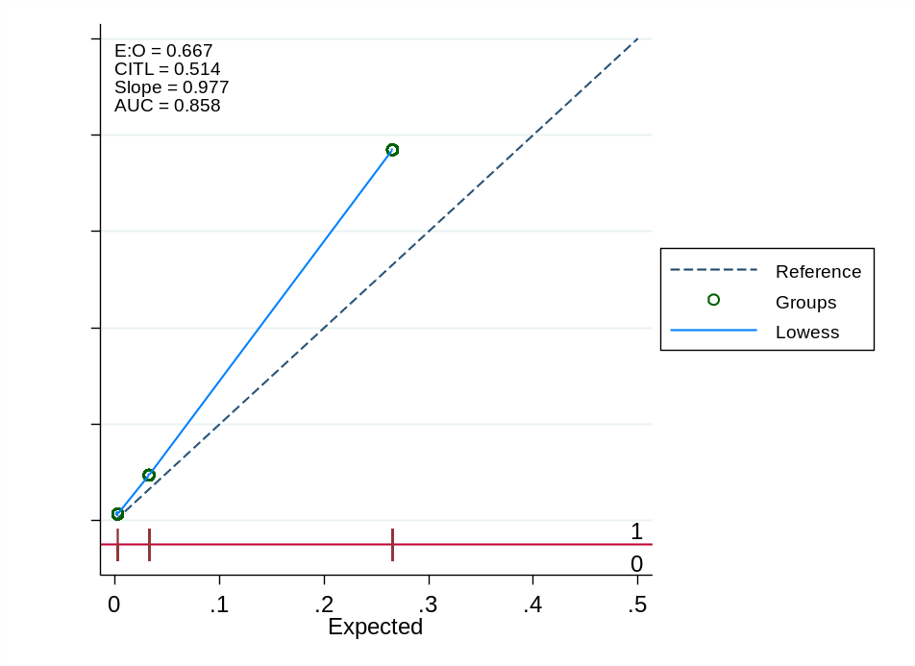

Abbreviations: E:O, ratio of expected to observed events for model calibration; CITL, calibration-in-the-large; AUC, Area under the curve.

Fig. 4: Time-to-event analyses by sTREM-1 zones in the derivation cohort for:

Whole derivation cohort
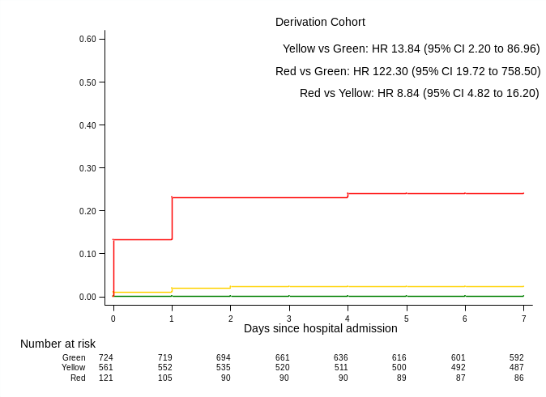

Subgroup of derivation cohort with malaria
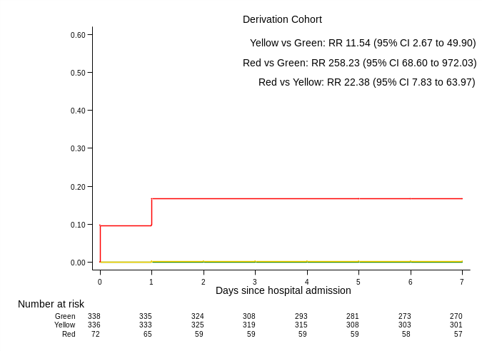

Subgroup of derivation cohort without malaria
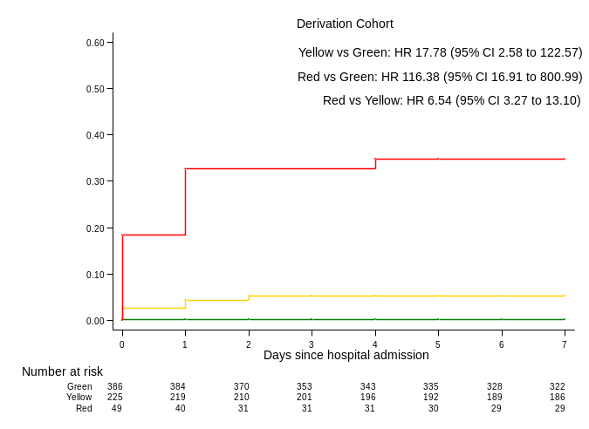
HR, hazard ratios; RR, rate ratios. In children with diagnosis of malaria, Cox models were unstable; we therefore used Poisson regression with robust standard errors to derive rate ratios.

Fig. 5: Time-to-event analyses by sTREM-1 zones in the validation cohort for:

Whole validation cohort
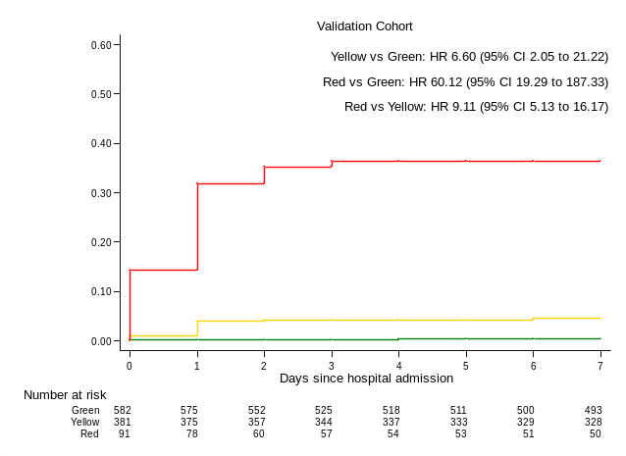

Subgroup of validation cohort with malaria
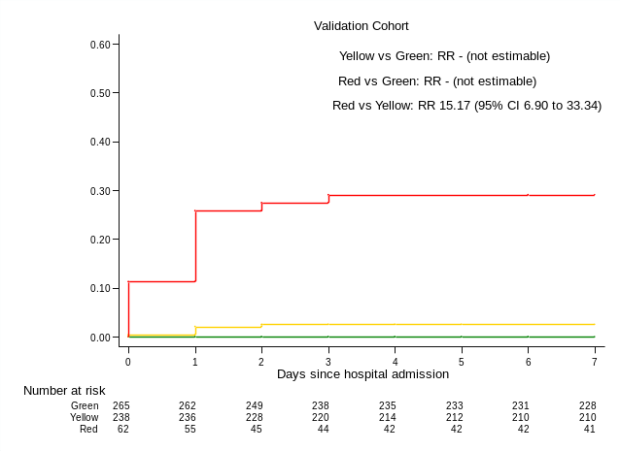

Subgroup of validation cohort without malaria
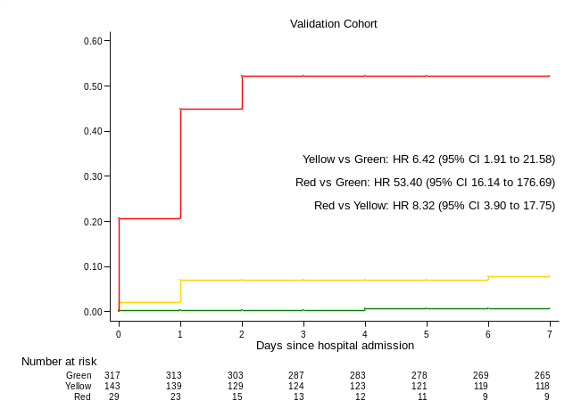
HR, hazard ratios; RR, rate ratios. In children with diagnosis of malaria, Cox models were unstable; we therefore used Poisson regression with robust standard errors to derive rate ratios. RR comparing yellow vs green, and red versus green zones were not estimable for children with diagnosis of malaria.

References

1. Erdman, L.K., et al. Combinations of host biomarkers predict mortality among Ugandan children with severe malaria: a retrospective case-control study. PloS one 6, e17440 (2011).
2. Leligdowicz, A., et al. Validation of two multiplex platforms to quantify circulating markers of inflammation and endothelial injury in severe infection. PloS one 12, e0175130 (2017).
3. Hawkes, M., et al. Use of a three-band HRP2/pLDH combination rapid diagnostic test increases diagnostic specificity for falciparum malaria in Ugandan children. Malar J 13, 43 (2014).
4. WHO. Handbook : IMCI integrated management of childhood illness. (Geneva, Switzerland, 2005).
5. Gelman, A. Scaling regression inputs by dividing by two standard deviations. Stat Med 27, 2865-2873 (2008).
6. Pontrelli, G., et al. Diagnostic value of soluble triggering receptor expressed on myeloid cells in paediatric sepsis: a systematic review. Ital J Pediatr 42, 44 (2016).
7. Bellos, I., et al. Soluble TREM-1 as a predictive factor of neonatal sepsis: a meta-analysis. Inflamm Res 67, 571-578 (2018).
8. Saldir, M., et al. Endocan and Soluble Triggering Receptor Expressed on Myeloid Cells-1 as Novel Markers for Neonatal Sepsis. Pediatr Neonatol 56, 415-421 (2015).
9. Stein, M., Schachter-Davidov, A., Babai, I., Tasher, D. & Somekh, E. The accuracy of C-reactive protein, procalcitonin, and s-TREM-1 in the prediction of serious bacterial infection in neonates. Clin Pediatr (Phila) 54, 439-444 (2015).
10. Mazzucchelli, I., et al. Diagnostic performance of triggering receptor expressed on myeloid cells-1 and CD64 index as markers of sepsis in preterm newborns. Pediatr Crit Care Med 14, 178-182 (2013).
11. Schlapbach, L.J., et al. Pancreatic stone protein as a novel marker for neonatal sepsis. Intensive Care Med 39, 754-763 (2013).
12. Sarafidis, K., et al. Diagnostic utility of elevated serum soluble triggering receptor expressed on myeloid cells (sTREM)-1 in infected neonates. Intensive Care Med 36, 864-868 (2010).
13. Chen, H.L., Hung, C.H., Tseng, H.I. & Yang, R.C. Soluble form of triggering receptor expressed on myeloid cells-1 (sTREM-1) as a diagnostic marker of serious bacterial infection in febrile infants less than three months of age. Jpn J Infect Dis 61, 31-35 (2008).
14. Carrol, E.D., et al. The diagnostic and prognostic accuracy of five markers of serious bacterial infection in Malawian children with signs of severe infection. PloS one 4, e6621 (2009).
15. Kevan, E.N., Simmons, J.R., Kocoshis, S.A., Cohen, M.B. & Rudolph, J.A. sTREM-1 and LBP in central venous catheter-associated bloodstream infections in pediatric intestinal failure. J Pediatr Gastroenterol Nutr 53, 627-633 (2011).
16. Miedema, K.G., et al. The diagnostic value of CRP, IL-8, PCT, and sTREM-1 in the detection of bacterial infections in pediatric oncology patients with febrile neutropenia. Support Care Cancer 19, 1593-1600 (2011).
17. Arzanian, M.T., et al. Association of serum soluble triggering receptor expressed on myeloid cells levels in malignant febrile neutropenic patients with bacteremia and fungemia. Iran J Pediatr 21, 301-306 (2011).
18. Arizaga-Ballesteros, V., et al. Can sTREM-1 predict septic shock & death in late-onset neonatal sepsis? A pilot study. Int J Infect Dis 30, 27-32 (2015).
19. Adly, A.A., Ismail, E.A., Andrawes, N.G. & El-Saadany, M.A. Circulating soluble triggering receptor expressed on myeloid cells-1 (sTREM-1) as diagnostic and prognostic marker in neonatal sepsis. Cytokine 65, 184-191 (2014).

