SUPPLEMENTARY FIGURES:

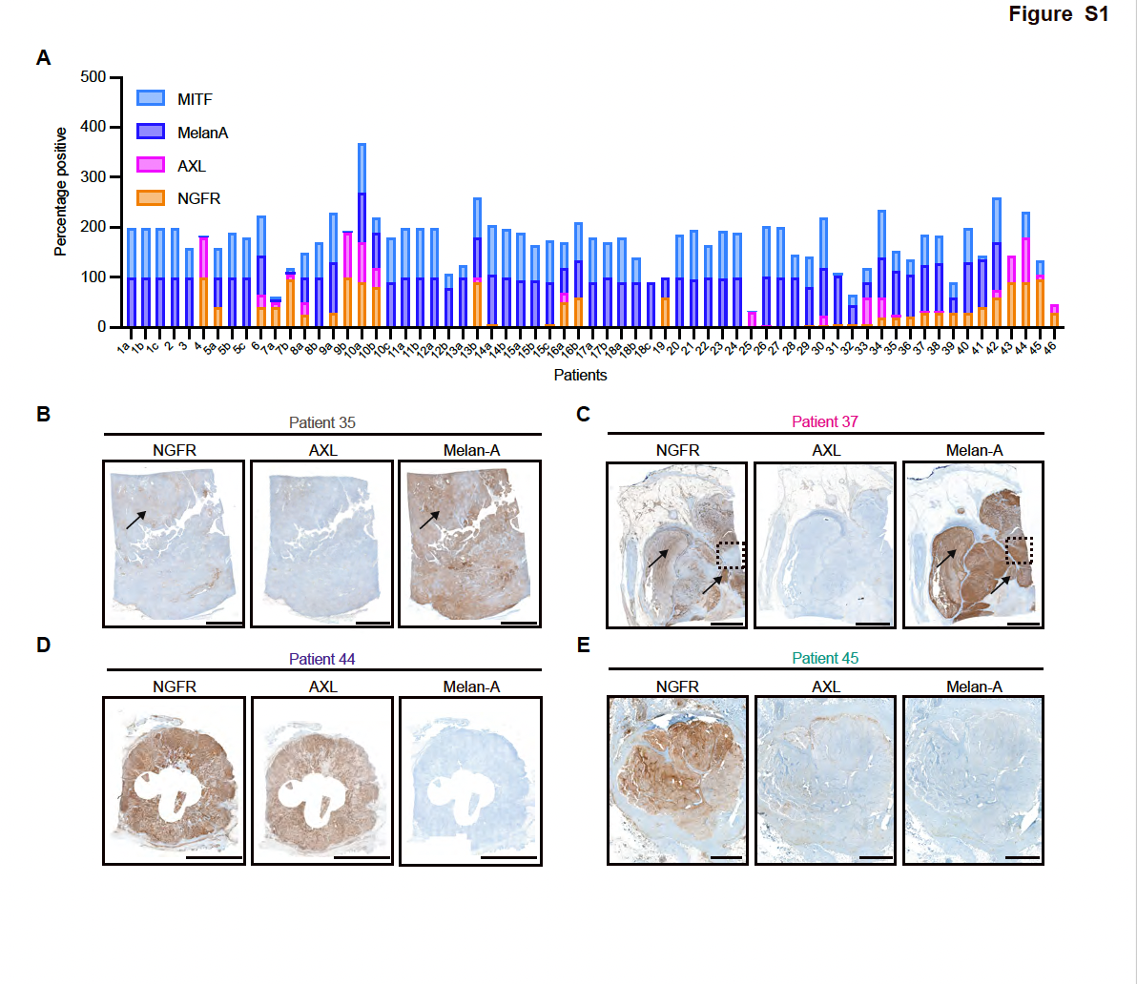

Figure S1: Extended data on Figure 1: NGFR-expressing melanomas are highly heterogeneous for differentiation and dedifferentiation markers.
- MITF, Melan-A, AXL and NGFR IHC scores (percentage positive of total viable tumor cells) per patient. All stained human melanoma samples are depicted, including patient samples without NGFR expression.
- NGFR, AXL and Melan-A IHC staining’s on patient tumor 35. Bar is 5 mm. Arrows indicate a tumor region where NGFR and Melan-A are positively associated.
- NGFR, AXL and Melan-A IHC staining’s on patient tumor 37. The dashed squares highlight a tumor area where Melan-A is negatively associated with NGFR expression. Arrows indicate a tumor region where NGFR and Melan-A are positively associated. Bar is 5 mm.
- NGFR, AXL and Melan-A IHC staining’s on patient tumor 44. Bar is 10 mm.
- NGFR, AXL and Melan-A IHC staining’s on patient tumor 45. Bar is 2 mm.

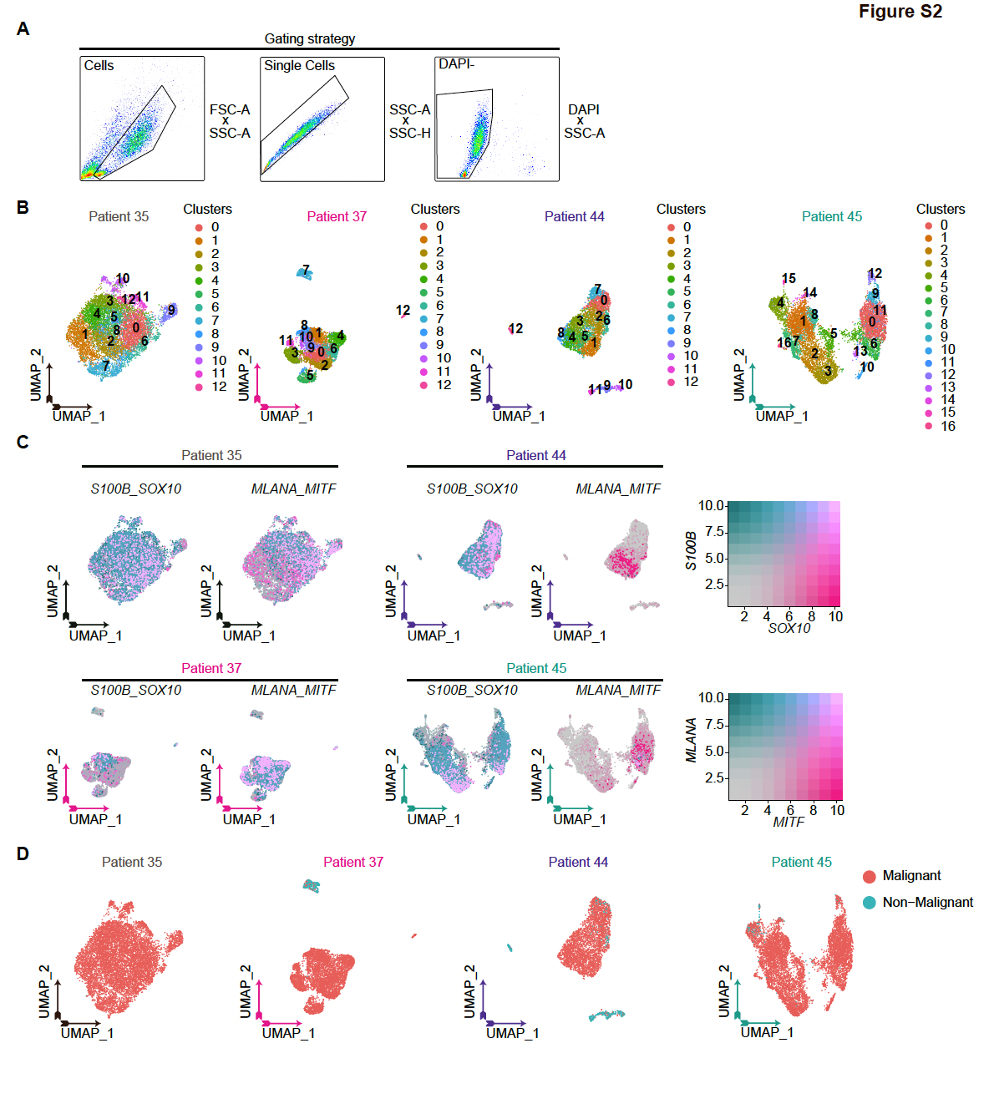

Figure S2: Extended data on Figure 2: ScRNA-seq identifies several transcriptomically distinct NGFR⁺ melanoma phenotypes.
- Gating strategy analysis for sorting viable CD45⁻/NGFR⁺ cells across the four patient tumor samples presented in figure 2A.
- UMAP of CD45⁻/NGFR⁺ melanoma cells derived from patients 35, 37, 44 and 45.
- Gene expression UMAPs of the four patients showing melanoma lineage markers S100B (cyan) and SOX10 (magenta) or MLANA (cyan) and MITF (magenta) expression. Log normalized expression values are depicted for all genes in the colored boxes.
- Single cells that had an AUCell score higher than 0.12 for the Jerby-Arnon malignant signature²⁹ were considered ‘Malignant’ cells and included for further downstream analyses. Cells that scored below the 0.12 threshold were considered ‘Non-Malignant’ and were thus not included in downstream analyses.

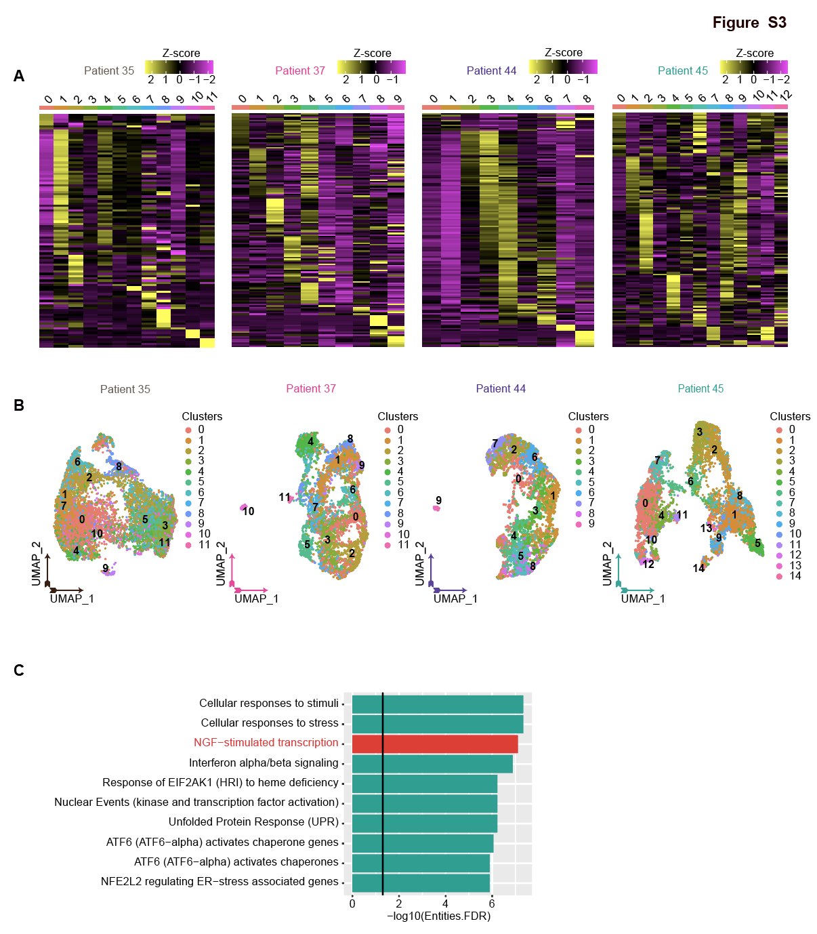

Figure S3: Extended data on Figure 3: NGFR⁺ melanoma cells are characterized by patient-specific gene-regulatory networks
- Heatmaps of patients 35, 37, 44 and 45 showing all significant differentially active regulons identified per regulon cluster. Z-score is plotted of the differential regulon activity across clusters per patient.
- Overlay of gene expression clusters identified in Figure 2C on corresponding regulon UMAPs identified in figure 3A.
- Reactome gene set enrichment analysis on the overlap of differentially active regulons found in patients 35, 37, 44 and 45. Top 10 significant pathways are shown. NGF-stimulated transcription is depicted in red.

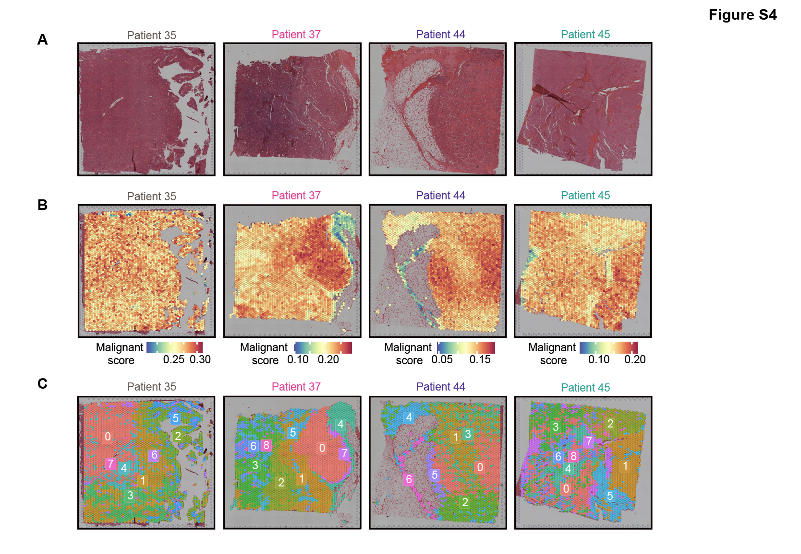

Figure S4: Extended data on Figure 4: Spatial organization of NGFR⁺ subpopulations.
- Images showing HE stainings of the Visium 10X tumor quadrants of patient tumors 35, 37, 44 and 45.
- Jerby-Arnon malignant signature²⁹ AUCell scores on the Visium 10X tumor quadrants of patient tumors 35, 37, 44 and 45.
- Visium 10X regulon clusters per patient are shown. ScRNA-seq derived regulon lists were scored on the matched Visium 10X quadrants followed by Louvain clustering, thereby generating regulon clusters on the Visium.

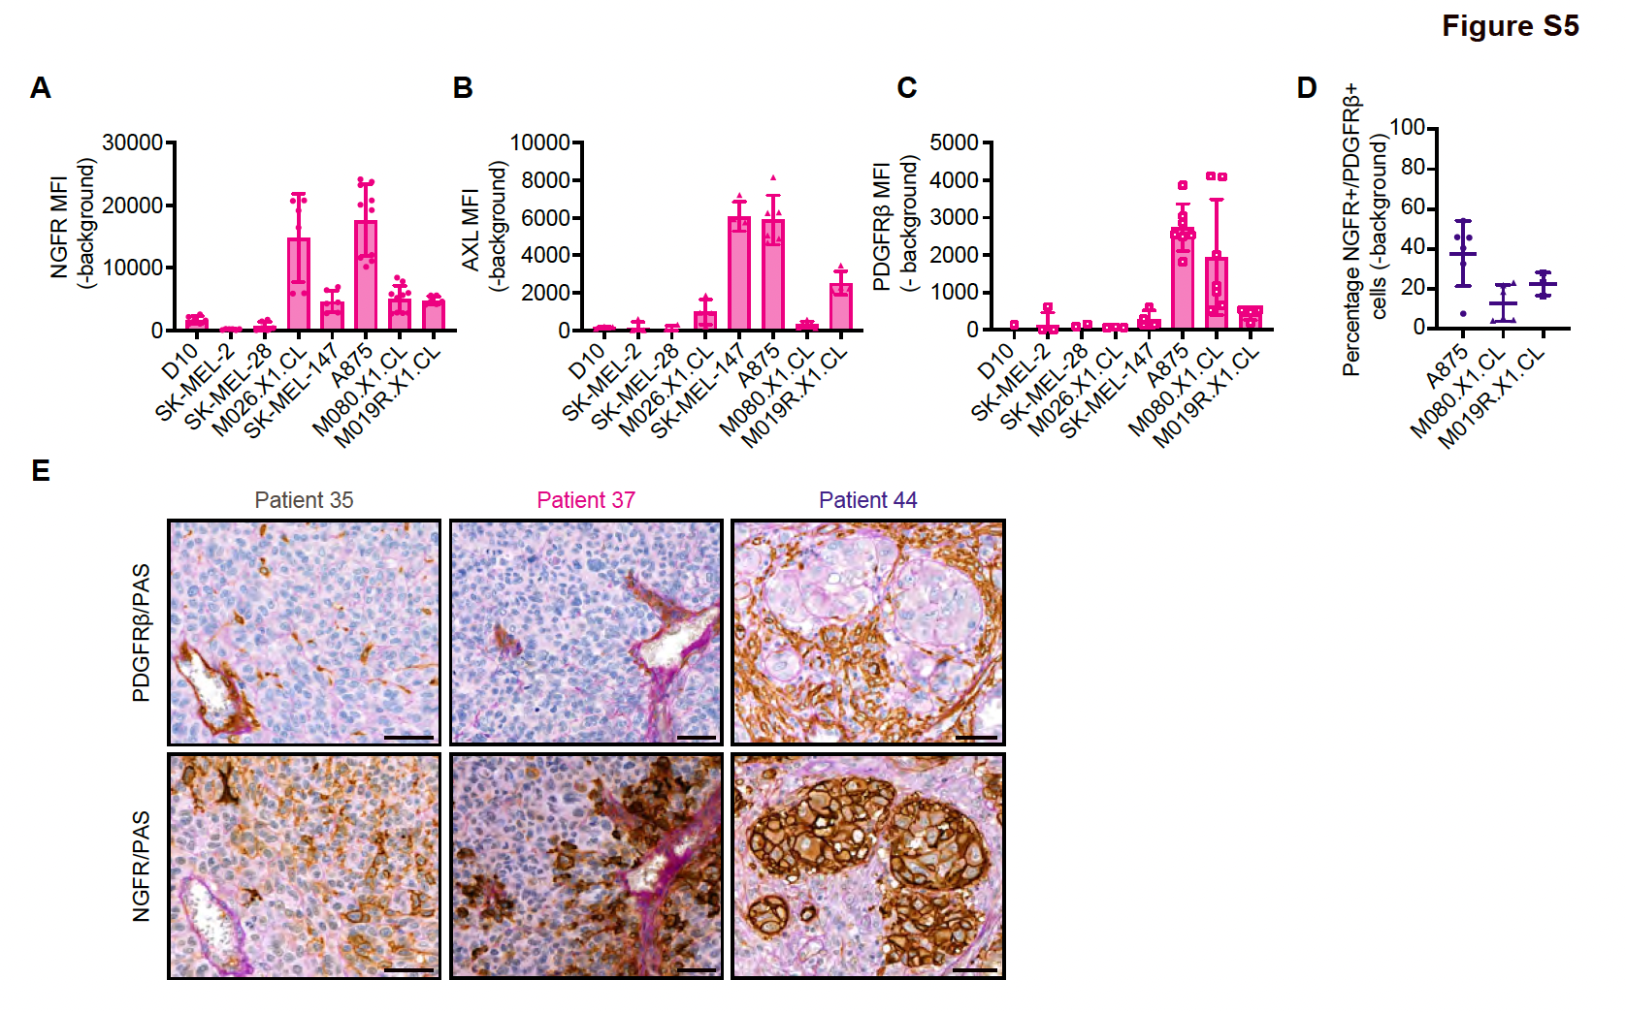

Figure S5: Extended data on Figure 5: PDGFR marks cytokine-resistant and mesenchymal-like NGFR⁺ melanoma cells.
- Cell surface NGFR MFI is depicted across the melanoma cell line panel. Mean with SD of pooled technical replicates is shown. At least 3 biological replicates with each at least 2 technical replicate is depicted.
- Cell surface AXL MFI is depicted across the melanoma cell line panel. Mean with SD of pooled technical replicates is shown. At least 2 biological replicates with each at least 1 technical replicate is depicted.
- Cell surface PDGFRβ MFI is depicted across the melanoma cell line panel. Mean with SD of pooled technical replicates is shown. At least 3 biological replicates with each at least 1 technical replicate is depicted.
- Percentages of cell surface NGFR⁺/PDGFRβ⁺ cells in A875, M080.X1.CL and M019R.X1.CL are depicted. Mean with SD of pooled technical replicates is shown. At least 2 biological experiments with each at least 1 technical replicate is depicted.
- PDGFRβ/PAS and NGFR/PAS stainings on patient tumors 35, 37 and 44. PAS staining (in pink) marks the vessel/ stromal component. Bar is 50 μm.

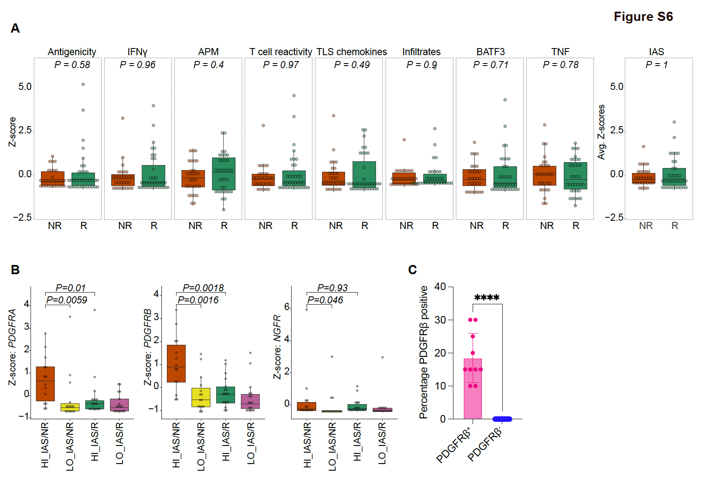

Figure S6: Extended data on Figure 6: PDGFR marks immune-active yet ICB non-responding melanomas.
- Z-score of all individual tested signatures and sum of the mean of all signatures (immune activity score (IAS)) plotted for non-responders and responders. Data of the combined RNA-seq datasets (i.e., Hugo and Riaz) was used. Average Z-score is shown for the IAS. The upper and lower quantile are shown in the boxplots with the median indicated by the center line. The whiskers show the 1.5 interquartile range. All datapoints are shown. Statistical test is Wilcoxon signed rank test. P values are plotted.
- Z-scores of the dedifferentiation markers PDGFRA, PDGFRB and NGFR are depicted across the different IAS patient groups. Data of the combined RNA-seq datasets was used. The upper and lower quantile are shown in the boxplots with the median indicated by the center line. The whiskers show the 1.5 interquartile range. All datapoints are shown. Statistical test is Wilcoxon rank test. P values are depicted.
- PDGFRβ IHC scores (percentage positive of total viable tumor cells) for PDGFRβ⁺ and PDGFRβ⁻ human melanoma samples. Mean with SD is depicted (n=10 and n=23). Statistical test is unpaired T test (****, P<0.0001).

