Supplementary Appendices for

Are Countries Regulating Veterinary Drug Residues That Are Important to Human Health?
Akinbode Okunola^{1,2}, Elliott Dennis^{1,2,*}, and Matthew Hille³
¹Institute of Agriculture and Natural Resources, University of Nebraska-Lincoln, Lincoln, NE, USA
²National Institute of Antimicrobial Resistance Research and Education (NIAMRRE), Ames, IA, USA
³School of Veterinary Medicine and Biomedical Sciences, University of Nebraska-Lincoln, USA.

*Corresponding Author Information
208A Filley Hall
University of Nebraska-Lincoln
Lincoln, NE 68583-0922
elliott.dennis@unl.edu

Appendix A

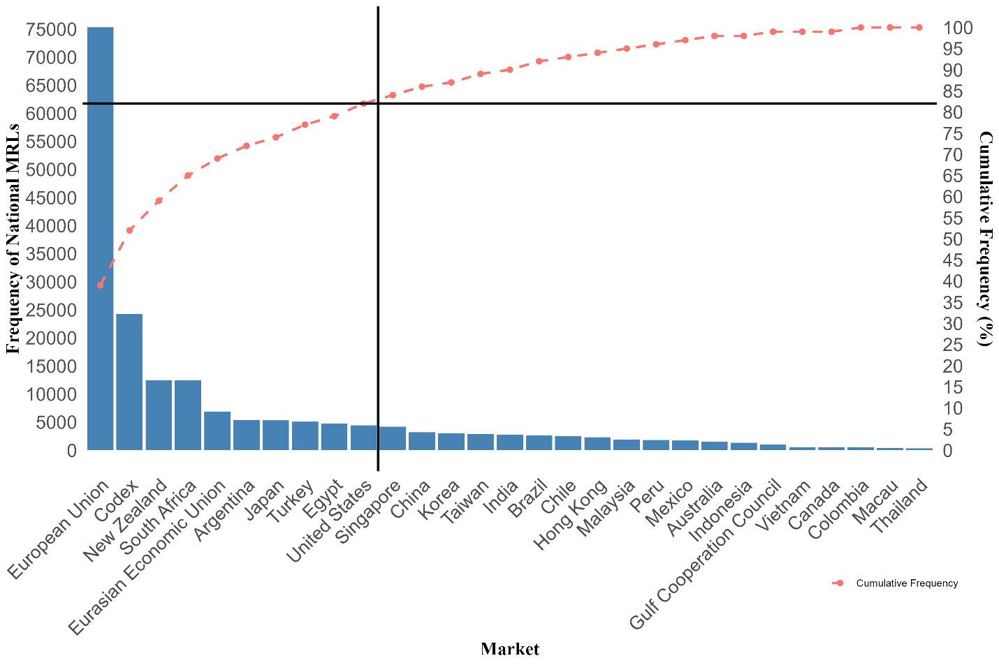Figure A1. Surveillance of medically important antimicrobials across countries. In this figure, the MRLs pairs of countries that defer to Codex, EU and U.S. MRLs are added to the country of origin. Accounting for the deferrals allows us to see the global influence of these leading regulators.

Table A2. Share of national MRL pairs by medical importance for each country
Market | H1V1 | H1V2 | H1V3 | H2V1 | H2V2 | H2V3 | H3V1 | H3V2 | H3V3 | H4V1 | H4V2 | H4V3
Argentina | 9.94(531) | 4.58(245) | 0(0) | 15.19(812) | 3.07(164) | 0(0) | 60.48(3232) | 3.01(161) | 0.32(17) | 2.34(125) | 1.07(57) | 0(0)
Australia | 0.4(6) | 0(0) | 0(0) | 35.36(529) | 0(0) | 0(0) | 45.52(681) | 6.89(103) | 2.74(41) | 6.08(91) | 3.01(45) | 0(0)
Brazil | 12.08(322) | 5.36(143) | 0(0) | 21.01(560) | 3.15(84) | 0(0) | 50.83(1355) | 3.38(90) | 1.28(34) | 0.94(25) | 1.99(53) | 0(0)
Canada | 4.91(26) | 0(0) | 0(0) | 30.94(164) | 0(0) | 0(0) | 54.72(290) | 2.83(15) | 1.89(10) | 0.94(5) | 3.77(20) | 0(0)
Chile | 5.35(134) | 1.36(34) | 0(0) | 8.86(222) | 0.04(1) | 0(0) | 79.1(1983) | 1(25) | 0.32(8) | 0.88(22) | 3.11(78) | 0(0)
China | 13.43(430) | 1.91(61) | 0(0) | 16.31(522) | 0(0) | 0(0) | 62.82(2011) | 2(64) | 1(32) | 0.56(18) | 1.97(63) | 0(0)
Codex | 4.38(21) | 3.55(17) | 0(0) | 27.97(134) | 0(0) | 0(0) | 57.41(275) | 2.92(14) | 0(0) | 3.76(18) | 0(0) | 0(0)
Colombia | 4.15(21) | 3.36(17) | 0(0) | 26.28(133) | 0(0) | 0(0) | 59.09(299) | 3.56(18) | 0(0) | 3.56(18) | 0(0) | 0(0)
Egypt | 12.55(595) | 5.23(248) | 0(0) | 18.12(859) | 1.79(85) | 0(0) | 55.27(2620) | 3.84(182) | 0(0) | 2.64(125) | 0.55(26) | 0(0)
Eurasian Economic Union | 14.56(1006) | 4.4(304) | 0(0) | 21.65(1496) | 0.01(1) | 0(0) | 51.11(3532) | 2.76(191) | 0(0) | 2.94(203) | 2.58(178) | 0(0)
European Union | 12.02(623) | 4.79(248) | 0(0) | 19.09(989) | 1.68(87) | 0(0) | 54.89(2844) | 3.84(199) | 0.6(31) | 2.41(125) | 0.68(35) | 0(0)
Gulf Cooperation Council | 14.62(139) | 1.47(14) | 0(0) | 26.29(250) | 0(0) | 0(0) | 47.11(448) | 4(38) | 1.16(11) | 3.15(30) | 2.21(21) | 0(0)
Hong Kong | 4.2(96) | 2.27(52) | 0(0) | 9.23(211) | 0(0) | 0(0) | 79.7(1822) | 1.27(29) | 0.13(3) | 1.27(29) | 1.92(44) | 0(0)
India | 12.53(346) | 1.48(41) | 0(0) | 9.96(275) | 0(0) | 0(0) | 51.99(1436) | 6.12(169) | 5.79(160) | 0.65(18) | 11.48(317) | 0(0)
Indonesia | 7.47(99) | 2.49(33) | 0(0) | 22.17(294) | 0(0) | 0(0) | 54.07(717) | 2.94(39) | 2.49(33) | 2.94(39) | 5.43(72) | 0(0)
Japan | 9.76(517) | 5.91(313) | 0(0) | 26.53(1405) | 3.1(164) | 0(0) | 44.14(2337) | 1.32(70) | 2.3(122) | 2.3(122) | 4.63(245) | 0(0)
Korea | 21.08(629) | 3.52(105) | 0(0) | 20.07(599) | 0.17(5) | 0(0) | 44.27(1321) | 5.13(153) | 1.31(39) | 0.87(26) | 3.59(107) | 0(0)
Macau | 5.03(20) | 4.27(17) | 0(0) | 14.57(58) | 0(0) | 0(0) | 69.35(276) | 2.26(9) | 0(0) | 4.52(18) | 0(0) | 0(0)
Malaysia | 2.17(40) | 1.9(35) | 0(0) | 11.21(207) | 0(0) | 0(0) | 81.8(1510) | 0.33(6) | 1.68(31) | 0.7(13) | 0.22(4) | 0(0)
Mexico | 14.21(240) | 5.68(96) | 0(0) | 17.47(295) | 0(0) | 0(0) | 62.64(1058) | 0(0) | 0(0) | 0(0) | 0(0) | 0(0)
New Zealand | 14.47(1804) | 5.26(656) | 0(0) | 23.69(2952) | 1.32(164) | 0(0) | 38.15(4755) | 9.21(1148) | 1.32(164) | 1.32(164) | 5.26(656) | 0(0)
Peru | 11.75(614) | 4.75(248) | 0(0) | 19.41(1014) | 0.04(2) | 0(0) | 56.78(2967) | 3.06(160) | 0.69(36) | 2.45(128) | 1.07(56) | 0(0)
Singapore | 9.48(400) | 4.55(192) | 0(0) | 32.27(1362) | 0(0) | 0(0) | 40.88(1725) | 7.91(334) | 0.33(14) | 3.86(163) | 0.71(30) | 0(0)
South Africa | 14.47(1804) | 5.26(656) | 0(0) | 23.69(2952) | 1.32(164) | 0(0) | 38.15(4755) | 9.21(1148) | 1.32(164) | 1.32(164) | 5.26(656) | 0(0)
Taiwan | 3.49(102) | 5.99(175) | 0(0) | 27.6(806) | 0(0) | 0(0) | 52.71(1539) | 4.52(132) | 0.17(5) | 2.57(75) | 2.95(86) | 0(0)
Thailand | 6.25(21) | 4.76(16) | 0(0) | 30.06(101) | 0(0) | 0(0) | 49.4(166) | 4.17(14) | 0(0) | 5.36(18) | 0(0) | 0(0)
Turkey | 11.81(600) | 4.84(246) | 0(0) | 19.18(974) | 1.67(85) | 0(0) | 55.6(2824) | 3.37(171) | 0.49(25) | 2.46(125) | 0.57(29) | 0(0)
United States | 6.94(30) | 0(0) | 0(0) | 25.23(109) | 0(0) | 0(0) | 50.46(218) | 2.55(11) | 3.24(14) | 3.94(17) | 7.64(33) | 0(0)
Vietnam | 5.46(30) | 4.01(22) | 0(0) | 30.05(165) | 0(0) | 0(0) | 53.19(292) | 3.28(18) | 0(0) | 4.01(22) | 0(0) | 0(0)
Source: Authors’ compilation. In parenthesis is the number of MRL pairs in each medical importance level for every country. The sum across the row gives the total percentage and number of national MRL pairs for each country.
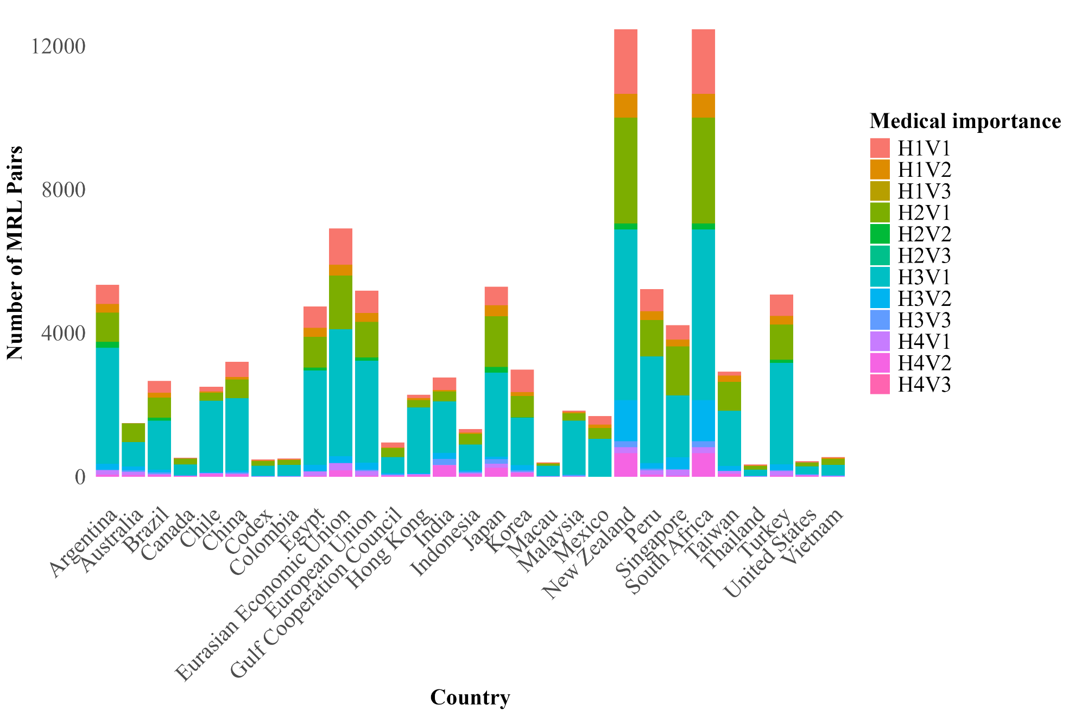
Figure A3. Medically important antimicrobials by country.
Note, these are MRL specific to each country. The deferral MRL pairs are not accounted for in the frequency of origin countries. The regulatory behavior of countries of origin directly reflects those of the countries that depend on them.

Table A4. List of countries and full deferral countries
Non-deferral countries |  | Codex deferral countries |  | EU deferral countries | US deferral countries
Argentina | Malaysia | Afghanistan | Lebanon | Algeria | American Samoa
Australia | Mexico | Angola | Libya | French West Indies | Guam
Brazil | New Zealand | Bahamas | Malawi | Georgia | Northern Mariana Islands
Canada | Nicaragua | Barbados | Mozambique | Montenegro | Puerto Rico
Chile | Peru | Belize | Myanmar | Suriname | U.S. Virgin Islands
China | Singapore | Bermuda | Nigeria | United Kingdom
Colombia | South Africa | Bosnia and Herzegovina | Pakistan
Costa Rica | Taiwan | British Virgin Islands | Papua New Guinea
Dominican Republic | Thailand | Cambodia | Senegal
Egypt | Turkey | Cameroon | Sint Maarten
El Salvador | United States | Cayman Islands | Sudan
Eurasian Economic Union | Vietnam | Cuba | Syria
European Union |  | Dominica Republic | Tanzania
Guatemala |  | Eswatini | Tonga
Gulf Cooperation Council |  | Fiji | Trinidad and Tobago
Honduras |  | Gambia | Tunisia
Hong Kong |  | Ghana | Uganda
India |  | Grenada | Venezuela
Indonesia |  | Haiti | Zimbabwe
Japan |  | Jamaica | Panama
Korea |  | Jordan | Uruguay
Macau |  | Kenya
Source: Authors’ compilation.

Appendix B

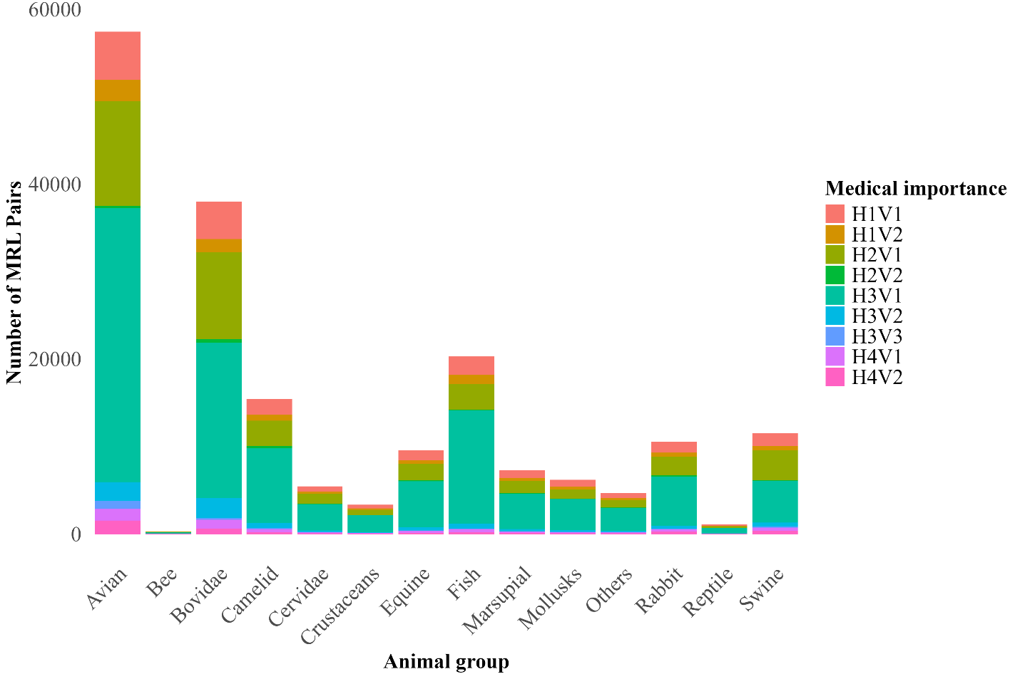
Figure B1. Medically important antimicrobials by animal group.

Table B2. Number of MRLs by Aggregate Animal Group
Animal group | H1V1 | H1V2 | H1V3 | H2V1 | H2V2 | H2V3 | H3V1 | H3V2 | H3V3 | H4V1 | H4V2 | H4V3
Avian | 9.6(5526) | 4.2(2406) | n.d. | 20.9(12019) | 0.4(204) | n.d. | 54.6(31363) | 3.7(2144) | 1.6(919) | 2.3(1322) | 2.7(1551) | n.d.
Bee | 11.6(35) | 4(12) | n.d. | 24.1(73) | 1.3(4) | n.d. | 42.9(130) | 10.6(32) | 1(3) | 1(3) | 3.6(11) | n.d.
Bovidae | 11.3(4279) | 4(1517) | n.d. | 26.1(9906) | 1.1(411) | n.d. | 46.7(17748) | 6.1(2324) | 0.5(183) | 2.7(1045) | 1.5(589) | n.d.
Camelid | 11.6(1780) | 4.4(673) | n.d. | 18.9(2908) | 1.6(241) | n.d. | 55.6(8574) | 3.8(583) | 0.5(72) | 2.3(353) | 1.5(225) | n.d.
Cervidae | 11.2(612) | 4.4(239) | n.d. | 20.5(1121) | 1.4(78) | n.d. | 54.9(2997) | 3.6(197) | 0.4(24) | 2.1(112) | 1.4(78) | n.d.
Crustaceans | 12.1(405) | 5.5(183) | n.d. | 16.8(562) | 0.4(12) | n.d. | 58.5(1954) | 3.2(108) | 0.2(6) | 2.3(78) | 1(33) | n.d.
Equine | 12.1(1165) | 4.3(413) | n.d. | 19.2(1843) | 1.6(150) | n.d. | 54.9(5265) | 3.8(363) | 0.4(42) | 2.3(216) | 1.4(136) | n.d.
Fish | 10.3(2100) | 5.2(1055) | n.d. | 14.5(2938) | 0.3(60) | n.d. | 63.8(12964) | 2.9(590) | 0.1(30) | 1.9(390) | 0.9(180) | n.d.
Marsupial | 11.9(870) | 4.6(336) | n.d. | 19(1383) | 1.6(120) | n.d. | 54.9(3994) | 3.7(272) | 0.5(34) | 2.2(162) | 1.5(110) | n.d.
Mollusks | 12.3(762) | 5.3(330) | n.d. | 17.5(1080) | 0.4(24) | n.d. | 57.3(3549) | 3.4(210) | 0.2(12) | 2.5(156) | 1.1(66) | n.d.
Others | 12(562) | 4.8(223) | n.d. | 18.6(872) | 1.4(64) | n.d. | 55.6(2608) | 3.6(171) | 0.4(19) | 2.3(107) | 1.4(66) | n.d.
Rabbit | 11.7(1232) | 4.4(468) | n.d. | 20(2104) | 1.6(165) | n.d. | 53.2(5609) | 3.5(370) | 0.4(47) | 2.1(218) | 3.1(323) | n.d.
Reptile | 11.8(127) | 5.2(56) | n.d. | 16.8(180) | 0.4(4) | n.d. | 58.9(632) | 3.3(35) | 0.2(2) | 2.4(26) | 1(11) | n.d.
Swine | 12.7(1458) | 4.3(491) | n.d. | 29.5(3399) | 0.8(90) | n.d. | 41.4(4768) | 4(456) | 1.2(143) | 3.1(356) | 3.1(361) | n.d.
Source: Authors’ compilation. The commodities included in each animal group are as follow: Avian includes chicken, duck, eggs, emu, goose, guinea-fowl, ostrich, partridge, pheasant, pigeon, quail, turkey. Bee includes Honey. Bovidae consists of buffalo, cattle, goat, sheep and their milk products. Camelid includes alpaca, camel meat and its milk product, llama. Cervidae comprises deer. Crustaceans include crab, lobster, prawn/shrimp. Equine group includes donkey, horse and its milk product. Fish are barramundi, carp, catfish, eel, flatfish, rockfish, salmon, sea bream, sturgeon, sweetfish, tilapia, trout, tuna, and yellowtail. Marsupial includes possum, and wallaby. Mollusks are abalone, clam, cockle, mussel, oyster, and scallop. Rabbit includes hare, and rabbit. Swine contains swine products. Reptiles include turtle. Others are frog and kangaroo commodities. Empty cells are pairs of animal groups and medical importance levels with no MRL pairs.

Appendix C
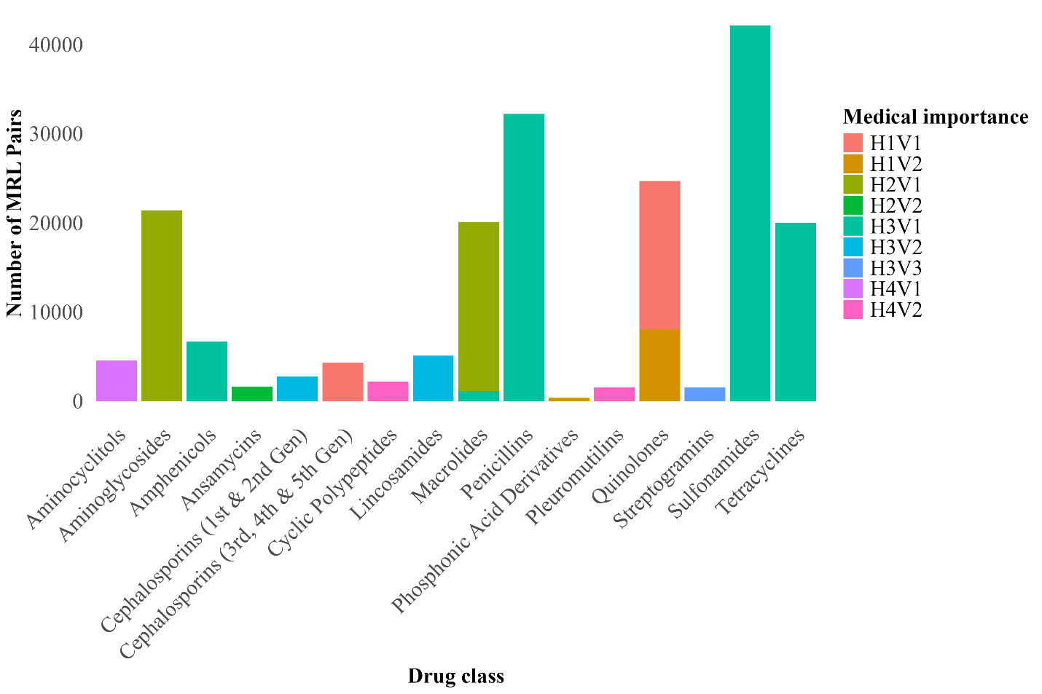
Figure C1. Medically important antimicrobials by drug class.

Table C1. Share of MRL pairs by medical importance by drug class
Drug class | H1V1 | H1V2 | H1V3 | H2V1 | H2V2 | H2V3 | H3V1 | H3V2 | H3V3 | H4V1 | H4V2 | H4V3
Aminocyclitols |  |  |  |  |  |  |  |  |  | 2.4(4,544)
Aminoglycosides |  |  |  | 11.2 (21,408)
Amphenicols |  |  |  |  |  |  | 3.5(6,695)
Ansamycins |  |  |  |  | 0.9(1,627)
Cephalosporins (1st- & 2nd-Gens) |  |  |  |  |  |  |  | 1.4(2,760)
Cephalosporins (3rd-, 4th- & 5th-Gens) | 2.2(4,274)
Cyclic Polypeptides |  |  |  |  |  |  |  |  |  |  | 1.1(2,172)
Lincosamides |  |  |  |  |  |  |  | 2.7(5,095)
Macrolides |  |  |  | 9.9(18,980) |  |  | 0.6(1,098)
Penicillins |  |  |  |  |  |  | 16.8(32,209)
Phosphonic Acid Derivatives |  | 0.2(343)
Pleuromutilins |  |  |  |  |  |  |  |  |  |  | 0.8(1,568)
Quinolones | 8.7(16,639) | 4.2(8,059)
Streptogramins |  |  |  |  |  |  |  |  | 0.8(1,536)
Sulfonamides |  |  |  |  |  |  | 22.1(42,160)
Tetracyclines |  |  |  |  |  |  | 10.5(19,993)
Source: Authors’ compilation. In parentheses are the number of MRL pairs for each drug class. For Cephalosporins, the 1st and 2nd generations have different medical importance levels (H3V2) from the 3rd-5th generations (H1V1). Also, Quinolones agents differ in human importance levels. Empty cells are pairs of drug class and medical importance levels with no MRL pairs.

Appendix D

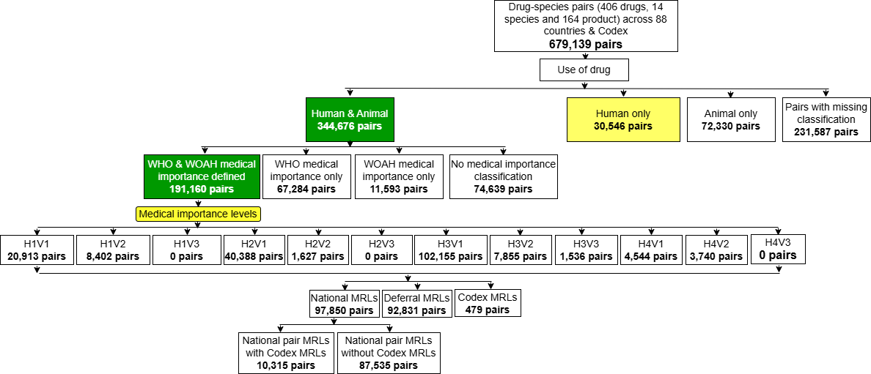
Figure D. Distribution of MRL pairs by existence of Codex standards.
Source: Authors calculations using data from Okunola et al. (2025)

Appendix E. One Health Scores
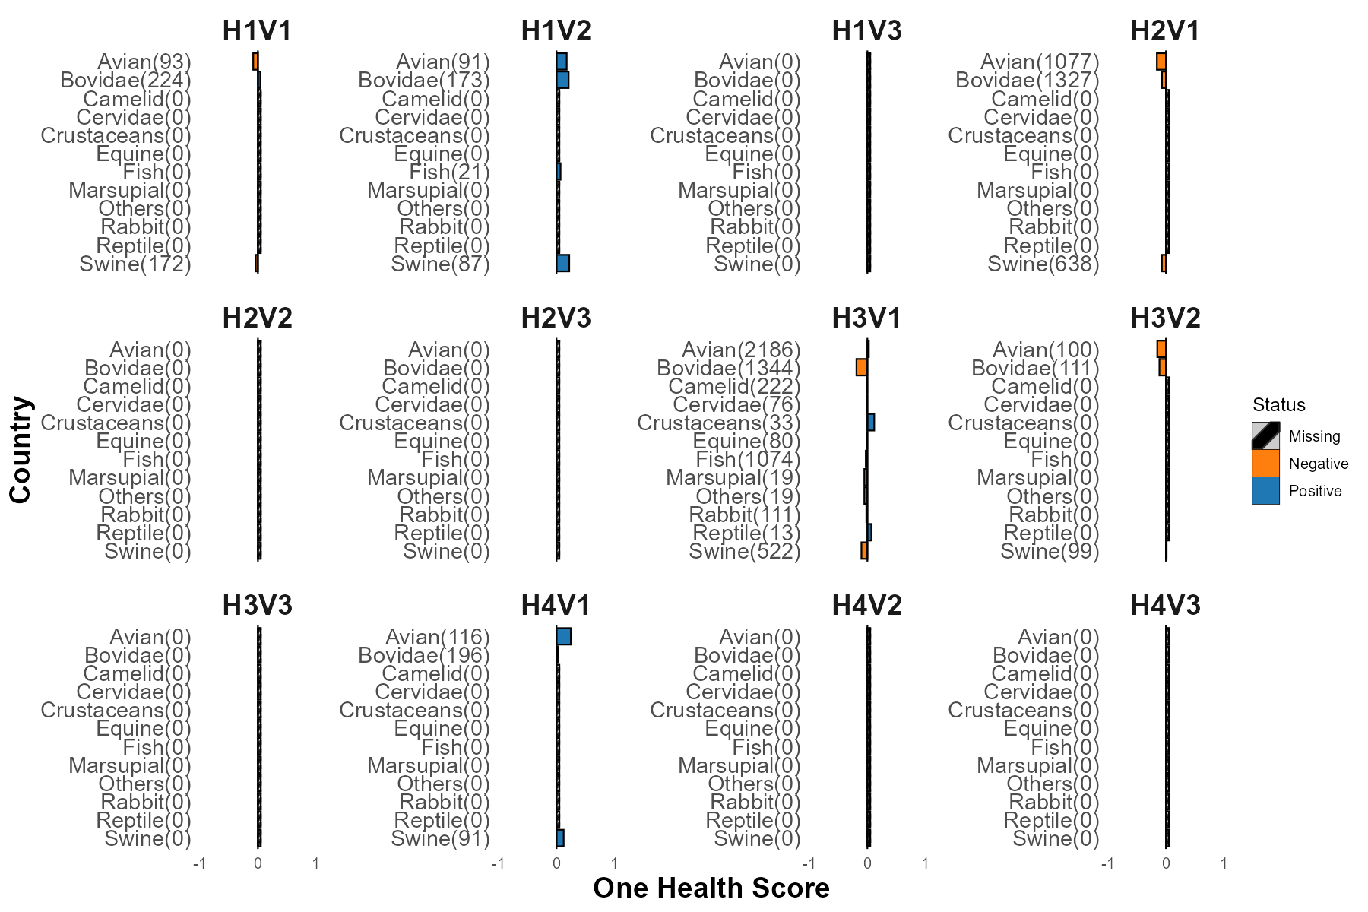Figure E1. Regulatory compliance with Codex by animal group.
Number of drug-product MRL pairs in parenthesis. Grey bars indicate animal groups without MRL pairs within medical importance level.

Table E2. Aggregate regulatory indices by animal group and medical importance.
Animal group | One Health Score
Animal group | H1V1 | H1V2 |  | H2V1 |  | H3V1 |  | H3V2 |  | H4V1 |  | Overall
Avian | –0.08 |  | 0.18 |  | –0.16 |  | 0.03 |  | –0.15 |  | 0.25 | -0.025
Bee
Bovidae | 0.04 |  | 0.21 |  | –0.07 |  | –0.19 |  | –0.11 |  | 0.02 | -0.092
Camelid |  |  |  |  |  |  | –0.01 |  |  |  |  | -0.014
Cervidae |  |  |  |  |  |  | –0.01 |  |  |  |  | -0.013
Crustaceans |  |  |  |  |  |  | 0.12 |  |  |  |  | 0.118
Equine |  |  |  |  |  |  | –0.01 |  |  |  |  | -0.013
Fish |  |  | 0.07 |  |  |  | –0.03 |  |  |  |  | -0.026
Marsupial |  |  |  |  |  |  | –0.05 |  |  |  |  | -0.053
Mollusks
Others |  |  |  |  |  |  | –0.05 |  |  |  |  | -0.053
Rabbit |  |  |  |  |  |  | –0.02 |  |  |  |  | -0.018
Reptile |  |  |  |  |  |  | 0.07 |  |  |  |  | 0.069
Swine | –0.04 |  | 0.22 |  | -0.07 |  | –0.10 |  | 0.01 |  | 0.12 | -0.046
Source: Authors’ computation.

Appendix F
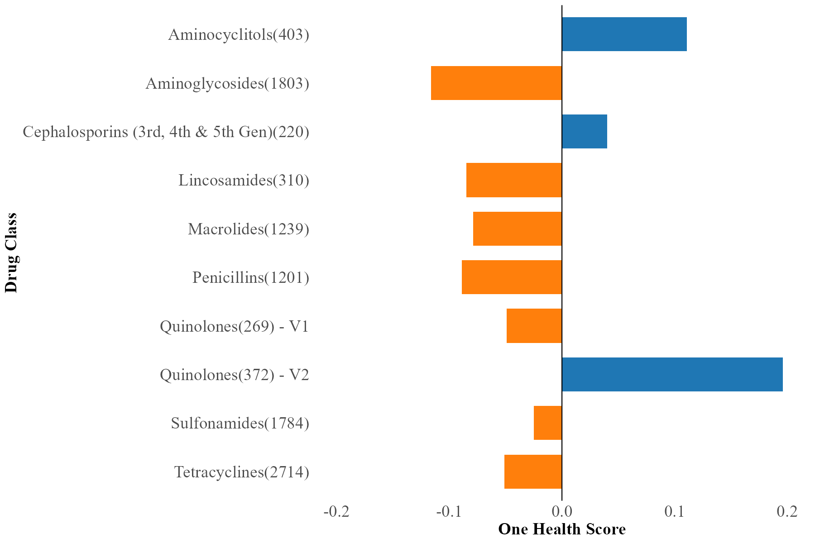

Figure F1. Regulatory compliance with Codex by drug class.
Number of drug-product MRL pairs in parenthesis.
Table F2. Aggregate regulatory indices by drug class and medical importance.
Drug class | H1V1 | H1V2 | H1V3 | H2V1 | H2V2 | H2V3 | H3V1 | H3V2 | H3V3 | H4V1 | H4V2 | H4V3
Aminocyclitols |  |  |  |  |  |  |  |  |  | 0.111(403)
Aminoglycosides |  |  |  | -0.116(1803)
Cephalosporins (3rd, 4th & 5th Gen) | 0.04(220)
Lincosamides |  |  |  |  |  |  |  | -0.085(310)
Macrolides |  |  |  | -0.079(1239)
Penicillins |  |  |  |  |  |  | -0.089(1201)
Quinolones | -0.049(269) | 0.196(372)
Sulfonamides |  |  |  |  |  |  | -0.025(1784)
Tetracyclines |  |  |  |  |  |  | -0.051(2714)
Source: Authors’ computation. One Health Score of zero implies aggregate compliance with international standards. Empty cells are pairs of class and medical importance without MRL pairs with both national and Codex MRLs.

Appendix G
Table G1. Aggregate regulatory compliance by country and medical importance levels.
Country | One Health Score
Country | HIV1 | H1V2 | H2V1 | H3V1 | H3V2 | H4V1 | Overall
Argentina | 0.00 | 0.00 | 0.03 | -0.20 | 0.00 | 0.00 | -0.115
Australia | 0.46 | 0.00 | -0.07 | 0.11 | 0.01 | 0.01 | 0.067
Brazil | 0.00 | 0.00 | -0.02 | -0.02 | 0.00 | 0.00 | -0.023
Canada | 0.14 | 0.00 | -0.19 | 0.05 | 0.92 | 0.92 | -0.068
Chile | 0.00 | 0.00 | 0.03 | 0.00 | 0.00 | 0.00 | -0.001
China | 0.00 | 0.00 | -0.54 | 0.02 | 0.00 | 0.00 | -0.14
Colombia | 0.00 | 0.00 | -0.15 | 0.00 | 0.00 | 0.00 | -0.055
Egypt | 0.00 | 0.37 | 0.02 | 0.21 | 0.36 | 0.36 | 0.154
Eurasian Econ. Union | -0.12 | 0.20 | 0.03 | 0.00 | 0.36 | 0.36 | 0.029
European Union | -0.12 | 0.37 | -0.57 | 0.21 | 0.36 | 0.36 | -0.012
Gulf Coop. Council | 0.29 | 0.00 | 0.08 | 0.18 | 0.50 | 0.50 | 0.157
Hong Kong | 0.00 | 0.00 | -0.40 | 0.21 | 0.00 | 0.00 | 0.07
India | 0.00 | 0.00 | 0.00 | 0.08 | 0.00 | 0.00 | 0.046
Indonesia | n.d. | 0.00 | 0.34 | 0.01 | -2.90 | -2.90 | -0.071
Japan | 0.00 | -0.01 | 0.02 | 0.09 | 0.00 | 0.00 | 0.041
Korea | 0.00 | 0.38 | 0.00 | -0.01 | 0.00 | 0.00 | 0.009
Macau | 0.00 | 0.00 | -0.03 | 0.00 | 0.00 | 0.00 | -0.006
Malaysia | -0.52 | 0.89 | -0.08 | 0.16 | 0.27 | 0.27 | 0.081
Mexico | 0.00 | -0.02 | 0.02 | 0.00 | n.d. | n.d. | 0.003
New Zealand | 0.17 | 0.86 | 0.24 | -0.19 | 0.69 | 0.69 | 0.034
Peru | 0.00 | 0.00 | 0.04 | 0.00 | 0.00 | 0.00 | 0.011
Singapore | 0.00 | 0.00 | -0.01 | -0.02 | n.d. | n.d. | -0.013
South Africa | 0.00 | 0.99 | 0.32 | 0.09 | 0.66 | 0.66 | 0.211
Taiwan | 0.00 | 0.05 | 0.01 | 0.07 | -0.08 | -0.08 | 0.033
Thailand | 0.00 | 0.00 | 0.00 | 0.00 | 0.00 | 0.00 | -0.003
Turkey | -0.12 | 0.37 | -0.57 | 0.21 | 0.36 | 0.36 | -0.012
United States | 0.10 | 0.00 | -1.72 | -6.34 | 0.12 | 0.12 | -3.635
Vietnam | 0.00 | 0.00 | -0.02 | 0.00 | 0.00 | 0.00 | -0.005
Source: Authors’ computation. One Health Score of zero implies aggregate compliance with international standards; n.d. implies no observations

Appendix H 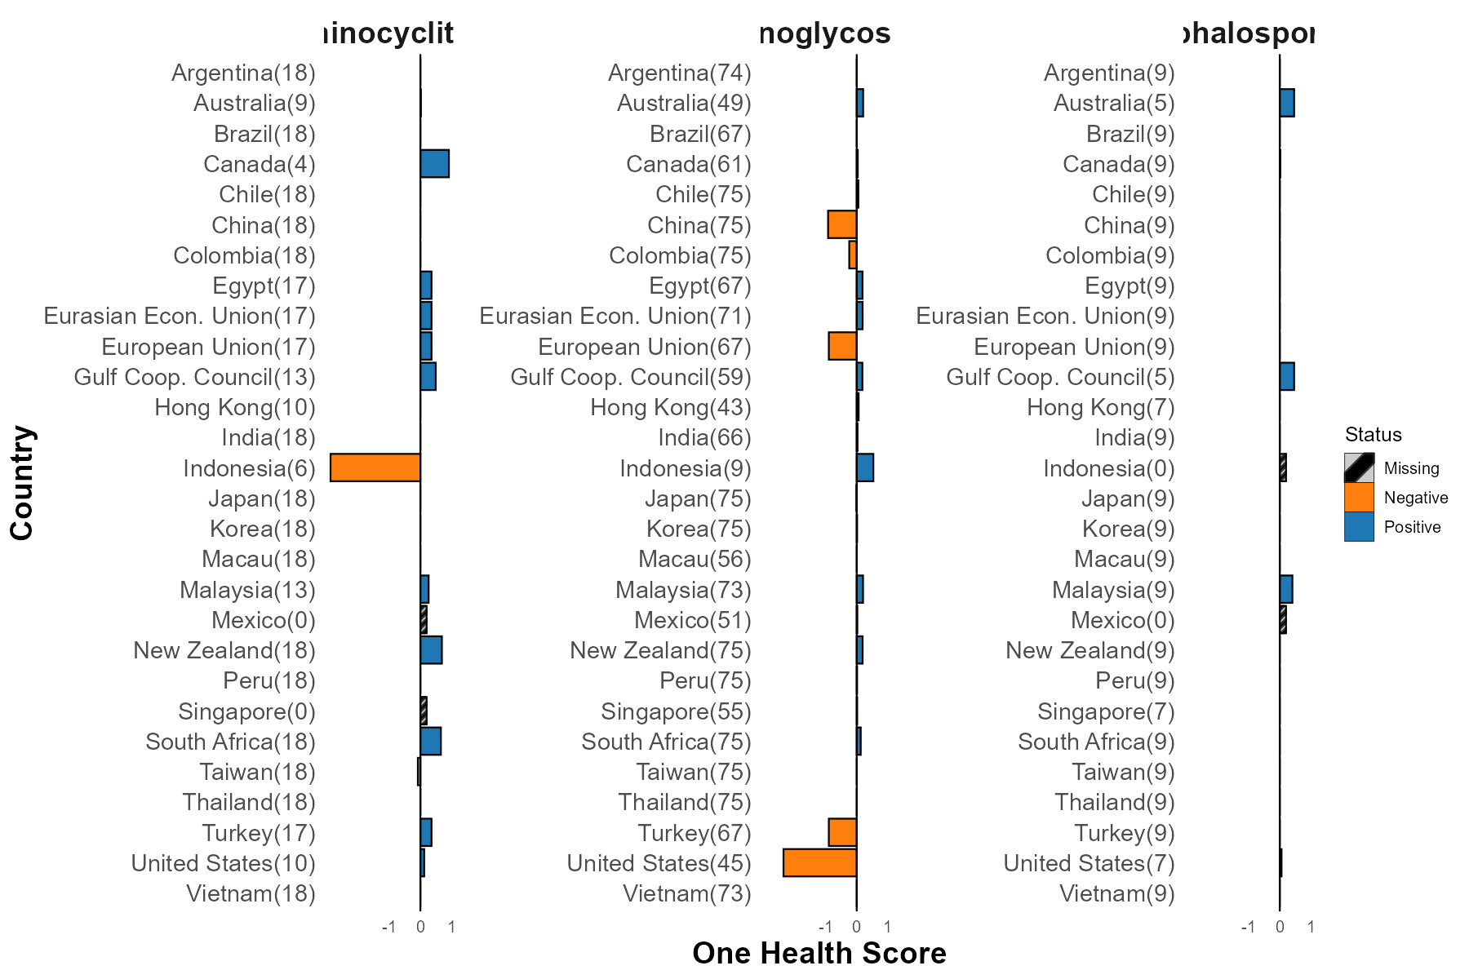
Figure H. Regulatory compliance with Codex by country and drug class.
Note: Number of drug-product MRL pairs in parenthesis. Countries with MRL pair observations but without bars have OHS of zero and are on aggregate compliant with Codex. Grey bars indicate countries without MRL pairs within drug class.
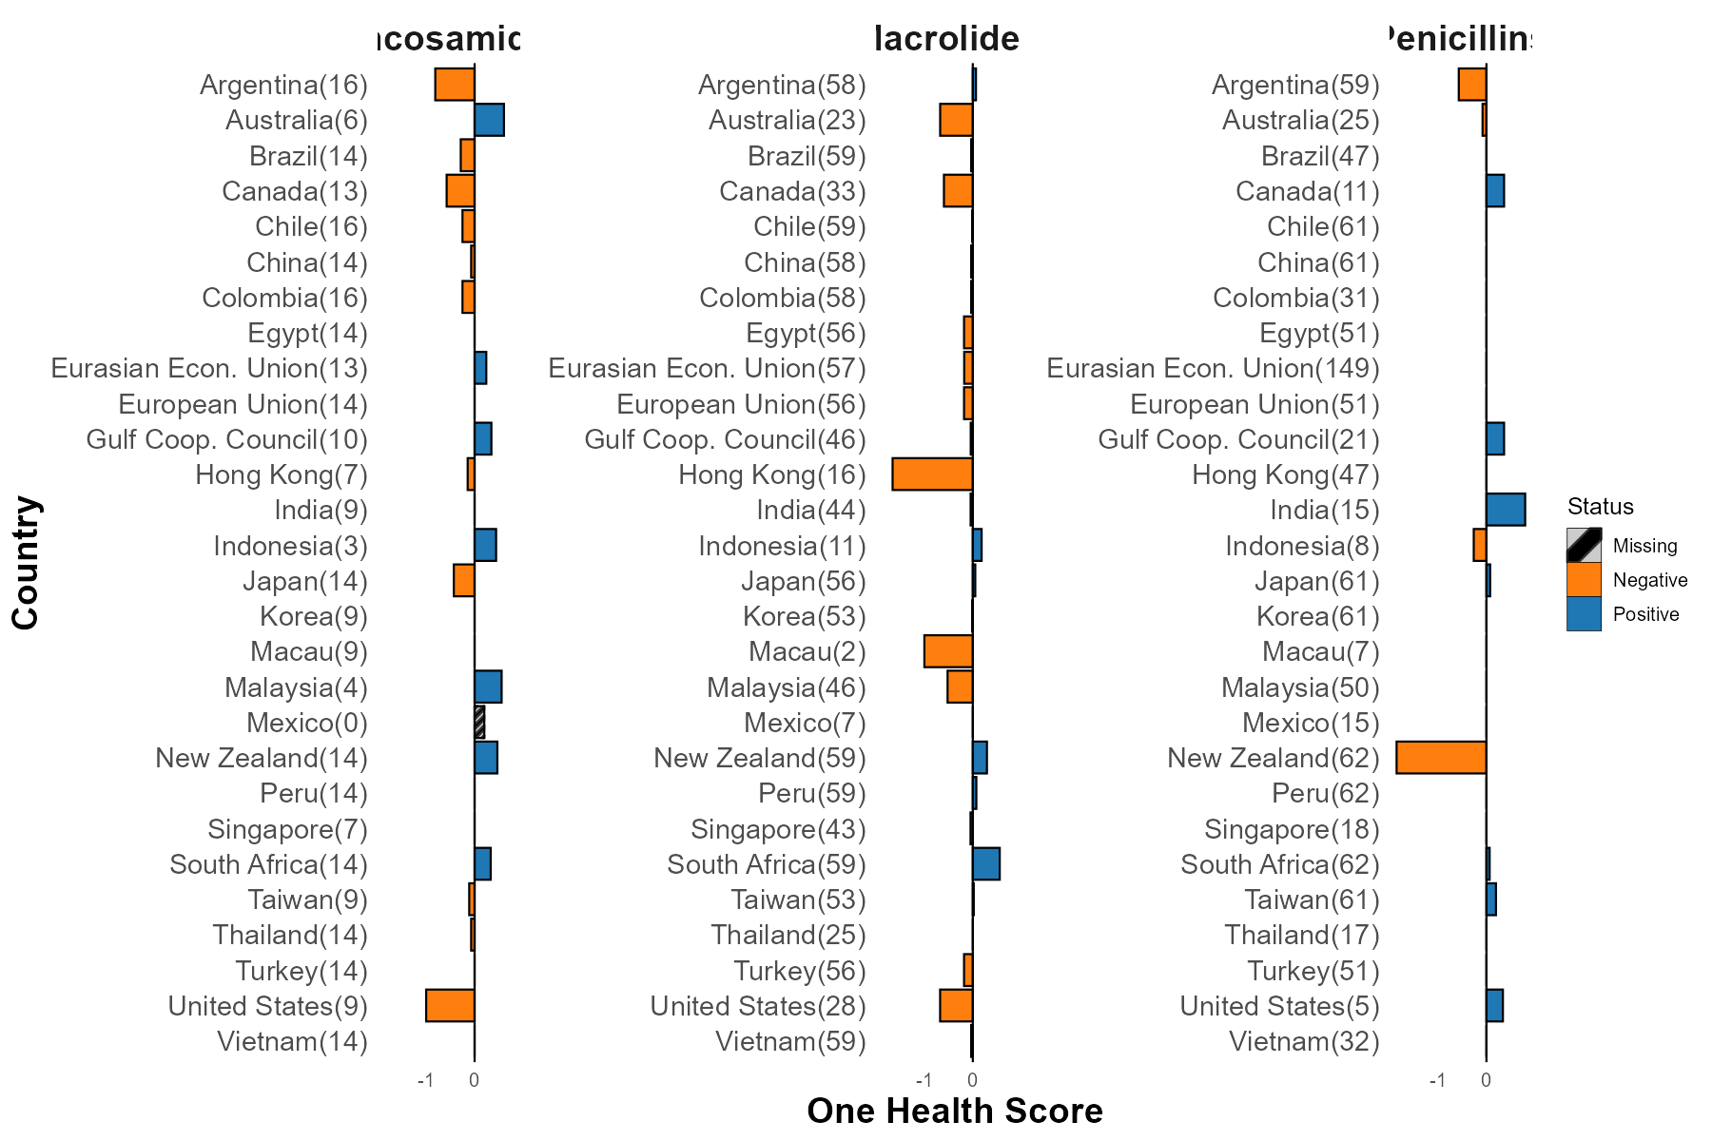
Figure H continued...
Note: Number of drug-product MRL pairs in parenthesis. Countries with MRL pair observations but without bars have OHS of zero and are on aggregate compliant with Codex. Grey bars indicate countries without MRL pairs within the drug class.
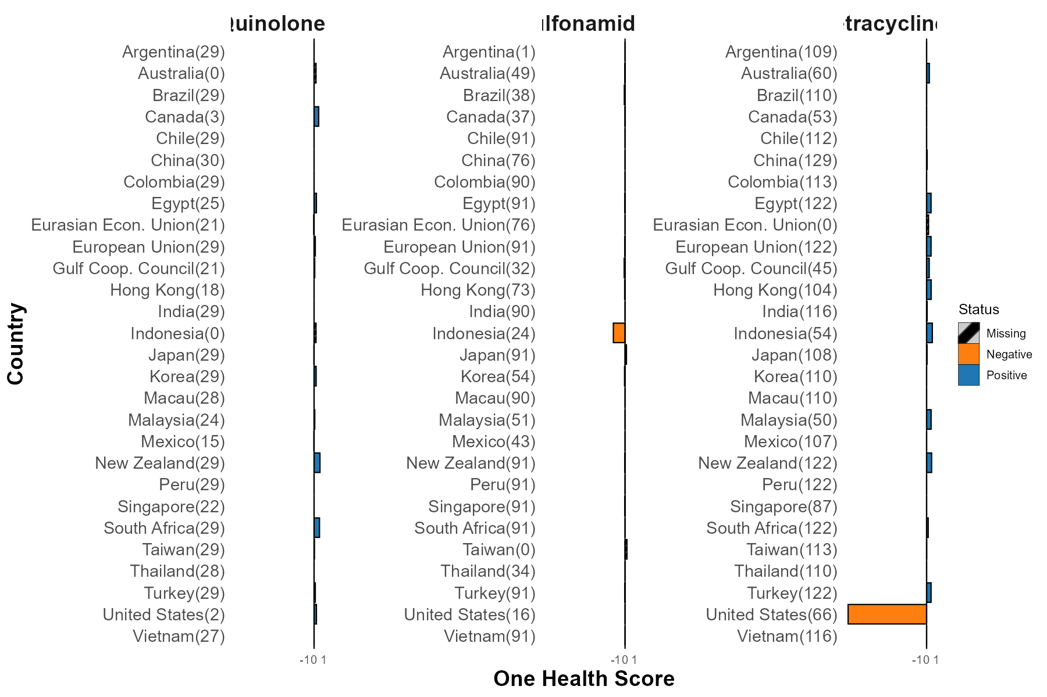
Figure H continued...
Note: Number of drug-product MRL pairs in parenthesis. Countries with MRL pair observations but without bars have OHS of zero and are on aggregate compliant with Codex. Grey bars indicate countries without MRL pairs within the drug class.

