Supplemental Materials

[⁹⁰Y]Y-L4-Lipo/ Ethyl esters of iodized fatty acids of poppy seed oil (Lipiodol® Ultra-Fluid), a new TARE formulation, designed from a lipophilic ligand for stability and safety.
Olivier Fougère¹, Anne Dencausse¹, Nicolas Lepareur², Gaetan Van Simaeys³, Gilles Doumont³, Isabelle Gardin⁴, Elisabeth Renard¹, Claire Hollenbeck¹, Coraline De Maeseneire³, Nicolas Passon³, Olivier Rousseaux¹, S Catoen¹
¹Research and Innovation Department, Guerbet, Roissy, France, ²Univ Rennes, Centre Eugène Marquis, Inrae, Inserm, Institut NUMECAN [(Nutrition, Métabolismes et Cancer)] - UMR_A 1341, UMR_S 1317, Avenue de la Bataille Flandres, Dunkerque CS 44229, 35042 Rennes Cedex, France, ³Université Libre de Bruxelles, Center for Microscopy and Molecular Imaging, Charleroi (Gosselies), Belgium, ⁴Department of Nuclear Medicine, Centre Henri Becquerel, Rouen, France

Methods
M1-Ex vivo biodistribution of [¹¹¹In]In-L4-Lipo/Lipiodol®
Intraarterial injection of [¹¹¹In]In-L4-Lipo/Lipiodol® in 50µL Lipiodol® Ultra Fluid in N1S1 hepatocarcinoma rat model was performed under anaesthesia (induced by intraperitoneal injection of a mix of ketamin (67.5 mg/kg rat) and xylazin (6.4 mg/kg rat) ) in animals with at least a 2mm-length hepatocarcinoma (3840 ± 690 kBq and 3700 ± 1280 kBq as mean ± standard deviation for time point “1 h” (n=3) and “6 d” (n=3), respectively). Injected doses were calculated by substraction of the activity present in the injection system before and after injection, both measured in a standardized way with an ionization chamber (VDC-405 dose calibrator with VIK-202 ionization chamber, Comecer, Italy).
Ex vivo biodistribution of [¹¹¹In]In-L4-Lipo/Lipiodol® was assessed 2h15 (time point “1 h”) and 6 days (time point “6 d”) post-injection. Rats were sacrificed and dissected to get the tumor (hepatocarcinoma), liver (without hepatocarcinoma), spleen, kidneys, lungs, stomach, intestines, right thigh bone and, separately, bone marrow, as well as blood and plasma. Samples were removed, weighed and placed in cryotubes. Urine samples were also recovered at time point “1 h” and “6 d” along with feces specifically at time point “6 d”. Radioactivity present in the carcass of the rats (“left over” after the dissection at time pint “day 6”) was measured with the dose calibrator. Sample counts were carried out in CPM using a gamma counter (Automatic Gamma Counter Wizard2 2480, Perkin Elmer, USA) calibrated to measure ¹¹¹In, and whose clock was synchronized with universal time on each counting day. Each sample was counted for 5 minutes provided that the count rate did not exceed 10⁶ CPM; in this case, the sample was counted again after suitable decay time. To establish the correspondence between well-counter measurements of radioactivity injected into rats and gamma counter biodistribution measurements, a cross-calibration factor was calculated. To this aim a concentrated quantity of activity in a tube was counted in both the well counter and the gamma counter. The counts are repeated over time in the gamma counter. After decay correction, a calibration line is fitted to the measurement points. Its slope is used to convert count results given in counts per minute (CPM) into activity (Bq).

M2-In vivo biodistribution of [¹¹¹In]In-L4-Lipo/Lipiodol®
To assess the in vivo biodistribution of [¹¹¹In]In-L4-Lipo/Lipiodol® in the N1S1 rat hepatocarcinoma model, SPECT/CT was performed on rats injected with [¹¹¹In]In-L4-Lipo/Lipiodol® with a nanoSPECTPlus (for SPECT) and a nanoScanPETCT (for CT) (Mediso, Hungary). Rats were imaged 1h after injection during 50min (n=3, for time point “1 h”) or 1h40 (n=3, for time point “6 d”). SPECT acquisitions were done with aperture APT105 on a scan range of 230mm in standard mode, 20s-25s/projection. SPECT reconstructions were performed with a multipinhole adapted OSEM in “standard” mode (i.e. 3 iterations, 3 subsets, 35% smoothing) for a reconstructed cubic voxel size of (500 μm)^3. CT was performed with the following parameters: 50 kV, 300 ms/projection, 480 projections, minimal zoom, binning 1:4, scan range of 240 mm and a reconstructed cubic voxel size of (250 μm)^3 using RAMLAK and a cosine filter with a cut-off of 100%. When SPECT and CT are merged, SPECT is automatically resampled to CT resolution. Qualitative analysis of the data was performed with VivoQuant software v3.0 (InVicro, USA).

Tables
Table S1 Descriptive statistics of ex vivo biodistribution of [⁹⁰Y]Y-L4-Lipo/Lipiodol® at time points “1 h”, “24 h”, “3 d” and “6 d”, respectively.
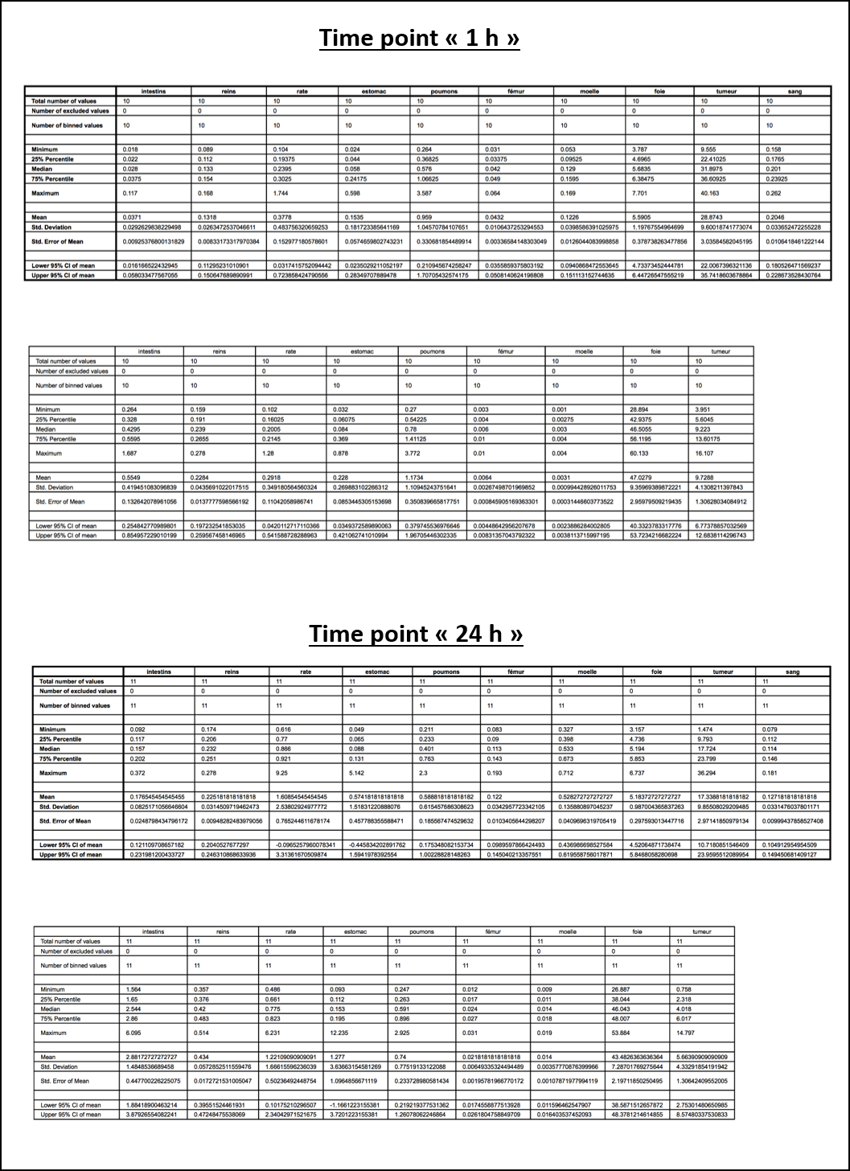
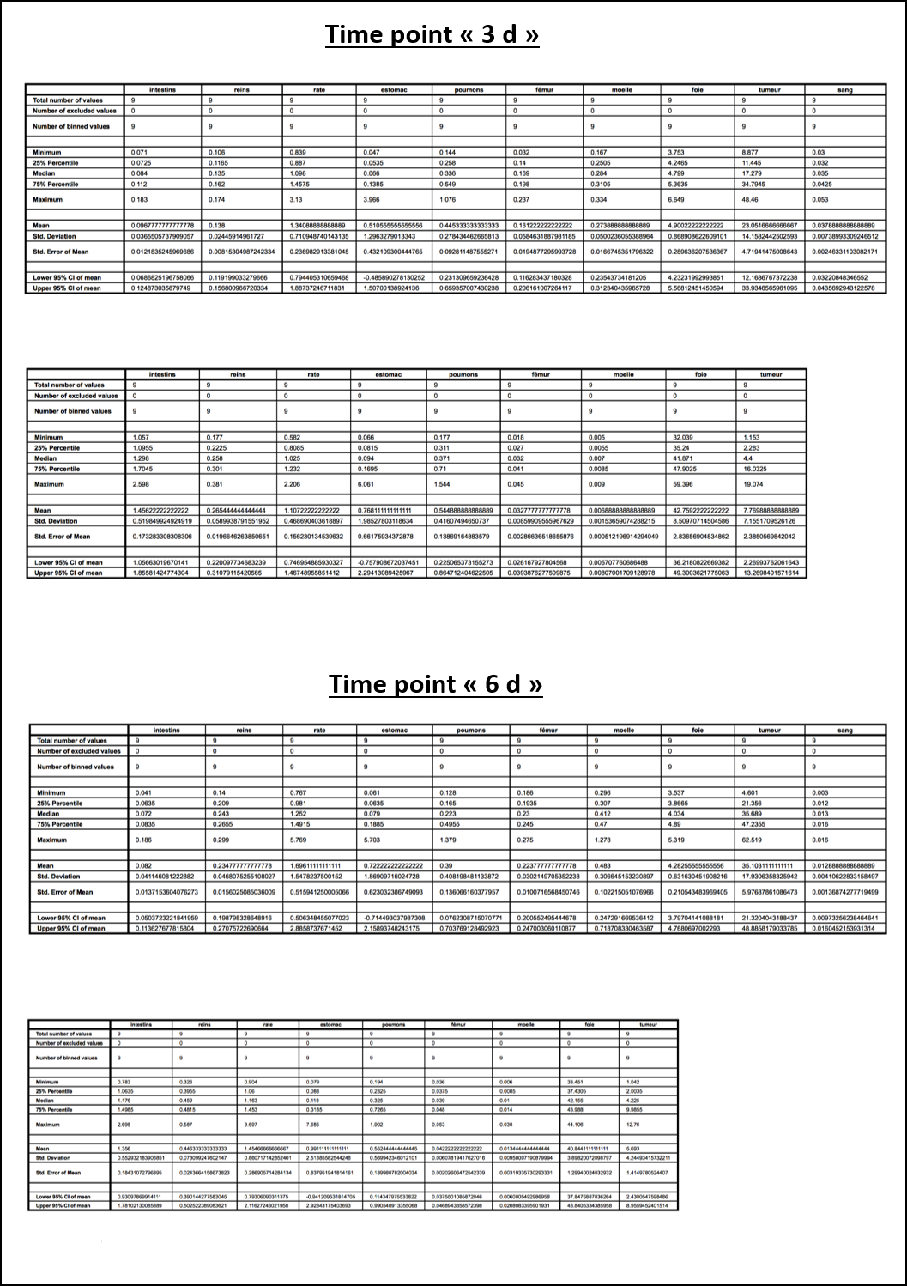

Table S2 Ratio T/NT, calculated from %ID/g biological sample measured at time points “1 h” (left) and “6 d” (right) post-injection of [¹¹¹In]In-L4-Lipo/Lipiodol®.
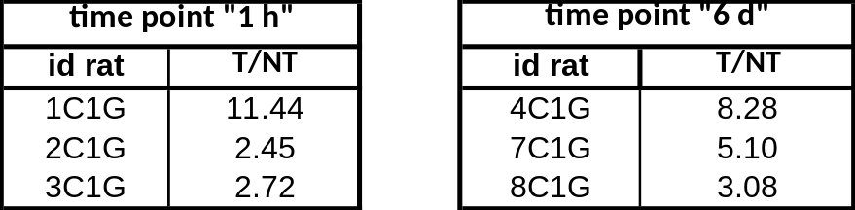

Table S3 Ex vivo biodistribution data related to the injection of [¹¹¹In]In-L4-Lipo/Lipiodol® in rats with hepatocarcinomas N1S1-derivedat time point “1 h” (up) and “6 d” (down). Data expressed in %ID/biological sample. “NA”: not applicable; “-“: not available
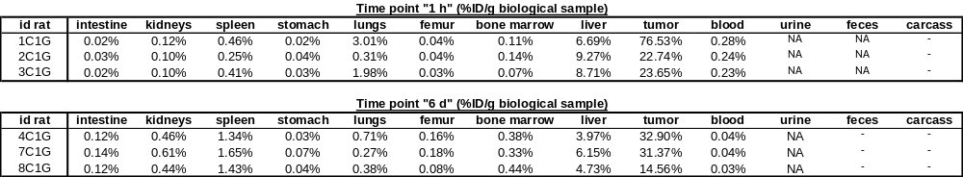

Table S4 %ID/biological sample calculated from the data obtained by gamma counting measurement of ¹¹¹In in each biological sample taken into consideration from rats injected with [¹¹¹In]In-L4-Lipo/Lipiodol® and sacrificed at time points “”1 h” (up) and “6 d” (down). “NA”: not applicable; “-“: not available
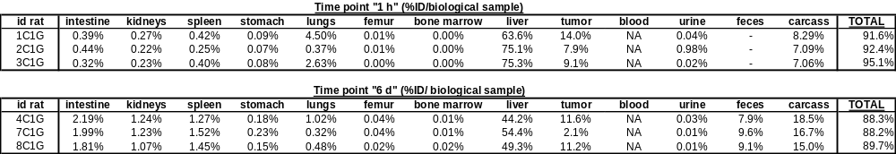
Table S5 Comparison of ex vivo biodistribution of [⁹⁰Y]Y-L4-Lipo/Lipiodol® and [¹¹¹In]In-L4-Lipo/Lipiodol® at the time points “1 h” (up) and “6 d” (down). Values expressed in %ID/tissue (left) or %ID/g sample (right).
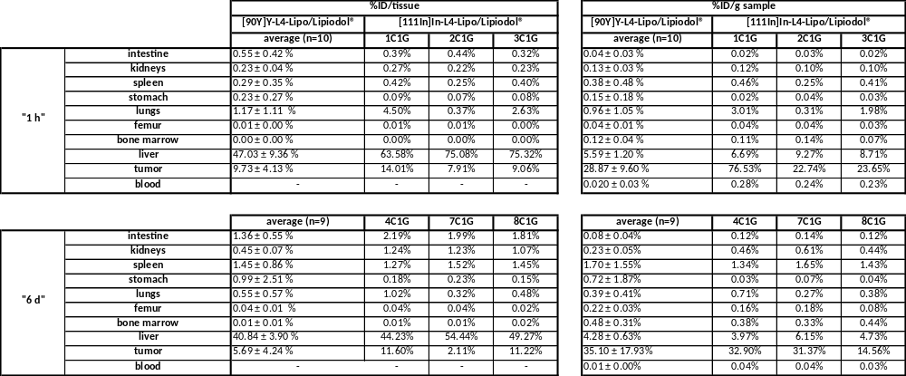

Figures
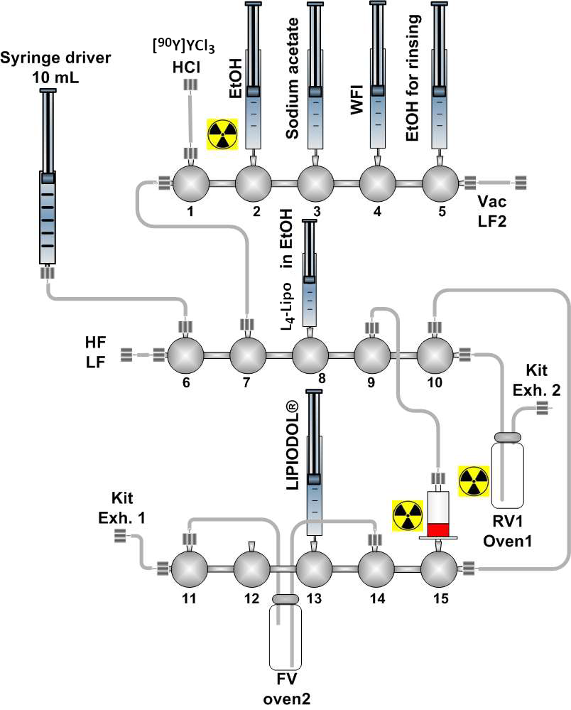
Fig. S1 Single-use cassette chart for the preparation of [⁹⁰Y]Y-L4-Lipo/Lipiodol® Ultra-Fluide with the NEPTIS LC module.

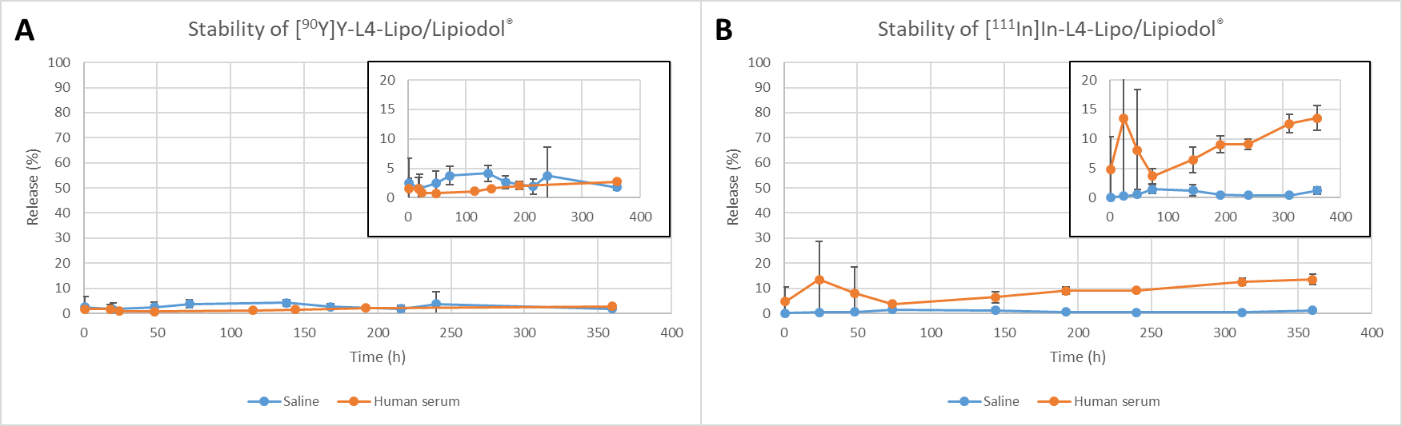
Fig. S2 Stability of the radiolabeled Lipiodol® Ultra Fluid solutions in aqueous phases. A) ⁹⁰Y, B) ¹¹¹In.

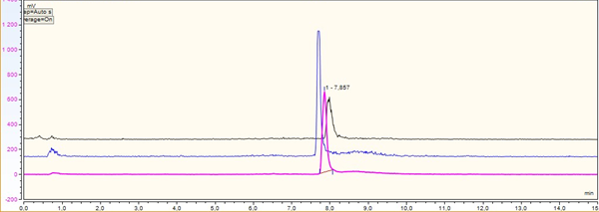
Fig. S3 HPLC chromatograms of [⁹⁰Y]Y-L4-Lipo/Lipiodol® at t₀ (pink) and after 6 days of incubation at 37°C in saline (black) or in human serum (blue).

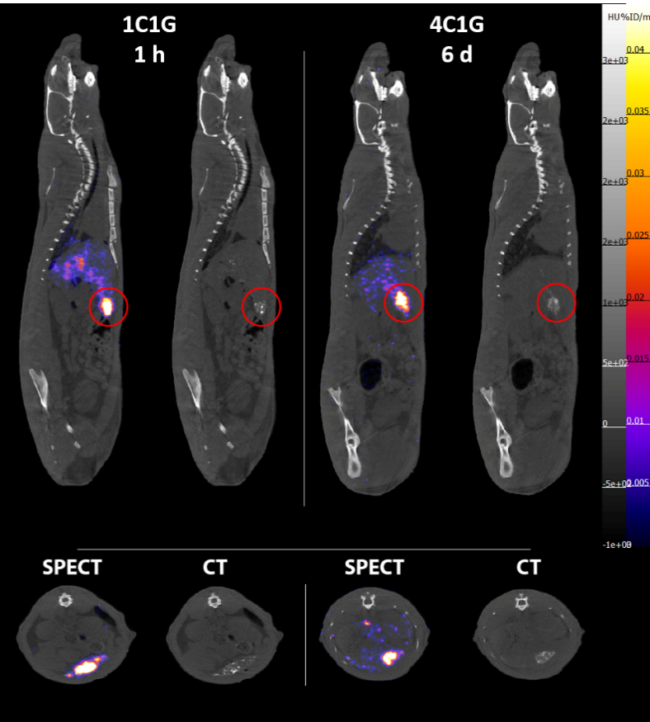
Fig. S4 Sagittal (upper row) and cross-sectional (lower row) views of representative SPECT/CT images of rats injected with [¹¹¹In]In-L4-Lipo/Lipiodol® at time points “1 h” and “6 d”.

