Supplemental Information for:

Regional coordination can alleviate the cost burden of a low-carbon electricity system
Jacob Wessel^{a,*}, AFM Kamal Chowdhury^{b}, Thomas Wild^{b}, Franklyn Kanyako^{c}, Gokul Iyer^{d}, Jonathan Lamontagneª
ª Department of Civil and Environmental Engineering, Tufts University, Medford, MA 02155, United States
^{b} Earth System Science Interdisciplinary Center, University of Maryland, College Park, MD 20740, United States
^{c} Nelson Institute Center for Sustainability and the Global Environment, University of Wisconsin, Madison, WI 53706, United States
^{d} Center for Global Sustainability, University of Maryland, College Park, MD 20740, United States
Contents
Text S1. Benefits of Regional Coordination 2
Text S2. Uncertainty and Resolution in Electricity System Models 6
Text S3. Mercosur and SIESUR 11
Supplemental Tables 13
Supplemental Figures 14
Text S4. Stranded Coordination Vulnerability 29
References for Supplemental Information 32

Table S1 2
Table S2 7
Table S3 8
Table S4 9
Table S5 12
Table S6 13
Table S7 13

Figure S1 14
Figure S2 15
Figure S3 16
Figure S4 17
Figure S5 18
Figure S6 19
Figure S7 20
Figure S8 21
Figure S9 22
Figure S10 23
Figure S11 24
Figure S12 25
Figure S13 26
Figure S14 27
Figure S15 27
Figure S16 28
Figure S17 29
Figure S18 30
Figure S19 31
Figure S20 31
- Benefits of Regional Coordination
There exist many regional initiatives worldwide with the goal of connecting and coordinating neighboring electric grids to derive mutual benefit from operating a larger system¹, including five African Power Pools², the Association of Southeast Asian Nations (ASEAN) Power Grid (APG)³, and the European Network of Transmission System Operators for Electricity (ENTSO-E)⁴. Researchers have also examined the potential of further integrating the United States’ three grid interconnections^{5,6}, which themselves trade large amounts of electricity with Canada and Mexico^{7,8}. Increasingly, more serious consideration is also being given to the potential implications of intercontinental and globally interconnected power systems^{9,10}.
Interregional electricity trade and coordinated planning can cost-effectively promote higher shares of renewables in the generation mix and reduce cumulative CO₂ emissions^{11,9,12}. This is primarily due to 1) a spatially heterogeneous distribution of renewable resource quality throughout a region¹³; 2) lower system costs offered by balancing supply and demand variability over a larger region^{6,14} as well as centralized dispatch¹⁵; and 3) increased reliability in the face of hydrometeorological extremes such as drought and heat waves¹⁶. Electricity systems with high shares of intermittent renewables can further benefit from investment in transmission expansion through decreases in curtailment, price volatility, and reliance on storage technologies^{5,10,11,17}. Still, such coordination must ensure benefits are distributed among participating regions and aligned with the goals and unique development contexts of individual countries^{18–20}. Table S1 provides an additional (non-exhaustive) review of relevant studies.
Table S1
: Review of studies (by region) examining increased regional coordination in electricity systems.
Ref. | Region | Focus | Detail
¹ | International | Review of “Macro Grids” worldwide, noting progress and opportunities in various regions. Relevant discussion for countries in South America included. | South America is largely lacking international transmission interconnections, despite geographic diversity in its renewable resource potential. However, there are ongoing initiatives increasing within-country transmission capacity in Brazil (to connect Amazonian hydro and wind in the northeast) and Chile (to connect Atacama solar).
¹² | Latin America and the Caribbean | Examines near-term benefits of increasing transnational electricity trade in Latin America by modeling short-term dispatch with a production-cost model. | Reviews benefits of short-term infra-marginal electricity trade, asserting that costs involved with new infrastructure and institution building in the region can be far exceeded by, e.g., savings in fuel & operational costs, lower peaking capacity investment, increased reliability, pooled reserve margins, optimal utilization of natural resources, and avoided emissions.
²¹ | Latin America and the Caribbean | Brazil-focused study applying cooperative game theory (Shapley values) to analyze the bargaining power of Latin American countries. | Three expansion scenarios are explored; increased integration comes from pre-specified transmission expansion. Brazil, Argentina, Paraguay, Peru, and Guyana are determined to have the most bargaining power. Models 48 time slices (one representative day per month, split into four 6-hour periods).
²² | Latin America and the Caribbean | Simulates grid integration in Latin America with a system dynamics model to articulate the opportunities and challenges involved. | Asserts that the benefits gained by increased integration will strongly depend on policy, regulatory, and technical issues. Further, countries should be wary of over-reliance on their neighbors. Four policy-based scenarios are considered.
²³ | Latin America and the Caribbean | Examines transnational electricity trade in South America through a surplus-based framework, proposing regulatory policy through empirical analysis and simulation. | Enhanced trade can reduce marginal generation costs and overall operational costs.
²⁴ | Latin America and the Caribbean | Examining alternative mitigation scenario for Latin America, in which transnational electricity trade is augmented through high-capacity smart grids region-wide. | Latin America could increase its contribution to the global mitigation effort through a “Super Smart grid”, enabling broader integration of renewables.
²⁵ | Latin America and the Caribbean | Hourly power system model with 100% renewables in 2030 in South and Central America. | Runs four scenarios varying the level of development.  Shows cost reductions associated with higher grid coordination.
²⁶ | Latin America and the Caribbean | Focus on detailed transmission topology. Proposes a grid configuration for an integrated Latin American “SuperGrid” by optimizing transmission investments under various weather scenarios. | Posits the “SuperGrid” as a means to guarantee energy security in the region, and more efficiently utilize natural renewable resources.
²⁷ | Latin America and the Caribbean (and Europe) | Focus on detailed transmission topology. Considers Super Grids in Latin America and in Europe for a comparative review. | Lists increased reliability and resilience to extreme weather events as a reason for larger grid integration.
² | Africa | Review of African power pools and the integration of electricity grids. Explores the drivers responsible for shaping the power pools over time. | Reports that unevenly distributed natural energy resources across countries drove development of transnational interconnections.
¹³ | Africa (EAPP and SAPP) | Wind and solar siting analysis for two African power pools, in order to propose specific regional interconnection opportunities of low regret, to make renewables competitive with conventional dispatchable generation. | Wind and solar resources are spatially heterogeneous, enabling transnational interconnections to add value transporting these resources. International trade reduces total system costs and reliance on conventional generators. Scenarios vary the objective function and the level of coordination (in terms of interconnections).
²⁸ | Africa (West Africa) | Analyzes the complementarity of wind, solar, and hydro in West Africa. | Enhanced management of hydropower generation can enable significant wind and solar integration, while reducing natural gas consumption and the overexploitation of hydro. Regional transmission planning should incorporate spatiotemporal synergies of renewables to maximize their utility.
²⁹ | Africa (SAPP) | Analyzing decarbonization pathways for Southern African Power Pool (SAPP) through power system modeling and scenario analysis. | Seven scenarios, including one which varies the level of coordination by limiting transmission expansion. Limited transmission expansion is the only scenario which must install new coal capacity to meet demand.
¹⁵ | Africa (SAPP) | Unit commitment / economic dispatch model of Southern African Power Pool, to quantify the value of full centralized coordination in electricity dispatch. | Annual benefits of full coordination are calculated to be $100 million, due in part to increased hydropower generation in certain countries and reducing fuel costs in others.
¹⁶ | Africa (EAPP) | Capacity expansion model analyzing economic and environmental benefits of integration and trade in the Eastern African Power Pool across policy scenarios. | The highest level of integration yields the most benefits, and emissions reductions are achieved at much lower cost while drought impacts are reduced. Constraining imports to a maximum allowed level still preserves most of the benefits.
³ | Southeast Asia (APG) | A review of the Southeast Asian Nations (ASEAN) power grid (APG) integration, technical challenges, transmission expansion plans, and modeling opportunities. | Proposes the use of simulation models to identify attractive interconnection projects which will optimally utilize renewable resources under various climate policies.
³⁰ | Southeast Asia | Examine the role of solar PV and regional coordination in limiting overexploitation of hydropower in Southeast Asia. | Countries may be able to meet future demand and emissions targets with less hydropower for a minimal cost premium, through solar PV and centralized coordination and trade.
¹⁴ | Europe | Examines the relationship between larger-scale grid integration and electricity costs and infrastructure requirements in Europe. | Larger interconnected European grids have lower costs, owing to increased flexibility in balancing the supply of renewables, but regional supply may only have a minimal cost premium by implementing continent-scale balancing. Expanding transmission is essential for lowering costs; the tradeoff is between requiring more generation infrastructure (regional supply) or more transmission expansion (continental supply). Uses costs of technologies as sensitivities.
²⁰ | Europe | Spatially resolved modeling in Europe to examine how regional inequalities may evolve under electricity decarbonization in a multinational electricity system. | Benefits are accrued throughout Europe in terms of investments, jobs, and reduced emissions, but they may be concentrated in certain regions while leaving others vulnerable. The study uses 250 MGA scenarios.
¹¹ | Europe (and MENA) | Capacity expansion modeling for Europe (EU) and Middle East / North Africa (MENA) decarbonization scenarios, with spatiotemporally resolved renewable generation. Uses four scenarios based on a 90% emissions cut and level of transmission expansion. | Finds that emissions reductions are cost-effective if transmission and storage are expanded, and that higher emissions reductions become feasible with this expansion. Limiting transmission expansion yields higher storage requirements, curtailment, and electricity price variability.
¹⁷ | Europe | Examines grid expansion in 2050 for Europe. | Finds tradeoff between storage capacity and grid expansion. i.e., slower grid extensions lead to higher storage capacities.
³¹ | Europe | Examines grid infrastructure expansion for Europe in 2050, using cost-minimizing mixed-integer optimization, with focus on transmission network architecture. | Scenarios vary the level of decarbonization and share of renewables.
³² | Europe | Discusses European electricity system cross-border transmission tariff structures. | Highlights practical difficulties of coordination.
³³ | Europe | Discusses the improvement of European electricity system cross-border transmission tariff structures. | Highlights practical difficulties of coordination.
⁶ | North America (United States) | Analyzes economic benefits related to transmission expansion connecting Eastern and Western Interconnections in the US and fully coordinated dispatch, using a multi-model analysis. | Eight scenarios are constructed under different transmission designs, gas prices, and technology costs. Results suggest substantial value in expanding transmission capacity, due to added flexibility and sharing of renewable resources. Scenarios vary gas price, transmission cost, VRE cost, and transmission network type.
⁵ | North America (United States) | Uses capacity expansion and hourly dispatch model to quantify benefits related to regional coordination and transmission expansion in the US under decarbonization. | Finds substantial reductions in total system costs overall. For transmission expansion scenarios, reduced costs of VRE technologies and short-duration battery storage yield the greatest reductions in total system costs, while for isolated systems, this is achieved through reductions in costs of nuclear power and long-duration storage.
³⁴ | North America (United States) | Examines transmission pathways for the US electricity system through 2050. Scenarios vary transmission expansion level, cost trajectories, and carbon tax. | Low-carbon electricity is achievable with modest cost premiums but net-zero is significantly more costly. In this study, investment in storage capacity is more critical than transmission expansion. Gas capacity continues to be used for reliability and reserve margins. Additionally, cost trends appear to shift towards capital investments under climate policy, away from operational costs.
⁷ | North America | Comprehensive review on natural renewable resources in North America, and discussion of challenges and opportunities for developing them. | Highlights energy storage as a crucial component of a future renewables-heavy US electricity system.
⁸ | North America (Northeastern) | Explores opportunities for decarbonization of Northeastern North American electricity system, using a capacity expansion / economic dispatch model. | Transmission expansion can lower system costs and new capacity requirements, while the combination of transmission expansion and hydropower can complement higher shares of wind generation. As the level of decarbonization increases, so does the value of market integration. However, costs and benefits are unevenly distributed throughout the region.
⁹ | Intercontinental | Global study exploring the possibility for intercontinental coordination of electricity systems and impacts on emissions, using an integrated assessment model. | More remote renewable resources could be accessed, enabling resource-limited countries to more efficiently decarbonize. Larger geographic scale leads to supply and demand smoothing, shared reserve margins, reduced reliance on storage technologies, and lower curtailments.
¹⁰ | Intercontinental | Global study analyzing the feasibility of intercontinental coordinated electricity systems to reduce system costs while satiating growing demand. Scenarios vary between country-level and intercontinental power pools as well as land constraints on renewables development. | South America experiences among the lowest system costs even if suitable land sites are constrained, and among the highest reductions in cost when integrating into a larger power pool (due to lower requirements for solar PV and battery storage). International trade enables better balancing of intermittent renewables and load, and less need for backup fossil generation.
- Uncertainty and Resolution in Electricity System Models
Effective long-term planning of bulk electric power systems undergoing a low-carbon transition represents complex, long-term infrastructure decision-making under deep uncertainty^{35,36}. Model-based decision support can aid policymakers in crafting more robust planning decisions in the face of this uncertainty³⁷. Electricity system models can vary widely in structure, resolution, assumptions, and the treatment of uncertainty, largely driven by the research question being addressed and the computational budget³⁸. Several existing reviews have documented and classified the evolution of these models^{39–48} (for a summary, see Table S2).
Different types of uncertainty may be mitigated in modeling in a variety of ways⁴⁹. Electricity System Models can be augmented by increasing spatiotemporal resolution, as well as sectoral and operational detail, at the expense of increased computational burden^{50–59} (for a summary, see Table S3). Parametric and sampling uncertainties have been incorporated and characterized through methods such as Sensitivity Analysis, Monte Carlo, Modeling to Generate Alternatives, Robust Optimization, and Scenario Discovery^{60–64}, to analyze the effects of, e.g., techno-economic parameters^{60,65–67}, resource potential^{68–70}, hydrometeorological variability^{71,72}, and policy scenario^{20,73–75}. However, the presence of deep uncertainty often precludes the use of probabilistic analyses in favor of exploratory modeling⁷⁶. For a summary, see Table S4.
Techno-economic characteristics in modeling are generally informed by scenarios of future projections, and can have a substantial impact on model outcomes; favorable cost projections of one technology relative to another can affect, e.g., the choice of intermittent renewable technology to deploy, the pace of fossil fuel phaseout, or the required deployment of battery storage⁶⁵. However, these cost forecasts are deeply uncertain predictions of average representative technology types, often without regard to location, and are constantly updated with newly available data. Optimizing capacity expansion under varying technology costs can result in relatively modest differences in total system-wide costs, but the resulting generation mix may be highly variable, especially in individual subregions^{77–79}. Because of this spatial variation in technology deployment, trade dynamics throughout the system can also change, as the model works to minimize the cost premium. In regions with minimal cross-border transmission capacity and non-cooperative infrastructure decisions, deep techno-economic uncertainty can imbue substantial risk in electricity decarbonization investments for individual countries.
Table S2
: List of (chronological) review articles covering long-term energy systems planning models for decision support that focus on the electricity sector in the 21st century, highlighting the various challenges, opportunities, tradeoffs, and best practices for the research space as it evolves over time.
Ref. | Subject of Review | Description
⁴⁸ | Optimization modeling techniques | Optimization approaches for energy systems planning under climate mitigation, from deterministic to fuzzy and stochastic, including a discussion of model-based decision support
⁴⁷ | Uncertainty modeling techniques | Approaches to modeling under uncertainty and their applications; proposed classification of uncertainties in power system modeling
⁴¹ | Comparison of model types | Long-term energy model types and their relative advantages or disadvantages, in order to select the most appropriate model in a given application
³⁹ | Capacity expansion modeling with high renewables shares | NREL report summarizing specific experiences modeling capacity expansion with high levels of renewables, primarily with the use of ReEDS
³⁸ | Best practices for modelers | Literature review to support creation of guidelines for energy system modeling, includes discussion of model features and treatment of uncertainty
⁴³ | Uncertainty modeling techniques | Comparison of methods to analyze risk and uncertainty in energy systems with high renewables shares
⁴⁶ | Capacity expansion modeling with high renewables shares | Literature review on designing/operating grids with large amounts of wind and solar; case study for the UK
⁴⁵ | Comparison of model types | Methods to classify bottom-up energy system models, and a proposed classification approach anchored around model resolution
⁴⁰ | Challenges and future research directions | Provides an additional list of reviews in the literature, and identifies uncertainty and resolution as two of four primary challenges in modeling
⁴⁴ | Best practices for modelers, Challenges and future research directions | Review of critiques, priorities, and best practices of Macro-Energy Systems (MES) research, identifying research which discusses and addresses each point.
⁴² | Capacity expansion modeling with high renewables shares | Review of research around identifying future sustainable energy mixes in developing regions, in line with (Sustainable Development Goal) SDG7.

Table S3
: List of selected (chronological) works which include discussion related to the value and influence of spatial and temporal model resolution for electricity and power system models.
Ref. | Model | Focus | Insight
⁵⁴ | ReEDS | Varies the level of spatial resolution in the ReEDS model (USA) between balancing authority, state, and NERC region levels to analyze renewables and transmission buildout. | Spatial aggregation in renewable resource quality can impact technology competitiveness, particularly for solar.
⁵⁶ | TIMES, LUSYM | Explores temporal representation across models (time slice structures, hourly resolution) as well as the level of technical operational detail, for a case study in Belgium. | Temporal detail can substantially impact grid dispatch, especially with high levels of renewables present.
⁵² | REMix | Models 5 different storage technologies which vary from short- to long-term for a European system with high spatial and temporal resolution. | Temporal patterns of intermittent renewables, and thus the relative generation shares of each technology, impact the expansion of storage.
⁵⁵ | C-CEM, TS-CEM | Compares two capacity expansion models which differ in temporal representation (month-hourly representative days vs. seasonal average time slices) for a Texas case study. | Month-hourly temporal resolution leads to lower levels of unmet demand.
⁵⁹ | Custom MILP | Uses high spatiotemporal detail in wind speed to co-optimize generation and transmission expansion at the wind farm level. | Reduced spatiotemporal detail in wind speed may lead to an overestimation of wind power potential.
⁴⁵ | multiple | Reviews bottom-up energy system models and their classification schemes, while framing modeling challenges around resolution (spatial, temporal, techno-economic, and sectoral). | Current modeling has not reached high resolution in all four areas simultaneously.
⁵⁷ | PyPSA-Eur | Describes methodology for assessing individual sensitivities in energy system optimizations through a distance error metric, using a model of Europe. | Temporal resolution should be fine enough to reasonably capture the variability of renewables and balancing through storage technologies.
⁸⁰ | Latin America and the Caribbean | Site selection analysis to assess complementarity of wind and solar PV to hydropower, specifically targeting ENSO periods in Latin America. | Uses spatially resolved wind and solar potentials, as well as site-specific hydropower availability, to statistically compute complementarity between individual projects. Shows the ability of complementary renewable technologies to balance fluctuations in energy availability, reducing reliance on thermal dispatchable generation.
⁵⁰ | MESSAGEix-GLOBIOM, PLEXOS-World | Presents a bi-directional soft coupling of a power system model with an integrated assessment model, to allow global IAM results to be analyzed with a more detailed sectoral model of the power system. | Copperplate regions may overestimate intermittent renewables, while relative underutilization of battery storage in more detailed power system models is in part due to advantages offered by transmission expansion. A range of storage options of varying timescales would improve such analyses (e.g., pumped hydro offering seasonal storage for wind and batteries offering diurnal storage for solar as well as peak management).
⁵³ | PyPSA-Eur | Explores methods to disaggregate lower resolution spatial outputs for use in more detailed modeling, using a Europe case study. | Results taken from a highly aggregated model may become infeasible when downscaled, in part due to load shedding and unmodeled transmission congestion, though computational tractability remains an issue.
Table S4
: List of selected (chronological) works incorporating uncertainty into electricity system models through random sampling or varying, e.g., parameter inputs, policy levers, structural relationships, etc.
Ref. | Model | Focus | Uncertainties
⁶¹ | Developed for Ref. | Brings modeling to generate alternatives (MGA) to energy system models for systematic exploration of outcomes by producing a broad set of near-optimal solutions; uses example of US electricity system | - Varies the “slack” in the objective function to produce alternative decision sets
⁸¹ | SWITCH | Optimal generation, storage, and transmission expansion in western North America, using carbon pricing to meet 2030 emission targets | - Overnight capital cost of nuclear  - Interannual change in gas price  - Cost decline rate of solar PV  - Cost decline rate of CSP
⁷³ | Stochastic MARKAL | Illustrates the value of a stochastic programming approach to an uncertainty analysis of the US electric sector, for policy decision support | - Climate policy  - CCS availability  - Nuclear availability
⁶⁰ | Developed for Ref. | Predicts potential grid integration of wind power in China; explores how increased flexibility in coal plant operation could increase this potential | - Wind turbine spacing  - Water depth (offshore wind)  - Capital and O&M costs for wind  - Grid integration costs for wind
⁶⁶ | energyscope, as in ⁸² | Method to characterize uncertainties and estimate uncertainty ranges in energy planning models, including a global sensitivity analysis case study for Switzerland | - 21 categories of uncertain parameters, including investment and operating costs, capacity factors, efficiencies, and interest rate, among others
⁸³ | ReEDS | Explores effects of higher intermittent renewable energy shares on grid operation in the US, finding increased value in flexibility from a broad range of technologies as well as altered temporal dynamics in extreme price hours | - Demand growth rate  - Vehicle electrification  - Natural gas price  - Costs of generation & storage technologies  - Financing assumptions  - Retirement timelines for nuclear and coal  - Climate impacts and resource supply curves  - Transmission expansion  - Cooling water use
⁶⁷ | Developed for Ref. | Estimates onshore wind potential in Finland and installation costs based on turbine characteristics and distance from transmission, noting economic potential calculations remain difficult due to cost uncertainty, with additional supplemental literature review highlighting previous work which examines specific wind turbine types | - Land use restrictiveness  - Turbine vintage and specific model  - Turbine hub height  - Sensitivity analysis shows impact of, e.g., capacity factor, interest rate, costs of grid connection and transmission lines, and O&M costs, among others
⁷⁷ | GLAES | Estimates potential of offshore wind in Europe using high spatial resolution and simulated future turbine designs | - Turbine capacity  - Turbine hub height  - Turbine rotor diameter  - Ocean eligibility restrictions
⁶³ | Balmorel | Uses sensitivity analysis and Monte Carlo simulation to explore the uncertainty space of a low-carbon Danish grid; notes that offshore wind integration will require international transmission expansion | - 36 uncertain parameters including, e.g., capacity factors, district heating fuels, capital costs of various technologies, transmission barriers, discount rate, and demand levels, among others
⁸⁴ | OSeMOSYS-CR | Uses scenario discovery to identify vulnerabilities and shared conditions among economy-wide uncertain factors which lead to potential negative outcomes in Costa Rica’s national decarbonization plan | - Economic growth rate  - Latin hypercube sampling of driver, benefit & cost, and decarbonization uncertainties across six sectors
⁶² | energyscope, as in ⁸² | Uses robust optimization to consider large set of uncertain parameters; literature review of robust optimization in energy modeling | - 160 uncertain parameters in both the objective function (e.g., investment and O&M costs, interest rate) and constraints (e.g., sectoral demand, conversion efficiencies, capacity factors)
⁷¹ | Modified IEEE 300-Bus System | Uses stochastic programming to analyze capacity expansion and grid integration of intermittent wind and solar PV in Texas | - Correlated random samples of irradiance, wind power potential, and electricity demand
⁷⁵ | EXPANSE | Applies MGA to examine the outcome space of spatially detailed, subregional inequalities resulting from Central European electric sector targets | - Varies “slack” in the objective function (minimize LCOE) to produce alternative decision sets
⁷⁹ | EOLES | Tests the impact of technology cost uncertainty on total system costs for France’s electricity system, as well as estimating regret from decisions based on incorrect cost assumptions | - Costs of solar and wind  - Costs of battery storage  - Cost of methanation
⁵ | Developed for Ref. | Models fully decarbonized US electricity system, noting that transmission expansion substantially lowers system costs and storage requirements | - CAPEX of wind, solar, and storage  - Transmission cost, expansion allowed  - Nuclear cost, flexibility, expansion allowed  - Load shedding assumptions  - Clean energy standard  - Allowing investment in gas
⁸⁵ | GCAM | Explores uncertainty in renewable resource potentials and their impacts on future global wind and solar PV generation projections using an integrated assessment model | - Turbine technology, hub height, power density  - Suitability factors for solar and wind  - PV performance ratio and land use factor  - Climate impacts on PV and wind power  - 2°C global mitigation scenario
⁶⁵ | REMIND–MAgPIE | Explores global electrification and decarbonization scenarios with an integrated assessment model to analyze cost parity potential of wind and solar under carbon pricing schemes with conventional thermal generation | - 1.5°C vs. 2°C global mitigation scenario  - Bioenergy potential  - CCS injection capacity  - Vehicle electrification barriers  - Electricity demand flexibility  - Solar PV capital cost projection

- Mercosur and SIESUR
This study analyzes the value of full regional electricity coordination under mid-century deep decarbonization in a five-country region of South America, encompassing the continent’s Southern Cone as well as the Southern Common Market (Mercosur) economic trade bloc; this includes Argentina, Brazil, Chile, Paraguay, and Uruguay. For consistency, our study region of these five countries is referred to throughout the paper as “Mercosur”. This region contains abundant but geographically variable natural renewable resources, with an electricity system historically dominated by hydropower but with relatively high shares of wind and solar as well⁸⁶. However, though the output of several large hydropower projects is shared by bordering countries, transnational interconnections remain limited despite the spatially variable endowment of renewable resources¹, requiring continued use of fossil fuel resources for load balancing⁸⁷. Phasing out the use of gas-fired power plants, meeting growing electricity demand, and mitigating uncertainty in the climate impacts on future hydropower and other renewable electricity generation will all require additional investment in wind and solar capacities^{88,89}. By coordinating these long-term planning decisions throughout a larger interconnected system, this region can also take advantage of complementarities and synergies between hydropower and intermittent wind and solar^{80,30,28,25}.
Latin America and the Caribbean has been identified as a region with opportunities for low-regret investment in regional electricity cooperation^{12,90} and coordinated transmission systems^{24,26,27}, subject to successful navigation of the regulatory and policy environment^{22,23,91} as well as balancing potential mismatches in neighboring countries’ bargaining power²¹. As LAC seeks to both decarbonize and avoid future emissions, many governments are turning to cooperative planning strategies to meet clean energy and economic development goals⁹².
Mercosur was formed in 1991 with the Treaty of Asunción, with original member countries Argentina, Brazil, Paraguay, Uruguay, and Venezuela (now suspended), to provide a common market promoting free trade and regional economic development⁹³. However, there is relatively very little electricity trade between countries, and it has decreased over time, with existing interconnections rarely being fully utilized¹². This is due in part to the exclusively binational sales and transfers of power across these lines, rather than through coordinated dispatch⁹⁴. Ríos et al. map a brief timeline of regional electricity coordination in LAC and propose the Southern Energy Integration System (SIESUR), consisting of Argentina, Brazil, Paraguay, Uruguay, and Chile (an associate member of Mercosur), to engage in regional electricity coordination by taking advantage of existing binational hydropower generators and transmission infrastructure⁹⁴. This initiative is currently being explored with support from the Inter-American Development Bank (IDB)⁹⁵. In addition to SIESUR, development banks support other coordination efforts for the electricity system in LAC as well, including SIEPAC (Central America; final transmission link completed in 2014), SINEA (Andean region; formed in 2011), and Arco Norte (Guyana, Suriname, French Guiana, and Northern Brazil; exploratory stages), which are at varying stages of implementation^{95,96}. See Table S5 for a general overview of the current landscape.
Table S5
: General overview of electricity system structures for Mercosur (SIESUR) countries.
 | Argentina | Brazil | Chile | Paraguay | Uruguay
Structure | Unbundled since 1991, regulated by ENRE | Unbundled since 1996, regulated by ANEEL | Unbundled and 100% private since 1982, regulated by SEC | Integrated and regulated under a public monopoly, ANDE, since 1949 | Integrated under a national utility, UTE, since 1912; regulated by URSEA
Generation | Competitive market with mostly private ownership (except nuclear and bi-national hydro), wholesale market administered by CAMMESA | Capacity owned mostly by federal and state-owned entities (the largest being Eletrobras), while a smaller but growing share is privately owned | Privately owned companies | Almost entirely hydropower-based from three dams, two being bi-nationally operated, with a few thermal power plants | Significant share owned by UTE, with some capacity (primarily wind generation) owned by private companies
Transmission | Operated primarily by a single private entity, Transener | Operated primarily through federal and state entities, but including some concessions | Privately owned, majority controlled by Transelec | Controlled by ANDE | Controlled by UTE
Distribution | Three main service providers (Edenor, Edesur, Edelap), majority private ownership | Majority are privately owned companies | Entirely privately owned companies | Operated exclusively by ANDE, with concessions | Controlled by UTE
Bi-National Capacity | Hydropower with Uruguay, hydropower with Paraguay | Hydropower with Paraguay | - | Hydropower with Argentina, hydropower with Brazil | Hydropower with Argentina
Links | National Electricity Regulator (ENRE) | Ministry of Mines and Energy (MME)  National Electric Energy Agency (ANEEL) | Ministry of Energy  Transelec | National Electricity Administration (ANDE) | National Administration of Power Plants and Electrical Transmissions (UTE)

Supplemental Tables
Table S6
: Model turbines T1-T10. Capital costs estimated from aggregate revenue data in public reports issued by manufacturers, and scaled such that T1 is consistent with data in previous studies⁹⁷.
Turbine | Modeled after: | Capital Cost ($/kW) | Hub Height (m) | Rotor Diameter (m) | Nameplate Capacity (MW) | Cut-in Speed (m/s) | Rated Speed (m/s) | Cut-out Speed (m/s)
T1 | Vestas V90 2000 | 1575 | 100 | 90 | 2 | 4 | 13 | 25
T2 | Vestas V164 7000 | 1575 | 100 | 164 | 7 | 4 | 11 | 25
T3 | Vestas V90 3000 | 1575 | 100 | 90 | 3 | 4 | 15 | 25
T4 | Siemens SWT 3.6 107 | 1264 | 90 | 107 | 3.6 | 3 | 13 | 25
T5 | Siemens SWT 2.3 93 | 1264 | 80 | 93 | 2.5 | 4 | 14 | 25
T6 | GE 2.5xl | 1645 | 100 | 100 | 2.5 | 3 | 13 | 25
T7 | GE 1.5sle | 1529 | 80 | 77 | 1.5 | 3.5 | 12 | 25
T8 | Gamesa G80 2000 | 1264 | 80 | 80 | 2 | 3.5 | 12 | 25
T9 | Enercon E126 7000 | 3684 | 135 | 126 | 7 | 3 | 16.5 | 34
T10 | Enercon E101 3000 | 1787 | 135 | 101 | 3.05 | 2 | 13 | 25
Table S7
: Practical resource potential for wind and solar PV in each country (modeled project sites only).
Wind
Country | Total Potential (GW) | Mean Annual Capacity Factor
Argentina | 631.6 | 0.409
Brazil | 282.0 | 0.280
Chile | 25.2 | 0.481*
Paraguay | 80.3 | 0.344
Uruguay | 102.6 | 0.300
Solar PV
Country | Total Potential (GW) | Mean Annual Capacity Factor
Argentina | 68.6 | 0.251
Brazil | 134.7 | 0.219
Chile | 94.1 | 0.286
Paraguay | 11.4 | 0.211
Uruguay | 8.1 | 0.220
*Capacity factor due to sites in remote far south. Values are only representative of sites in the model.

Supplemental Figures
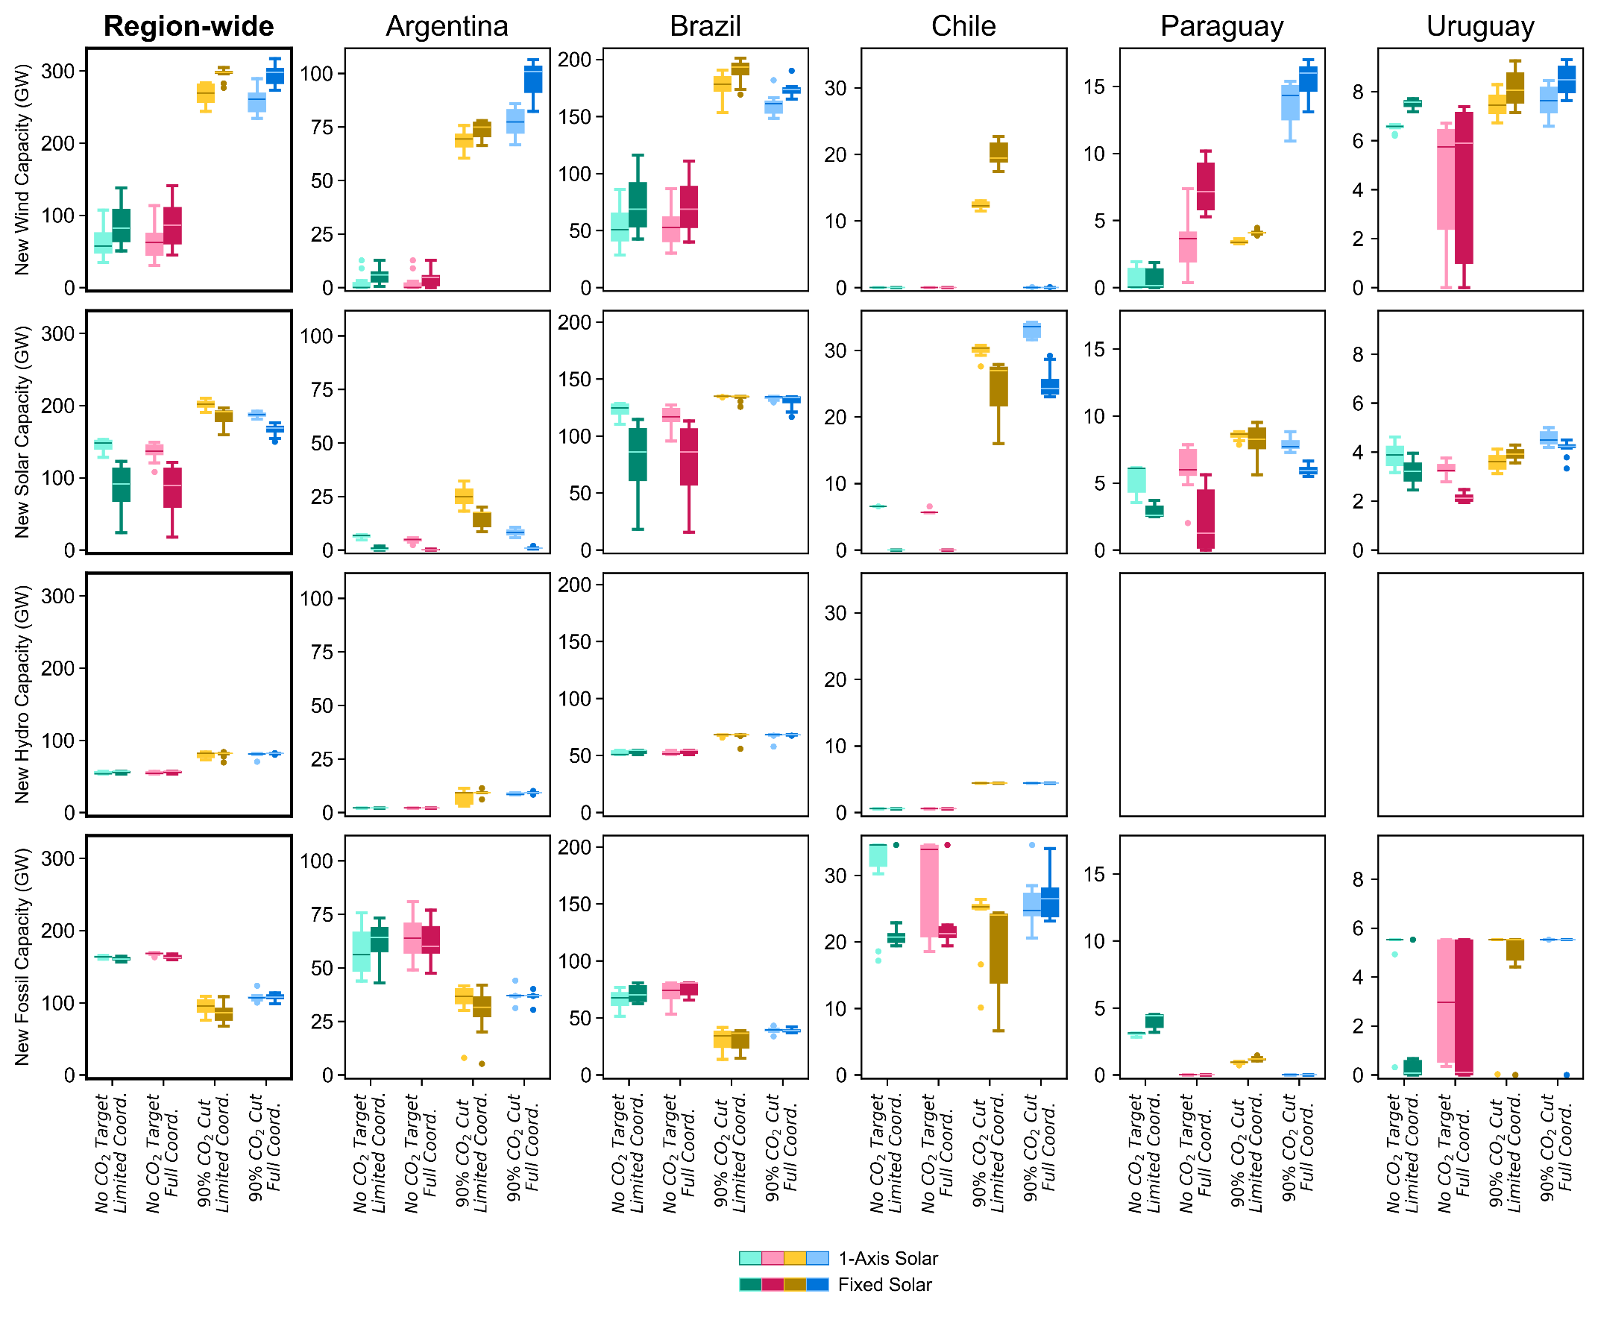
Figure S1
: New capacity requirements by 2050 for full system and each country. Under Limited Coordination and especially with Fixed Solar, Chile begins to install wind capacity in addition to solar PV in order to meet demand as well as the Mitigation constraint.
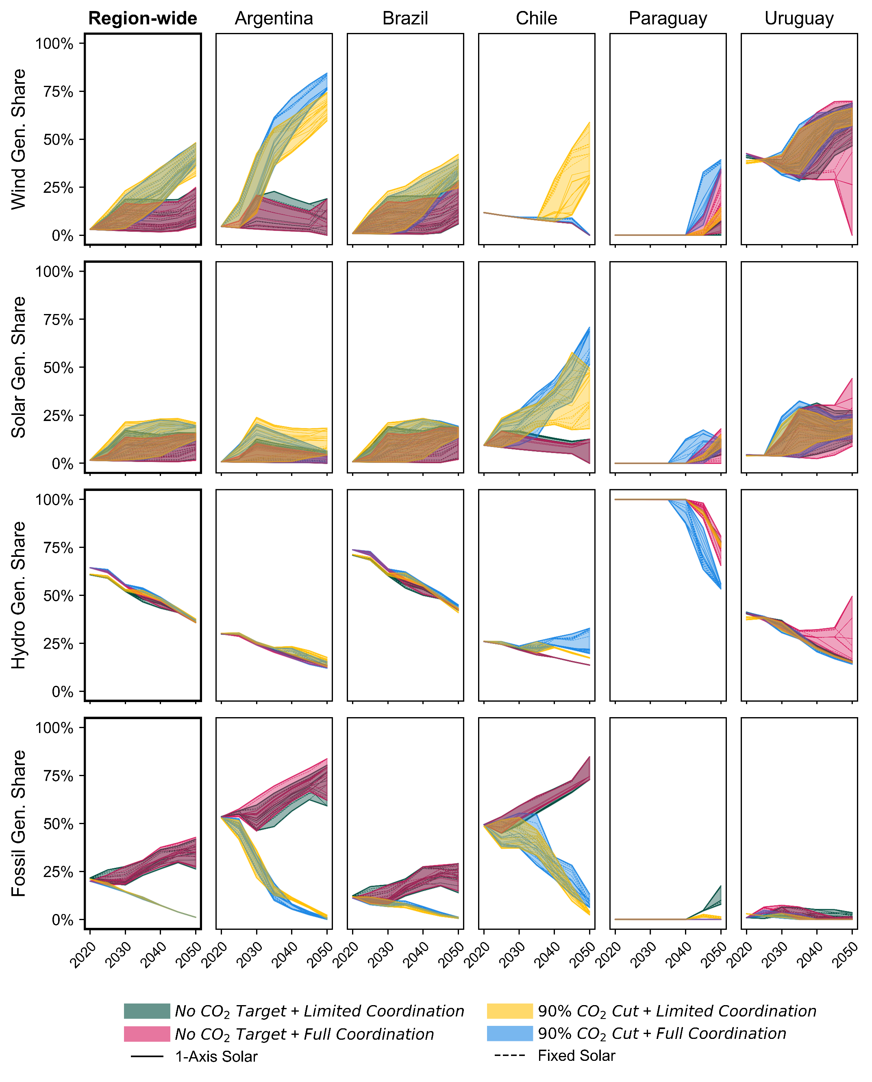
Figure S2
: Generation mix over time for full system and each country. Shaded bands show the range of outcomes within each scenario group, while each line within a shaded band represents one of 80 total model realizations.
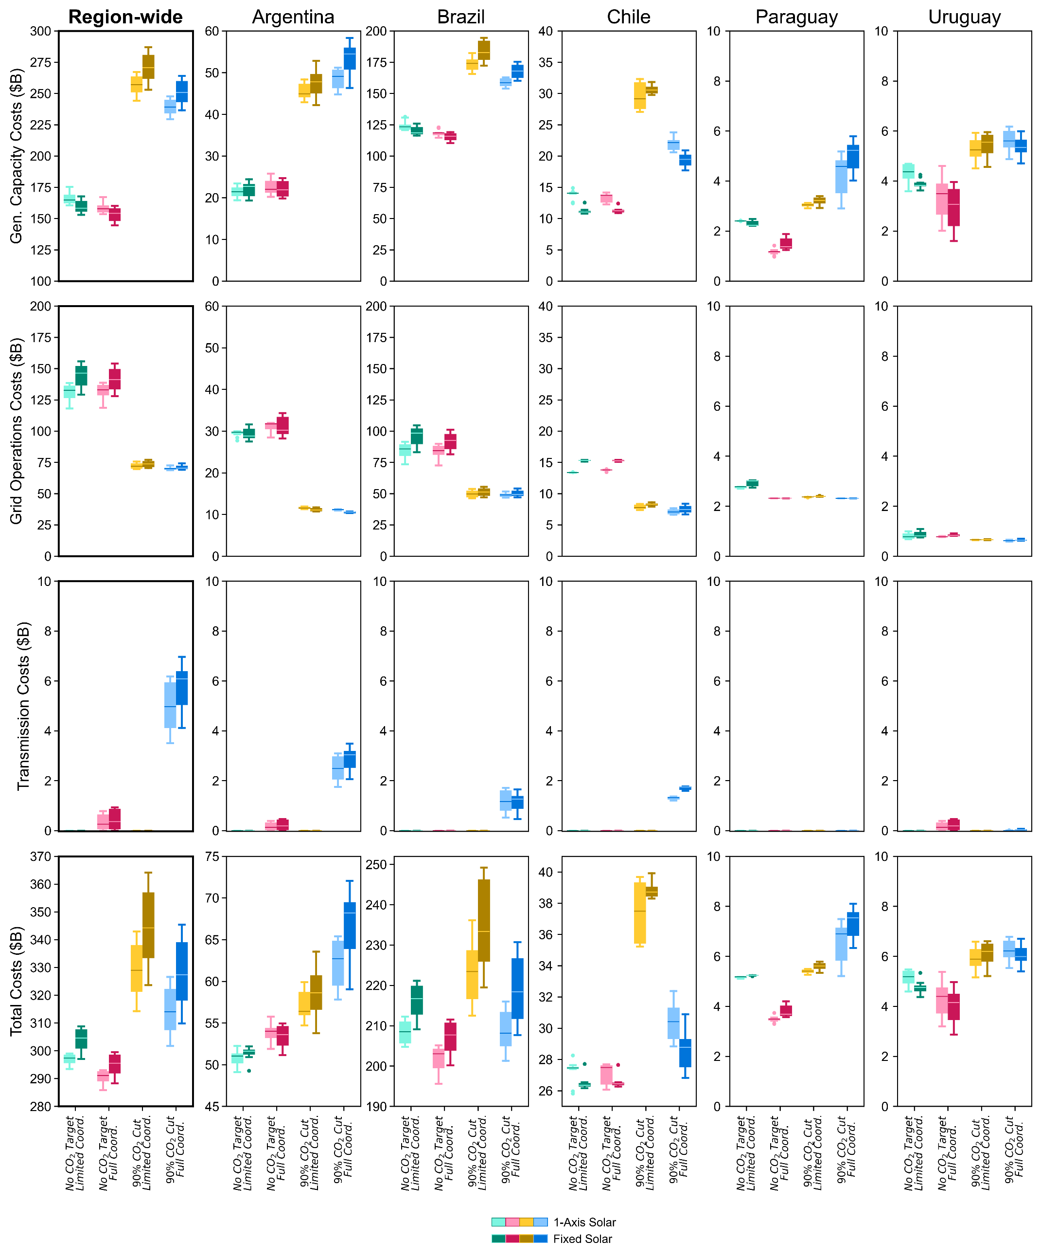
Figure S3
: Components of cumulative system costs split out by country. Transmission expansion costs are assumed to be shared equally by the two countries represented by the interconnection. Total costs for net exporters increase under Full Coordination, as these costs do not account for increased revenue resulting from exports. Grid operation costs generally decrease substantially under Mitigation (using less fuel), while capacity investments increase (new wind and solar projects). These capacity costs tend to drive total costs the most.
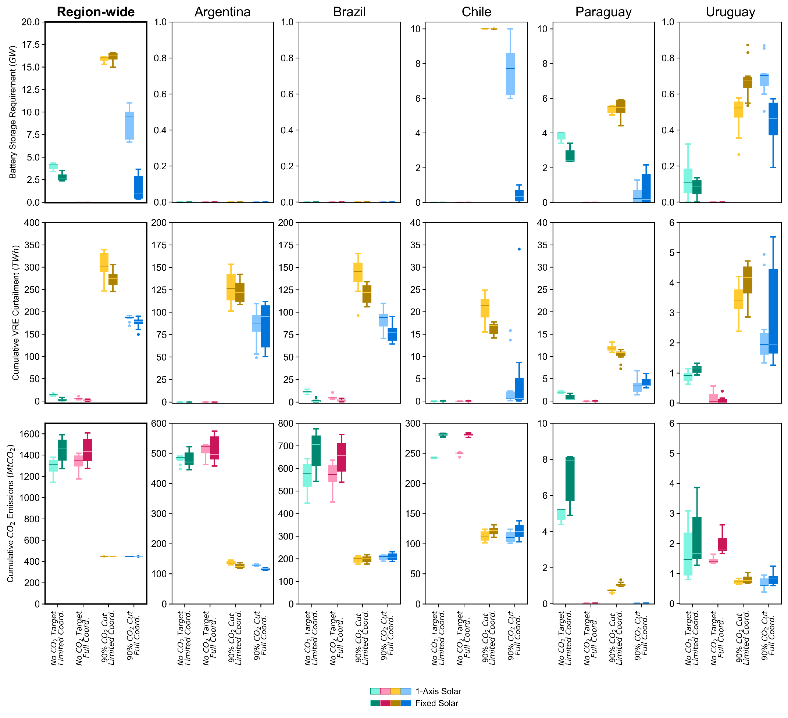
Figure S4
: Grid performance metrics (cumulative 2020-2050), system-wide and split out by country.
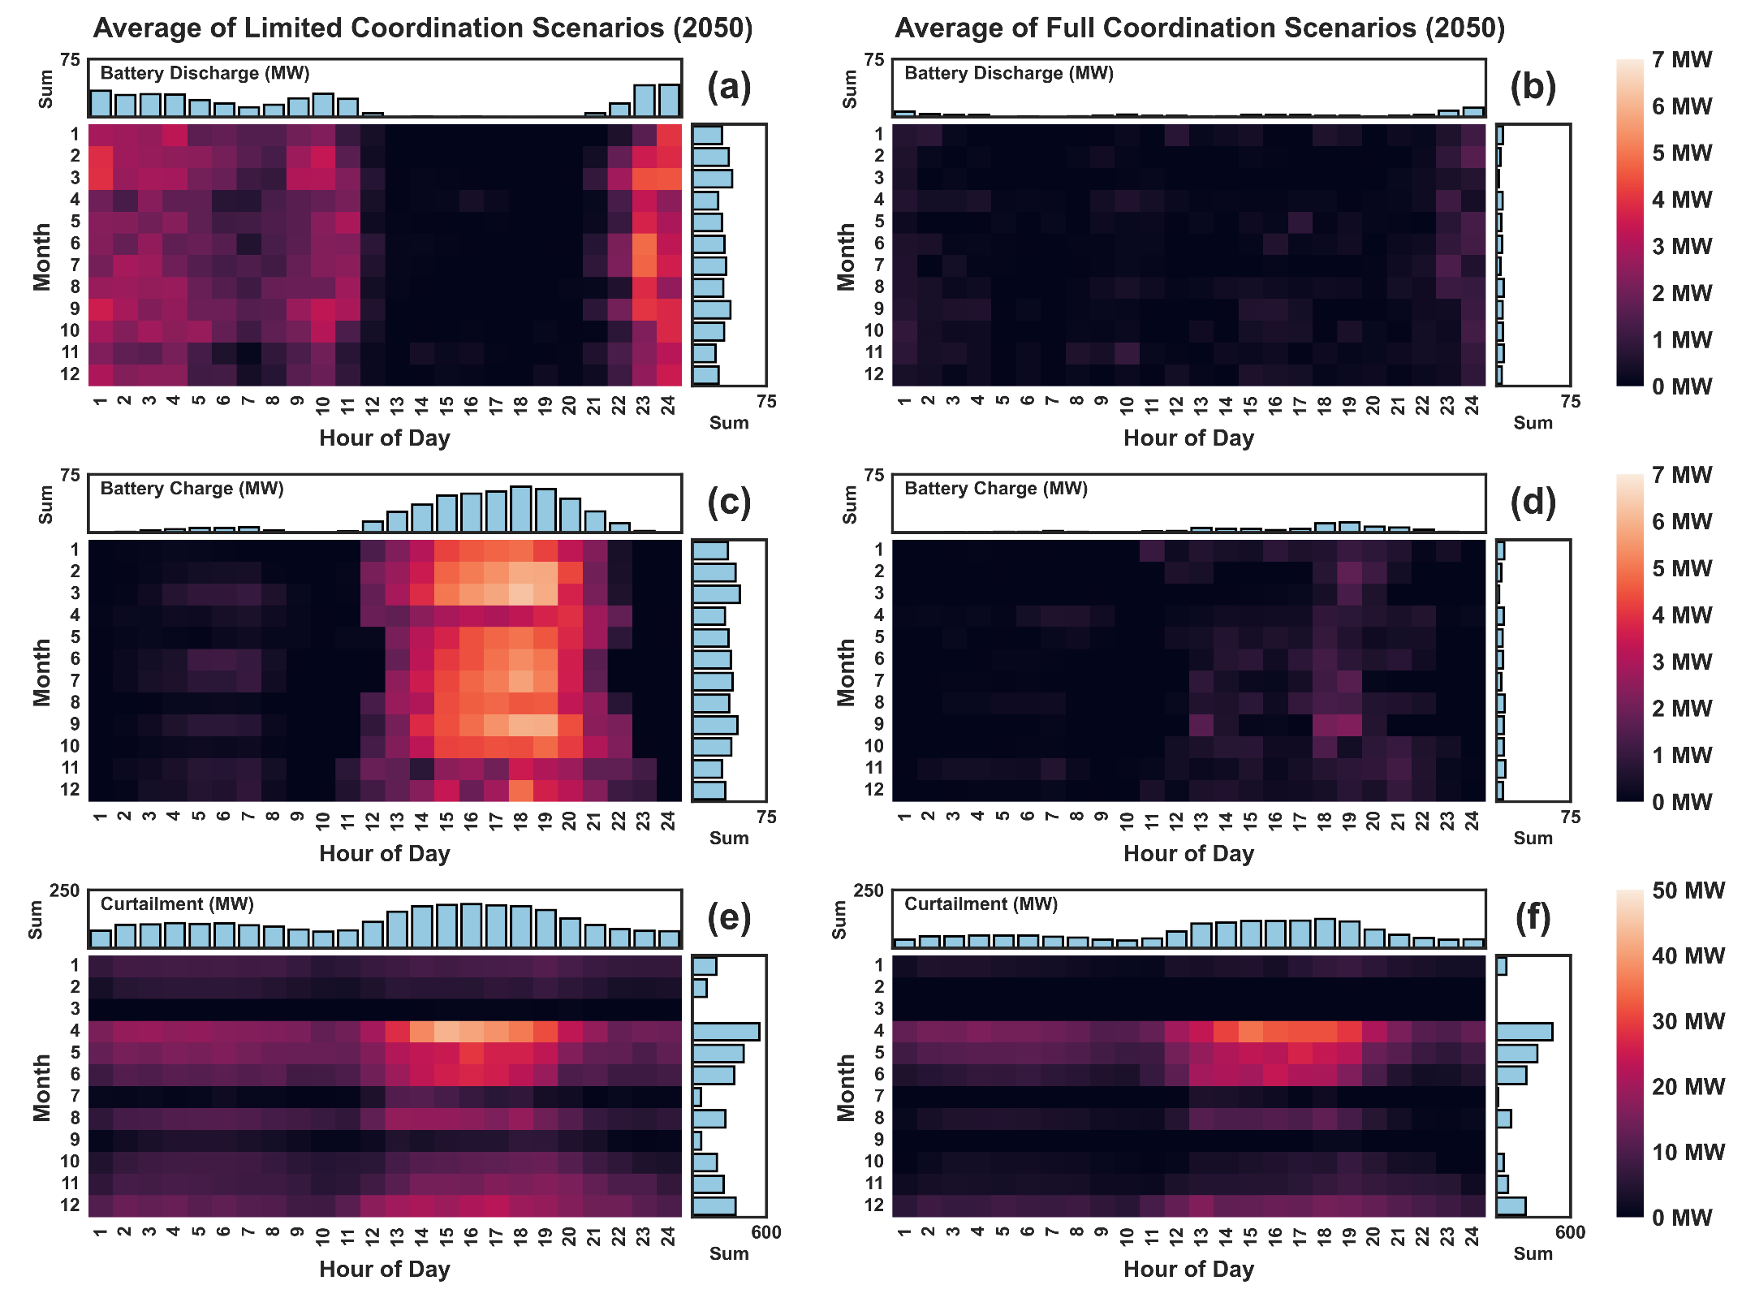
Figure S5
: Heatmaps showing seasonal and diurnal patterns of average grid battery usage and curtailment in the year 2050 for (a; c; e) Limited Coordination scenarios and (b; d; f) Full Coordination scenarios. Battery use and curtailment is higher under a limited coordination scenario. Batteries tend to charge during peak sunlight hours and discharge after sunset and overnight. Curtailment has a much stronger seasonal signal.
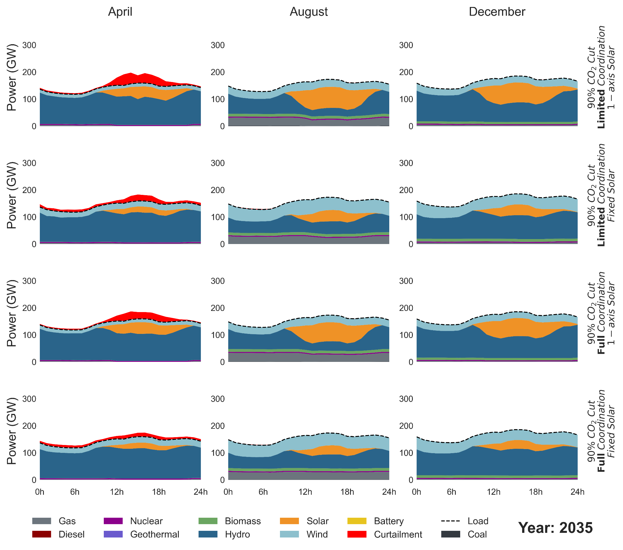
Figure S6
: Hourly dispatch system-wide in the year 2035 for three representative months and four scenario groups, averaged across the ten wind turbines in each group. All four groups are Mitigation scenarios but differ in the level of coordination and the type of solar technology modeled. By 2035, there is little deployment of battery storage, and most curtailment occurs around the month of April. Curtailment (for wind and solar) is higher for single-axis solar scenarios, which have higher solar deployment, and for limited coordination scenarios.
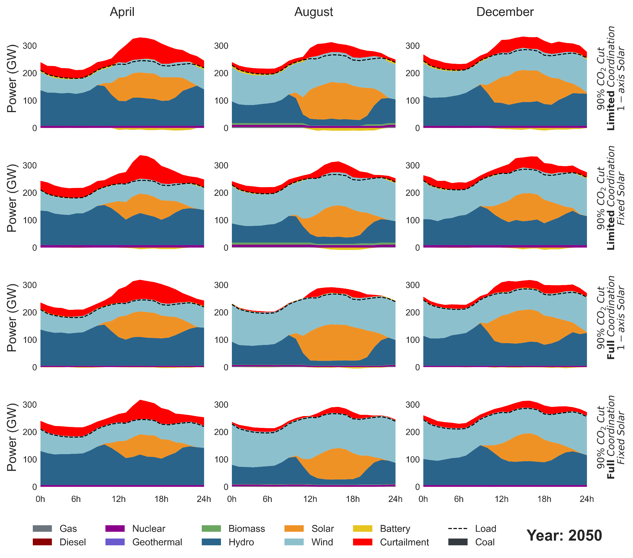
Figure S7
: Hourly dispatch system-wide in the year 2050 for three representative months and four scenario groups, averaged across the ten wind turbines in each group. All four groups are Mitigation scenarios but differ in the level of coordination and the type of solar technology modeled. By 2050, battery storage helps limited coordination scenarios store otherwise curtailed solar energy to be dispatched at night. Curtailment (for wind and solar) is still highest around the month of April but is now seen throughout the year (see Figure S5 for seasonal pattern). Curtailment is higher for single-axis solar scenarios, which have higher solar deployment, and for limited coordination scenarios (consistent with Figure S4).
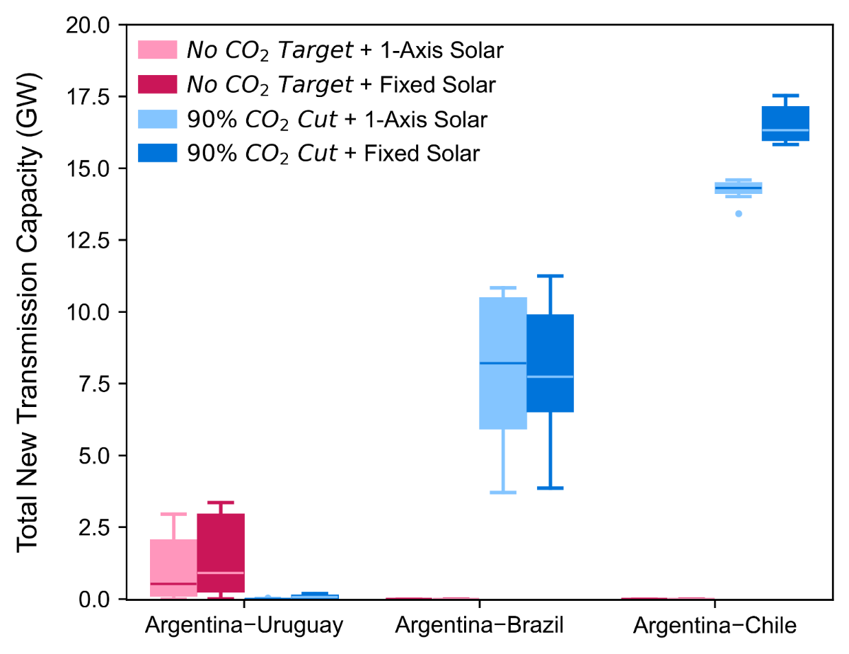
Figure S8
: Total new transmission capacity from 2020-2050. Interconnections which are not shown built no new transmission capacity.
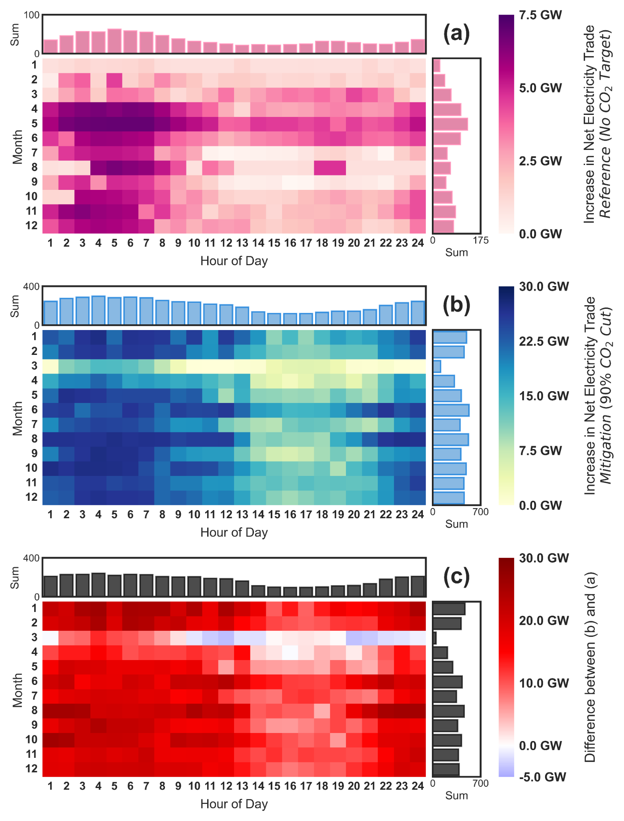
Figure S9
: Additional net electricity trade in the year 2050 when allowing Full Coordination. Panels show seasonal and diurnal patterns of individual representative (a) Reference (No CO₂ Target) and (b) Mitigation (90% CO₂ Cut) scenarios, and (c) the difference between (a) and (b). Note the color scale varies across panels, as trade is substantially higher under Mitigation. Heatmap values for (a) and (b) are computed by summing net electricity trade from all interconnections for a single Full Coordination scenario, then subtracting values computed from the corresponding Limited Coordination scenario. Refer to Figure S10 for averaged heatmaps for individual interconnections under Full Coordination and Mitigation. Under the Reference case, trading electricity is done primarily to lower costs through balancing the grid, which remains strongly influenced by hydropower but sees increasing fossil fuel use. Under Mitigation (b), however, Full Coordination also enables more strategic deployment of large amounts of wind and solar capacity, to capture the most economic and highest quality resources throughout the region. Additionally, the impact of seasonal hydropower availability on trade patterns is diminished under Mitigation, as wind and solar gain prominence in the generation mix. In both cases, substantially higher cross-border trade occurs overnight; panel (c) shows this effect is relatively even stronger for the Mitigation case. Further, the increase in trade is higher for the Mitigation case in every timepoint except around the month of March, a high-load, high-hydropower month for this system.

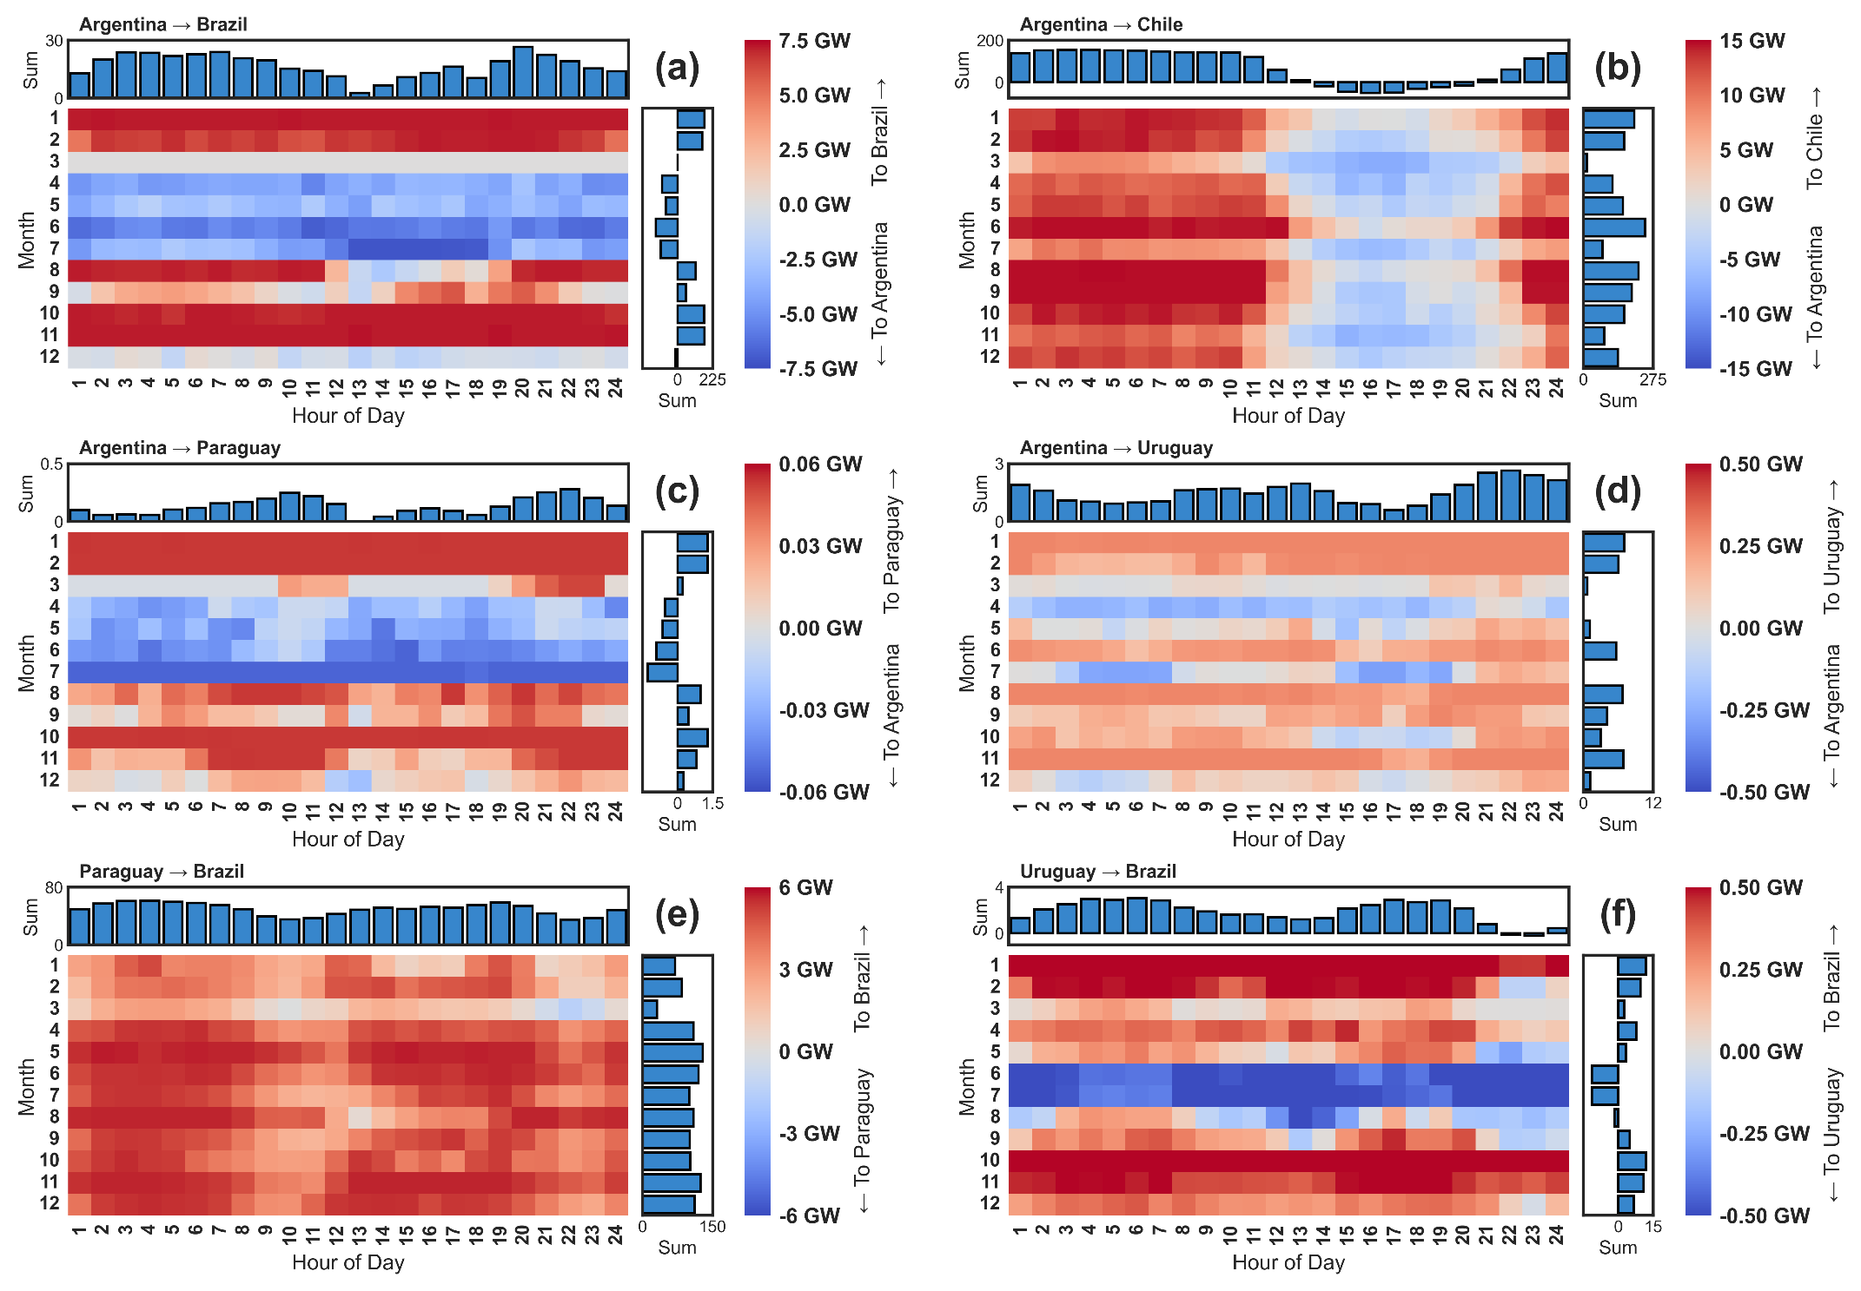
Figure S10
: Heatmaps showing seasonal and diurnal patterns of average net bilateral electricity trade in the year 2050 for each interconnection under Full Coordination + Mitigation (90% CO₂ Cut) scenarios. All heatmap color bars are centered at zero, though the scale (magnitude) varies across panels. Each panel contains information from averaging 20 model realizations; therefore, values near zero may not suggest minimal trade, but rather equivalent amounts of electricity flowing on average in each direction during that month-hourly timepoint. This figure shows seasonal and diurnal patterns of average net electricity trade in 2050 for each of the six modeled interconnections under Mitigation and Full Coordination. The diurnal effect of Chile’s solar generation can be seen in (b), while imports to Argentina during seasonal periods of lower wind generation can be seen in (a, c). To accommodate this increased electricity trade in later years, new transmission capacity is built between Argentina-Chile and Argentina-Brazil (Figure S8). Under Limited Coordination, Chile instead relies on battery storage to integrate its solar resources (Figure S4), and in some cases, wind capacity (Figure S1). Finally, the peak daily generation of both solar (day) and wind (night) can be seen in (e), when Paraguay’s steady exports to Brazil are slightly dampened by the availability of intermittent renewables. (d, f) show the minimal trade between Uruguay and Argentina under Mitigation, and that Uruguay instead primarily utilizes its interconnection with Brazil for balancing.
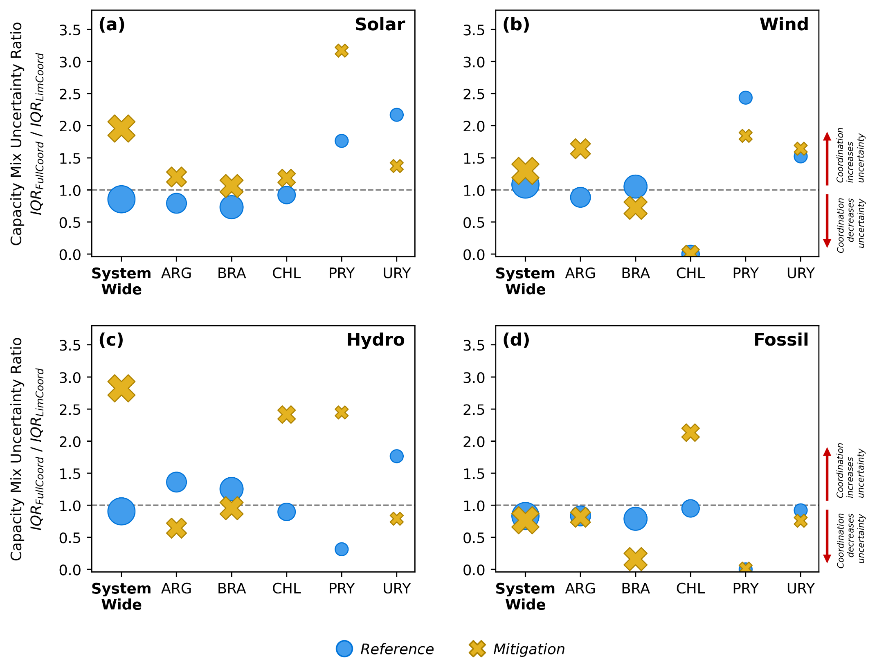
Figure S11
: Same as Figure 5, but IQR ratio is computed between Full Coordination and Limited Coordination cases. The markers now show the differences between these IQR ratios for Reference and Mitigation scenarios. (By contrast, Figure 5 computes the IQR ratios between Reference and Mitigation, and plots by level of coordination).
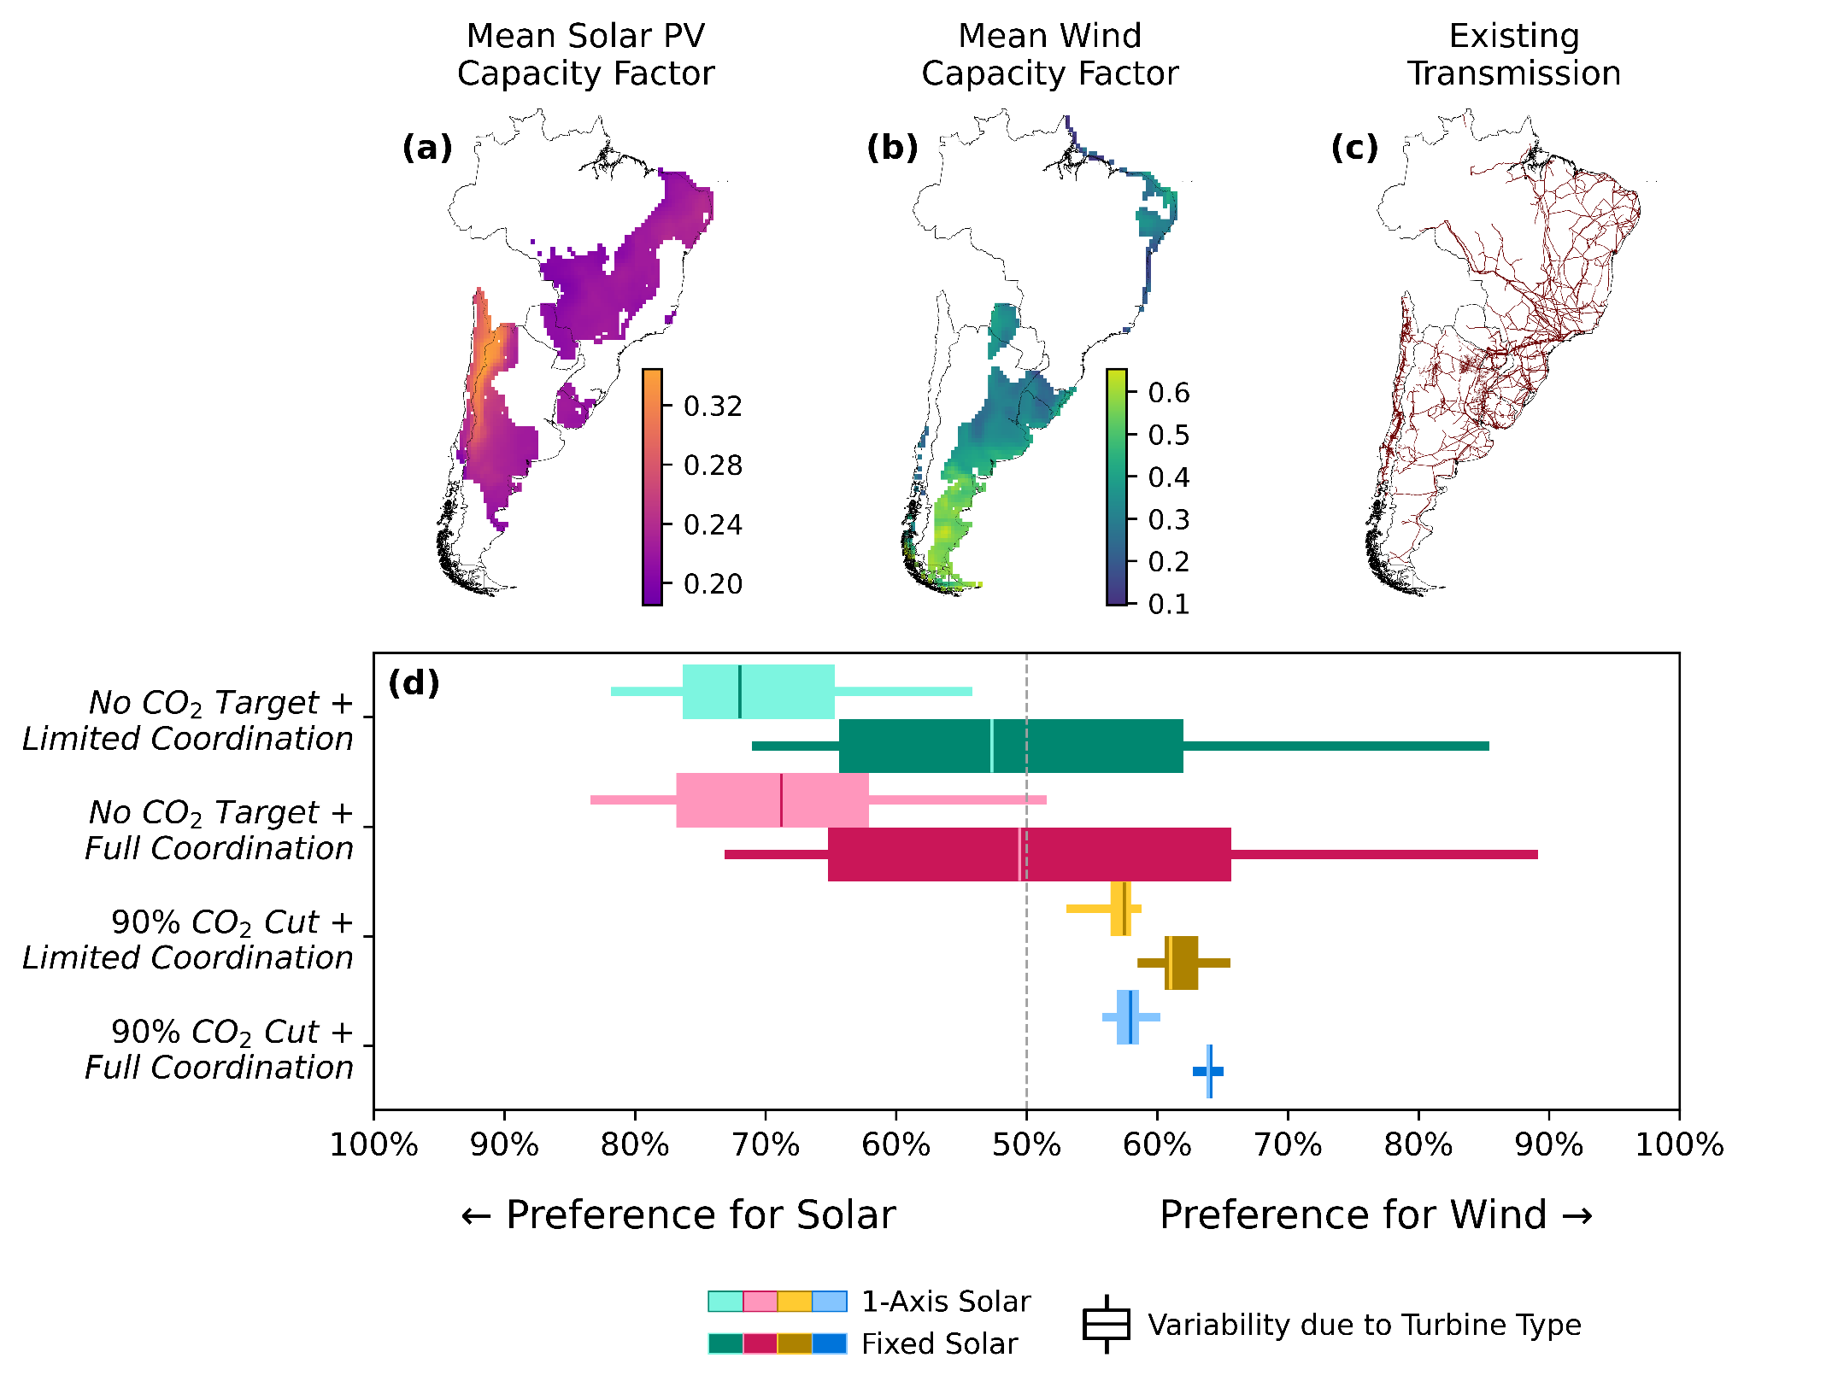
Figure S12
: Patterns of region-wide wind and solar deployment. Maps show sites for building new (a) solar and (b) wind projects (pre-processed for viability), colored by mean annual capacity factor. (c) Locations of existing transmission lines, the proximity to which affects wind and solar project costs. (d) Preference metric for wind vs. solar PV capacity, computed as the installed proportion of each relative to their cumulative sum in 2050. This metric is computed as the installed proportion of a single technology (i.e., wind or solar PV) in a given model period relative to the cumulative sum of wind and solar PV capacity in the same model period. This metric can be used to assess how substitutable these technologies may become under techno-economic uncertainty. (d) shows that under Mitigation where fossil-based generation is largely constrained, there is a preference system-wide for installing more wind capacity than solar PV. Under no such emissions target, deployment slightly favors solar PV under 1-Axis tracking and is roughly equal when Fixed Solar is deployed. The variability in this preference, which is driven by the techno-economic uncertainty across solar PV and turbine types, is greatly reduced under Mitigation, and is further narrowed under Full Coordination. Lower absolute variability in the preference metric in Mitigation scenarios is due in part to much higher deployment of variable renewable energy (VRE, i.e., wind and solar) under deep decarbonization. Further, differences in wind and solar deployment across scenarios which offset system-wide can still result in considerably different capacity expansion outcomes for individual countries and are dependent on the uncertain technology characteristics modeled in addition to the emissions pathway and level of coordination. Figure S15 and Figure S16 give annual capacity factors for each wind and solar technology, respectively, for each project site considered. Figure S14 shows the distance from each project site to the nearest transmission line within the same country. Table S7 gives summary statistics for each country (total resource potential and mean annual capacity factor).
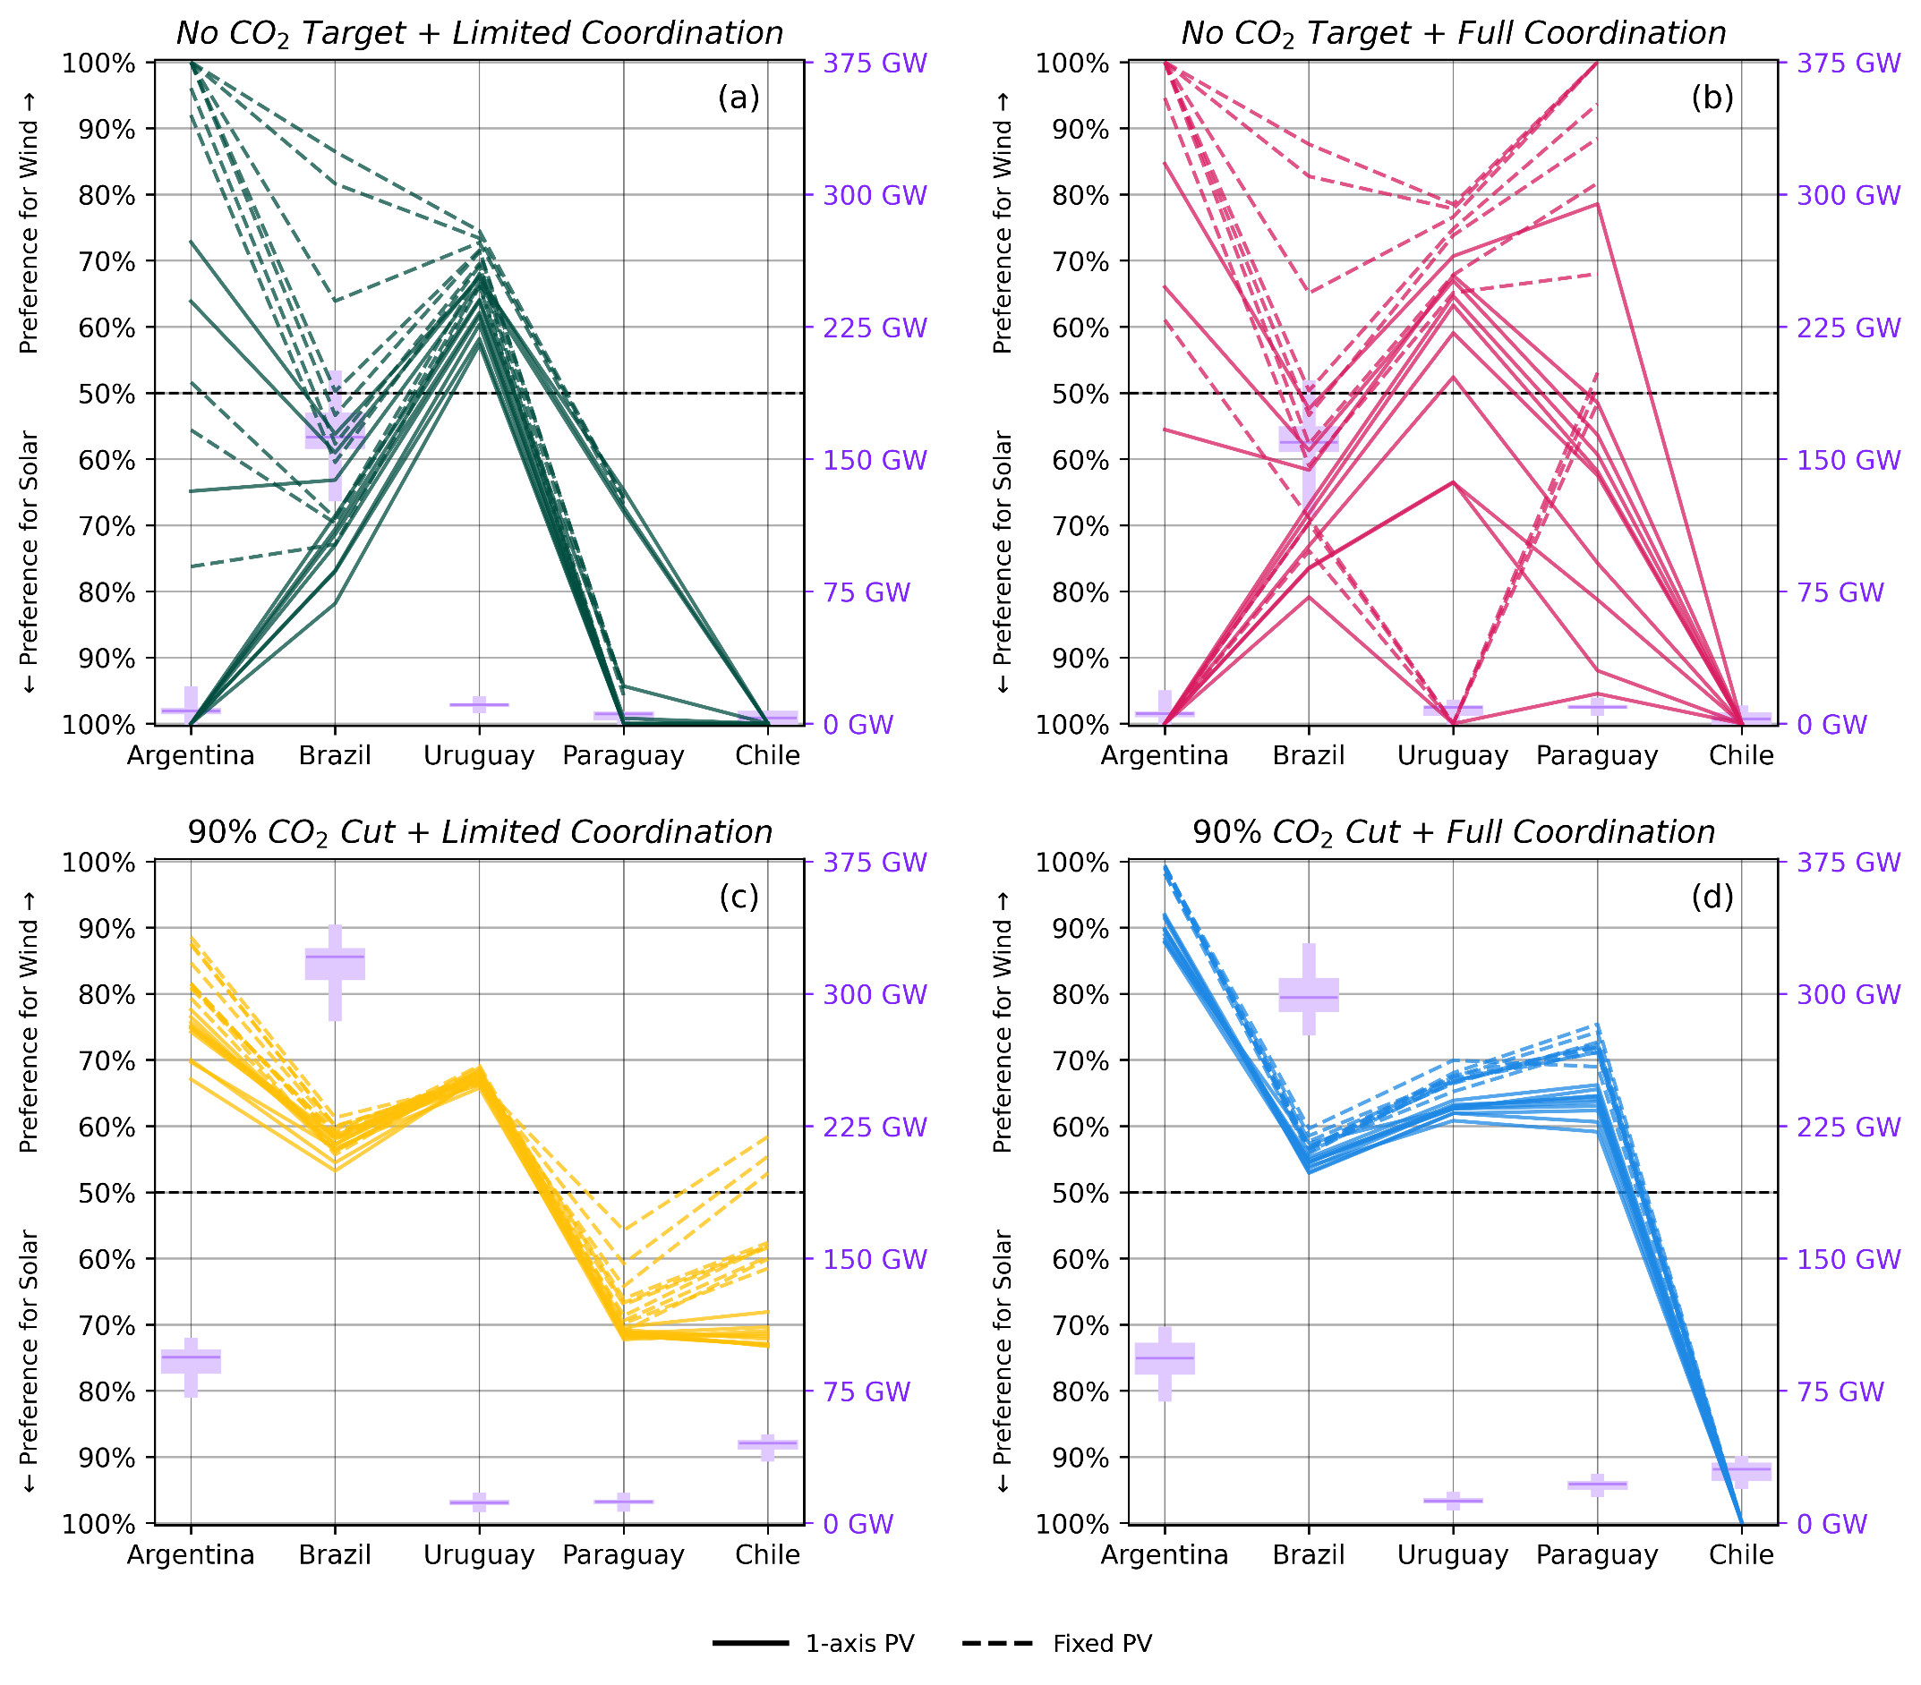
Figure S13
: Country-level decarbonization pathways illustrated through parallel axis plots of the relative preference for wind vs. solar PV as the primary variable renewable energy source (left vertical axes). Also shown are boxplots of the sum total capacities of wind and solar PV installed in each country (right vertical axes) by 2050. (a-d) split out four groups of scenarios. Each panel contains 20 lines (one for each combination of 10 turbines and 2 solar PV types), while each boxplot similarly contains 20 data points. A wide range of VRE preference in combination with a large installed VRE capacity thus illustrates high variability in installed wind vs. installed solar PV capacity within a country.
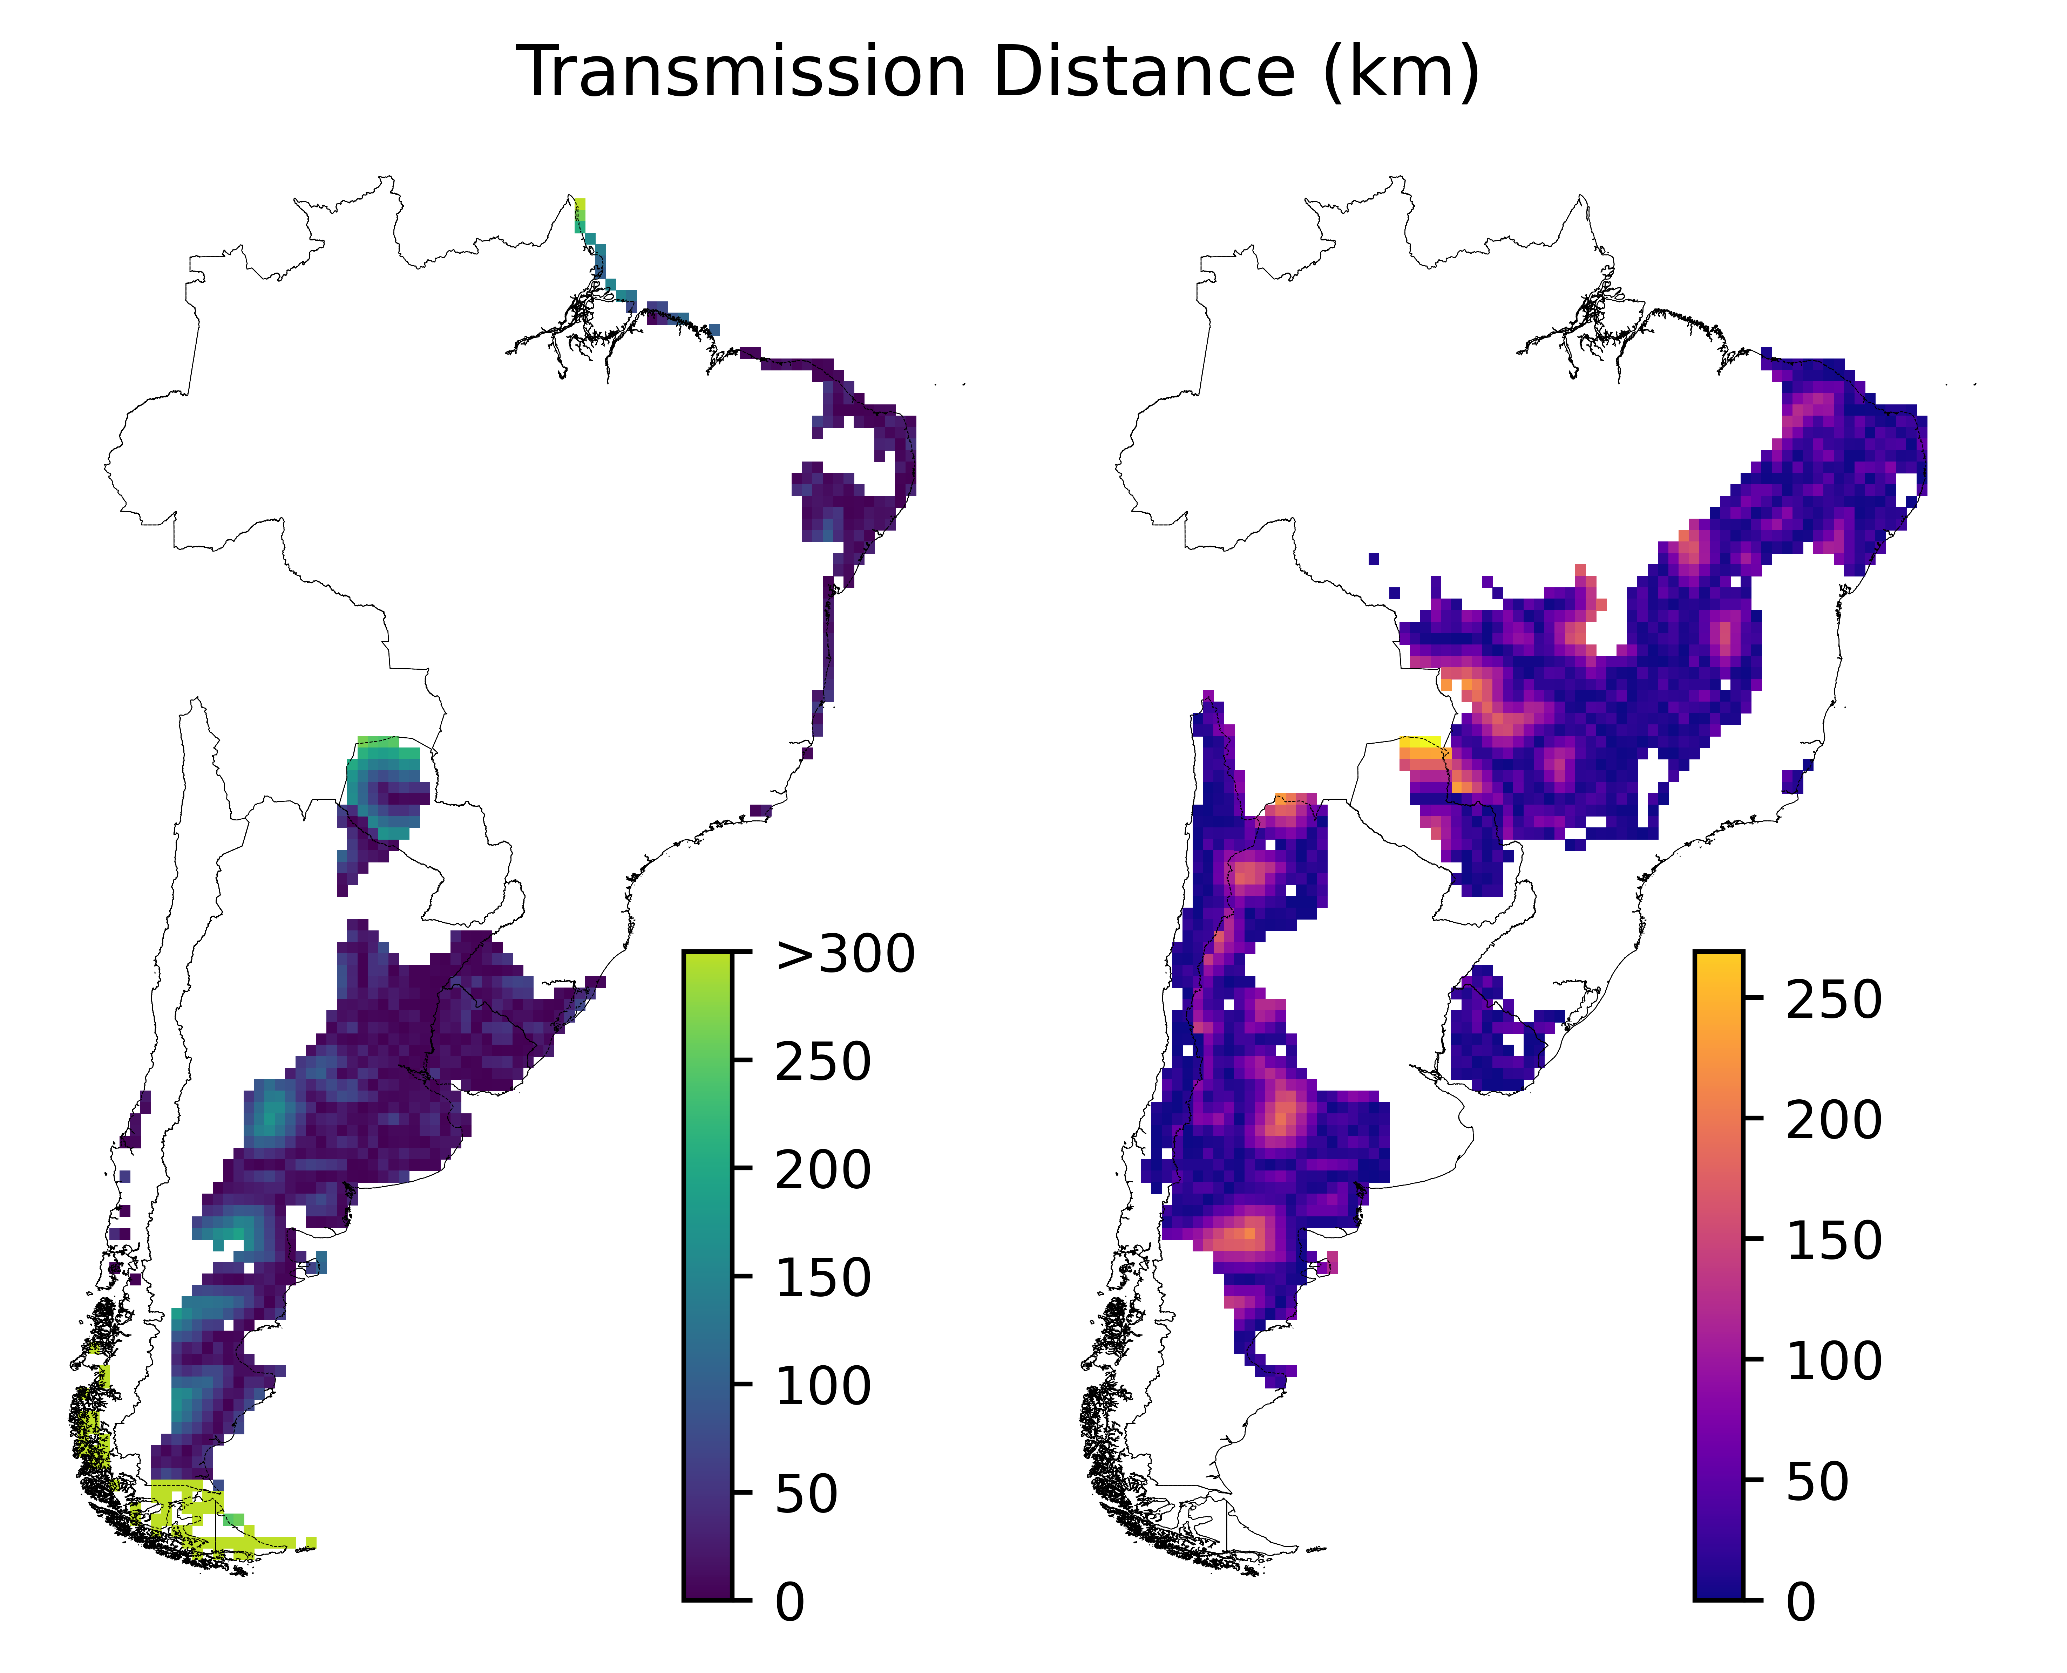
Figure S14
: Distance (in km) from the center of each wind (left) and solar PV (right) project site to the nearest within-country transmission line.
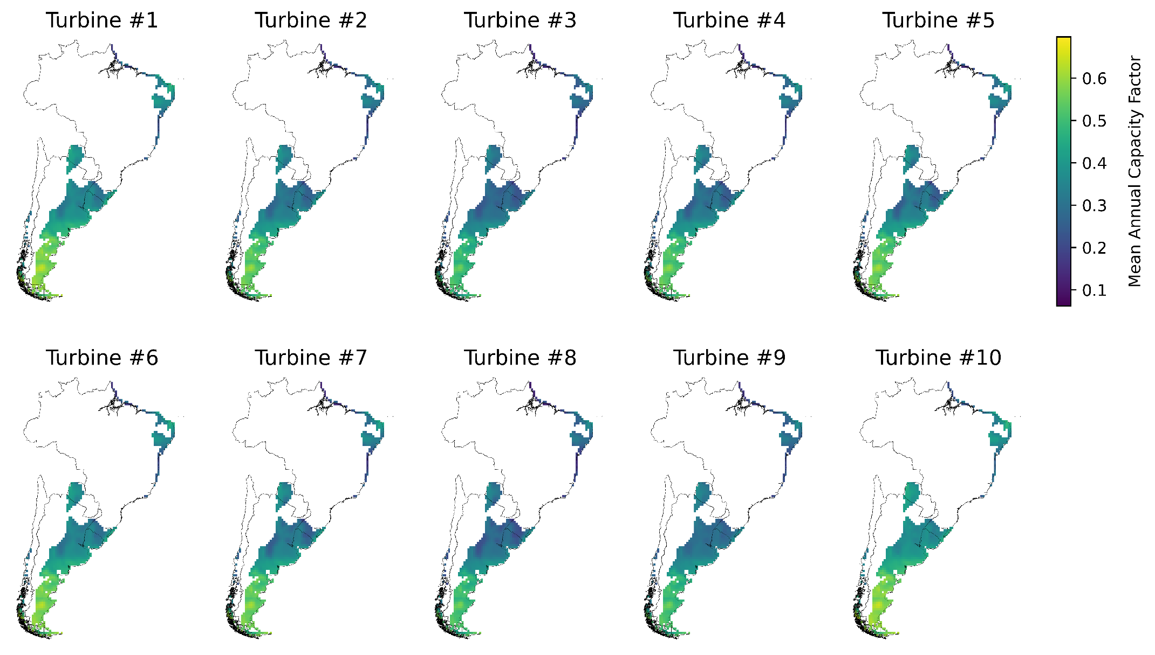
Figure S15
: Grid-scale annual average capacity factors of wind power for 10 turbine types.
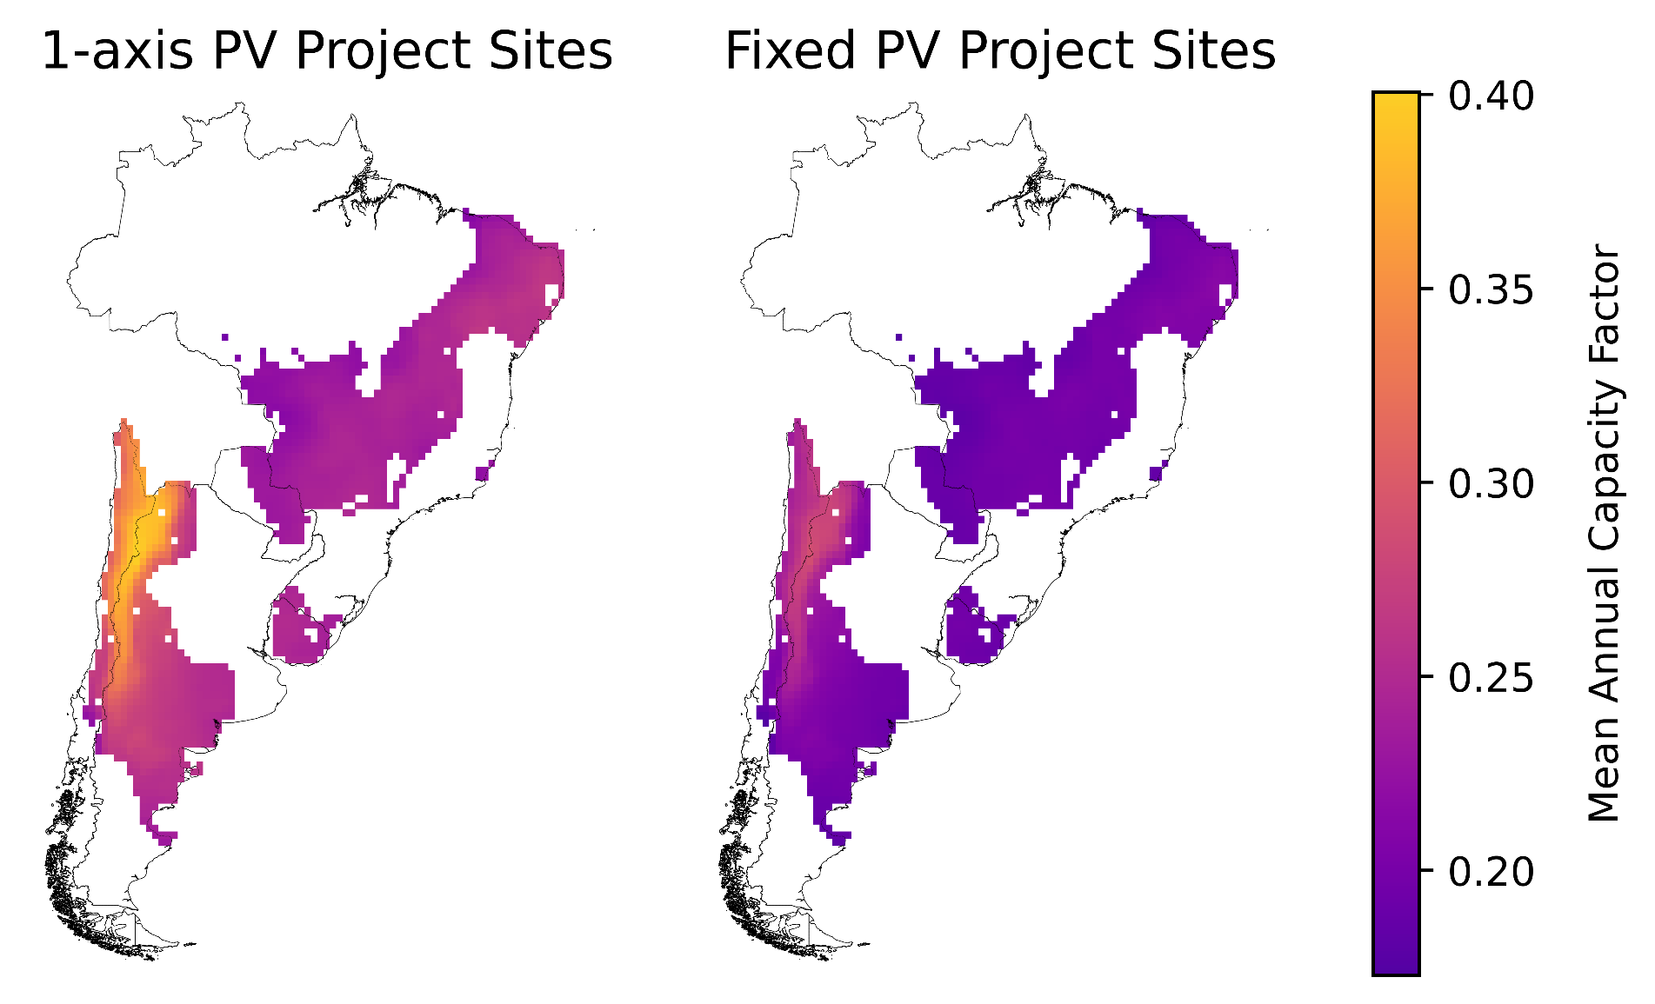
Figure S16
: Grid-scale annual average capacity factors of solar power for two PV panel types.
- Stranded Coordination Vulnerability
To consider the possible regret of planning for future interconnection that does not materialize, an additional set of 40 scenarios were run through the model. This group of realizations, termed Stranded Coordination, exogenously defines all capacity expansion decisions to exactly match capacity mixes found under Full Coordination. In contrast, however, the new Stranded Coordination scenarios are otherwise configured according to Limited Coordination assumptions; that is, transmission expansion and increased electricity trade are not allowed.
This additional modeling exercise explores potential consequences of optimally building new generation capacity under an assumption of future transnational transmission expansion, which is either never built or otherwise cannot be utilized. Figure S17 illustrates a sharp increase in unmet demand with strong seasonality, especially for Mitigation scenarios. Because the emissions reduction constraints are binding, the model is forced to leave load unserved rather than run fossil-based generation. However, even without any emissions constraint, there remain instances of unmet demand, representing supply shortfalls. Figure S18 compares total system costs for the region and each country under the new scenarios. However, the cost assigned to each MWh of unmet load is a modeling choice with a substantial impact on these costs. Further, the cost of required transmission expansion is not included here but could represent an added cost if the transmission was built and simply unused. Figure S19 shows system-wide curtailment of wind and solar PV for Stranded Coordination scenarios, which increases over time and is similar in magnitude to unmet load. Figure S20 shows seasonal and diurnal patterns of unmet demand and total curtailment (including hydropower), both with (right) and without (left) Mitigation.
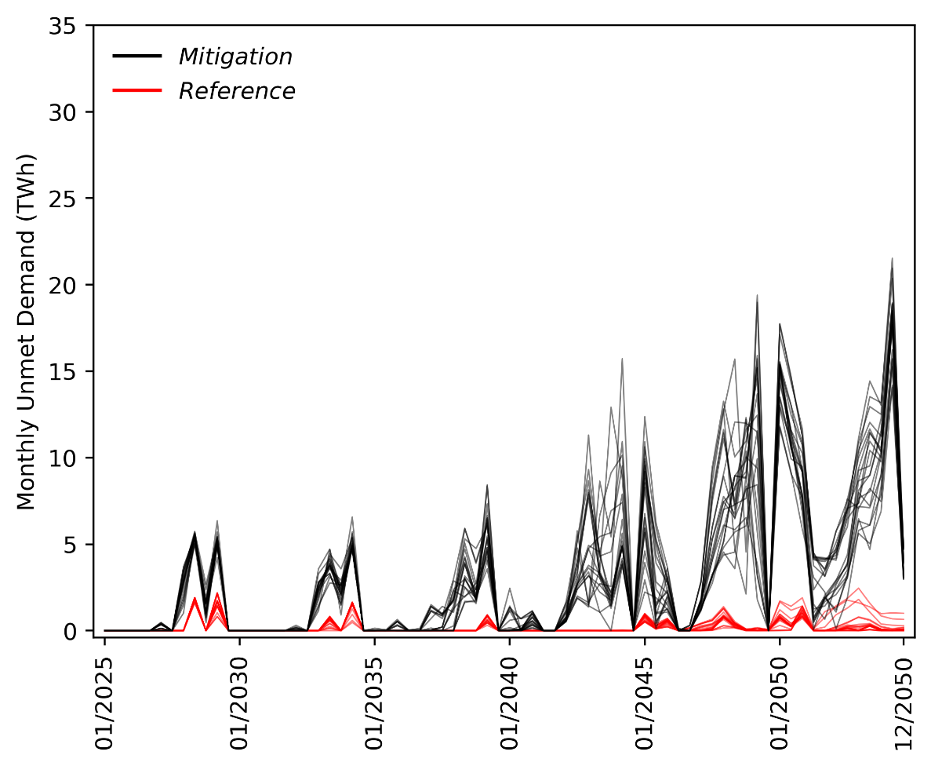
Figure S17
: Monthly summed levels of unmet demand under Stranded Coordination. The new scenario configuration results in significant unmet demand due to the lack of new transmission capacity and stranded renewable energy located across borders. Unmet demand is higher under Mitigation as the model is unable to dispatch fossil fuels to meet demand. Rather than simply a supply shortfall, the unmet demand here can also be interpreted as an inability to meet the emissions reduction goals when capacity decisions are coordinated but cross-border transmission is not utilized and expanded. Unmet demand in the absence of emissions constraints represents a supply shortfall. Unmet demand primarily occurs in Brazil and Chile.
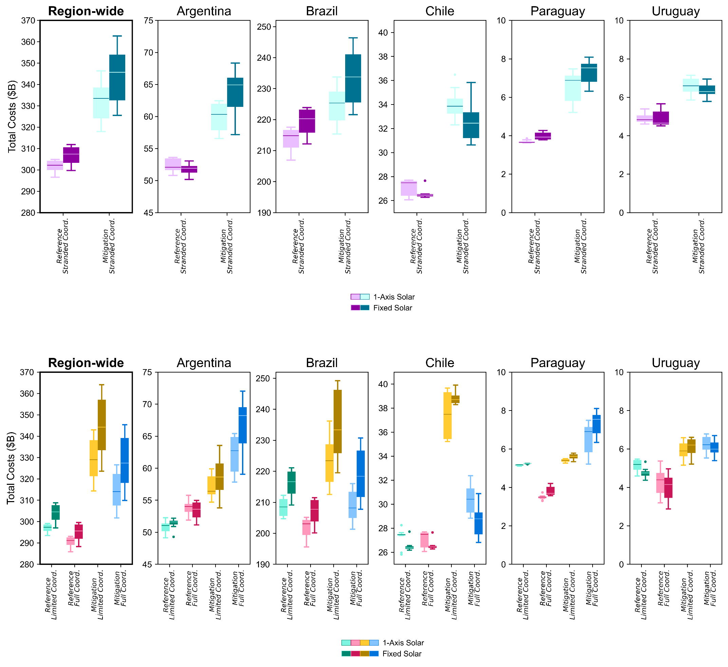
Figure S18
: Total costs system-wide and by country. The top row reproduces part of Figure S3, while the bottom row shows the Stranded Coordination scenarios. The new configuration (bottom), though having identical capacity costs, has much higher operational costs as more fossil fuels are needed to meet demand (when there is no emissions cut requirement). Under Mitigation, operational costs do not increase as much, as the model is not able to dispatch additional CO₂-emitting energy which would violate the emissions constraint. Here, the increase in costs mainly comes from a penalty associated with unmet demand in the model. Here, the most expensive marginal generator is used as a proxy for this cost, though this amount is likely a conservative lower bound for the actual cost of unmet demand. This lower bound causes the distribution of system-wide costs for Mitigation cases (teal boxplots, bottom row) to roughly match the costs of the Limited Coordination cases (yellow boxplots, top row). However, the choice of the cost of unmet demand would impact the total system costs.
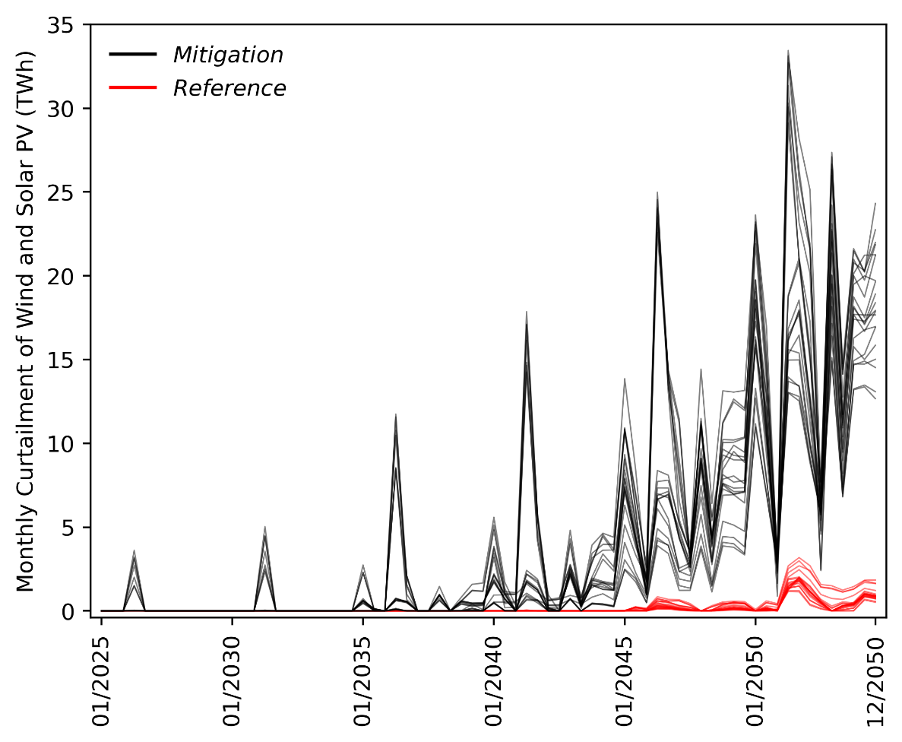
Figure S19
: System-wide curtailment of intermittent renewables (wind and solar) under Stranded Coordination over time. There is substantially increased curtailment of wind and solar associated with this configuration (beyond that of other scenarios); curtailment is similar in magnitude to unmet demand.
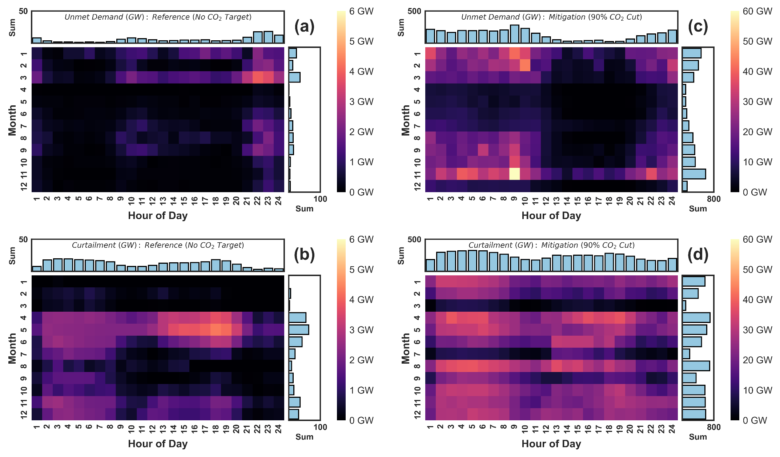
Figure S20
: Seasonal and diurnal patterns of average unmet demand and average total curtailment (including hydro) in 2050 for the Stranded Coordination scenarios. Note the differing scales of the color bars (order of magnitude increases from left to right). There is much more unmet demand and curtailment for Mitigation cases than for scenarios with no such emissions constraint. Unmet demand is lowest in the winter months and during hours in which solar power is available. Stranded Coordination scenarios, as constructed here, represent an extreme case in which no adaptive decisions are made over the model horizon.

References for Supplemental Information
1. McCalley, J. & Zhang, Q. Macro Grids in the Mainstream: An International Survey of Plans and Progress. elabb (2020).
2. Elabbas, M. A. E., de Vries, L. & Correljé, A. African power pools and regional electricity market design: Taking stock of regional integration in energy sectors. Energy Research & Social Science 105, 103291 (2023).
3. Ahmed, T. et al. ASEAN power grid: A secure transmission infrastructure for clean and sustainable energy for South-East Asia. Renewable and Sustainable Energy Reviews 67, 1420–1435 (2017).
4. Hirth, L., Mühlenpfordt, J. & Bulkeley, M. The ENTSO-E Transparency Platform – A review of Europe’s most ambitious electricity data platform. Applied Energy 225, 1054–1067 (2018).
5. Brown, P. R. & Botterud, A. The Value of Inter-Regional Coordination and Transmission in Decarbonizing the US Electricity System. Joule 5, 115–134 (2021).
6. Bloom, A. et al. The Value of Increased HVDC Capacity Between Eastern and Western U.S. Grids: The Interconnections Seam Study. IEEE Transactions on Power Systems 37, 1760–1769 (2022).
7. Azarpour, A., Mohammadzadeh, O., Rezaei, N. & Zendehboudi, S. Current status and future prospects of renewable and sustainable energy in North America: Progress and challenges. Energy Conversion and Management 269, 115945 (2022).
8. Rodríguez-Sarasty, J. A., Debia, S. & Pineau, P.-O. Deep decarbonization in Northeastern North America: The value of electricity market integration and hydropower. Energy Policy 152, 112210 (2021).
9. Guo, F. et al. Implications of intercontinental renewable electricity trade for energy systems and emissions. Nat Energy 7, 1144–1156 (2022).
10. Yang, H., Deshmukh, R. & Suh, S. Global transcontinental power pools for low-carbon electricity. Nat Commun 14, 8350 (2023).
11. Haller, M., Ludig, S. & Bauer, N. Decarbonization scenarios for the EU and MENA power system: Considering spatial distribution and short term dynamics of renewable generation. Energy Policy 47, 282–290 (2012).
12. Timilsina, G., Deluque Curiel, I. & Chattopadhyay, D. How Much Does Latin America Gain from Enhanced Cross-Border Electricity Trade in the Short Run ? (The World Bank, 2021). doi:10.1596/1813-9450-9692.
13. Wu, G. C. et al. Strategic siting and regional grid interconnections key to low-carbon futures in African countries. Proceedings of the National Academy of Sciences 114, E3004–E3012 (2017).
14. Tröndle, T., Lilliestam, J., Marelli, S. & Pfenninger, S. Trade-Offs between Geographic Scale, Cost, and Infrastructure Requirements for Fully Renewable Electricity in Europe. Joule 4, 1929–1948 (2020).
15. Bowen, B. H., Sparrow, F. T. & Yu, Z. Modeling electricity trade policy for the twelve nations of the Southern African Power Pool (SAPP). Utilities Policy 8, 183–197 (1999).
16. Remy, T. & Chattopadhyay, D. Promoting better economics, renewables and CO2 reduction through trade: A case study for the Eastern Africa Power Pool. Energy for Sustainable Development 57, 81–97 (2020).
17. Fürsch, M. et al. The role of grid extensions in a cost-efficient transformation of the European electricity system until 2050. Applied Energy 104, 642–652 (2013).
18. Esteves, F., Molina-Perez, E., Kalra, N., Syme, J. & Vogt-Schilb, A. Job creation and decarbonization synergies in Latin America: a simulation-based exploratory modeling analysis. Front. Clim. 6, (2024).
19. Mulugetta, Y. et al. Africa needs context-relevant evidence to shape its clean energy future. Nat Energy 7, 1015–1022 (2022).
20. Sasse, J.-P. & Trutnevyte, E. A low-carbon electricity sector in Europe risks sustaining regional inequalities in benefits and vulnerabilities. Nat Commun 14, 2205 (2023).
21. de Moura, G. N. P., Legey, L. F. L. & Howells, M. A Brazilian perspective of power systems integration using OSeMOSYS SAMBA – South America Model Base – and the bargaining power of neighbouring countries: A cooperative games approach. Energy Policy 115, 470–485 (2018).
22. Ochoa, C., Dyner, I. & Franco, C. J. Simulating power integration in Latin America to assess challenges, opportunities, and threats. Energy Policy 61, 267–273 (2013).
23. Agostini, C. A., Guzmán, A. M., Nasirov, S. & Silva, C. A surplus based framework for cross-border electricity trade in South America. Energy Policy 128, 673–684 (2019).
24. De Oliveira-De Jesus, P. M., González De León, M. & Melán, R. A. A mitigation scenario for Latin American power-related carbon dioxide emissions. Energy Sources, Part B: Economics, Planning, and Policy 15, 492–512 (2020).
25. Barbosa, L. de S. N. S., Bogdanov, D., Vainikka, P. & Breyer, C. Hydro, wind and solar power as a base for a 100% renewable energy supply for South and Central America. PLOS ONE 12, e0173820 (2017).
26. Vera, N. A. & Ríos, M. A. Planning a Latin America SuperGrid: A First Approach. in 2018 IEEE ANDESCON 1–5 (2018). doi:10.1109/ANDESCON.2018.8564578.
27. Itiki, R., Manjrekar, M. & Di Santo, S. G. Comparative Evaluation of Super Grid Topologies proposed for Europe and Latin America. in 2019 North American Power Symposium (NAPS) 1–6 (2019). doi:10.1109/NAPS46351.2019.9000193.
28. Sterl, S. et al. Smart renewable electricity portfolios in West Africa. Nat Sustain 3, 710–719 (2020).
29. Chowdhury, A. F. M. K. et al. Enabling a low-carbon electricity system for Southern Africa. Joule 6, 1826–1844 (2022).
30. Siala, K., Chowdhury, A. K., Dang, T. D. & Galelli, S. Solar energy and regional coordination as a feasible alternative to large hydropower in Southeast Asia. Nat Commun 12, 4159 (2021).
31. Egerer, J., Lorenz, C. & Gerbaulet, C. European electricity grid infrastructure expansion in a 2050 context. in 2013 10th International Conference on the European Energy Market (EEM) 1–7 (2013). doi:10.1109/EEM.2013.6607408.
32. Stoilov, D., Dimitrov, Y. & François, B. Challenges facing the European power transmission tariffs: The case of inter-TSO compensation. Energy Policy 39, 5203–5210 (2011).
33. Stoilov, D. & Stoilov, L. Improving inter-transmission compensation in EU. Energy Policy 62, 282–291 (2013).
34. Jayadev, G., Leibowicz, B. D. & Kutanoglu, E. U.S. electricity infrastructure of the future: Generation and transmission pathways through 2050. Applied Energy 260, 114267 (2020).
35. Paredes-Vergara, M., Palma-Behnke, R. & Haas, J. Characterizing decision making under deep uncertainty for model-based energy transitions. Renewable and Sustainable Energy Reviews 192, 114233 (2024).
36. Walker, W. E., Lempert, R. J. & Kwakkel, J. H. Deep Uncertainty. in Encyclopedia of Operations Research and Management Science (eds. Gass, S. I. & Fu, M. C.) 395–402 (Springer US, Boston, MA, 2013). doi:10.1007/978-1-4419-1153-7_1140.
37. Lempert, R. J. Robust Decision Making (RDM). in Decision Making under Deep Uncertainty: From Theory to Practice (eds. Marchau, V. A. W. J., Walker, W. E., Bloemen, P. J. T. M. & Popper, S. W.) 23–51 (Springer International Publishing, Cham, 2019). doi:10.1007/978-3-030-05252-2_2.
38. DeCarolis, J. et al. Formalizing best practice for energy system optimization modelling. Applied Energy 194, 184–198 (2017).
39. Blair, N., Zhou, E. & Getman, D. Electricity Capacity Expansion Modeling, Analysis, and Visualization: A Summary of Selected High-Renewable Modeling Experiences. https://www.nrel.gov/docs/fy16osti/64831.pdf (2015).
40. Fodstad, M. et al. Next frontiers in energy system modelling: A review on challenges and the state of the art. Renewable and Sustainable Energy Reviews 160, 112246 (2022).
41. Gargiulo, M. & Gallachóir, B. Ó. Long-term energy models: Principles, characteristics, focus, and limitations. WIREs Energy and Environment 2, 158–177 (2013).
42. Ibrahim, H. A. et al. Sustainability of power generation for developing economies: A systematic review of power sources mix. Energy Strategy Reviews 47, 101085 (2023).
43. Ioannou, A., Angus, A. & Brennan, F. Risk-based methods for sustainable energy system planning: A review. Renewable and Sustainable Energy Reviews 74, 602–615 (2017).
44. Moglen, R. et al. The state of macro-energy systems research: Common critiques, current progress, and research priorities. iScience 26, 106325 (2023).
45. Prina, M. G., Manzolini, G., Moser, D., Nastasi, B. & Sparber, W. Classification and challenges of bottom-up energy system models - A review. Renewable and Sustainable Energy Reviews 129, 109917 (2020).
46. Sharifzadeh, M., Lubiano-Walochik, H. & Shah, N. Integrated renewable electricity generation considering uncertainties: The UK roadmap to 50% power generation from wind and solar energies. Renewable and Sustainable Energy Reviews 72, 385–398 (2017).
47. Soroudi, A. & Amraee, T. Decision making under uncertainty in energy systems: State of the art. Renewable and Sustainable Energy Reviews 28, 376–384 (2013).
48. Zeng, Y., Cai, Y., Huang, G. & Dai, J. A Review on Optimization Modeling of Energy Systems Planning and GHG Emission Mitigation under Uncertainty. Energies 4, 1624–1656 (2011).
49. Srikrishnan, V. et al. Uncertainty Analysis in Multi-Sector Systems: Considerations for Risk Analysis, Projection, and Planning for Complex Systems. Earth’s Future 10, e2021EF002644 (2022).
50. Brinkerink, M. et al. Assessing global climate change mitigation scenarios from a power system perspective using a novel multi-model framework. Environmental Modelling & Software 150, 105336 (2022).
51. Cao, K.-K., Metzdorf, J. & Birbalta, S. Incorporating Power Transmission Bottlenecks into Aggregated Energy System Models. Sustainability 10, 1916 (2018).
52. Cebulla, F., Naegler, T. & Pohl, M. Electrical energy storage in highly renewable European energy systems: Capacity requirements, spatial distribution, and storage dispatch. Journal of Energy Storage 14, 211–223 (2017).
53. Frysztacki, M. M., Hagenmeyer, V. & Brown, T. Inverse methods: How feasible are spatially low-resolved capacity expansion modelling results when disaggregated at high spatial resolution? Energy 281, 128133 (2023).
54. Krishnan, V. & Cole, W. Evaluating the value of high spatial resolution in national capacity expansion models using ReEDS. in 2016 IEEE Power and Energy Society General Meeting (PESGM) 1–5 (2016). doi:10.1109/PESGM.2016.7741996.
55. Mallapragada, D. S., Papageorgiou, D. J., Venkatesh, A., Lara, C. L. & Grossmann, I. E. Impact of model resolution on scenario outcomes for electricity sector system expansion. Energy 163, 1231–1244 (2018).
56. Poncelet, K., Delarue, E., Six, D., Duerinck, J. & D’haeseleer, W. Impact of the level of temporal and operational detail in energy-system planning models. Applied Energy 162, 631–643 (2016).
57. Schyska, B. U., Kies, A., Schlott, M., von Bremen, L. & Medjroubi, W. The sensitivity of power system expansion models. Joule 5, 2606–2624 (2021).
58. Zappa, W. & van den Broek, M. Analysing the potential of integrating wind and solar power in Europe using spatial optimisation under various scenarios. Renewable and Sustainable Energy Reviews 94, 1192–1216 (2018).
59. Moghaddam, S. Z. Generation and transmission expansion planning with high penetration of wind farms considering spatial distribution of wind speed. International Journal of Electrical Power & Energy Systems 106, 232–241 (2019).
60. Davidson, M. R., Zhang, D., Xiong, W., Zhang, X. & Karplus, V. J. Modelling the potential for wind energy integration on China’s coal-heavy electricity grid. Nat Energy 1, 1–7 (2016).
61. DeCarolis, J. F. Using modeling to generate alternatives (MGA) to expand our thinking on energy futures. Energy Economics 33, 145–152 (2011).
62. Moret, S., Babonneau, F., Bierlaire, M. & Maréchal, F. Decision support for strategic energy planning: A robust optimization framework. European Journal of Operational Research 280, 539–554 (2020).
63. Pizarro-Alonso, A., Ravn, H. & Münster, M. Uncertainties towards a fossil-free system with high integration of wind energy in long-term planning. Applied Energy 253, 113528 (2019).
64. Woodard, D. L. et al. Scenario Discovery Analysis of Drivers of Solar and Wind Energy Transitions Through 2050. Earth’s Future 11, e2022EF003442 (2023).
65. Luderer, G. et al. Impact of declining renewable energy costs on electrification in low-emission scenarios. Nat Energy 7, 32–42 (2022).
66. Moret, S., Codina Gironès, V., Bierlaire, M. & Maréchal, F. Characterization of input uncertainties in strategic energy planning models. Applied Energy 202, 597–617 (2017).
67. Rinne, E., Holttinen, H., Kiviluoma, J. & Rissanen, S. Effects of turbine technology and land use on wind power resource potential. Nat Energy 3, 494–500 (2018).
68. McKenna, R., Hollnaicher, S. & Fichtner, W. Cost-potential curves for onshore wind energy: A high-resolution analysis for Germany. Applied Energy 115, 103–115 (2014).
69. Santos da Silva, S. R. et al. Power sector investment implications of climate impacts on renewable resources in Latin America and the Caribbean. Nat Commun 12, 1276 (2021).
70. Santos da Silva, S. R. et al. The implications of uncertain renewable resource potentials for global wind and solar electricity projections. Environ. Res. Lett. 16, 124060 (2021).
71. Park, H. & Baldick, R. Optimal capacity planning of generation system integrating uncertain solar and wind energy with seasonal variability. Electric Power Systems Research 180, 106072 (2020).
72. Wessel, J., Kern, J. D., Voisin, N., Oikonomou, K. & Haas, J. Technology Pathways Could Help Drive the U.S. West Coast Grid’s Exposure to Hydrometeorological Uncertainty. Earth’s Future 10, e2021EF002187 (2022).
73. Bistline, J. E. & Weyant, J. P. Electric sector investments under technological and policy-related uncertainties: a stochastic programming approach. Climatic Change 121, 143–160 (2013).
74. Höltinger, S., Salak, B., Schauppenlehner, T., Scherhaufer, P. & Schmidt, J. Austria’s wind energy potential – A participatory modeling approach to assess socio-political and market acceptance. Energy Policy 98, 49–61 (2016).
75. Sasse, J.-P. & Trutnevyte, E. Regional impacts of electricity system transition in Central Europe until 2035. Nat Commun 11, 4972 (2020).
76. Bankes, S. Exploratory Modeling for Policy Analysis. Operations Research 41, 435–449 (1993).
77. Caglayan, D. G. et al. The techno-economic potential of offshore wind energy with optimized future turbine designs in Europe. Applied Energy 255, 113794 (2019).
78. Chowdhury, A. F. M. K., Wessel, J., Wild, T., Lamontagne, J. & Kanyako, F. Exploring sustainable electricity system development pathways in South America’s MERCOSUR sub-region. Energy Strategy Reviews 49, 101150 (2023).
79. Shirizadeh, B., Perrier, Q. & Quirion, P. How Sensitive are Optimal Fully Renewable Power Systems to Technology Cost Uncertainty? SSRN Scholarly Paper at https://doi.org/10.2139/ssrn.3592447 (2020).
80. Gonzalez-Salazar, M. & Poganietz, W. R. Evaluating the complementarity of solar, wind and hydropower to mitigate the impact of El Niño Southern Oscillation in Latin America. Renewable Energy 174, 453–467 (2021).
81. Nelson, J. et al. High-resolution modeling of the western North American power system demonstrates low-cost and low-carbon futures. Energy Policy 43, 436–447 (2012).
82. Moret, S., Bierlaire, M. & Maréchal, F. Strategic Energy Planning under Uncertainty: a Mixed-Integer Linear Programming Modeling Framework for Large-Scale Energy Systems. in Computer Aided Chemical Engineering (eds. Kravanja, Z. & Bogataj, M.) vol. 38 1899–1904 (Elsevier, 2016).
83. Cole, W. & Frazier, A. W. Impacts of increasing penetration of renewable energy on the operation of the power sector. The Electricity Journal 31, 24–31 (2018).
84. Groves, D. G. et al. The Benefits and Costs of Decarbonizing Costa Rica’s Economy: Informing the Implementation of Costa Rica’s National Decarbonization Plan Under Uncertainty. https://www.rand.org/pubs/research_reports/RRA633-1.html (2020).
85. Santos Da Silva, S. R. et al. The implications of uncertain renewable resource potentials for global wind and solar electricity projections. Environ. Res. Lett. 16, 124060 (2021).
86. IEA. Latin America Energy Outlook 2023. https://www.oecd-ilibrary.org/energy/latin-america-energy-outlook-2023_fd3a6daa-en (2023) doi:10.1787/fd3a6daa-en.
87. Guerrero-Lemus, R. & Shephard, L. E. Low-Carbon Energy in Africa and Latin America. vol. 38 (Springer International Publishing, Cham, 2017).

88. Sabbatella, I. M. Energy Transition and Climate Justice After Paris Agreement: Achievements and New Goals in South America. in Energy Transitions in Latin America (eds. Lazaro, L. L. B. & Serrani, E.) 27–41 (Springer International Publishing, Cham, 2023). doi:10.1007/978-3-031-37476-0_2.
89. Santos Da Silva, S. R. et al. Power sector investment implications of climate impacts on renewable resources in Latin America and the Caribbean. Nat Commun 12, 1276 (2021).
90. Burgos, F. Regional Electricity Cooperation and Integration in the Americas: Potential Environmental, Social and Economic Benefits. https://www.oas.org/DSD/Documents/RegionalElectricityCooperationandIntegration.pdf (2007).
91. Lembo, C. M. & Eleoterio, B. E. Latin American Experiments in Promoting Green Electricity. in International Trade in Sustainable Electricity: Regulatory Challenges in International Economic Law (eds. Espa, I. & Cottier, T.) 169–190 (Cambridge University Press, Cambridge, 2017). doi:10.1017/9781316681275.011.
92. IRENA. Scenarios for the Energy Transition: Experience and Good Practices in Latin America and the Caribbean. https://www.irena.org/publications/2022/Jul/Scenarios-for-the-Energy-Transition-LAC (2022).
93. MERCOSUR. MERCOSUR in brief. MERCOSUR https://www.mercosur.int/en/about-mercosur/mercosur-in-brief/ (2024).
94. Ríos, R., Oxilia, V., Ortigoza, E. & Blanco, G. Guidelines for a regional electricity market model in the Southern Cone. in 2017 IEEE URUCON 1–4 (2017). doi:10.1109/URUCON.2017.8171882.
95. IDB. Inter-American Development Bank Annual Report 2021: The Year in Review. IDB Publications (2022) doi:10.18235/0004187.
96. Elizondo Azuela, G. et al. Energy Markets in Latin America: Emerging Disruptions and the Next Frontier. https://documents.worldbank.org/pt/publication/documents-reports/documentdetail/261321529384235010/Overview (2017).
97. NREL. 2019 Annual Technology Baseline. https://atb-archive.nrel.gov/electricity/2019/about.html (2019).

