One-axis Two-wing Guest-Host Strategy for Constructing Ultralong-lifetime Near-infrared Organic Phosphorescence Materials for Bioimaging

Fuming Xiao‡ª, Heqi Gao‡^{b}, Yunxiang Lei^{*a}, Wenbo Dai^{c}, Miaochang Liuª, Xiaoyan Zheng^{c}, Zhengxu Cai^{c}, Xiaobo Huang^{*a}, Huayue Wuª and Dan Ding^{*b}

ª School of Chemistry and Materials Engineering, Wenzhou University. Wenzhou 325035 (China)
^{b} State Key Laboratory of Medicinal Chemical Biology, Key Laboratory of Bioactive Materials, Ministry of Education, and College of Life Sciences, Nankai University, Tianjin 300071 (China)
^{c} School of Materials Science & Engineering, Beijing Institute of Technology, Beijing, 10081 (China)
E-mail: yunxianglei@wzu.edu.cn (Y. Lei); xiaobhuang@wzu.edu.cn (X. Huang); dingd@nankai.edu.cn (D. Ding).
‡ These authors contributed equally to this work.

1. Materials, Characterization and Molecular dynamics (MD) simulations.
¹H and ¹³C NMR spectra were carried out by a Bruker ARX500 spectrometer with CDCl₃ as the solvent. UV-vis absorption spectra were measured by a Persee TU-1901 spectroscopy. Fluorescence spectra were measured by a Hitachi F-7000 spectrophotometer. Phosphorescence spectra were measured by a FLS920 lifetime and steady state spectrometer. X-Ray crystal structure analyses were conducted on a Bruker-AXS SMART APEX2 CCD diffractometer. Solid-state emission quantum yields (Φ) were collected on a FluoroMax-4 (Horiba Jobin Yvon) fluorimeter equipped with integrated sphere. The emission decay data were analyzed using DAS-6 Fluorescence Decay Analysis software with 2 exponential analysis the program. The quality of the exponential fits was evaluated by the χ2 of <2.0.
The atom types and parameters of Py and BPO were built from the general AMBER force field. To obtain the partial charge of each atom of two molecules, the electrostatic potential of two molecules were calculated at the B3LYP/6-31G* level based on the optimized geometric structures using Gaussian 16 package1. The partial charges of the atoms reproducing the electrostatic potential of two molecules were obtained by using restrained electrostatic potential (RESP)2, 3 fit methods. In order to simulate Py/BPO system, we firstly built a 4.6×3.1×4.4 nm TPA unit cell with 192 TPA molecules, and then a Py molecule was placed in the position vacated by the one host molecules to obtain the Py/BPO model as an initial model. For MD simulations, firstly, the energy minimization was performed by using steepest descent algorithm and the conjugate gradient, then we performed the 500 ps MD simulations under the NVT (P = 1 bar, T = 10 K) ensemble. The temperature was controlled by the velocity rescaling thermostat4. Then we performed the 10 ns MD simulations under the NPT (P = 1 bar, T = 10 K) ensemble coupled by Parrinello-Rahman barostat. The Newton's classical equations of motion were integrated at a time step of 2 fs using the classical leapfrog algorithm. Trajectory analysis was done with the help of utility tools included in the GROMACS (version 5.1.5)6 and VMD7 packages.

2. Molecular structure of organic RTP materials

Scheme 1. Organic RTP materials that have been reported.

References

[1] Xu, S.; Wang, W.; Li, H.; Zhang, J.; Chen, R.; Wang, S.; Zheng, C.; Xing, G.; Song, C.; Huang, W. Design of highly efficient deep-blue organic afterglow through guest sensitization and matrices rigidification. Nat. Commun. 2020, 11, 4802.
[2] Wei, P.; Zhang, X.; Liu, J.; Shan, G. G.; Zhang, H.; Qi, J.; Zhao, W.; Sung, H. H.; Williams, I. D.; Lam, J. W. Y.; Tang, B. Z. New Wine in Old Bottles: Prolonging room-temperature phosphorescence of crown ethers by supramolecular interactions. Angew. Chem. Int. Ed. 2020, 59, 9293-9298.
[3] Wang, Y.; Yang, J.; Gong, Y.; Fang, M.; Li, Z.; Tang, B. Z. Host-guest materials with room temperature phosphorescence: Tunable emission color and thermal printing patterns. SmartMat 2020, 1, 1006.
[4] Zhang, Y.; Gao, L.; Zheng, X.; Wang, Z.; Yang, C.; Tang, H.; Qu, L.; Li, Y.; Zhao, Y. Ultraviolet irradiation-responsive dynamic ultralong organic phosphorescence in polymeric systems. Nat. Commun. 2021, 12, 2297.
[5] Yang, J.; Gao, H.; Wang, Y.; Yu, Y.; Gong, Y.; Fang, M.; Ding, D.; Hu, W.; Tang, B. Z.; Li, Z. The odd–even effect of alkyl chain in organic room temperature phosphorescence luminogens and the corresponding in vivo imaging. Mater. Chem. Front. 2019, 3, 1391-1397.
[6] Wang, Y.; Yang, J.; Tian, Y.; Fang, M.; Liao, Q.; Wang, L.; Hu, W.; Tang, B. Z.; Li, Z. Persistent organic room temperature phosphorescence: what is the role of molecular dimers? Chem. Sci. 2019, 11, 833-838.
[7] Lei, Y.; Dai, W.; Tian, Y.; Yang, J.; Li, P.; Shi, J.; Tong, B.; Cai, Z.; Dong, Y. Revealing insight into long-lived room-temperature phosphorescence of host-guest systems. J. Phys. Chem. Lett. 2019, 10, 6019-6025.
[8] Wang, J.; Chai, Z.; Wang, J.; Wang, C.; Han, M.; Liao, Q.; Huang, A.; Lin, P.; Li, C.; Li, Q.; Li, Z. Mechanoluminescence or room-temperature phosphorescence: molecular packing-dependent emission response. Angew. Chem. Int. Ed. 2019, 58, 17297-17302.
[9] Shoji, Y.; Ikabata, Y.; Wang, Q.; Nemoto, D.; Sakamoto, A.; Tanaka, N.; Seino, J.; Nakai, H.; Fukushima, T. Unveiling a new aspect of simple arylboronic esters: Long-lived room-temperature phosphorescence from heavy-atom-free molecules. J. Am. Chem. Soc. 2017, 139, 2728-2733.
[10] Alam, P.; Leung, N. L. C.; Liu, J.; Cheung, T. S.; Zhang, X.; He, Z.; Kwok, R. T. K.; Lam, J. W. Y.; Sung, H. H. Y.; Williams, I. D.; Chan, C. C. S.; Wong, K. S.; Peng, Q.; Tang, B. Z. Two are better than one: A design principle for ultralong-persistent luminescence of pure organics. Adv. Mater. 2020, 32, 2001026.
[11] Gu, L.; Shi, H.; Bian, L.; Gu, M.; Ling, K.; Wang, X.; Ma, H.; Cai, S.; Ning, W.; Fu, L.; Wang, H.; Wang, S.; Gao, Y.; Yao, W.; Huo, F.; Tao, Y.; An, Z.; Liu, X.; Huang, W. Colour-tunable ultra-long organic phosphorescence of a single-component molecular crystal. Nat. Photon. 2019, 13, 406-411.
[12] Ren, J.; Wang, Y.; Tian, Y.; Liu, Z.; Xiao, X.; Yang, J.; Fang, M.; Li, Z. Force-induced turn-on persistent room-temperature phosphorescence in purely organic luminogen. Angew. Chem. Int. Ed. 2021, 60, 12335-12340.
[13] Tian, S.; Ma, H.; Wang, X.; Lv, A.; Shi, H.; Geng, Y.; Li, J.; Liang, F.; Su, Z. M.; An, Z.; Huang, W. Utilizing d-pπ bonds for ultralong organic phosphorescence. Angew. Chem. Int. Ed. 2019, 58, 6645-6649.
[14] Liu, Z.-F.; Chen, X.; Jin, W. J. Ultralong lifetime room temperature phosphorescence and dual-band waveguide behavior of phosphoramidic acid oligomers. J. Mater. Chem. C 2020, 8, 7330-7335.
[15] Li, M.; Ling, K.; Shi, H.; Gan, N.; Song, L.; Cai, S.; Cheng, Z.; Gu, L.; Wang, X.; Ma, C.; Gu, M.; Wu, Q.; Bian, L.; Liu, M.; An, Z.; Ma, H.; Huang, W. Prolonging ultralong organic phosphorescence lifetime to 2.5 s through confining rotation in molecular rotor. Adv. Opt. Mater. 2019, 7, 1800820.
[16] Liu, X.; Dai, W.; Qian, J.; Lei, Y.; Liu, M.; Cai, Z.; Huang, X.; Wu, H.; Dong, Y. Pure room temperature phosphorescence emission of an organic host-guest doped system with a quantum efficiency of 64%. J. Mater. Chem. C 2021, 9, 3391-3395.
[17] Nidhankar, A. D.; Goudappagouda; Mohana Kumari, D. S.; Chaubey, S. K.; Nayak, R.; Gonnade, R. G.; Kumar, G. V. P.; Krishnan, R.; Babu, S. S. Self-assembled helical arrays for the stabilization of the triplet state. Angew. Chem. Int. Ed. 2020, 59, 13079-13085.
[18] Jin, J.; Jiang, H.; Yang, Q.; Tang, L.; Tao, Y.; Li, Y.; Chen, R.; Zheng, C.; Fan, Q.; Zhang, K. Y.; Zhao, Q.; Huang, W. Thermally activated triplet exciton release for highly efficient tri-mode organic afterglow. Nat. Commun. 2020, 11, 842.
[19] He, Z.; Gao, H.; Zhang, S.; Zheng, S.; Wang, Y.; Zhao, Z.; Ding, D.; Yang, B.; Zhang, Y.; Yuan, W. Z. Achieving persistent, efficient, and robust room-temperature phosphorescence from pure organics for versatile applications. Adv. Mater. 2019, 31, 1807222.
[20] Cai, S.; Shi, H.; Li, J.; Gu, L.; Ni, Y.; Cheng, Z.; Wang, S.; Xiong, W. W.; Li, L.; An, Z.; Huang, W. Visible-light-excited ultralong organic phosphorescence by manipulating intermolecular interactions. Adv. Mater. 2017, 29. 1701244.
[21] Xie, Y.; Ge, Y.; Peng, Q.; Li, C.; Li, Q.; Li, Z. How the molecular packing affects the room temperature phosphorescence in pure organic compounds: Ingenious molecular design, detailed crystal analysis, and rational theoretical calculations. Adv. Mater. 2017, 29. 1606829.
[22] Wang, Y.; Yang, J.; Fang, M.; Yu, Y.; Zou, B.; Wang, L.; Tian, Y.; Cheng, J.; Tang, B. Z.; Li, Z. Förster resonance energy transfer: An efficient way to develop stimulus-responsive room-temperature phosphorescence materials and their applications. Matter. 2020, 3, 449-463.
[23] Tang, L.; Zan, J.; Peng, H.; Yan, X.; Tao, Y.; Tian, D.; Yang, Q.; Li, H.; Chen, Q.; Huang, W.; Chen, R. X-ray excited ultralong room-temperature phosphorescence for organic afterglow scintillators. Chem. Commun. 2020, 56, 13559-13562.
[24] Zhang, X.; Du, L.; Zhao, W.; Zhao, Z.; Xiong, Y.; He, X.; Gao, P. F.; Alam, P.; Wang, C.; Li, Z.; Leng, J.; Liu, J.; Zhou, C.; Lam, J. W. Y.; Phillips, D. L.; Zhang, G.; Tang, B. Z. Ultralong UV/mechano-excited room temperature phosphorescence from purely organic cluster excitons. Nat. Commun. 2019, 10, 5161.
[25] Mao, Z.; Yang, Z.; Xu, C.; Xie, Z.; Jiang, L.; Gu, F. L.; Zhao, J.; Zhang, Y.; Aldred, M. P.; Chi, Z. Two-photon-excited ultralong organic room temperature phosphorescence by dual-channel triplet harvesting. Chem. Sci. 2019, 10, 7352-7357.
[26] Gu, M.; Shi, H.; Ling, K.; Lv, A.; Huang, K.; Singh, M.; Wang, H.; Gu, L.; Yao, W.; An, Z.; Ma, H.; Huang, W. Polymorphism-dependent dynamic ultralong organic phosphorescence. Research 2020, 2020, 8183450.
[27] Li, M.; Cai, X.; Qiao, Z.; Liu, K.; Xie, W.; Wang, L.; Zheng, N.; Su, S. J. Achieving high-efficiency purely organic room-temperature phosphorescence materials by boronic ester substitution of phenoxathiine. Chem. Commun. 2019, 55, 7215-7218.
[28] Shi, H.; Song, L.; Ma, H.; Sun, C.; Huang, K.; Lv, A.; Ye, W.; Wang, H.; Cai, S.; Yao, W.; Zhang, Y.; Zheng, R.; An, Z.; Huang, W. Highly efficient ultralong organic phosphorescence through intramolecular-space heavy-atom effect. J. Phys. Chem. Lett. 2019, 10, 595-600.
[29] Mao, Z.; Yang, Z.; Fan, Z.; Ubba, E.; Li, W.; Li, Y.; Zhao, J.; Yang, Z.; Aldred, M. P.; Chi, Z. The methylation effect in prolonging the pure organic room temperature phosphorescence lifetime. Chem. Sci. 2019, 10, 179-184.
[30] Ishi, I. T.; Tanaka, H.; Park, I. S.; Yasuda, T.; Kato, S. I.; Ito, M.; Hiyoshi, H.; Matsumoto, T. White-light emission from a pyrimidine-carbazole conjugate with tunable phosphorescence-fluorescence dual emission and multicolor emission switching. Chem. Commun. 2020, 56, 4051-4054.
[31] Wang, J.; Gu, X.; Ma, H.; Peng, Q.; Huang, X.; Zheng, X.; Sung, S. H. P.; Shan, G.; Lam, J. W. Y.; Shuai, Z.; Tang, B. Z. A facile strategy for realizing room temperature phosphorescence and single molecule white light emission. Nat. Commun. 2018, 9, 2963.
[32] Yuan, J.; Wang, Y.; Li, L.; Wang, S.; Tang, X.; Wang, H.; Li, M.; Zheng, C.; Chen, R. Activating intersystem crossing and aggregation coupling by CN-substitution for efficient organic ultralong room temperature phosphorescence. J. Phy. Chem. C 2020, 124, 10129-10134.
[33] Bi, X.; Shi, Y.; Peng, T.; Yue, S.; Wang, F.; Zheng, L.; Cao, Q. E. Multi-stimuli responsive and multicolor adjustable pure organic room temperature fluorescence-phosphorescent dual-emission materials. Adv. Funct. Mater. 2021, 31, 2101312.
[34] Zhao, W.; Cheung, T. S.; Jiang, N.; Huang, W.; Lam, J. W. Y.; Zhang, X.; He, Z.; Tang, B. Z. Boosting the efficiency of organic persistent room-temperature phosphorescence by intramolecular triplet-triplet energy transfer. Nat. Commun. 2019, 10, 1595.
[35] Zhang, L.; Li, M.; Gao, Q. Y.; Chen, C. F. An ultralong room-temperature phosphorescent material based on the combination of small singlet-triplet splitting energy and H-aggregation. Chem. Commun. 2020, 56, 4296-4299.
[36] Sun, H.; Ding, R.; Lv, S.; Zhou, S.; Guo, S.; Qian, Z.; Feng, H. Clustering-triggered ultralong room-temperature phosphorescence of organic crystals through halogen-mediated molecular assembly. J. Phys. Chem. Lett. 2020, 11, 4962-4969.
[37] Xu, L.; Li, G.; Xu, T.; Zhang, W.; Zhang, S.; Yin, S.; An, Z.; He, G. Chalcogen atom modulated persistent room-temperature phosphorescence through intramolecular electronic coupling. Chem. Commun. 2018, 54, 9226-9229.
[38] Li, J. A.; Zhou, J.; Mao, Z.; Xie, Z.; Yang, Z.; Xu, B.; Liu, C.; Chen, X.; Ren, D.; Pan, H.; Shi, G.; Zhang, Y.; Chi, Z. Transient and persistent room-temperature mechanoluminescence from a white-light-emitting AIEgen with tricolor emission switching triggered by light. Angew. Chem. Int. Ed. 2018, 57, 6449-6453.
[39] Xiao, F.; Wang, M.; Lei, Y.; Dai, W.; Zhou, Y.; Liu, M.; Gao, W.; Huang, X.; Wu, H. Achieving crystal-induced room temperature phosphorescence and reversible photochromic properties by strong intermolecular interactions. J. Mater. Chem. C 2020, 8, 17410-17416.
[40] Feng, H. T.; Zeng, J.; Yin, P. A.; Wang, X. D.; Peng, Q.; Zhao, Z.; Lam, J. W. Y.; Tang, B. Z. Tuning molecular emission of organic emitters from fluorescence to phosphorescence through push-pull electronic effects. Nat. Commun. 2020, 11, 2617.
[41] Tani, Y.; Komura, M.; Ogawa, T. Mechanoresponsive turn-on phosphorescence by a desymmetrization approach. Chem. Commun. 2020, 56, 6810-6813.
[42] Wang, J. X.; Fang, Y. G.; Li, C. X.; Niu, L. Y.; Fang, W. H.; Cui, G.; Yang, Q. Z. Time-dependent afterglow color in a single-component organic molecular crystal. Angew. Chem. Int. Ed. 2020, 59, 10032-10036.
[43] Chen, Y.; Xie, Y.; Shen, H.; Lei, Y.; Zhou, Y.; Dai, W.; Cai, Z.; Liu, M.; Huang, X.; Wu, H. Tunable phosphorescence/fluorescence dual emissions of organic isoquinoline-benzophenone doped systems by alkoxy engineering. Chem. Eur. J. 2020, 26, 17376-17380.
[44] Chen, B.; Huang, W.; Su, H.; Miao, H.; Zhang, X.; Zhang, G. An unexpected chromophore-solvent reaction leads to bicomponent aggregation-induced phosphorescence. Angew. Chem. Int. Ed. 2020, 59, 10023-10026.
[45] Wang, X.; Ma, H.; Gu, M.; Lin, C.; Gan, N.; Xie, Z.; Wang, H.; Bian, L.; Fu, L.; Cai, S.; Chi, Z.; Yao, W.; An, Z.; Shi, H.; Huang, W. Multicolor ultralong organic phosphorescence through alkyl engineering for 4D coding applications. Chem. Mater. 2019, 31, 5584-5591.
[46] Yang, Z.; Mao, Z.; Zhang, X.; Ou, D.; Mu, Y.; Zhang, Y.; Zhao, C.; Liu, S.; Chi, Z.; Xu, J.; Wu, Y. C.; Lu, P. Y.; Lien, A.; Bryce, M. R. Intermolecular electronic coupling of organic units for efficient persistent room-temperature phosphorescence. Angew. Chem. Int. Ed. 2016, 55, 2181-2185.
[47] Xu, Z.; Climent, C.; Brown, C. M.; Hean, D.; Bardeen, C. J.; Casanova, D.; Wolf, M. O. Controlling ultralong room temperature phosphorescence in organic compounds with sulfur oxidation state. Chem. Sci. 2021, 12, 188-195.
[48] Salla, C. A. M.; Farias, G.; Rouzieres, M.; Dechambenoit, P.; Durola, F.; Bock, H.; de Souza, B.; Bechtold, I. H. Persistent solid-state phosphorescence and delayed fluorescence at room temperature by a twisted hydrocarbon. Angew. Chem. Int. Ed. 2019, 58, 6982-6986.
[49] Xie, Z.; Zhang, X.; Wang, H.; Huang, C.; Sun, H.; Dong, M.; Ji, L.; An, Z.; Yu, T.; Huang, W. Wide-range lifetime-tunable and responsive ultralong organic phosphorescent multi-host/guest system. Nat. Commun. 2021, 12, 3522.
[50] Cai, S.; Shi, H.; Tian, D.; Ma, H.; Cheng, Z.; Wu, Q.; Gu, M.; Huang, L.; An, Z.; Peng, Q.; Huang, W. Enhancing ultralong organic phosphorescence by effective π-type halogen bonding. Adv. Funct. Mater. 2018, 28, 1705045.
[51] Liao, Q.; Gao, Q.; Wang, J.; Gong, Y.; Peng, Q.; Tian, Y.; Fan, Y.; Guo, H.; Ding, D.; Li, Q.; Li, Z. 9,9-Dimethylxanthene derivatives with room-temperature phosphorescence: substituent effects and emissive properties. Angew. Chem. Int. Ed. 2020, 59, 9946-9951.
[52] Ma, X.; Jia, L.; Yang, B.; Li, J.; Huang, W.; Wu, D.; Wong, W.-Y. A color-tunable single molecule white light emitter with high luminescence efficiency and ultra-long room temperature phosphorescence. J. Mater. Chem. C 2021, 9, 727-735.
[53] Wu, Z.; Nitsch, J.; Schuster, J.; Friedrich, A.; Edkins, K.; Loebnitz, M.; Dinkelbach, F.; Stepanenko, V.; Wurthner, F.; Marian, C. M.; Ji, L.; Marder, T. B. Persistent room temperature phosphorescence from triarylboranes: A combined experimental and theoretical study. Angew. Chem. Int. Ed. 2020, 59, 17137-17144.
[54] Chen, X.; Liu, Z. F.; Jin, W. J. The effect of electron donation and intermolecular interactions on ultralong phosphorescence lifetime of 4-carnoyl phenylboronic acids. J. Phys. Chem. A 2020, 124, 2746-2754.
[55] Xu, L.; Zhou, K.; Qiu, X.; Rao, B.; Pei, D.; Li, A.; An, Z.; He, G. Tunable ultralong organic phosphorescence modulated by main-group elements with different Lewis acidity and basicity. J. Mater. Chem. C 2020, 8, 14740-14747.
[56] Wang, F.; Sun, J.; Liu, M.; Shi, H.; Ma, H.; Ye, W.; Wang, H.; Zhang, H.; An, Z.; Huang, W. D-A-D-type bipolar host materials with room temperature phosphorescence for high-efficiency green phosphorescent organic light-emitting diodes. J. Mater. Chem. C 2020, 8, 1871-1878.
[57] Fateminia, S. M. A.; Mao, Z.; Xu, S.; Yang, Z.; Chi, Z.; Liu, B. Organic nanocrystals with bright red persistent room-temperature phosphorescence for biological applications. Angew. Chem. Int. Ed. 2017, 56, 12160-12164.
[58] Wang, D.; Xie, Y.; Wu, X.; Lei, Y.; Zhou, Y.; Cai, Z.; Liu, M.; Wu, H.; Huang, X.; Dong, Y. Excitation-dependent triplet-singlet intensity from organic host-guest materials: Tunable color, white-light emission, and room-temperature phosphorescence. J. Phys. Chem. Lett. 2021, 12, 1814-1821.
[59] Yu, Y.; Fan, Y.; Wang, C.; Wei, Y.; Liao, Q.; Li, Q.; Li, Z. Achieving enhanced ML or RTP performance: alkyl substituent effect on the fine-tuning of molecular packing. Mater. Chem. Front. 2021, 5, 817-824.
[60] Tao, Y.; Chen, R.; Li, H.; Yuan, J.; Wan, Y.; Jiang, H.; Chen, C.; Si, Y.; Zheng, C.; Yang, B.; Xing, G.; Huang, W. Resonance-activated spin-flipping for efficient organic ultralong room-temperature phosphorescence. Adv. Mater. 2018, 30, 1803856.
[61] Garain, S.; Kuila, S.; Garain, B. C.; Kataria, M.; Borah, A.; Pati, S. K.; George, S. J. Arylene diimide phosphors: aggregation modulated twin room temperature phosphorescence from pyromellitic diimides. Angew. Chem. Int. Ed. 2021, 60, 12323-12327.
[62] Liu, Y.; Ma, Z.; Liu, J.; Chen, M.; Ma, Z.; Jia, X. Robust white-light emitting and multi‐responsive luminescence of a dual-mode phosphorescence molecule. Adv. Opt. Mater. 2020, 9, 2001685.
[63] Xiong, Y.; Zhao, Z.; Zhao, W.; Ma, H.; Peng, Q.; He, Z.; Zhang, X.; Chen, Y.; He, X.; Lam, J. W. Y.; Tang, B. Z. Designing efficient and ultralong pure organic room-temperature phosphorescent materials by structural isomerism. Angew. Chem. Int. Ed. 2018, 57, 7997-8001.
[64] Li, H.; Li, H.; Wang, W.; Tao, Y.; Wang, S.; Yang, Q.; Jiang, Y.; Zheng, C.; Huang, W.; Chen, R. Stimuli-responsive crcularly polarized organic ultralong room temperature phosphorescence. Angew. Chem. Int. Ed. 2020, 59, 4756-4762.
[65] Li, X. N.; Yang, M.; Chen, X. L.; Jia, J. H.; Zhao, W. W.; Wu, X. Y.; Wang, S. S.; Meng, L.; Lu, C. Z. Synergistic intra- and intermolecular noncovalent interactions for ultralong organic phosphorescence. Small 2019, 15, 1903270.
[66] Yuan, J.; Chen, R.; Tang, X.; Tao, Y.; Xu, S.; Jin, L.; Chen, C.; Zhou, X.; Zheng, C.; Huang, W. Direct population of triplet excited states through singlet-triplet transition for visible-light excitable organic afterglow. Chem. Sci. 2019, 10, 5031-5038.
[67] Yuan, J.; Wang, S.; Ji, Y.; Chen, R.; Zhu, Q.; Wang, Y.; Zheng, C.; Tao, Y.; Fan, Q.; Huang, W. Invoking ultralong room temperature phosphorescence of purely organic compounds through H-aggregation engineering. Mater. Horiz. 2019, 6, 1259-1264.
[68] He, Z.; Zhao, W.; Lam, J. W. Y.; Peng, Q.; Ma, H.; Liang, G.; Shuai, Z.; Tang, B. Z. White light emission from a single organic molecule with dual phosphorescence at room temperature. Nat. Commun. 2017, 8, 416.
[69] Bhattacharjee, I.; Acharya, N.; Karmakar, S.; Ray, D. Room-temperature orange-red phosphorescence by way of intermolecular charge transfer in single-component phenoxazine-quinoline conjugates and chemical sensing. J. Phys. Chem. C 2018, 122, 21589-21597.
[70] Shi, H.; Zou, L.; Huang, K.; Wang, H.; Sun, C.; Wang, S.; Ma, H.; He, Y.; Wang, J.; Yu, H.; Yao, W.; An, Z.; Zhao, Q.; Huang, W. A highly efficient red metal-free organic phosphor for time-resolved luminescence imaging and photodynamic therapy. ACS Appl. Mater. Interfaces 2019, 11, 18103-18110.
[71] Chen, X.; Xu C.; Wang, T.; Zhou, Cao.; Du, J.; Wang, Z.; Xu, H.; Xie, T.; Bi, G.; Jiang, J.; Zhang, X.; Demas, J. N.; Trindle, Carl. O.; Luo, Y.; Zhang, G. Q. Versatile room-temperature-phosphorescent materials prepared from N-substituted naphthalimides: emission enhancement and chemical conjugation. Angew. Chem. Int. Ed. 2016, 55, 9872-9876.
[72] Dou, X.; Zhu, T.; Wang, Z.; Sun, W.; Lai, Y.; Sui, K.; Tan, Y.; Zhang, Y.; Yuan, W. Z. Color-tunable, excitation-dependent, and tme-dependent afterglows from pure organic amorphous polymers. Adv. Mater. 2020, 32, 2004768.
[73] Xiao, L.; Wu, Y.; Yu, Z.; Xu, Z.; Li, J.; Liu, Y.; Yao, J.; Fu, H. Room-temperature phosphorescence in pure organic materials: halogen bonding switching effects. Chem. Eur. J. 2018, 24, 1801-1805.
[74] Huang, L.; Liu, L.; Li, X.; Hu, H.; Chen, M.; Yang, Q.; Ma, Z.; Jia, X. Crystal-state photochromism and dual-mode mechanochromism of an organic molecule with fluorescence, room-temperature phosphorescence, and delayed fluorescence. Angew. Chem. Int. Ed. 2019, 58, 16445-16450.
[75] Tu, D.; Cai, S.; Fernandez, C.; Ma, H.; Wang, X.; Wang, H.; Ma, C.; Yan, H.; Lu, C.; An, Z. Boron-cluster-enhanced ultralong organic phosphorescence. Angew. Chem. Int. Ed. 2019, 58, 9129-9133.
[76] He, G.; Du, L.; Gong, Y.; Liu, Y.; Yu, C.; Wei, C.; Yuan, W. Z. Crystallization-induced red phosphorescence and grinding-induced blue-shifted emission of a benzobis(1,2,5-thiadiazole)-thiophene conjugate. ACS Omega 2019, 4, 344-351.
[77] Wang, X. F.; Guo, W. J.; Xiao, H.; Yang, Q. Z.; Chen, B.; Chen, Y. Z.; Tung, C. H.; Wu, L. Z. Pure organic room temperature phosphorescence from unique micelle-assisted assembly of nanocrystals in water. Adv. Funct. Mater. 2020, 30, 1907282.
[78] An, Z.; Zheng, C.; Tao, Y.; Chen, R.; Shi, H.; Chen, T.; Wang, Z.; Li, H.; Deng, R.; Liu, X.; Huang, W. Stabilizing triplet excited states for ultralong organic phosphorescence. Nat. Mater. 2015, 14, 685-690.
[79] Wang, X. F.; Xiao, H.; Chen, P. Z.; Yang, Q. Z.; Chen, B.; Tung, C. H.; Chen, Y. Z.; Wu, L. Z. Pure organic room temperature phosphorescence from excited dimers in self-assembled nanoparticles under visible and near-infrared irradiation in water. J. Am. Chem. Soc. 2019, 141, 5045-5050.
[80] Wu, H.; Zhao, P.; Li, X.; Chen, W.; Agren, H.; Zhang, Q.; Zhu, L. Tuning for visible fluorescence and near-infrared phosphorescence on a unimolecular mechanically sensitive platform via adjustable CH-π interaction. ACS Appl. Mater. Interfaces 2017, 9, 3865-3872.
[81] Su, Y.; Zhang, Y.; Wang, Z.; Gao, W.; Jia, P.; Zhang, D.; Yang, C.; Li, Y.; Zhao, Y. Excitation-dependent long-life luminescent polymeric systems under ambient conditions. Angew. Chem. Int. Ed. 2020, 59, 9967-9971.
[82] Gutierrez, G. D.; Sazama, G. T.; Wu, T.; Baldo, M. A.; Swager, T. M. Red phosphorescence from benzo[2,1,3]thiadiazoles at room temperature. J. Org. Chem. 2016, 81, 4789-4796.
[83] Wang, J.-X.; Zhang, H.; Niu, L.-Y.; Zhu, X.; Kang, Y.-F.; Boulatov, R.; Yang, Q.-Z. Organic composite crystal with persistent room-temperature luminescence above 650 nm by combining triplet-triplet energy transfer with thermally activated delayed fluorescence. CCS Chem. 2020, 2, 1391-1398.
[84] Kuila, S.; Ghorai, A.; Samanta, P. K.; Siram, R. B. K.; Pati, S. K.; Narayan, K. S.; George, S. J. Red-emitting delayed fluorescence and room temperature phosphorescence from core-Substituted naphthalene diimides. Chem. Eur. J. 2019, 25, 16007-16011.
[85] Wu, X.; Huang, C. Y.; Chen, D. G.; Liu, D.; Wu, C.; Chou, K. J.; Zhang, B.; Wang, Y.; Liu, Y.; Li, E. Y.; Zhu, W.; Chou, P. T. Exploiting racemism enhanced organic room-temperature phosphorescence to demonstrate Wallach's rule in the lighting chiral chromophores. Nat. Commun. 2020, 11, 2145.
[86] Ono, T.; Kimura, K.; Ihara, M.; Yamanaka, Y.; Sasaki, M.; Mori, H.; Hisaeda, Y. Room-temperature phosphorescence emitters exhibiting red to near-infrared emission derived from intermolecular charge-transfer triplet states of naphthalenediimide-halobenzoate triad molecules. Chem. Eur. J. 2021. DOI:10.1002/chem.202100906.
[87] Dang, Q.; Jiang, Y.; Wang, J.; Wang, J.; Zhang, Q.; Zhang, M.; Luo, S.; Xie, Y.; Pu, K.; Li, Q.; Li, Z. Room-temperature phosphorescence resonance energy transfer for construction of near-infrared afterglow imaging agents. Adv. Mater. 2020, 32, 2006752.
[88] Sun, S.; Ma, L.; Wang, J.; Ma, X.; Tian, H. Red-light excited efficient metal-free near-infrared room-temperature phosphorescent films. Natl. Sci. Rev. 2021, DOI:10.1093/nsr/nwab085.
[89] Liao, F.; Du, J.; Nie, X.; Wu, Z.; Su, H.; Huang, W.; Wang, T.; Chen, B.; Jiang, J.; Zhang, X.; Zhang, G. Modulation of red organic room-temperature phosphorescence in heavy atom-free phosphors. Dyes. Pigm. 2021, 193, 109505.
[90] Paisley, N. R.; Halldorson, S. V.; Tran, M. V.; Gupta, R. M.; Kamal, S.; Algar, W. R.; Hudson, Z. M. Near-infrared emitting boron difluoride curcuminoid-based polymers exhibiting thermally activated delayed fluorescence as biological imaging probes. Angew. Chem. Int. Ed. 2021, DOI: 10.1002/anie.202103965.

3. Synthesis of target compounds
Scheme 2. Synthetic routes of five guest compounds.

The Pyrene compound is directly purchased commercially and purified by column chromatography twice. Pyrene (Py): ¹H NMR (400 MHz, DMSO-d₆) δ: 8.29 (d, J = 7.6 Hz, 4H), 8.19 (s, 4H), 8.07 (d, J = 7.6 Hz, 2H), ppm. ¹³C NMR (125 MHz, DMSO-d₆) δ: 130.7, 127.3, 126.2, 125.1, 123.9 ppm. HRMS (ESI) m/z: [M+H]⁺ calculated for C₁₆H₁₁, 203.0863; found, 203.0855.

Synthesis of pyrene derivatives.
The mixture of compound 1 or compound 2 (10.0 mmol), boronic acid (12.0 or 24.0 mmol), Pd(PPh₃)₄ (5.0 mol%), and K₂CO₃ (5.0 mol%) were dissolved in THF (10.0 mL) and water (1.0 mL). The mixture was stirred for 12 h at 80°C under nitrogen atmosphere. The solvent was removed under reduced pressure and the residue were purified by column chromatography (petroleum ether: ethyl acetate = 1:100, v:v) to afford the pure MOPy/MAPy/DMOPy/DMAPy compound.
1-(4-Methoxyphenyl)pyrene (MOPy): White solid (2.22 g, 72%). ¹H NMR (400 MHz, DMSO-d₆) δ: 8.34-8.08 (m, 8H), 7.98 (d, J = 7.6 Hz, 1H), 7.55 (d, J = 8.4 Hz, 2H), 7.16 (d, J = 8.4Hz, 2H), 3.87 (s, 3H) ppm. ¹³C NMR (125 MHz, DMSO-d₆) δ: 158.8, 137.0, 132.5, 131.5, 131.1, 130.5, 129.9, 127.8, 127.6, 127.5, 127.3, 126.4, 125.3, 125.0, 124.9, 124.8, 124.3, 124.2, 114.2, 55.3 ppm. HRMS (ESI) m/z: [M+H]⁺ calculated for C₂₃H₁₇O, 309.1274; found, 309.1278.
N,N-Dimethyl-4-(pyren-1-yl)aniline (MAPy): Green solid (2.09 g, 65%). ¹H NMR (400 MHz, DMSO-d₆ ) δ: 8.31-8.04 (m, 8H), 7.97 (d, J = 7.6 Hz, 1H), 7.46 (d, J = 8.4 Hz, 2H), 6.93 (d, J = 8.4 Hz, 2H), 3.00 (s, 6H) ppm. ¹³C NMR (125 MHz, CDCl₃) δ: 149.7, 137.8, 131.1, 131.0, 130.6, 129.5, 127.8, 127.7, 127.65, 127.5, 127.2, 127.0, 126.3, 125.1, 125.0, 124.7, 124.4, 124.3, 112.4 ppm. HRMS (ESI) m/z: [M+H]⁺ calculated for C₂₄H₁₉N, 322.1590; found, 322.1583.
1,6-Bis(4-methoxyphenyl)pyrene (DMOPy): Green solid ( 2.28 g, 55%). ¹H NMR (400 MHz, CDCl₃) δ: 8.19 (t, J = 8.0 Hz, 4H), 8.03 (d, J = 9.2 Hz, 2H), 7.97 (d, J = 8.0 Hz, 2H), 7.58 (d, J = 8.4 Hz, 4H), 7.12 (d, J = 8.4 Hz, 4H), 3.94 (s, 6H) ppm. HRMS (ESI) m/z: [M+H]⁺ calculated for C₃₀H₂₃O₂, 415.1693; found, 415.1691.
4,4'-(Pyrene-1,6-diyl)bis(N,N-dimethylaniline) (DMAPy): Green solid (2.33 g, 53%). ¹H NMR (500 MHz, CDCl₃ ) δ: 8.26 (d, J = 9.0 Hz, 2H), 8.15 (d, J = 8.0 Hz, 2H), 7.99 (q, J = 9.0 Hz, 4H), 7.55 (d, J = 8.5 Hz, 4H), 6.94 (d, J = 8.5 Hz, 4H), 3.08 (s, 12H) ppm. HRMS (ESI) m/z: [M+H]⁺ calculated for C₃₂H₂₉N₂, 441.2325; found, 441.2334.

4. Experimental data
Fig. S1. single-crystals of MOPy (a), MAPy (b), DMOPy (c), DMAPy (d). (CCDC: MOPy: 2091331, MAPy: 2091334, DMOPy: 2091335, DMAPy: 2091336)

Fig. S2. High performance liquid chromatography of Py (a), MOPy (b), MAPy (c), DMOPy (d), DMAPy (e) (CH₃OH/H₂O= 80%: 20%)

Fig. S3. (a) Normalized absorption spectra of the guests in THF solvent. (b) Normalized emission spectra of the guests in THF solvent. Concentration: 1.0×10⁻⁵ mol/L.

Fig. S4. (a) Normalized absorption spectra of the guests in solid state. (b) Normalized emission spectra of the guests in solid state.

Fig. S5. Delayed emission spectra of Py/BPO guest-host materials with different amounts of Py. (Delayed time: 5 ms, Ex.: 380 nm).

Fig. S6. Fluorescence spectra of guest-host materials. (Ex.: 360 nm)
Fig. S7. CIE coordinates of delayed emission of guest-host materials.
Fig. S8. Fluorescence decay curves of guest-host materials. (Ex.: 360 nm)
Fig. S9. Absorption spectra of guest-host materials.

Fig. S10. The phosphorescence spectra of the guests in 77 K (Delayed time: 5 ms; Ex: 380 nm; Concentration: 1×10⁻⁵ mol/L; Solvent: 2-methyltetrahydrofuran).

Fig. S11. (a) The molecular configuration of BPO in single crystal. (b) The molecular configuration of BPO in simulated Py/BPO system.
Fig. S12. Molecular packing along the a-axis (a), b-axis(b), c-axis(c) of BPO single crystal.

Fig. S13. Molecular packing along the a-axis (a), b-axis(b), c-axis(c) of simulated Py/BPO guest-host system.

Fig. S14. The XRD of BPO and Py/BPO doped material.

Fig. S15. Fluorescence (a) and phosphorescence (b) spectra of the reference guest-host materials

4. Bio-imaging measurement
4.1 Materials.
The amphiphilic co-polymer PEG-b-PPG-b-PEG (F127) was purchased from Aladdin Ltd. Fetal bovine serum (FBS) was provided by Thermo Fisher Scientific Inc. (Waltham, MA, USA). Transmission electron microscopy (TEM) images were acquired from a JEM-2010F transmission electron microscope with an accelerating voltage of 200 kV. Dynamic light scattering (DLS) was measured on a 90 plus particle size analyzer. In vitro and in vivo phosphorescence imaging was performed by IVIS® Lumina II imaging system.
4.2 Preparation of nanoparticles.
To 1 mL of the aqueous solution of F127 (10 mg), the DMAPy/BPO crystals (1 mg) were added. The mixture was then sonicated by a microtip-equipped probe sonicator (Branson, S-250D) for 10 min. The resultant suspension was filtered through a 0.45 μm syringe driven filter to afford solution of nanoparticles. And then the resultant solution was concentrated.
4.3 In vitro phosphorescent imaging of nanoparticles solutions.
The phosphorescent intensities of DMAPy/BPO and DOB/BPO nanoparticles were recorded using IVIS® Lumina II imaging system at t = 10 s after each kind of nano solutions were irradiated by 365 nm handheld UV lamp (12 W) for 1 min. The IVIS system was set in bioluminescence mode with open/GFP/Dsred filter setting (exposure time: 17 s).
4.4 Cell Culture.
4T1 breast cancer cells were obtained from American Type Culture Collection (ATCC). The cells were cultured in DMEM (Dulbecco’s Modified Eagle Medium) (GIBCO) supplemented with 10% FBS and 1% penicillin streptomycin at 37 ºC in a humidified environment containing 5% CO2, which were regularly checked for mycoplasma contamination.
4.4 Cytotoxicity Study.
In vitro cytotoxicities of the nanocrystals against cancer cells were assessed by 3-(4,5-
dimethylthiazol-2-yl)-2,5-diphenyl tetrazolium bromide (MTT) assay. Briefly, 4T1 breast cancer cells seeded in 96-well plates (Costar, IL, USA) were exposed to each kind of nanocrystals at the RTP dye concentrations of 25, 50, 100, 200, 400 μg mL⁻¹, respectively, at 37 °C. After 8 h incubation, the wells were washed twice with 1×PBS, and 100 μL of freshly prepared MTT (0.5 mg mL⁻¹) solution in culture medium was added into each well. The MTT medium solution was carefully removed after 3 h incubation in the incubator. DMSO (100 μL) was then added into each well and the plate was gently shaken for 10 min at room temperature to dissolve all the precipitates formed. The absorbance of MTT at 490 nm was monitored by the microplate reader (Genios Tecan). Cell viability was expressed by the ratio of absorbance of the cells incubated with nanoparticles suspension to that of the cells incubated with culture medium only.
4.6 Animals and tumor models.
Six-weeks-old BALB/c nude mice were purchased from the Laboratory Animal Center of the Academy of Military Medical Sciences (Beijing, China).
To establish the armpit tumor-bearing mouse model, 5 × 10⁵ 4T1 cancer cells in 100 μL of cell culture medium were injected into the armpit of healthy mice. After about 7 days, the armpit tumor was formed.
4.7 Statement of ethical approval
All animal studies were performed according to the guidelines set by the Tianjin Committee of Use and Care of Laboratory Animals, and the overall project protocols were approved by the Animal Ethics Committee of Nankai University. The accreditation number of the laboratory is SYXK(Jin) 2019-0003 promulgated by
In vivo imaging.
4.8 Subcutaneous phosphorescent imaging with nanoparticles. The healthy nude mice were anesthetized using 2% isoflurane in oxygen and placed into the box of IVIS® instrument. Then, 100 μL of the DMAPy/BPO and DOB/BPO nanoparticles were subcutaneously injected into the mice, respectively, followed by irradiating by 365 nm hand-held UV lamp (12 W) for 1 min and imaging with IVIS® instrument. During the imaging process, the mice were warmed with a heating pad under continued isoflurane anesthesia. The phosphorescent images were acquired in bioluminescence mode with open filter setting (exposure time: 17 s) and in fluorescence mode with Dsred filter setting (excitation: 430 nm, exposure time: auto).
4.9 Phosphorescent imaging of sentinel lymph node. The healthy nude mice were anesthetized using 2% isoflurane in oxygen and placed into the box of IVIS® instrument. Then, 100 μL of the DMAPy/BPO nanoparticles were into the forepaws of live nude mice, followed by irradiating with 365 nm hand-held UV lamp (12 W) for 1 min and imaging with IVIS® instrument. During the imaging process, the mice were warmed with a heating pad under continued isoflurane anesthesia. The phosphorescent images were acquired in bioluminescence mode with open filter setting (exposure time: 17 s) and in fluorescence mode with Dsred filter setting (excitation: 430 nm, exposure time: auto).
4.10 Phosphorescent imaging of armpit tumor in vivo. 200 μL of DMAPy/BPO nanoparticles (4 mg mL-1 based on nanoparticles) were injected into the armpit tumor-bearing mice via the tail vein. At 6 h post-injection, the tumor bearing mice were irradiated with 365 nm hand-held UV lamp (12 W) for 1 min. During the imaging process, the mice were warmed with a heating pad under continued isoflurane anesthesia. The phosphorescent images were acquired in bioluminescence mode with open filter setting (exposure time: 17 s) and in fluorescence mode with Dsred filter setting (excitation: 430 nm, exposure time: auto). After that, the mice were sacrificed and main tissues including heart, lung, spleen, kidneys and liver were excised. These organs were imaged with the same conditions in fluorescence mode to obtain the phosphorescence signals.
4.11 Statistical analysis
Quantitative data were expressed as mean ± standard deviation (SD). Statistical comparisons were made by ANOVA analysis and two-sample Student’s t-test. p value < 0.05 was considered statistically significant.
Fig. S16. Diameter distribution of DOB/BPO nanoparticles. Inset: TEM image, scale bar = 100 nm.
Fig. S17. The phosphorescence intensities for DMAPy/BPO nanoparticles with varying UV exposure time. Error bars, mean ±standard deviation (n = 3).
Fig. S18. (a) The phosphorescence intensities of DOB /BPO nanoparticles as a function of the cycle number of UV light irradiation (n = 3). (b) The phosphorescence intensities for DOB /BPO nanoparticles with varying UV exposure time. Error bars, mean ±standard deviation (n = 3).
Fig. S19. The phosphorescence intensities as a function of the concentration of DMAPy/BPO nanoparticles (n = 3).
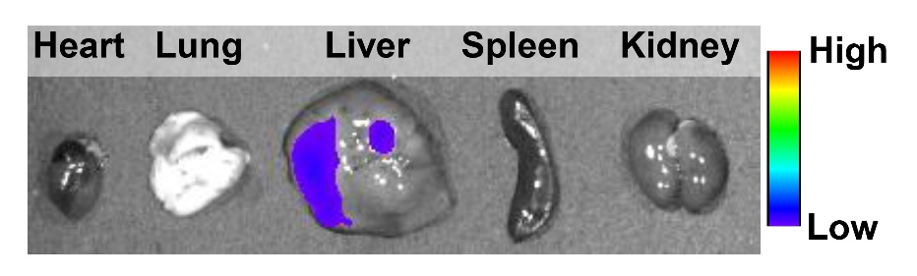
Fig. S20. The phosphorescence signals of different organs (1-heart, 2-liver, 3-spleen, 4-lung and 5-kidney) from tumor-bearing mice at 6 h post intravenous injection of DMAPy/BPO nanoparticles.
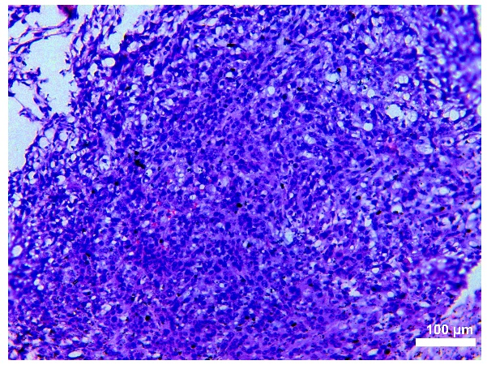
Fig. S21. H&E-stained image indicated that the light-up tissue was tumor.
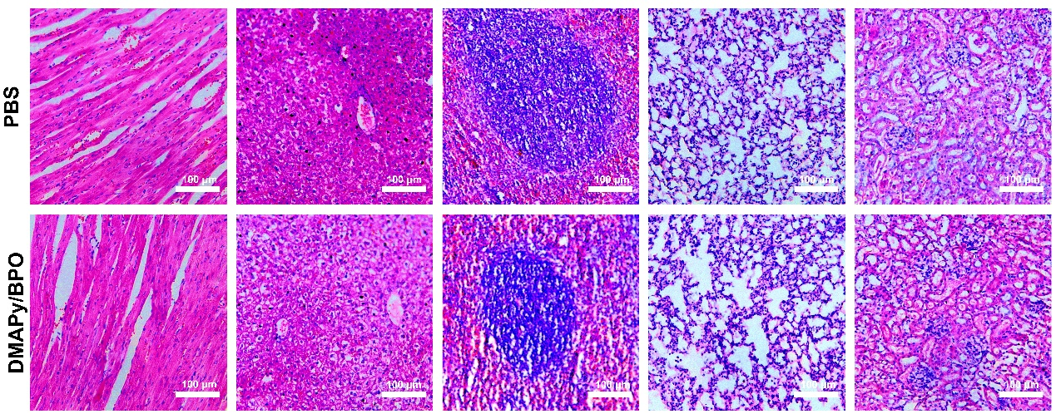
Fig. S22. H&E-stained images of major organs of the tumor-bearing mice after intravenous injection of saline and DMAPy/BPO nanoparticles, respectively.

5. NMR spectra
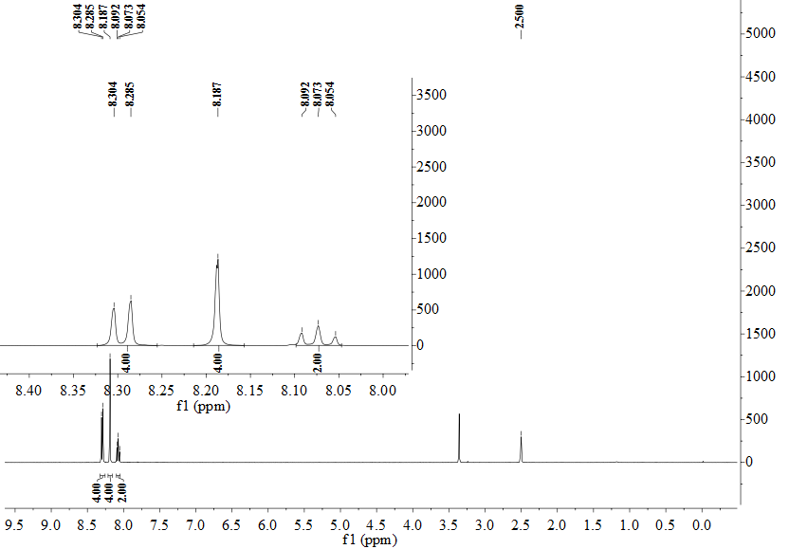 Fig. S23. ¹H NMR of compound Py (DMSO-d₆, 400 MHz).

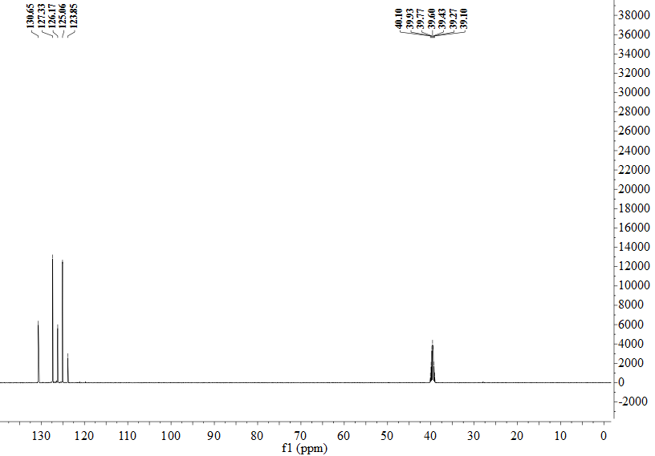
Fig. S24. ¹³C NMR of compound Py (DMSO-d₆, 125 MHz).

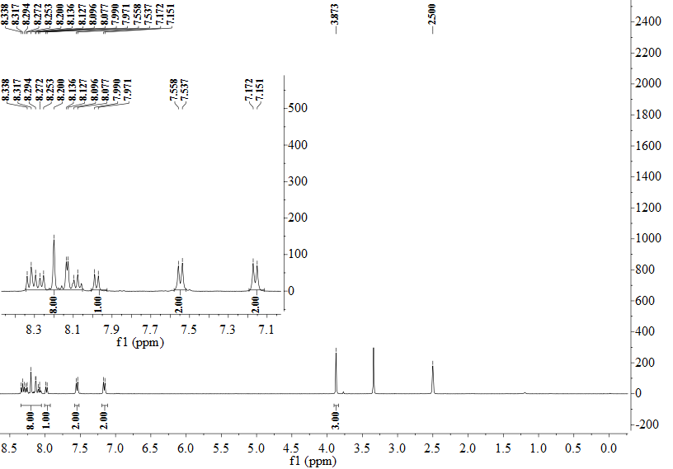
Fig. S25. ¹H NMR of compound MOPy (DMSO-d₆, 400 MHz).

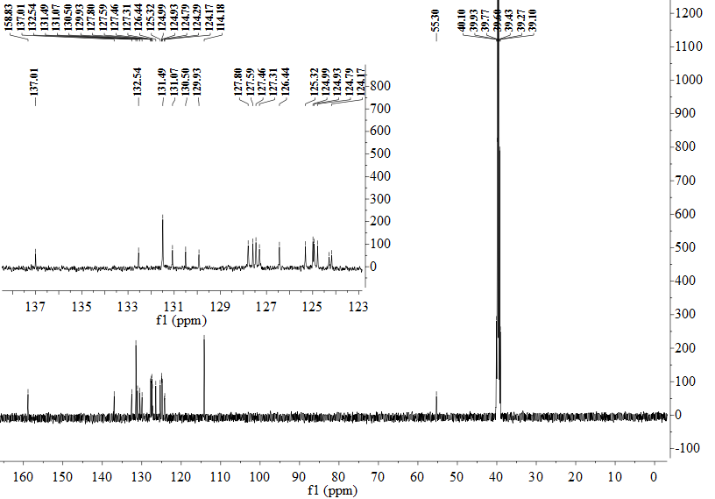
Fig. S26. ¹³C NMR of compound MOPy (DMSO-d₆, 125 MHz).

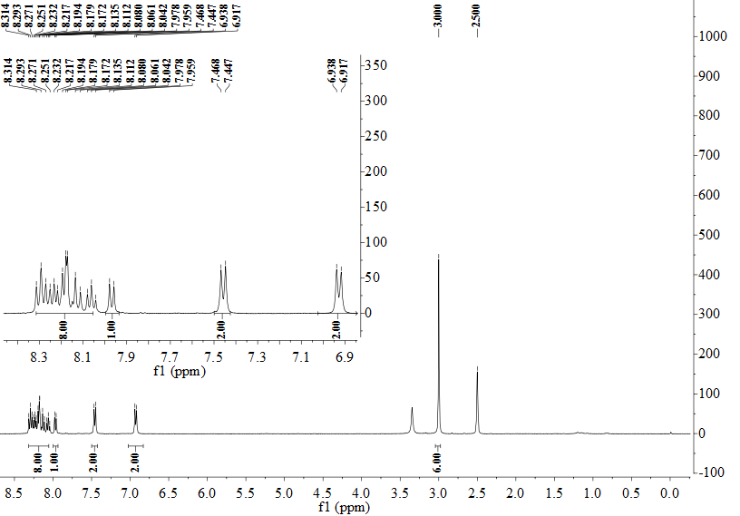 Fig. S27. ¹H NMR of compound MAPy (DMSO-d₆, 400 MHz).

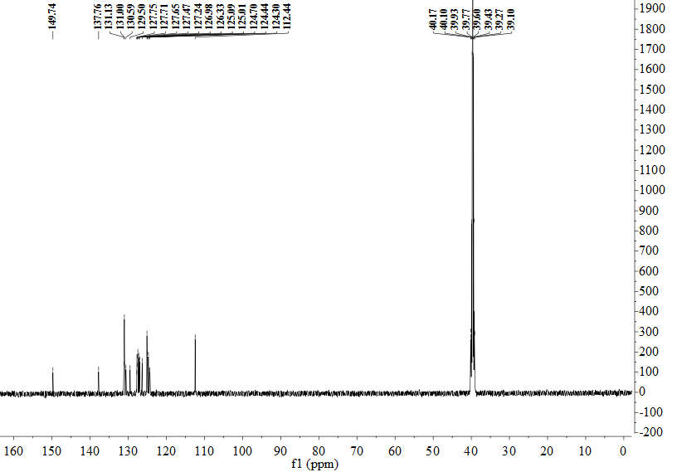
Fig. S28. ¹³C NMR of compound MAPy (DMSO-d₆, 125 MHz).
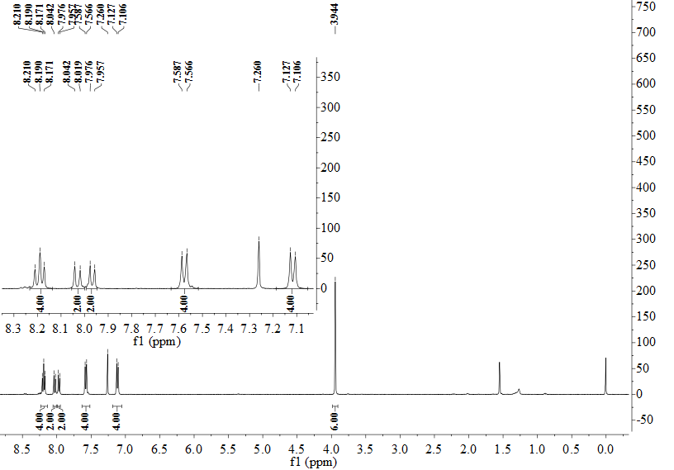 Fig. S29. ¹H NMR of compound DMOPy (CDCl₃, 400 MHz).

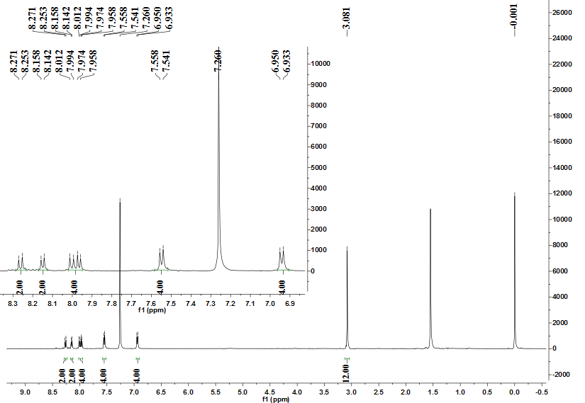 Fig. S30. ¹H NMR of compound DMAPy (CDCl₃, 500 MHz).

