Supplementary Materials

Causal Relationship between White Matter Tracts and Psychiatric Disorders: A Mendelian Randomization Study
Yifan Yu,^{1#} Sizhi Ai,^{2#} Tianye Jia,³ Xiao Lin,¹ Yanping Bao,⁴ Suhua Chang,¹ Jie Sun,⁵ Teng Gao,¹ Jie Shi,^{5, 6} Kai Yuan,¹*
^{1．}Peking University Sixth Hospital, Peking University Institute of Mental Health, NHC Key Laboratory of Mental Health (Peking University), National Clinical Research Center for Mental Disorders (Peking University Sixth Hospital), Chinese Academy of Medical Sciences Research Unit (No.2018RU006), Peking University, Beijing, China.
^{2．}Center for Sleep and Circadian Medicine, The Affiliated Brain Hospital of Guangzhou Medical University, Guangzhou, 510370, China.
^{3．} Institute of Science and Technology for Brain-Inspired Intelligence, Fudan University, Shanghai, China.
^{4．} National Institute on Drug Dependence and Beijing Key Laboratory of Drug Dependence, Peking University, Beijing 100191, China.
^{5．}Center for Pain Medicine, Peking University Third Hospital, Beijing 100191, China.
^{6．}Peking University Health Science Center, Peking University, Beijing, China.
# These authors contributed equally to this work.
* Corresponding author

This file includes:
Supplementary Text
Figs. S1 to S25
Tables S1 to S2
Legends for tables S3 to S25
Other Supplementary Materials for this manuscript include the following:
Tables S3 to S25

Contents
Preface 3
Supplementary Text 4
A step-by-step description of MR processing 4
Mini-review of the association between WMTs and psychiatric disorders 4
ADHD and ASD 4
MDD, SCZ, BD, and PTSD 5
More details for forward Mendelian randomization 5
Causal effects of white matter tracts on PTSD 6
Confounding factors, outliers, and sensitivity analysis 6
Fig. S1. Leave-one-out plot of ACR_MO on PTSD. 7
Fig. S2. Leave-one-out plot of CGH_MD on PTSD. 8
Fig. S3. Leave-one-out plot of CGH_RD on PTSD. 9
Fig. S4. Leave-one-out plot of FX_MO on ADHD. 10
Fig. S5. Leave-one-out plot of FXST_FA on SCZ. 11
Fig. S6. Leave-one-out plot of FXST_MO on BD. 12
Fig. S7. Leave-one-out plot of FXST_MO on TS. 13
Fig. S8. Leave-one-out plot of FXST_RD on PTSD. 14
Fig. S9. Leave-one-out plot of GCC_MD on MDD. 15
Fig. S10. Leave-one-out plot of GCC_MD on OUD. 16
Fig. S11. Leave-one-out plot of GCC_RD on OUD. 17
Fig. S12. Leave-one-out plot of IFO_AD on AUD. 18
Fig. S13. Leave-one-out plot of PCR_AD on PTSD. 19
Fig. S14. Leave-one-out plot of PCR_FA on PTSD. 20
Fig. S15. Leave-one-out plot of PCR_RD on PTSD. 21
Fig. S16. Leave-one-out plot of RLIC_MO on SCZ. 22
Fig. S17. Leave-one-out plot of RLIC_RD on PTSD. 23
Fig. S18. Leave-one-out plot of SCR_FA on SCZ. 24
Fig. S19. Leave-one-out plot of SFO_FA on PTSD. 25
Fig. S20. Leave-one-out plot of SFO_MD on PTSD. 26
Fig. S21. Leave-one-out plot of SLF_FA on PTSD. 27
Fig. S22. Leave-one-out plot of SLF_RD on PTSD. 28
Fig. S23. Leave-one-out plot of UNC_FA on PTSD. 29
Fig. S24. Leave-one-out plot of UNC_MD on PTSD. 30
Fig. S25. Scatter plot 31
Table S1. The summary of the association between WMTs and psychiatric disorders 32
Table S2. STROBE-MR checklist of recommended items to address in reports of Mendelian randomization studies ^{51,52} 42
References 46
Legends for tables S3 to S25 49

Preface
Due to the extensive use of abbreviations for white matter tracts (WMTs) and psychiatric disorders in this article, to avoid the disruption of readers' reading experience caused by the frequent appearance of abbreviations and their full forms, we have listed here the abbreviations for 21 WMTs and 10 psychiatric disorders presented in this article, for the convenience of readers.

Abbreviations of 21 WMTs:
ACR: anterior corona radiata
ALIC: anterior limb of internal capsule
BCC: body of corpus callosum
CGC: cingulum (cingulate gyrus)
CGH: cingulum (hippocampus)
CST: corticospinal tract
EC: external capsule
FX: fornix (column and body of fornix)
FXST: fornix (cres) / stria terminalis
GCC: genu of corpus callosum
IFO: inferior fronto-occipital fasciculus
PCR: posterior corona radiata
PLIC: posterior limb of the internal capsule
PTR: posterior thalamic radiation
RLIC: retrolenticular part of internal capsule
SCC: splenium of corpus callosum
SCR: superior corona radiata
SFO: superior fronto-occipital fasciculus
SLF: superior longitudinal fasciculus
SS: sagittal stratum
UNC: uncinate fasciculus

Abbreviations of 10 psychiatric disorders:
ADHD: attention deficit hyperactivity disorder
ASD: autism disorder
AUD: Alcohol use disorder
BD: bipolar disorder
CUD: cannabis use disorder
MDD: major depression disorder
PD: phobic anxiety disorders
PTSD: post-traumatic stress disorder
SCZ: schizophrenia
OUD: opioid use disorder

Abbreviations of 5 DTI parameters:
FA: fractional anisotropy
MD: mean diffusivities
AD: axial diffusivities
RD: radial diffusivities
MO: mode of anisotropy

Supplementary Text

A step-by-step description of MR processing
Before addressing confounding factors, we screened 1,667 SNP loci as instrumental variables for forward MR (Table S5) and 301 for reverse MR (Table S6), leaving 1,376 and 301 respectively after confounders removal (Table S7 - S10). Besides previously reported confounders such as socioeconomic status and education, additional non-brain structural and non-psychiatric factors were included, such as pulse pressure (rs2645466), coronary artery disease (rs4894803), and uterine leiomyoma or ER-positive breast cancer (rs10828248), etc. (Table S9). After outliers detection (Table S11 - S12), 11,745 validated WMT-psychiatric disorder pairs were tested for forward MR analysis (Table S13), and 30,343 psychiatric disorder-WMT pairs were tested for reverse MR analysis (Table S14).

In the results of forward MR, 150 WMTs-psychiatric disorders pairs were nominally significant (p < 0.05), 37 pairs were significant still after FDR adjustment (FDR_p < 0.05), and 29 pairs survived after sensitivity analysis. Of these 29 pairs, 5 pairs’ SNP numbers were < 4. Besides, there was a directional difference of β in 3 pairs: MDD-CST_MO, PTSD-FXST_AD, and SCZ-FXST_FA. 6 pairs showed changes in significance after outlier removal, but the directionality of the results remained unchanged, indicating reliable post-removal results with appropriate outlier detection and removal. Furthermore, the alteration of all parameters (FA, MD, AD, RD) was coordinated, greatly enhancing the interpretability of the association between WMTs and psychiatric disorders at neurobiological and mathematical levels. After removing 5 pairs (SNP < 4), we got 24 pairs finally. Among the 24 WMT-psychiatric disorder pairs, 12 unique WMTs were identified. In addition to PTSD being widely distributed, the significant causal associations of 7 other psychiatric disorders were concentrated in 6 WHTs. During statistical analysis, the F-values of the instrumental variables in the final results were all > 20, and the statistical power was > 90%. Additionally, we observed the presence of reverse causal associations between substance abuse-related psychiatric disorders (AUD and OUD) and WMTs. The results and outlier analysis details of forward MR and reverse MR can be found in Table S15 - S22.

Finally, we discovered that FXST was a dominant WMT in PTSD using a multivariate MR approach (Table S23) and partially validated the results for ADHD, AUD, BD, and SCZ using the FinnGen R11 database (Table S24). Our findings indicate causal associations between WMTs and SCZ, BD, PTSD, MDD, AUD, ADHD, and TS, with these causal associations being associated with specific WMT types and specific parameter types.

Mini-review of the association between WMTs and psychiatric disorders
We used the following subject terms to search literature published in PubMed in the last 5 years (until Aug 2024): ((Diffusion tensor imaging) OR (White matter tract*)) AND ((Schizophrenia) OR (Bipolar disorder) OR (Cannabis use disorder) OR (Opioid use disorder) OR (Post-traumatic stress disorder) OR (Major depression) OR (General anxious disorder) OR (Autism disorder) OR (Tourette syndrome) OR (Attention deficit hyperactivity disorder)). Finally, we got 868 results, and 32 articles were included (Table S1). Our review revealed that most current research focuses on the association between fractional anisotropy (FA) (32/32) values and psychiatric disorders. At the same time, discussions on mean diffusivity (MD) (7/32), axial diffusivity (AD) (3/32), and radial diffusivity (RD) (9/32) parameters were relatively limited. ADHD, ASD, SCZ, BD, MDD, and PTSD were the major psychiatric disorders researchers reported. Additionally, significant positive results exhibit specific regional dependencies: the limbic system, thalamic radiation, and corpus callosum, which correlate with their respective brain functions and clinical symptoms of the diseases. Although the association between WMTs and psychiatric disorders varies according to age, gender, and other factors, the preponderance of evidence currently supports that decreases in FA (28/32) and increases in MD (6/7), AD (2/3), and RD (7/9) were associated with the risk of psychiatric disorders and the severity of progression. The potential neurobiological mechanism may be as follows: alterations in the structure/function of WMTs change the efficiency or pattern of neuronal transmission within these tracts. The altered neuro signals originating from WMTs, upon processing by gray matter, produce abnormal neural decoding results, manifesting as neurological dysfunction. Overall, these studies qualitatively reflect the close association between WMTs and psychiatric disorders and reveal some of the associations between this association and tract type, as well as parameter type.

ADHD and ASD
The research on ADHD was controversial due to the different developing characteristics of white matter tracts in children. At the genetic level, children with higher polygenic risk scores (PRS) for ADHD tend to have more severe ADHD symptoms and a reduction of FA in several WMTs ¹. Furthermore, a sibling study revealed that AD values of some WMTs were significantly associated with ADHD symptoms: sustained attention and working memory ². Besides, the abnormalities in the anterior portion of the left inferior longitudinal fasciculus (ILF) can help us to distinguish between probands with persisting ADHD symptomatology and probands with desisting ADHD symptomatology ³. However, a study illustrates that in-scanner head motion may fully mediate some causal mediation effects ⁴. And some negative evidence showed no significant effect on FA in the ADHD children group(from a meta-analysis containing 15 studies, n= 607) ⁵ or for any specific tract ⁶.

Compared with ADHD, the changes in WMTs appear to be more pronounced in ASD. Post hoc analyses revealed significantly lower FA among children with ASD compared with children with ADHD. Furthermore, children with ASD had significantly higher mean MD, RD, and AD compared with those having ADHD ⁷. Differences in white matter development between individuals whose ASD severity increased remained stable or decreased, suggesting that these functional differences were associated with fiber development in the autistic brain⁸. Autistic individuals whose autistic severity was increasing over time had a slower developmental trajectory of FA compared with individuals whose autistic severity was decreasing ⁸. Moreover, a twin study of ASD indicated that genetic factors contributed to ∼40% to 50% of the covariation between IQ scores and FA of the CC, while environmental factors contributed to ∼10% to 20% of the covariation between ASD-related symptom severity and FA of the CP and EC, which means the WMTs alterations were associated with both genetic contributions and environmental influences⁹. We could find different alterations of WMTs in developmental disorders such as ADHD and ASD, but these changes did not seem to be very obvious (perhaps because the brain development of children is not complete, so it is not easy to observe obvious characteristics after covariate analysis with the control group).

MDD, SCZ, BD, and PTSD
The MDD population’s complexity makes the research's influential factors more obvious. Reviewing 57 longitudinal studies investing the structural connectivity in MDD patients undergoing 4 different treatment methods: pharmacotherapy, psychotherapy, electroconvulsive therapy (ECT), and repetitive transcranial magnetic stimulation (rTMS), Tura et al. summarized that the results were widespread and inconsistent, which makes it difficult to make conclusions¹⁰. Gene polymorphism ¹¹, negative stressful life events ¹² , and social support were both related to WM integrity (lower FA values) in MDD. However, the results were robust when MDD patients had specific characteristics, such as acute episodes and non-suicidal self-injury (NSSI). MDD patients with NSSI showed reduced CG integrity compared to MDD patients without NSSI and healthy controls¹³. And the dysfunction of the kynurenine/tryptophan ((Kyn/Trp) pathway may serve as a potential cause ¹⁴.

Compared with MDD, the alterations of WMTs in BD were more evident. BD patients showed higher Kyn levels and Kyn/Trp ratio than MDD patients and lower FA in several WM tracts, including the CC and the IFO. Lower Trp levels are associated with more severe depressive symptomatology irrespective of diagnosis and with lower FA in the CC and EC ¹⁵. The present review summarizes studies on twin samples concordant or discordant for BD or MDD: WM integrity emerges as a hallmark of BD under genetic influence¹⁶. While the change of MDD only reached the trend level, BD showed a more significant decrease in FA, so disruptions in WMTs in BD might be a trait effect of the disorder¹⁷. Furthermore, there were different changes in FA in various subgroups of BD¹⁸ , and better complex attention skills and executive functioning was associated with higher FA both globally and in the CC of BD patients ¹⁹.

The association between SCZ and WMTs is presented in detail in the Table S1. The psychopathological syndrome of formal thought disorder (FTD) is not only present in SCZ but also highly prevalent in MDD and BD ²⁰. Seitz-Holland J et al. observed evidence for cellular and extracellular white matter abnormalities in adolescent-onset psychosis (ADO). Although cellular white matter abnormalities were more prominent in ADO-SCZ, such alterations may reflect a shared trait, i.e., neurodevelopmental pathology, present across the psychosis spectrum. Extracellular abnormalities were evident in psychotic ADO-BD, potentially indicating a more dynamic, state-dependent brain reaction to psychosis ²¹. 3 psychopathological formal thought disorder dimensions were delineated, i.e., disorganization, emptiness, and incoherence. Disorganization and incoherence were associated with global dysconnectivity²⁰.

From the perspective of WMTs deficits mechanism, MDD, and BD focused more on the Kyn/Trp pathway and inflammatory factors (proinflammatory and counter-regulatory immunomarkers, including regulatory T cells and natural killer cells markers) ²², while SCZ focuses on the response of cortisol ²³.

For PTSD, in addition to the changes summarized in the Table S1, PTSD had some similarities with MDD: WMTs changes were more pronounced only in certain situations. The severity of PTSD symptom of those who experienced childhood maltreatment was inversely varied with FA in the IC ²⁴. Besides, there was evidence from shared genetics suggesting that PTSD was a subtype of MDD ²⁵.

More details for forward Mendelian randomization
In forward MR, we identified causal associations for 24 significant WMT traits across 8 psychiatric disorders. (PTSD: 14, SCZ: 3, ADHD: 1, MDD: 1, OUD: 2, AUD: 1, BD: 1, TS: 1). The distribution of these WMTs includes FXST(4), GCC(3), PCR(3), CGH(2), RLIC(2), SFO(2), SLF(2), UNC(2), ACR(1), FX(1), IFO(1), SCR(1), which can be categorized into 5 groups: the thalamic radiations (thalamocortical, corticothalamic fibers)(11), limbic system(5), connections between left/right cerebral hemisphere or different lobes(6), and connections between the cortex(2). The parameters of WMTs encompass MO(5), FA(6), RD(6), AD(2), and MD(5), reflecting 4 presumed types of structural damage: axonal damage (indicated by AD↑), cellular membrane damage (indicated by MD↑), myelin damage (indicated by RD↑), and white matter tract integrity damage (indicated by FA↓). Among the 24 WMT-psychiatric disorder pairs, 12 unique WMTs were identified. In addition to PTSD being widely distributed, the significant causal associations of 7 other psychiatric disorders were concentrated in 6 WMTs.

Causal effects of white matter tracts on PTSD
As illustrated in Fig. 2 and detailed in Table S22, we uncovered causal associations between PTSD and 7 WMTs: CGH, FXST, PCR, RLIC, SFO, SLF, and UNC. Increase in FA for PCR, SFO, SLF, and UNC were found to decrease the risk of PTSD by 2.2% (OR = 0.978, 95% CI = 0.960 - 0.996), 4.3% (OR = 0.957, 95% CI = 0.930 - 0.986), 2.3% (OR = 0.977, 95% CI = 0.959 - 0.995), and 3.8% (OR = 0.962, 95% CI = 0.938 - 0.987), respectively. Furthermore, elevations in MD, RD, and AD values contributed to an increased risk of PTSD: specifically, one s.d. increases in MD (OR = 1.036, 95% CI = 1.017 - 1.055) and RD (OR = 1.050, 95% CI = 1.025 - 1.076) for CGH, AD (OR = 1.047, 95% CI = 1.016 -1.080) and RD (OR = 1.025, 95% CI = 1.007 - 1.043) for PCR, RD (OR = 1.027, 95% CI = 1.009 - 1.045) for RLIC, MD (OR = 1.042, 95% CI = 1.013 - 1.072) for SFO, RD (OR = 1.023, 95% CI = 1.006 - 1.041) for SLF, and MD (OR = 1.040, 95% CI = 1.011 - 1.070) for UNC were associated with increased PTSD risk. However, the association of PTSD with Average_MO and FXST_AD was not considered due to the number of SNPs being < 4 (n=3).

Confounding factors, outliers, and sensitivity analysis
We compared the forward MR results before and after removing confounding factors. We found that the significance of P-values for 110 WMT-psychiatric disorder pairs changed (from non-significant to significant or significant to non-significant) due to removing confounding factors, with a reversal direction of β-value in 6 pairs. Among the 24 significant results, the significance of P-values for FX_MO - ADHD and GCC_MD - MDD changed after removing confounding factors. Specifically, 1 SNP related to ascending thoracic aortic diameter was removed from FX_MO. And 6 SNPs, primarily associated with lipids, Alzheimer's disease, aging, and glutamic-oxaloacetic transaminase levels, were removed from GCC_MD (please see the details in Table S8 and S17).

Regarding outliers, among the 24 significant results, 8 were obtained after excluding outliers: FXST_FA - SCZ (3), ACR_MO - PTSD (3), FXST_RD - PTSD (1), PCR_AD - PTSD (1), PCR_RD - PTSD (1), RLIC_RD - PTSD (2), SFO_MD - PTSD (3), SLF_FA - PTSD (4), SLF_RD - PTSD (4), UNC_FA - PTSD (3), , and GCC_MD - MDD (3). The direction of all β-values remained unchanged, indicating that the impact of outlier removal on the results is acceptable (please see the details in Table S10 and S18).

For sensitivity analysis, both the MR-Presso global test and MR-Egger intercept for all results satisfied P > 0.05. Although the IVW β-values for FXST_FA - SCZ were in the opposite direction compared to MR-Egger β-values, all MR-Egger P > 0.5, and they were in the same direction as β-values from MR-median and MR-mode. Therefore, we can conclude that the sensitivity analysis confirms the reliability of the causal associations assumed in our MR results (please see the details in Table S19).

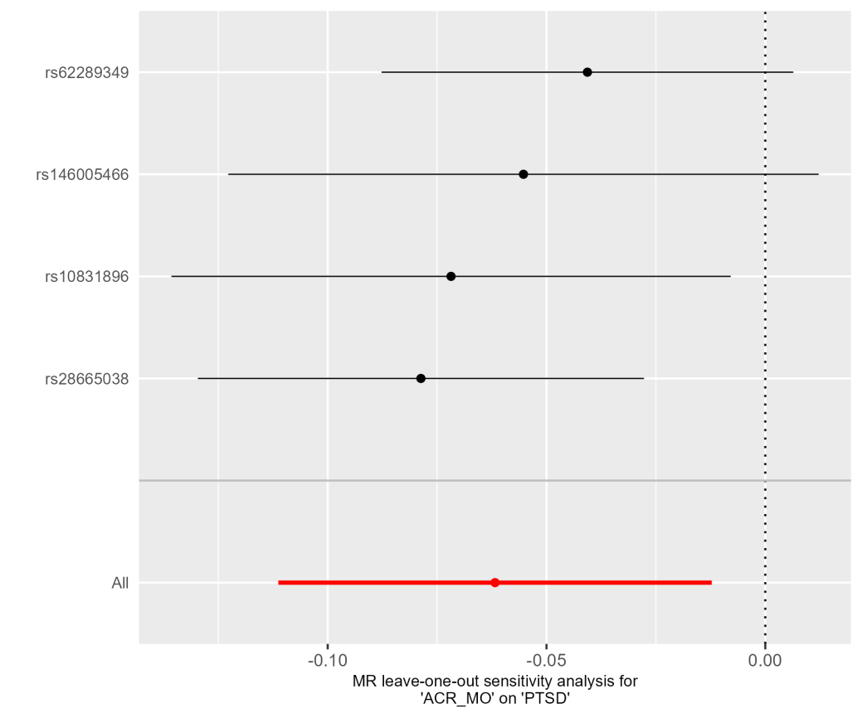

Fig. S1. Leave-one-out plot of ACR_MO on PTSD.

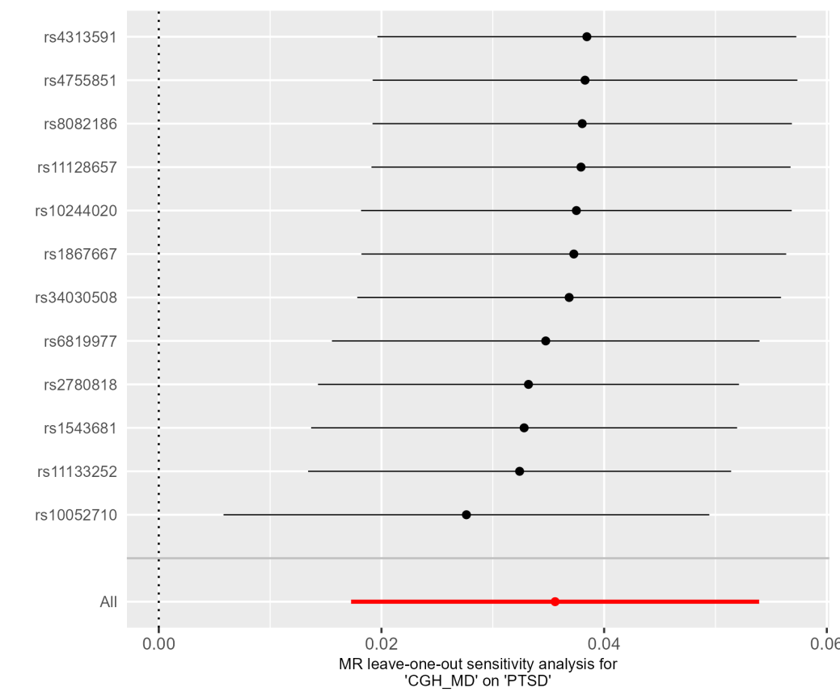

Fig. S2. Leave-one-out plot of CGH_MD on PTSD.
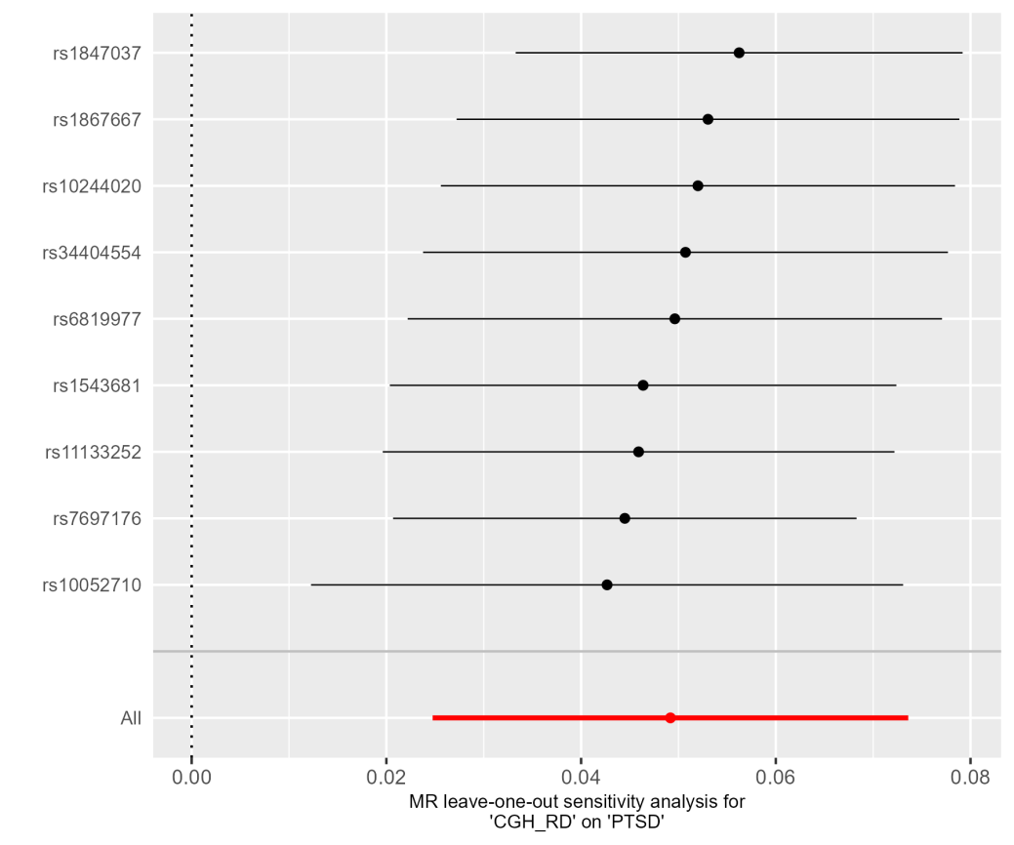

Fig. S3. Leave-one-out plot of CGH_RD on PTSD.

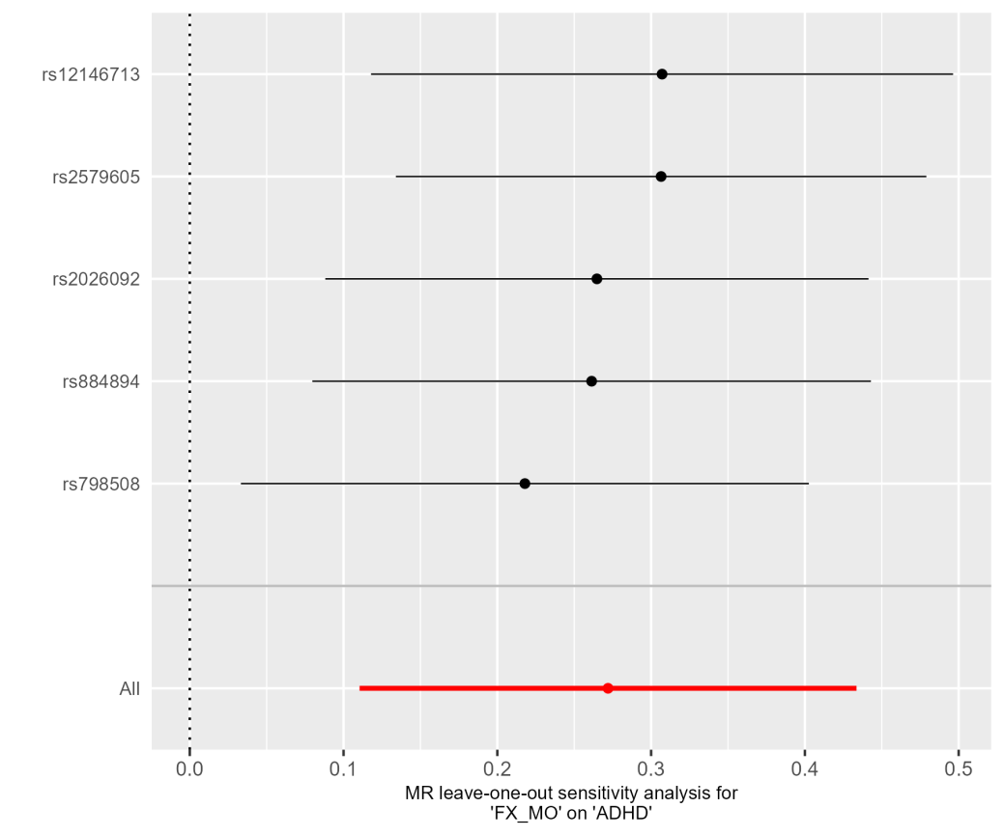

Fig. S4. Leave-one-out plot of FX_MO on ADHD.

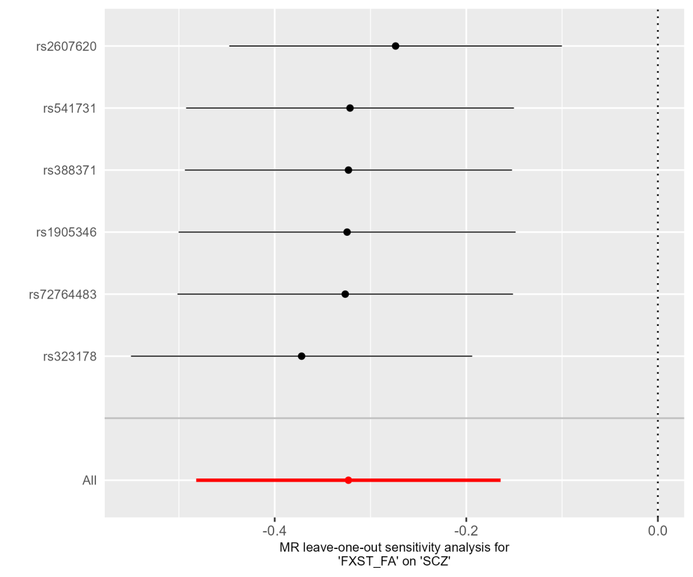

Fig. S5. Leave-one-out plot of FXST_FA on SCZ.

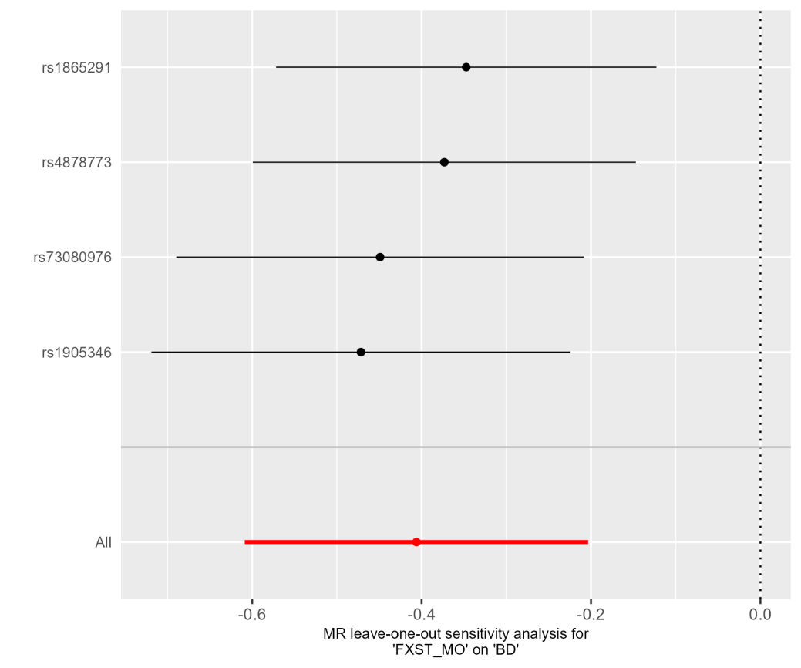

Fig. S6. Leave-one-out plot of FXST_MO on BD.

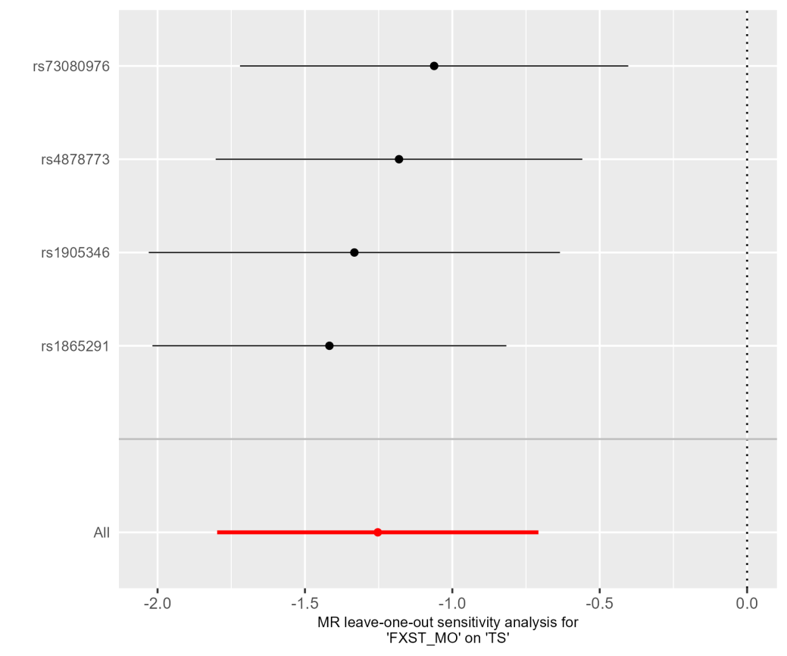

Fig. S7. Leave-one-out plot of FXST_MO on TS.

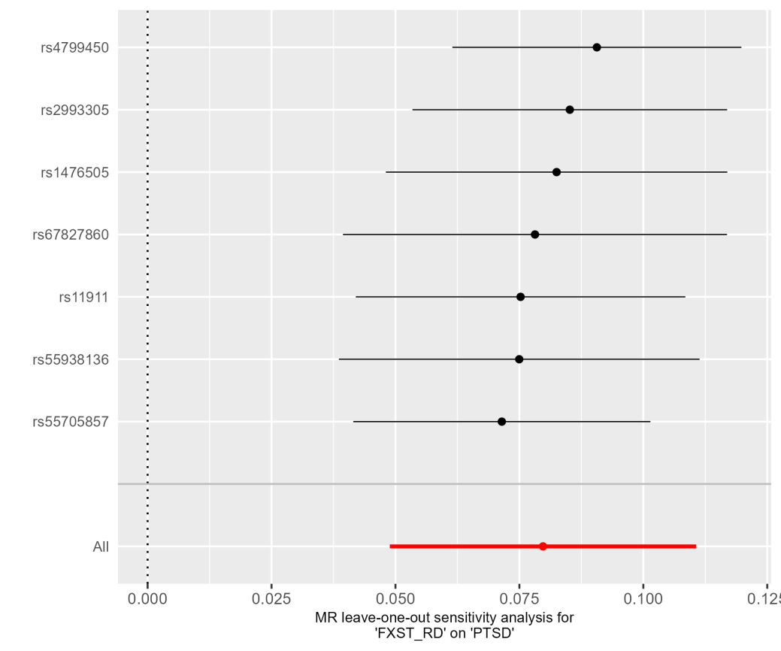

Fig. S8. Leave-one-out plot of FXST_RD on PTSD.

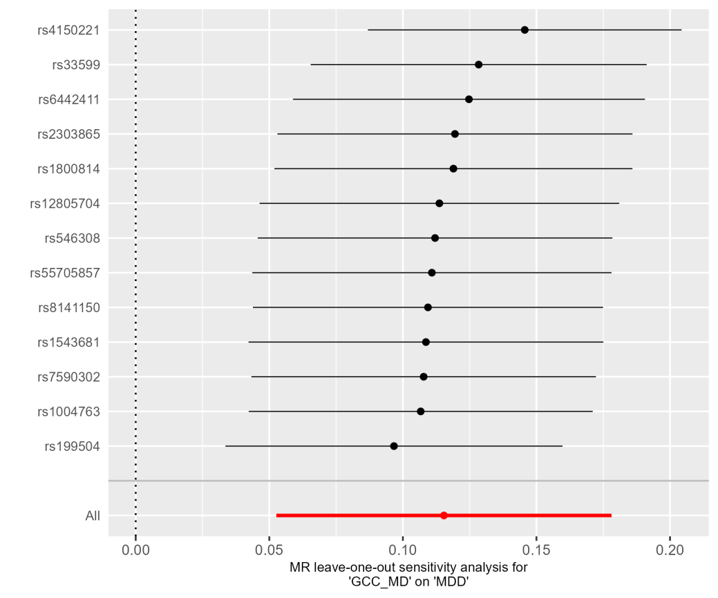

Fig. S9. Leave-one-out plot of GCC_MD on MDD.

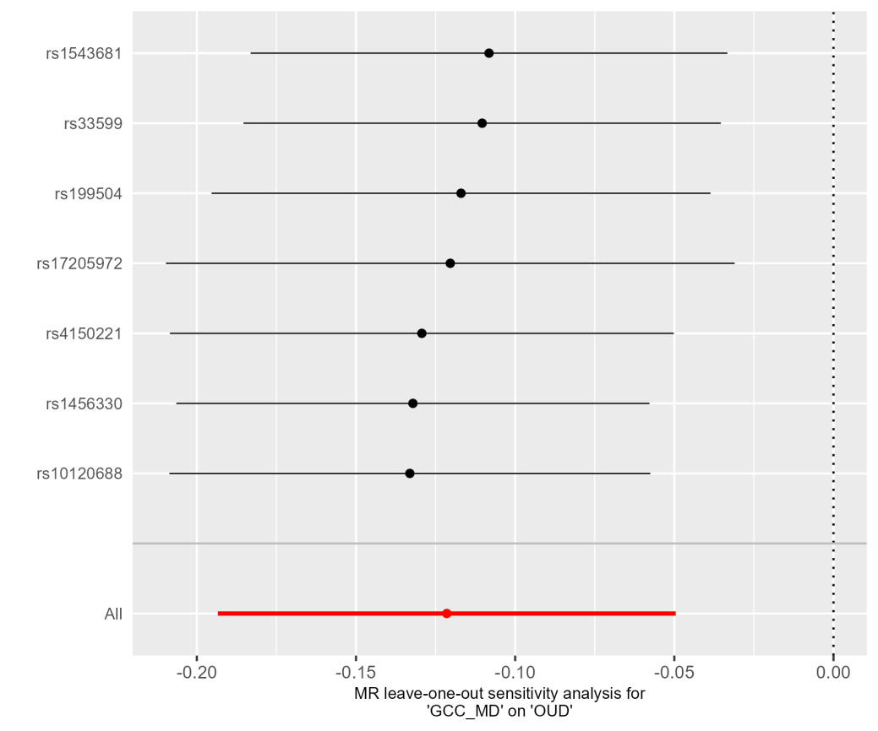

Fig. S10. Leave-one-out plot of GCC_MD on OUD.

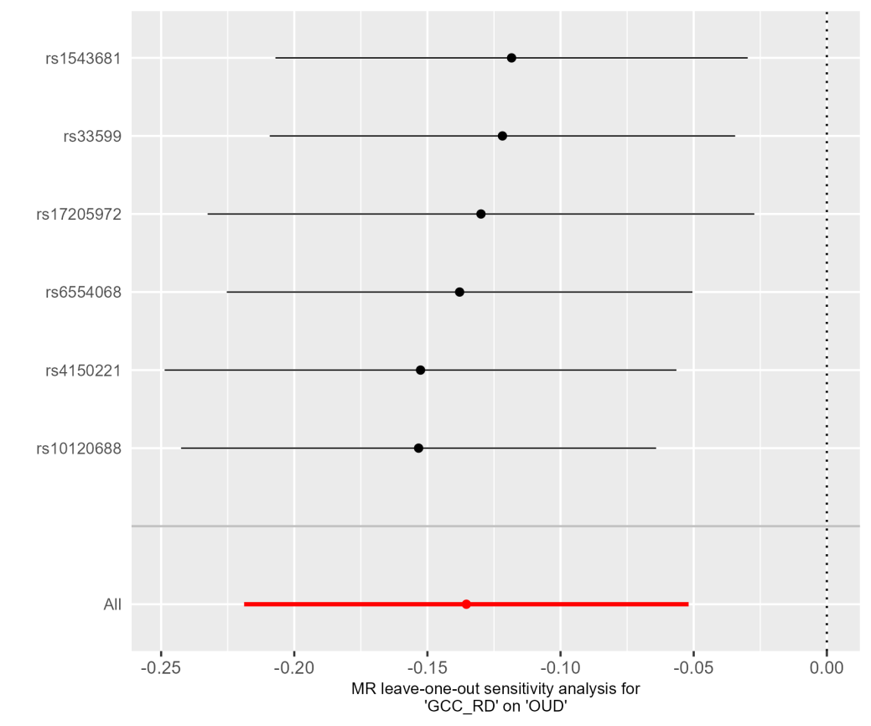

Fig. S11. Leave-one-out plot of GCC_RD on OUD.

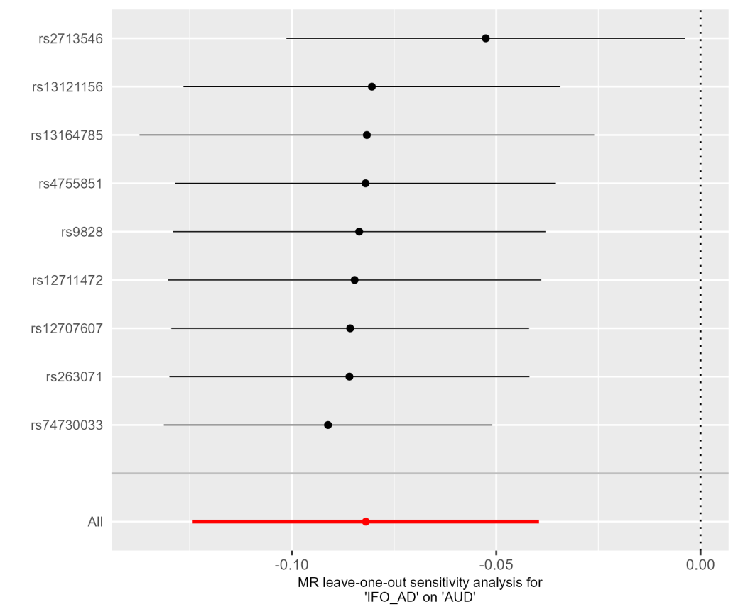

Fig. S12. Leave-one-out plot of IFO_AD on AUD.

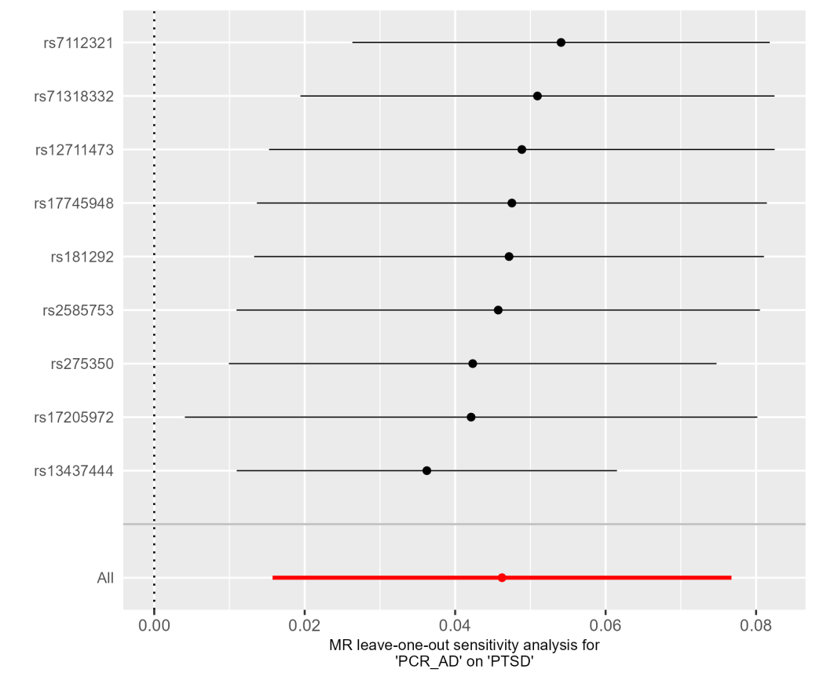

Fig. S13. Leave-one-out plot of PCR_AD on PTSD.

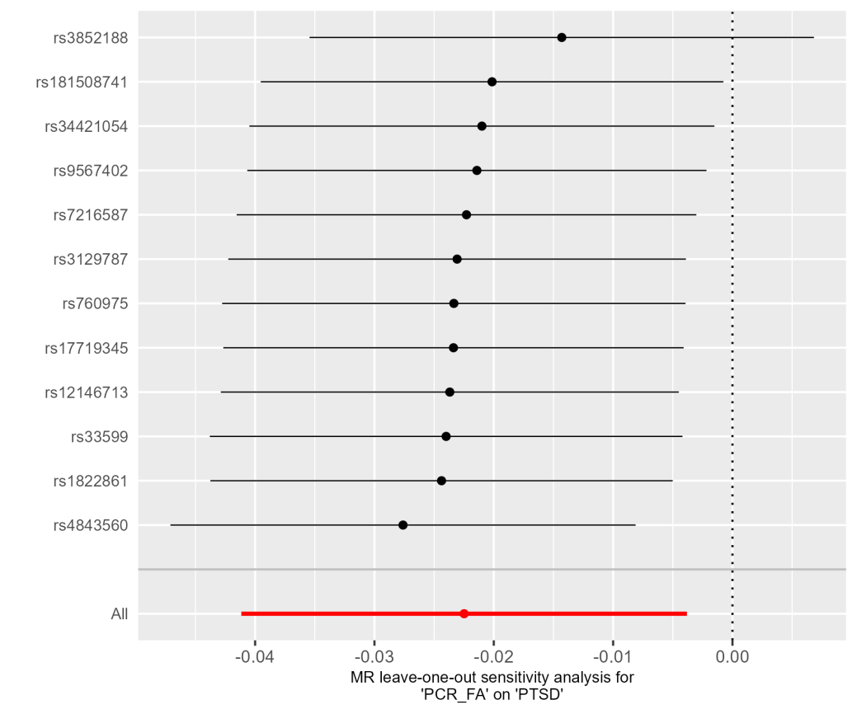

Fig. S14. Leave-one-out plot of PCR_FA on PTSD.

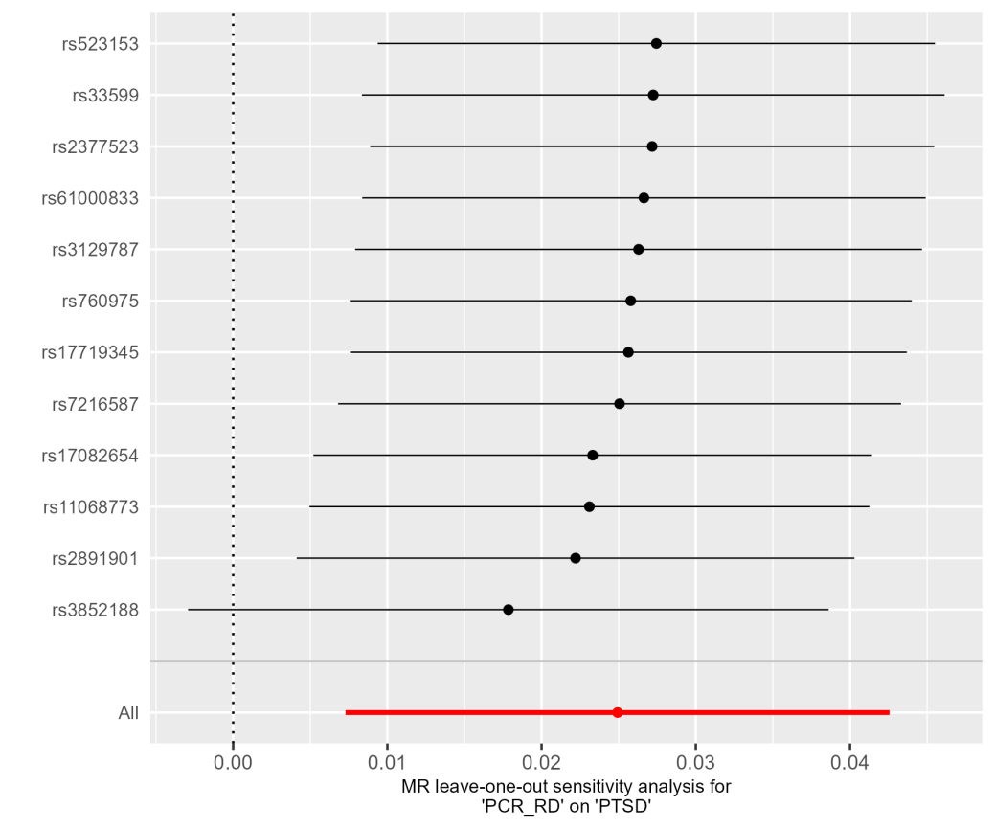

Fig. S15. Leave-one-out plot of PCR_RD on PTSD.

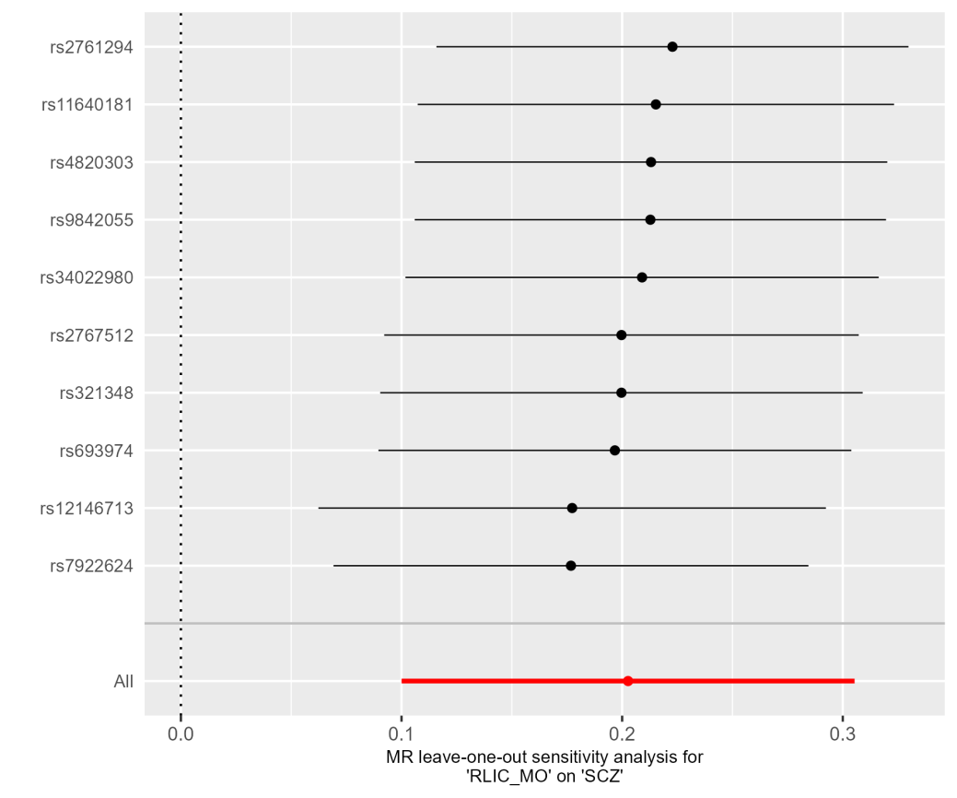

Fig. S16. Leave-one-out plot of RLIC_MO on SCZ.

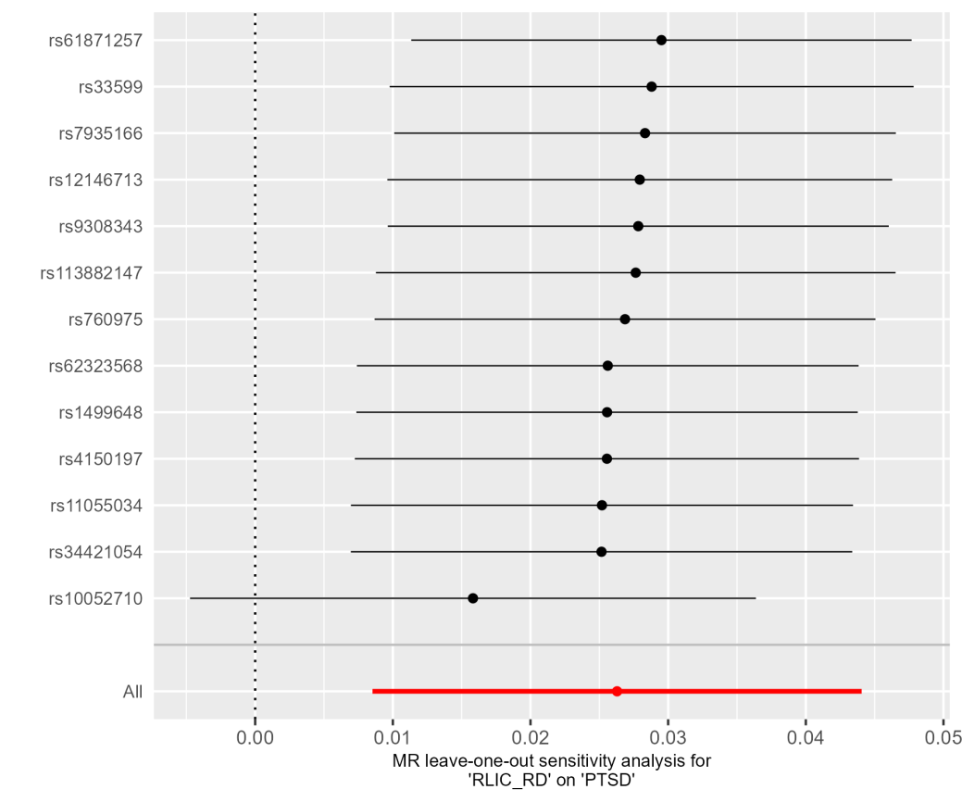

Fig. S17. Leave-one-out plot of RLIC_RD on PTSD.

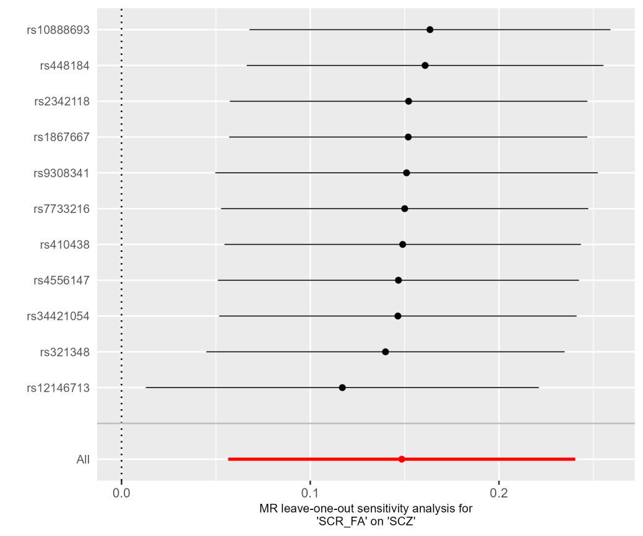

Fig. S18. Leave-one-out plot of SCR_FA on SCZ.

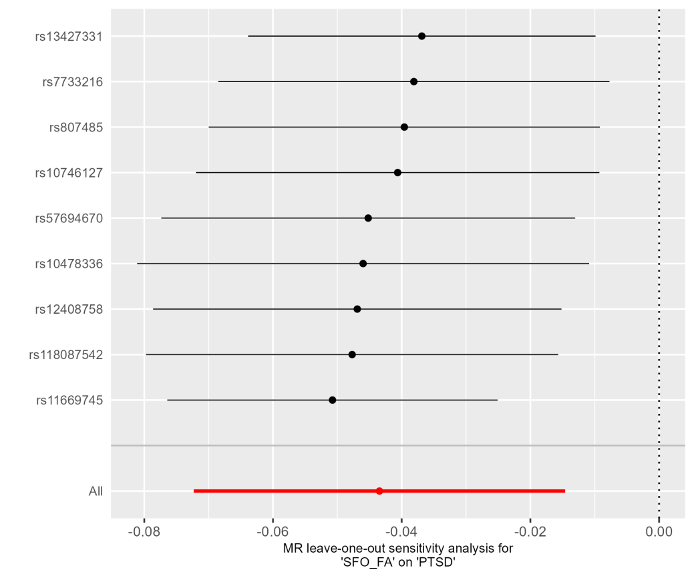

Fig. S19. Leave-one-out plot of SFO_FA on PTSD.

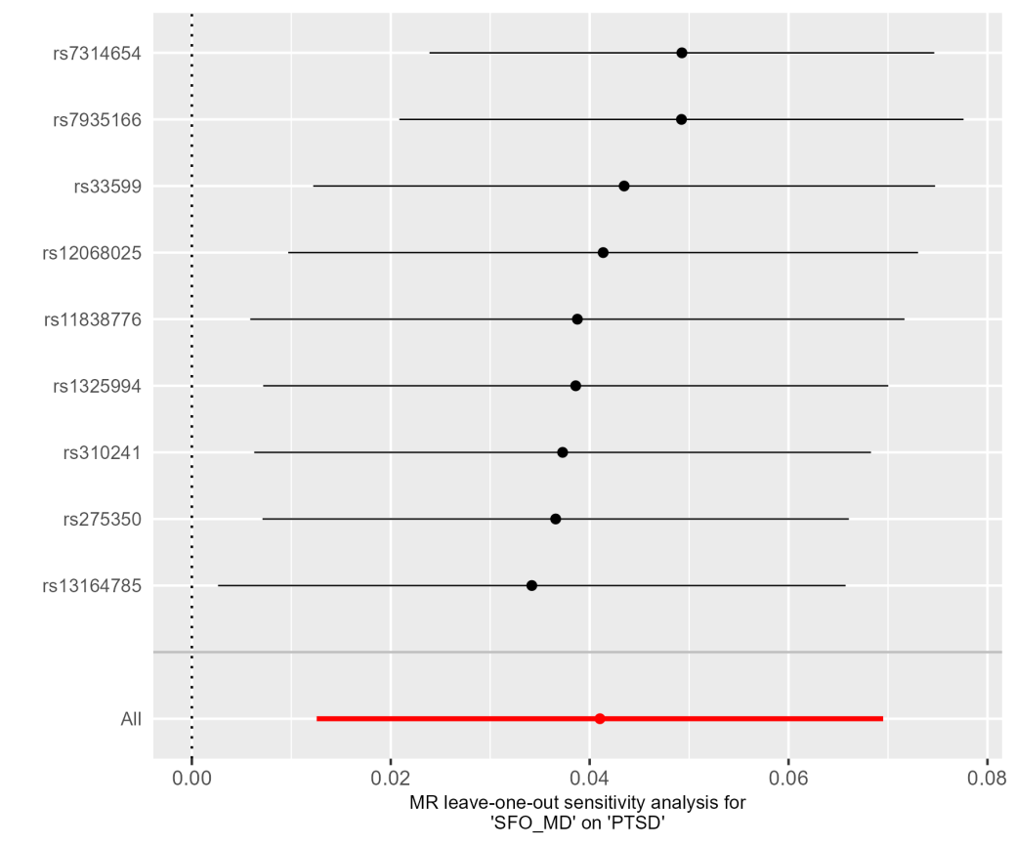

Fig. S20. Leave-one-out plot of SFO_MD on PTSD.

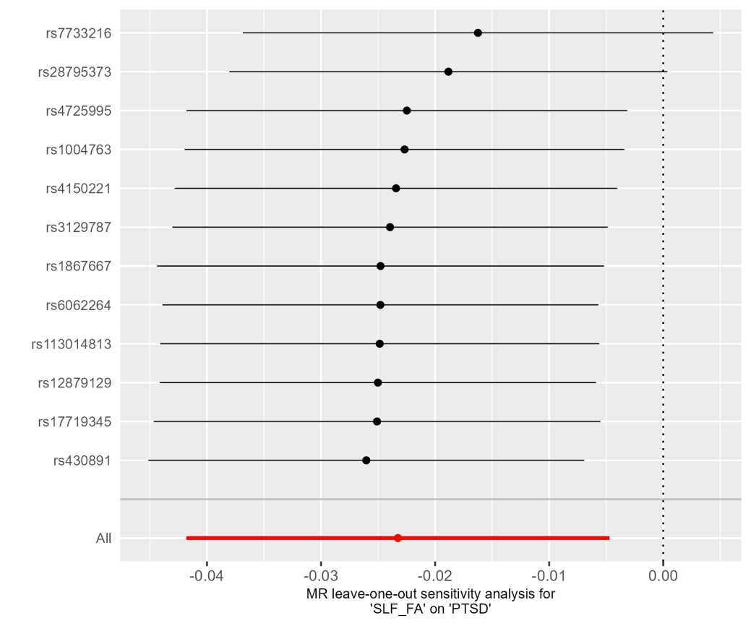

Fig. S21. Leave-one-out plot of SLF_FA on PTSD.

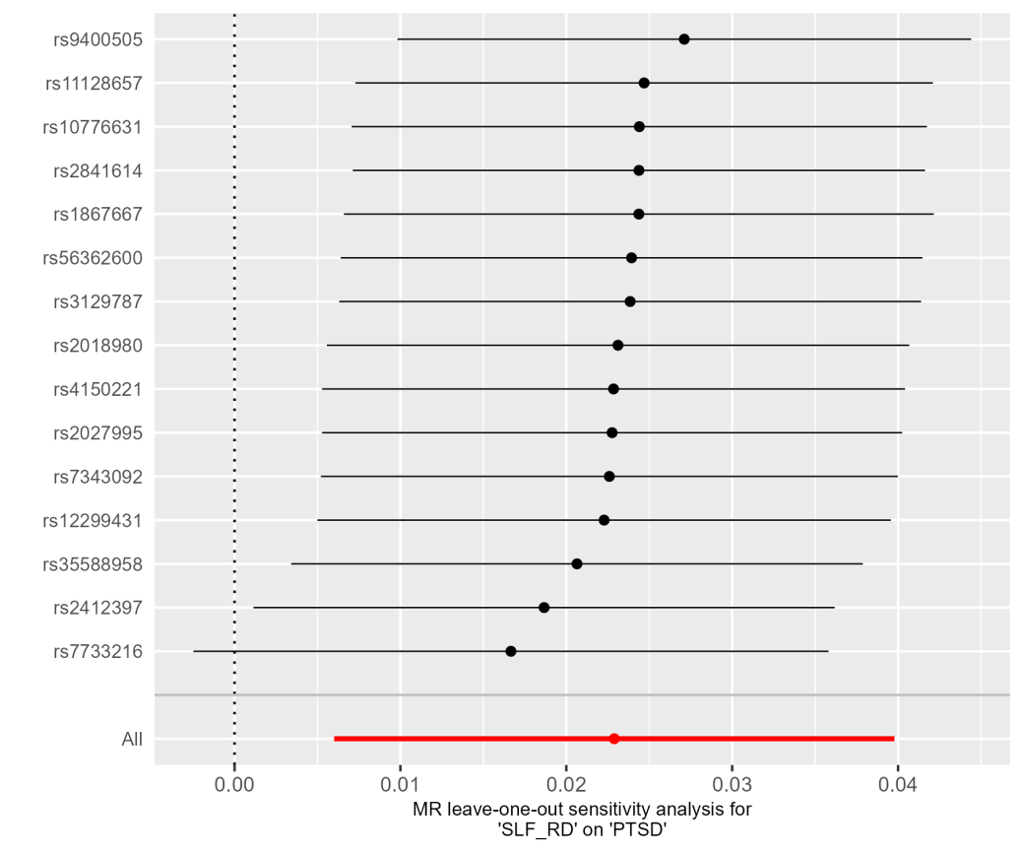

Fig. S22. Leave-one-out plot of SLF_RD on PTSD.

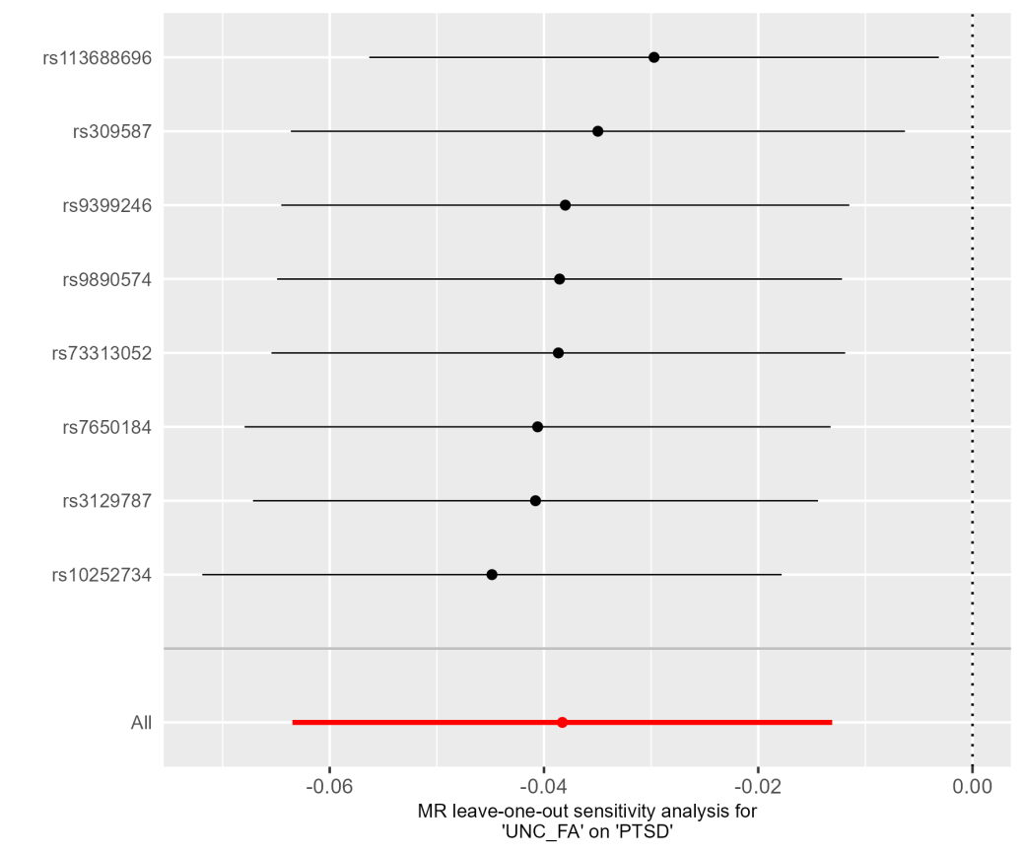

Fig. S23. Leave-one-out plot of UNC_FA on PTSD.

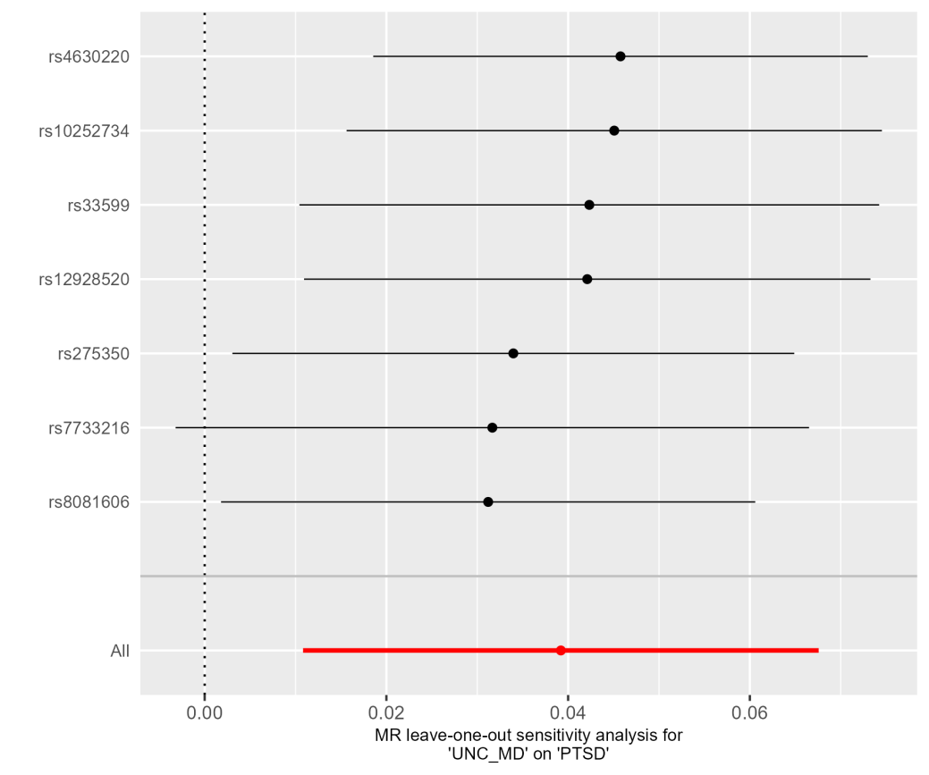

Fig. S24. Leave-one-out plot of UNC_MD on PTSD.

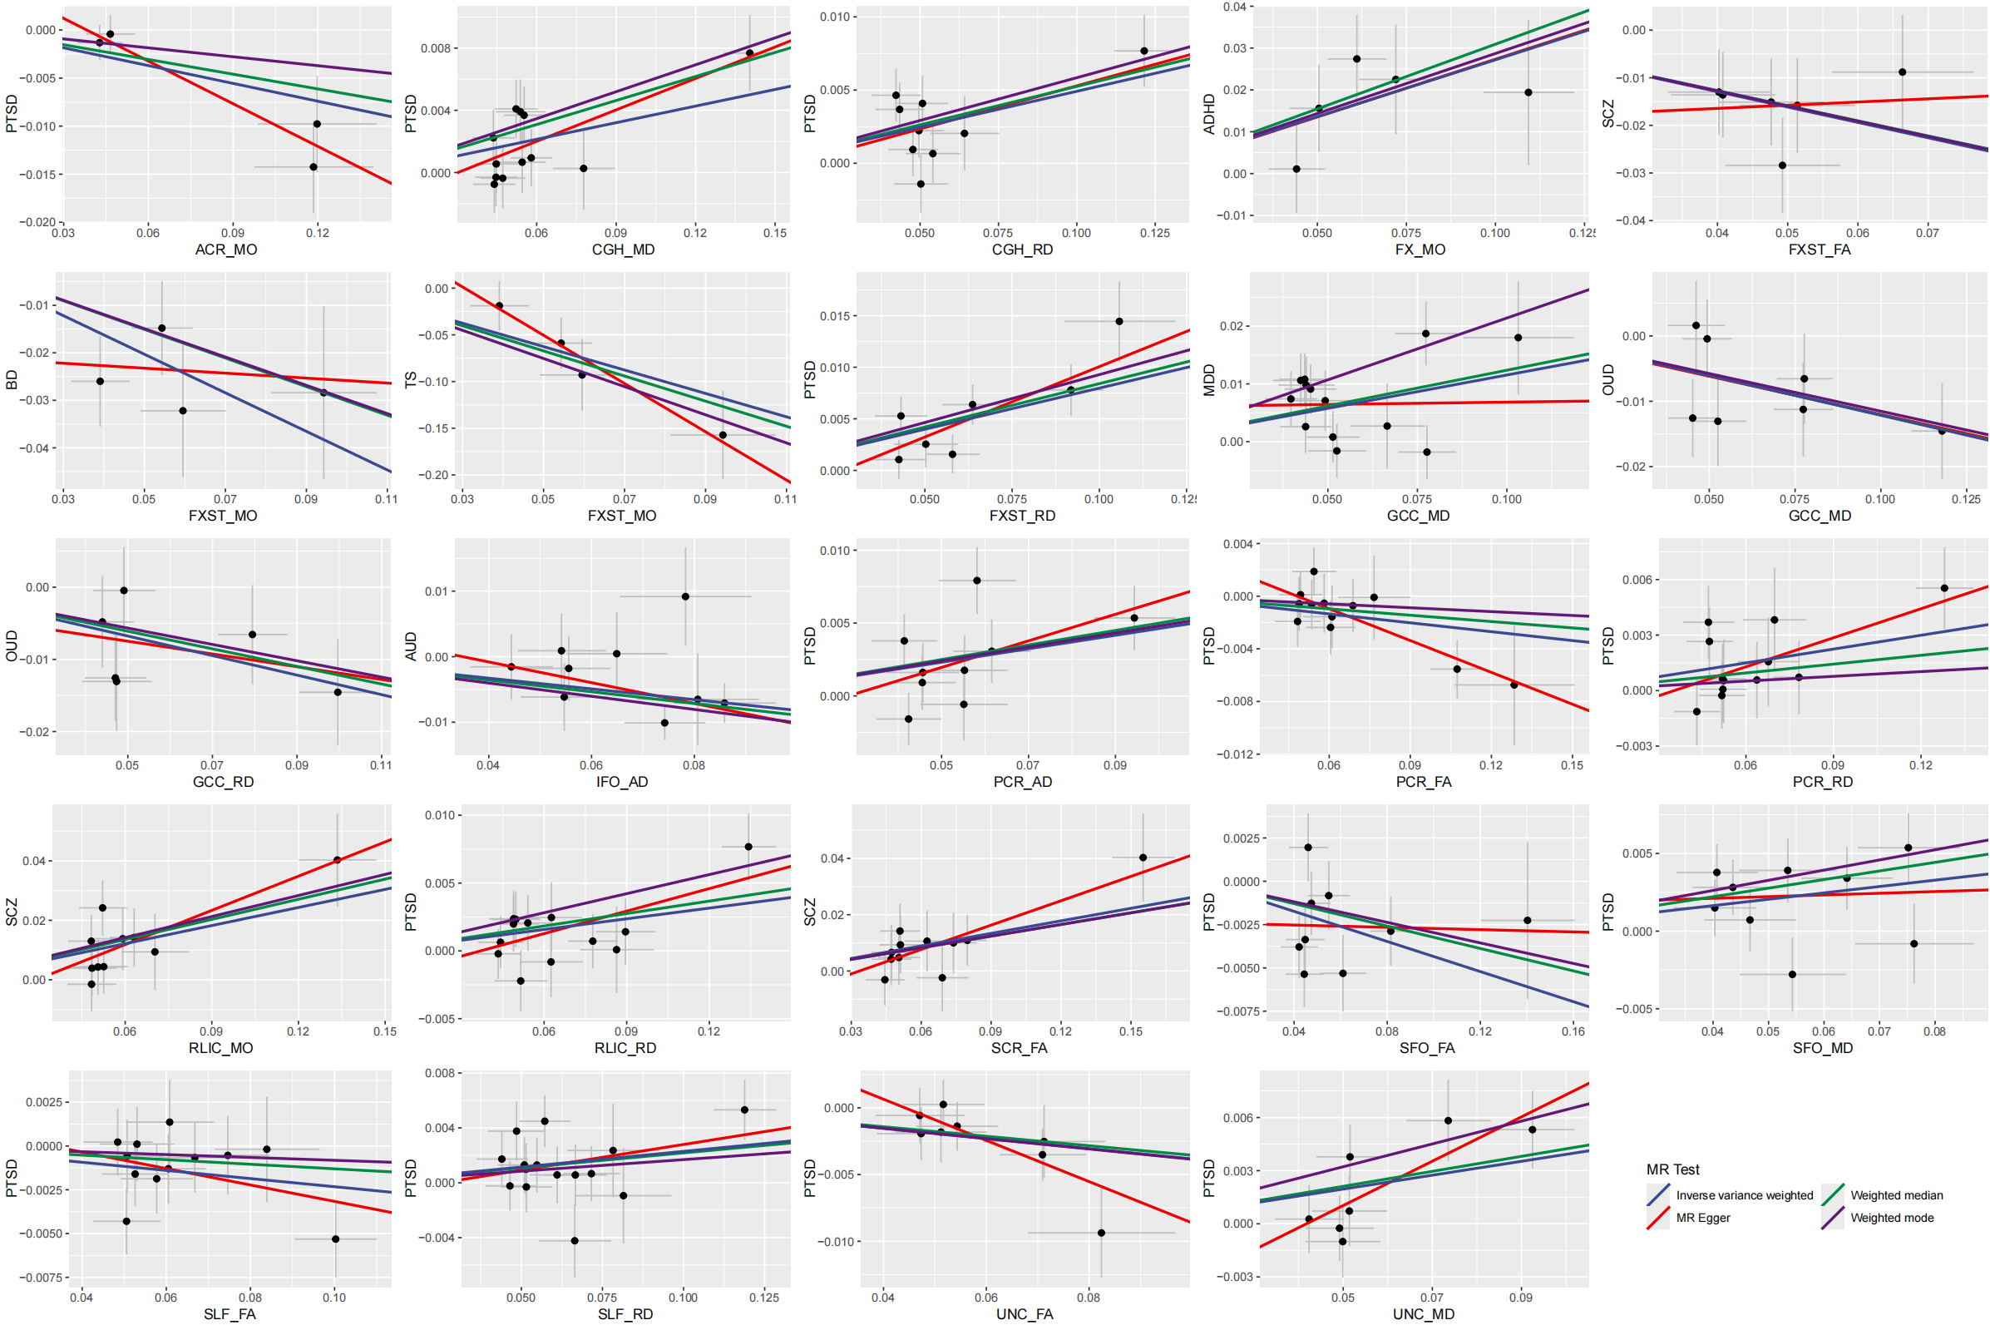

Fig. S25. Scatter plot

Table S1. The summary of the association between WMTs and psychiatric disorders
White matter tracts | Psychiatric  disorders | Parameters | Alteration | Patient | Control | Study design | Note and Reference
CC | ADHD | AD | ↑ | 50 | 50 | Sibling design, RCT | Unaffected siblings were in the intermediate position between those of the ADHD and control groups.  ²
CST | ADHD | AD | ↑ | 50 | 50 | Sibling design, RCT | Unaffected siblings were in the intermediate position between those of the ADHD and control groups.  ²
Perpendicular fasciculus | ADHD | AD | ↑ | 50 | 50 | Sibling design, RCT | Unaffected siblings were in the intermediate position between those of the ADHD and control groups.  ²
SLF | ADHD | AD | ↑ | 50 | 50 | Sibling design, RCT | Unaffected siblings were in the intermediate position between those of the ADHD and control groups.  ²
BCC | BD | AD | ↑ | 211 | 1506 | Case-control | ²⁶
FX | BD | AD | ↑ | 211 | 1506 | Case-control | ²⁶
PLIC | BD | AD | ↑ | 211 | 1506 | Case-control | ²⁶
FX | SCZ | AD | ↑ | 696 | 1506 | Case-control | ²⁶
PCR | SCZ | AD | ↑ | 696 | 1506 | Case-control | ²⁶
SCR | SCZ | AD | ↑ | 696 | 1506 | Case-control | ²⁶
UNC | SCZ | AD | ↑ | 696 | 1506 | Case-control | ²⁶
GCC | BD | AD | ↓ | 36 | 38 | Case-control | ²⁷
PLIC | BD | AD | ↓ | 36 | 38 | Case-control | ²⁷
SCR | BD | AD | ↓ | 36 | 38 | Case-control | ²⁷
BCC | ADHD | FA | ↑ | 278 in total | 278 in total | Meta  6 studies | ⁵
Fronto-straital tract | ADHD | FA | ↑ | 50 | 50 | Sibling design, RCT | Unaffected siblings were in the intermediate position between those of the ADHD and control groups.  ²
Precuneus | ADHD | FA | ↑ | 278 in total | 278 in total | Meta  6 studies | ⁵
SLF | ADHD | FA | ↑ | 278 in total | 278 in total | Meta  6 studies | ⁵
Cerebellum | ASD | FA | ↑ | 117 in total | 117 in total | Meta  6 studies | ⁵
CST | ASD | FA | ↑ | 117 in total | 117 in total | Meta  6 studies | ⁵
SLF | ASD | FA | ↑ | 278 in total | 278 in total | Meta  6 studies | ⁵
IFO | PTSD | FA | ↑ | 80 | 103 | Meta  3 studies | ²⁸
ALIC | SCZ | FA | ↑ | 1543 | 983 | Meta | SCZ vs BD  ²⁹
BCC | ADHD | FA | ↓ | - | - | Meta  17 studies | ³⁰
BCC | ADHD | FA | ↓ | 278 in total | 278 in total | Meta  6 studies | ⁵
CC | ADHD | FA | ↓ | 55 | 50 | Case-control | ⁷
Cerebellum | ADHD | FA | ↓ | - | - | Meta  8 studies | ³⁰
MCP | ADHD | FA | ↓ | - | - | Meta  8 studies | ³⁰
CG | ADHD | FA | ↓ | - | - | Meta  21 studies | ³⁰
CG | ADHD | FA | ↓ | 128 | 58 | Case-control | ³
Thalamus and the ATR | ADHD | FA | ↓ | - | - | Meta  32 studies | ³⁰
GCC | ADHD | FA | ↓ | 278 in total | 278 in total | Meta  6 studies | ⁵
IFO | ADHD | FA | ↓ | - | - | Meta  11 studies | ³⁰
ILF | ADHD | FA | ↓ | - | - | Meta  13 studies | ³⁰
ILF | ADHD | FA | ↓ | 128 | 58 | Case-control | Only abnormalities in the anterior portion of the left ILF distinguished probands with persisting versus desisting ADHD symptomatology, suggesting that abnormalities in the cingulum angular bundle might reflect "scarring" effects of childhood ADHD.  ³
ILF | ADHD | FA | ↓ | 951 | 4884 | Meta  5 cohorts | ³¹
ICP | ADHD | FA | ↓ | 16 | 20 | Case-control | ³²
PILC/CST | ADHD | FA | ↓ | - | - | Meta  15 studies | ³⁰
SCC | ADHD | FA | ↓ | - | - | Meta  17 studies | ³⁰
SCC | ADHD | FA | ↓ | 278 in total | 278 in total | Meta  6 studies | ⁵
SLF | ADHD | FA | ↓ | - | - | Meta  17 studies | ³⁰
UNF | ADHD | FA | ↓ | 951 | 4884 | Meta  5 cohorts | ³¹
BCC | ASD | FA | ↓ | 126 | 1506 | Case-control | ²⁶
BCC | ASD | FA | ↓ | 176 in total | 176 in total | Meta  6 studies | ⁵
BCC | ASD | FA | ↓ | 176 in total | 176 in total | Meta  6 studies | ⁵
BCC | ASD | FA | ↓ | 26 | 26 | Cross-sectional | ³³
CC | ASD | FA | ↓ | 69 | 50 | Case-control | ⁷
CG | ASD | FA | ↓ | 125 | 69 | Longitudinal cohort | ⁸
Cortico-basal ganglia tract | ASD | FA | ↓ | 49 | 96 | Case-control | ³⁴
Arcuate fasciculus/SLF | ASD | FA | ↓ | 596 | 587 | Meta  26 studies | Dorsal pathway: language-related.  ⁶⁶
Forceps major | ASD | FA | ↓ | 26 | 26 | Cross-sectional | ³³
Forceps minor | ASD | FA | ↓ | 26 | 26 | Cross-sectional | ³³
GCC | ASD | FA | ↓ | 278 in total | 278 in total | Meta  6 studies | ⁵
IC | ASD | FA | ↓ | 125 | 69 | Longitudinal cohort | ⁸
IFO | ASD | FA | ↓ | - | - | Meta  9 studies | ³⁵
IFOF | ASD | FA | ↓ | 26 | 26 | Cross-sectional | ³³
ILF | ASD | FA | ↓ | 278 in total | 278 in total | Meta  10 studies | ³⁵
SCC | ASD | FA | ↓ | 278 in total | 278 in total | Meta  6 studies | ⁵
SCC | ASD | FA | ↓ | 125 | 69 | Longitudinal cohort | ⁸
SLF | ASD | FA | ↓ | 26 | 26 | Cross-sectional | ³³
SLF | ASD | FA | ↓ | 125 | 69 | Longitudinal cohort | ⁸
SS | ASD | FA | ↓ | 125 | 69 | Longitudinal cohort | ⁸
Thalamus | ASD | FA | ↓ | 117 in total | 117 in total | Meta  6 studies | ⁵
UNC | ASD | FA | ↓ | 316 | 321 | Meta  12 studies | ³⁵
UNC | ASD | FA | ↓ | 125 | 69 | Case-control | ⁸
ACR | BD | FA | ↓ | 49 | 32 | Case-control | ³⁶
BCC | BD | FA | ↓ | 2054 | 2577 | Meta  57 studies | ³⁷
CC | BD | FA | ↓ | 1482 | 1551 | Meta  26 cohorts | ³⁸
CC | BD | FA | ↓ | 983 | 1612 | Case-control | ²⁹
CG | BD | FA | ↓ | 1482 | 1551 | Meta  26 cohorts | ³⁸
CGC | BD | FA | ↓ | 211 | 1506 | Case-control | ²⁶
CST | BD | FA | ↓ | 49 | 32 | Case-control | ³⁶
CST | BD | FA | ↓ | 36 | 38 | Case-control | ²⁷
Forceps major | BD | FA | ↓ | 136 | 136 | Case-control | ¹⁷
Forceps minor | BD | FA | ↓ | 136 | 136 | Case-control | ¹⁷
Fronto-orbito-polar tracts | BD | FA | ↓ | - | - | Meta  57 studies | This fiber is related to reward processing.  ³⁷
GCC | BD | FA | ↓ | 36 | 38 | Case-control | ²⁷
IFO | BD | FA | ↓ | 136 | 136 | Case-control | ¹⁷
ILF | BD | FA | ↓ | 136 | 136 | Case-control | ¹⁷
PCR | BD | FA | ↓ | 49 | 32 | Case-control | ³⁶
PLIC | BD | FA | ↓ | 49 | 32 | Case-control | ³⁶
SCC | BD | FA | ↓ | - | - | Meta  57 studies | ³⁷
SCC | BD | FA | ↓ | 36 | 38 | Case-control | ²⁷
SCR | BD | FA | ↓ | 49 | 32 | Case-control | ³⁶
SCR | BD | FA | ↓ | 36 | 38 | Case-control | ²⁷
SLF | BD | FA | ↓ | 2054 | 2577 | Case-control | ³⁷
SLF | BD | FA | ↓ | 136 | 136 | Case-control | ¹⁷
SLF | BD | FA | ↓ | 36 | 38 | Case-control | ²⁷
ATR | BD | FA | ↓ | 2054 | 2577 | Case-control | This fiber is related to reward processing.  ³⁷
Forceps minor | Depression | FA | ↓ | 4471 | 4182 | Case-control | ³⁹
TR | Depression | FA | ↓ | 4471 | 4182 | Case-control | ³⁹
ALIC | MDD | FA | ↓ | - | - | Meta  84 studies | ⁴⁰
BCC | MDD | FA | ↓ | - | - | Meta  84 studies | ⁴⁰
CG | MDD | FA | ↓ | - | - | Meta  84 studies | ⁴⁰
ACR | MDD | FA | ↓ | - | - | Meta  84 studies | ⁴⁰
SCR | MDD | FA | ↓ | - | - | Meta  84 studies | ⁴⁰
PCR | MDD | FA | ↓ | - | - | Meta  84 studies | ⁴⁰
GCC | MDD | FA | ↓ | - | - | Meta  84 studies | ⁴⁰
IFO | MDD | FA | ↓ | - | - | Meta  84 studies | ⁴⁰
ILF | MDD | FA | ↓ | - | - | Meta  84 studies | ⁴⁰
SCC | MDD | FA | ↓ | - | - | Meta  84 studies | ⁴⁰
SLF | MDD | FA | ↓ | 250 | 281 | Case-control | Acute MDD vs remitted MDD.  ⁴¹
ATR | MDD | FA | ↓ | - | - | Meta  84 studies | ⁴⁰
PTR | MDD | FA | ↓ | - | - | Meta  84 studies | ⁴⁰
UNC | MDD | FA | ↓ | - | - | Meta  84 studies | ⁴⁰
CG | PTSD | FA | ↓ | 322 | 335 | Meta  14 studies | ²⁸
CST | PTSD | FA | ↓ | 322 | 335 | Meta  14 studies | ²⁸
GCC | PTSD | FA | ↓ | 322 | 335 | Meta  14 studies | ²⁸
PCR | PTSD | FA | ↓ | 36 | 33 | Case-control | ⁴²
TAP | PTSD | FA | ↓ | 1377 | 1620 | Meta  28 cohorts | ⁴³
ACR | SCZ | FA | ↓ | 1377 | 1620 | Meta  28 cohorts | ⁴³
ACR | SCZ | FA | ↓ | 84 | 93 | Case-control | ⁴⁴
ATR | SCZ | FA | ↓ | 69369 | 236642 | Case-control | UKB samples and PRS analysis.  ⁴⁵
BCC | SCZ | FA | ↓ | 696 | 1506 | Case-control | ²⁶
BCC | SCZ | FA | ↓ | 84 | 93 | Case-control | ⁴⁴
Brainstem | SCZ | FA | ↓ | 39 | 30 | Case-control | Patient characteristic: never-treated first episode.  ⁴⁶
CC | SCZ | FA | ↓ | 696 | 1506 | Case-control | ²⁶
CC | SCZ | FA | ↓ | 1543 | 1612 | Case-control | ²⁹
CC | SCZ | FA | ↓ | 39 | 30 | Case-control | Patient characteristic: never-treated first episode.  ⁴⁶
CG | SCZ | FA | ↓ | 1543 | 983 | Case-control | The control was BD patients.  ²⁹
CG | SCZ | FA | ↓ | 39 | 30 | Case-control | Patient characteristic: never-treated first episode.  ⁴⁶
CGC | SCZ | FA | ↓ | 600 | 492 | Cross-sectional, from 13 different sites | Multiple illness stages analysis  Stable trajectory  ⁴⁷
CGH | SCZ | FA | ↓ | 600 | 492 | Cross-sectional, from 13 different sites | Multiple illness stages analysis  Stable trajectory  ⁴⁷
CGC | SCZ | FA | ↓ | 696 | 1506 | Case-control | ²⁶
EC | SCZ | FA | ↓ | 49 | 123 | Case-control | ⁴⁸
Forceps major | SCZ | FA | ↓ | 600 | 492 | Cross-sectional, from 13 different sites | Multiple illness stages analysis  Stable trajectory  ⁴⁷
Forceps minor | SCZ | FA | ↓ | 600 | 492 | Cross-sectional, from 13 different sites | Multiple illness stages analysis  Stable trajectory  ⁴⁷
Forceps minor | SCZ | FA | ↓ | 69369 | 236642 | Case-control | UKB samples and PRS analysis.  ⁴⁵
FX | SCZ | FA | ↓ | 696 | 1506 | Case-control | ²⁶
GCC | SCZ | FA | ↓ | 84 | 93 | Case-control | ⁴⁴
IC | SCZ | FA | ↓ | 39 | 30 | Case-control | Patient characteristic: never-treated first episode.  ⁴⁶
IFO | SCZ | FA | ↓ | 600 | 492 | Cross-sectional, from 13 different sites | Multiple illness stages analysis  Stable trajectory  ⁴⁷
ILF | SCZ | FA | ↓ | 600 | 492 | Cross-sectional, from 13 different sites | Multiple illness stages analysis  Stable trajectory  ⁴⁷
SCR | SCZ | FA | ↓ | 84 | 93 | Case-control | ⁴⁴
SLF | SCZ | FA | ↓ | 600 | 492 | Cross-sectional, from 13 different sites | Multiple illness stages analysis  Stable trajectory  ⁴⁷
STR | SCZ | FA | ↓ | 69369 | 236642 | Case-control | UKB samples and PRS analysis. ⁴⁵
UNC | SCZ | FA | ↓ | 600 | 492 | Cross-sectional, from 13 different sites | Multiple illness stages analysis  Stable trajectory  ⁴⁷
Whole brain | SCZ | FA | ↓ | 518 | 452 | Cross-sectional, 13 independent and international sites | ⁴⁹
UNC | ADHD | FA | - | - | - | Meta  13 studies | ³⁰
CC | BD | FA AD MD | - | - | - | Descriptive review  10 studies | ⁵⁰
IFO | ASD | MD | ↑ | 147 | 162 | Meta  6 studies | ³⁵
CC | ADHD | MD | ↑ | 55 | 50 | Case-control | ⁷
ALIC | ASD | MD | ↑ | 26 | 26 | Cross-sectional | ³³
ATR | ASD | MD | ↑ | 26 | 26 | Cross-sectional | ³³
BCC | ASD | MD | ↑ | 26 | 26 | Cross-sectional | ³³
CC | ASD | MD | ↑ | 69 | 50 |  | ⁷
Arcuate fasciculus/SLF | ASD | MD | ↑ | 245 | 242 | Meta  12 studies | ³⁵
Forceps major | ASD | MD | ↑ | 26 | 26 | Cross-sectional | ³³
Forceps minor | ASD | MD | ↑ | 26 | 26 | Cross-sectional | ³³
IFO | ASD | MD | ↑ | 26 | 26 | Cross-sectional | ³³
ILF | ASD | MD | ↑ | - | - | Meta  6 studies | ³⁵
ILF | ASD | MD | ↑ | 26 | 26 | Cross-sectional | ³³
PLIC | ASD | MD | ↑ | 26 | 26 | Cross-sectional | ³³
SCC | ASD | MD | ↑ | 26 | 26 | Cross-sectional | ³³
SLF | ASD | MD | ↑ | 26 | 26 | Cross-sectional | ³³
UNC | ASD | MD | ↑ | 164 | 179 | Meta  7 studies | ³⁵
UNC | ASD | MD | ↑ | 26 | 26 | Cross-sectional | ³³
BCC | BD | MD | ↑ | 211 | 1506 | Case-control | ²⁶
FX | BD | MD | ↑ | 211 | 1506 | Case-control | ²⁶
SLF | MDD | MD | ↑ | 250 | 281 | Case-control | Acute MDD vs remitted MDD.  ⁴¹
BCG | SCZ | MD | ↑ | 696 | 1506 | Case-control | ²⁶
CC | SCZ | MD | ↑ | 696 | 1506 | Case-control | ²⁶
CGC | SCZ | MD | ↑ | 69369 | 236642 | Case-control | UKB samples and PRS analysis.  ⁴⁵
Forceps minor | SCZ | MD | ↑ | 69369 | 236642 | Case-control | UKB samples and PRS analysis. ⁴⁵
FX | SCZ | MD | ↑ | 696 | 1506 | Case-control | ²⁶
UNC | SCZ | MD | ↑ | 696 | 1506 | Case-control | ²⁶
UNF | SCZ | MD | ↑ | 69369 | 236642 | Case-control | UKB samples and PRS analysis. ⁴⁵
TR | ADHD | MD | ↓ | 50 | 50 | Sibling design, RCT | Only showed significant difference in ADHD vs siblings.  ²
CC | ADHD | RD | ↑ | 55 | 50 | Case-control | ⁷
ALIC | ASD | RD | ↑ | 26 | 26 | Cross-sectional | ³³
ATR | ASD | RD | ↑ | 26 | 26 | Cross-sectional | ³³
BCC | ASD | RD | ↑ | 26 | 26 | Cross-sectional | ³³
CC | ASD | RD | ↑ | 69 | 50 | Case-control | ⁷
Forceps major | ASD | RD | ↑ | 26 | 26 | Cross-sectional | ³³
Forceps minor | ASD | RD | ↑ | 26 | 26 | Cross-sectional | ³³
IFO | ASD | RD | ↑ | 26 | 26 | Cross-sectional | ³³
ILF | ASD | RD | ↑ | 26 | 26 | Cross-sectional | ³³
SCC | ASD | RD | ↑ | 26 | 26 | Cross-sectional | ³³
SLF | ASD | RD | ↑ | 26 | 26 | Cross-sectional | ³³
UNC | ASD | RD | ↑ | 26 | 26 | Cross-sectional | ³³
CC | BD | RD | ↑ | 462 | 511 | Meta  15 studies | ³⁷
CST | BD | RD | ↑ | 36 | 38 | Case-control | ²⁷
EC | BD | RD | ↑ | 49 | 123 | Case-control | ⁴⁸
Fronto-orbito-polar tracts | BD | RD | ↑ | 462 | 511 | Case-control | ³⁷
GCC | BD | RD | ↑ | 36 | 38 | Case-control | ²⁷
SLF | BD | RD | ↑ | - | - | Meta  15 studies | ³⁷
ATR | BD | RD | ↑ | - | - | Meta  15 studies | ³⁷
SLF | MDD | RD | ↑ | 250 | 281 | Case-control | Acute MDD vs remitted MDD.  ⁴¹
Tapetum | PTSD | RD | ↑ | 1377 | 1620 | Meta  28 cohorts | ⁴³
ACR | SCZ | RD | ↑ | 696 | 1506 | Case-control | ²⁶
BCC | SCZ | RD | ↑ | 696 | 1506 | Case-control | ²⁶
CC | SCZ | RD | ↑ | 696 | 1506 | Case-control | ²⁶
CGC | SCZ | RD | ↑ | 696 | 1506 | Case-control | ²⁶
EC | SCZ | RD | ↑ | 49 | 123 | Case-control | ⁴⁸
FX | SCZ | RD | ↑ | 696 | 1506 | Case-control | ²⁶
UNC | SCZ | RD | ↑ | 696 | 1506 | Case-control | ²⁶
Fronto-striatal tract | ADHD | RD | ↓ | 50 | 50 | Sibling design, RCT | Only showed significant difference in ADHD vs siblings.  ²
TR | ADHD | RD | ↓ | 50 | 50 | Sibling design, RCT | Only showed significant difference in ADHD vs siblings.  ²
FX | BD | RD | ↓ | 211 | 1506 | Case-control | ²⁶
Abbreviations: AC: anterior commissure; ACR: anterior corona radiata; AD: axial diusivities; ALIC: anterior limb of internal capsule; ASD: Autism disorderTS: Tourette syndromeADHD: Attention deficit hyperactivity disorder; ATR: anterior thalamic radiation; AUD: alcohol use disorder; CUD: cannabis use disorderOUD: opioid use disorder; BCC: body of corpus callosum; CC: corpus callosum; CGC: cingulum connecting to cingulate gyrus; CGH: cingulum connecting to hippocampus; CP: cerebellar peduncle; CR: corona radiata; CST: corticospinal tract; EC: external capsule; FA: fractional anisotropy, white matter integrity; FX/ST: fornix and stria terminalis; FX: Fornix (column and body of fornix); GCC: genu of corpus callosum; IC: internal capsule; ICP: inferior cerebellar peduncle; IFO/ILF: inferior fronto-occipital fasciculus/inferior longitudinal fasciculus; IFO/UNC: inferior fronto-occipital fasciculus/uncinate fasciculus; ILF: inferior longitudinal fasciculus; MCP: medial cerebellar peduncle; MD: mean diusivities, cell damage; MDD: major depression; PTSD: post-traumatic stress disorder; ML: medial lemniscus; MLF: medial longitudinal fasciculus; MO: mode of anisotropy; PCR: posterior corona radiata; PLIC: posterior limb of internal capsule; PRS: polygenic risk score; PTR: posterior thalamic radiation (include optic radiation); PTR: Posterior thalamic radiation (include optic radiation); RCT: randomized controlled trail; RD: radial diusivities, myelin integrity; RLIC: retrolenticular part of internal capsule; SCC: splenium of corpus callosum; SCP: superior cerebellar peduncle; SCR: superior corona radiata; SCZ: schizophrenia; BD: bipolar disorder; PD: panic disorder; SFO: superior fronto-occipital fasciculus; SLF: superior longitudinal fasciculus; SS: Sagittal stratum; STR: superior thalamic radiation; TAP: tapetum TR: thalamic radiation; UKB: UK biobank; UNC: uncinate fasciculus.

Table S2. STROBE-MR checklist of recommended items to address in reports of Mendelian randomization studies ^{51,52}
Item No. | Section | Checklist item | Location addressed
1 | TITLE and ABSTRACT | Indicate Mendelian randomization (MR) as the study’s design in the title and/or the abstract if that is a main purpose of the study | Title and abstract.
INTRODUCTION
2 | Background | Explain the scientific background and rationale for the reported study. What is the exposure? Is a potential causal association between exposure and outcome plausible? Justify why MR is a helpful method to address the study question | Introduction.
3 | Objectives | State specific objectives clearly, including pre-specified causal hypotheses (if any). State that MR is a method that, under specific assumptions, intends to estimate causal effects | Introduction.
METHODS
4 | Study design and data sources | Present key elements of the study design early in the article. Consider including a table listing sources of data for all phases of the study. For each data source contributing to the analysis, describe the following: | - Introduction, Methods, Figure 1, Table S3 - S5.  - Methods, Table S3 - 4.  - Methods.  - Methods.  - Methods.
4 | a) | Setting: Describe the study design and the underlying population, if possible. Describe the setting, locations, and relevant dates, including periods of recruitment, exposure, follow-up, and data collection, when available.
4 | b) | Participants: Give the eligibility criteria, and the sources and methods of selection of participants. Report the sample size, and whether any power or sample size calculations were carried out prior to the main analysis
4 | c) | Describe measurement, quality control and selection of genetic variants
4 | d) | For each exposure, outcome, and other relevant variables, describe methods of assessment and diagnostic criteria for diseases
4 | e) | Provide details of ethics committee approval and participant informed consent, if relevant
5 | Assumptions | Explicitly state the three core IV assumptions for the main analysis (relevance, independence and exclusion restriction) as well assumptions for any additional or sensitivity analysis | Figure 1, Methods.
6 | Statistical methods: main analysis | Describe statistical methods and statistics used | - Introduction, Methods, Figure 1, Table S 3 - 4.  - Methods, Table S3 - 4.  - Methods.  - Methods.  - Methods.
6 | a) | Describe how quantitative variables were handled in the analyses (i.e., scale, units, model)
6 | b) | Describe how genetic variants were handled in the analyses and, if applicable, how their weights were selected
6 | c) | Describe the MR estimator (e.g. two-stage least squares, Wald ratio) and related statistics. Detail the included covariates and, in case of two-sample MR, whether the same covariate set was used for adjustment in the two samples
6 | d) | Explain how missing data were addressed
6 | e) | If applicable, indicate how multiple testing was addressed
7 | Assessment of assumptions | Describe any methods or prior knowledge used to assess the assumptions or justify their validity | Methods, Figure 1.
8 | Sensitivity analyses and additional analyses | Describe any sensitivity analyses or additional analyses performed (e.g. comparison of effect estimates from different approaches, independent replication, bias analytic techniques, validation of instruments, simulations) | Methods, Figure 1.
9 | Software and pre-registration |  | - Methods.  - The research protocol and information are not registered.
9 | a) | Name statistical software and package(s), including version and settings used
9 | b) | State whether the study protocol and details were pre-registered (as well as when and where)
RESULTS
10 | Descriptive data |  | - Not applicable, since, in this study, we used genome-wide summary statistics from previously published genome-wide association studies.  - Results, Methods, eResults, Table S3 - 4.  - Not applicable, since, in this study, we used genome-wide summary statistics from previously published genome-wide association studies.  - Results, eResults, Table S 5-6.
10 | a) | Report the numbers of individuals at each stage of included studies and reasons for exclusion. Consider use of a flow diagram
10 | b) | Report summary statistics for phenotypic exposure(s), outcome(s), and other relevant variables (e.g. means, SDs, proportions)
10 | c) | If the data sources include meta-analyses of previous studies, provide the assessments of heterogeneity across these studies
10 | d) | For two-sample MR:  i. Provide justification of the similarity of the genetic variant-exposure associations between the exposure and outcome samples  ii. Provide information on the number of individuals who overlap between the exposure and outcome studies
11 | Main results |  | - Not applicable, since in this study we used genome-wide summary statistics from previously published genome-wide association studies. No individual level data available.  - Results, eResults, Table S4 - 5.  - Not applicable.  - Figures 2 - 3 and Figures S1 - S25.
11 | a) | Report the associations between genetic variant and exposure, and between genetic variant and outcome, preferably on an interpretable scale
11 | b) | Report MR estimates of the association between exposure and outcome, and the measures of uncertainty from the MR analysis, on an interpretable scale, such as odds ratio or relative risk per SD difference
11 | c) | If relevant, consider translating estimates of relative risk into absolute risk for a meaningful time period
11 | d) | Consider plots to visualize results (e.g. forest plot, scatterplot of associations between genetic variants and outcome versus between genetic variants and exposure)
12 | Assessment of assumptions |  | - Methods.  - Results, Table S15 - 16.
12 | a) | Report the assessment of the validity of the assumptions | - Methods.  - Results, Table S15 - 16.
12 | b) | Report any additional statistics (e.g., assessments of heterogeneity across genetic variants, such as I², Q statistic or E-value) | - Methods.  - Results, Table S15 - 16.
13 | Sensitivity analyses and additional analyses |  | - Results, Table S 15 - 22.  - Results, Table S 15 - 22.  - Results, Table S 15 - 22.  - Introduction, Results, Discussion, Table S1.  - Figures 2 - 4 and Figures S1 - S25.
13 | a) | Report any sensitivity analyses to assess the robustness of the main results to violations of the assumptions
13 | b) | Report results from other sensitivity analyses or additional analyses
13 | c) | Report any assessment of direction of causal association (e.g., bidirectional MR)
13 | d) | When relevant, report and compare with estimates from non-MR analyses
13 | e) | Consider additional plots to visualize results (e.g., leave-one-out analyses)
DISCUSSION
14 | Key results | Summarize key results with reference to study objectives | Discussion.
15 | Limitations | Discuss limitations of the study, taking into account the validity of the IV assumptions, other sources of potential bias, and imprecision. Discuss both direction and magnitude of any potential bias and any efforts to address them | Methods, Discussion.
16 | Interpretation |  | - Discussion.  - Discussion, Table S22.  - Abstract, Introduction, Discussion.
16 | a) | Meaning: Give a cautious overall interpretation of results in the context of their limitations and in comparison with other studies
16 | b) | Mechanism: Discuss underlying biological mechanisms that could drive a potential causal association between the investigated exposure and the outcome, and whether the gene-environment equivalence assumption is reasonable. Use causal language carefully, clarifying that IV estimates may provide causal effects only under certain assumptions
16 | c) | Clinical relevance: Discuss whether the results have clinical or public policy relevance, and to what extent they inform effect sizes of possible interventions
17 | Generalizability | Discuss the generalizability of the study results (a) to other populations, (b) across other exposure periods/timings, and (c) across other levels of exposure | - Discussion.  - Discussion.  - Not applicable.
OTHER INFORMATION
18 | Funding | Describe sources of funding and the role of funders in the present study and, if applicable, sources of funding for the databases and original study or studies on which the present study is based | Fundings.
19 | Data and data sharing | Provide the data used to perform all analyses or report where and how the data can be accessed, and reference these sources in the article. Provide the statistical code needed to reproduce the results in the article, or report whether the code is publicly accessible and if so, where | Methods, Table S3 - S13, Reference, Supplementary Materials and R codes.
20 | Conflicts of Interest | All authors should declare all potential conflicts of interest | The authors declare that there is no conflict of interest.
This checklist is copyrighted by the Equator Network under the Creative Commons Attribution 3.0 Unported (CC BY 3.0) license.

References
1. Yang, A., et al. Longer screen time utilization is associated with the polygenic risk for Attention-deficit/hyperactivity disorder with mediation by brain white matter microstructure. EBioMedicine 80, 104039 (2022).
2. Chiang, H.L., Hsu, Y.C., Shang, C.Y., Tseng, W.I. & Gau, S.S. White matter endophenotype candidates for ADHD: a diffusion imaging tractography study with sibling design. Psychol Med 50, 1203-1213 (2020).
3. Versace, A., et al. White matter abnormalities associated with ADHD outcomes in adulthood. Mol Psychiatry 26, 6655-6665 (2021).
4. Dziemian, S., Barańczuk-Turska, Z. & Langer, N. Association between attention-deficit/hyperactivity disorder symptom severity and white matter integrity moderated by in-scanner head motion. Transl Psychiatry 12, 434 (2022).
5. Zhang, K., et al. The shared white matter developmental trajectory anomalies of attention-deficit/hyperactivity disorder and autism spectrum disorders: A meta-analysis of diffusion tensor imaging studies. Prog Neuropsychopharmacol Biol Psychiatry 124, 110731 (2023).
6. Damatac, C.G., et al. White Matter Microstructure in Attention-Deficit/Hyperactivity Disorder: A Systematic Tractography Study in 654 Individuals. Biol Psychiatry Cogn Neurosci Neuroimaging 7, 979-988 (2022).
7. Aoki, Y., et al. Association of White Matter Structure With Autism Spectrum Disorder and Attention-Deficit/Hyperactivity Disorder. JAMA Psychiatry 74, 1120-1128 (2017).
8. Andrews, D.S., et al. A Longitudinal Study of White Matter Development in Relation to Changes in Autism Severity Across Early Childhood. Biol Psychiatry 89, 424-432 (2021).
9. Hegarty, J.P., 2nd, et al. A Twin Study of Altered White Matter Heritability in Youth With Autism Spectrum Disorder. J Am Acad Child Adolesc Psychiatry 63, 65-79 (2024).
10. Tura, A. & Goya-Maldonado, R. Brain connectivity in major depressive disorder: a precision component of treatment modalities? Transl Psychiatry 13, 196 (2023).
11. Ping, L., et al. Tryptophan hydroxylase-2 polymorphism is associated with white matter integrity in first-episode, medication-naïve major depressive disorder patients. Psychiatry Res Neuroimaging 286, 4-10 (2019).
12. Flinkenflügel, K., et al. Negative Stressful Life Events and Social Support Are Associated With White Matter Integrity in Depressed Patients and Healthy Control Participants: A Diffusion Tensor Imaging Study. Biol Psychiatry 94, 650-660 (2023).
13. Hu, C., et al. Microstructural abnormalities of white matter in the cingulum bundle of adolescents with major depression and non-suicidal self-injury. Psychol Med 54, 1113-1121 (2024).
14. Wang, L., et al. Associations between the kynurenine pathway and the brain in patients with major depressive disorder-A systematic review of neuroimaging studies. Prog Neuropsychopharmacol Biol Psychiatry 121, 110675 (2023).
15. Comai, S., et al. Selective association of cytokine levels and kynurenine/tryptophan ratio with alterations in white matter microstructure in bipolar but not in unipolar depression. Eur Neuropsychopharmacol 55, 96-109 (2022).
16. Delvecchio, G., Pigoni, A., Bauer, I.E., Soares, J.C. & Brambilla, P. Disease-discordant twin structural MRI studies on affective disorders. Neurosci Biobehav Rev 108, 459-471 (2020).
17. Thiel, K., et al. Reduced fractional anisotropy in bipolar disorder v. major depressive disorder independent of current symptoms. Psychol Med 53, 4592-4602 (2023).
18. Thiel, K., et al. White and gray matter alterations in bipolar I and bipolar II disorder subtypes compared with healthy controls - exploring associations with disease course and polygenic risk. Neuropsychopharmacology 49, 814-823 (2024).
19. Caruana, G.F., Carruthers, S.P., Berk, M., Rossell, S.L. & Van Rheenen, T.E. To what extent does white matter map to cognition in bipolar disorder? A systematic review of the evidence. Prog Neuropsychopharmacol Biol Psychiatry 128, 110868 (2024).
20. Stein, F., et al. Brain Structural Network Connectivity of Formal Thought Disorder Dimensions in Affective and Psychotic Disorders. Biol Psychiatry 95, 629-638 (2024).
21. Seitz-Holland, J., et al. Shared and distinct white matter abnormalities in adolescent-onset schizophrenia and adolescent-onset psychotic bipolar disorder. Psychol Med 53, 4707-4719 (2023).
22. Aronica, R., Enrico, P., Squarcina, L., Brambilla, P. & Delvecchio, G. Association between Diffusion Tensor Imaging, inflammation and immunological alterations in unipolar and bipolar depression: A review. Neurosci Biobehav Rev 143, 104922 (2022).
23. Goldwaser, E.L., et al. White matter in prolonged glucocorticoid response to psychological stress in schizophrenia. Neuropsychopharmacology 46, 2312-2319 (2021).
24. Wong, S.A., et al. Internal capsule microstructure mediates the relationship between childhood maltreatment and PTSD following adulthood trauma exposure. Mol Psychiatry 28, 5140-5149 (2023).
25. Zhang, F., et al. Genetic evidence suggests posttraumatic stress disorder as a subtype of major depressive disorder. J Clin Invest 132(2022).
26. Koshiyama, D., et al. White matter microstructural alterations across four major psychiatric disorders: mega-analysis study in 2937 individuals. Mol Psychiatry 25, 883-895 (2020).
27. Linke, J.O., et al. White Matter Microstructure in Pediatric Bipolar Disorder and Disruptive Mood Dysregulation Disorder. J Am Acad Child Adolesc Psychiatry 59, 1135-1145 (2020).
28. Ju, Y., et al. White matter microstructural alterations in posttraumatic stress disorder: An ROI and whole-brain based meta-analysis. J Affect Disord 266, 655-670 (2020).
29. Zhao, G., et al. A Comparative Multimodal Meta-analysis of Anisotropy and Volume Abnormalities in White Matter in People Suffering From Bipolar Disorder or Schizophrenia. Schizophr Bull 48, 69-79 (2022).
30. Parlatini, V., et al. White matter alterations in Attention-Deficit/Hyperactivity Disorder (ADHD): a systematic review of 129 diffusion imaging studies with meta-analysis. Mol Psychiatry 28, 4098-4123 (2023).
31. Sudre, G., et al. A Mega-analytic Study of White Matter Microstructural Differences Across 5 Cohorts of Youths With Attention-Deficit/Hyperactivity Disorder. Biol Psychiatry 94, 18-28 (2023).
32. Nagel, B.J., et al. Altered white matter microstructure in children with attention-deficit/hyperactivity disorder. J Am Acad Child Adolesc Psychiatry 50, 283-292 (2011).
33. Andica, C., et al. Neurite orientation dispersion and density imaging reveals white matter microstructural alterations in adults with autism. Mol Autism 12, 48 (2021).
34. Wilkes, B.J., et al. Cortico-basal ganglia white matter microstructure is linked to restricted repetitive behavior in autism spectrum disorder. Mol Autism 15, 6 (2024).
35. Li, M., Wang, Y., Tachibana, M., Rahman, S. & Kagitani-Shimono, K. Atypical structural connectivity of language networks in autism spectrum disorder: A meta-analysis of diffusion tensor imaging studies. Autism Res 15, 1585-1602 (2022).
36. Jiang, X., et al. Association of polygenic risk for bipolar disorder with grey matter structure and white matter integrity in youth. Transl Psychiatry 13, 322 (2023).
37. Hu, R., Stavish, C., Leibenluft, E. & Linke, J.O. White Matter Microstructure in Individuals With and At Risk for Bipolar Disorder: Evidence for an Endophenotype From a Voxel-Based Meta-analysis. Biol Psychiatry Cogn Neurosci Neuroimaging 5, 1104-1113 (2020).
38. Favre, P., et al. Widespread white matter microstructural abnormalities in bipolar disorder: evidence from mega- and meta-analyses across 3033 individuals. Neuropsychopharmacology 44, 2285-2293 (2019).
39. Nothdurfter, D., Jawinski, P. & Markett, S. White Matter Tract Integrity Is Reduced in Depression and in Individuals With Genetic Liability to Depression. Biol Psychiatry 95, 1063-1071 (2024).
40. Luttenbacher, I., et al. Transdiagnostic role of glutamate and white matter damage in neuropsychiatric disorders: A Systematic Review. J Psychiatr Res 147, 324-348 (2022).
41. Meinert, S., et al. White matter fiber microstructure is associated with prior hospitalizations rather than acute symptomatology in major depressive disorder. Psychol Med 52, 1166-1174 (2022).
42. Korgaonkar, M.S., et al. White matter anisotropy and response to cognitive behavior therapy for posttraumatic stress disorder. Transl Psychiatry 11, 14 (2021).
43. Dennis, E.L., et al. Altered white matter microstructural organization in posttraumatic stress disorder across 3047 adults: results from the PGC-ENIGMA PTSD consortium. Mol Psychiatry 26, 4315-4330 (2021).
44. Su, W., et al. Effects of polygenic risk of schizophrenia on interhemispheric callosal white matter integrity and frontotemporal functional connectivity in first-episode schizophrenia. Psychol Med 53, 2868-2877 (2023).
45. Stauffer, E.M., et al. Grey and white matter microstructure is associated with polygenic risk for schizophrenia. Mol Psychiatry 26, 7709-7718 (2021).
46. Yang, M., Gao, S. & Zhang, X. Cognitive deficits and white matter abnormalities in never-treated first-episode schizophrenia. Transl Psychiatry 10, 368 (2020).
47. Cetin-Karayumak, S., et al. White matter abnormalities across the lifespan of schizophrenia: a harmonized multi-site diffusion MRI study. Mol Psychiatry 25, 3208-3219 (2020).
48. Joo, S.W., et al. Shared and distinct white matter abnormalities in schizophrenia and bipolar disorder. Prog Neuropsychopharmacol Biol Psychiatry 108, 110175 (2021).
49. Seitz-Holland, J., et al. Cognitive deficits, clinical variables, and white matter microstructure in schizophrenia: a multisite harmonization study. Mol Psychiatry 27, 3719-3730 (2022).
50. Videtta, G., et al. White matter modifications of corpus callosum in bipolar disorder: A DTI tractography review. J Affect Disord 338, 220-227 (2023).
51. Burgess, S., et al. Guidelines for performing Mendelian randomization investigations: update for summer 2023. Wellcome Open Res 4, 186 (2019).
52. Skrivankova, V.W., et al. Strengthening the Reporting of Observational Studies in Epidemiology Using Mendelian Randomization: The STROBE-MR Statement. Jama 326, 1614-1621 (2021).

Legends for tables S3 to S25
Table S3. GWAS summary-level data of white matter microstructures.
Table S4. GWAS summary-level data of psychiatric disorders.
Table S5. IVs in forward MR (before confounder selection)
Table S6. IVs in reverse MR.
Table S7. IVs associated gwas traits in opengwas in forward MR
Table S8. IVs associated gwas traits in opengwas in reverse MR
Table S9. Confounders' selection of IVs
Table S10. IVs in forward MR without confounders
Table S11. Outliers detected by MR-PRESSO in forward MR analyses.
Table S12. Outliers detected by MR-PRESSO in reverse MR analyses.
Table S13. Information of IVs for all exposure-outcome pairs in forward MR analyses.
Table S14. Information of IVs for all exposure-outcome pairs in reverse MR analyses.
Table S15. Forward MR analysis results.
Table S16. Rreverse MR analysis results.
Table S17. Forward MR analysis results (before confounder fixing).
Table S18. Comparing the IVW results before and after confounder filtering.
Table S19. Comparing the IVW results before and after outlier filtering.
Table S20. Significant forward and reverse MR results after adjusting and pleiotropy tests
Table S21. Multiple comparison of significant MR results.
Table S22. The summary and interpretation of significant MR results.
Table S23. MVMR analysis results.
Table S24. Replication MR of BD, AUD, SCZ and ADHD in FinnGen R11
Table S25. Significant MR results both in GWAS summary-level data(FDR_P < 5e-2) and replication data (P < 5e-2)

