Supplementary Information

Energy-efficient artificial pyramidal neuron dendrites for visual information inference

Rui Wang^{1,2}†, Guolei Liu¹†, Saisai Wang³†, Xiaotao Jing², Jing Sun², Dingwei Li¹, Min Qiu^{1,3}, Hong Wang^{2*}, Bowen Zhu^{1,3,4*}

†Those authors contributed equally to this work.
¹Key Laboratory of 3D Micro/Nano Fabrication and Characterization of Zhejiang Province, School of Engineering, Westlake University, Hangzhou 310024, China.
²State Key Laboratory of Wide Band Gap Semiconductor Devices and Integrated Technology, School of Microelectronics, Xidian University, Xi'an, 710071 China.
³Westlake Institute for Optoelectronics, Hangzhou 311421, China.
⁴Institute of Advanced Technology, Westlake Institute for Advanced Study, Hangzhou 310024, China
*Corresponding author.

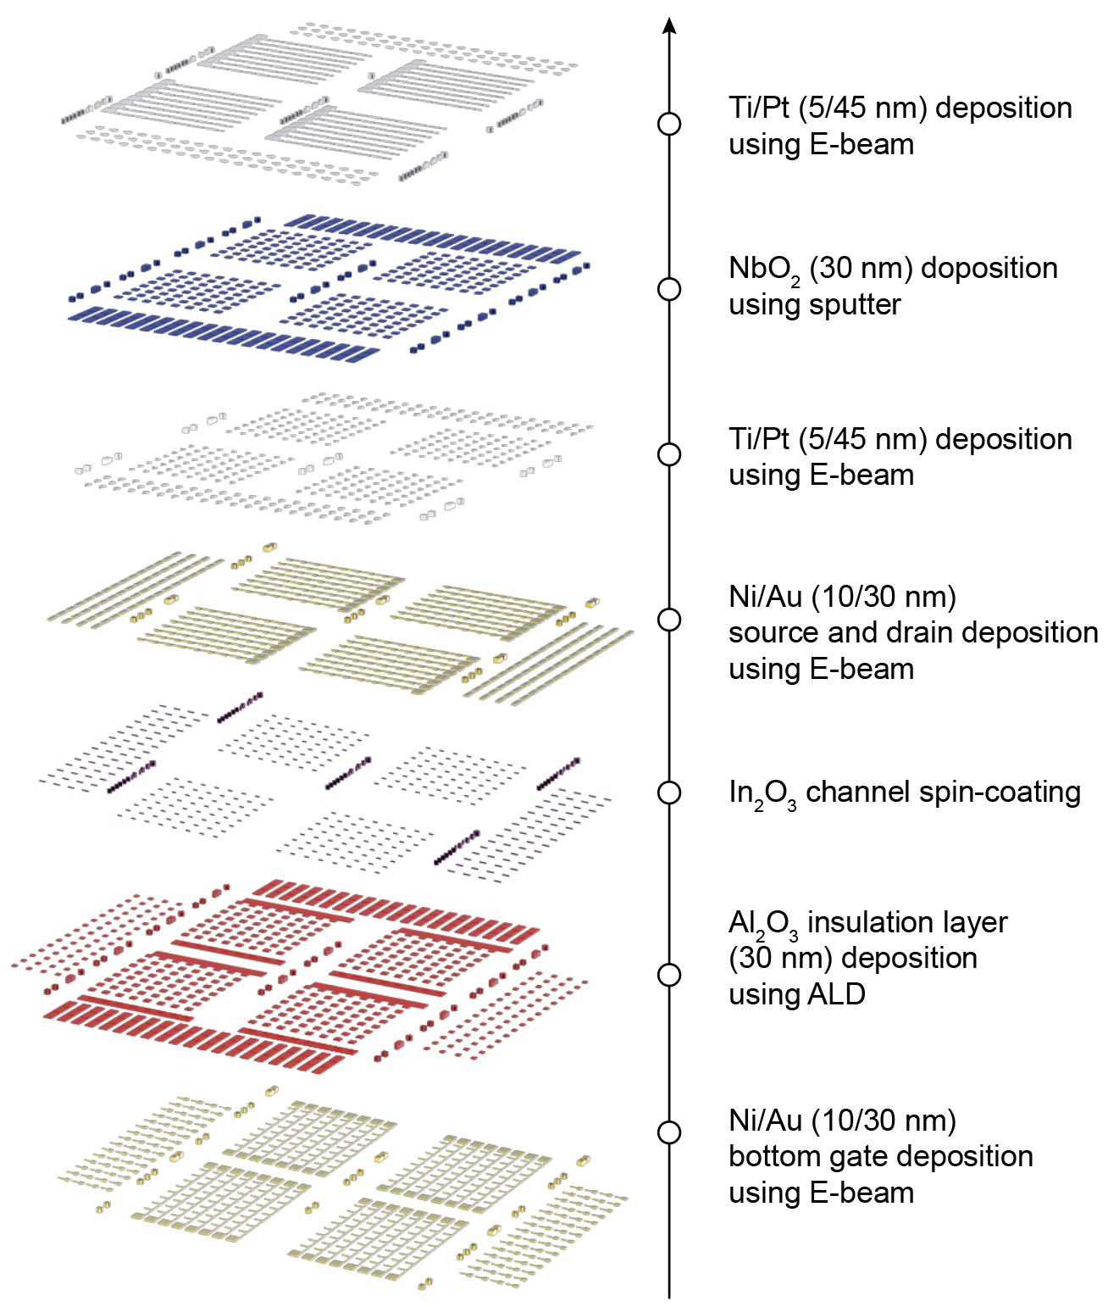
Figure S1. The layer structure of artificial pyramidal neuron dendrite arrays.

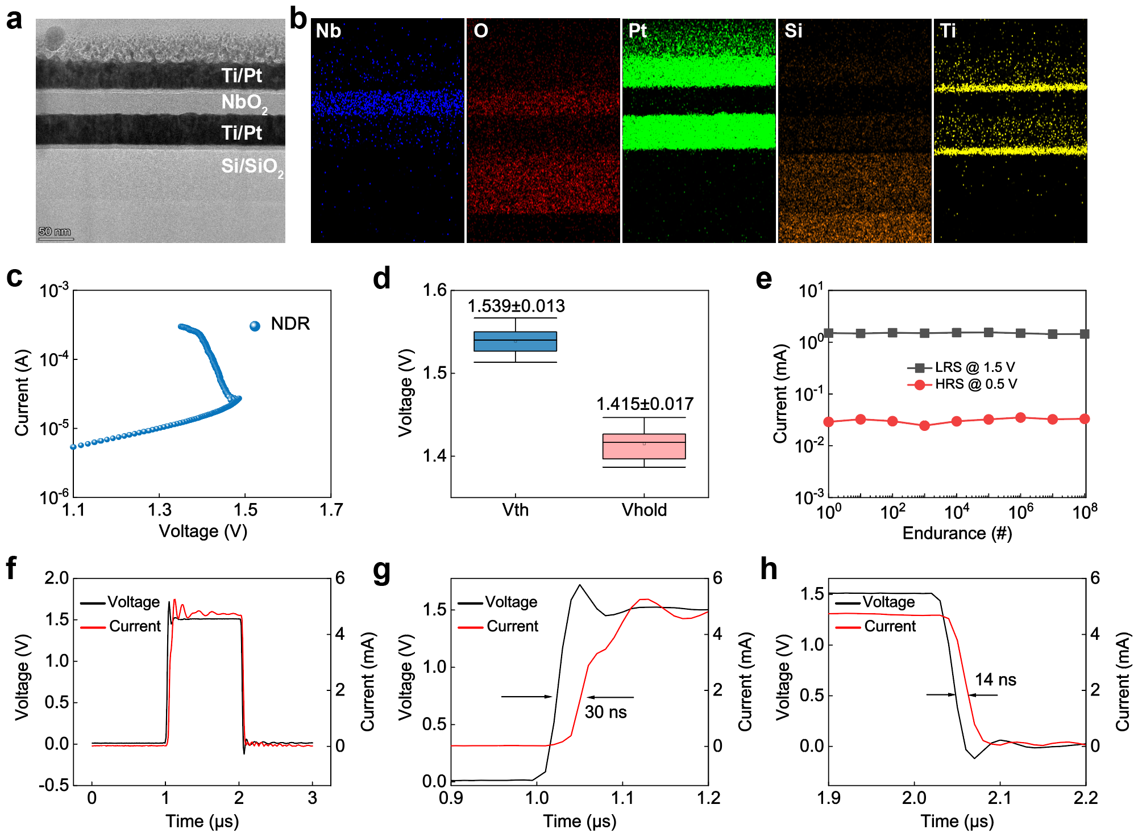
Figure S2. Characteristics of the NbO₂ pyramidal neuron device. a Cross-sectional TEM image of the NbO₂ neuron device. b EDS mapping of Nb, O, Pt, Si, and Ti elements in the device. c NDR behavior of the NbO₂ neuron device in current-sweeping mode. d Cycle-to-cycle distribution of V_{th} and V_{hold} during 600 cycles. e Endurance of the NbO₂ device over 10⁸ cycles. f Real-time switching response triggered by an input pulse. g Response time from off- to on-state is 30 ns. h Response time from on- to off-state is 14 ns.

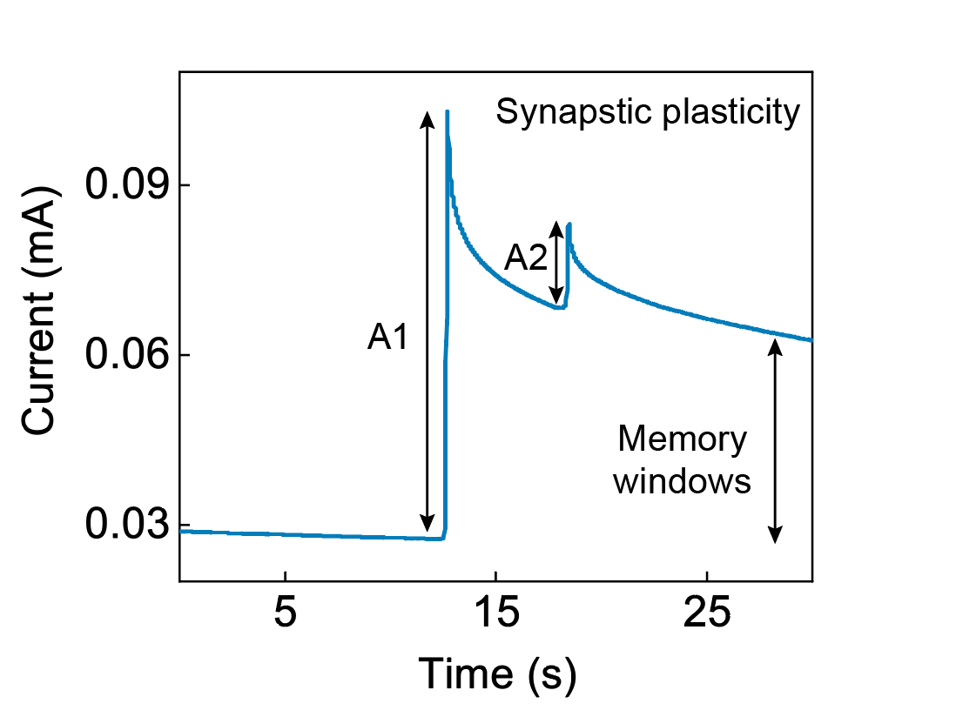
Figure S3. Synaptic current of the In₂O₃ transistor triggered by optical pulses ($λ$=365nm).

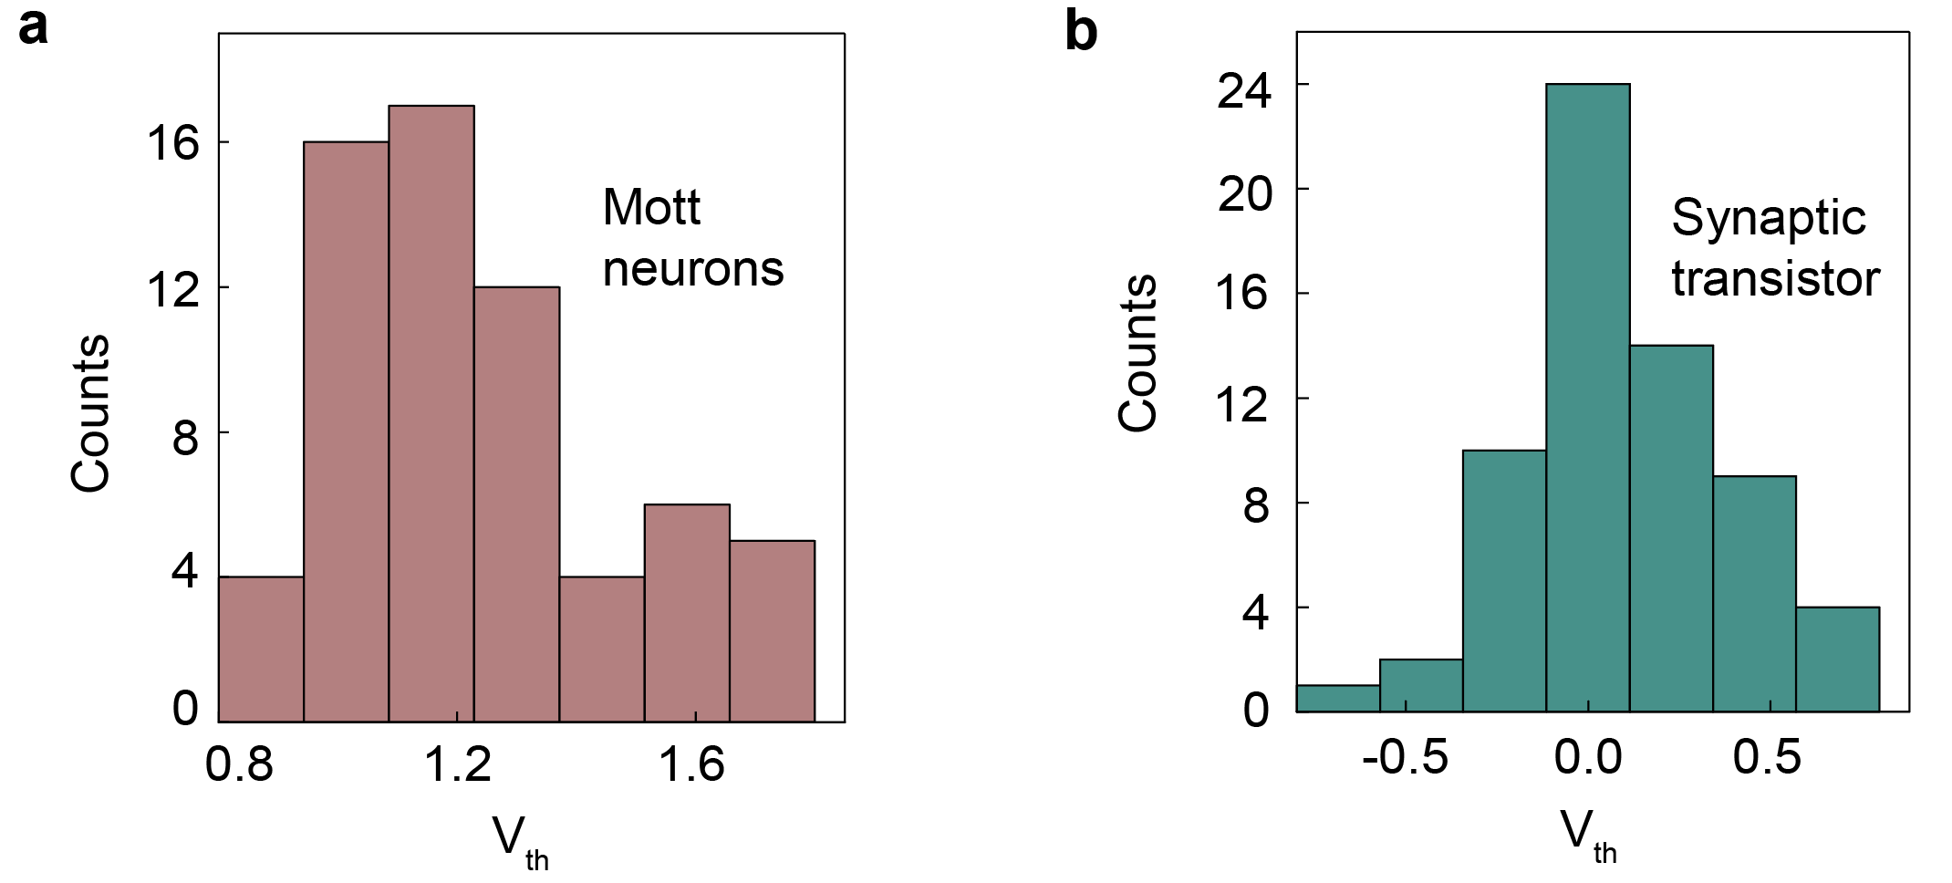
Figure S4. (a-b) The V_{th} distribution of NbO₂ and In₂O₃ devices in the array, respectively. All 64 devices demonstrate robust performance, achieving a yield rate of 100%.

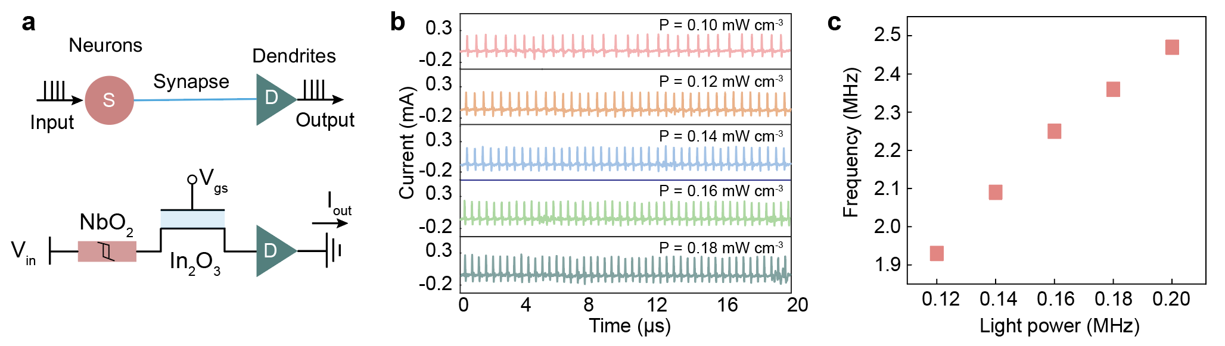
Figure S5. a Illustration of a single dendrite for spike generation. b Dendritic spikes as a function of light power density (0.10 to 0.18 mW/cm²). The dendritic spikes are output as currents over a recording duration of 20 μs. c Spiking frequency as a function of light power.

Supplementary Fig. 5a depicts a schematic diagram of a single dendrite with one pyramidal neuron and synapse connected to a single dendritic branch. Supplementary Fig. 5b illustrates the single dendritic outputs at different light power densities. As the light power varies from 0.10 to 0.18 mW/cm², the spike frequency increases from 1.9 to 2.5 MHz (Supplementary Fig. 5c). Since only one pyramidal neuron is connected, the dendrite primarily filters the spike signal.

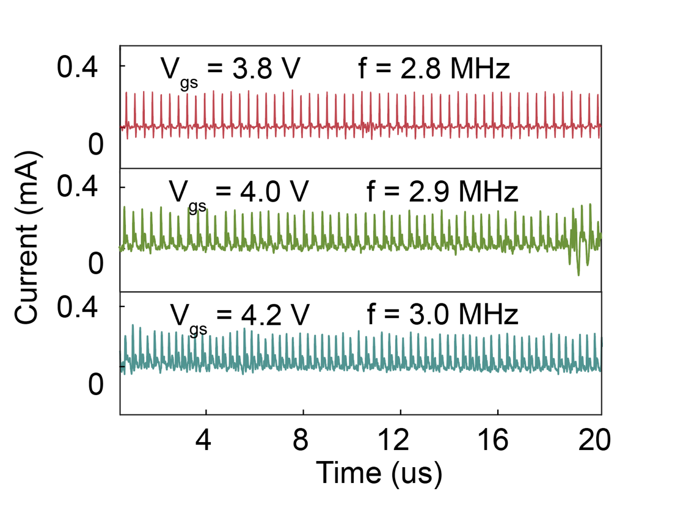
Figure S6. Adjusting the spike frequency by V_{gs} (3.8 V, 4.0 V, and 4.2 V) with the light stimulli (365 nm, 0.14 mW/cm²) under V_{ds} of 2 V.

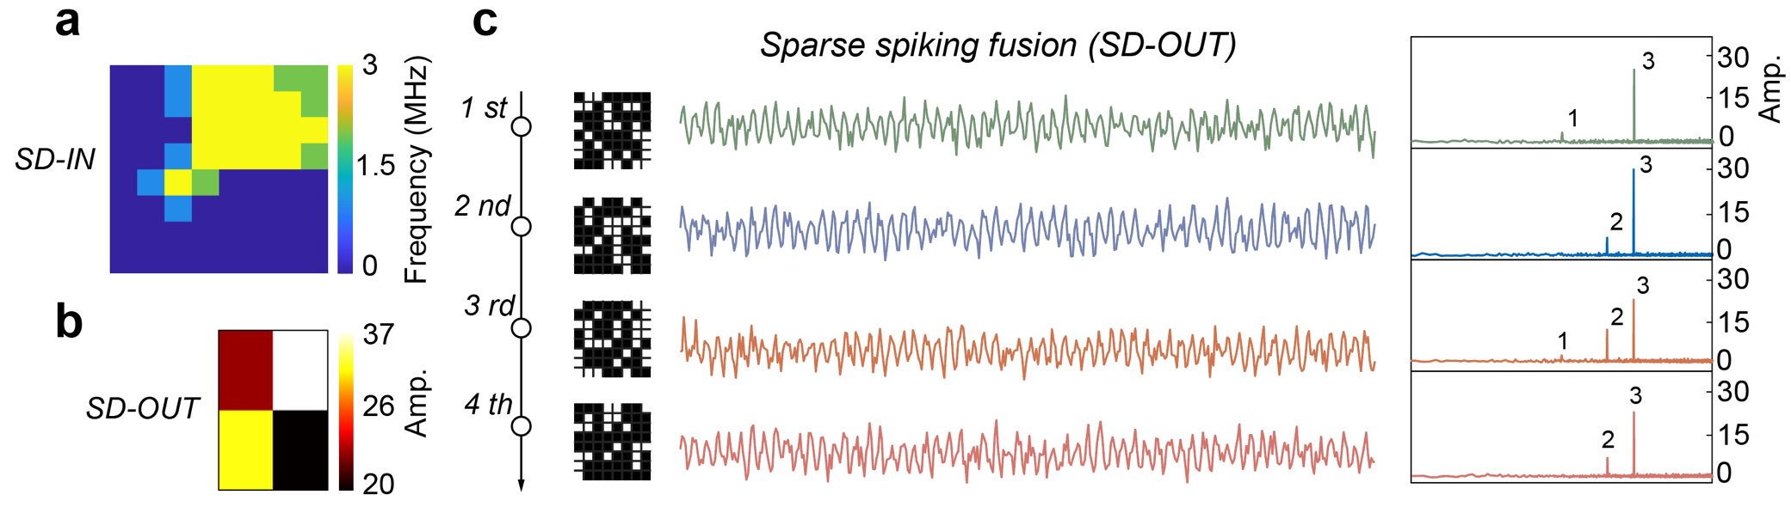
Figure S7. APND-based FMC parallel spiking computation with tunable sparse neural activity. a The 8×8 optical pattern mapped to spike frequency. b The sparse dendritic outputs. c Sprase dendritic outputs (SD-OUTs) from different neural activities. Black indicates inhibitory neural activities, while white represents excitatory neural activities. Using FMC, the amplitude spectrum can clearly decode the frequencies of active neurons. Dendrites can compress the neural activity from 64 channels into a single channel for integration and firing. The low-dimensional output from the dendrite (resulting from compression) can be used for further image recognition and reconstruction. The dendrites experimentally compress the data to 6.25%.

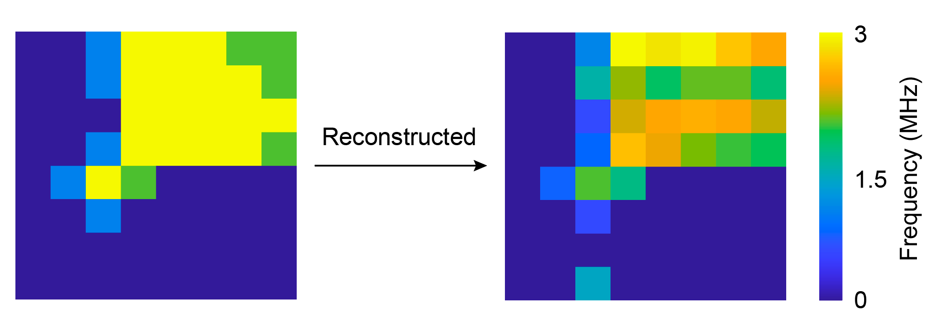
Figure S8. The reconstructed result of the 8 × 8 optical pattern. The outputs from the four dendrites were reconstructed with high accuracy using deep learning, demonstrating the potential of dendrites for efficient, low-power parallel computing.

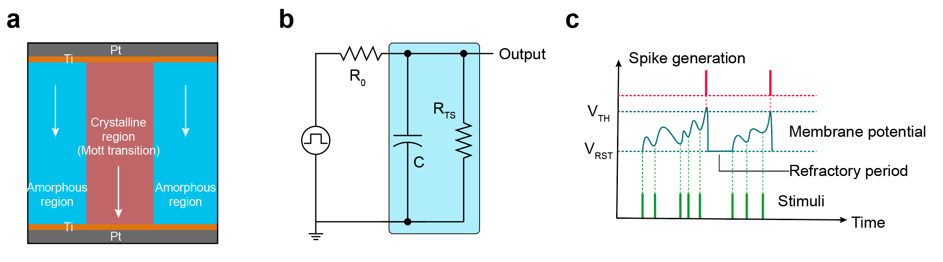
Figure S9. SPICE model of the NbO₂ device. a 2D structural diagram of the NbO₂ device, showing both crystalline and amorphous regions. b Schematic of the neuron circuit used in the APND-based SD-SNN simulation in pulse mode. c Spiking neurons are activated when membrane potentials exceed a certain threshold.

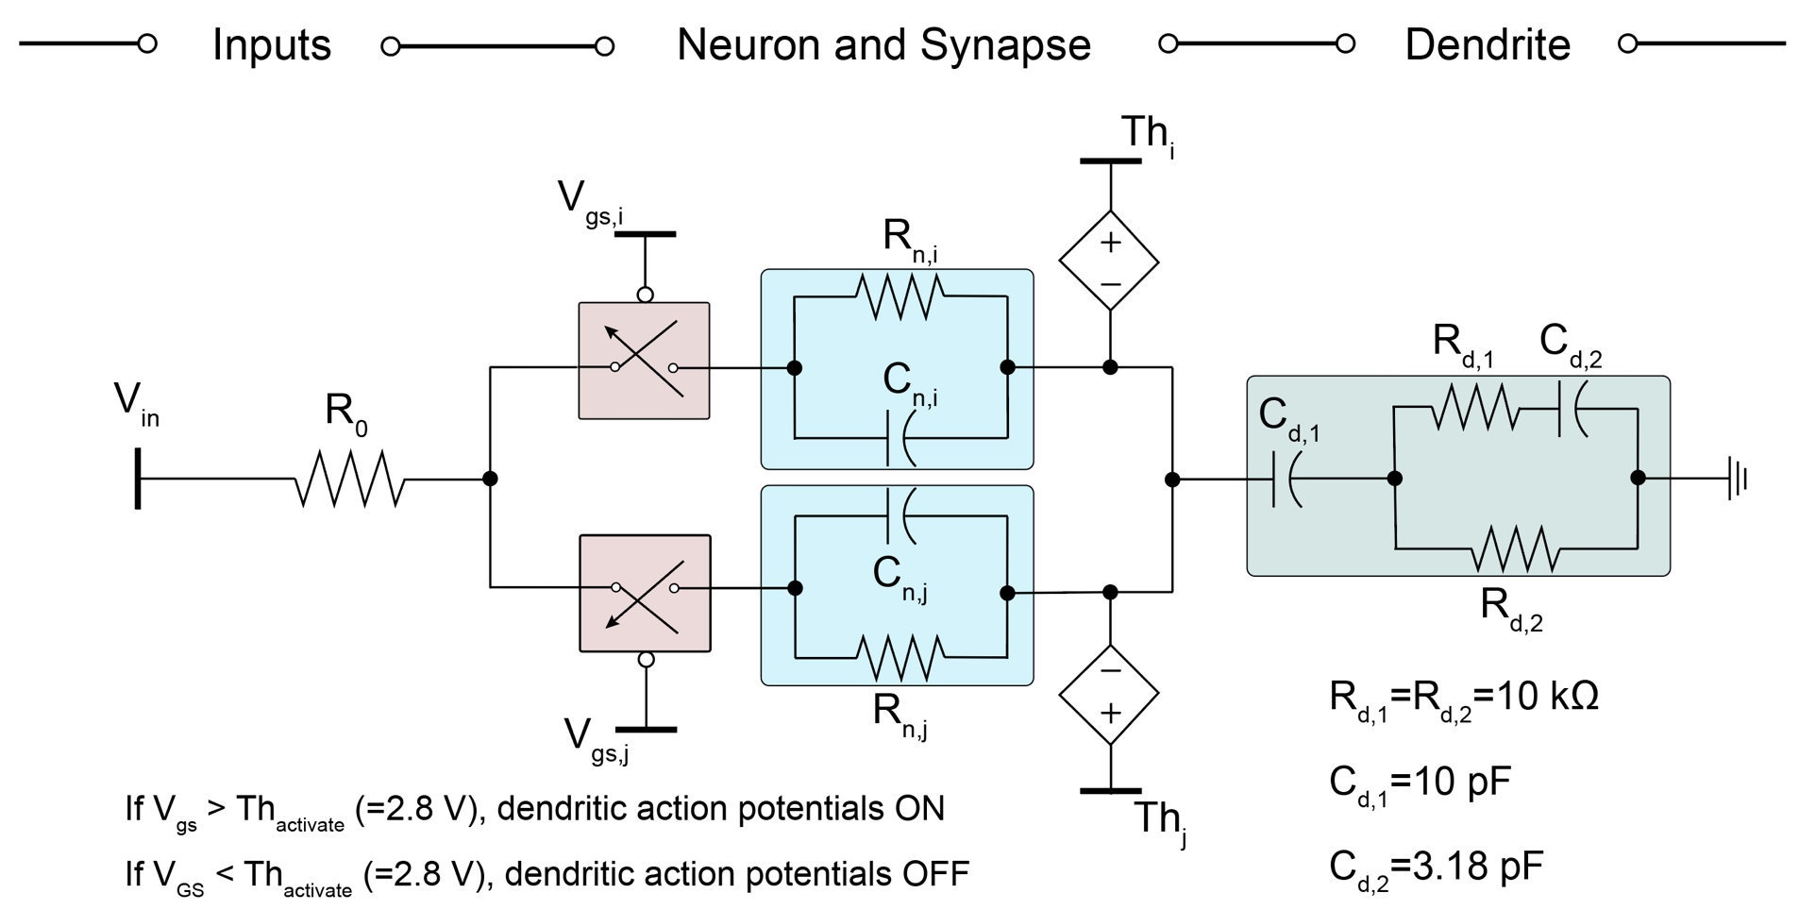
Figure S10. The circuit model of single dendrite for FMC operation.

Two pyramidal neurons and synapses were simultaneously connected to a single dendrite to demonstrate dendritic nonlinear spike integration and FMC operation. The silent synapse is modeled using a voltage-controlled switch (indicated by the red rectangle in the figure). The switch is ON to activate the neuron-synapse connection when the effective gate voltage V_{gs} exceeds the threshold voltage (V_{th, activate} = 2.8 V). The switch is OFF to inhibit the neuron-synapse connection when V_{gs} is below V_{th, activate}. The neuron model is shown in Supplementary Fig. 9. The dendrite is designed to filter and integrate multiple neural inputs into a single dendritic spike signal.

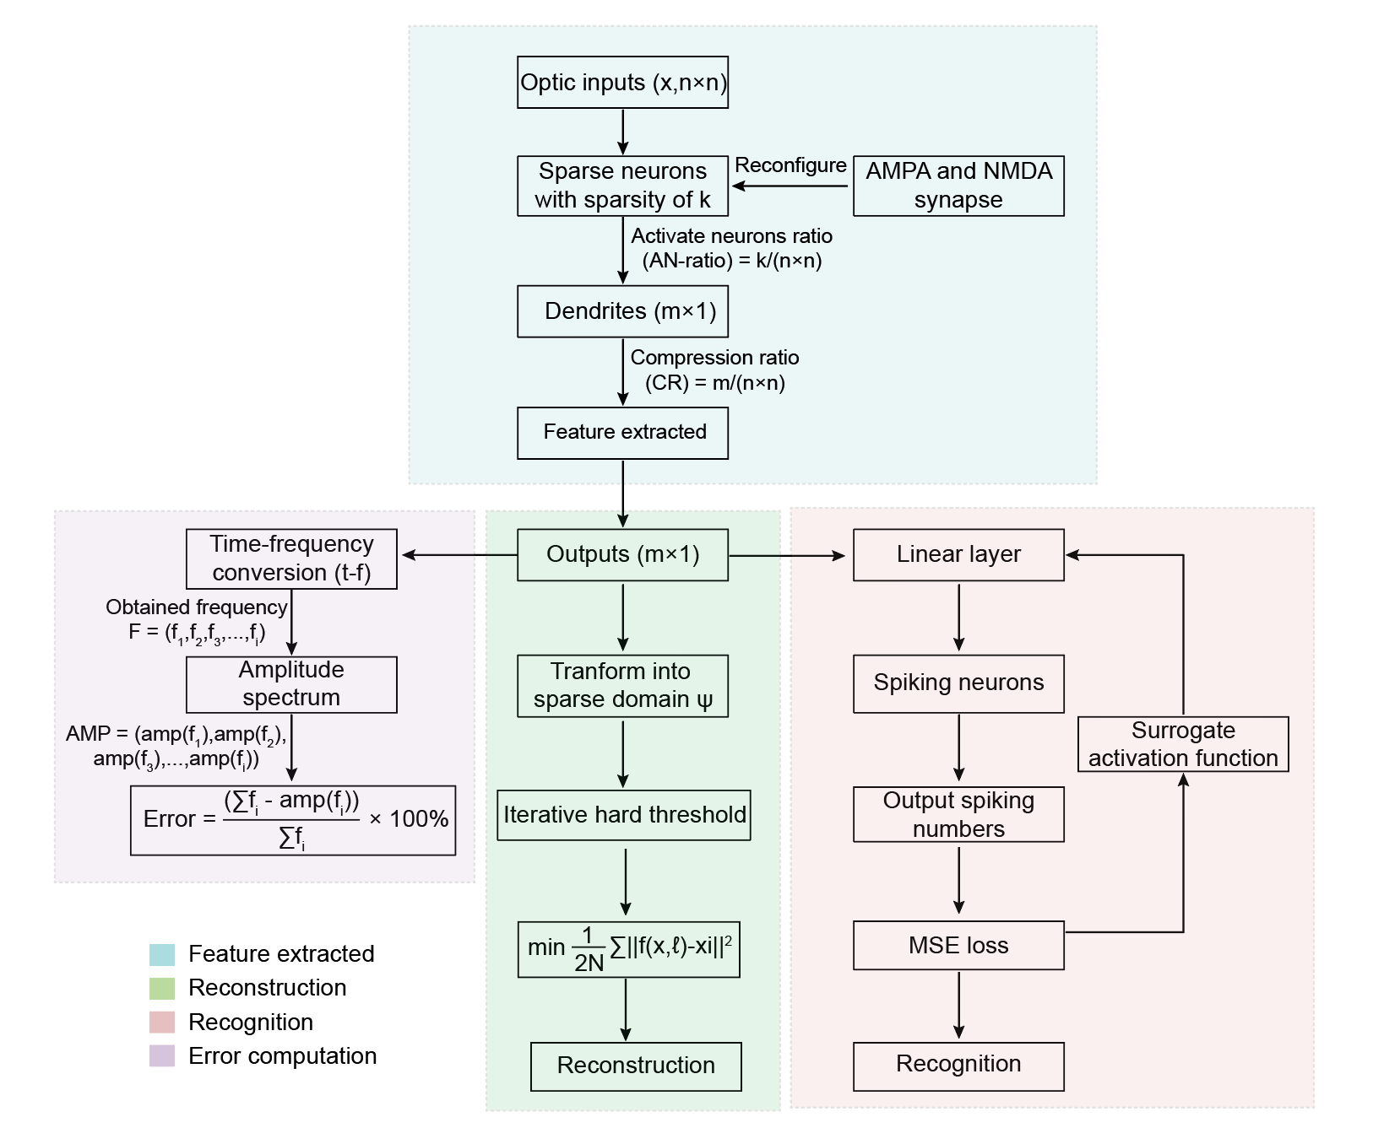
Figure S11. Flow chart of SD-SNN’s feature extraction, static recognition, image reconstruction and parallel error calculation.

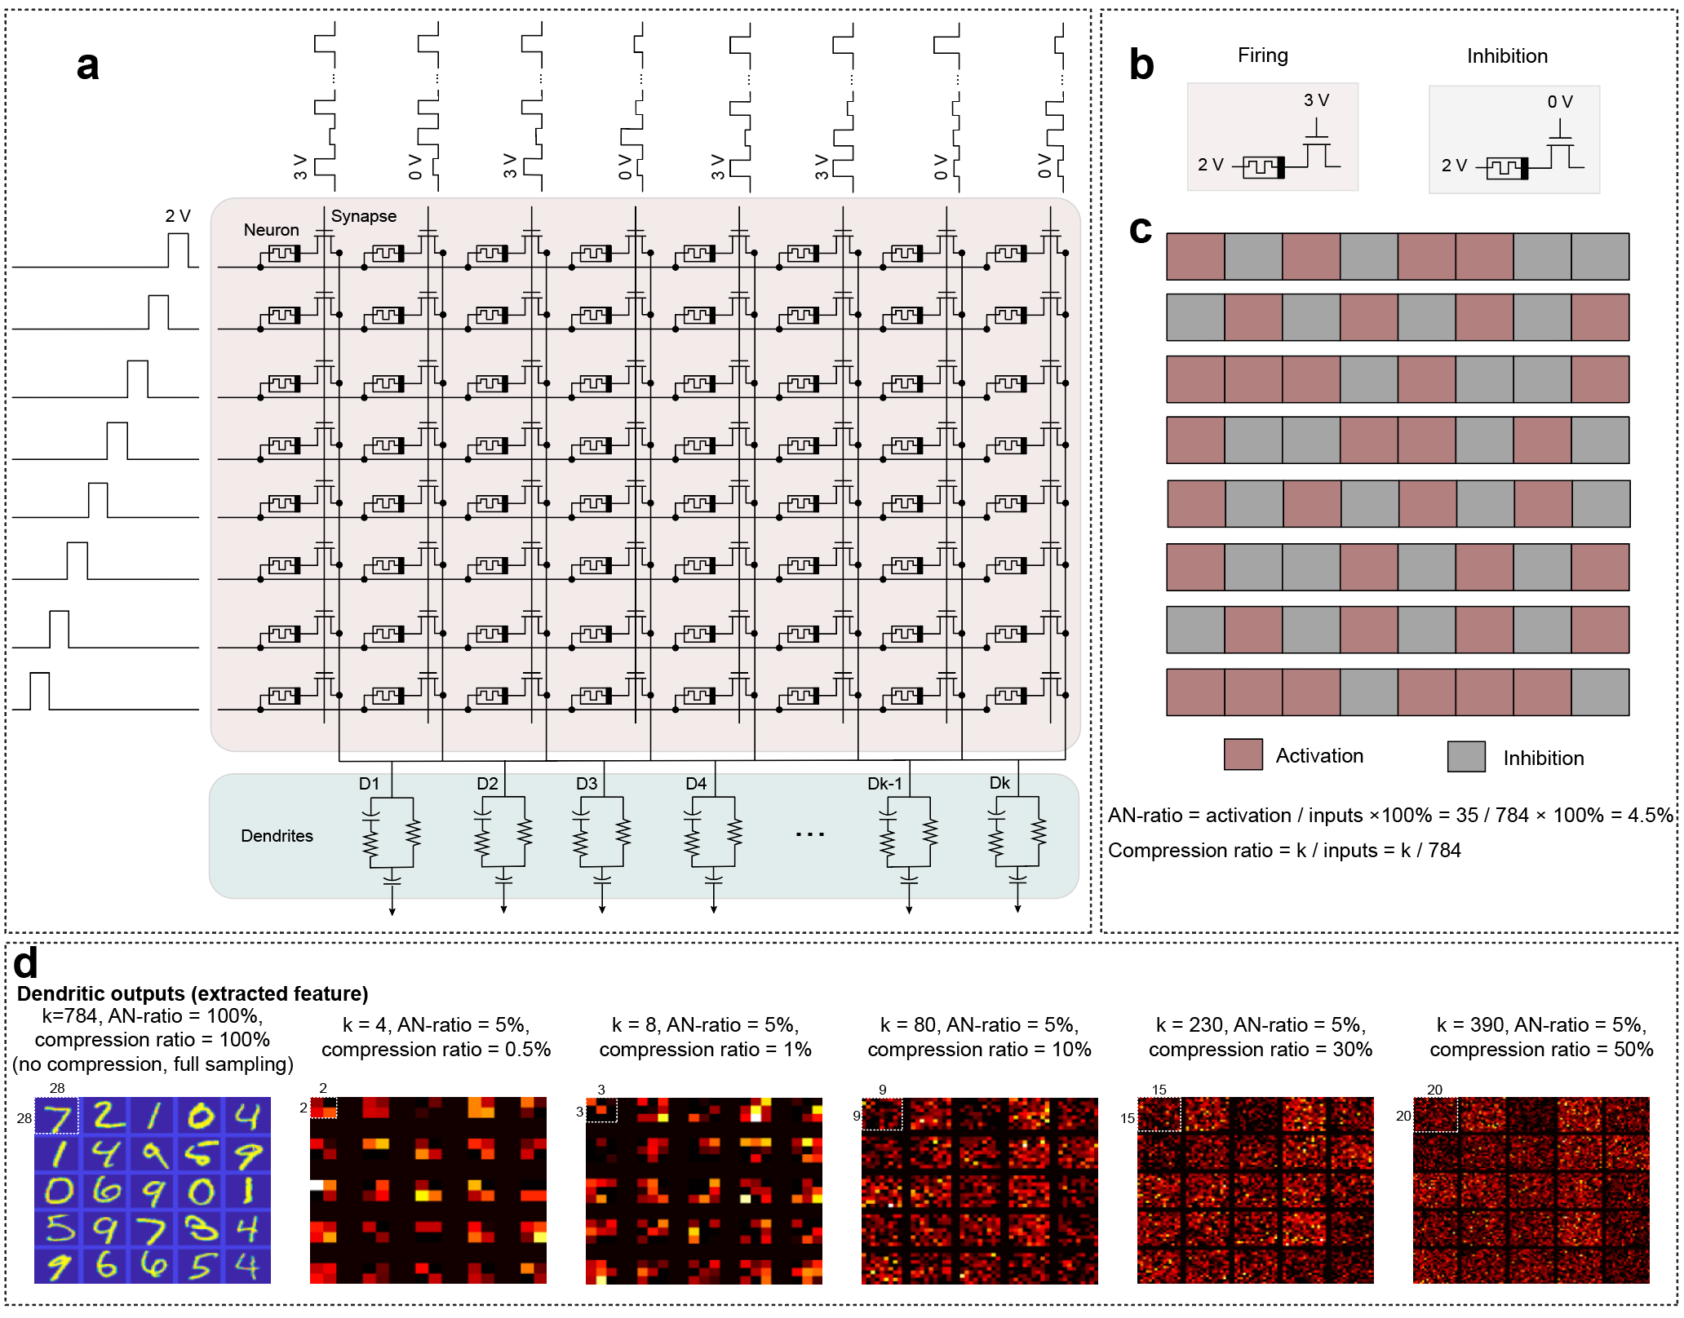
Figure S12. SD-SNN for feature extraction. a Schematic diagram of the SD-SNN for feature extraction. b Neuronal activation and inhibition operations. c Results of activated neurons in the array. For large-scale images (28×28, MNIST), 35 activated neurons (AN ratio ≈ 5%) connected to k dendrites can complete the image feature extraction. d Results of feature extraction for k values of 4, 8, 80, 230, and 390. The 28×28 MNIST image is sparsely sampled by neurons and compressed into k outputs by the dendrites. The compression ratio is the number of dendrites (k) divided by the total number of neurons.

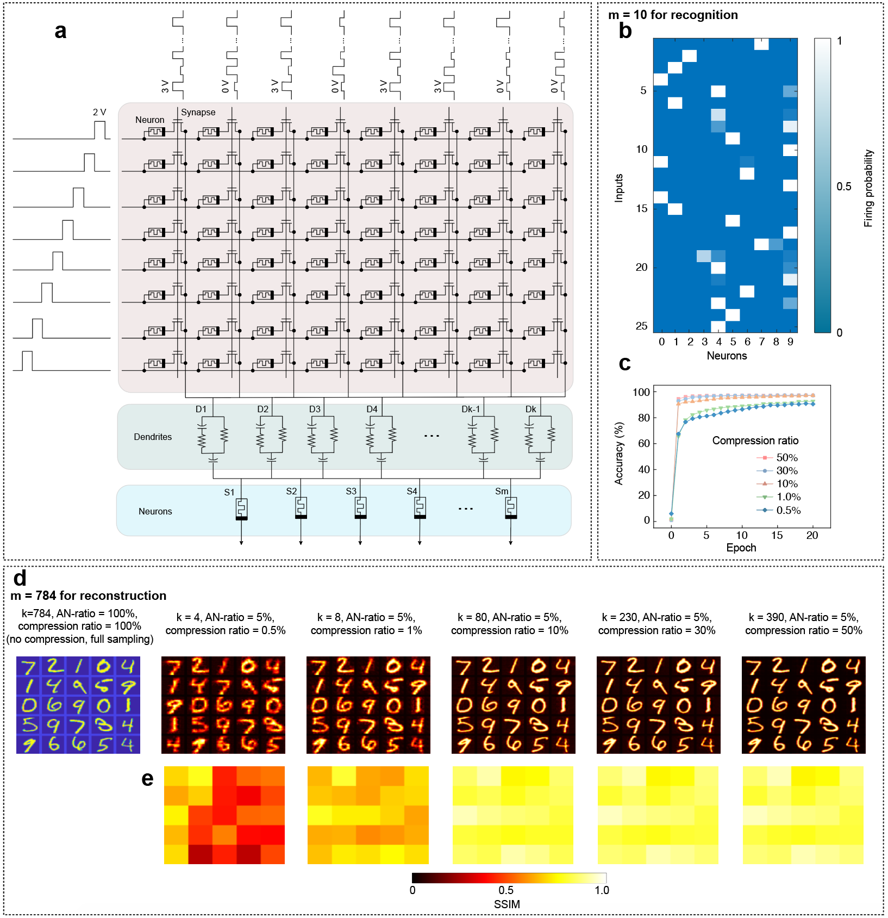
Figure S13. SD-SNN for image recognition and reconstruction. a Schematic diagram of the SD-SNN for image recognition and reconstruction. The 64×k SD-SNN is connected to m spiking neurons in a linear layer. The value of m can be adjusted to perform two functions: recognition and reconstruction. When m equals the number of image types (m = 10), image recognition is achieved by calculating the error through backpropagation of features extracted from the k dendrites. When m matches the number of pixels in the original image (m = 784), the original image can be reconstructed using the hard threshold solution method. b When m = 10, specific image types activate the neural activities of corresponding neurons for image recognition. c Test iteration accuracy for different compression ratio (0.5%, 1%, 10%, 30%, and 50%). d Results of image reconstruction for k values of 4, 8, 80, 230 and 390 respectively. e SSIM results for various compression ratios.

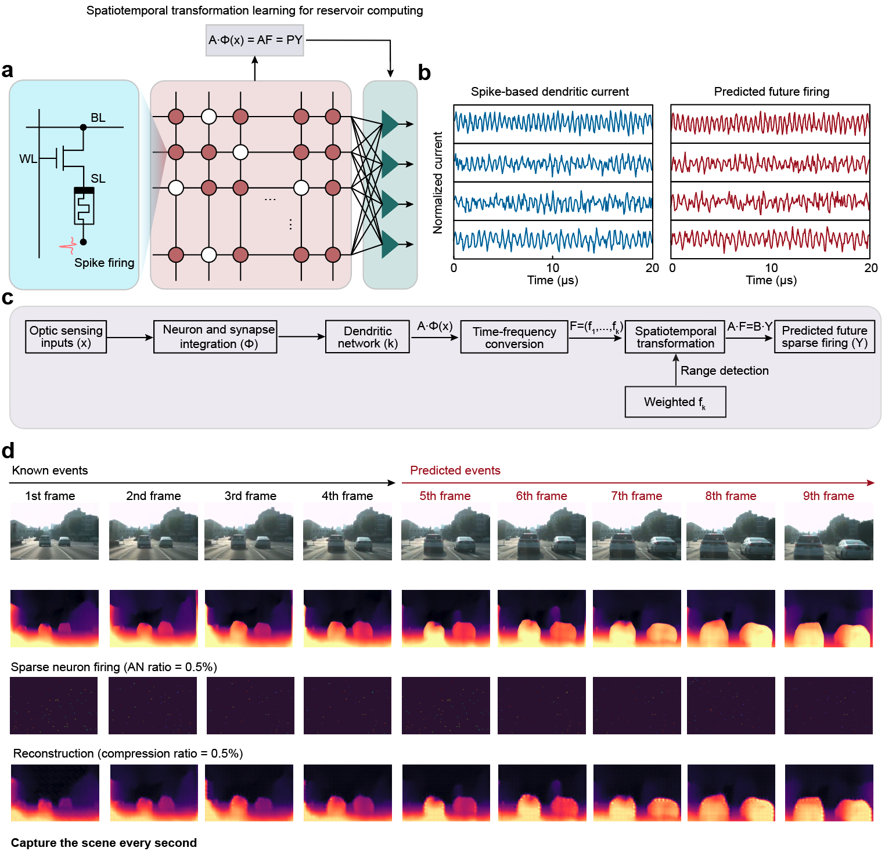
Figure S14. SD-SNN for dynamic motion processing. a Schematic diagram of the APND-based SD-SNN for dynamic motion processing. b The current dendritic spiking outputs and predicted future outputs. c Flowchart of the SD-SNN for dynamic motion prediction and depth detection in a 3D unstructured environment. d The SD-SNN depth prediction results with AN ratio = compression ratio = 0.5%.

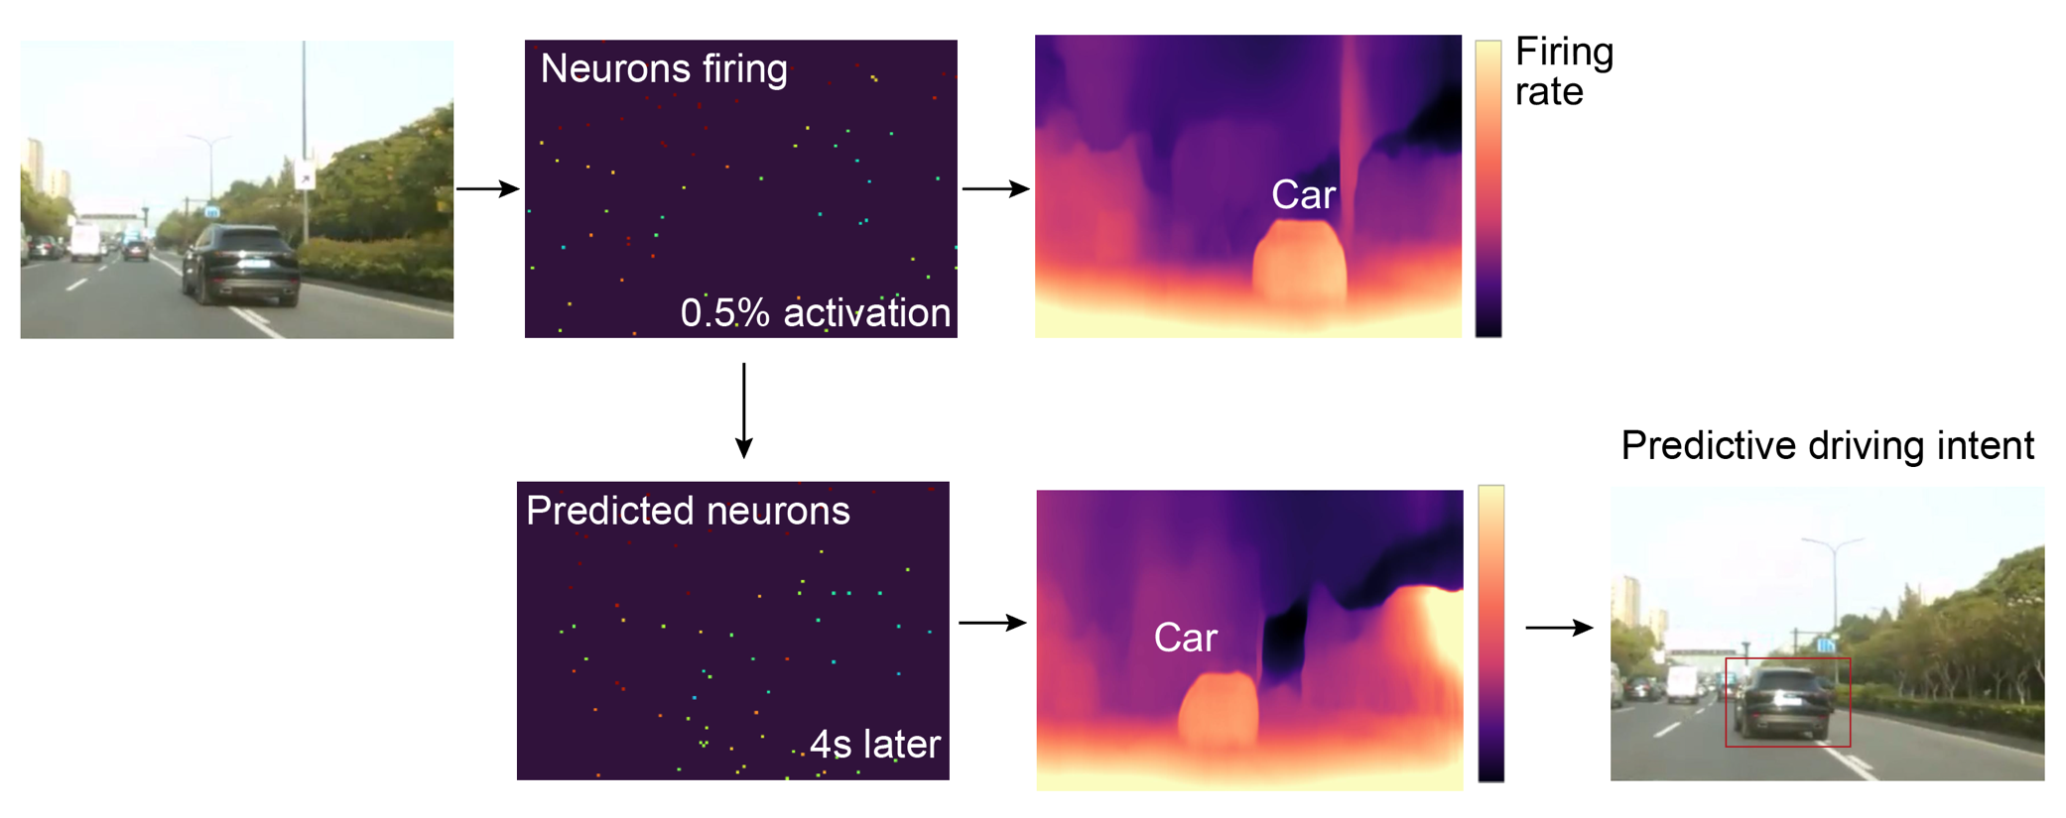
Figure S15. SD-SNN can accurately predict the driving intentions of other vehicles in a 3D unstructured environment, with minimal cost (only 0.5% of neural activity).

