Table 3: Forest attributes and their aesthetic impact from a visitor's perspective. Overview of key forest attributes influencing aesthetics. The impact on aesthetics is categorized as linear positive, linear negative, or bell-shaped, with visitor preferences indicated by descriptive quotes.
Possible point of view of a forest visitor | Attribute | Impact on aesthetics
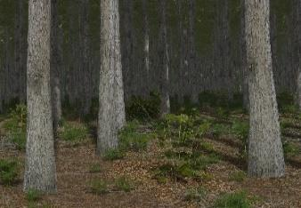 | Tree size  Tree height and stem diameter | Linear positive  “The bigger, the better"
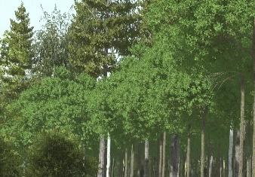 | Variation of tree height  Determining the number of canopy layers | Linear positive  “The more layers the better”
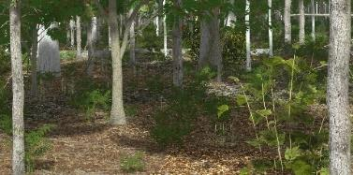 | Density of understory  A dense understory and shrub layer results in a low visual penetration | Bell shaped  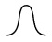  “Presence of understory without obscuring the view”
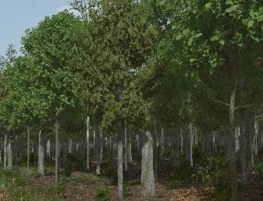 | Tree species variability  Number of different tree species within a stand | Linear positive  “The more species the better”
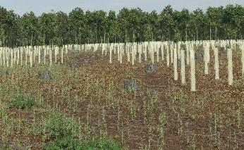 | Probability and size of clear-cut areas  Determined by the probability of calamities | Linear negative  “The lesser clear cuts the better”
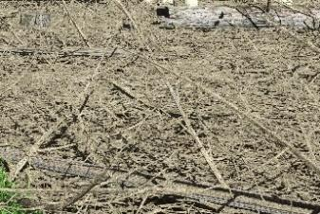 | Volume of woody residues  Resulting from harvesting and thinning e.g. tree stumps, branches etc. | Linear negative  “The lesser residues the better”
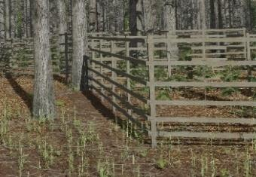 | Traces of intervention  E.g. lanes, fences, high seats | Linear negative  “The lesser traces the better”
Table 4: Expert assessment of climate change adaptation measures (CCAMs) and their impacts on forest attributes and outcomes for aesthetics. Arrows indicate whether a measure increases (upward), decreases (downward) , or has no effect on the attribute (circle). The consistency of expert responses is represented by the borders of the icons: a strong majority (thick border), means at least 9 of 11 experts agree; an absolute majority (no border), indicates at least 6 of 11 experts agree; no clear trend (NT) if less than 6 experts agree. A small arrow within a circle reflects a majority with no expected effect but a strong minority opinion on its potential impact. The color of the symbols indicates whether the resulting impact on aesthetics is positive (green), negative (red), situation-dependent (two-colored), or neutral (grey).
Attribute: |  | Tree size | Variation of tree height | Density of understory | Tree species variability | Clear cuts | Residues | Traces of intervention | Overall impact on aesthetics
Influence on aesthetics: |  | linear positive | linear positive | Bell shaped | linear positive | linear negative | linear negative | linear negative | Overall impact on aesthetics
Adaptation strategy | Adaptation measures | Impacts on forest attributes, consistency of responses & impact on aesthetics |  |  |  |  |  |  | Overall impact on aesthetics
Adaptation of the tree species mixture | Diversifying tree species mix | NT |  |  |  |  |  | 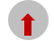 | positive
Adaptation of the tree species mixture | Increased use of natural regeneration |  |  |  | NT |  | NT |  | positive
Strengthening basic ecological functions | Leave more harvest residues |  |  |  |  |  |  |  | negative
Strengthening basic ecological functions | Soil-friendly harvesting | 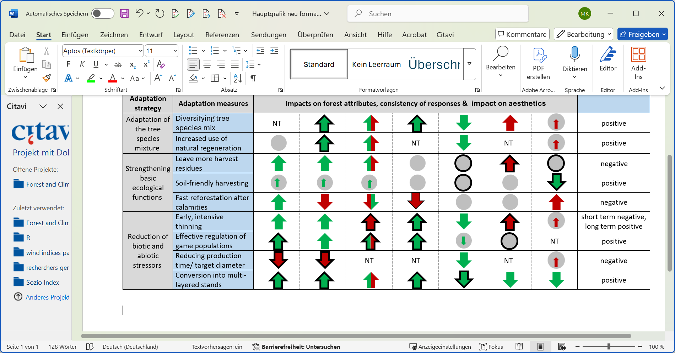 |  |  |  |  |  |  | positive
Strengthening basic ecological functions | Fast reforestation after calamities |  |  |  |  |  |  |  | negative
Reduction of biotic and abiotic stressors | Early, intensive thinning |  |  |  |  |  |  |  | short term negative, long term positive
Reduction of biotic and abiotic stressors | Effective regulation of game populations |  |  |  |  |  |  | NT | positive
Reduction of biotic and abiotic stressors | Reducing production time/ target diameter |  |  | NT | NT |  | NT |  | negative
Reduction of biotic and abiotic stressors | Conversion into multi-layered stands |  |  |  |  |  |  |  | positive

