Supplementary Material

Breaking the size limit: efficient sampling of large-scale transition pathways and intermediate conformations in sub-mesoscopic protein complexes

Domenico Scaramozzino¹, Byung Ho Lee¹, Laura Orellana^{1,*}

¹Protein Dynamics and Mutation Lab, Department of Oncology-Pathology, Karolinska Institutet, Solna, Sweden.

*Corresponding author: laura.orellana@ki.se

Generation of the protein dataset

In this work, we have investigated in detail the conformational diversity and transition pathways of several proteins. Three of these systems (Supplementary Table 1), i.e., ribose-binding protein (RBP, 30 kDa), RNA endonuclease III (RNAseIII, 48 kDa), and sarcoplasmic/endoplasmic reticulum Ca²⁺ ATPase1 (SERCA, 109 kDa), are of medium-size and come from our previous eBDIMS benchmark¹. These proteins have been used here to test the impact of two main parameters in eBDIMS2, as well as to assess the performance of our method against other existing path-sampling algorithms.
In order to build a comprehensive dataset of large proteins undergoing large-scale conformational changes, we performed a far-reaching bioinformatic search combining the Protein Data Bank (PDB)² and the UniProt database³. First, we have retrieved all UniProt IDs that satisfy the following criteria: (i) reviewed entries; (ii) monomeric sequence of at least 500 amino acids; (iii) at least 3 structural models from cryogenic Electron Microscopy (cryo-EM). This provided a list of 1,376 UniProt candidates. Then we screened the PDB for structures satisfying the following conditions: (i) model obtained from cryo-EM; (ii) resolution < 5Å; (iii) molecular weight in the range 400 kDa – 3 MDa. This generated a list of 6,114 PDB codes. Cross-referencing the two lists from UniProt and PDB, we narrowed down our search to 855 UniProt candidates. Note that, in this stage, we looked for cryo-EM models because these are the most common types of structural data for large proteins captured in different conformations. However, in the subsequent steps, both cryo-EM and X-ray structures were considered for the ensemble generation. Then, we applied the condition that every entry should contain at least 3 models with: (i) good-to-medium resolution (< 5Å); (ii) large molecular weight (400 kDa – 3 MDa); (iii) number of modelled residues in the range 3,000 – 30,000. Note that the availability of at least 3 models is the minimum condition to build a structural ensemble. The lower limits of molecular weight and modelled residues allowed us to discard small- and medium-size proteins, whereas the upper limit was used to exclude extremely large assemblies. This reduced our UniProt list to 511 candidates (Supplementary Table 2).
In the second stage of our search, we implemented additional criteria to retrieve ensembles of large proteins, discarding protein-protein assembly machines and ensuring enough conformational diversity. A proper protein ensemble should contain at least 3 PDB structures including a maximum of 10 different polymer entries. This condition allowed us to exclude gigantic assemblies of proteins whose behavior is driven by protein-protein interactions, rather than the conformational dynamics of individual entities. We also looked for cases where there were at least two structures with a Root Mean Square Deviation (RMSD) > 4Å. This condition guarantees that the ensemble has an acceptable degree of conformational diversity. We used US-Align⁴ to align PDB models and compute RMSD values. At the end of this stage, we narrowed down our list to 158 candidates (Supplementary Table 3).
Finally, we manually went through each of the 158 UniProt retained entries and retrieved all high-quality PDB models to build structural ensembles. Certain cases where proper ensembles could not be built were excluded from subsequent analysis. For example, for the S. Flexneri outer membrane protein MxiD (Q04641), our search provided only 3 good PDB models: 8axk, 8axl, and 8axn. While 8axk and 8akn report the MxiD ring in a 16-mer configuration, 8axl reports MxiD in a 15-mer oligomeric state, making the generation of a coherent ensemble impossible. Most of the remaining UniProt IDs are linked to each other to form heteromeric protein complexes. For example, the S. Cerevisiae DNA replication licensing factor MCM complex is composed of six subunits, four of which have UniProt IDs that were independently included in our list (P24279, P30665, P53091, P38132, see Supplementary Table 3). By gathering all these inter-connected UniProt entries, we finally built independent ensembles for 40 large proteins (see Supplementary Table 4). Some of these proteins were considered in multiple oligomerization states, e.g., GroEL, MCM, VCP, etc., with different interacting partners, e.g., ClpA/P, or considering different isoforms, e.g., Nf1. This finally led us to analyze 47 ensembles of large protein systems.

Construction of structural ensembles and Principal Component Analysis (PCA)

Structural ensembles were generated by downloading all PDB models fulfilling the above-mentioned criteria and making sure that they are all structurally consistent. This was achieved by: (i) checking that chain labels are coherent with relative orientations of protomers in homo- and heteromeric systems; (ii) making sure that all structures have the same number of residues and that all residues belong to the same sequence positions. The last column of Supplementary Table 4 reports all PDB IDs used for generation of the ensembles. For each ensemble, a reference structure - generally associated to an apo-resting state - was chosen. All structures in the ensembles were subsequently aligned to the reference to get rid of translational and rotational degrees of freedom (DOFs). Structural alignment was carried out using the gmx confrms tool from Gromacs⁵. We then carried out Principal Component Analysis (PCA) to extract apparent collective motions from the aligned ensembles.
Supplementary Table 5 and Supplementary Figure 1 report the PCA results, showing the variance captured by the first two principal components (PCs), and the total number of PCs needed to describe at least 90% of the variance. Within our dataset, the variance covered by PC1 ranges from a minimum of ~41% (MCM 6mer) to a maximum of ~99.9% (Nf1 isoform 2), with an average of ~75%. The variance covered by PC2 ranges from ~0.1% (Nf1 isoform 2) to a maximum of ~44% (S. Oleracea ATP synthase), with an average of ~17% (Supplementary Figure 1a). For the majority of ensembles (33/47), PC1 and PC2 alone cover more than 90% of the variance. An additional PC is needed in 9 systems, while in the remaining cases, 4-7 PCs should be considered to reconstruct >90% of the variance (Supplementary Figure 1b). PC1 and PC2 always allow to capture at least ~70%. Our PCA results suggest that these large systems undergo collective motions and that their conformational diversity can be explained by just a few PC motions. Based on the projections of all experimental structures in the PC space, we can find relevant conformational clusters and select representative end-state conformations to simulate transitions with eBDIMS2.

eBDIMS2 development and testing

eBDIMS2 exploits the fact that, in the essential-dynamics Elastic Network Model (edENM)⁶, non-bonded interactions exhibit a strong decay for increasing particle-particle distances, i.e.:

 | $$k_{ij}={\left(\frac{6}{r_{ij}}\right)}^{6}$$ | (S1)

where k_{ij} is the spring constant (in kcal/molÅ²) between particles i and j in the network, and r_{ij} is their Cartesian distance (in Å). Notice that if the distance between two residues is greater than, e.g., 8Å, their interaction force becomes so weak that it can in principle be ignored. Instead of considering all (N² – N)/2 pairwise interactions like in our previous algorithm^{1,7}, we implemented a more efficient approach based on an adaptive spatial cutoff r_{c}, similar to what is done in Molecular Dynamics (MD) simulations. Every 1,000 steps along the Brownian Dynamics (BD) simulation, we generate a list of interacting pairs (r_{ij} < r_{c}), where residue-residue distances r_{ij} are evaluated based on the updated coordinates of C^{α} atoms. This list is used to calculate new interacting forces at each BD step. In this way, we reduce the number of iterations to be performed at each step, resulting in a much more efficient algorithm.
The lower r_{c}, the lower the number of residue-residue interactions, resulting into a faster simulation especially for larger proteins. Yet, this might come at the expense of ignoring potentially relevant contributions to the total interacting force. To look for optimal values of r_{c}, we tested the performance of eBDIMS2 by using four cutoff values, i.e., 8, 10, 15, and 20Å. We looked both at the computational efficiency to achieve transition convergence and at the accuracy in predicting the transition pathway. All calculations were performed on a Linux workstation with an Intel® Core i9-13900K processor and using OpenMP parallelization on 16 threads. Supplementary Figures 2 and 3 show the results for the transitions for RBP, RNAseIII, SERCA, and GroEL 7-mer. In this range of cutoff values, r_{c} does not significantly modify the PC projection of the transitions (Supplementary Figure 3), hence it does not impact the pathway accuracy. However, it plays a relevant role for computational efficiency (Supplementary Figure 2). On average, smaller cutoffs (8-10Å) lead to the lowest computing times, especially as the scale of the system increases (Supplementary Figures 2c-d). A value of r_{c} = 8Å was selected as optimal and used for all subsequent calculations.
While r_{c} controls the amounts of force calculations to be performed at each BD step, the biasing frequency k is used to check the outcomes of the BD simulation periodically and drive the pathway towards the target¹. Hence, k can also have a profound impact on the method performance. Supplementary Figures 2 and 3 show the computing times and projections of the eBDIMS2 transitions also as a function of four distinct values of the biasing frequency, i.e., k = 1, 2, 5, and 10. The method is very robust, as it provides similar pathways for different k values in this range (Supplementary Figure 3). However, biasing the transition every (k = 1) or every other (k = 2) step results in a larger loss of efficiency. Greater performance is generally achieved with k = 5 and k = 10 (Supplementary Figure 2). Since for the largest system, k = 10 provides the highest computing speed (Supplementary Figure 2d), we selected k = 10 as optimal.
Since conformational changes can also involve quasi-rigid rotations of entire domains, an additional feature that we implemented in eBDIMS2 is the possibility to consider explicit rigid blocks in the protein structure. In these cases, using classical ENM parametrizations for non-bonded interactions can often lead to artifacts along the transition pathway. This occurrence was observed, e.g., in M. Smegmatis ATP synthase (Supplementary Figure 4), which undergoes a large-scale conformational cycle where the F₀ rotor covers a 360° rotation in three steps of ~120°. When the standard ENM is applied to this system, the predicted pathway gives rise to an unrealistic deformation of the rotor (Supplementary Figure 4a). We fixed this issue in eBDIMS2 by increasing the spring connectivity between all residues in the rotor and setting the values of these spring constants to 1 kcal/molÅ², which corresponds to much stronger connections than those employed in the edENM above an 8Å cutoff. This strategy allowed us to model the rotor as a rigid block with no internal deformations. The resulting transition showed a more realistic pathway, with the F₀ subunit completing each 120° rotation with no internal deformation, like in the experimental end-state conformers (Supplementary Figure 4b).
Another advantage of eBDIMS2 compared to our previous C⁺⁺ code⁷ and the majority of path-sampling algorithms is that it can also deal with proteins with missing residues. Missing regions are dealt with by ignoring bonded interactions in the portion of the sequence affected by unmodelled amino acids, and by using long-range non-bonded interactions to guarantee the connectivity of the network before and after the gap. Note that, if the string of missing residues is very long, e.g., > 40, and it is placed in a crucial region of the protein, one must first verify that the spatial cutoff used for non-bonded interactions (8Å) is enough to ensure a full connectivity of the network. If this is not guaranteed, either the cutoff value is increased or a reconstruction of the missing region is recommended, e.g., via tools like Modeller⁸ or Swiss-Model⁹.
In eBDIMS2 we also included the possibility to simulate transitions between end states with different numbers of residues. In this case, the correspondence between residues in the two end conformations is found by searching for correspondences between protomer chain labels and residue numberings. This works not only in the case of minor differences between sequence coverages, but also in the case of entire domains missing in one of the two end-state conformers. Supplementary Figure 5a shows the transitions between a full-length Ca²-E1 open conformation of SERCA (PDB: 2c9m, 994 residues) and a mutant Ca²-E1-MgAMPPCP closed state that is completely lacking the headpiece A-domain (4nab, residues 1-46 and 123-240 missing). In the simulation from the full-length open state, the A-domain is performing small-amplitude fluctuations around its original position, while the rest of the structure is undergoing a large-scale conformational change to converge into the (incomplete) target. Similarly, Supplementary Figure 5b shows the transitions of the large ITPR3 (> 8k residues), between a quasi-complete apo state (6dqj) and an inhibited conformation where all the N-terminal domains are missing (8tla, residues 1-234 missing in each protomer). Also in this case, the NTDs of the apo state perform small-scale oscillations while the rest of the structure is able to correctly converge to the target.

Application of eBDIMS2 to large proteins: computing times, stereochemistry, and approaching experimental intermediates

To simulate transition pathways for the large proteins in our dataset, relevant end-state conformations were selected from the ensemble projections in the PC1-PC2 space. For each conformational cluster, we selected as relevant end-state conformer the structure with the best experimental resolution, the lowest number of missing residues, and we tried to prioritize transitions between models that have been deposited by the same research group and in the same publication. We also carefully checked the literature to assign functional states to different conformers. Out of the 872 experimental structures used in our 47 ensembles, we selected a total of 124 relevant end states, we simulated 191 transition pathways (Supplementary Table 6), and computed projections on the experimental PC spaces (see Supplementary Figures 6-10). Except for the three ATP synthases where the conformational cycles associated to ATP synthesis are directional, we explored both the forward (R₀ → R_{t}) and backward (R_{t} → R₀) transitions. In the cases of ATP synthases, as well as in the case of T. Thermophilus V-type ATPase/synthase, we also applied rigid constraints to all c-chains in order remove internal deformations within the rotating F₀ domain (Supplementary Figure 4).
For each pathway, we computed RMSD and collectivity values between R₀ and R_{t} (see Eqs. (7-8) in the main text), the RMSD value from the target state R_{t} at convergence, and the computing time needed to reach convergence. All simulations were performed on a Linux workstation with an Intel® Core i9-13900K processor, 64 GB of RAM, and using 16 OpenMP parallelization threads. The convergence of the simulations was often achieved when one of two conditions was met: (i) RMSD from the target <0.8Å; (ii) convergence of the Γ parameter to 99.9%. In just a few cases, we manually increased the convergence thresholds to have a longer sampling of the transition, e.g. Γ convergence of 99.95% for Nf1, or decreased them to avoid spending am excessive amount of time to refine the last steps of the pathway, e.g. Γ convergence of 99.5% for ATP synthases. Supplementary Table 6 reports the results for all 191 transition pathways, in terms of RMSD, collectivity degree, and computing times. We also generated animated movies in GIF format for all transition cycles, which can be downloaded from the Supplementary Material.
We investigated the relationship between the computing time (CT) required by eBDIMS2 to simulate the transition pathways and three fundamental variables that characterize the transition of the system, i.e., protein size, transition RMSD, and collectivity of the conformational change (Supplementary Table 6). When we look at the whole dataset, we observe a strong correlation between the CT and the sizes, with Pearson Correlation Coefficients (PCCs) of ~0.89, showing an almost linear relationship between computing times and system size (Fig. 2c in the main text). However, this correlation decreases if we focus on systems with N < 10k residues, i.e., not including RyR1, RyR2, and FAS 12-mer. In this case, PCCs are still positive, but reaching a value of ~0.67. Overall, these results suggest that, especially for not extremely large systems (~ 1 MDa), several features other than the size of the system can affect the computing time to simulate the conformational change. Not surprisingly, we observe a positive correlation between the size-normalized computing time (CT/N) and the RMSD of the transition, with a PCC of ~0.5. This confirms that, size being equal, larger transitions require more time to be simulated (see the Nf1 and ATP synthase outliers in Fig. 2c in the main text, right panel). Interestingly, we also find a slightly negative correlation between the size-normalized computing time (CT/N) and the collectivity of the conformational change, with a PCC value of ~-0.2. This suggests that, size being equal, a collective transition is “easier” to simulate than a localized one, which stems from the capability of ENMs to describe large-scale global motions better.
We also checked the stereochemical quality of eBDIMS2-generated intermediates. Supplementary Figure 11 shows the distribution of distances between consecutive C^{α} atoms for all 191 eBDIMS2 mid-point intermediates (panel a), as well as for all 124 experimental end-state conformers (panel b) and all 872 experimental structures used in our ensembles (panel c). Boxplot representations of these distribution are reported in panel d. The distributions related to the end states and experimental conformations are sharply centered at ~3.8Å, which represents the theoretical value of consecutive C^{α}-C^{α} distance. The average distance values in eBDIMS2 intermediates are also centered at ~3.8Å, with 25th and 75th percentiles at ~3.7Å and ~3.9Å, and minimum and maximum values (not including outliers) at ~3.4Å and ~4.2Å (Supplementary Figure 11a). Minimum and maximum values, also including outliers (red points in panel d), are 2.4-6.2Å for eBDIMS2, 2.7-6.2Å for end-state conformations, and 2.6-6.2Å for all experimental structures. These results show that, unlike MinActionPath2 (see below), eBDIMS2 tends to add only minor (sub-Å) stereochemical distortions to the C^{α} backbone and does not add extra outliers to those already present in experimental models.
We also checked the atomistic quality of eBDIMS2 intermediates after all-atom reconstruction via cg2all¹⁰. MolProbity¹¹ quality scores for GroEL 7-mer conformations are reported in Supplementary Table 7. The quality of experimental end states is compared to the (reconstructed) eBDIMS2 mid-point intermediate along the opening pathway (1ss8-1sx4). We observe good rotameric states in the eBDIMS2 intermediate, but worse Ramachandran ϕ-ψ values and a higher number of bad bonds and bad angles (Supplementary Table 7, Supplementary Figure 12a). However, after carrying out a short energy minimization (Supplementary Figure 12b), the majority of bad bonds and bad angles could be fixed (Supplementary Table 7). Also, the total number of Ramachandran outliers and unfavorable ϕ-ψ values were minimized after equilibration (Supplementary Figure 12c) and especially after a short (1ns) MD production run (Supplementary Figure 12d). This shows that eBDIMS2 conformers are able to reach a good level of structural quality also at the atomistic level, which makes them suitable for MD simulations and further atomistic analysis.
We and others have previously shown that transition pathways connecting stable end states from X-ray can sample the crystallographic motions and spontaneously predict on-path experimental intermediates^{1,12}. To assess whether this also holds true also for larger cryoEM systems, we have evaluated how close eBDIMS2 paths approach experimental intermediates. The identification of intermediate states is straightforward if we use projections of structural ensembles on the low-dimensionality spaces defined by the lowest PCs. From our benchmark we have selected six systems for which this identification was rather straightforward: the two spike glycoproteins from SARS-CoV and SARS-CoV-2 (Supplementary Figure 6), DNA-PKcs (Supplementary Figure 6), ATP-citrate synthase (ACLY, Supplementary Figure 7), H. Sapiens T-complex chaperonin 16-mer (TRiC, Supplementary Figure 10) and inositol 1,4,5-trisphosphate receptor type 3 (ITPR3, Supplementary Figure 10). Despite no information on the selected experimental intermediates is fed to the algorithm, eBDIMS2 always tends to closely approach the cryo-EM intermediates before converging to the target with RMSDs as low as ~3-4Å (Supplementary Figure 13), as already found in our previous work on smaller proteins¹.

Comparison with other path-sampling algorithms

We compared eBDIMS2 transition pathways with those from our previous eBDIMS code^{1,7} and eight other algorithms that have been widely used for modeling conformational transitions¹³ and whose executables were freely available, i.e., iMOD¹⁴, GOdMD¹⁵, NGENI¹⁶, ICONGENI¹⁷, Climber¹², ENI¹⁸, aANM¹⁹, ANMPathway²⁰. All methods were used with default parameters on the Linux workstation mentioned above.
These path-sampling algorithms exhibit both differences and similarities. First, they can adopt different representations of the protein DOFs. While iMOD and ICONGENI use soft torsional angles of the backbone, all other methods use Cartesian coordinates, often considering only positions of C^{α} atoms. Second, they can adopt different frameworks to simulate the protein dynamics. eBDIMS and eBDIMS2 use Brownian Dynamics (BD), while GOdMD exploits discrete Molecular Dynamics (dMD) simulations. iMOD and ICONGENI use internal-coordinate Normal Mode Analysis (ic-NMA), whereas NGENI and aANM use Cartesian-coordinate Normal Mode Analysis (cc-NMA). A different scheme is used by Climber, ENI, and ANMPathway, which are based on stepwise refinement iterations on morphing conformations between the two end states. Third, these methods differ for the criteria used to bias the transitions to the target conformation R_{t}. eBDIMS uses dynamic importance sampling (DIMS) and minimizes the differences in internal pairwise distances. GOdMD uses a similar scheme but implementing a Maxwell Demon approach with a Monte Carlo energy penalty function. Minimization of RMSD from R_{t} is used in iMOD, while ENI, NGENI, and ICONGENI minimize a cost function based on interatomic distances. Climber adopts a combination of distance-restrained energy minimization and RMSD biasing. aANM combines small incremental displacements obtained from the low-frequency modes of the end states, while ANMPathway uses interpolations of 3D coordinates followed by energy minimizations to relax intermediate conformers. Lastly, these algorithms can generate either reversible or irreversible pathways. If the pathway is reversible, i.e., if the transition R₀ → R_{t} is equal to the transition R_{t} → R₀, the algorithm is classified as linear. On the other hand, non-linear methods usually generate irreversible pathways, i.e., the forward (R₀ → R_{t}) and backward (R_{t} → R₀) transitions are different. eBDIMS, eBDIMS2, iMOD, GOdMD, NGENI, ICONGENI and Climber are non-linear methods, while ENI, aANM, and ANMPathway are linear.
In this work, we used four proteins to compare the algorithm performances, i.e., RBP (271 residues), RNAseIII (432), SERCA (993), and GroEL 7-mer (3,626). We chose these systems as they do not exhibit missing residues in the polypeptide chain, which is a necessary condition for the applicability of most path-sampling algorithms. Supplementary Figure 14 shows the PCA spaces of the protein ensembles, together with the projections of transition pathways, whereas Supplementary Figure 15 reports the computing times to simulate the transitions.
For RBP, the first two PCs cover almost the entire variance in the ensemble, with PC1 (~98%) representing the opening-closing mechanism, and PC2 (~2%) showing rotations in the two domains (Supplementary Figure 14a). PC1 broadly separates the RBP ensemble in three clusters of varying opening angles: unbound/open conformers (e.g., 1ba2), intermediate states (e.g. 1urp and 2gx6), and ligand-bound/closed conformations (e.g., 2dri)¹. All methods are able to model the transition between the open and closed conformation, and all non-linear algorithms can reach a convergence with RMSD < 1.5Å (Supplementary Figure 15a). eBDIMS2, eBDIMS, iMOD, Climber, and GOdMD also get close to the experimental intermediates, whereas the pathways from other methods (ENI, NGENI, ICONGENI, aANM, and ANMPathway) exhibit more straight-like projections in the PCA space. In terms of computing time, Climber is the slowest, taking ~4 and ~7 minutes for the forward and backward transitions (Supplementary Figure 15a). ANMPathway and ENI are the fastest, taking only 6 and 23 seconds, respectively (Supplementary Figure 15b). All other methods take approximately 1-2 minutes to achieve convergence.
For RNAseIII, the first two PCs cover ~95% of the variance, PC1 (~51%) describing the opening or ‘breathing’ of the two RNA-binding domains, whereas PC2 (~44%) tracks their concerted rotation (Supplementary Figure 14b). These PCs cluster the ensemble into four functional groups: the closed cluster (e.g., 1yyo), an intermediate state (1yz9), a pre-catalytic state (e.g., 1yyw), and the catalytic cluster (e.g., 2ez6)¹. The transition pathways involve a complex motion along both PCs. The majority of non-linear methods, such as eBDIMS2, eBDIMS, GOdMD, NGENI, ICONGENI, and Climber, provide pathways with smooth PC projections that are also able to capture an on-path intermediate (1yz9). On the other hand, iMOD irregularly samples a broader space that is not populated by experimental conformers (Supplementary Figure 14b). Among linear algorithms, ANMPathway cannot reach convergence in reasonable times, whereas ENI and aANM successfully simulate the transition, but their pathway shows straight projections between the end states. Most of the methods can sample the RNAseIII transition in approximately 5 minutes or faster (Supplementary Figure 15c-d), while iMOD and ICONGENI take ~10 minutes and Climber ~15 minutes.
The first two PCs of the SERCA ensemble also cover ~95% of the total variance, with PC1 (~56%) describing the mechanism related to ion pumping and PC2 (~29%) the closure of the actuator (A) and phosphorylation (P) domains. In this case, the 2c9m-1t5s transition follows the PC2 direction, along which three main groups are distributed: the most open E1-2Ca²⁺ structures (e.g., 2c9m), the most closed E1-2Ca²⁺-P structures (e.g., 1t5s), and an intermediate cluster of E1-Mg²⁺-bound structures (e.g., 3w5a). PC1 separates an additional cluster of E2-closed conformations¹. All algorithms are able to simulate the transition of SERCA, and they all tend to sample the same PCA area and capture intermediate conformers (Supplementary Figure 14c). Compared to the other algorithms, ANMPathway is extremely fast, providing the full transition in only 2.5 minutes (Supplementary Figure 15f). However, like the other two linear algorithms, its transition pathway is a straight projection between the end states. All other methods require similar amounts of computing time (Supplementary Figure15e-f). eBDIMS, eBDIMS2 and NGENI take ~20 minutes, GOdMD, ENI, and aANM ~30 minutes, ICONGENI and Climber ~40 minutes, with iMOD being the slowest with ~60/70 minutes. Non-linear methods exhibit different RMSDs at the time of convergence, e.g., eBDIMS2, eBDIMS, and Climber reach ~1Å from the target, while other methods stop at ~2Å (iMOD), or even at ~3Å (GOdMD, NGENI, ICONGENI) from the target (Supplementary Figure 15e-f).
In the three cases shown so far, eBDIMS2 performs well, as it generally requires low computing time with low RMSD convergence (Supplementary Figure 15), predicts smooth transitions in the PCA space, and is able to capture experimental intermediate (Supplementary Figure 14). However, it is not the top-performing method, and for these medium-size proteins it shows similar computing efficiency to our previous C⁺⁺ code. However, when we upscale to larger systems (>3k residues), not only eBDIMS2 is the best-performing method, but the only one that is able to predict transitions in reasonable times (Supplementary Figures 15g-h). In the case of GroEL 7-mer (~400 kDa), we set up a computing threshold of 12 hours: if a method did not reach convergence in 12 hours, the simulation was stopped. eBDIMS2 is able to simulate the ~15Å conformational change of GroEL in less than 1.5 hours, reaching an RMSD from the target of 0.6Å (Supplementary Figure 15g). To do the same, our previous eBDIMS code takes more than 7 hours. Remarkably, none of the other non-linear/linear methods is able to reach convergence within the 12-hour threshold. In this time window, iMOD can only simulate ~2Å of the transition. A similar outcome is observed with GOdMD, whose simulation gets stopped automatically for poor convergence after ~6 hours. NGENI and ICONGENI are able to simulate half of the transition (~6/8Å from the target), while the Climber code cannot deal with such a large system. In 12 hours, none of the linear methods is able to generate a complete pathway (Supplementary Figure 15h). The PC1 eigenvector of GroEL 7-mer captures the main opening and closing of the oligomeric ring, separating structures that are trapped in the unbound/closed conformation from those in the GroES-bound/open conformations. PC2 captures internal rotations in the apical domains that are observed in a set of closed structures more recently observed in time-resolved cryo-EM (e.g., 8bmd). From the PC projections (Supplementary Figure 14d), it is clear that eBDIMS and eBDIMS2 are the only algorithms able to simulate the full transition pathway, with eBDIMS2 being extremely more efficient (Supplementary Figure 15g).
Recently, MinActionPath2 was published²¹, an extension and improvement of the previous MinActionPath algorithm²², now able to deal with large macromolecular assemblies. MinActionPath finds the (common) transition path connecting two protein end states by building the ENM of both conformers, computing the two Hessian matrices, and solving a pair of linear differential equations arising from an overdamped Langevin equation, joined by a non-linear boundary matching condition at the transition point²². We did not include MinActionPath and MinActionPath2 in our comparisons (Supplementary Figures 14 and 15) because these methods were only available as webservers, which prevented a thorough assessment of computing times. However, after the recent release of MinActionPath2, we used its webserver to investigate the transition intermediates of a few of our large systems, i.e., the M. Smegmatis ATP synthase, the isoform 2 of neurofibromin (Nf1), and α-macroglobulin (A2M), all undergoing large-scale conformational changes. In all these cases, MinActionPath2 was extremely fast in providing output files (<30 minutes), whereas eBDIMS2 took a few hours, but the transition points were found to exhibit major structural distortions (see Supplementary Figures 16-18). To quantify these structural distortions, we computed distances between consecutive C^{α} atoms (i, i + 1), which in a perfect model should be ~3.8Å.
For ATP synthase, we simulated the complex 14Å transition that leads the rotary state 1 (PDB: 7jg5) to the rotary state 2 (7jg6), which undergoes a rigid 120° rotation of the F₀ rotor c-chains (Supplementary Figure 4), coupled with opening-closing motions of the α- and β-subunits (Fig. 3 in the main text). MinActionPath2 cannot simulate the rotational motion of the F₀ domain, which remains in the configuration adopted in rotary state 1 (Supplementary Figure 16a). Moreover, while in the end-state experimental conformers (7jg5, 7jg6) distances between consecutive C^{α} atoms range from a minimum of 2.9Å to a maximum if 3.9Å, in the MinActionPath2 transition point this distribution ranges from 0.6Å to 9.3Å (Supplementary Figure 16b-c), suggesting a complete disruption of parts of the protein backbone. On the other hand, the eBDIMS2 intermediate exhibits distance values between 2.8Å and 4.2Å, which are in line with values from the experimental conformers (Supplementary Figure 16).
Similar findings were obtained for the other two transitions that we simulated in Nf1 and A2M. For Nf1, the 23Å transition from the active (7pgt) to the inactive state (7pgr) of isoform 2 involves a complex and large-scale roto-translation of the GRD and SEC14-PH domains²³. In this case, the structure of the MinActionPath2 transition point is even more distorted than in the previous ATP synthase case (Supplementary Figure 17a). The GRD domain is completely disrupted, and the distribution of C^{α}-C^{α} distances range from 0.3Å to an astonishing maximum of 33.9Å (Supplementary Figure 17b-c), being completely out of scale compared to the values in experimental (3.8Å-3.9Å) and eBDIMS2 (3.4Å-4.2Å) conformers. Also in the case of the 29Å transition of A2M from its native (7o7l) to its activated state (7o7p), MinActionPath2 provides a transition point where the moving domains are completely distorted (Supplementary Figure 18a), with C^{α}-C^{α} distances ranging from 0.7Å to 19.4Å. Distances in the experimental structures and the eBDIMS2 intermediate are in the range 3.7Å-4.6Å and 3.4Å-4.8Å, respectively (Supplementary Figures 18b-c). These findings show that, even if MinActionPath2 transitions are fast to compute, their major structural distortions make the resulting pathways and transition intermediates unrealistic and practically useless for further atomistic analyses.

Molecular Dynamics (MD) simulations

To assess the sampling of eBDIMS2 pathways, we performed MD simulations of several systems (Supplementary Table 8). We carried out targeted MD (TMD)²⁴ to compare eBDIMS2 transitions with atomistic pathways, and unbiased MD simulations (starting from end-state and intermediate conformations) to obtain Free-Energy Landscapes (FELs). Additional details on MD protocols and the investigated systems can be found in the Methods Section of the main text and in Supplementary Table 8, respectively.
Supplementary Figure 19 show the results of TMD simulations for RBP (271 residues), RNAseIII (432), SERCA (993), DNA-PKcs (4,118), and ACLY (4,384), respectively. For RBP, RNAseIII and SERCA, 1 ns was enough to achieve convergence, while 2-ns production runs were used for DNA-PKcs and ACLY. For these two larger proteins, we also used the SWISS-MODEL⁹ webserver to reconstruct missing gaps in the sequence before carrying out atomistic simulations. By comparing projections on experimental PC spaces, we observe that TMD is in general agreement with eBDIMS2, as both methods provide transition pathways that sample similar portions of the conformational space. In some cases, the level of agreement between TMD and eBDIMS2 paths is impressive, e.g., the opening transition of RNAseIII and the activation-inactivation pathways of DNA-PKcs (Supplementary Figure 19). The inactivation pathway of DNA-PKcs (7k0y-7k19) samples the same portion of the conformational space in all TMD replicas. On the contrary, the activation transition (7k19-7k07) goes straight from the inactive (7k19) to the active (7k0y) state in replica 2, while it visits the intermediate (DNA-bound inactive) conformation (7k1n) in replicas 1 and 3 (Supplementary Figure 19, panel 4). eBDIMS2 is also able to sample this two-step process if the trajectories from the inactive to the intermediate state (7k19-7k1n), and from the intermediate to the active state (7k1n-7k0y) are merged together.
While the sampling between eBDIMS2 and TMD is in fairly good agreement, the former requires much less computational resources. As an example, the 7k19-7k07 activation pathway of DNA-PKcs was computed by eBDIMS2 in only ~29 minutes (Supplementary Table 6) using 16 OpenMP threads on a standard desk computer, while it took ~11 hours and 128 parallel cores on our high-performance computing servers for TMD. This suggests a total CPU consumption of ~8 and ~1,400 core-hours for eBDIMS2 and TMD, respectively. Moreover, TMD (like all MD simulations) requires a careful preparation of the molecular system, the creation of a solvated water box, a few rounds of energy minimizations and equilibrations, and generally leads to the prediction of different trajectories when different starting seeds are used. On the contrary, eBDIMS2 simulations does not need particular preparations of the system (other than ensuring proper correspondence between reference and target structures), are computationally much cheaper and mostly deterministic.
Results from unbiased MD simulations are reported in Supplementary Figures 20-23. Three independent 200-ns replicas were carried out for different conformational states of the same five proteins (see Supplementary Table 8), and they were merged together to generate FELs. PCA of each MD trajectory, i.e., essential dynamics (ED)²⁵, was also performed to extract the motions that can describe most of the variance in the MD simulation. The similarity between ED and PC modes was assessed by computing the overlap O_{i,j}:

 | $$O_{ij}=\frac{\left|{{ED}_{i}}^{T}∙{{PC}_{j}}^{T}\right|}{\sqrt{{{ED}_{i}}^{T}∙{{ED}_{i}}^{T}}\sqrt{{{PC}_{j}}^{T}∙{{PC}_{j}}^{T}}}$$ | (S2)

where ED_{i} is eigenvector corresponding to the i^{th} ED mode, and PC_{j} is eigenvector of the j^{th} experimental PC. O_{i,j} values range from 0 to 1, 0 meaning no correlation (orthogonality) between the two eigenvectors and 1 implying perfect overlap. We also used the Root Mean Squared Inner Product (RMSIP) to assess the similarity between the two vectorial spaces:

 | $${RMSIP}_{m}=\sqrt{\frac{1}{m}\sum_{i=1}^{m}{\sum_{j=1}^{m}{{O_{ij}}^{2}}}}$$ | (S3)

where m is the total number of ED and PC eigenvectors considered (we used 3, 5, and 10). Supplementary Table 9 reports the results of ED analysis, showing the amount of variance captured by the first two ED modes, RMSIP values, and maximum overlap scores.
For RBP, the correlation between MD trajectories and the experimental PCs is impressive, with RMSIPs up to ~0.8 and individual mode overlaps up to 0.97 (Supplementary Table 9). As we have shown previously²⁶, eBDIMS paths of RBP are in agreement with data from atomistic MD that capture the opening-closing motion. We also observe a large overlap between the distinct FELs that are obtained from the open (1ba2) and closed (2dri) end states, as well as from the atomistic reconstructions of the eBDIMS2 mid-point intermediates along the closing (1ba2-2dri) and opening (2dri-1ba2) transitions (Supplementary Figures 20 and 21). This confirms that eBDIMS2-generated conformers are able to sample conformations that are consistent with those obtained from the experimental end states. In RNAseIII, MD simulations from the open conformation (1yyw) do not sample broadly the conformational space, while in one replica from the closed conformation (1yyo) the eBDIMS2 opening pathway is reproduced with tremendous accuracy by the unbiased MD trajectory (Supplementary Figure 20, replica 1 from 1yyo). Unbiased simulations from the eBDIMS2-generated intermediate along the opening pathway (1yyo-1yyw) allow to enhance the sampling of the conformational space and visit additional RNAseIII atomistic conformations (Supplementary Figures 20 and 21), although 200 ns might not be enough for exhaustive sampling of all possible conformations from the intermediate. For SERCA, MD trajectories from the closed state (1t5s) are not able to escape the low-energy minimum, while those from the open structure (2c9m) sample the direction of the transition along PC2 (Supplementary Figure 20). In this case, overlaps between ED modes and PC eigenvectors reach values as high as 0.83 and RMSIP scores of ~0.7. Like in the case of RNAseIII, MD simulations from an eBDIMS2-generated intermediate allow to enhance the sampling of the conformational space (Supplementary Figures 20 and 21).
In DNA-PKcs, the unbiased simulations from the active state (7k0y, Supplementary Figure 22) do not exhibit significant structural variations, as revealed by the limited sampling in the PC space (Supplementary Figure 23) and by low similarities between ED and PC modes (<0.4, Supplementary Table 9). Although overlaps do not reach more than ~0.6 even in the simulations from the inactive state (7k19), MD trajectories starting from this more flexible conformation display a somewhat larger degree of conformational dynamics, especially along PC1, which points in the direction of the inactivation-activation pathways (Supplementary Figure 22). The conformational variability in the MD simulations of ACLY (Supplementary Figures 22 and 23) is much larger. When simulations are started from the apo-open state (6pof), the three replicas exhibit large motions along PC1, as also reflected from the large overlaps between ED eigenvectors and PC1 (~0.8, Supplementary Table 9). The FEL generated from these trajectories samples a large portion of the conformational space along PC1 but limited only to high PC2 values (Supplementary Figure 23). This is likely due to the fact that conformations lying at low-PC2 values are only stable in presence of ligands (citrate, coenzyme-A, etc.). The eBDIMS2 pathways between an inhibited ACLY state (6o0h) and a CoA-bound conformation in a partially open state (6uia) are consistent with the directions of motion sampled by these MD simulations. On the other hand, MD trajectories starting from the holo-closed state of ACLY (6hxh, in absence of ligands) describe opening motions towards higher values of PC2, spontaneously going back to the apo-open state (6pof), in agreement with the eBDIMS2 pathway from the holo-closed to the apo-open conformation (Supplementary Figure 22). In this case, we observe that the FEL obtained from the holo-closed state in absence of ligand clearly captures intermediate experimental conformations, e.g., 8g1e, 6ui9, etc., which are also approached by the eBDIMS2 transition pathway (Supplementary Figure 23).
In this work we also used simulations of the SARS-CoV-2 spike glycoprotein, publicly available from the Amaro’s lab^{27,28}. Several unbiased MD simulations from the open (wild-type and double-mutant) and closed conformation (Supplementary Table 8) of the spike glycoprotein²⁷ were downloaded from https://amarolab.ucsd.edu/covid19.php, and projected on the experimental PC space of the SARS-CoV-2 spike (Supplementary Figure 6, panel 3). The resulting FELs are shown in Supplementary Figure 24. As can be seen, simulations starting from the open state with one receptor-binding domain (RBD) up (Supplementary Figures 24a-d) tend to sample the area towards the fully closed state of the trimer (cluster containing our reference closed conformation, 6xr8). This is especially evident for simulations with the N165A-N234A double-mutant (Supplementary Figures 24c-d; Fig. 5b in the main text), whose FEL is pointing in the same directions of the eBDIMS2 transition paths between the fully closed and one-RBD-up conformation. Conversely, all MD simulations starting from the closed state do not show a substantial amount of sampling (Supplementary Figure 24e), suggesting that this conformation lies in a low-energy minimum. The results from the ED calculations show relatively low similarity between ED eigenvectors and experimental PCs (Supplementary Table 9). This is due to the fact that the experimental PCs capture large-scale conformational changes of the RBDs and underlie a large variety of conformational diversity, i.e., fully closed (6xr8) and fully open (8cy6) trimers, as well as conformations with only one (7a94) or two (7tpr) RBDs up. Such large-scale motions cannot be easily captured by unbiased MD simulations.
We also made use of another simulation from the Amaro’s lab²⁸, that employs a weighted ensemble (WE) enhanced sampling approach²⁹ to capture the transition from the fully closed state of the spike to the conformation with one RBD up. This transition is necessary for spike activation, but it can occur on biological timescales that are generally not accessible by traditional MD, as shown above. In the WE method, several short simulations are run in parallel along selected reaction coordinates and the trajectories that rarely sample high-energy regions are replicated, while those that sample low-energy ones are merged. This makes sampling rare events computationally tractable²⁸. Supplementary Figure 25 shows the projection of the 175-ns WE simulation of RBD opening on our experimental PC space. Towards the end of simulation (~150 ns), the trajectory is clearly moving from the cluster of closed conformations and samples the cluster of one-RBD-up states (see Supplementary Figure 6). The WE simulation was run for 8.77 days on 80 GPUs, which amounts to ~17,000 GPU-hours, collecting a total sampling of ~7.5 μs²⁸. While adopting a completely different strategy, eBDIMS2 can also provide a realistic description for the RBD opening, simulating the transition pathway from a fully closed trimer (6xr8) to the open one (7a94). To do so, eBDIMS2 just needs ~1.2 hours (Supplementary Table 6), on a standard desktop computer, using 16 OpenMP threads (which amounts to only ~20 CPU core-hours), and achieving a convergence to the one-RBD-up target of ~0.6Å RMSD. The WE simulation and the eBDIMS2 pathways have different starting and end points (see Supplementary Figure 25a). To assess the similarity between the two trajectories, we computed the RMSD between each WE and eBDIMS2 frame describing the RBD opening. Supplementary Figure 25b reports RMSD values between WE and eBDIMS2 trajectories, showing that intermediates along the two pathways have RMSD values as low as ~4Å, which is similar to the value between the two different starting states. Supplementary Figure 25c highlights the pairs of WE and eBDIMS2 intermediates with RMSD close to the minimum value (lower than 2% difference). This figure shows that the eBDIMS2 sequential transition generally agrees with the opening motion captured at the end of the WE simulation (Supplementary Figure 25d), indicating that eBDIMS2 is clearly able to provide a realistic description of the RBD opening, while consuming much less computational resources than enhanced-MD sampling methods like WE.

References

1. Orellana, L., Yoluk, O., Carrillo, O., Orozco, M. & Lindahl, E. Prediction and validation of protein intermediate states from structurally rich ensembles and coarse-grained simulations. Nat Commun 7, 12575 (2016).
2. Berman, H. M. et al. The Protein Data Bank. Nucleic Acids Research 28, 235–242 (2000).
3. The UniProt Consortium. UniProt: the Universal Protein Knowledgebase in 2023. Nucleic Acids Research 51, D523–D531 (2023).
4. Zhang, C., Shine, M., Pyle, A. M. & Zhang, Y. US-align: universal structure alignments of proteins, nucleic acids, and macromolecular complexes. Nat Methods 19, 1109–1115 (2022).
5. Abraham, M. J. et al. GROMACS: High performance molecular simulations through multi-level parallelism from laptops to supercomputers. SoftwareX 1–2, 19–25 (2015).
6. Orellana, L. et al. Approaching Elastic Network Models to Molecular Dynamics Flexibility. J. Chem. Theory Comput. 6, 2910–2923 (2010).
7. Orellana, L., Gustavsson, J., Bergh, C., Yoluk, O. & Lindahl, E. eBDIMS server: protein transition pathways with ensemble analysis in 2D-motion spaces. Bioinformatics 35, 3505–3507 (2019).
8. Eswar, N. et al. Comparative Protein Structure Modeling Using Modeller. Current Protocols in Bioinformatics 15, 5.6.1-5.6.30 (2006).
9. Waterhouse, A. et al. SWISS-MODEL: homology modelling of protein structures and complexes. Nucleic Acids Research 46, W296–W303 (2018).
10. Heo, L. & Feig, M. One bead per residue can describe all-atom protein structures. Structure 32, 97-111.e6 (2024).
11. Williams, C. J. et al. MolProbity: More and better reference data for improved all-atom structure validation. Protein Sci 27, 293–315 (2018).
12. Weiss, D. R. & Levitt, M. Can Morphing Methods Predict Intermediate Structures? Journal of Molecular Biology 385, 665–674 (2009).
13. Zheng, W. & Wen, H. A survey of coarse-grained methods for modeling protein conformational transitions. Current Opinion in Structural Biology 42, 24–30 (2017).
14. Lopéz-Blanco, J. R., Garzón, J. I. & Chacón, P. iMod: multipurpose normal mode analysis in internal coordinates. Bioinformatics 27, 2843–2850 (2011).
15. Sfriso, P., Hospital, A., Emperador, A. & Orozco, M. Exploration of conformational transition pathways from coarse-grained simulations. Bioinformatics 29, 1980–1986 (2013).
16. Lee, B. H. et al. Normal mode-guided transition pathway generation in proteins. PLoS ONE 12, e0185658 (2017).
17. Lee, B. H., Park, S. W., Jo, S. & Kim, M. K. Protein conformational transitions explored by a morphing approach based on normal mode analysis in internal coordinates. PLoS ONE 16, e0258818 (2021).
18. Kim, M. K., Chirikjian, G. S. & Jernigan, R. L. Elastic models of conformational transitions in macromolecules. Journal of Molecular Graphics and Modelling 21, 151–160 (2002).
19. Yang, Z., Májek, P. & Bahar, I. Allosteric Transitions of Supramolecular Systems Explored by Network Models: Application to Chaperonin GroEL. PLoS Comput Biol 5, e1000360 (2009).
20. Das, A. et al. Exploring the Conformational Transitions of Biomolecular Systems Using a Simple Two-State Anisotropic Network Model. PLoS Comput Biol 10, e1003521 (2014).
21. Koehl, P., Navaza, R., Tekpinar, M. & Delarue, M. MinActionPath2: path generation between different conformations of large macromolecular assemblies by action minimization. Nucleic Acids Research 52, W256–W263 (2024).
22. Franklin, J., Koehl, P., Doniach, S. & Delarue, M. MinActionPath: maximum likelihood trajectory for large-scale structural transitions in a coarse-grained locally harmonic energy landscape. Nucleic Acids Research 35, W477–W482 (2007).
23. Naschberger, A., Baradaran, R., Rupp, B. & Carroni, M. The structure of neurofibromin isoform 2 reveals different functional states. Nature 599, 315–319 (2021).
24. Schlitter, J., Engels, M. & Krüger, P. Targeted molecular dynamics: a new approach for searching pathways of conformational transitions. J Mol Graph 12, 84–89 (1994).
25. Daidone, I. & Amadei, A. Essential dynamics: foundation and applications. WIREs Comput Mol Sci 2, 762–770 (2012).
26. Mhashal, A., Emperador, A. & Orellana, L. Computational techniques to study protein dynamics and conformations. in Advances in Protein Molecular and Structural Biology Methods 199–212 (Elsevier, 2022). doi:10.1016/B978-0-323-90264-9.00013-1.
27. Casalino, L. et al. Beyond Shielding: The Roles of Glycans in the SARS-CoV-2 Spike Protein. ACS Cent. Sci. 6, 1722–1734 (2020).
28. Casalino, L. et al. AI-driven multiscale simulations illuminate mechanisms of SARS-CoV-2 spike dynamics. The International Journal of High Performance Computing Applications 35, 432–451 (2021).
29. Zuckerman, D. M. & Chong, L. T. Weighted Ensemble Simulation: Review of Methodology, Applications, and Software. Annual Review of Biophysics 46, 43–57 (2017).
30. Des Georges, A. et al. Structural Basis for Gating and Activation of RyR1. Cell 167, 145-157.e17 (2016).

Supplementary Table 1. Three medium-size proteins (< 1k residues) used as benchmark to assess eBDIMS2 optimal parameters and comparison with other path-sampling algorithms. Oligomeric state refers to the most relevant oligomerization for the protein function. When this is uncertain or a protein has been captured in several oligomeric forms, all relevant states are considered. Number of common residues is the total number of amino acids that remain after the removal of missing residues in the structural ensemble. Mass provides an estimate of the molecular weight of the protein, based on the number of common residues and considering an average mass of 110 Da per amino acid. Experimental structures used for PCA lists all the PDB models used for the generation of the structural ensemble. When present, suffixes “_1”, “_2”, “_3”, etc., indicate the first, second, third, etc., molecular entity in the PDB file. Structures used for the eBDIMS2 transitions are shown in italic, while the reference used for PCA is shown in bold italic.

Protein | UniProt ID | Oligomeric state | Number of common residues | Mass (kDa) | Experimental structures used for PCA
Escherichia Coli ribose import binding protein (RBP) | P02925 | Monomer | 271 | 30 | 1ba2_1, 2dri, 1ba2_1, 1dbp, 1drj, 1drk, 1urp_1, 1urp_2, 1urp_3, 1urp_4, 2gx6
Aquifex Aeolicus ribonuclease III (RNAseIII) | O67082 | Homodimer | 432 | 48 | 1yyo, 1yyw_1, 1yyk, 1yyw_2, 1yz9, 2ez6, 2nue, 2nuf, 2nug, 4m2z, 4m30
Oryctolagus Cuniculus Sarcoplasmic/endoplasmic reticulum Ca²⁺ ATPase 1  (SERCA) | P04191 | Monomer | 993 | 109 | 2c9m_1, 1t5s, 2c9m_2, 5xab, 5xa7, 5xa8, 3ar7, 3n5k_1, 3n5k_2, 5zmw, 5xa9, 6rb2, 2zbd, 3ar5, 3w5d, 3ar4, 4uu0, 5xaa, 4ycl, 5zmv, 3ar6, 5a3s_1, 5a3s_2, 4xou, 1wpg_1, 1wpg_2, 1wpg_3, 1wpg_4, 3ar3, 6hef, 2zbf, 4bew_1, 4bew_2, 1su4, 2agv_1, 2agv_2, 3fgo_1, 3fgo_2, 3ar2, 3w5c, 3ar9, 4uu1, 2zbg, 2dqs, 3ar8, 3n8g, 3b9b, 3gbp, 6yaa, 3w5a_1, 3w5a_2,1t5t, 2c8k, 2eau, 2eat, 2c8l, 3b9r_1, 3b9r_2, 1vfp_1, 1vfp_2, 1xp5, 2yfy, 3fps, 3j7t, 4j2t, 3w5b, 2c88, 2ear, 2by4, 1iwo_1, 1iwo_2, 2zbe_1, 2zbe_2, 1kju, 5a3r, 4ycm, 4ycn, 3ba6

Supplementary Table 2. List of the 511 UniProt entries retrieved after the first stage of the bioinformatic search. These are all UniProt IDs that satisfy the following criteria: (i) reviewed entries; (ii) monomeric sequence of > 500 amino acids; (iii) at least 3 cryo-EM models available with medium-to-good resolution (< 5Å), with sufficiently large molecular weight (400 kDa – 3 MDa), and sufficiently large number of modelled residues (3,000 – 30,000). Search performed in January 2024.

UniProt entries
P0DTD1, E9Q555, P11716, Q92736, E9Q401, Q9NR09, Q14204, P78527, P36022, P38811, Q03131, Q8N2C7, Q03133, P03186, Q13315, P21359, P04275, O95071, Q9UQ35, P29994, Q14573, Q9P2D8, A6H8Y1, P42345, E2JF22, Q8JUX6, P33334, P38111, Q6P2Q9, P21951, Q8N201, P32639, O75643, P07149, P34731, P10587, P11414, P24928, Q9H1A4, P21675, P19097, P43098, P16157, Q923J1, Q14997, Q07163, Q8IZF0, P04050, Q7KZ85, O95602, Q6R327, P15398, P01031, P10964, P51532, Q8NI27, Q04781, Q8RQE8, Q05755, Q9Y4B6, P35956, O94759, Q03468, P53115, O60306, Q00960, P01023, A0A0R4IMY7, Q5SXM2, P09884, Q96RY7, P04051, O15360, O60244, Q9BXW9, P0A8T7, Q9HWC9, P9WNA5, O14802, Q14152, P03226, P40340, Q2HRA7, Q9ULK4, Q04693, Q51561, K9N5Q8, P36334, P0A8V2, Q8NEZ3, Q8N122, Q6TS43, P03726, A0QS66, P9WGY7, O75533, Q8CJT1, Q5JTH9, Q04183, Q48245, P0DTC2, P59594, P05674, O14727, Q5XXP3, Q92833, Q9HBG6, P53840, Q12791, P08518, Q14562, Q6QGE7, Q15393, Q2NKJ3, Q8TAQ2, Q8TD43, Q7TN37, Q9H0H0, P22138, Q03720, P37871, Q6P1X5, P37870, O14114, Q08965, Q9P2L0, P11498, P9WGY9, P30876, Q9P7X8, Q6PD62, Q9LK40, P60281, Q9L0L0, P22276, P30958, P24384, Q16531, Q9H9Y6, Q9NW08, P11513, Q8RQE9, Q8R4D5, Q03660, P53396, O00267, O00268, P19263, P17255, O60566, P52002, O60231, Q12532, Q96P20, P00722, Q6P9B9, P53091, P36048, Q08162, Q75QN2, P38764, O75448, Q06337, Q15029, P24279, P49955, P60240, P38249, Q96HW7, Q9NVH2, P36776, Q99460, P04133, Q6QGE9, P32565, O94906, P17427, P35439, P13671, P30665, Q5VWG9, Q01454, Q99613, P02730, P49917, P33602, P42260, Q13200, Q9HCG8, P49736, Q8IYB3, P19735, Q55544, Q13435, P32786, P0A705, P49735, Q9UL03, P19491, Q0VG06, P11512, P76272, Q9Y2X0, Q9HBA0, P29469, Q26454, P33991, Q04048, Q8NB91, P63284, Q9HCS7, P9WPC9, P9WPD1, Q9BZJ0, P38132, P10643, Q00578, P25582, P32563, Q9HV55, P25286, Q29466, Q93050, P25694, P43572, P30260, Q9UJX6, Q14566, Q9XYU1, Q9V461, P55884, P32497, Q80WG5, Q8IWT6, P15917, P25205, Q9UJX5, Q04660, P55072, Q8R0I0, Q9BYF1, Q2NL82, Q8R502, O42832, Q99459, O43290, P40136, Q15542, P03747, Q15459, Q07381, Q96RN5, Q56223, P19447, P32794, P06839, P29496, O32215, Q9IMP3, P13423, P06103, P02786, P18074, P0ABH9, P0A405, P53946, Q9UJX4, Q9IMP4, P58576, P12154, P29254, P56766, Q8MFA3, Q9FGI6, P03725, Q04377, Q15910, P0AG20, P18708, P0A407, P58565, O74399, Q15022, P09144, P41895, P33992, P56767, Q8MFA2, Q12149, Q9VGW6, P13010, P29255, Q13823, Q94511, P15690, P28331, P46199, Q91VD9, Q6SZW1, Q13144, Q9XYU0, P33993, Q2M385, P0A9H3, A1L314, P32501, Q92541, Q2YD98, Q9IMP5, Q9NVU0, P0A6M8, P32325, O15234, P02787, P16452, Q5SHN5, P24482, Q96EY7, P32569, Q12309, Q9UXG1, P0CG48, Q14C51, O43395, Q13769, P77455, P49848, Q8TAF3, P29388, Q8WVC0, Q07896, Q9NV88, Q96FV9, Q9B6D3, P32349, P12754, Q9NVC6, Q08032, Q02892, O94659, P32776, P53145, Q13409, Q9BZE4, P39682, P36056, P36070, Q9SM09, O15287, P53207, Q13042, Q9BRD0, P40991, P31404, P38606, Q29048, P00579, P33607, Q12136, P12956, P9WQN5, O60164, P03921, O78756, P03920, P25808, Q56227, Q9TDR1, P53261, P03915, Q5TA45, Q14181, Q9UJX2, P29056, P33599, P46678, P47083, Q03862, P07358, Q03654, Q8IXH7, P30153, O00541, Q12420, O95391, O53945, P07357, Q79VD7, Q9GS23, Q8N1G4, P33755, Q8WX92, O60508, P09032, Q09916, Q56403, A0JNT9, P53333, P03420, P10809, P12538, O34693, P03233, P69996, P47079, Q9BRS2, O75419, Q04641, Q12321, Q9UJX3, Q9Y262, P35672, P40413, P15928, P32893, P02748, P12612, P9WQK3, Q00597, P0AG67, P17987, P19483, P25705, Q9BVS4, P42943, P9WP37, A0R202, B7USU2, O15371, P0A6F5, P32780, P50990, P39079, P07251, P49368, Q03776, Q99832, P48643, P50991, Q79VE9, P03728, Q13573, Q9HB96, P78371, O43242, P00401, P39077, Q9BUI4, P40227, Q42290, Q6P1J9, Q8N7H5, P19736, P06576, P0A7I4, Q8DKY0, P00829, P39078, P9WGI1, Q9H3P2, P32481, P39076, C6K2K4, P40016, Q00539, Q9UI10, O43172, Q9BPZ7, P40010, Q1JQ97, Q79PF4, Q9GPE9, P38861, P16140, P35269, O43824, P25382, Q8DMR6, Q96GM5, A3M142, O43660, P00396, P00397, P12268, P20839, P40992, P0ABB0, Q02939, P00830, P18183, P21281, P31408, P62815, O15446, P0AFE8, P49643, P37255, P03222, P06243, P06450, Q04712, P9WNQ9, D0VWR1, P15723, Q03532, Q9UMS4, P32523, P9WNP9, Q96D46, Q9ZU25, Q12874.

Supplementary Table 3. List of the 158 UniProt IDs retrieved after the second stage of our bioinformatic search. These are all UniProt entries from the first-stage list (see Supplementary Table 2) that satisfy the additional criteria: (i) at least 3 good-quality PDB models that have a maximum of 10 different polymer entries; (ii) RMSD between two conformers in the ensemble > 4Å. Search performed in January 2024.

UniProt entries
P0DTD1, P11716, Q92736, E9Q401, Q14204, P78527, P36022, Q03131, Q8N2C7, Q03133, P21359, P29994, Q14573, Q9P2D8, P42345, Q8JUX6, P33334, P38111, P07149, P10587, P19097, P16157, Q923J1, Q8IZF0, P04050, Q6R327, P01031, Q8RQE8, Q9Y4B6, O94759, Q00960, P01023, A0A0R4IMY7, P09884, Q96RY7, P0A8T7, P03226, Q2HRA7, K9N5Q8, P0A8V2, Q8NEZ3, Q8N122, P03726, A0QS66, P9WGY7, Q04183, P0DTC2, P59594, Q5XXP3, Q9HBG6, Q12791, P08518, Q8TD43, Q03720, P37871, P37870, O14114, Q9P2L0, P9WGY9, P60281, Q16531, Q8RQE9, Q03660, P53396, P17255, P52002, Q96P20, P53091, Q06337, P24279, P36776, P04133, P17427, P35439, P30665, P02730, P49917, P42260, P19491, P29469, P63284, P38132, P25694, Q80WG5, P15917, P55072, Q9BYF1, Q8R502, P40136, P03747, Q56223, P32794, P29496, P13423, P02786, P0ABH9, P03725, Q04377, P13010, Q6SZW1, A1L314, P32501, P02787, P16452, P0CG48, Q8TAF3, P12754, P00579, P12956, P9WQN5, Q14181, P33755, P09032, Q56403, P03420, P10809, P12538, P47079, Q04641, P35672, P40413, P15928, P32893, P02748, P12612, P17987, P19483, P42943, A0R202, B7USU2, P0A6F5, P50990, P39079, P07251, P49368, Q99832, P48643, P50991, P03728, P78371, P39077, P40227, P00829, P39078, P9WGI1, P32481, P39076, C6K2K4, Q9BPZ7, Q79PF4, P16140, A3M142, P12268, P20839, P00830, P62815, P49643, P06450.

Supplementary Table 4. Dataset of the 47 investigated large protein systems (>~2.8k residues). The labels and contents of the columns have the same meaning as in Supplementary Table 1. Here we also report the ensemble RMSD (in Å), which provides the average (and standard deviation) of all pairwise RMSDs between the experimental PDB models in the ensemble.

Protein | UniProt ID | Oligomeric state | Number of common residues | Mass (kDa) | Ensemble RMSD (Å) | Experimental structures used for PCA
SARS-CoV spike glycoprotein  (SARS_Spike) | P59594 | Homo-trimer | 2,801 | 308 | 9.0 ± 4.6 | 5x58, 5x5b, 6ack, 6nb7, 5xlr, 6acc, 6acd, 6acg, 6acj, 6crw, 6crx, 6crz, 6cs0, 6cs1, 6nb6, 7akj, 7sg4, 7zh1, 7zh2, 8h0x, 8h0y, 8h0z, 8h10, 8h12, 8h14
Saccharomyces Cerevisiae cell division control protein 48 (sc_CDC48) | P25694 | Homo-6-mer | 2,895 | 318 | 4.5 ± 4.3 | 8dar, 6oa9, 6opc, 8das, 8dat, 8dau, 8dav, 8daw
SARS-CoV-2 spike glycoprotein  (SARS2_Spike) | P0DTC2 | Homo-trimer | 2,910 | 320 | 9.3 ± 5.3 | 6xr8, 8cy6, 7tpr, 7a94, 6zge, 6zgi, 7upy, 7krr, 7jjj_1, 7jjj_2, 7upw, 7dwy, 7jji, 7krq, 8cyc, 8cxn, 7x08, 7sbp, 8cyb, 8cya, 7ybj, 7sbs, 8cxq, 7sbt, 7krs, 8cy9, 7qur, 7qus, 8uun, 7e7b, 8uum, 7e7d, 8uul, 8k46, 7wo5, 7woa, 7v26, 7nt9, 7ru1, 7s6i, 7df3, 7n0g, 7ntc, 7rw2, 7l2d, 8k47, 7n0h, 7z3z, 7wz2, 7nta, 7rq6, 7u0x, 7ddd, 7l2e, 7ls9, 7mxp, 7vq0, 7l2f, 7kqb, 7ru2, 7wob, 7wo4_1, 7wo4_2, 7dzw, 7tgy, 8g77, 8g70, 7tgx, 7tb8, 7lqv, 7lrt, 7mm0, 7rbv, 7tyz, 6zp2, 7n9t, 7swx, 8csj, 8cyd, 7cws, 7dzy, 7dzx
Homo Sapiens DNA-dependent protein kinase catalytic subunit (hs_DNA-PKcs) | P78527 | Monomer | 2,993 | 329 | 6.2 ± 3.1 | 7k19, 7k0y, 7k1n, 7sud, 7k17_1, 7k17_2, 7k1b, 7k1j, 7k1k, 7otw, 7otm, 7otp, 7otv, 7oty, 7tyr, 6zh4, 6zfp, 6zh2, 6zh6, 6zh8, 6zha 7su3, 7sgl, 7z87, 7z88, 7nfe, 7nfc_1, 7nfc_2, 7lt3_1, 7lt3_2, 5w1r, 5luq_1, 5luq_2, 8eza_1, 8eza_2, 8ez9_1, 8ez9_2, 8bhy_1, 8bhy_2, 8bh3_1, 8bh3_2, 8bhv_1, 8bhv_2
Saccharomyces Cerevisiae DNA replication licensing factor MCM complex (sc_MCM 6mer) | A0A6A5Q1S9  P24279  P30665  A0A6A5PUY8  P53091  P38132 | Hetero-6-mer  (MCM2-7) | 3,047 | 335 | 4.3 ± 2.6 | 3ja8, 5v8f, 7z13_1, 3jc5, 3jc7, 5bk4_1, 5bk4_2, 5u8t, 6eyc, 6f0l_1, 6f0l_2, 6hv9, 6rqc, 6skl, 7p5z_1, 7p5z_2, 7p30_1, 7p30_2, 7pmk, 7pmn, 7pt6_1, 7pt6_2, 7pt7_1, 7pt7_2, 7qhs, 7v3u_1, 7v3u_2, 7v3v_1, 7v3v_2, 7w8g_1, 7w8g_2, 7z13_2, 8b9a, 8b9b, 8b9c, 8kg6, 8kg8, 8kg9, 8w7m
MERS-CoV spike glycoprotein  (MERS_Spike) | K9N5Q8 | Homo-trimer | 3,243 | 357 | 10.9 ± 4.6 | 7m5e, 5x59, 5x5f, 5w9l, 5x5c, 7v5j, 7v5k, 7v6n, 7x25, 5w9h, 5w9j, 5w9k, 5w9m, 5w9o
Homo Sapiens Ca²⁺-activated K-channel  (hs_KCNMA) | Q12791 | Homo-tetramer | 3,295 | 362 | 4.0 ± 1.8 | 6v3g, 6v38, 6v22, 6v35, 8gh9, 8ghf, 8ghg
Schizosaccharomyces Pombe ATPase histone chaperone Abo1  (sp_Abo1) | O14114 | Homo-6-mer | 3,322 | 365 | 6.5 ± 3.5 | 6jpu, 6jq0, 6jpq
Escherichia Coli chaperone protein ClpB  (ec_ClpB) | P63284 | Homo-6-mer | 3,354 | 369 | 3.5 ± 1.2 | 5og1, 6oax, 5ofo, 6oay, 6qs6, 6qs7, 6qs8
Escherichia Coli ATP-dependent Clp protease ATP-binding ClpA subunit  (ec_ClpA) | P0ABH9 | Homo-6-mer | 3,355 | 369 | 5.4 ± 3.2 | 6w20, 7uiy, 6w21, 6w22, 6w23, 6w24, 6w1z, 6uqe, 6uqo, 7uiv, 7uix, 7uiw, 7uiz, 7uj0
Homo Sapiens Ca²⁺-activated K-channel slowpoke  (hs_SLO) | Q03720 | Homo-tetramer | 3,540 | 389 | 2.8 ± 2.1 | 7pxf, 7pxe, 7pxg, 7pxh
Escherichia Coli GroEL chaperonin  (ec_GroEL 7mer) | P0A6F5 | Homo-7-mer | 3,626 | 399 | 8.1 ± 5.9 | 1ss8_1, 1sx4_1, 1ss8_2, 1sx4_2, 1kp8_1, 1kp8_2, 1mnf_1, 1mnf_2, 1sx3_1, 1sx3_2, 2yey_1, 2yey_2, 2nwc_1, 2nwc_2, 1xck_1, 1xck_2, 5w0s_1, 5w0s_2, 5opw_1, 5opw_2, 4wgl_1, 4wgl_2, 4wsc_1, 4wsc_2, 4v43_1, 4v43_2, 1grl_1, 1grl_2, 1oel_1, 1oel_2, 1aon_1, 1aon_2, 1pf9_1, 1pf9_2, 1pcq_1, 1pcq_2, 1svt_1, 1pcq_2, 7pbj_1, 7pbj_2, 7pbx_1, 7pbx_2, 3wvl_1, 3wvl_2, 5opx_1, 5opx_2, 7oxj_1, 7oxj_2, 7oxk_1, 7oxk_2, 7oxl_1, 7oxl_2, 7oxm_1, 7oxm_2, 7ywy_1, 7ywy_2, 8ba7_1, 8ba7_2, 8ba8_1, 8ba8_2, 8ba9_1, 8ba9_2, 8bkz_1, 8bkz_2, 8bl2_1, 8bl2_2, 8bl7_1, 8bl7_2, 8blc_1, 8blc_2, 8bld_1, 8bld_2, 8ble_1, 8ble_2, 8blf_1, 8blf_2, 8bly_1, 8bly_2, 8bmd_1, 8bmd_2, 8bmt_1, 8bmt_2, 8bm0_1, 8bm0_2, 8bm1_1, 8bm1_2, 8bmo_1, 8bmo_2
Saccharomyces Cerevisiae T-complex chaperonin  (sc_TRiC 8mer) | P12612  P39076  P39078  P40413  P39077  P42943  P47079  P39079 | 1 α-chain  1 β-chain  1 δ-chain  1 ε-chain  1 γ-chain  1 η-chain  1 ϑ-chain  1 z-chain | 3,645 | 401 | 11.9 ± 7.0 | 7ylw_1, 7ylu_1, 6ks8_1, 7ylw_2, 7ylu_2, 6ks8_2, 7ylv_1, 7ylv_2, 7ylx_1, 7ylx_2, 7yly_1, 7yly_2, 5gw4_1, 5gw4_2, 5gw5_1, 5gw5_2, 6krd_1, 6krd_2, 6kre_1, 6kre_2, 6ks6_1, 6ks6_2, 6ks7_1, 6ks7_2
Homo Sapiens 60 kDa mitochondrial heat shock protein  (hs_HSP60 7mer) | P10809 | Homo-7-mer | 3,668 | 403 | 9.0 ± 6.0 | 8g7j, 8g7n_1, 8g7n_2, 8g7l_1, 8g7l_2, 4pj1_1, 4pj1_2, 6mrc_1, 6mrc_2, 6ht7_1, 6ht7_2, 6mrd, 7azp, 7l7s, 8g7k, 8g7o
Homo Sapiens T-complex chaperonin  (hs_TRiC 8mer) | P17987  P78371  P50991  P48643  P49368  Q99832  P50990  P40227 | 1 α-chain  1 β-chain  1 δ-chain  1 ε-chain  1 γ-chain  1 η-chain  1 ϑ-chain  1 z-chain | 3,822 | 420 | 5.4 ± 6.4 | 8sff_1, 8sfe_1, 8sgq_1, 8i9u_1, 8sff_2, 8sfe_2, 8sgq_2, 8sgq_2, 8sg8_1, 8sg8_2, 8sg9_1, 8sg9_2, 8sgc_1, 8sgc_2, 8sgl_1, 8sgl_2, 8sh9_1, 8sh9_2, 8sha_1, 8sha_2, 8shd_1, 8shd_2, 8she_1, 8she_2, 8shf_1, 8shf_2, 8shg_1, 8shg_2, 8shl_1, 8shl_2, 8shn_1 8shn_2, 8sho_1, 8sho_2, 8shp_1, 8shp_2, 8shq_1, 8shq_2, 8sht_1, 8sht_2, 6qb8_1, 6qb8_2, 7nvl_1, 7nvl_2, 7nvm_1, 7nvm_2, 7nvn_1, 7nvn_2, 7x3j_1, 7x3j_2, 7x7y_1, x7y_2, 8i1u_1, 8i1u_2, 8ib8_1, 8ib8_2, 7wu7_1, 7wu7_2, 7x6q_1, 7x6q_2, 7x0v_1, 7x0v_2, 7x0s_1, 7x0s_2, 7lum_1, 7lum_2
Homo Sapiens ATP-citrate synthase  (hs_ACLY) | P53396 | Homo-tetramer | 4,032 | 444 | 7.2 ± 4.6 | 6pof, 6hxh_1, 6uia, 6o0h, 6hxh_2, 6poe, 6ui9, 6uu, 6uuz, 6uv5, 7rig, 7rkz, 7rmp, 8g1e, 8g1f, 7lla
Homo Sapiens transitional endoplasmic reticulum ATPase  (hs_VCP 6mer) | P55072 | Homo-6-mer | 4,131 | 454 | 3.9 ± 6.5 | 7vcu_1, 7vcs_1, 7vcu_2, 7vcs_2, 7vct, 7vcv, 7vcx, 5ftl, 5ftm, 5ftn, 5ftj, 5ftk, 7rlh, 7rlf, 7rlg, 7rli_1, 7rli_2, 7rlj_1, 7rlj_2, 7rl6, 7rl7, 7rl9, 7rla, 7rlb, 7rlc, 7rld, 7lmy, 7r7t, 7bpa, 7bpb, 7bp8, 7bp9, 7k56_1, 7k56_2, 7k57_1, 7k57_2, 7k59, 7jy5, 7y4w, 7y53, 7y59, 8fcl, 8fcm, 8fcn, 8fco, 8fcp, 8fcq, 8fcr, 8ooi
Escherichia Phage T7 portal protein  (T7_Portal) | P03728 | Homo-12-mer | 4,212 | 463 | 5.2 ± 2.0 | 6qx5, 6qxm, 7ey6, 7ey8, 7bou, 7bp0, 6r21
Saccharomyces Cerevisiae ATPase family gene 2 protein (sc_AFG2) | P32794 | Homo-6-mer | 4,241 | 467 | 7.1 ± 3.5 | 7ykk, 7z11, 7wbb, 7ykl, 7ykt, 7ykz, 7wd3
Homo Sapiens Ser/Thr-protein kinase mTOR  (hs_mTOR) | P42345 | Homodimer | 4,282 | 471 | 5.6 ± 2.5 | 6zwm, 7uxh, 6bcu, 7tzo, 7pe7, 7pea, 6bcx, 5zcs
Mus Musculus volume-regulated anion channel subunit LRRC8A  (mm_ LRRC8A) | Q80WG5 | Homo-6-mer | 4,308 | 474 | 3.7 ± 1.8 | 6g9l, 7p5y, 6g90, 7p5v, 7p5w, 7p6k, 7p60
Homo Sapiens neurofibromin  (hs_Nf1 – isoform 1)* | P21359 | Homodimer | 4,325 | 476 | 20.2 ± 15.3 | 7r03, 7r04, 8e20
Mus Musculus transient receptor potential cation channel subfamily M member 7 (mm_TRPM7) | Q923J1 | Homo-tetramer | 4,388 | 483 | 2.2 ± 1.6 | 8si2, 8si5, 8si3, 8si4, 8si6, 8si7, 8si8, 8sia
Escherichia Coli ATP-dependent Clp protease ATP-binding ClpA/P  (ec_ClpA/P 13mer) | P0ABH9  P0A6G7 | ClpA 6-mer  ClpP 7-mer | 4,598 | 506 | 5.9 ± 3.2 | 6w20, 7uiy, 6w21, 6w1z, 6uqe, 6uqo, 7uiv, 7uix, 7uiw, 7uiz, 7uj0
Homo Sapiens mitochondrial lon protease homolog (hs_LONP1) | P36776 | Homo-6-mer | 4,656 | 512 | 7.8 ± 3.7 | 7oxo, 7ng5, 7ngf, 7nfy, 7ng4, 7ngl
Escherichia Phage T7 tail tubular protein gp12  (T7_gp12) | P03747 | Homo-6-mer | 4,662 | 513 | 5.2 ± 4.7 | 7boy, 7ey7, 7ey9, 6r21
Mycolicibacterium Smegmatis ATP synthase  (ms_ATPs) | A0R202  A0R200  A0R201  A0R1Z9  A0R206  A0R204  A0R203  A0R205 | 3 α-chains  3 β-chains  1 γ-chain  1 ε-chain  1 a-chain  1 b-chain  1 bδ-chain  9 c-chains | 4,716 | 519 | 10.5 ± 5.4 | 7jg5, 7jg6, 7jg7, 7jg8, 7jg9, 7jga, 7njk, 7njl, 7njm 7njn, 7njo, 7njp, 7njq, 7njr, 7njs, 7y5b, 7y5c, 7y5d, 8g08, 8g09, 8g0a, 8g0c, 8g0d, 8g0e
Chikungunya Virus polyprotein P1234  (cv_P1234) | Q8JUX6 | Homo-12-mer | 4,776 | 525 | 2.4 ± 1.4 | 6z0u_1, 7y38, 6z0u_2, 6z0v, 7dop, 7fgg, 7fgh, 7fgi, 7x01, 8aov, 8aow, 8aox_1, 8aox_2, 8jce, 8apx, 8axv
Homo Sapiens neurofibromin  (hs_Nf1 – isoform 2)* | P21359 | Homodimer | 4,846 | 533 | 15.7 ± 12.9 | 7pgr, 7pgt, 7pgu
Acinetobacter Baumannii ATP synthase  (ab_ATPs) | A3M142  A3M144  A3M137  A3M140  A3M141  A3M145  A3M143  A3M139 | 3 α-chains  3 β-chains  1 a-chain  2 b-chains  1 δ-chain  1 ε-chain  1 γ-chain  10 c-chains | 4,881 | 537 | 15.6 ± 0.4 | 7p2y, 7p3n, 7p3w
Homo Sapiens α-2-macroglobulin  (hs_A2M) | P01023 | Homo-tetramer | 5,082 | 559 | 15.0 ± 10.2 | 7o7l, 7o7o, 7o7p, 7o7r, 7o7s, 7o7q, 6tav
Spinacia Oleracea ATP synthase  (so_ATPs) | P06450  P00825  P05435  P11402  P31853  P06453  P06451  P00833  P69447 | 3 α-chains  3 β-chains  1 γ-chain  1 δ-chain  1 b’-chain  1 b-chain  1 a-chain  1 ε-chain  14 c-chains | 5,149 | 566 | 14.8 ± 8.2 | 6fkf, 6fkh, 6fki, 6vmb, 6vof, 6voh, 6voj, 6vol, 6von
Homo Sapiens transient receptor potential cation channel subfamily M member 2  (hs_TRPM2) | O94759 | Homo-tetramer | 5,208 | 573 | 6.8 ± 4.5 | 6puo, 6pus, 6pur, 6puu, 6mix, 7vq1
Saccharomyces Cerevisiae Ser/Thr-protein kinase MEC1  (sc_MEC1) | P38111  Q04377 | Homodimer +  2 x LCD1 | 5,264 | 579 | 5.2 ± 2.3 | 7wzw, 7wzr, 6z2x, 6z3a, 6z2w
Thermus Thermophilus V-type ATPase/synthase  (tt_V-ATPs) | Q56403  Q56404  O87880  P74903  Q5SIT5  P74901  P74902  Q5SIT6  Q5SIT7 | 3 α-chains  3 β-chains  1 D-chain  1 F-chain  2 V-T chains  2 E-chains  1 C-chain  1 I-chain  12 K-chains | 5,839 | 642 | 12.3 ± 6.2 | 6r0w, 6r0w, 6r0y, 6r0z, 6r10
Saccharomyces Cerevisiae DNA replication licensing factor MCM complex (sc_MCM 12mer) | A0A6A5Q1S9  P24279  P30665  A0A6A5PUY8  P53091  P38132 | Hetero-12-mer  (2 x MCM2-7) | 6,094 | 670 | 4.8 ± 5.8 | 7w8g, 7z13, 5bk4, 6f0l, 7p5z, 7p30, 7pt6, 7pt7, 7v3u 7v3v
Escherichia Coli ATP-dependent Clp protease ATP-binding ClpA/P  (ec_ClpA/P 20mer) | P0ABH9  P0A6G7 | ClpA 6-mer  ClpP 14-mer | 6,110 | 672 | 2.9 ± 0.9 | 6w20, 6uqo, 6w21, 6w1z, 6uqe
Escherichia Coli GroEL chaperonin  (ec_GroEL 14mer)⁺ | P0A6F5 | Homo-14-mer | 7,252 | 798 | 10.5 ± 5.0 | 1ss8, 1sx4, 1sx4_fl, 3wvl, 1kp8, 1mnf, 1sx3, 2yey, 2nwc, 1xck, 5w0s, 5opw, 4wgl, 4wsc, 4v43, 5opx, 1grl, 1oel, 7xoj, 7xok, 7xol, 7xom, 7ywy, 8ba7, 8ba8, 8bkz, 8bl2, 8bl7, 8blc, 8bld, 8ble, 8blf, 8bly, 8bmd, 8bmt, 1aon, 1aon_fl, 1pf9, 1pf9_fl, 1pcq, 1pcq_fl, 1svt, 1svt_fl, 7pbj, 7bpj_fl, 7pbx, 7pbx_fl, 8ba9, 8ba9_fl, 8bm0, 8bm0_fl, 8bm1, 8bm1_fl, 8bmo, 8bmo_fl
Homo Sapiens 60 kDa mitochondrial heat shock protein  (hs_HSP60 14mer) | P10809 | Homo-14-mer | 7,336 | 807 | 7.2 ± 4.6 | 8g7l, 8g7n, 4pj1, 6mrc, 6ht7
Saccharomyces Cerevisiae T-complex chaperonin  (sc_TRiC 16mer) | P12612  P39076  P39078  P40413  P39077  P42943  P47079  P39079 | 2 α-chains  2 β-chains  2 δ-chains  2 ε-chains  2 γ-chains  2 η-chains  2 ϑ-chains  2 z-chains | 7,475 | 822 | 13.7 ± 7.5 | 7ylw, 7ylu, 6ks8, 6kre, 7ylv, 7ylx, 7yly, 5gw4, 5gw5, 6krd, 6ks6, 6ks7
Homo Sapiens T-complex chaperonin  (hs_TRiC 16mer) | P17987  P78371  P50991  P48643  P49368  Q99832  P50990  P40227 | 2 α-chains  2 β-chains  2 δ-chains  2 ε-chains  2 γ-chains  2 η-chains  2 ϑ-chains  2 z-chains | 7,716 | 850 | 5.9 ± 6.8 | 8sff, 8sfe, 8sgq, 8i9u, 8sg8, 8sg9, 8sgc, 8sgl, 8sh9, 8sha, 8shd, 8she, 8shf, 8shg, 8shl, 8shn, 8sho, 8shp, 8shq, 8sht, 6qb8, 7nvl, 7nvm, 7nvn, 7x3j, 7x7y, 8i1u, 8ib8, 7wu7, 7x6q, 7x0v, 7x0s, 7lum
Homo Sapiens inositol 1,4,5-trisphosphate receptor type 3  (hs_ITPR3) | Q14573 | Homo-tetramer | 8,036 | 884 | 8.7 ± 5.2 | 6dqj, 7t3t, 6dr2, 6dqn, 6dqs, 6dqv, 6dqz, 6dr0, 6dra, 6drc, 7t3p, 7t3q, 7t3r, 8tk8, 8tkd, 8tke, 8tkf, 8tkg, 8tkh, 8tki
Homo Sapiens transitional endoplasmic reticulum ATPase  (hs_VCP 12mer) | P55072 | Homo-12-mer | 8,328 | 916 | 7.7 ± 4.6 | 7vcu, 7vcs, 7rli, 7rlj, 7k56, 7k57
Saccharomyces Cerevisiae fatty acid synthase  (sc_FAS 6mer) | P19097  P07149 | 3 α-subunits  3 β-subunits | 8,469 | 932 | 5.3 ± 5.9 | 6u5t_1, 6ql5_1, 6u5t_2, 6ql5_2, 6utu_1, 6utu_2, 6ql6_1, 6ql6_2, 6ql7_1, 6ql7_2, 6ql7_3, 6ql7_4, 6ql9_1, 6ql9_2, 6ta1_1, 6ta1_2, 2uv8_1, 2uv8_2, 8prw_1, 8prw_2, 2vkz, 3hmj, 6jsh, 6jsi
Homo Sapiens ryanodine receptor 2 (hs_RyR2) | Q92736 | Homo-tetramer | 15,716 | 1,729 | 2.1 ± 0.9 | 7ua5, 7ua4, 7u9q, 7u9r, 7u9t, 7u9x, 7u9z, 7ua1, 7ua3, 7ua9, 8uq5, 8uxc, 8uxe, 8uxh, 8uq2, 8uxg, 8uq4, 8uxf, 8uxl, 8uxi, 8uq3, 8uxm
Oryctolagus Cuniculus ryanodine receptor 1  (oc_RyR1)☨ | P11716 | Homo-tetramer | 16,672 | 1,834 | 2.8 ± 1.3 | 5tb4, 5t9v, 5tb1, 5tb2, 5tb3, 5tb0, 5tap, 5tas, 5tat, 5tau, 5tav, 5ta3, 5tal, 5tan, 5tam, 5taq, 5taw, 5tax, 5tay, 5taz, 5t15, 5t9m, 5t9n, 5t9r, 5t9s
Saccharomyces Cerevisiae fatty acid synthase  (sc_FAS 12mer) | P19097  P07149 | 6 α-subunits  6 β-subunits | 20,820 | 2,290 | 3.1 ± 1.9 | 6u5t, 6ql5, 6utu, 6ql6, 6ql7_1, 6ql7_2, 6ql9, 6ta1, 2uv8, 8prw
*For H. Sapiens Nf1, we considered separately the two isoforms for which structural information was available from the UniProt ID P21359. ⁺For GroEL 14-mer, we also considered flipped conformations of the asymmetric open-closed conformers (i.e., 1sx4 and 1sx4_fl). These flipped conformations were obtained by swapping the chain labels of the open and closed 7-mer rings. ☨For the O. Cuniculus RyR1, we considered the smaller, yet more consistent, ensemble coming from the work of des Georges et al.³⁰.

Supplementary Table 5. Results from PCA of the 47 large-protein ensembles. For each system, the number of conformations included in the ensemble, the amount of variance (%) captured by the first two PCs, and the total number of PCs needed to describe at least 90% of the variance are reported.

Protein | Number of conformers in the ensemble | PC1 (%) | PC2 (%) | PC_{90%} (-) | Protein | Number of conformers in the ensemble | PC1 (%) | PC2 (%) | PC_{90%} (-)
SARS_Spike | 25 | 58.95 | 18.62 | 3 | hs_LONP1 | 6 | 68.16 | 28.87 | 2
sc_CDC48 | 8 | 88.52 | 8.75 | 2 | T7_gp12 | 4 | 98.84 | 0.73 | 1
SARS2_Spike | 82* | 70.92 | 13.6 | 3 | ms_ATPs | 24 | 53.06 | 41.40 | 2
hs_DNA-PKcs | 43 | 52.95 | 21.17 | 4 | cv_P1234 | 16 | 81.54 | 15.39 | 2
sc_MCM 6mer | 39 | 40.90 | 25.77 | 5 | hs_Nf1 (isoform 2) | 3 | 99.92 | 0.08 | 1
MERS_Spike | 14 | 52.25 | 34.57 | 3 | ab_ATPs | 3 | 57.44 | 42.56 | 2
hs_KCNMA | 7 | 70.99 | 23.86 | 2 | hs_A2M | 7 | 77.37 | 14.63 | 2
sp_Abo1 | 3 | 93.60 | 6.40 | 1 | so_ATPs | 9 | 54.74 | 44.54 | 2
ec_ClpB | 7 | 53.78 | 24.63 | 4 | hs_TRPM2 | 6 | 93.06 | 5.50 | 1
ec_ClpA | 14 | 88.40 | 5.12 | 2 | sc_MEC1 | 5 | 60.41 | 30.60 | 2
hs_SLO | 4 | 94.54 | 4.96 | 1 | tt_V-ATPs | 5 | 56.62 | 40.52 | 2
ec_GroEL 7mer | 88 | 74.25 | 17.98 | 2 | sc_MCM 12mer | 10 | 93.10 | 5.58 | 1
sc_TRiC 8mer | 24 | 79.80 | 14.61 | 2 | ec_ClpA/P 20mer | 5 | 69.27 | 19.17 | 3
hs_HSP60 7mer | 16 | 83.63 | 10.65 | 2 | ec_GroEL 14mer | 55 | 45.82 | 31.75 | 3
hs_TRiC 8mer | 66 | 92.64 | 3.22 | 1 | hs_HSP60 14mer | 5 | 81.12 | 15.93 | 2
hs_ACLY | 16 | 57.12 | 29.97 | 3 | sc_TRiC 16mer | 12 | 80.76 | 13.15 | 2
hs_VCP 6mer | 50 | 78.36 | 6.01 | 5 | hs_TRiC 16mer | 33 | 92.91 | 2.98 | 1
T7_Portal | 7 | 56 | 34.48 | 2 | hs_ITPR3 | 20 | 73.25 | 18.08 | 2
sc_AFG2 | 7 | 74.37 | 14.2 | 3 | hs_VCP 12mer | 6 | 94.12 | 4.08 | 1
hs_mTOR | 8 | 60.63 | 29.37 | 2 | sc_FAS 6mer | 24 | 83.50 | 13.99 | 2
mm_ LRRC8A | 7 | 66.21 | 20.7 | 3 | hs_RyR2 | 22 | 71.88 | 6.73 | 7
hs_Nf1  (isoform 1) | 3 | 99.44 | 0.56 | 1 | oc_RyR1 | 25 | 75.31 | 18.01 | 2
mm_TRPM7 | 8 | 79.55 | 7.59 | 3 | sc_FAS 12mer | 10 | 87.87 | 6.26 | 2
ec_ClpA/P 13mer | 11 | 88.27 | 5.12 | 2
*The actual number of conformations for the SARS-CoV-2 spike glycoprotein available on the PDB is much higher than 82. However, here we only retained PDB models with less than 60 missing residues and those associated with the fundamental amino acid sequence. Considering additional structures would have just reduced the number of common residues available for PCA and would not have provided additional insights into the main conformational clusters.

Supplementary Table 6. RMSD values, collectivity degrees, and computing times for the transition pathways simulated with eBDIMS2.

Protein | Number of residues (-) | Transition pathway (Reference – Target PDB) | Transition RMSD (Å) | Collectivity degree (-) | Computing time (hours) | Convergence RMSD (Å)
SARS_Spike | 2,801 | 5x58-5x5b | 9.5 | 0.10 | 0.85 | 0.55
SARS_Spike | 2,801 | 5x5b-5x58 | 9.5 | 0.10 | 0.52 | 0.73
SARS_Spike | 2,801 | 5x58-6ack | 11.0 | 0.11 | 1.69 | 0.75
SARS_Spike | 2,801 | 6ack-5x58 | 11.0 | 0.11 | 1.08 | 0.67
SARS_Spike | 2,801 | 5x58-6nb7 | 17.6 | 0.23 | 1.21 | 0.96
SARS_Spike | 2,801 | 6nb7-5x58 | 17.6 | 0.23 | 0.99 | 0.83
SARS_Spike | 2,801 | 6ack-5x5b | 14.3 | 0.19 | 1.49 | 0.82
SARS_Spike | 2,801 | 5x5b-6ack | 14.3 | 0.19 | 1.35 | 0.74
SARS_Spike | 2,801 | 6nb7-6ack | 13.7 | 0.17 | 1.32 | 0.59
SARS_Spike | 2,801 | 6ack-6nb7 | 13.7 | 0.17 | 1.49 | 0.64
SARS_Spike | 2,801 | 6nb7-5x5b | 14.4 | 0.20 | 1.07 | 0.68
SARS_Spike | 2,801 | 5x5b-6nb7 | 14.4 | 0.20 | 1.27 | 0.75
sc_CDC48 | 2,895 | 8dar-6oa9 | 5.2 | 0.69 | 0.59 | 0.80
sc_CDC48 | 2,895 | 6oa9-8dar | 5.2 | 0.69 | 0.64 | 0.79
sc_CDC48 | 2,895 | 8dar-6opc | 11.5 | 0.86 | 1.09 | 0.78
sc_CDC48 | 2,895 | 6opc-8dar | 11.5 | 0.86 | 1.23 | 0.74
SARS2_Spike | 2,910 | 6xr8-8cy6 | 22.6 | 0.23 | 1.51 | 0.82
SARS2_Spike | 2,910 | 8cy6-6xr8 | 22.6 | 0.23 | 1.32 | 0.75
SARS2_Spike | 2,910 | 6xr8-7tpr | 11.6 | 0.19 | 1.24 | 0.61
SARS2_Spike | 2,910 | 7tpr-6xr8 | 11.6 | 0.19 | 0.80 | 0.70
SARS2_Spike | 2,910 | 6xr8-7a94 | 9.1 | 0.18 | 1.16 | 0.56
SARS2_Spike | 2,910 | 7a94-6xr8 | 9.1 | 0.18 | 0.62 | 0.75
SARS2_Spike | 2,910 | 7a94-7tpr | 13.3 | 0.23 | 1.38 | 0.61
SARS2_Spike | 2,910 | 7tpr-7a94 | 13.3 | 0.23 | 1.17 | 0.61
SARS2_Spike | 2,910 | 7a94-8cy6 | 18.7 | 0.17 | 1.55 | 0.58
SARS2_Spike | 2,910 | 8cy6-7a94 | 18.7 | 0.17 | 1.39 | 0.54
SARS2_Spike | 2,910 | 8cy6-7tpr | 15.4 | 0.19 | 1.13 | 0.72
SARS2_Spike | 2,910 | 7tpr-8cy6 | 15.4 | 0.19 | 1.27 | 0.55
hs_DNA-PKcs | 2,993 | 7k19-7k1n | 5.8 | 0.17 | 0.31 | 0.78
hs_DNA-PKcs | 2,993 | 7k1n-7k19 | 5.8 | 0.17 | 0.34 | 0.77
hs_DNA-PKcs | 2,993 | 7k1n-7k0y | 4.8 | 0.58 | 0.32 | 0.79
hs_DNA-PKcs | 2,993 | 7k0y-7k1n | 4.8 | 0.58 | 0.31 | 0.78
hs_DNA-PKcs | 2,993 | 7k19-7k0y | 7.8 | 0.46 | 0.48 | 0.79
hs_DNA-PKcs | 2,993 | 7k0y-7k19 | 7.8 | 0.46 | 0.49 | 0.76
hs_DNA-PKcs | 2,993 | 7k0y-7sud | 13.4 | 0.63 | 1.17 | 0.54
hs_DNA-PKcs | 2,993 | 7sud-7k0y | 13.4 | 0.63 | 2.03 | 0.52
sc_MCM 6mer | 3,047 | 3ja8-5v8f | 10.2 | 0.64 | 0.71 | 0.78
sc_MCM 6mer | 3,047 | 5v8f-3ja8 | 10.2 | 0.64 | 0.71 | 0.79
sc_MCM 6mer | 3,047 | 3ja8-7z13 | 5.7 | 0.75 | 0.42 | 0.78
sc_MCM 6mer | 3,047 | 7z13-3ja8 | 5.7 | 0.75 | 0.45 | 0.79
MERS_Spike | 3,243 | 7m5e-5x59 | 19.7 | 0.22 | 3.14 | 0.80
MERS_Spike | 3,243 | 5x59-7m5e | 19.7 | 0.22 | 2.85 | 0.80
MERS_Spike | 3,243 | 7m5e-5x5f | 11.5 | 0.13 | 4.19 | 0.86
MERS_Spike | 3,243 | 5x5f-7m5e | 11.5 | 0.13 | 3.68 | 0.75
MERS_Spike | 3,243 | 7m5e-5w9l | 12.2 | 0.12 | 1.85 | 0.56
MERS_Spike | 3,243 | 5w9l-7m5e | 12.2 | 0.12 | 1.09 | 0.65
MERS_Spike | 3,243 | 5w9l-5x5f | 14.9 | 0.19 | 3.59 | 1.07
MERS_Spike | 3,243 | 5x5f-5w9l | 14.9 | 0.19 | 3.80 | 0.81
MERS_Spike | 3,243 | 5x59-5w9l | 14.6 | 0.18 | 2.76 | 0.80
MERS_Spike | 3,243 | 5w9l-5x59 | 14.6 | 0.18 | 2.75 | 1.02
MERS_Spike | 3,243 | 5x59-5x5f | 14.7 | 0.15 | 0.93 | 0.61
MERS_Spike | 3,243 | 5x5f-5x59 | 14.7 | 0.15 | 1.05 | 0.67
hs_KCNMA | 3,295 | 6v3g-6v38 | 4.6 | 0.53 | 0.42 | 0.79
hs_KCNMA | 3,295 | 6v38-6v3g | 4.6 | 0.53 | 0.45 | 0.79
sp_Abo1 | 3,322 | 6jpu-6jq0 | 8.5 | 0.53 | 1.48 | 0.77
sp_Abo1 | 3,322 | 6jq0-6jpu | 8.5 | 0.53 | 1.33 | 0.78
ec_ClpB | 3,354 | 5og1-6oax | 5.3 | 0.65 | 0.73 | 0.79
ec_ClpB | 3,354 | 6oax-5og1 | 5.3 | 0.65 | 0.78 | 0.80
ec_ClpA | 3,355 | 6w20-7uiy | 8.8 | 0.63 | 0.81 | 0.78
ec_ClpA | 3,355 | 7uiy-6w20 | 8.8 | 0.63 | 0.89 | 0.79
hs_SLO | 3,540 | 7pxf-7pxe | 4.7 | 0.52 | 0.42 | 0.80
hs_SLO | 3,540 | 7pxe-7pxf | 4.7 | 0.52 | 0.43 | 0.79
ec_GroEL 7mer | 3,626 | 1ss8-1sx4 | 15.2 | 0.56 | 1.20 | 0.55
ec_GroEL 7mer | 3,626 | 1sx4-1ss8 | 15.2 | 0.56 | 1.22 | 0.60
sc_TRiC 8mer | 3,645 | 7ylw-7ylu | 21.3 | 0.34 | 2.18 | 1.29
sc_TRiC 8mer | 3,645 | 7ylu-7ylw | 21.3 | 0.34 | 1.87 | 1.14
sc_TRiC 8mer | 3,645 | 7ylw-6ks8 | 15.1 | 0.42 | 1.93 | 0.84
sc_TRiC 8mer | 3,645 | 6ks8-7ylw | 15.1 | 0.42 | 1.77 | 0.82
sc_TRiC 8mer | 3,645 | 7ylu-6ks8 | 12.5 | 0.14 | 1.26 | 0.53
sc_TRiC 8mer | 3,645 | 6ks8-7ylu | 12.5 | 0.14 | 2.04 | 0.58
hs_HSP60 7mer | 3,668 | 8g7j-8g7n | 15.8 | 0.58 | 1.53 | 0.55
hs_HSP60 7mer | 3,668 | 8g7n-8g7j | 15.8 | 0.58 | 1.25 | 0.78
hs_TRiC 8mer | 3,822 | 8sff-8i9u | 16.0 | 0.56 | 2.21 | 0.95
hs_TRiC 8mer | 3,822 | 8i9u-8sff | 16.0 | 0.56 | 2.49 | 0.90
hs_TRiC 8mer | 3,822 | 8sff-8sgq | 11.5 | 0.33 | 1.57 | 0.71
hs_TRiC 8mer | 3,822 | 8gsq-8sff | 11.5 | 0.33 | 1.44 | 0.79
hs_TRiC 8mer | 3,822 | 8sgq-8i9u | 9.4 | 0.46 | 1.37 | 1.00
hs_TRiC 8mer | 3,822 | 8i9u-8sgq | 9.4 | 0.46 | 1.56 | 0.96
hs_ACLY | 4,032 | 6pof-6hxh | 12.5 | 0.60 | 1.74 | 0.79
hs_ACLY | 4,032 | 6hxh-6pof | 12.5 | 0.60 | 2.03 | 0.82
hs_ACLY | 4,032 | 6uia-6o0h | 20.2 | 0.50 | 2.54 | 0.96
hs_ACLY | 4,032 | 6o0h-6uia | 20.2 | 0.50 | 3.42 | 1.22
hs_VCP 6mer | 4,131 | 7vcu-7vcs | 9.6 | 0.30 | 1.73 | 0.78
hs_VCP 6mer | 4,131 | 7vcs-7vcu | 9.6 | 0.30 | 2.09 | 0.79
T7_Portal | 4,212 | 6qx5-6qxm | 6.9 | 0.21 | 1.75 | 0.79
T7_Portal | 4,212 | 6qxm-6qx5 | 6.9 | 0.21 | 1.88 | 0.79
sc_AFG2 | 4,241 | 7ykk-7z11 | 10.9 | 0.72 | 3.27 | 1.00
sc_AFG2 | 4,241 | 7z11-7ykk | 10.9 | 0.72 | 3.50 | 0.90
sc_AFG2 | 4,241 | 7ykk-7wbb | 10.8 | 0.73 | 3.18 | 0.85
sc_AFG2 | 4,241 | 7wbb-7ykk | 10.8 | 0.73 | 3.30 | 0.80
hs_mTOR | 4,282 | 6zwm-6bcu | 9.4 | 0.83 | 1.36 | 0.75
hs_mTOR | 4,282 | 6bcu-6zwm | 9.4 | 0.83 | 1.22 | 0.78
hs_mTOR | 4,282 | 6zwm-7uxh | 7.1 | 0.67 | 1.03 | 0.80
hs_mTOR | 4,282 | 7uxh-6zwm | 7.1 | 0.67 | 1.00 | 0.79
mm_ LRRC8A | 4,308 | 6g9l-7p5y | 6.1 | 0.74 | 0.78 | 0.88
mm_ LRRC8A | 4,308 | 7p5y-6g9l | 6.1 | 0.74 | 0.80 | 0.92
hs_Nf1  (isoform 1) | 4,325 | 7r03-7r04 | 29.2 | 0.26 | 7.80 | 1.66
hs_Nf1  (isoform 1) | 4,325 | 7r04-7r03 | 29.2 | 0.26 | 7.34 | 1.53
mm_TRPM7 | 4,388 | 8si2-8si5 | 4.9 | 0.69 | 0.90 | 0.80
mm_TRPM7 | 4,388 | 8si5-8si2 | 4.9 | 0.69 | 0.90 | 0.80
ec_ClpA/P 13mer | 4,500 | 6w20-7uiy | 8.9 | 0.68 | 1.90 | 0.77
ec_ClpA/P 13mer | 4,500 | 7uiy-6w20 | 8.9 | 0.68 | 1.82 | 0.79
hs_LONP1 | 4,656 | 7oxo-7ng5 | 10.4 | 0.73 | 2.31 | 0.77
hs_LONP1 | 4,656 | 7ng5-7oxo | 10.4 | 0.73 | 2.24 | 0.77
hs_LONP1 | 4,656 | 7oxo-7ngf | 11.2 | 0.72 | 2.60 | 0.75
hs_LONP1 | 4,656 | 7ngf-7oxo | 11.2 | 0.72 | 2.45 | 0.75
T7_gp12 | 4,662 | 7boy-7ey7 | 9.5 | 0.57 | 2.17 | 0.78
T7_gp12 | 4,662 | 7ey7-7boy | 9.5 | 0.57 | 2.67 | 0.8
ms_ATPs* | 4,716 | 7jg5-7jg6 | 14.0 | 0.27 | 9.09 | 1.15
ms_ATPs* | 4,716 | 7jg6-7jg7 | 16.0 | 0.34 | 7.61 | 1.12
ms_ATPs* | 4,716 | 7jg7-7jg5 | 13.6 | 0.33 | 6.65 | 1.62
cv_P1234 | 4,776 | 6z0u-7y38 | 4.2 | 0.90 | 0.62 | 0.79
cv_P1234 | 4,776 | 7y38-6z0u | 4.2 | 0.90 | 0.66 | 0.80
hs_Nf1  (isoform 2) | 4,846 | 7pgr-7pgt | 23.1 | 0.11 | 5.04 | 0.90
hs_Nf1  (isoform 2) | 4,846 | 7pgt-7pgr | 23.1 | 0.11 | 6.39 | 0.99
ab_ATPs* | 4,881 | 7p2y-7p3n | 15.4 | 0.30 | 9.09 | 2.13
ab_ATPs* | 4,881 | 7p3n-7p3w | 16.0 | 0.31 | 10.04 | 1.95
ab_ATPs* | 4,881 | 7p3w-7p2y | 15.4 | 0.30 | 9.57 | 1.91
hs_A2M | 5,082 | 7o7l-7o7o | 19.2 | 0.29 | 5.20 | 0.88
hs_A2M | 5,082 | 7o7o-7o7l | 19.2 | 0.29 | 6.40 | 1.00
hs_A2M | 5,082 | 7o7l-7o7s | 26.0 | 0.43 | 5.74 | 1.36
hs_A2M | 5,082 | 7o7s-7o7l | 26.0 | 0.43 | 6.48 | 1.50
hs_A2M | 5,082 | 7o7l-7o7p | 28.8 | 0.46 | 5.41 | 1.51
hs_A2M | 5,082 | 7o7p-7o7l | 28.8 | 0.46 | 6.09 | 1.77
hs_A2M | 5,082 | 7o7o-7o7s | 15.8 | 0.32 | 5.47 | 0.89
hs_A2M | 5,082 | 7o7s-7o7o | 15.8 | 0.32 | 5.13 | 0.99
hs_A2M | 5,082 | 7o7o-7o7p | 19.4 | 0.40 | 4.78 | 0.90
hs_A2M | 5,082 | 7o7p-7o7o | 19.4 | 0.40 | 6.32 | 1.00
hs_A2M | 5,082 | 7o7s-7o7r | 11.9 | 0.16 | 4.17 | 0.66
hs_A2M | 5,082 | 7o7r-7o7s | 11.9 | 0.16 | 5.00 | 0.75
so_ATPs* | 5,149 | 6fkf-6fkh | 19.5 | 0.36 | 14.50 | 1.40
so_ATPs* | 5,149 | 6fkh-6fki | 22.6 | 0.42 | 13.39 | 0.94
so_ATPs* | 5,149 | 6fki-6fkf | 20.4 | 0.34 | 13.59 | 1.51
hs_TRPM2 | 5,164 | 6puo-6pus | 10.8 | 0.63 | 2.42 | 0.77
hs_TRPM2 | 5,164 | 6pus-6puo | 10.8 | 0.63 | 2.47 | 0.78
sc_MEC1 | 5,264 | 7wzw-7wzr | 7.7 | 0.55 | 10.21 | 1.46
sc_MEC1 | 5,264 | 7wzr-7wzw | 7.7 | 0.55 | 8.93 | 1.54
sc_MEC1 | 5,264 | 7wzw-6z2x | 7.6 | 0.55 | 8.71 | 0.84
sc_MEC1 | 5,264 | 6z2x-7wzw | 7.6 | 0.55 | 6.56 | 0.90
tt_V-ATPs* | 5,839 | 6qum-6r0w | 16.3 | 0.28 | 11.93 | 1.50
tt_V-ATPs* | 5,839 | 6r0w-6qum | 16.3 | 0.28 | 14.63 | 1.39
tt_V-ATPs* | 5,839 | 6r0w-6r0y | 16.4 | 0.31 | 13.50 | 1.39
tt_V-ATPs* | 5,839 | 6r0y-6r0w | 16.4 | 0.31 | 13.78 | 1.35
tt_V-ATPs* | 5,839 | 6r0y-6qum | 16.0 | 0.28 | 13.96 | 1.54
tt_V-ATPs* | 5,839 | 6qum-6r0y | 16.0 | 0.28 | 13.65 | 1.57
sc_MCM 12mer | 6,094 | 7w8g-7z13 | 16.4 | 0.81 | 6.63 | 0.94
sc_MCM 12mer | 6,094 | 7z13-7w8g | 16.4 | 0.81 | 5.63 | 0.83
ec_ClpA/P 20mer | 6,110 | 6w20-6uqo | 4.0 | 0.75 | 3.12 | 0.80
ec_ClpA/P 20mer | 6,110 | 6uqo-6w20 | 4.0 | 0.75 | 2.66 | 0.80
ec_GroEL 14mer | 7,252 | 1ss8-1sx4 | 11.4 | 0.29 | 4.53 | 0.94
ec_GroEL 14mer | 7,252 | 1sx4-1ss8 | 11.4 | 0.29 | 4.44 | 0.99
ec_GroEL 14mer | 7,252 | 1ss8-1sx4_{fl} | 11.4 | 0.29 | 4.56 | 0.95
ec_GroEL 14mer | 7,252 | 1sx4_{fl}-1ss8 | 11.4 | 0.29 | 4.15 | 1.00
ec_GroEL 14mer | 7,252 | 1ss8-3wvl | 12.9 | 0.46 | 8.11 | 0.98
ec_GroEL 14mer | 7,252 | 3wvl-1ss8 | 12.9 | 0.46 | 7.33 | 0.98
ec_GroEL 14mer | 7,252 | 1sx4-3wvl | 12.8 | 0.38 | 5.82 | 0.99
ec_GroEL 14mer | 7,252 | 3wvl-1sx4 | 12.8 | 0.38 | 5.49 | 0.99
ec_GroEL 14mer | 7,252 | 1sx4_{fl}-3wvl | 12.8 | 0.38 | 5.78 | 0.99
ec_GroEL 14mer | 7,252 | 3wvl-1sx4_{fl} | 12.8 | 0.38 | 5.51 | 0.99
ec_GroEL 14mer | 7,252 | 1sx4-1sx4_{fl} | 15.1 | 0.59 | 5.45 | 0.96
ec_GroEL 14mer | 7,252 | 1sx4_{fl}-1sx4 | 15.1 | 0.59 | 5.39 | 0.95
hs_HSP60 14mer | 7,336 | 8g7l-8g7n | 12.3 | 0.25 | 4.92 | 0.80
hs_HSP60 14mer | 7,336 | 8g7n-8g7l | 12.3 | 0.25 | 4.77 | 0.79
sc_TRiC 16mer | 7,475 | 7ylw-7ylu | 23.3 | 0.30 | 11.85 | 1.02
sc_TRiC 16mer | 7,475 | 7ylu -7ylw | 23.3 | 0.30 | 12.89 | 0.95
sc_TRiC 16mer | 7,475 | 7ylw-6ks8 | 16.3 | 0.40 | 8.06 | 0.98
sc_TRiC 16mer | 7,475 | 6ks8-7ylw | 16.3 | 0.40 | 7.76 | 0.85
sc_TRiC 16mer | 7,475 | 7ylu -6ks8 | 13.9 | 0.12 | 7.95 | 0.65
sc_TRiC 16mer | 7,475 | 6ks8-7ylu | 13.9 | 0.12 | 6.74 | 0.70
hs_TriC 16mer | 7,716 | 8sff-8i9u | 17.6 | 0.51 | 10.88 | 1.00
hs_TriC 16mer | 7,716 | 8i9u-8sff | 17.6 | 0.51 | 10.62 | 0.97
hs_TriC 16mer | 7,716 | 8sff-8sgq | 12.0 | 0.31 | 7.87 | 0.76
hs_TriC 16mer | 7,716 | 8gsq-8sff | 12.0 | 0.31 | 6.64 | 0.78
hs_TriC 16mer | 7,716 | 8sgq-8i9u | 10.2 | 0.47 | 7.77 | 1.06
hs_TriC 16mer | 7,716 | 8i9u-8sgq | 10.2 | 0.47 | 7.75 | 1.05
hs_ITPR3 | 8,036 | 6dqj-7t3t | 9.2 | 0.66 | 5.53 | 0.80
hs_ITPR3 | 8,036 | 7t3t-6dqj | 9.2 | 0.66 | 5.49 | 0.79
hs_ITPR3 | 8,036 | 6dqj-6dr2 | 16.5 | 0.58 | 7.76 | 1.03
hs_ITPR3 | 8,036 | 6dr2-6dqj | 16.5 | 0.58 | 7.77 | 1.03
hs_ITPR3 | 8,036 | 7t3t-6dr2 | 13.7 | 0.77 | 8.89 | 0.85
hs_ITPR3 | 8,036 | 6dr2-7t3t | 13.7 | 0.77 | 8.43 | 0.83
hs_VCP 12mer | 8,328 | 7vcu-7vcs | 10.2 | 0.21 | 8.79 | 0.99
hs_VCP 12mer | 8,328 | 7vcs-7vcu | 10.2 | 0.21 | 8.29 | 0.95
sc_FAS 6mer | 8,469 | 6u5t-6ql5 | 5.0 | 0.44 | 3.25 | 0.79
sc_FAS 6mer | 8,469 | 6ql5-6u5t | 5.0 | 0.44 | 3.16 | 0.80
hs_RyR2 | 15,716 | 7ua5-7ua4 | 4.0 | 0.62 | 23.99 | 1.21
hs_RyR2 | 15,716 | 7ua4-7ua5 | 4.0 | 0.62 | 24.35 | 1.20
oc_RyR1 | 16,672 | 5tb4-5t9v | 7.7 | 0.66 | 43.65 | 1.27
oc_RyR1 | 16,672 | 5t9v-5tb4 | 7.7 | 0.66 | 41.02 | 1.23
sc_FAS 12mer | 20,820 | 6u5t-6ql5 | 5.1 | 0.44 | 49.26 | 0.86
sc_FAS 12mer | 20,820 | 6ql5-6u5t | 5.1 | 0.44 | 49.58 | 0.85
*Rigidity constraints applied to the rotor chains of ATP synthases (see Supplementary Figure 4).

Supplementary Table 7. MolProbity¹¹ assessment of GroEL 7-mer end-state and intermediate conformations. Experimental end states (1ss8, 1sx4) and the eBDIMS2 intermediate along the opening pathway (1ss8-1sx4) reconstructed via cg2all¹⁰. The quality of the eBDIMS2 intermediate is assessed: (i) right after all-atom reconstruction; (ii) after additional 5,000 minimization steps with solvent; (iii) after additional 125 ps NPT equilibration; (iv) after additional 1ns of unbiased MD.

Conformation | cg2all | Additional refinement | Poor/favored rotamers | Ramachandran outliers/favored | Ramachandran distribution Z-score | Bad bonds | Bad angles
1ss8 | No | No | 420/2,094  (15.0/74.8%) | 16/3,497  (0.4/96.8%) | -2.74 ± 0.11 | 286  (1.1%) | 123  (0.3%)
1sx4 | No | No | 510/1,910  (18.2/68.2%) | 38/3,291  (1.1/91.1%) | -4.52 ± 0.11 | 135  (2.1%) | 107  (0.7%)
eBDIMS2 intermediate | Yes | No | 78/2,412  (3.0/93.6%) | 122/3,191  (3.4/88.3%) | -4.25 ± 0.11 | 1,339  (5.0%) | 939  (2.6%)
Energy-minimized eBDIMS2 intermediate | Yes | Minimization | 124/2,240  (4.8/87.2%) | 125/3,222  (3.5/89.7%) | -1.02 ± 0.13 | 22  (0.1%) | 345  (1.0%)
Equilibrated eBDIMS2 intermediate | Yes | Minimization Equilibration | 145/2,185  (5.6/85.1%) | 97/3,291  (2.7/91.7%) | -2.99 ± 0.12 | 760  (2.8%) | 1,721  (4.8%)
MD-refined eBDIMS2 intermediate | Yes | Minimization Equilibration  Short 1ns MD | 80/2,310  (3.1/90.0%) | 55/3,351  (1.5/93.3%) | -2.34 ± 0.13 | 751  (2.8%) | 1,675  (4.6%)

Supplementary Table 8. System and simulation details for unbiased MD and TMD simulations.

Protein | Number of residues for MD (PCA) | Conformation | Number of atoms☨ | MD type | Production-run time (ns)
RBP | 271 (271) | Open (1ba2) | 66,166 | Unbiased | 3 x 200 ns
 |  |  |  | TMD  (target: 2dri) | 3 x 1 ns
RBP | 271 (271) | Closed (2dri) | 51,856 | Unbiased | 3 x 200 ns
 |  |  |  | TMD  (target: 1ba2) | 3 x 1 ns
RBP | 271 (271) | Closing intermediate  (eBDIMS2 midpoint in 1ba2-2dri pathway)* | 55,755 | Unbiased | 3 x 200 ns
RBP | 271 (271) | Opening intermediate  (eBDIMS2 midpoint in 2dri-1ba2 pathway)* | 68,100 | Unbiased | 3 x 200 ns
RNAseIII | 432 (432) | Closed (1yyo) | 70,318 | Unbiased | 3 x 200 ns
 |  |  |  | TMD  (target: 1yyw) | 3 x 1 ns
RNAseIII | 432 (432) | Open (1yyw) | 197,588 | Unbiased | 3 x 200 ns
 |  |  |  | TMD  (target: 1yyo) | 3 x 1 ns
RNAseIII | 432 (432) | Opening intermediate  (eBDIMS2 midpoint in 1yyo-1yyw pathway)* | 112,421 | Unbiased | 3 x 200 ns
SERCA | 993 (993) | Open (2c9m) | 386,047 | Unbiased | 3 x 200 ns
 |  |  |  | TMD  (target: 1t5s) | 3 x 1 ns
SERCA | 993 (993) | Closed (1t5s) | 401,947 | Unbiased | 3 x 200 ns
 |  |  |  | TMD  (target: 2c9m) | 3 x 1 ns
SERCA | 993 (993) | Opening intermediate  (eBDIMS2 midpoint in 1t5s-2c9m pathway)* | 432,138 | Unbiased | 3 x 200 ns
hs_DNA-PKcs | 4,118 (2,993) ⁺ | Inactive (7k19) | 738,102 | Unbiased | 3 x 200 ns
 |  |  |  | TMD  (target: 7k0y) | 3 x 2 ns
hs_DNA-PKcs | 4,118 (2,993) ⁺ | Active (7k0y) | 807,845 | Unbiased | 3 x 200 ns
 |  |  |  | TMD  (target: 7k19) | 3 x 2 ns
hs_ACLY | 4,384 (4,032) ⁺ | Apo (6pof) | 949,448 | Unbiased | 3 x 200 ns
 |  |  |  | TMD  (target: 6hxh) | 3 x 2 ns
hs_ACLY | 4,384 (4,032) ⁺ | Holo (6hxh) | 888,395 | Unbiased | 3 x 200 ns
 |  |  |  | TMD  (target: 6pof) | 3 x 2 ns
SARS2_Spike  (from Amaro’s lab^{27,28}) | 3,774 (2,910) | Open (6vsb) | 72,759 | Unbiased | 3 x ~ 1000 ns
 |  |  |  | Adaptive sampling | 3 x ~ 400 ns
SARS2_Spike  (from Amaro’s lab^{27,28}) | 3,774 (2,910) | Closed (6vxx) | 72,759 | Unbiased | 3 x ~ 550 ns
SARS2_Spike  (from Amaro’s lab^{27,28}) | 3,774 (2,910) | Open mutant (6vsb + N165A + N234A) | 71,294 | Unbiased | 3 x ~ 1000 ns
 |  |  |  | Adaptive sampling | 3 x ~ 400 ns
SARS2_Spike  (from Amaro’s lab^{27,28}) | 3,774 (2,910) | Closed (model from Casalino et al.²⁷) | 63,787 | Weighted ensemble (WE) propagation²⁸ | 1 x 175 ns
*All-atom reconstruction of CG eBDIMS2 intermediates was performed via cg2all¹⁰. ⁺Missing residues were added via SWISS-MODEL⁹. ☨Total number of atoms correspond to all protein, water, and ions in the MD simulation, except for SARS-CoV-2 spike, where these correspond only to the number protein atoms and glycans, since water molecules and ions are not provided.

Supplementary Table 9. Essential dynamics (ED) analysis of unbiased MD trajectories and overlaps with experimental PCs.

Protein | PDB | Trajectory | ED1 (%) | ED2 (%) | RMSIP₃ | RMSIP₅ | RMSIP₁₀ | O_{max} (ED, PC mode)
RBP | 1ba2 | Replica 1 | 40.82 | 24.73 | 0.76 | 0.64 | 0.65 | 0.87 (1,1)
RBP | 1ba2 | Replica 2 | 46.24 | 21.64 | 0.77 | 0.67 | 0.65 | 0.92 (1,1)
RBP | 1ba2 | Replica 3 | 61.28 | 10.46 | 0.77 | 0.65 | 0.65 | 0.78 (1,1)
RBP | 1ba2 | All replicas | 54.16 | 19.16 | 0.76 | 0.64 | 0.65 | 0.81 (1,1)
RBP | 2dri | Replica 1 | 61.74 | 21.67 | 0.75 | 0.61 | 0.66 | 0.84 (1,1)
RBP | 2dri | Replica 2 | 83.94 | 7.19 | 0.79 | 0.68 | 0.67 | 0.95 (1,1)
RBP | 2dri | Replica 3 | 62.19 | 15.68 | 0.73 | 0.64 | 0.67 | 0.95 (1,1)
RBP | 2dri | All replicas | 72.23 | 13.75 | 0.77 | 0.63 | 0.67 | 0.93 (1,1)
RBP | 1ba2-2dri | Replica 1 | 44.11 | 19.83 | 0.77 | 0.65 | 0.65 | 0.93 (1,1)
RBP | 1ba2-2dri | Replica 2 | 30.06 | 26.13 | 0.76 | 0.65 | 0.65 | 0.96 (2,1)
RBP | 1ba2-2dri | Replica 3 | 36.78 | 29.37 | 0.77 | 0.65 | 0.65 | 0.87 (2,1)
RBP | 1ba2-2dri | All replicas | 36.85 | 26.58 | 0.78 | 0.65 | 0.65 | 0.94 (1,1)
RBP | 2dri-1ba2 | Replica 1 | 51.76 | 22.97 | 0.68 | 0.65 | 0.64 | 0.75 (2,1)
RBP | 2dri-1ba2 | Replica 2 | 45.64 | 26.20 | 0.70 | 0.63 | 0.62 | 0.94 (2,1)
RBP | 2dri-1ba2 | Replica 3 | 43.00 | 23.04 | 0.77 | 0.64 | 0.63 | 0.97 (2,1)
RBP | 2dri-1ba2 | All replicas | 40.96 | 23.17 | 0.64 | 0.63 | 0.64 | 0.91 (2,1)
RNAseIII | 1yyo | Replica 1 | 66.91 | 13.48 | 0.60 | 0.67 | 0.65 | 0.62 (1,3)
RNAseIII | 1yyo | Replica 2 | 40.87 | 14.86 | 0.45 | 0.51 | 0.57 | 0.63 (1,3)
RNAseIII | 1yyo | Replica 3 | 47.07 | 23.37 | 0.54 | 0.59 | 0.61 | 0.68 (1,3)
RNAseIII | 1yyo | All replicas | 72.63 | 12.50 | 0.65 | 0.67 | 0.64 | 0.60 (2,1)
RNAseIII | 1yyw | Replica 1 | 41.15 | 19.94 | 0.57 | 0.59 | 0.57 | 0.55 (2,1)
RNAseIII | 1yyw | Replica 2 | 59.90 | 20.93 | 0.53 | 0.58 | 0.60 | 0.71 (3,1)
RNAseIII | 1yyw | Replica 3 | 42.08 | 17.84 | 0.48 | 0.62 | 0.60 | 0.55 (4,1)
RNAseIII | 1yyw | All replicas | 43.40 | 19.50 | 0.48 | 0.60 | 0.60 | 0.58 (3,1)
RNAseIII | 1yyo-1yyw | Replica 1 | 51.71 | 15.19 | 0.72 | 0.63 | 0.63 | 0.70 (1,1)
RNAseIII | 1yyo-1yyw | Replica 2 | 45.64 | 23.79 | 0.47 | 0.58 | 0.64 | 0.51 (2,3)
RNAseIII | 1yyo-1yyw | Replica 3 | 45.55 | 14.45 | 0.56 | 0.55 | 0.58 | 0.57 (5,6)
RNAseIII | 1yyo-1yyw | All replicas | 50.03 | 21.23 | 0.58 | 0.59 | 0.64 | 0.66 (1,1)
SERCA | 2c9m | Replica 1 | 42.48 | 18.48 | 0.68 | 0.66 | 0.64 | 0.58 (2,2)
SERCA | 2c9m | Replica 2 | 70.02 | 15.64 | 0.63 | 0.65 | 0.65 | 0.80 (2,2)
SERCA | 2c9m | Replica 3 | 75.83 | 5.81 | 0.63 | 0.60 | 0.63 | 0.83 (1,2)
SERCA | 2c9m | All replicas | 57.54 | 22.52 | 0.69 | 0.63 | 0.64 | 0.81 (1,2)
SERCA | 1t5s | Replica 1 | 43.95 | 9.97 | 0.36 | 0.45 | 0.53 | 0.46 (4,5)
SERCA | 1t5s | Replica 2 | 47.35 | 10.39 | 0.20 | 0.38 | 0.48 | 0.55 (5,6)
SERCA | 1t5s | Replica 3 | 25.07 | 12.89 | 0.36 | 0.41 | 0.48 | 0.53 (2,6)
SERCA | 1t5s | All replicas | 36.35 | 17.71 | 0.22 | 0.39 | 0.49 | 0.44 (5,5)
SERCA | 1t5s-2c9m | Replica 1 | 47.49 | 12.25 | 0.37 | 0.51 | 0.58 | 0.69 (5,2)
SERCA | 1t5s-2c9m | Replica 2 | 47.17 | 10.61 | 0.45 | 0.53 | 0.61 | 0.67 (2,2)
SERCA | 1t5s-2c9m | Replica 3 | 32.64 | 18.46 | 0.52 | 0.54 | 0.60 | 0.51 (2,2)
SERCA | 1t5s-2c9m | All replicas | 35.24 | 23.99 | 0.48 | 0.51 | 0.58 | 0.59 (1,2)
hs_DNA-PKcs | 7k19 | Replica 1 | 34.04 | 14.80 | 0.47 | 0.47 | 0.53 | 0.45 (3,3)
hs_DNA-PKcs | 7k19 | Replica 2 | 37.99 | 22.98 | 0.43 | 0.46 | 0.54 | 0.51 (6,1)
hs_DNA-PKcs | 7k19 | Replica 3 | 36.48 | 13.03 | 0.53 | 0.54 | 0.55 | 0.58 (1,1)
hs_DNA-PKcs | 7k19 | All replicas | 55.57 | 14.16 | 0.44 | 0.51 | 0.55 | 0.40 (3,3)
hs_DNA-PKcs | 7k0y | Replica 1 | 53.30 | 9.55 | 0.22 | 0.24 | 0.40 | 0.32 (1,10)
hs_DNA-PKcs | 7k0y | Replica 2 | 41.24 | 14.81 | 0.18 | 0.26 | 0.42 | 0.39 (10,9)
hs_DNA-PKcs | 7k0y | Replica 3 | 50.52 | 7.50 | 0.18 | 0.26 | 0.44 | 0.37 (8,1)
hs_DNA-PKcs | 7k0y | All replicas | 29.99 | 22.86 | 0.18 | 0.24 | 0.38 | 0.36 (1,10)
hs_ACLY | 6pof | Replica 1 | 39.18 | 22.10 | 0.58 | 0.68 | 0.67 | 0.76 (2,1)
hs_ACLY | 6pof | Replica 2 | 57.75 | 17.28 | 0.51 | 0.65 | 0.66 | 0.77 (1,1)
hs_ACLY | 6pof | Replica 3 | 48.15 | 16.72 | 0.45 | 0.60 | 0.62 | 0.55 (2,1)
hs_ACLY | 6pof | All replicas | 55.37 | 25.11 | 0.50 | 0.60 | 0.68 | 0.68 (1,1)
hs_ACLY | 6hxh | Replica 1 | 43.67 | 14.60 | 0.65 | 0.63 | 0.68 | 0.75 (2,1)
hs_ACLY | 6hxh | Replica 2 | 45.84 | 13.74 | 0.41 | 0.58 | 0.66 | 0.51 (5,5)
hs_ACLY | 6hxh | Replica 3 | 55.67 | 16.28 | 0.58 | 0.69 | 0.67 | 0.80 (2,1)
hs_ACLY | 6hxh | All replicas | 55.24 | 12.63 | 0.50 | 0.60 | 0.71 | 0.58 (4,1)
SARS2_Spike²⁷ | 6vsb | Replica 1 | 31.79 | 14.07 | 0.32 | 0.32 | 0.48 | 0.33 (5,6)
SARS2_Spike²⁷ | 6vsb | Replica 2 | 30.85 | 11.99 | 0.18 | 0.36 | 0.41 | 0.33 (7,4)
SARS2_Spike²⁷ | 6vsb | Replica 3 | 26.66 | 12.54 | 0.20 | 0.32 | 0.41 | 0.38 (3,4)
SARS2_Spike²⁷ | 6vsb | All replicas | 39.58 | 28.99 | 0.36 | 0.37 | 0.45 | 0.44 (7,4)
SARS2_Spike²⁷ | 6vsb (adaptive sampling) | Replica 1 | 23.28 | 11.41 | 0.15 | 0.28 | 0.40 | 0.41 (5,6)
SARS2_Spike²⁷ | 6vsb (adaptive sampling) | Replica 2 | 33.12 | 14.93 | 0.32 | 0.42 | 0.46 | 0.39 (2,4)
SARS2_Spike²⁷ | 6vsb (adaptive sampling) | Replica 3 | 26.85 | 10.68 | 0.15 | 0.39 | 0.42 | 0.40 (4,2)
SARS2_Spike²⁷ | 6vsb (adaptive sampling) | All replicas | 41.84 | 34.59 | 0.40 | 0.43 | 0.46 | 0.38 (2,2)
SARS2_Spike²⁷ | 6vxx | Replica 1 | 26.25 | 13.30 | 0.23 | 0.29 | 0.41 | 0.36 (4,3)
SARS2_Spike²⁷ | 6vxx | Replica 2 | 37.82 | 9.78 | 0.27 | 0.34 | 0.42 | 0.39 (10,10)
SARS2_Spike²⁷ | 6vxx | Replica 3 | 34.22 | 11.97 | 0.25 | 0.26 | 0.38 | 0.28 (8,9)
SARS2_Spike²⁷ | 6vxx | All replicas | 30.26 | 26.94 | 0.27 | 0.32 | 0.40 | 0.25 (2,1)
SARS2_Spike²⁷ | Mutant 6vsb | Replica 1 | 39.93 | 15.97 | 0.31 | 0.29 | 0.42 | 0.40 (9,5)
SARS2_Spike²⁷ | Mutant 6vsb | Replica 2 | 39.41 | 12.98 | 0.43 | 0.46 | 0.48 | 0.54 (2,5)
SARS2_Spike²⁷ | Mutant 6vsb | Replica 3 | 23.95 | 16.22 | 0.25 | 0.34 | 0.42 | 0.32 (6,5)
SARS2_Spike²⁷ | Mutant 6vsb | All replicas | 46.91 | 24.02 | 0.34 | 0.41 | 0.46 | 0.48 (4,5)
SARS2_Spike²⁷ | Mutant 6vsb (adaptive sampling) | Replica 1 | 29.86 | 12.69 | 0.18 | 0.43 | 0.48 | 0.44 (4,1)
SARS2_Spike²⁷ | Mutant 6vsb (adaptive sampling) | Replica 2 | 44.45 | 9.02 | 0.42 | 0.41 | 0.49 | 0.48 (6,5)
SARS2_Spike²⁷ | Mutant 6vsb (adaptive sampling) | Replica 3 | 34.42 | 10.32 | 0.25 | 0.32 | 0.32 | 0.30 (8,10)
SARS2_Spike²⁷ | Mutant 6vsb (adaptive sampling) | All replicas | 55.18 | 21.81 | 0.34 | 0.41 | 0.48 | 0.33 (3,5)

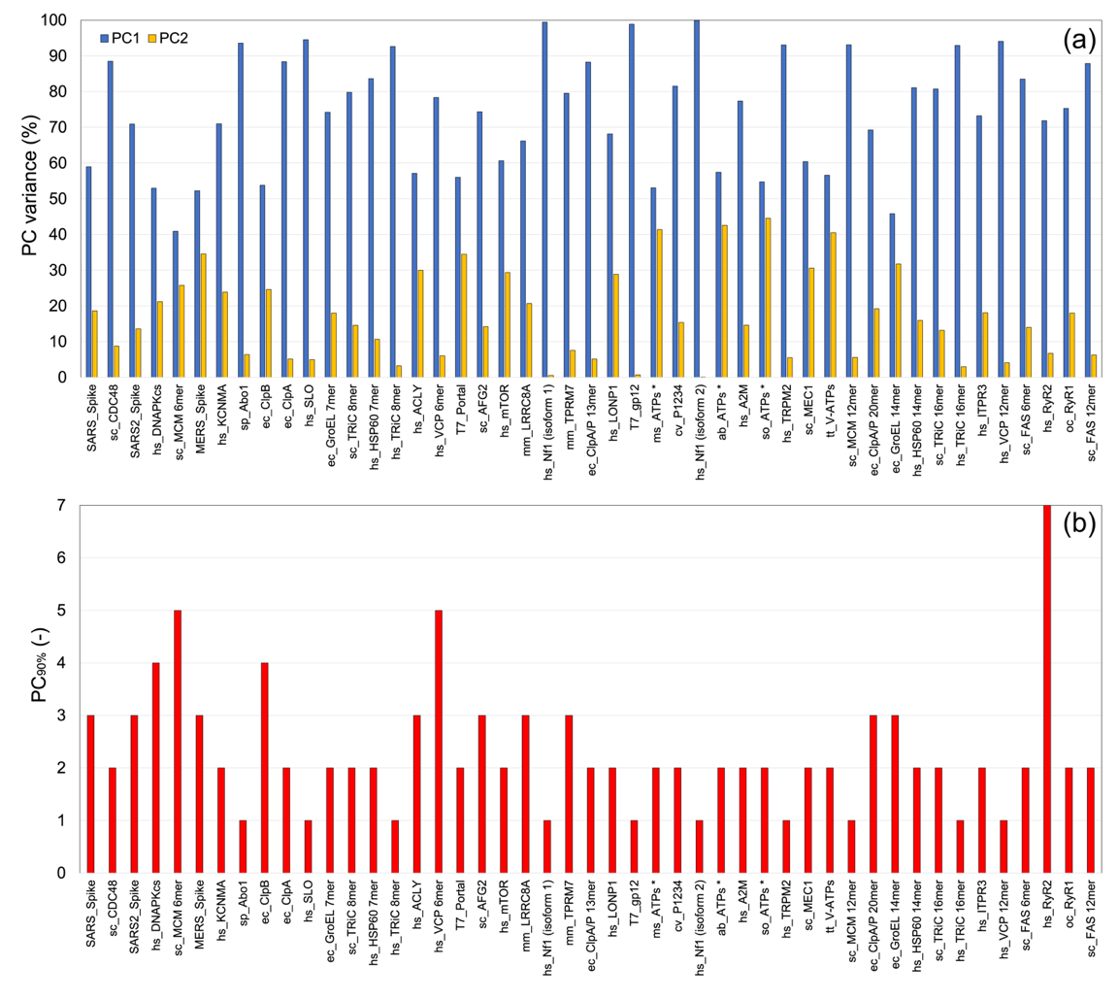
Supplementary Figure 1. PCA results of the investigated experimental ensembles: (a) variance covered by the first 2 PCs; (b) number of PCs needed to describe at least 90% of the variance.

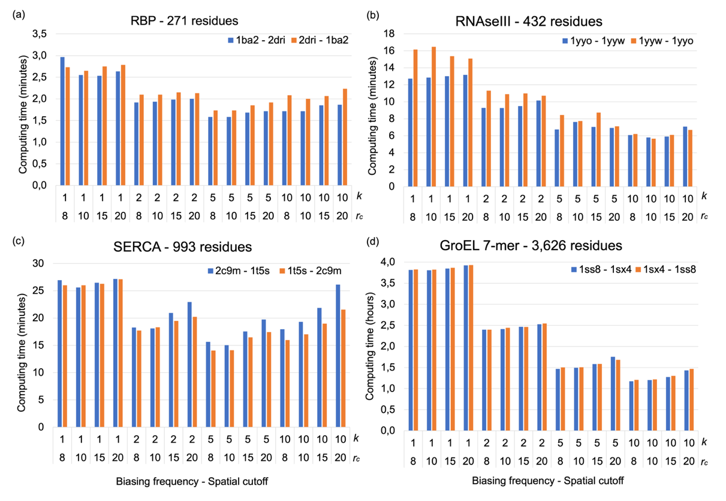
Supplementary Figure 2. Effect of the spatial cutoff r_{c} (8, 10, 15, 20Å) and biasing frequency k (1, 2, 5, 10) on the computational efficiency of eBDIMS2: (a) RBP; (b) RNAseIII; (c) SERCA; (d) GroEL 7-mer. All computations have been performed on a Linux workstation with an Intel® Core i9-13900K processor and 64 GB of RAM. Values corresponding to r_{c} = 8Å and k = 10 were selected as optimal and used for all subsequent calculations.
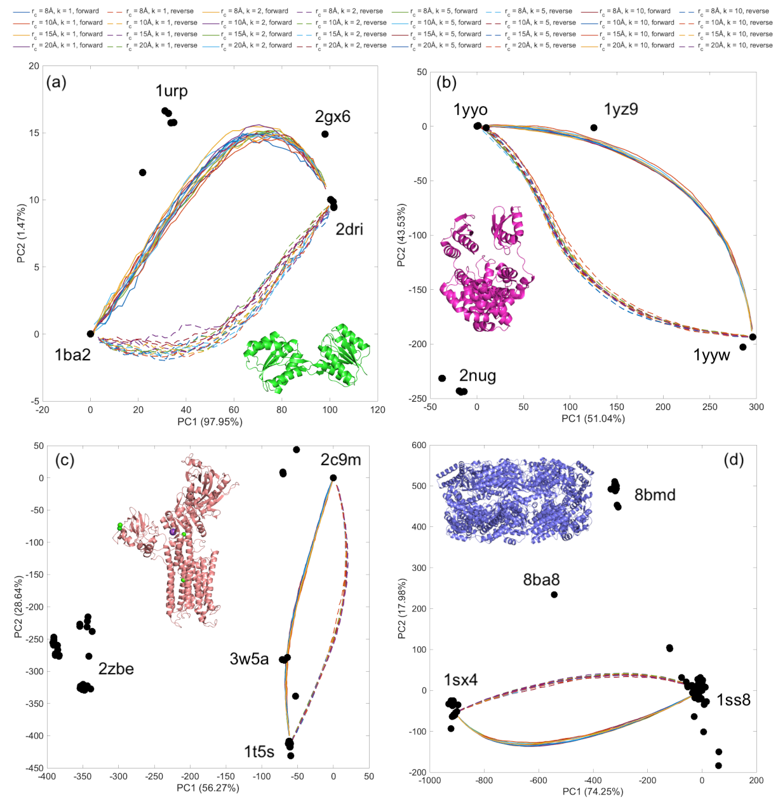
Supplementary Figure 3. Effect of the spatial cutoff r_{c} (8, 10, 15, 20Å) and biasing frequency k (1, 2, 5, 10) on the accuracy of the eBDIMS2 pathways: (a) RBP; (b) RNAseIII; (c) SERCA; (d) GroEL 7-mer. No evident impact can be observed on the PC projections of the pathways for different values of r_{c} or k.

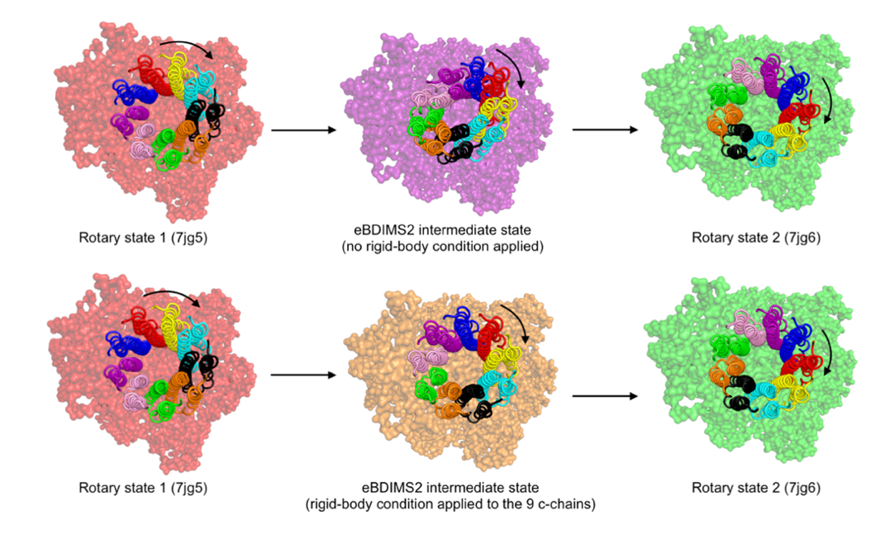
(b)
(a)
Supplementary Figure 4. Large-scale rigid rotational motions modelled in eBDIMS2: (a) artifact in the transition pathway of the F₀ rotor subunit of M. Smegmatis ATP synthase when standard ENM parameters are used for non-bonded interactions in the c-chains of the rotor; (b) more realistic pathway obtained by minimizing internal rotor deformations in eBDIMS2. All ATP synthase structures are viewed from the periplasm side. All structural components, except the nine c-chains, are drawn with a semi-transparent surface representation, while the F₀ rotor subunits are shown as cartoons. Each c-chain is drawn in a different color to highlight the ~120° rotation from rotary state 1 to state 2.

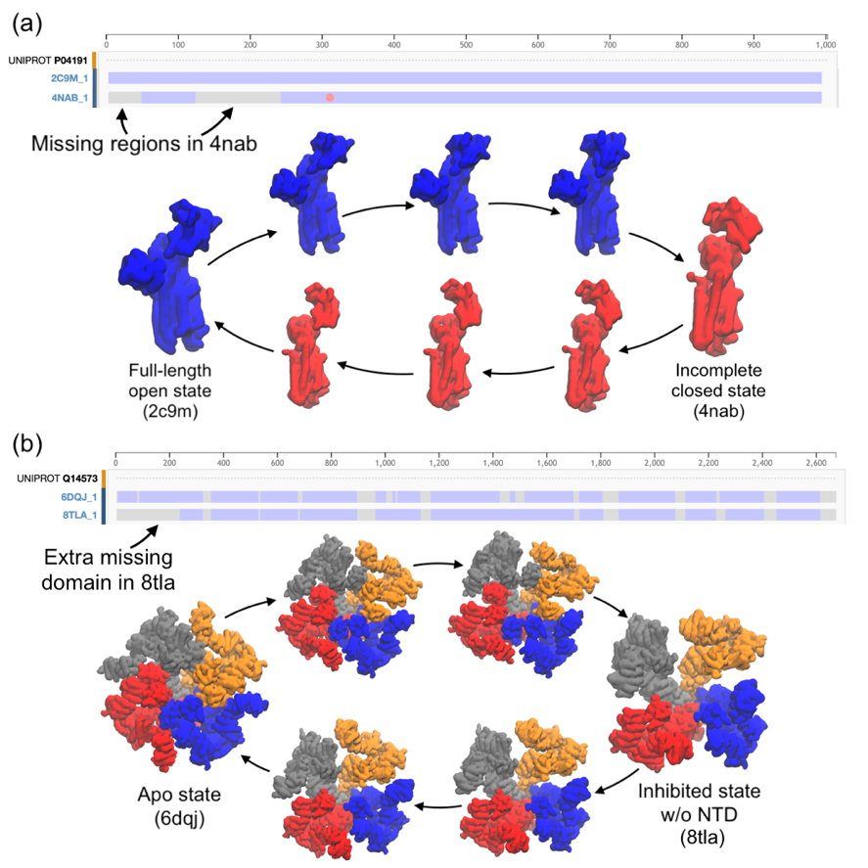
Supplementary Figure 5. Transition pathways between end-state conformers with different numbers of residues: (a) transition in SERCA between the full-length open state (PDB: 2c9m) and a closed state with most of the residues in the A-domain missing (4nab); (b) transition in ITPR3 between the apo state (6dqj) and an inhibited state with most of the residues in the N-terminal domain missing (8tla). Missing residues are highlighted in the sequences via the Sequence Alignment PDB webpage image: violet regions correspond to residues deposited in the 3D model, while grey ones account for missing residues.
Supplementary Figure 6. PC space and eBDIMS2 transitions for: (1) SARS-CoV spike glycoprotein; (2) S. Cerevisiae CDC48; (3) SARS-CoV-2 spike glycoprotein; (4) H. Sapiens DNA-PKcs; (5) S. Cerevisiae MCM 6-mer; (6) MERS spike glycoprotein; (7) H. Sapiens KCNMA; (8) S. Pombe Abo1; (9) E. Coli ClpB; (10) E. Coli ClpA. PC1-2 space report experimental structures (black dots) and eBDIMS2 pathways (colored lines). Graphical representations of the apparent motions associated with PC1 (green) and PC2 (red) eigenvectors are also reported.

Supplementary Figure 7. PC space and eBDIMS2 transitions for: (11) H. Sapiens SLO; (12) E. Coli GroEL 7-mer; (13) S. Cerevisiae TRiC 8-mer; (14) H. Sapiens HSP60 7-mer; (15) H. Sapiens TRiC 8-mer; (16) H. Sapiens ACLY; (17) H. Sapiens VCP 6-mer; (18) E. Phage Portal; (19) S. Cerevisiae AFG2; (20) H. Sapiens mTOR.

Supplementary Figure 8. PC space and eBDIMS2 transitions for: (21) M. Musculus LRRC8A; (22) H. Sapiens Nf1 (isoform 1); (23) M. Musculus TRPM7; (24) E. Coli ClpA/P 13-mer; (25) H. Sapiens LONP1; (26) E. Phage gp12; (27) M. Smegmatis ATP synthase; (28) C. Virus P1234; (29) H. Sapiens Nf1 (isoform 2); (30) A. Baumannii ATP synthase.

Supplementary Figure 9. PC space and eBDIMS2 transitions for: (31) H. Sapiens A2M; (32) S. Oleracea ATP synthase; (33) H. Sapiens TRPM2; (34) S. Cerevisiae MEC1; (35) T. Thermophilus V-type ATPase/synthase; (36) S. Cerevisiae MCM 12-mer; (37) E. Coli ClpA/P 20-mer; (38) E. Coli GroEL 14-mer; (39) H. Sapiens HSP60 14-mer; (40) S. Cerevisiae TRiC 16-mer.

Supplementary Figure 10. PC space and eBDIMS2 transitions for: (41) H. Sapiens TRiC 16-mer; (42) H. Sapiens ITPR3; (43) H. Sapiens VCP 12-mer; (44) S. Cerevisiae FAS 6-mer; (45) H. Sapiens RyR2; (46) M. Musculus RyR1; (47) S. Cerevisiae FAS 12-mer.

Supplementary Figure 11. Comparison between distribution of distances between consecutive C^{α}-C^{α} atoms for: (a) mid-point intermediates along all 191 eBDIMS2 transition pathways; (b) the 124 end-state experimental conformers used to simulate transition pathways; and (c) all 872 experimental structures used to build structural ensembles.
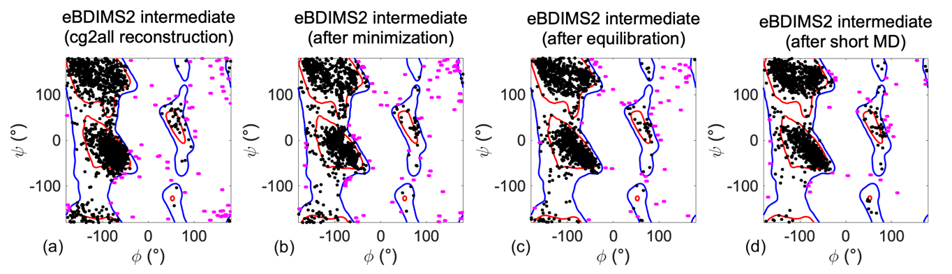
Supplementary Figure 12. Quality assessment of GroEL 7-mer eBDIMS2 intermediate along the opening pathway (1ss8-1sx4) based the all-atom reconstruction performed with cg2all¹⁰: (a) no additional refinement; (b) after 5,000 steps of minimization with solvent; (c) after additional 125 ps of NPT equilibration; (d) after a short 1-ns unbiased MD. Ramachandran ϕ-ψ plots for the general amino acids, assessed from the MolProbity webserver¹¹. Additional details on several MolProbity scores are reported in Supplementary Table 7.

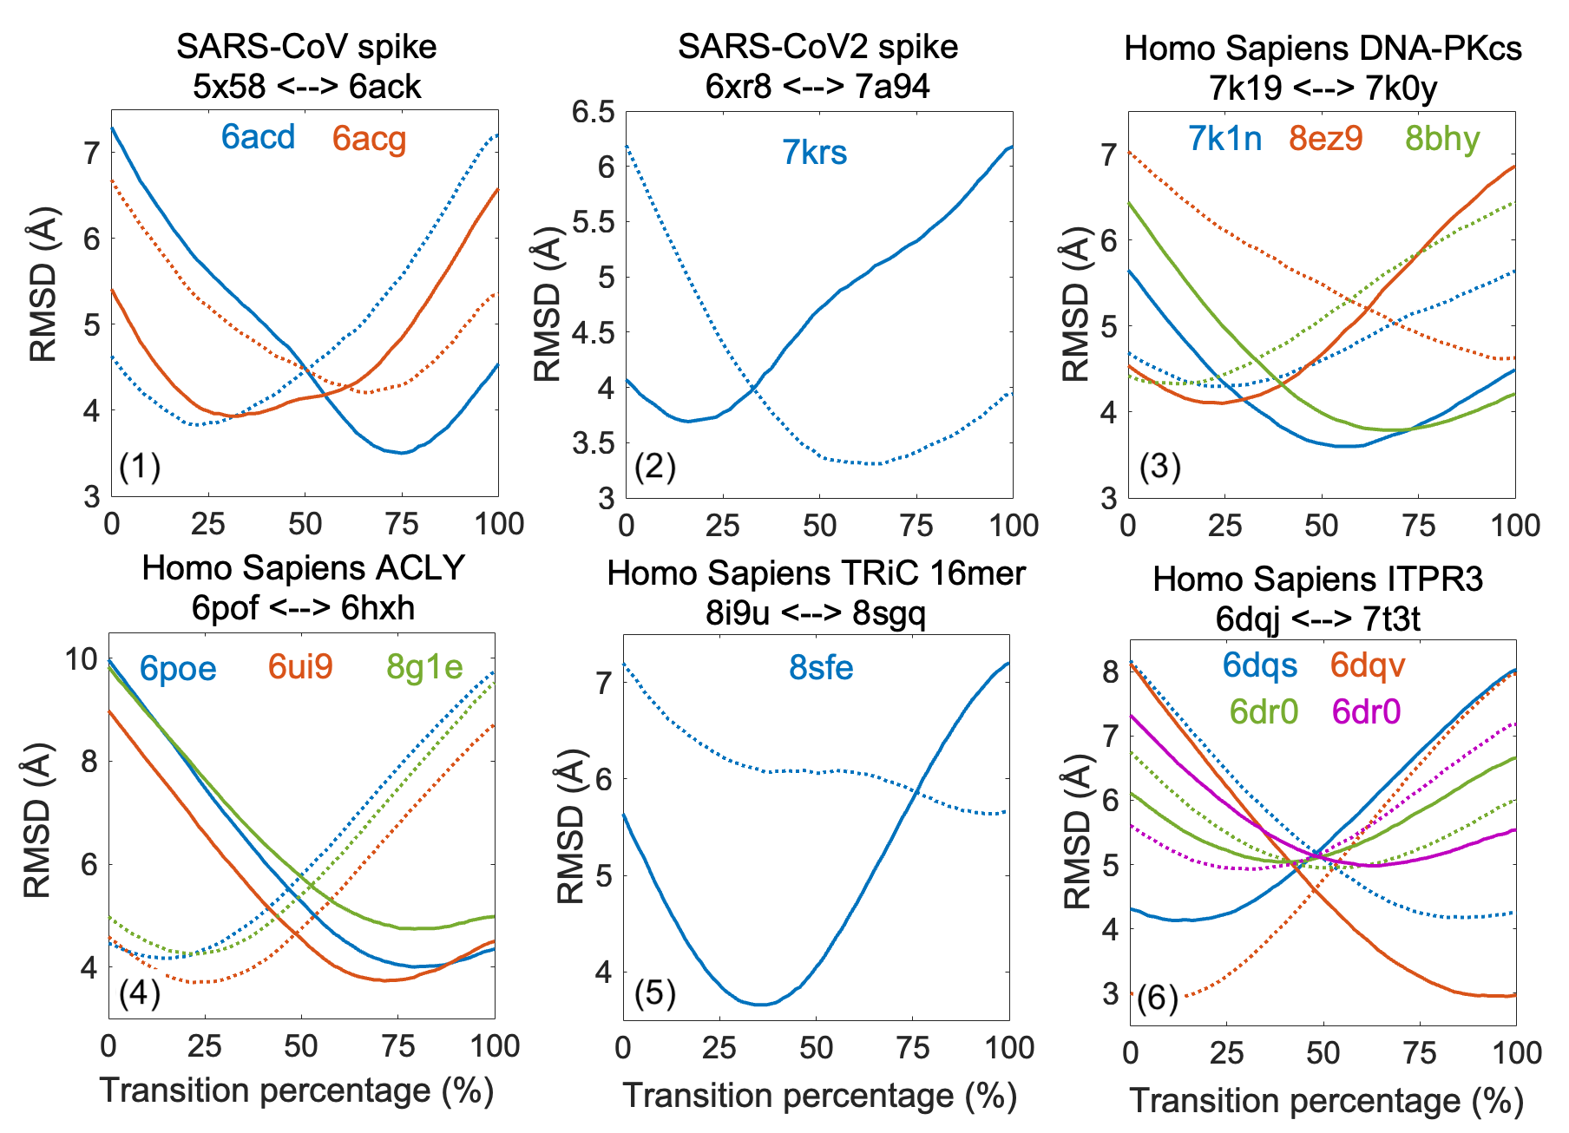
Supplementary Figure 13. RMSD values of eBDIMS2 pathways from on-path experimental intermediates for six selected systems: (1) SARS-CoV spike glycoprotein, transition between fully closed trimer (5x58) to one-RBP-up state (6ack); (2) SARS-CoV-2 spike glycoprotein, transition between fully closed trimer (6xr8) to the one-RBP-up state (7a94); (3) DNA-PKcs, transition from apo-like inactive state (7k19) to active conformer (7k0y); (4) ACLY, transition from the apo state (6pof) to the conformation in complex with citrate-CoA-Mg-ADP (6hxh); (5) H. Sapiens TRiC 16-mer, transition between PhLP2A-ADP-bound open conformation (8i9u) to ADP-bound open state (8sgq); (6) ITPR3, transition between apo conformation (6dqj) to IP3-, ATP-, and Ca2+-bound active state (7t3t). Experimental intermediates that were used to compute RMSD are reported with different colors. Continuous and dashed lines refer to the distance between forward and reverse pathways, respectively.

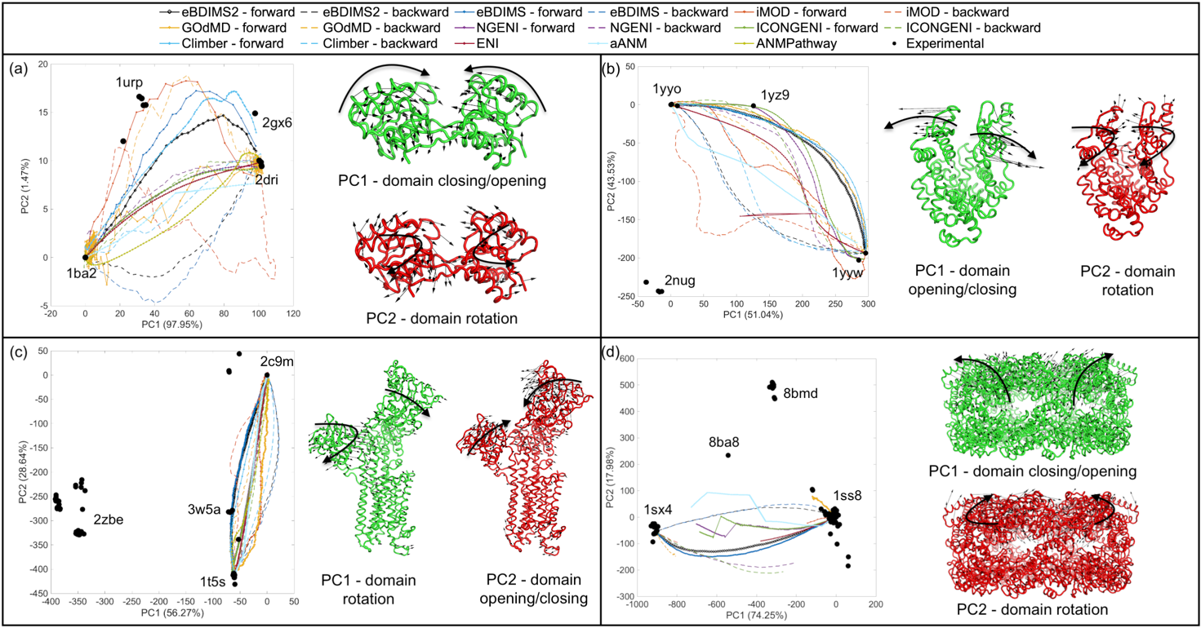
Supplementary Figure 14. PC results and transition pathways projections for: (a) RBP; (b) RNAseIII; (c) SERCA; (d) GroEL 7-mer. In the PC spaces, black dots indicate the experimental conformations in the ensemble, while colored lines represent the transition pathways evaluated with eBDIMS2, eBDIMS, iMOD, GOdMD, NGENI, ICONGENI, Climber, ENI, aANM, and ANMPathway. Non-linear methods show two distinct pathways for the forward (continuous lines) and backward (dashed lines) directions, while linear methods predict one single pathway. Vector representations of the PC1 and PC2 essential motions are also shown for each protein.
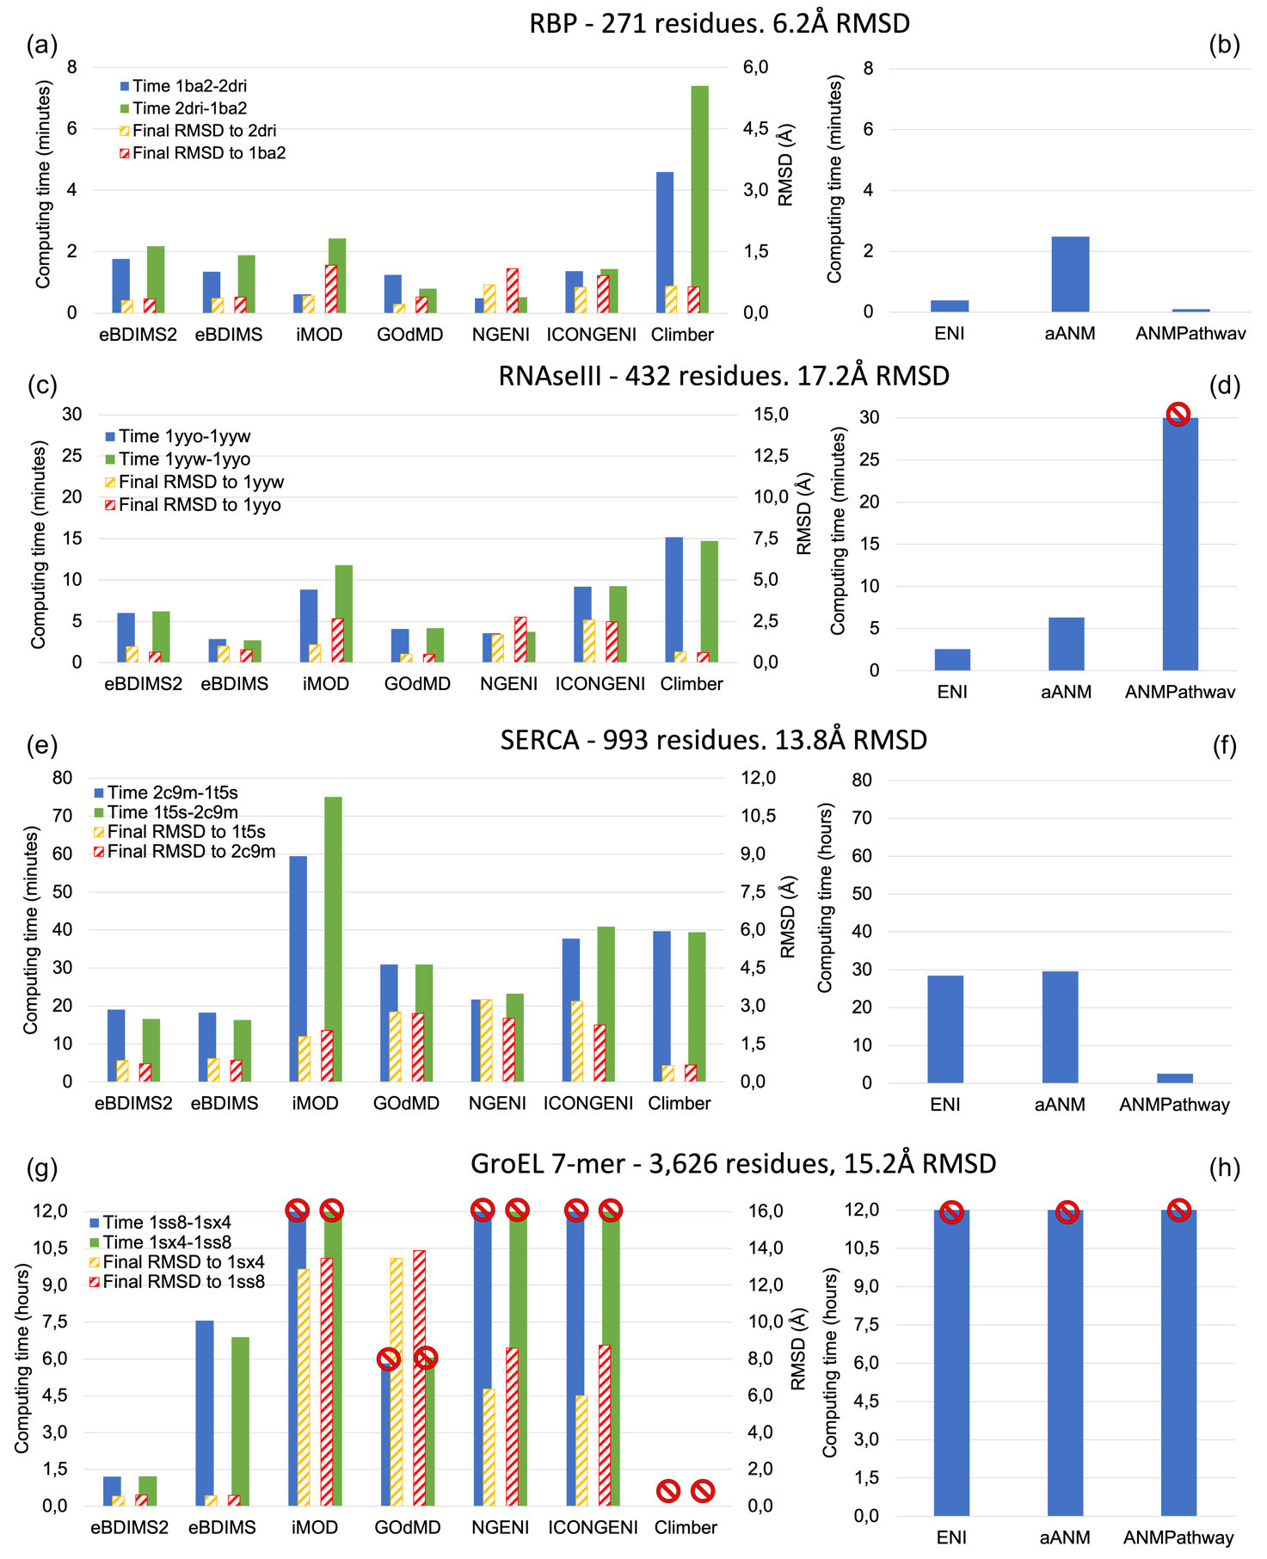
Supplementary Figure 15. Computing times for the conformational transitions of: (a,b) RBP; (c,d) RNAseIII; (e,f) SERCA; and (g,h) GroEL 7-mer. Panels (a,c,e,g) report the computing times for non-linear algorithms, for both the forward and backward directions, together with the value of RMSD from R_{t} at the moment of convergence. Panels (b,d,f,h) report the computing times for linear algorithms, where a single morphing transition connects the end states. Red stop signals in panels (d,g,h) indicate simulations that were killed because they did not achieve convergence in the allowed time threshold. For RNAseIII and GroEL, we have used time thresholds of 30 minutes and 12 hours, respectively.

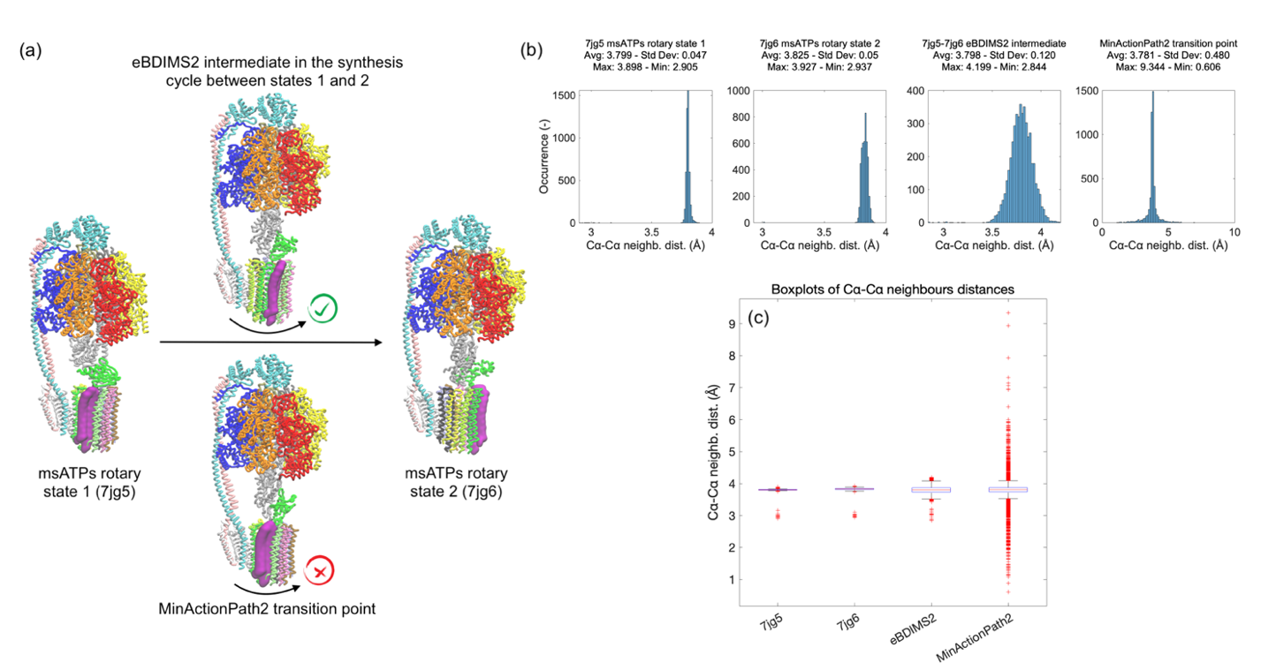
Supplementary Figure 16. Transition pathway for M. Smegmatis ATP synthase from rotary state 1 (7jg5) to rotary state 2 (7jg6) computed with eBDIMS2 and the MinActionPath2 webserver: (a) ribbon representation of the two end states, the eBDIMS2 intermediate (above), and the MinActionPath2 transition point (below). One c-chain of the rotor domain has been highlighted with purple surface representation to show that MinActionPath2 transition does not generate any rotation of the F₀ rotor domain; (b) histogram distributions of distances between consecutive C^{α} atoms (i, i + 1). From left to right: 7jg5 end state, 7jg6 end state, eBDIMS2 intermediate, MinActionPath2 transition point; (c) boxplot representations of the consecutive C^{α} atom distances reported in panel (b), where red crosses represent outliers of the distribution.

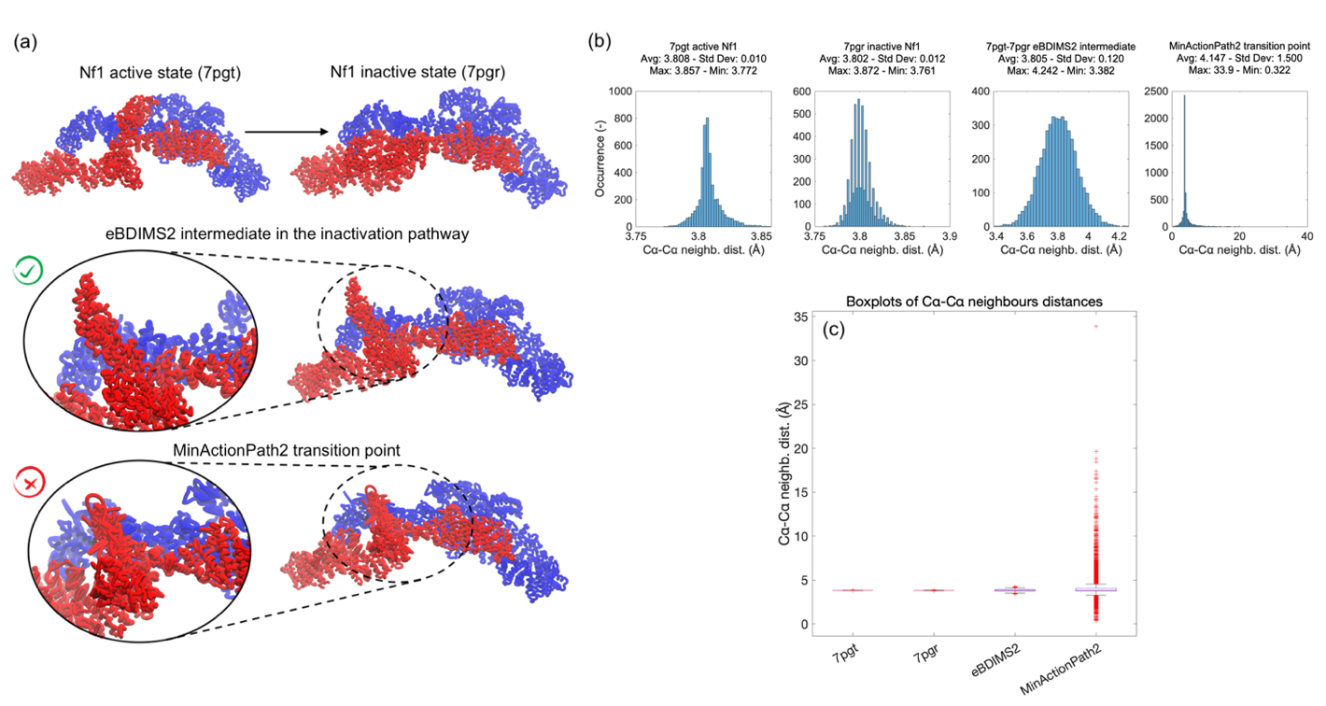
Supplementary Figure 17. Transition pathway for H. Sapiens Nf1 isoform 2 from active state (7pgt) to inactive state (7pgr) computed with eBDIMS2 and the MinActionPath2 webserver: (a) ribbon representation of the two end states, the eBDIMS2 intermediate, and the MinActionPath2 transition point. Zoomed views of the moving GRD domains to highlight the large internal distortions in the MinActionPath2 intermediate; (b) histogram distributions of distances between consecutive C^{α} atoms (i, i + 1). From left to right: 7pgt end state, 7pgr end state, eBDIMS2 intermediate, MinActionPath2 transition point; (c) boxplot representations of the consecutive C^{α} atom distances reported in panel (b), where red crosses represent outliers of the distribution.
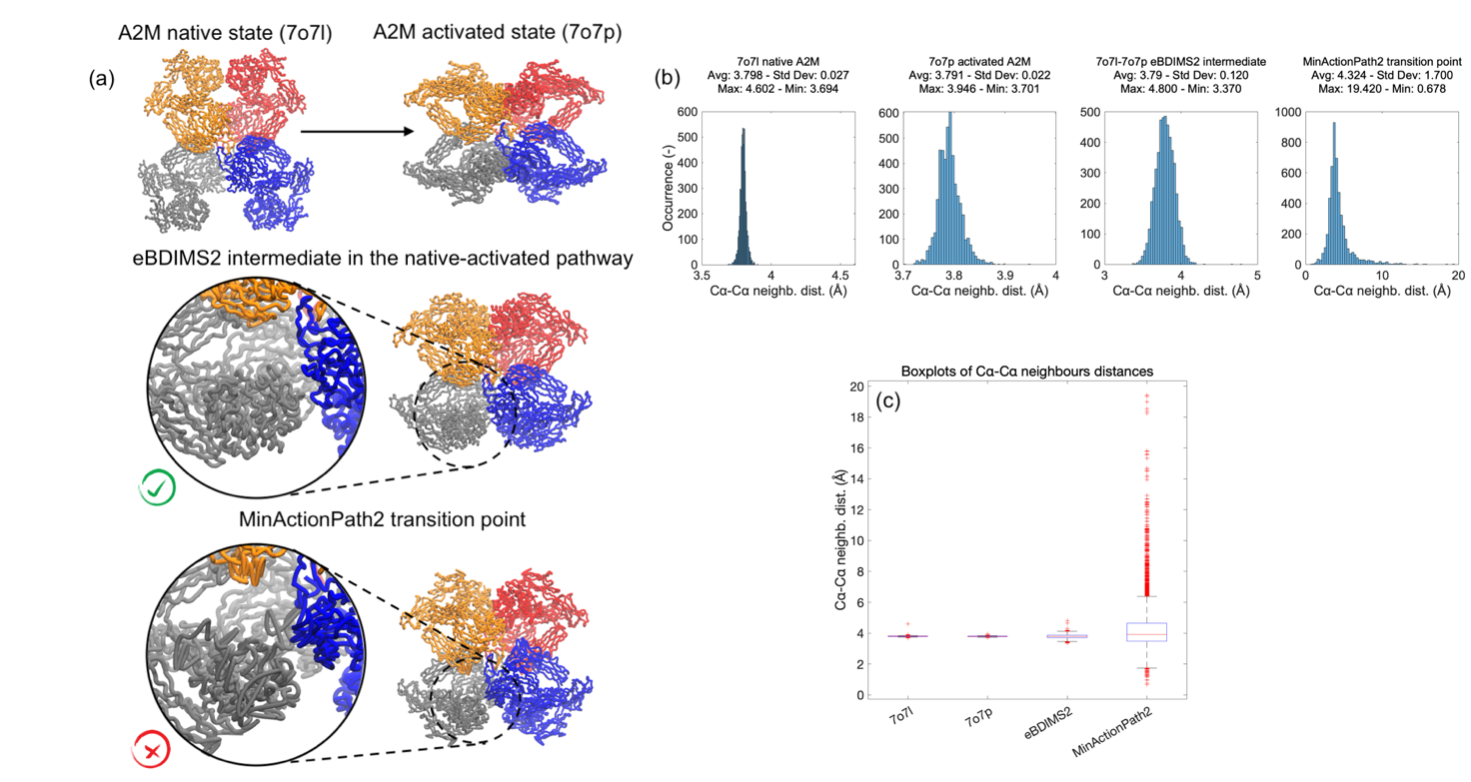
Supplementary Figure 18. Transition pathway for H. Sapiens A2M from native state (7o7l) to activated state (7o7p) computed with eBDIMS2 and the MinActionPath2 webserver: (a) ribbon representation of the two end states, the eBDIMS2 intermediate, and the MinActionPath2 transition point. Zoomed views of one of the moving domains to highlight the large internal distortions in the MinActionPath2 transition point; (b) histogram distributions of distances between consecutive C^{α} atoms (i, i + 1). From left to right: 7o7l end state, 7o7p end state, eBDIMS2 intermediate, MinActionPath2 transition point; (c) boxplot representations of the consecutive C^{α} atom distances reported in panel (b), where red crosses represent outliers of the distribution.

Supplementary Figure 19. PC projections of the TMD simulations for: (1) RBP, open-closed (1ba2-2dri) and closed-open transition (2dri-1ba2); (2) RNAseIII, closed-open (1yyo-1yyw) and open-closed transition (1yyw-1yyo); (3) SERCA, open-closed (2c9m-1t5s) and closed-open transition (1t5s-2c9m); (4) DNA-PKcs, inactive-active (7k19-7k0y) and active-inactive transition (7k0y-7k19); (5) ACLY, apo-holo (6pof-6hxh) and holo-apo transition (6hxh-6pof). Colored stars and circles refer to the starting and target TMD conformations, respectively. Scattered points are the projections of the TMD trajectories from 0 ns (blue) to 1-2 ns (yellow).

Supplementary Figure 20. PC projections of the unbiased MD simulations for: (1) RBP starting from open conformation (1ba2, blue), closed conformation (2dri, red), eBDIMS2 mid-point intermediate in the closing pathway (1ba2-2dri, green), and eBDIMS2 intermediate in the opening pathway (2dri-1ba2, orange); (2) RNAseIII starting from closed conformation (1yyo, blue), open conformation (1yyw, red), and eBDIMS2 mid-point intermediate in the opening pathway (1yyo-1yyw, green); (3) SERCA starting from open conformation (2c9m, blue), closed conformation (1t5s, red), and eBDIMS2 mid-point intermediate in the opening pathway (1t5s-2c9m, green). Colored stars refer to the starting seeds for MD simulations, and scattered points are the projections of the trajectories from 0 ns (blue) to 200 ns (yellow).
Supplementary Figure 21. PC projections of the FELs of unbiased MD simulations for: (1) RBP starting from open conformation (blue), closed conformation (red), eBDIMS2 mid-point intermediate in the open-closed pathway (green), and eBDIMS2 intermediate in the closed-open pathway (orange); (2) RNAseIII starting from closed conformation (blue), eBDIMS2 mid-point intermediate in the closed-open pathway (green), and open conformation (red); (3) SERCA starting from open conformation (blue), eBDIMS2 mid-point intermediate in the closed-open pathway (orange), and closed conformation (red). Energy values are expressed in kJ/mol.

Supplementary Figure 22. PC projections of the unbiased MD simulations for: (1) DNA-PKcs starting from inactive conformation (7k19, blue), and active conformation (7k0y, red); (2) ACLY starting from apo state (6pof, blue), and holo conformation (6hxh, red). Colored stars refer to the starting seeds for MD simulations, and scattered points are the projections of the trajectories from 0 ns (blue) to 200 ns (yellow).

Supplementary Figure 23. PC projections of the FELs of unbiased MD simulations for: (1) DNA-PKcs starting from inactive conformation (blue), and active conformation (red); (2) ACLY starting from apo state (blue), and holo state (red). Energy values are expressed in kJ/mol.

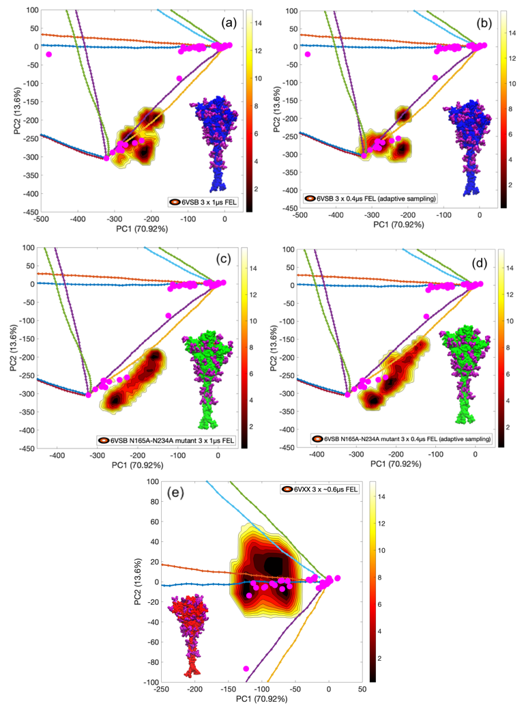
Supplementary Figure 24. PC projections of the FELs of: (a) unbiased and (b) adaptive sampling MD simulations for SARS-CoV-2 spike glycoprotein in the open conformation (PDB: 6vsb); (c) unbiased and (d) adaptive sampling MD simulations of the open conformation with N165A and N234A mutations; (e) unbiased MD simulations of the closed conformation (PDB: 6vxx). All simulations come from the Amaro’s lab²⁷ and energy values are expressed in kJ/mol.

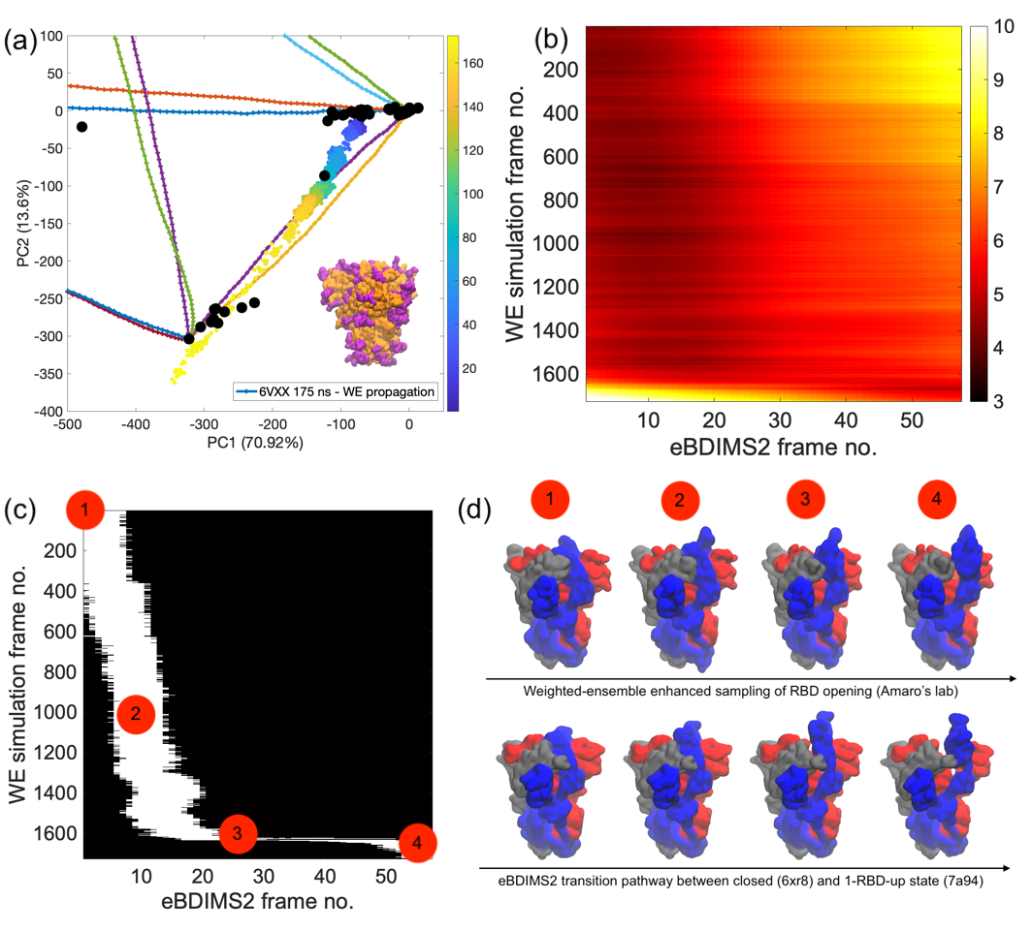
Supplementary Figure 25. Weighted-ensemble (WE) enhanced MD simulation from Amaro’s lab²⁸ for SARS-CoV-2 spike glycoprotein, starting from the closed state (PDB: 6vxx) and showing full opening of one receptor binding domain (RBP): (a) projection of the WE trajectory - from 0 ns (blue points) to 175 ns (bright yellow points) - on a zoomed portion of the experimental PC space; (b) RMSD values - from 3Å (black) to 10 Å (white) - between WE and eBDIMS2 conformers from fully closed state (6xr8) to the 1-RBD-up conformation (7a94); (c) RMSD matrix from panel (b), highlighting in white only couples of WE-eBDIMS2 conformations with low RMSD values (RMSD < RMSD_{min} + 2%); (d) comparison between four selected conformations along the WE and eBDIMS2 trajectories with minimum pairwise RMSD (~4Å).

