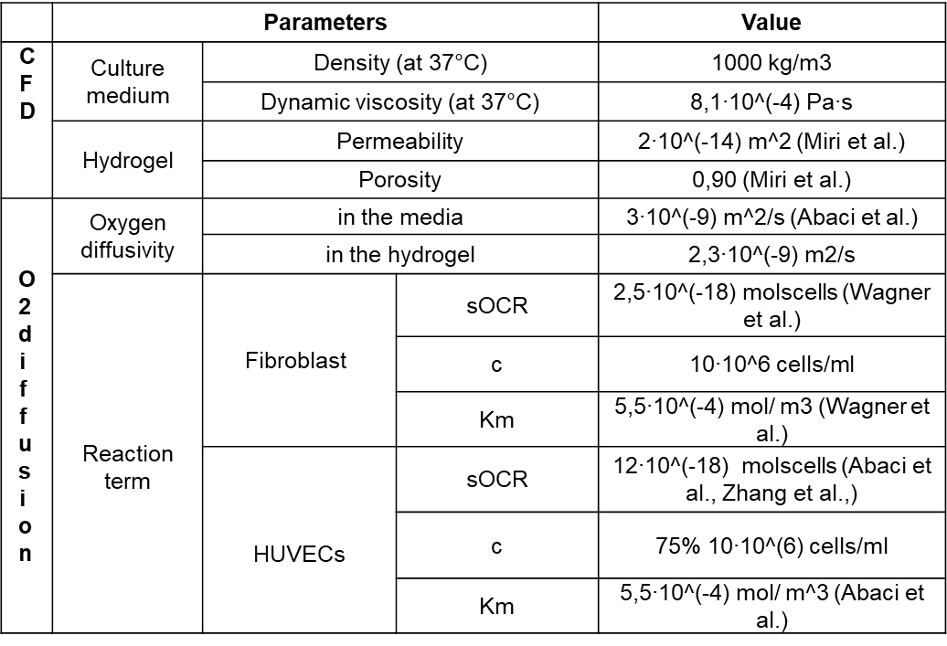
Table 1: Parameters used in the computational fluid-dynamics (CFD) simulation and O₂ diffusion.
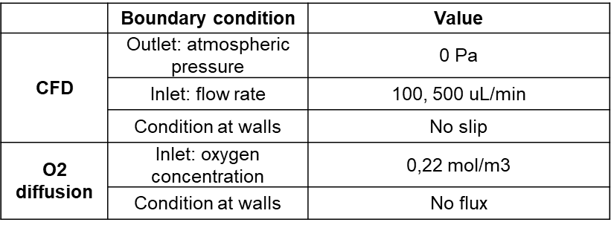
Table 2: Boundary conditions used in the simulations.

