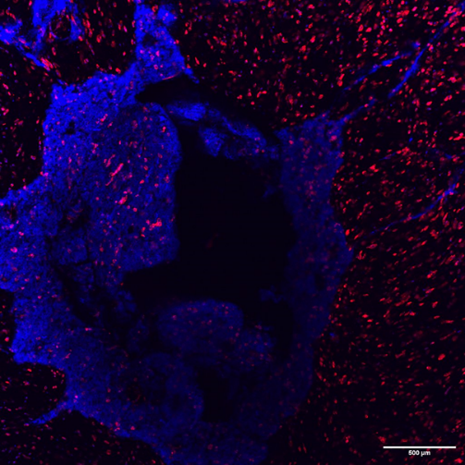

Supplementary Figure 1.
Immunophenotype Top view of fully bioprinted scaffold 7 days post-manufacturing.
Red (phalloidin), blue (Hoechst 33342)

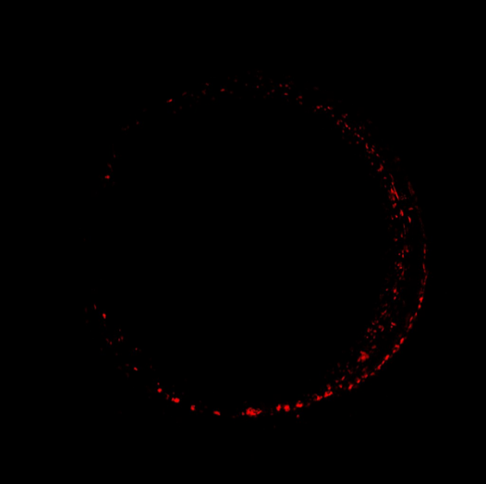

Supplementary Figure 2.
Top view of HUVEC cells distribution 1 day post-seeding in casted GelMA Fibrin.
Red (phalloidin)

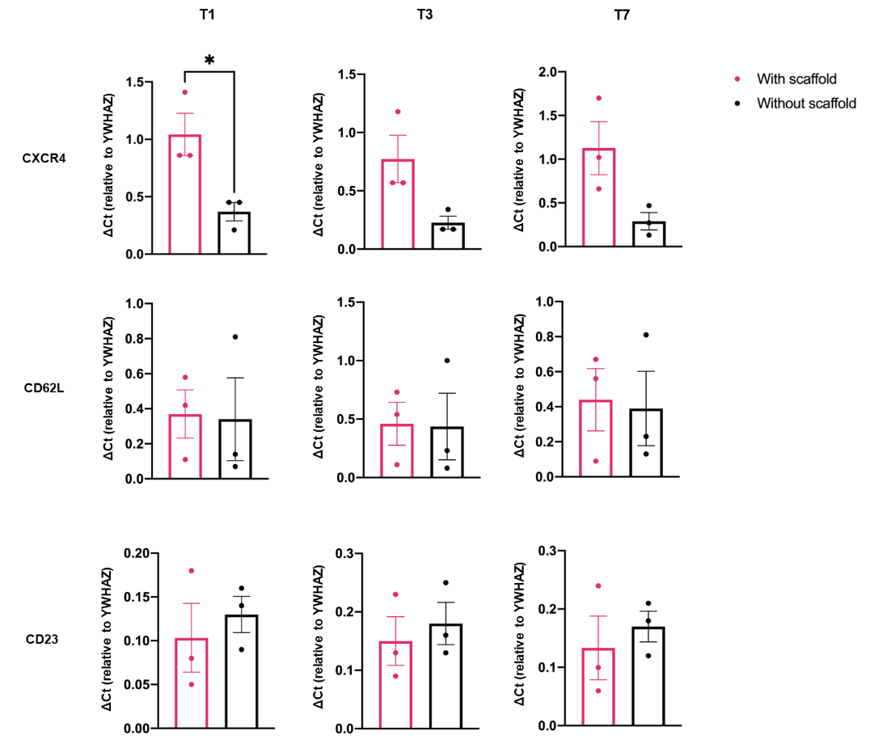

Supplementary Figure 3.
Evaluation of genes involved in activation and homing processes in circulating CLL primary cells.
CXCR4, CD62L and CD23 gene expression levels in CLL primary cells circulating in the presence (pink line) or absence (black line) of the scaffold (n=3). The data have been normalized on YWHAZ housekeeping gene. Data are represented as mean ± SEM (n=3).

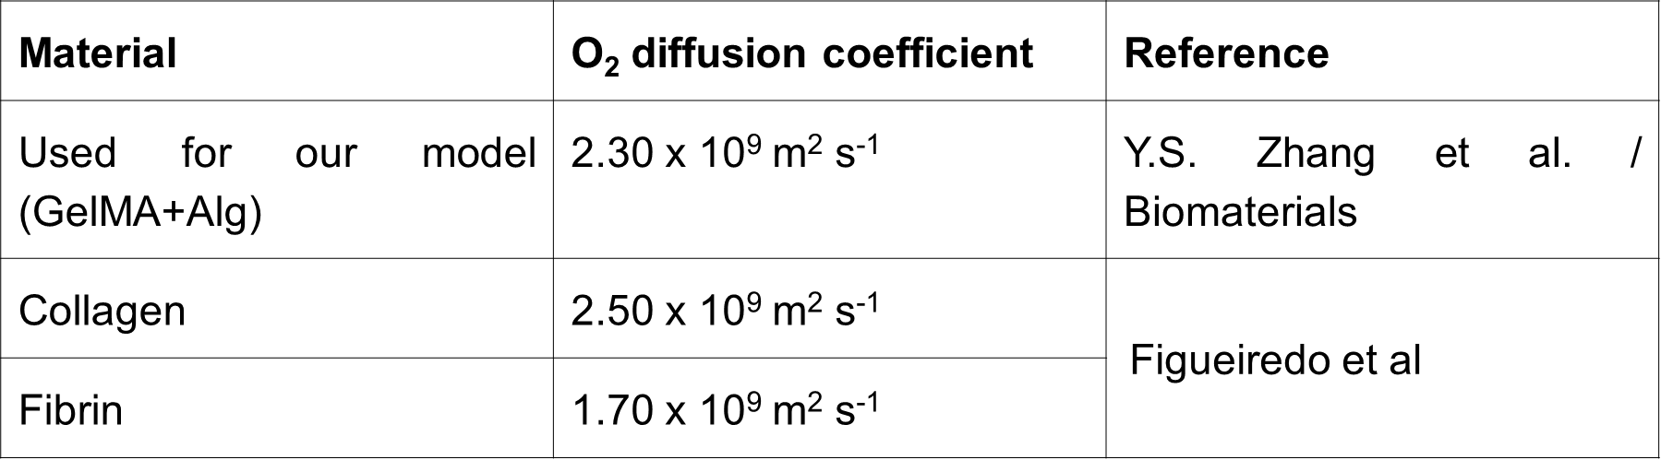

Supplementary Table 1.
Diffusion coefficient.

Supplementary Movie 1.
3D reconstruction of endothelial cells forming a mature lumen wall after 14 days of static culture.
Green (CD31), Red (phalloidin), blue (Hoechst 33342)

