Extended Data Table 1. Model results under different conditions. Letters in brackets correspond to model results in Figure 2. Permeability of the seal at the top of the main conduit and of the sides of both conduits were different for each model run. Gas input rate was divided evenly across the base of the conduit at different rates for each run. Stage 2 run for 200 years was treated as the default model, with 50 years also run for comparison. Heterogeneous porosity was tested with seals 0.05, conduit 0.3, and host rock 0.15. Modelled overpressure was calculated just below the top seal after three months of model simulation, unless the model ended prematurely in which case the end time is in brackets alongside the overpressure. Failure time was when overpressure exceeded 5 MPa. Blank cells indicate failure overpressure was never reached.
 |  |  | Stage 2 200 years |  | Stage 2 50 years |  | Heterogeneous porosity |  | Model to 1 km
Permeability top seal | Permeability side seals | Gas input rate | Over-pressure | Failure time | Over-pressure | Failure time | Over-pressure | Failure time | Over-pressure | Failure time
(log m²) | (log m²) | (kg/s) | (MPa) | (days) | (MPa) | (days) | (MPa) | (days) | (MPa) | (days)
(a) -12 | -14 | 50 | 1.8 |  | 1.8 |  | 1.8 |  | 1.8
(a) -12 | -14 | 150 | 1.9 |  | 2.1 |  | 1.9 |  | 2.0
(a) -12 | -14 | 500 | 2.6 |  | 3.4 |  | 2.7 |  | 2.8
-13 | -14 | 50 | 2.2 |  | 2.3 |  | 2.2 |  | 2.5
-13 | -14 | 150 | 2.4 |  | 2.8 |  | 2.5 |  | 2.7
-13 | -14 | 500 | 3.6 |  | 4.7 |  | 3.6 |  | 4.0
-14 | -14 | 50 | 2.4 |  | 2.4 |  | 2.4 |  | 3.0
-14 | -14 | 150 | 2.5 |  | 3.1 |  | 2.6 |  | 3.0
-14 | -14 | 500 | 3.8 |  | 5.7 | 37 | 4.0 |  | 4.3
-15 | -14 | 50 | 2.5 |  | 2.5 |  | 2.5 |  | 3.2
-15 | -14 | 150 | 2.6 |  | 3.5 |  | 2.6 |  | 3.2
-15 | -14 | 500 | 4.3 |  | 6.6 | 29 | 4.5 |  | 4.6
-16 | -14 | 50 | 2.5 |  | 2.5 |  | 2.5 |  | 3.2
-16 | -14 | 150 | 2.6 |  | 3.6 |  | 2.6 |  | 3.3
-16 | -14 | 500 | 4.4 |  | 6.7 | 23 | 4.6 |  | 4.6
(b) -17 | -14 | 50 | 2.5 |  | 2.5 |  | 2.5 |  | 3.2
(b) -17 | -14 | 150 | 2.6 |  | 3.7 |  | 2.6 |  | 3.3
(b) -17 | -14 | 500 | 4.5 |  | 6.7 | 23 | 4.6 |  | 4.6
-12 | -15 | 50 | 1.9 |  | 1.9 |  | 1.9 |  | 1.9
-12 | -15 | 150 | 2.3 |  | 2.4 |  | 2.4 |  | 2.6
-12 | -15 | 500 | 3.7 |  | 4.1 |  | 3.8 |  | 4.6
(d) -13 | -15 | 50 | 2.5 |  | 2.6 |  | 2.5 |  | 2.7
(d) -13 | -15 | 150 | 3.0 |  | 3.2 |  | 3.1 |  | 3.4
(d) -13 | -15 | 500 | 5.4 | 71 | 6.3 | 41 | 5.5 | 68 | 6.9 | 34
-14 | -15 | 50 | 2.7 |  | 2.7 |  | 2.6 |  | 2.9
-14 | -15 | 150 | 3.7 |  | 4.3 |  | 3.8 |  | 4.5
-14 | -15 | 500 | 7.4 | 14 | 9.2 | 12 | 7.6 | 15 | 10.1 | 20
-15 | -15 | 50 | 2.8 |  | 2.9 |  | 2.8 |  | 3.0
-15 | -15 | 150 | 3.9 |  | 4.7 |  | 4.0 |  | 4.8
-15 | -15 | 500 | 8.1 | 14 | 10.3 | 11 | 8.4 | 12 | 10.9 | 20
-16 | -15 | 50 | 2.9 |  | 3.0 |  | 2.8 |  | 3.0
-16 | -15 | 150 | 4.0 |  | 4.9 |  | 4.1 |  | 4.8
-16 | -15 | 500 | 8.4 | 10 | 10.5 | 9 | 8.6 | 12 | 11.3 | 20
-17 | -15 | 50 | 2.9 |  | 3.0 |  | 2.8 |  | 3.0
-17 | -15 | 150 | 4.1 |  | 4.9 |  | 4.1 |  | 4.8
-17 | -15 | 500 | 8.4 | 10 | 10.6 | 9 | 8.6 | 12 | 11.3 | 20
-12 | -16 | 50 | 1.9 |  | 1.9 |  | 1.9 |  | 1.9
-12 | -16 | 150 | 2.8 |  | 2.8 |  | 2.9 |  | 3.0
-12 | -16 | 500 | 4.8 |  | 4.9 |  | 4.9 |  | 6.4 | 49
-13 | -16 | 50 | 2.6 |  | 2.6 |  | 2.5 |  | 2.8
-13 | -16 | 150 | 4.0 |  | 4.1 |  | 4.1 |  | 4.3
-13 | -16 | 500 | 9.1 | 6 | 9.2 | 6 | 9.2 | 9 | 10.9 | 19
-14 | -16 | 50 | 3.6 |  | 3.7 |  | 3.4 |  | 3.0
-14 | -16 | 150 | 7.9 | 16 | 8.1 | 17 | 8.3 | 25 | 8.2 | 56
-14 | -16 | 500 | 16.9 (13) | 4 | 17.3 (12) | 5 | 16.7 (13) | 8 | 24.3 | 17
-15 | -16 | 50 | 4.2 |  | 4.4 |  | 4.3 |  | 3.2
-15 | -16 | 150 | 10.1 | 15 | 10.4 | 13 | 10.5 | 24 | 10.7 | 50
-15 | -16 | 500 | 19.7 (11) | 4 | 20.2 (11) | 5 | 18.7 (12) | 8 | 28.0 (28) | 17
-16 | -16 | 50 | 4.4 |  | 4.5 |  | 4.5 |  | 3.2
-16 | -16 | 150 | 10.4 | 14 | 10.8 | 13 | 10.8 | 23 | 11.2 | 48
-16 | -16 | 500 | 20.6 (11) | 4 | 21.1 (11) | 5 | 19.0 (12) | 8 | 28.6 (27) | 15
-17 | -16 | 50 | 4.5 |  | 4.6 |  | 4.6 |  | 3.2
-17 | -16 | 150 | 10.6 | 13 | 11.0 | 13 | 10.9 | 23 | 11.3 | 49
-17 | -16 | 500 | 20.9 (11) | 4 | 21.4 (11) | 5 | 19.3 (12) | 8 | 28.8 (26) | 15
(c) -12 | -17 | 50 | 1.9 |  | 1.9 |  | 1.9 |  | 1.9
(c) -12 | -17 | 150 | 3.0 |  | 3.0 |  | 3.0 |  | 3.1
(c) -12 | -17 | 500 | 4.9 |  | 5.0 |  | 5.1 | 55 | 6.8 | 46
-13 | -17 | 50 | 2.6 |  | 2.6 |  | 2.5 |  | 2.8
-13 | -17 | 150 | 4.5 |  | 4.6 |  | 4.5 |  | 4.6
-13 | -17 | 500 | 8.2 (22) | 5 | 8.3 (24) | 6 | 8.3 (22) | 10 | 12.1 | 17
-14 | -17 | 50 | 4.9 |  | 4.9 |  | 4.4 |  | 3.1
-14 | -17 | 150 | 11.4 | 15 | 11.4 | 15 | 11.8 | 22 | 11.1 | 47
-14 | -17 | 500 | 26.5 (9) | 5 | 26.7 (9) | 5 | 20.4 (11) | 8 | 29.7 (23) | 15
-15 | -17 | 50 | 6.9 | 43 | 7.0 | 43 | 6.1 | 76 | 3.2
-15 | -17 | 150 | 17.0 | 12 | 17.2 | 11 | 17.9 (87) | 21 | 16.4 | 46
-15 | -17 | 500 | 32.4 (8) | 4 | 32.2 (8) | 4 | 22.5 (10) | 7 | 35.1 (19) | 14
-16 | -17 | 50 | 7.3 | 39 | 7.4 | 40 | 6.4 | 73 | 3.3
-16 | -17 | 150 | 17.8 (88) | 11 | 17.9 (86) | 13 | 18.5 (78) | 22 | 17.2 | 44
-16 | -17 | 500 | 34.3 (8) | 4 | 34.1 (8) | 4 | 22.9 (10) | 7 | 35.7 (19) | 14
(e) -17 | -17 | 50 | 7.5 | 39 | 7.6 | 39 | 6.5 | 72 | 3.3
(e) -17 | -17 | 150 | 17.9 (82) | 12 | 18.0 (84) | 13 | 18.6 (77) | 22 | 17.5 | 44
(e) -17 | -17 | 500 | 35.1 (8) | 4 | 34.8 (8) | 4 | 23.1 (10) | 7 | 35.9 (19) | 14

Extended Data Figure 1. Plot of model results with different permeabilities and magmatic gas inputs in a grid block within the vent directly below the seal (red star in Figure 1). Orange lines with triangles show overpressure, grey dashed lines represent failure overpressure corresponding to the tensile strength threshold of ~5 MPa. Green lines with circles show vapour saturation, given by the proportion of air + steam as a fraction of total fluid. Each page corresponds to a different side seal permeability, each row a different top seal permeability, and each column a different basal gas input rate. If model results exceeded Waiwera capabilities (>100 MPa, 350 °C) the model ended prematurely.

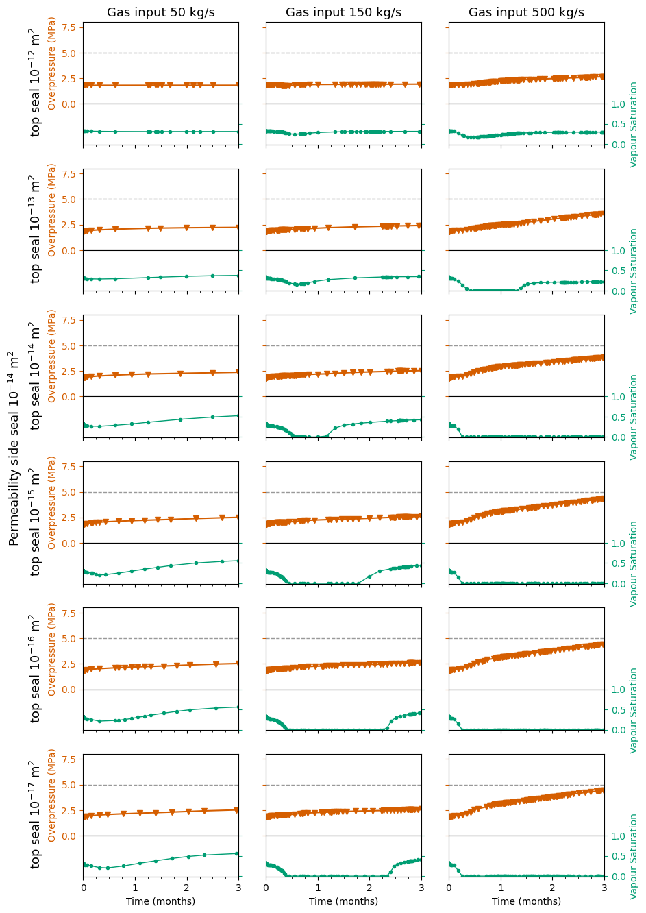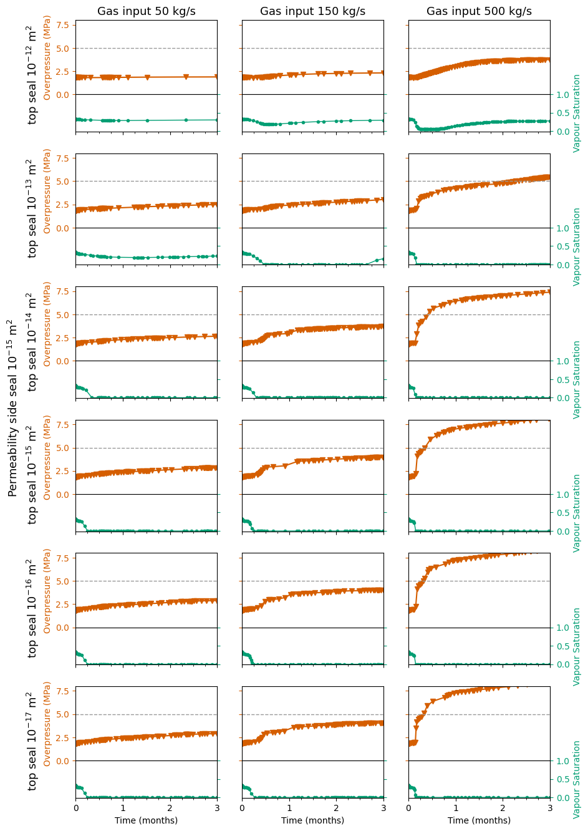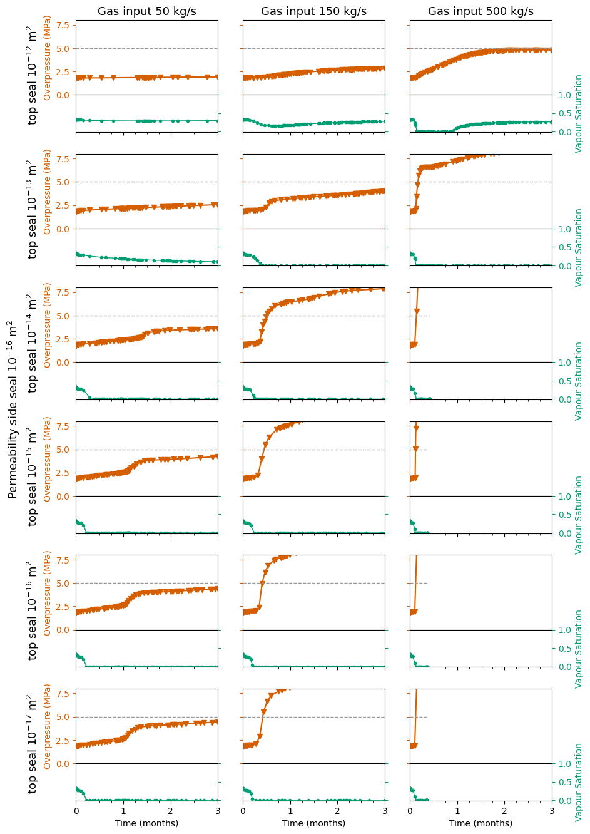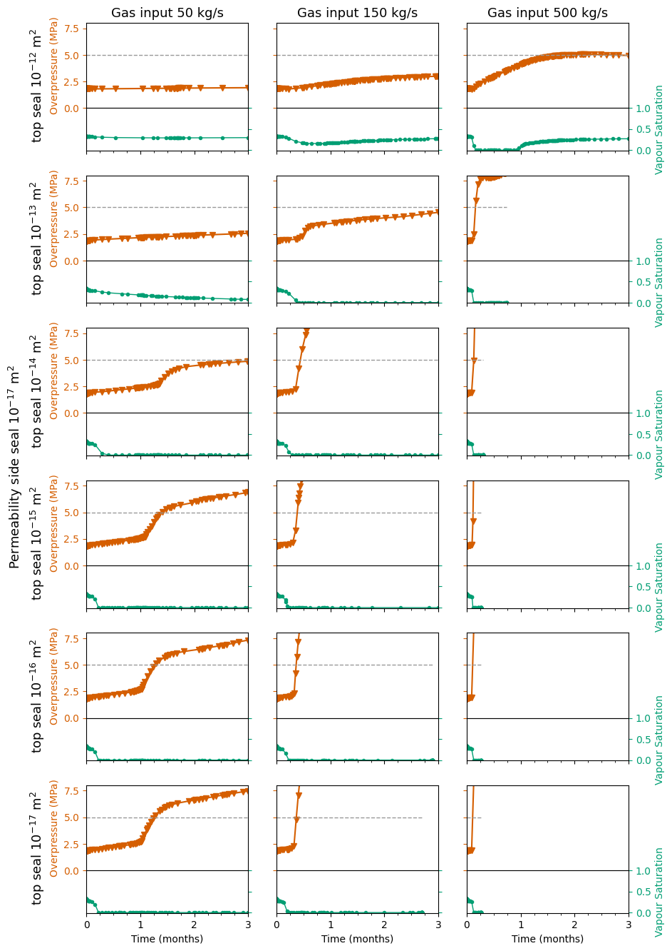

Extended Data Figure 2. Cross-section of Waiwera model grid using TIM visualisation tool. Grid spacing was the same in the perpendicular horizontal direction. Heat was injected across the base of the model (yellow) and hot mass was also injected across the base of the conduit (orange). Cold rainfall was injected into all cells across the top of the model (blues) and the top boundary was set at atmospheric temperature. Aerial blocks (light blue) were set at atmospheric pressure, oceanic blocks (dark blue) at hydrostatic pressure. Vertical boundaries were no-flow.
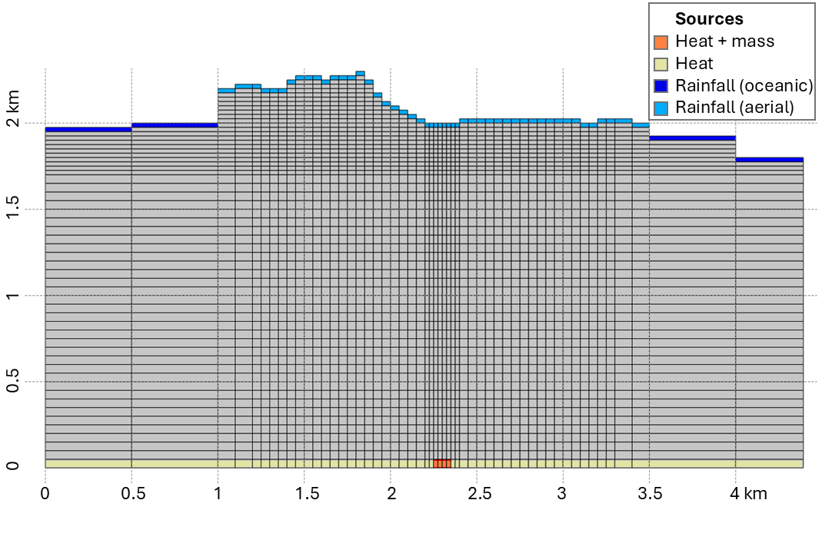
Extended Data Figure 3. Initial pressure (left), temperature (centre), and vapour saturation (right) for different stages of Waiwera hydrothermal modelling. 1) Initial modelled temperature and pressure were uniform at atmospheric values. The model was run for 1 Myr with magmatic gas input from depth at 5 kg/s and 350 °C corresponding to the first, long-term stage of hydrothermal activity. 2) Results of Stage 1 were used as initial conditions for a model representing increased activity over the last 200 years. 3) Results from Stage 2 were used as initial conditions for models of pre-eruptive activity over three months as described in the main body of the text.
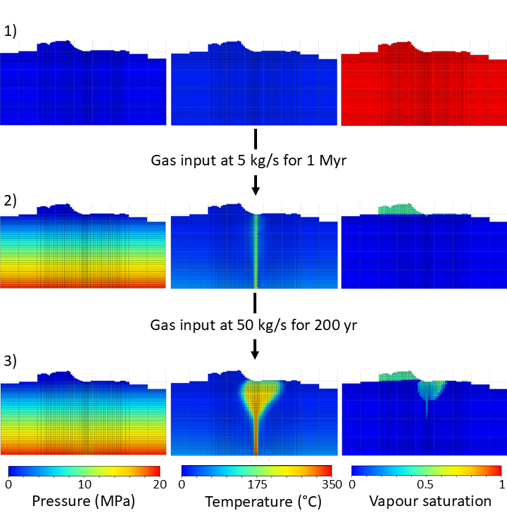

Extended Data Table 2. Simulation parameters used in Waiwera models.
Model parameter | Value or range | Units | Source
Porosity | 0.15 |  | ^{19,31}
Wet heat conductivity | 1.5 | W/m°C | ⁶⁰
Specific heat capacity | 900 | J/kg°C | ⁵⁹
Permeability host rock | 1 × 10^{–14} | m² | ^{19,31}
Permeability conduit | 1 × 10^{–12} | m² | ^{19,31}
Permeability top seal | 1 × 10^{–17} to 1 × 10^{–12} | m² | ^{19,31}
Permeability side seals | 1 × 10^{–17} to 1 × 10^{–14} | m² | ^{19,31}
Basal heat flux | 0.1 | W/m² | ⁶⁰
Conduit total mass rate | 5 to 500 | kg/s | ^{12,16,30,61}
Conduit mass enthalpy | 1600 | kJ/kg | ⁶¹
Rainfall mass input rate | 1.93 × 10^{–6} | Kg/s/m² | ⁵⁹
Rainfall enthalpy | 60 | kJ/kg | ⁵⁹

Extended Data Figure 4. Final modelled pressure (left), temperature (centre), and vapour saturation (right) for different scenarios corresponding to different columns of Extended Data Table 1. Results are shown for the same model as Figure 4, with top seal permeability of 10⁻¹⁴ m², side seals permeability of 10⁻¹⁵ m², and gas input at 500 kg/s, where the difference between the times to 5 MPa overpressure were greatest (Extended Data Table 1). a) The default model, with uniform porosity and Stage 2 run for 200 years. b) Stage 2 run for 50 years; all else the same as in (a). c) With heterogeneous porosity of 0.05 (seals), 0.3 (conduit) and 0.15 (host rock). d) With the model to 1 km depth rather than 2 km, corresponding to a shallower magma reservoir. All other parameters as in model (a).
