Table S1. Participant biometric and Stress perception details
 | Female  N=18 | Male  N=22 | Total  N=40
Age (years) | 21.9 ± 2.89 | 22.5 ± 3.83 | 22.2 ± 3.40
Weight (kg)** | 56.9 ± 5.19 | 75.7 ± 9.45 | 67.2 ± 12.23
Height (cm)** | 166 ± 4.58 | 178 ± 4.95 | 172.6 ± 7.92
BMI (kg/m²)** | 20.7 ± 1.38 | 23.8 ± 2.78 | 22.4 ± 2.73
Perceived Stress (0-100) | 48.3 ± 17.9 | 50.2 ± 15.70 | 49.4 ± 16.55
Data presented as mean ± standard deviation. Confidence interval for the differences observed between females and males was 99%. ** Variables that show significant differences between sexes (p < 0.001)

Supplementary Figure S1. Schematic representation of the research approach. Stress induction/relaxation protocol steps and sample collection timeline are shown. Instructions: participants were asked to wake up at least 2 hours before the sessions, have a light breakfast without caffeine or tea, and refrain from exercising or consuming any psychotropic substance, drinking alcohol, or smoking 24 hours before the session day. Four different saliva samples were collected: two after each baseline stage (B_{RS}, B_{SS}) and the other two at the end of each session (RS, SS). At the end of each session, blood sample collection and psychometric tests were performed. For TSST-M implementation, a series of stressful tasks, including storytelling stage (STS), memory test stage (MTS), stress anticipation stage (SAS), video display stage (VDS), and arithmetic task stage (ATS), were run.

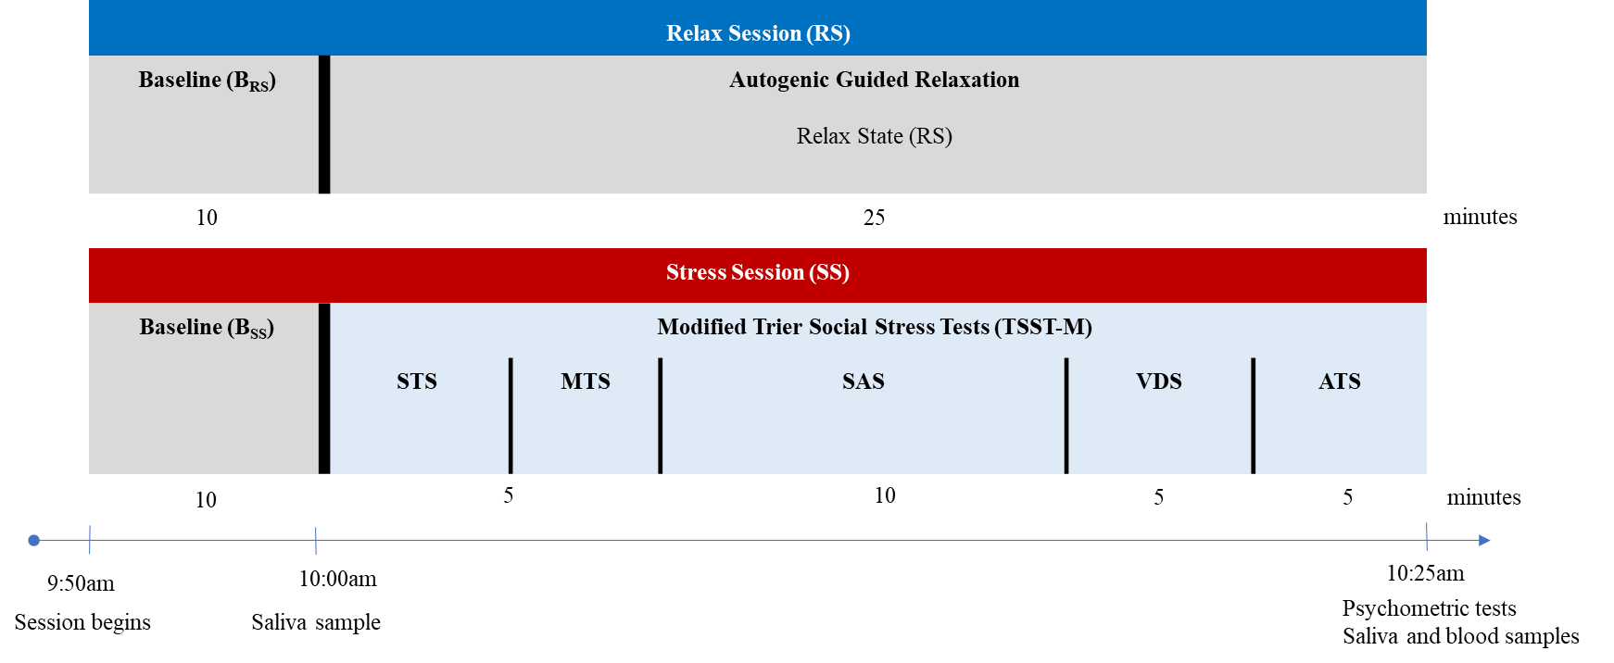

Supplementary Figure S2. PC loading plots of the m/z of the features for both ESI (+) and ESI (-) modes (A and B, respectively). Each dot represents an individual metabolite.

