Table 1: pharmacophore generated selected compounds
COMPOUND ID | STRUCTUTE | Molecular Weight | Rule of 5
ZINC000049420826 | 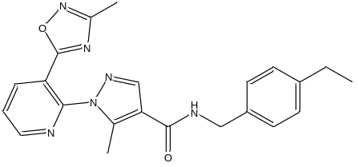 | 402.4 g/mol | pass
ZINC000071768678 | 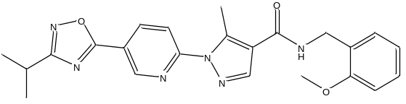 | 432.5 g/mol | pass
ZINC000071768664 | 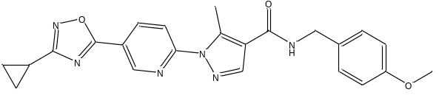 | 430.5 g/mol | pass
ZINC000071768289 | 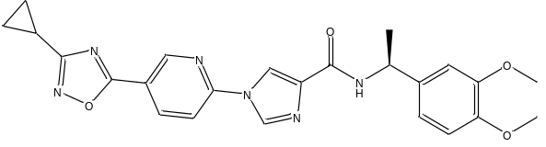 | 460.5 g/mol | pass
ZINC000071768671 | 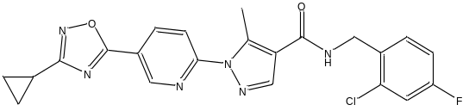 | 452.9 g/mol | pass
ZINC000071768673 | 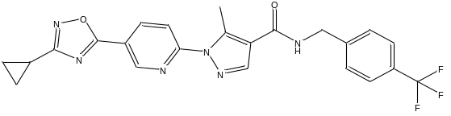 | 468.4 g/mol | pass
ZINC000071768663 | 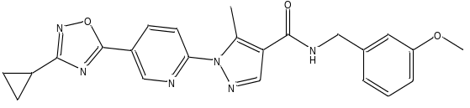 | 430.5 g/mol | pass
ZINC000062551494 | 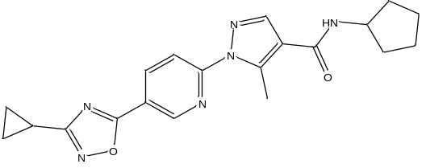 | 378.4 g/mol | pass
ZINC000065251501 | 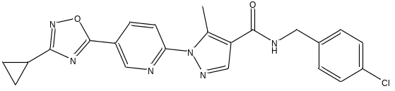 | 434.9 g/mol | pass
ZINC000071768662 | 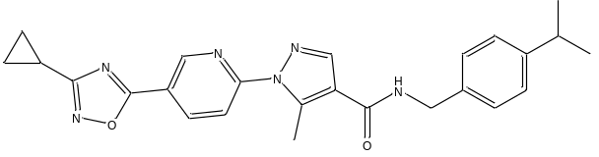 | 442.5 g/mol | pass
ZINC000065251495 | 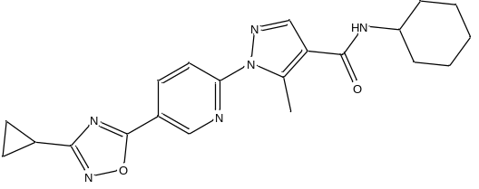 | 392.5 g/mol | pass
ZINC000071768666 | 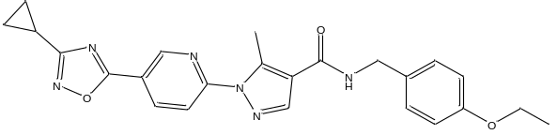 | 444.5 g/mol | pass
ZINC000071768672 | 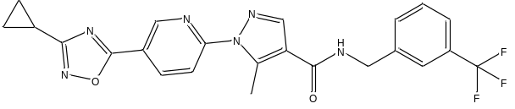 | 468.4 g/mol | pass

