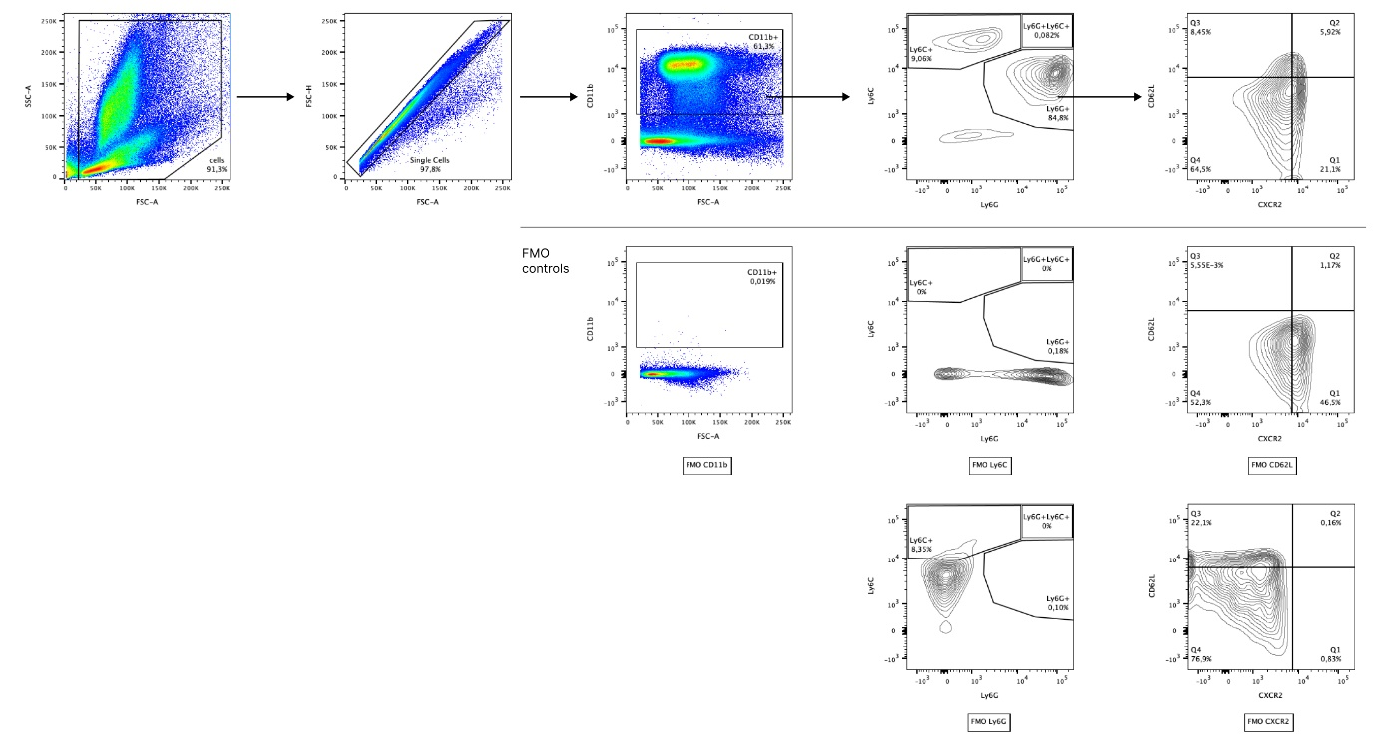
Supplementary Figure 1.
Flow cytometry gating strategy for analyzes of bone marrow neutrophils. Sequential gating shows the initial cell population based on forward and side scatter (FSC-A vs. SSC-A), followed by singlet identification (FSC-A vs. FSC-H) and subsequent analysis of neutrophil subsets based on cell surface marker presence (CD11b, Ly6C, Ly6G, CXCR2, CD62L). Top row demonstrates the gating strategy for stained samples, while bottom row shows corresponding FMO (Fluorescence Minus One). Representative plots from one sample are shown.

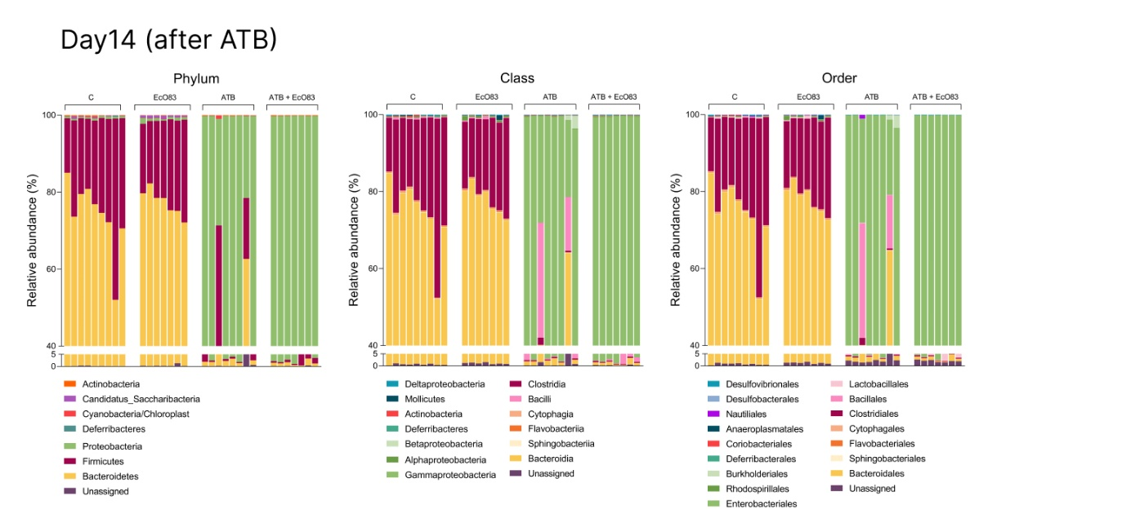
Supplementary Figure 2.
Analysis of bacterial composition at day 14 (i.e. immediately after antibiotic treatment). Stacked bar charts showing relative abundance at phylum, class, and order levels in control mice (C), antibiotic-treated mice (ATB), mice designated for subsequent EcO83 treatment (EcO83), and mice designated for combined antibiotic and EcO83 treatment (ATB+EcO83). Data represent mean relative abundance of bacterial taxa. C - non-treated controls, EcO83 – Escherichia coli O83:K24:H31-treated group, ATB - antibiotic-treated group to induce dysbiosis, ATB+EcO83 - combined antibiotic-treated group with subsequent Escherichia coli O83:K24:H31 administration.
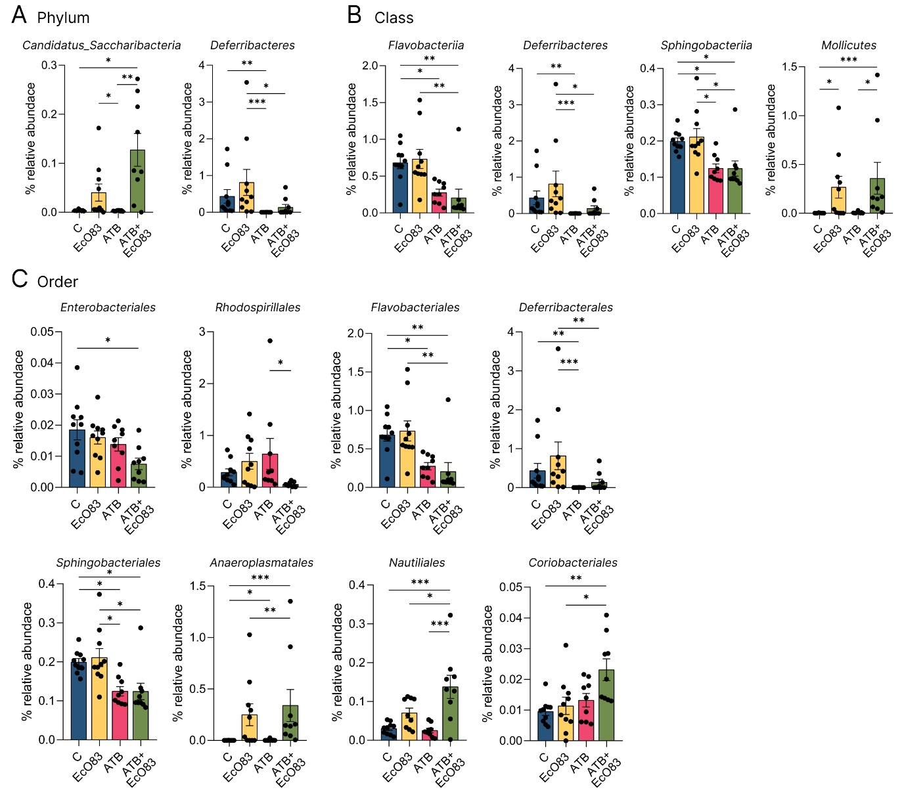
Supplementary Figure 3.
Relative abundance of significantly altered bacterial taxa at the day of sacrifice. (A) Changes in the relative abundance of bacterial phyla Candidatus_Saccharibacteria and Deferribacteres. (B) Differences in bacterial classes Flavobacteriia, Deferribacteres, Sphingobacteriia, and Mollicutes. (C) Alterations in bacterial orders Enterobacteriales, Rhodospirillales, Flavobacteriales, Deferribacterales, Sphingobacteriales, Anaeroplasmatales, Nautiliales, and Coriobacteriales in control mice (C), mice designated for subsequent EcO83 treatment (EcO83), antibiotic-treated mice (ATB), and mice designated for combined antibiotic and EcO83 treatment (ATB+EcO83). Data are presented as mean ± SEM. Statistical significance was determined using one-way ANOVA or Kruskal-Wallis test based on data distribution, where *p<0.05, **p<0.01, ***p<0.001. Absence of significance indicators represents non-significant differences. C - non-treated controls, EcO83 – Escherichia coli O83:K24:H31-treated group, ATB - antibiotic-treated group to induce dysbiosis, ATB+EcO83 - combined antibiotic-treated group with subsequent Escherichia coli O83:K24:H31 administration.
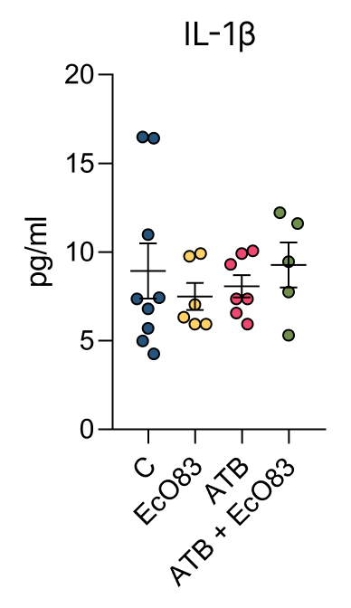
Supplementary Figure 4.
Detection of IL-1β concentration in sera. Concentration of IL-1β was measured by ELISA in mice treated with antibiotics and/or probiotic EcO83, compared to untreated controls. Data represent mean ± SEM. No significant differences were observed between groups. C - non-treated controls, EcO83 – Escherichia coli O83:K24:H31-treated group, ATB - antibiotic-treated group to induce dysbiosis, ATB+EcO83 - combined antibiotic-treated group with subsequent Escherichia coli O83:K24:H31 administration.

