Supplementary figures :
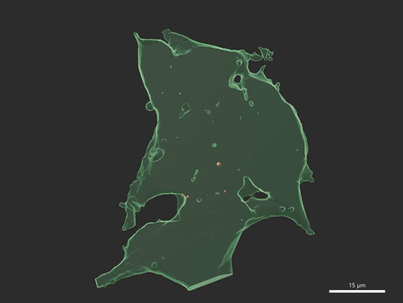
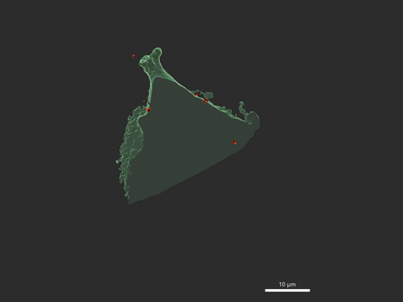
b
a
Supplementary figure 1: 3D Animation showing isolated mitochondria into the undifferentiated SH-SY5Y cells at 24h and 48h. (a-b) Vector cells were stained with the CellTracker blue dye (green false color) and the isolated mitochondria from A172 cells expressing the MitoRFP tag are shown in red at 24h (a) and 48h (b) post-transplantation.

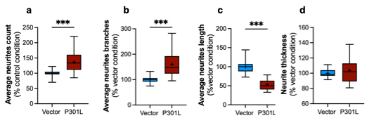
Supplementary figure 2 : Characterization of the neurite outgrowth parameters on vector and P301L cells. (a) Average neurites count per cells of vector versus P301L. (b) Average neurites branches of vector versus P301L cells. (c) Average neurites length of vector versus P301L cells (d) Neurites thickness of vector versus P301L. The boxes represent the median (full line) and the mean (“ + ” symbol), and the whiskers represent the minimal and maximal values. Each dataset represents N=3 independent experiments. Values are shown as the percentage of the control condition. Student’s test *p< 0,05 ; **p<0,01 ; ***p<0,001.

