Supplementary Material
Table 1. Sociodemographic data and performance of the participants entering the experiment. The meaningful labels they gave at encoding phase, the presence/absence of graphic transmutation (GT) at recall with the label of any recognizable drawing, the actual reproduction from memory of the ROCF and the relative raw score are also given.

Participant | Label at encoding | ROCF delay | Actual reproduction of the ROCF | ROCF Score
HC1, F, 70y/o, 13y education | House | House and human face | 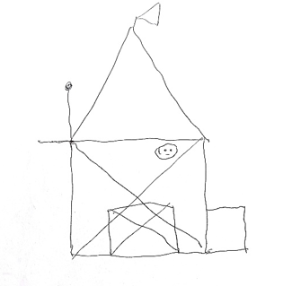 | 8
HC2, M, 68y/o, 17y education | Floor plan of a house | House and smiley face | 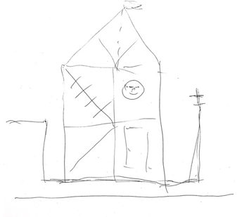 | 11
HC3, M, 74y/o, 8y education | House | House | 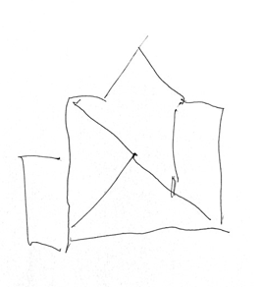 | 2.50*
HC4, F, 67y/o, 8y education | House | Church | 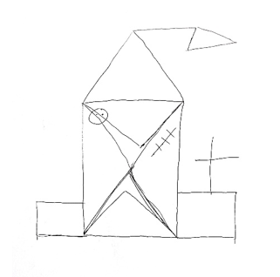 | 7
HC5, M, 67y/o, 10y education | House | No GT | 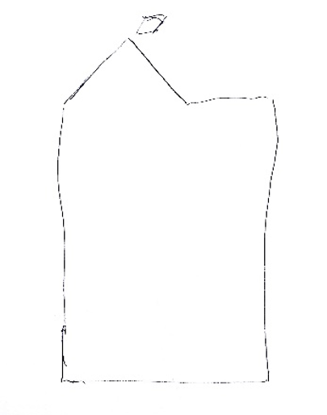 | 3*
HC6, M, 66y/o, 8y education | Arrow | No GT | 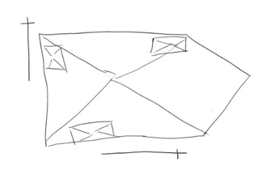 | 5.50*
HC7, M, 65y/o, 17y education | Sailing boat | Spaceship | 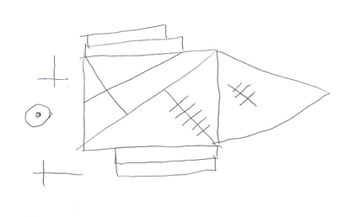 | 8.50*
HC8, F, 65y/o, 13y education | House or a Church | House/Church | 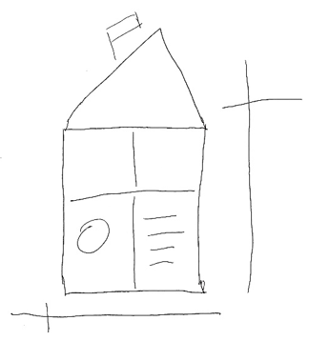 | 8
HC9, M, 77y/o, 11y education | Church with cemetery | No GT | 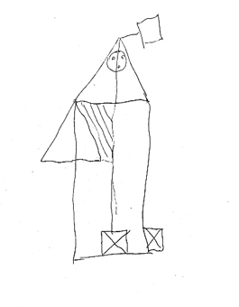 | 13
HC10, F, 65y/o, 8y education | House | No GT | 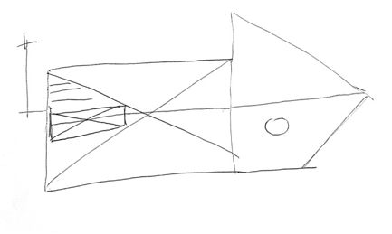 | 12
HC11, M, 68y/o, 8y education | Spaceship | No GT | 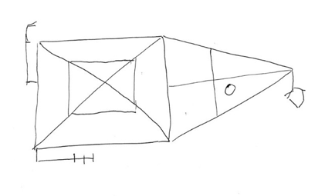 | 13
HC12, F, 68y/o, 8y education | House | No GT | 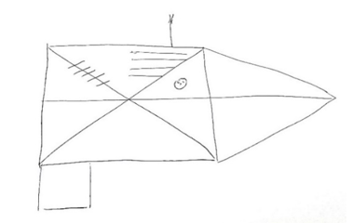 | 15
HC13, F, 69y/o, 16y education | Barracks | House | 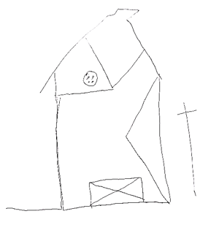 | 5*
HC14, F, 70y/o, 8y education | House | No GT | 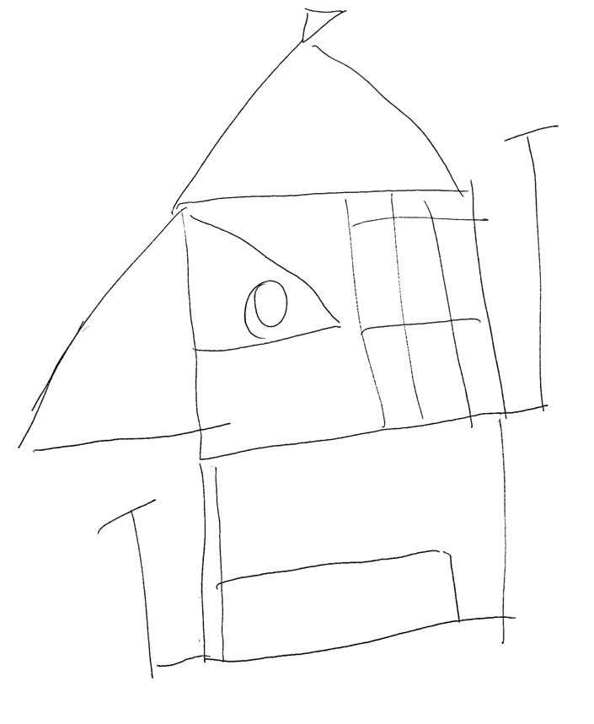 | 10
* Raw scores below cut-off once corrected for age and education according to [14].

