Supplementary Materials for preprint

Comparative evaluation of in-depth mass spectrometry and Olink Explore 3072 for plasma proteome profiling

Noora Sissala et al.

Corresponding authors: Noora Sissala (noora.sissala@ki.se) and Maria Pernemalm (maria.pernemalm@ki.se)

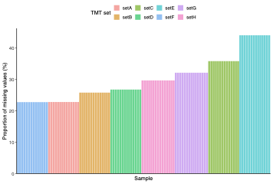

Figure S1. Proportion of missing values per sample in the MS data. The y-axis shows the proportion of missing values per sample in the HiRIEF LC-MS/MS data, with bars colored by TMT set.

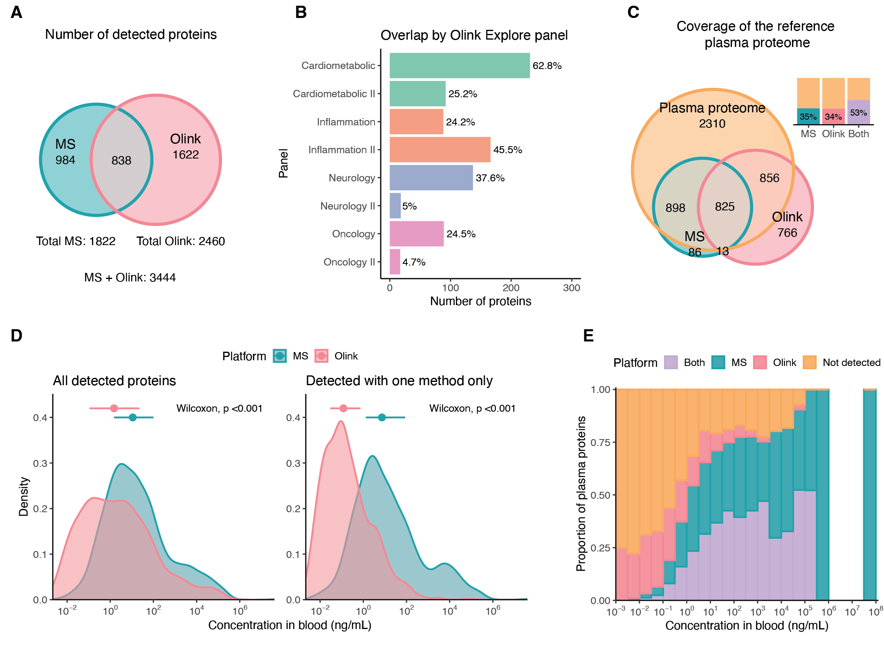
Figure S2. Detected proteins and proteome coverage after excluding proteins with >50% missing values. (A) Venn diagram of proteins detected in at least 50% of samples with HiRIEF LC-MS/MS and/or Olink Explore 3072, based on unique UniProt IDs. (B) Number and percentage of Olink assays in each Olink Explore panel detected with both Olink and MS (= overlapping proteins). (C) Venn diagram comparing proteins detected by MS and Olink to proteins in the reference human plasma proteome, compiled from the PeptideAtlas and the HPA (see Methods). (D) Distribution of the estimated protein concentrations of all detected proteins and proteins detected exclusively by MS or Olink. Concentration data were downloaded from the HPA. Medians and IQRs are indicated with points and error bars. Differences in protein concentration between platforms were tested using the Wilcoxon rank-sum test. (E) Plasma proteome coverage by estimated protein concentration. Each bar shows the proportion of proteins in the reference plasma proteome, within a specific concentration interval, that were detected with either MS only, Olink only, both methods, or neither method (“Not detected”). The x-axis intervals are right closed.
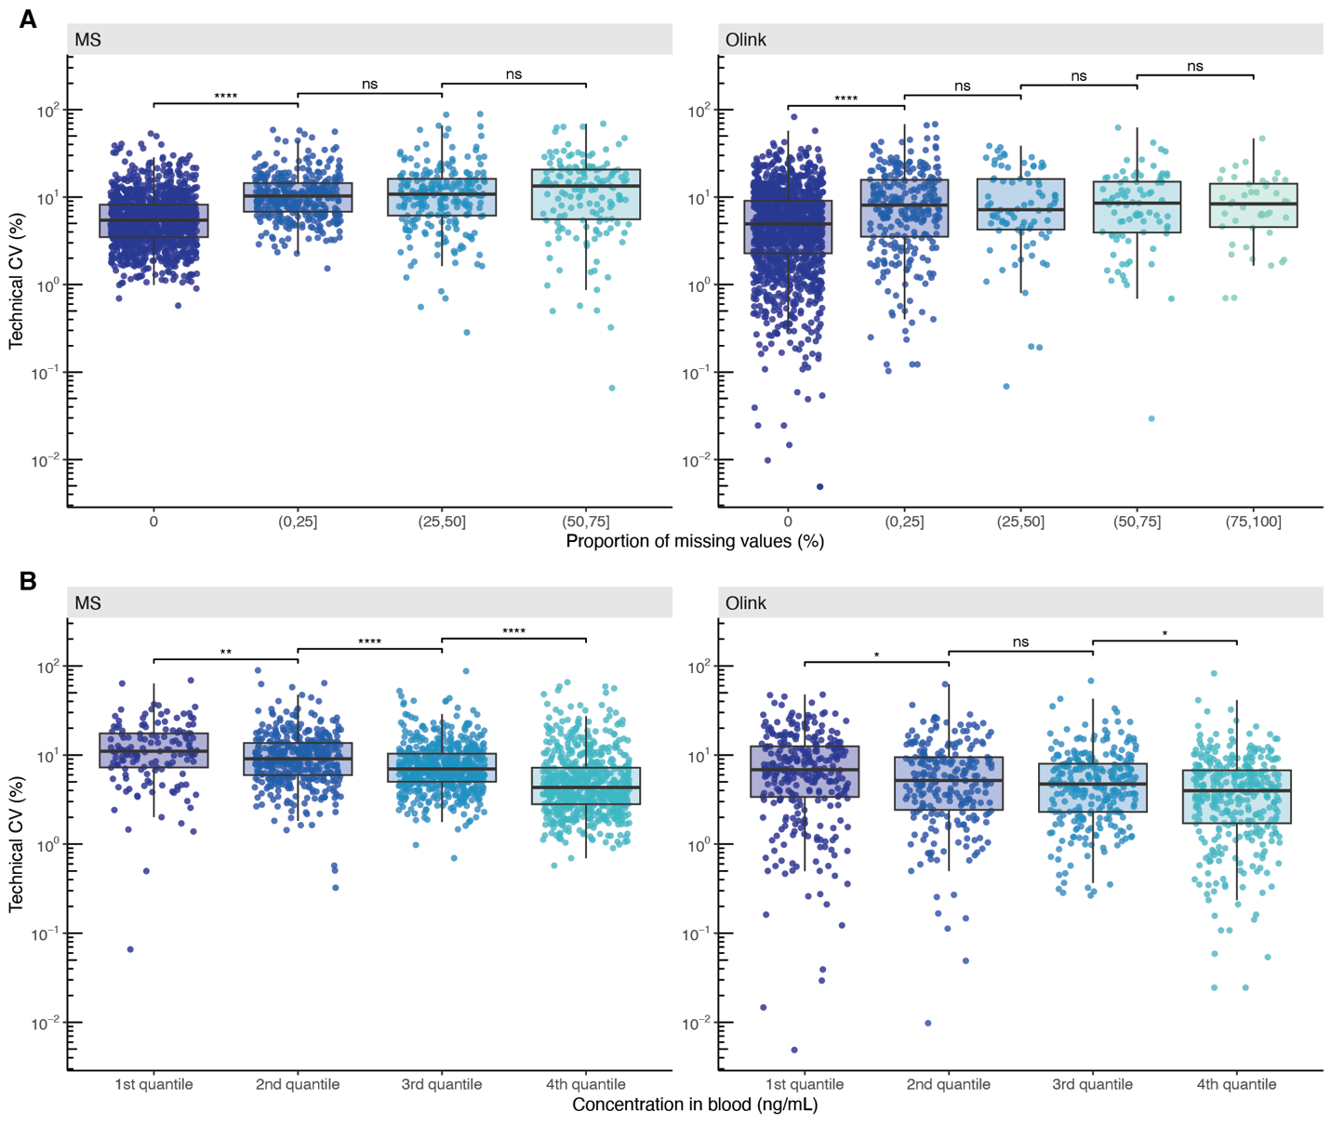

Figure S3. Relationship between technical CVs, missing values, and protein concentration. (A) Boxplots showing the distribution of technical CVs by the proportion of missing values per protein. (B) Boxplots showing the distribution of technical CVs versus the estimated concentration in blood from the HPA. Concentrations were divided into quantiles based on the estimated concentration of all detected proteins. The x-axis intervals therefore correspond to [0.003, 0.4], (0.4, 4.1], (4.1, 51] and (51, 4.0x10⁷] ng/mL. In both (A) and (B), the y-axes are presented on a log₁₀-scale, and differences between x-axis intervals were tested using the Wilcoxon rank-sum test. P-values were adjusted using the FDR method. ns = not significant, * = p < 0.05, ** = p < 0.01, *** = p < 0.001, **** = p < 0.0001.

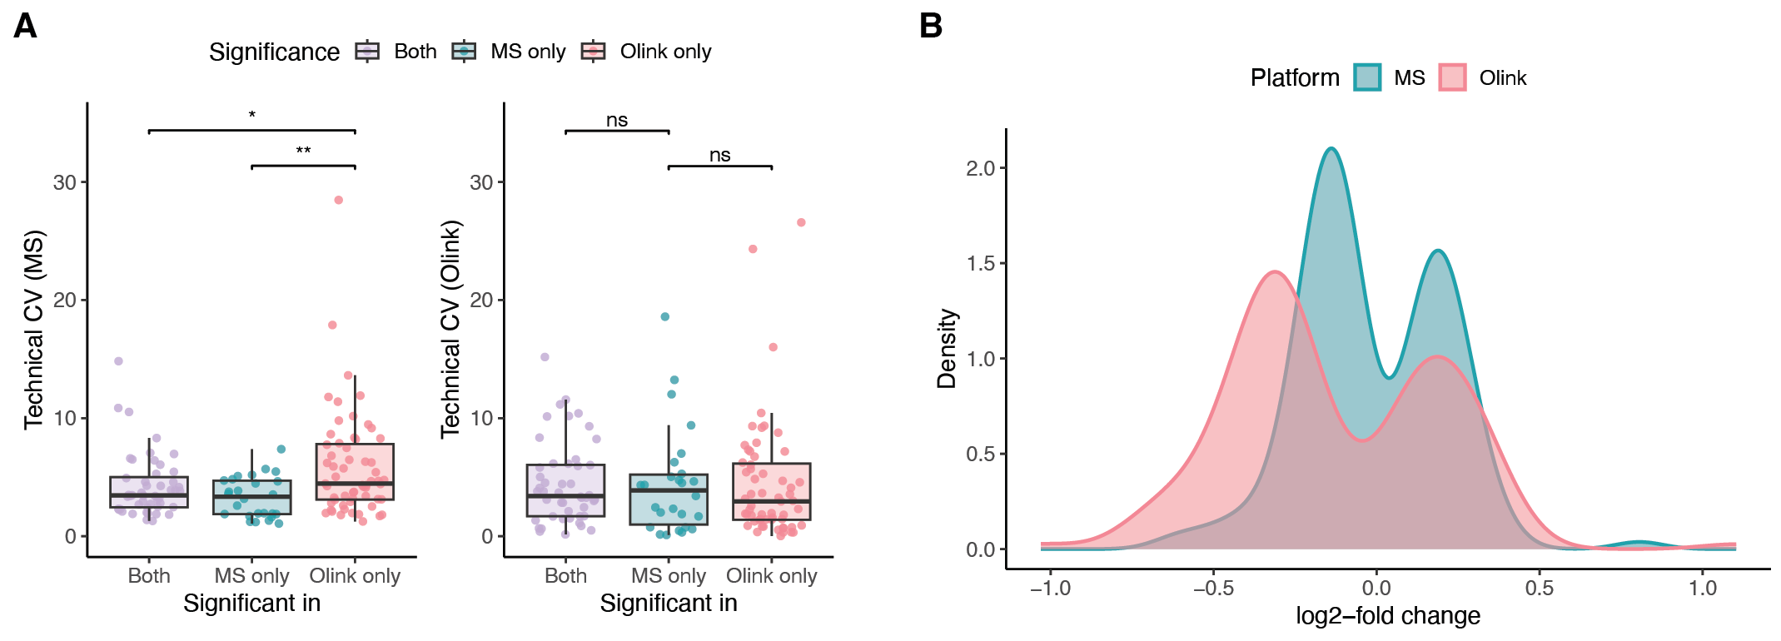

Figure S4. Technical CVs and log2-fold change values of DAPs. (A) Boxplots showing the distribution of technical CVs for HiRIEF LC-MS/MS and Olink Explore 3072 relative to the statistical significance of the protein in the differential abundance analysis between males and females. Proteins in the “Olink only” category were identified as differentially abundant with Olink but not MS, “MS only” proteins were identified as differentially abundant with MS but not Olink, and proteins in the “Both” category were differentially abundant in both datasets. Differences between categories were tested using the Wilcoxon rank-sum test. ns = not significant, * = p < 0.05, ** = p < 0.01, *** = p < 0.001, **** = p < 0.0001. (B) Distribution of log2-fold change values between males and females (calculated as female-male) for the DAPs identified in each dataset.
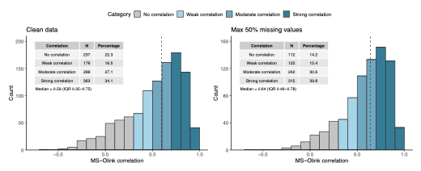

Figure S5. Cross-platform correlation of protein levels on filtered datasets. Histograms of per-protein Spearman’s rank correlations between HiRIEF LC-MS/MS and Olink Explore 3072 measurements for matching proteins, shown for two datasets: a cleaned dataset with values <LOD and QC warnings in the Olink data removed, i.e. set to NA (N = 1064), and a cleaned dataset additionally filtered for proteins with a maximum of 50% missing values (N = 791). Correlations were categorized into groups of no correlation: ρ ∈ [-1, 0.3); weak correlation: ρ ∈ [0.3, 0.5); moderate correlation: ρ ∈ [0.5, 0.7); and strong correlation: ρ ∈ [0.7, 1.0]. Dashed lines indicate the medians.

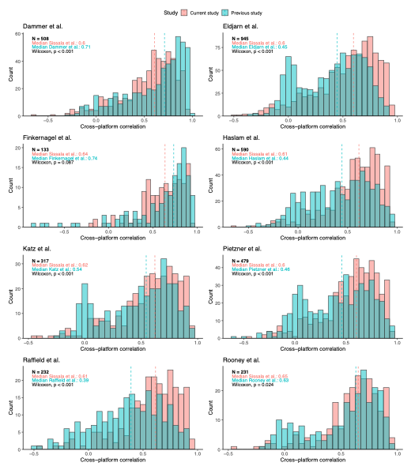
Figure S6. Comparison of MS-Olink correlations with Olink-SomaScan correlations from previous studies. Histograms showing per-protein MS-Olink correlations from this study and Olink-SomaScan correlations from previous studies for matching protein pairs. The number of matching protein pairs and the median cross-platform correlations for each study are shown on each plot. Dashed lines indicate the medians, and differences between studies were tested using the Wilcoxon rank-sum test.
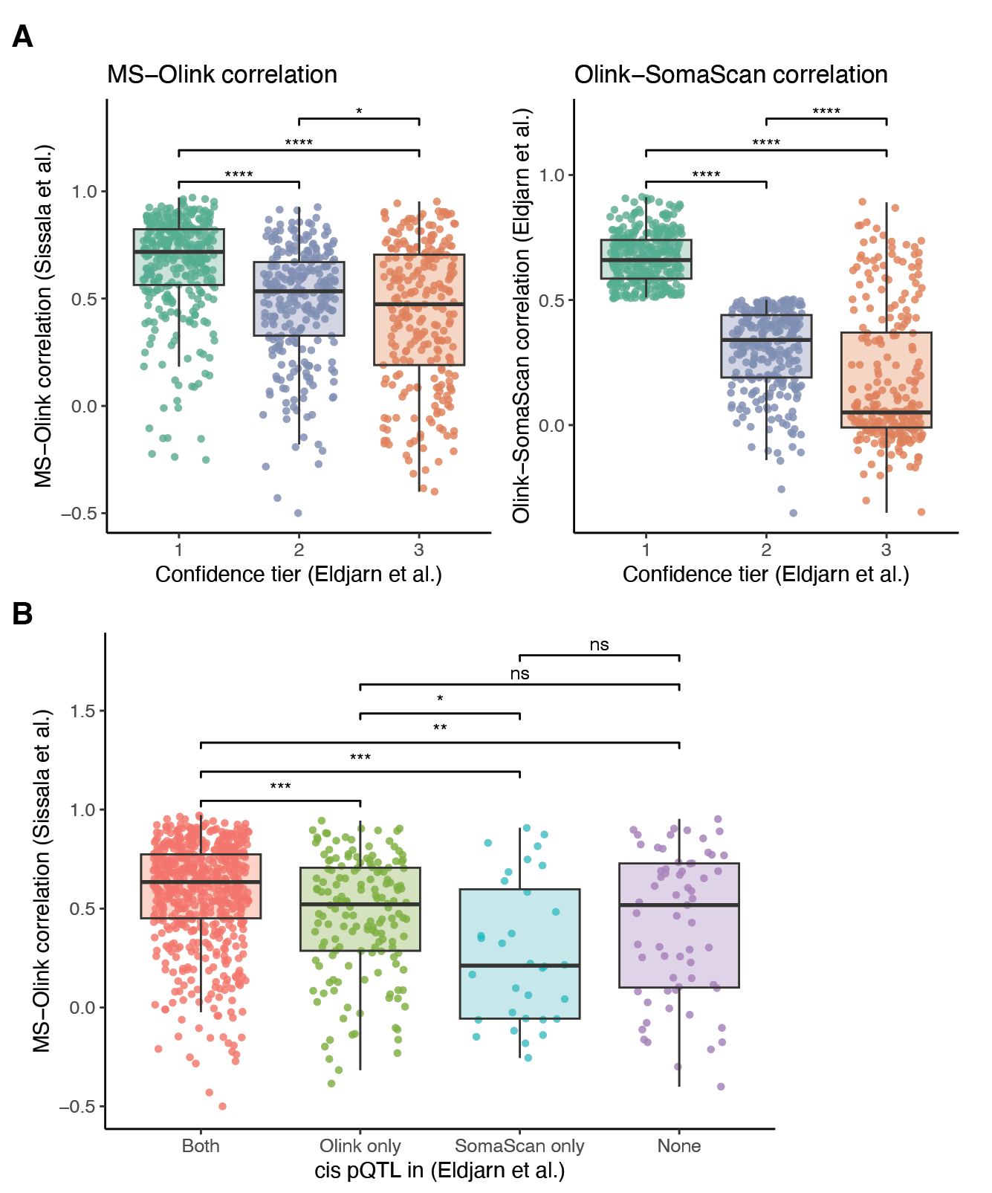
Figure S7. Cross-platform correlations by confidence of measurement with Olink and SomaScan. (A) Boxplots showing the distribution of MS-Olink correlations from the current study and Olink-SomaScan correlations from Eldjarn et al. (15), grouped by the confidence tiers introduced by Eldjarn et al. to categorize affinity-based assays based on measurement reliability. (B) Boxplots showing the distribution of MS-Olink correlations for proteins with a pQTL present on SomaScan only, Olink only, both platforms, or neither platform (“None”). In both subfigures, brackets indicate Wilcoxon rank-sum tests between categories. ns = not significant, * = p < 0.05, ** = p < 0.01, *** = p < 0.001, **** = p < 0.0001. P-values were adjusted for multiple testing with the FDR method.

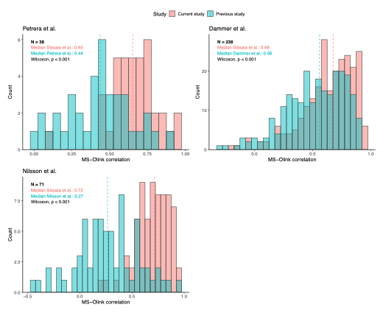

Figure S8. Comparison of MS-Olink correlations across studies. Histograms showing per-protein MS-Olink correlations from this study and previous studies for matching protein pairs. The number of matching protein pairs and the median cross-platform correlations for each study are indicated on each plot. Dashed lines represent the medians, and differences between studies were tested using the Wilcoxon rank-sum test.

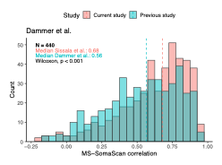

Figure S9. Comparison of MS-Olink correlations from this study to MS-SomaScan correlations from previous studies. Histogram showing per-protein MS-Olink correlations from this study and MS-SomaScan correlations of Dammer et al. for corresponding protein pairs. The number of matching protein pairs and the median cross-platform correlation is indicated on the plot. The dashed line represents the median, and differences between studies were tested using the Wilcoxon rank-sum test.

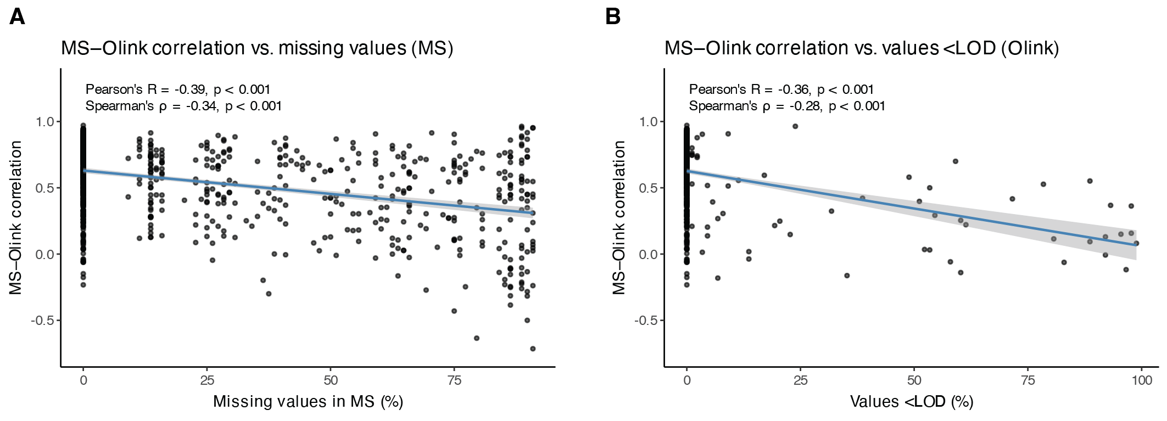

Figure S10. Relationship between missing values and cross-platform correlations. Scatter plots showing cross-platform correlations versus the proportion of missing values in (A) HiRIEF LC-MS/MS and (B) Olink Explore 3072 data. Spearman’s and Pearson’s correlation coefficients are displayed on each plot, with a regression line indicating the trend.

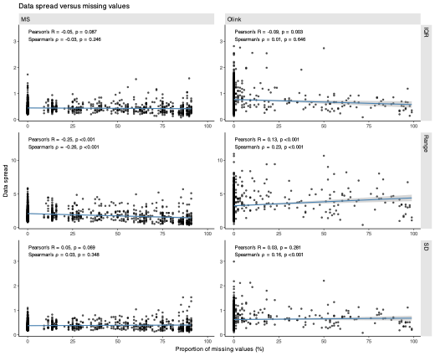

Figure S11. Relationship between missing values and data spread. Scatter plots showing the relationship between inter-quartile range (IQR), range, as well as standard deviation (SD) of protein abundance values and the proportion of missing values per protein in HiRIEF LC-MS/MS and Olink Explore 3072 data. Spearman’s and Pearson’s correlation coefficients are displayed on each plot, with a regression line indicating the trend.

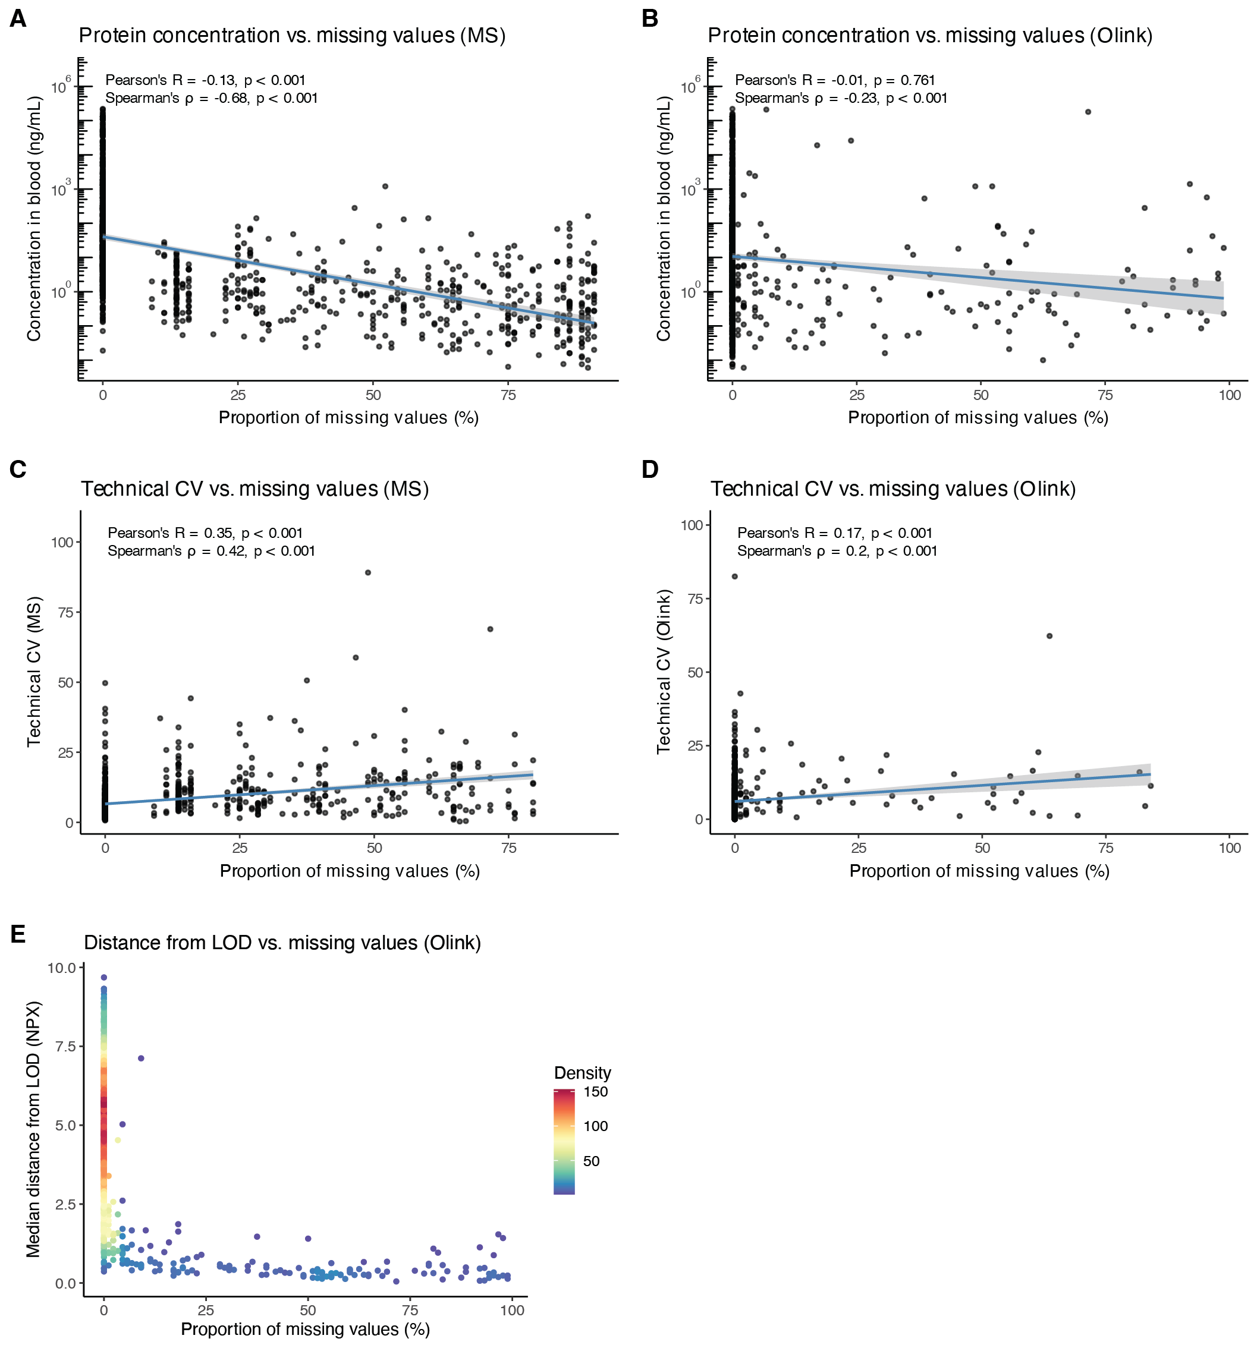

Figure S12. Relationship between missing values and other technical factors. (A-B) Scatter plots showing the relationship between estimated protein concentration from the HPA and the proportion of missing values for each protein in (A) HiRIEF LC-MS/MS and (B) Olink Explore 3072 data. The y-axis is presented on a log₁₀-scale. Spearman’s and Pearson’s correlation coefficients are displayed on each plot, with a regression line indicating the trend. (C-D) Same as (A-B), but for technical CVs versus the proportion of missing values in each data set. (E) Distribution of the median distance from the LOD, expressed in Normalized Protein eXpression (NPX) units, versus the proportion of missing values per protein in the Olink data. Points are colored by point density to better visualize overlapping points.
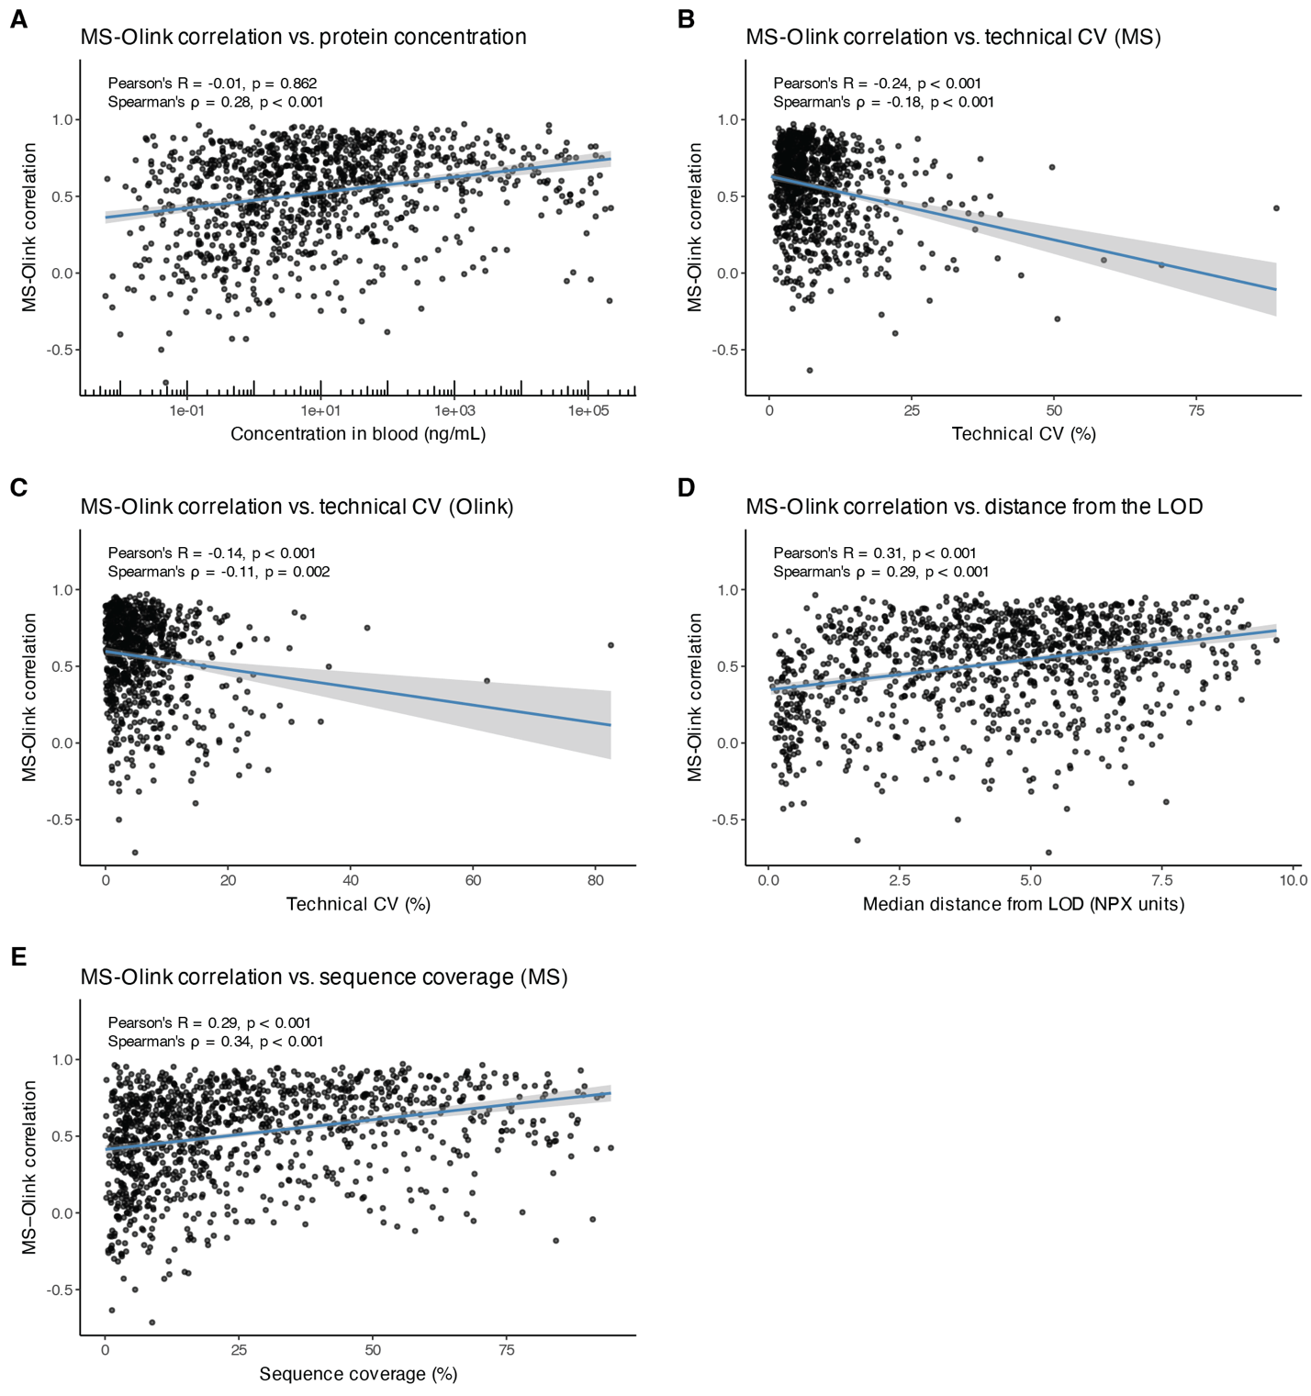

Figure S13. Relationship between various technical factors and cross-platform correlations. MS-Olink correlation versus (A) estimated protein concentration in the blood from the HPA, (B) technical CV in the MS data, (C) technical CV in the Olink data, (D) median distance from the LOD in the Olink data, expressed in NPX units, and (E) protein sequence coverage by MS. Spearman’s and Pearson’s correlation coefficients are displayed on each plot, with a regression line indicating the trend.

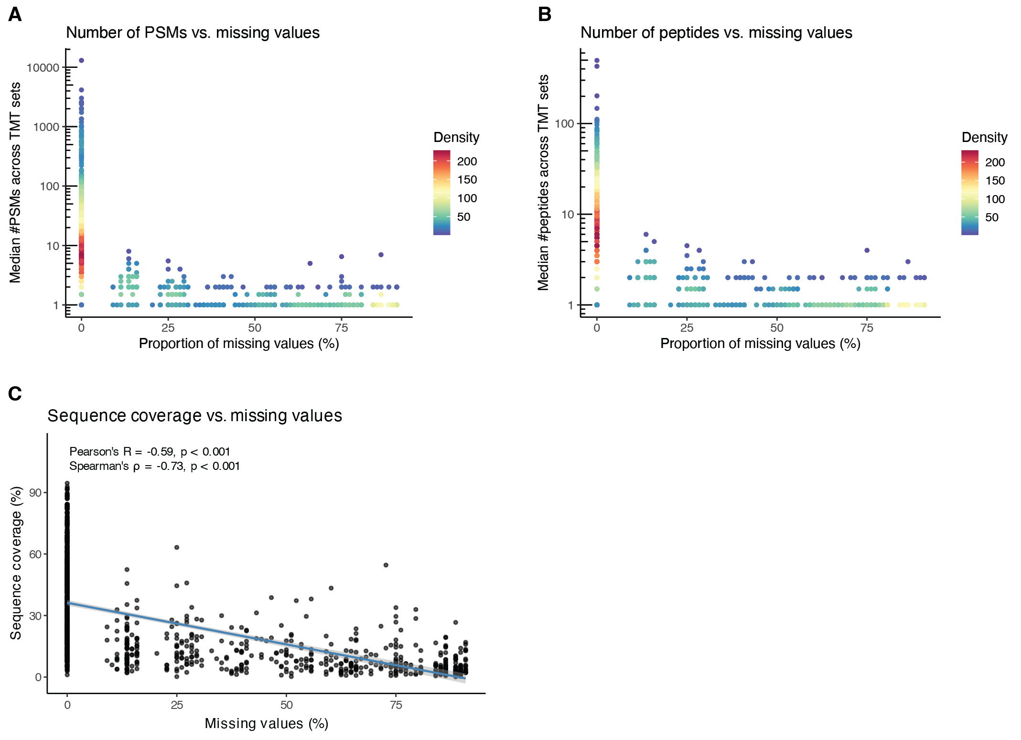

Figure S14. Relationship between number of PSMs and peptides, sequence coverage, and missing values in the MS data. Distribution of the median number of (A) peptide spectrum matches (PSMs) and (B) unique peptides used for quantification across tandem mass tag (TMT) sets versus the proportion of missing values per protein in the MS data. Points are colored by point density to better visualize overlapping points. (C) Scatter plot showing the relationship between sequence coverage by MS and proportion of missing values for each protein in the MS data. Spearman’s and Pearson’s correlation coefficients are displayed on the plot, with a regression line indicating the trend.
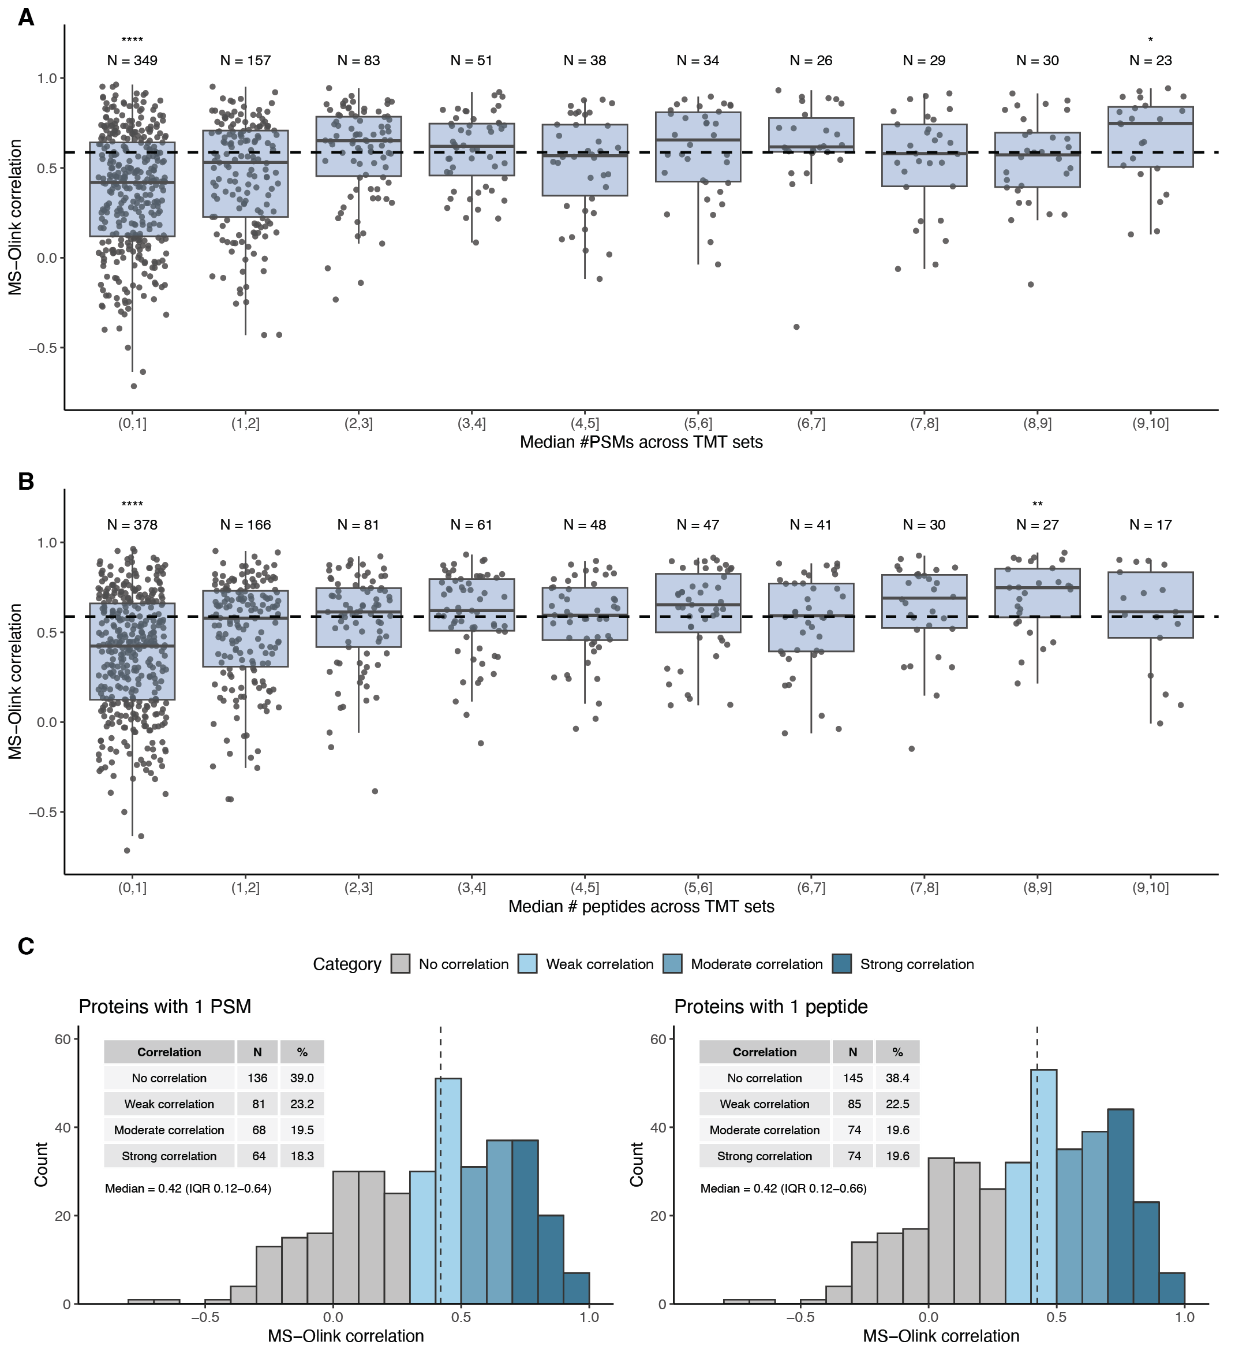

Figure S15. Impact of the number of PSMs and peptides in the MS data on cross-platform correlations. (A) Boxplots showing the distribution of MS-Olink correlations by the median number of PSMs per protein. Asterisks indicate statistically significant differences from the median MS-Olink correlation of all overlapping proteins, shown as a dashed line. Significance was tested using the Wilcoxon rank-sum test, and p-values were adjusted for multiple testing with the FDR method. ** = p < 0.01, **** = p < 0.0001. (B) Same as (A), but for the number of peptides per protein. (C) Histograms of MS-Olink correlations for proteins with one median PSM across TMT sets (left) and proteins with one median peptide across TMT sets (right). The dashed line indicates the median correlation. Correlations were categorized into groups of no correlation: ρ ∈ [-1, 0.3); weak correlation: ρ ∈ [0.3, 0.5); moderate correlation: ρ ∈ [0.5, 0.7); and strong correlation: ρ ∈ [0.7, 1.0].

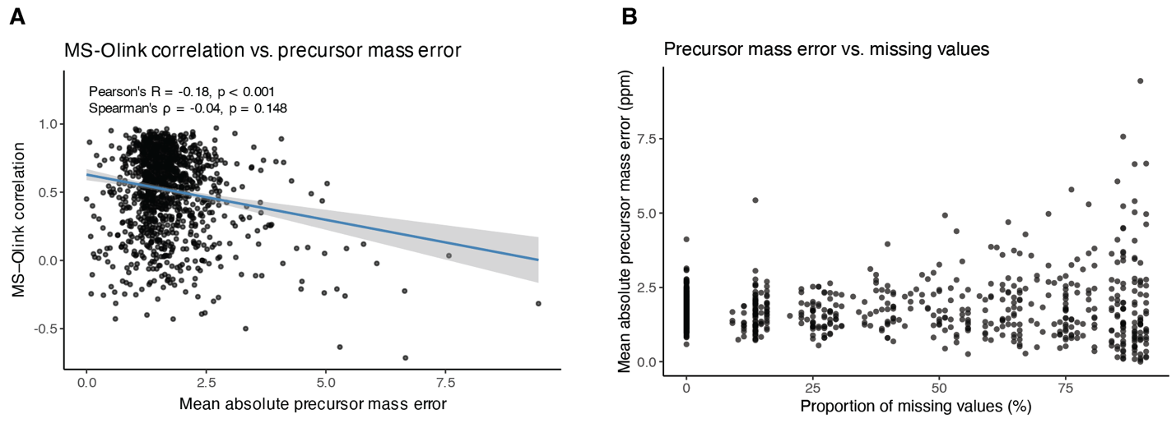

Figure S16. Relationship between precursor mass errors, missing values, and cross-platform correlations in the MS data. (A) MS-Olink correlation versus mean absolute precursor mass error per protein. Spearman’s and Pearson’s correlation coefficients are shown on the plot, with a regression line indicating the trend. (B) Proportion of missing values versus the median absolute precursor mass error per protein the HiRIEF LC-MS/MS data.

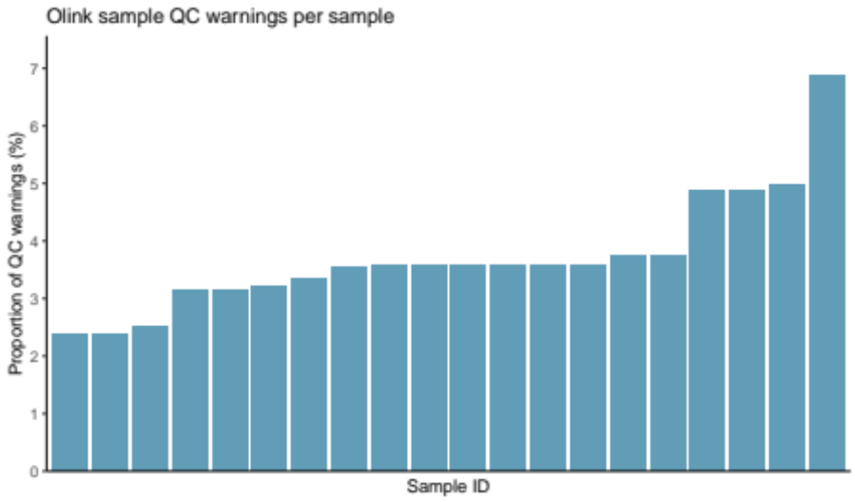

Figure S17. Sample QC warnings in the Olink data. Proportion of NPX values flagged with a sample QC warning (y-axis) for every sample (x-axis) that had at least one sample QC warning in the Olink Explore 3072 data.

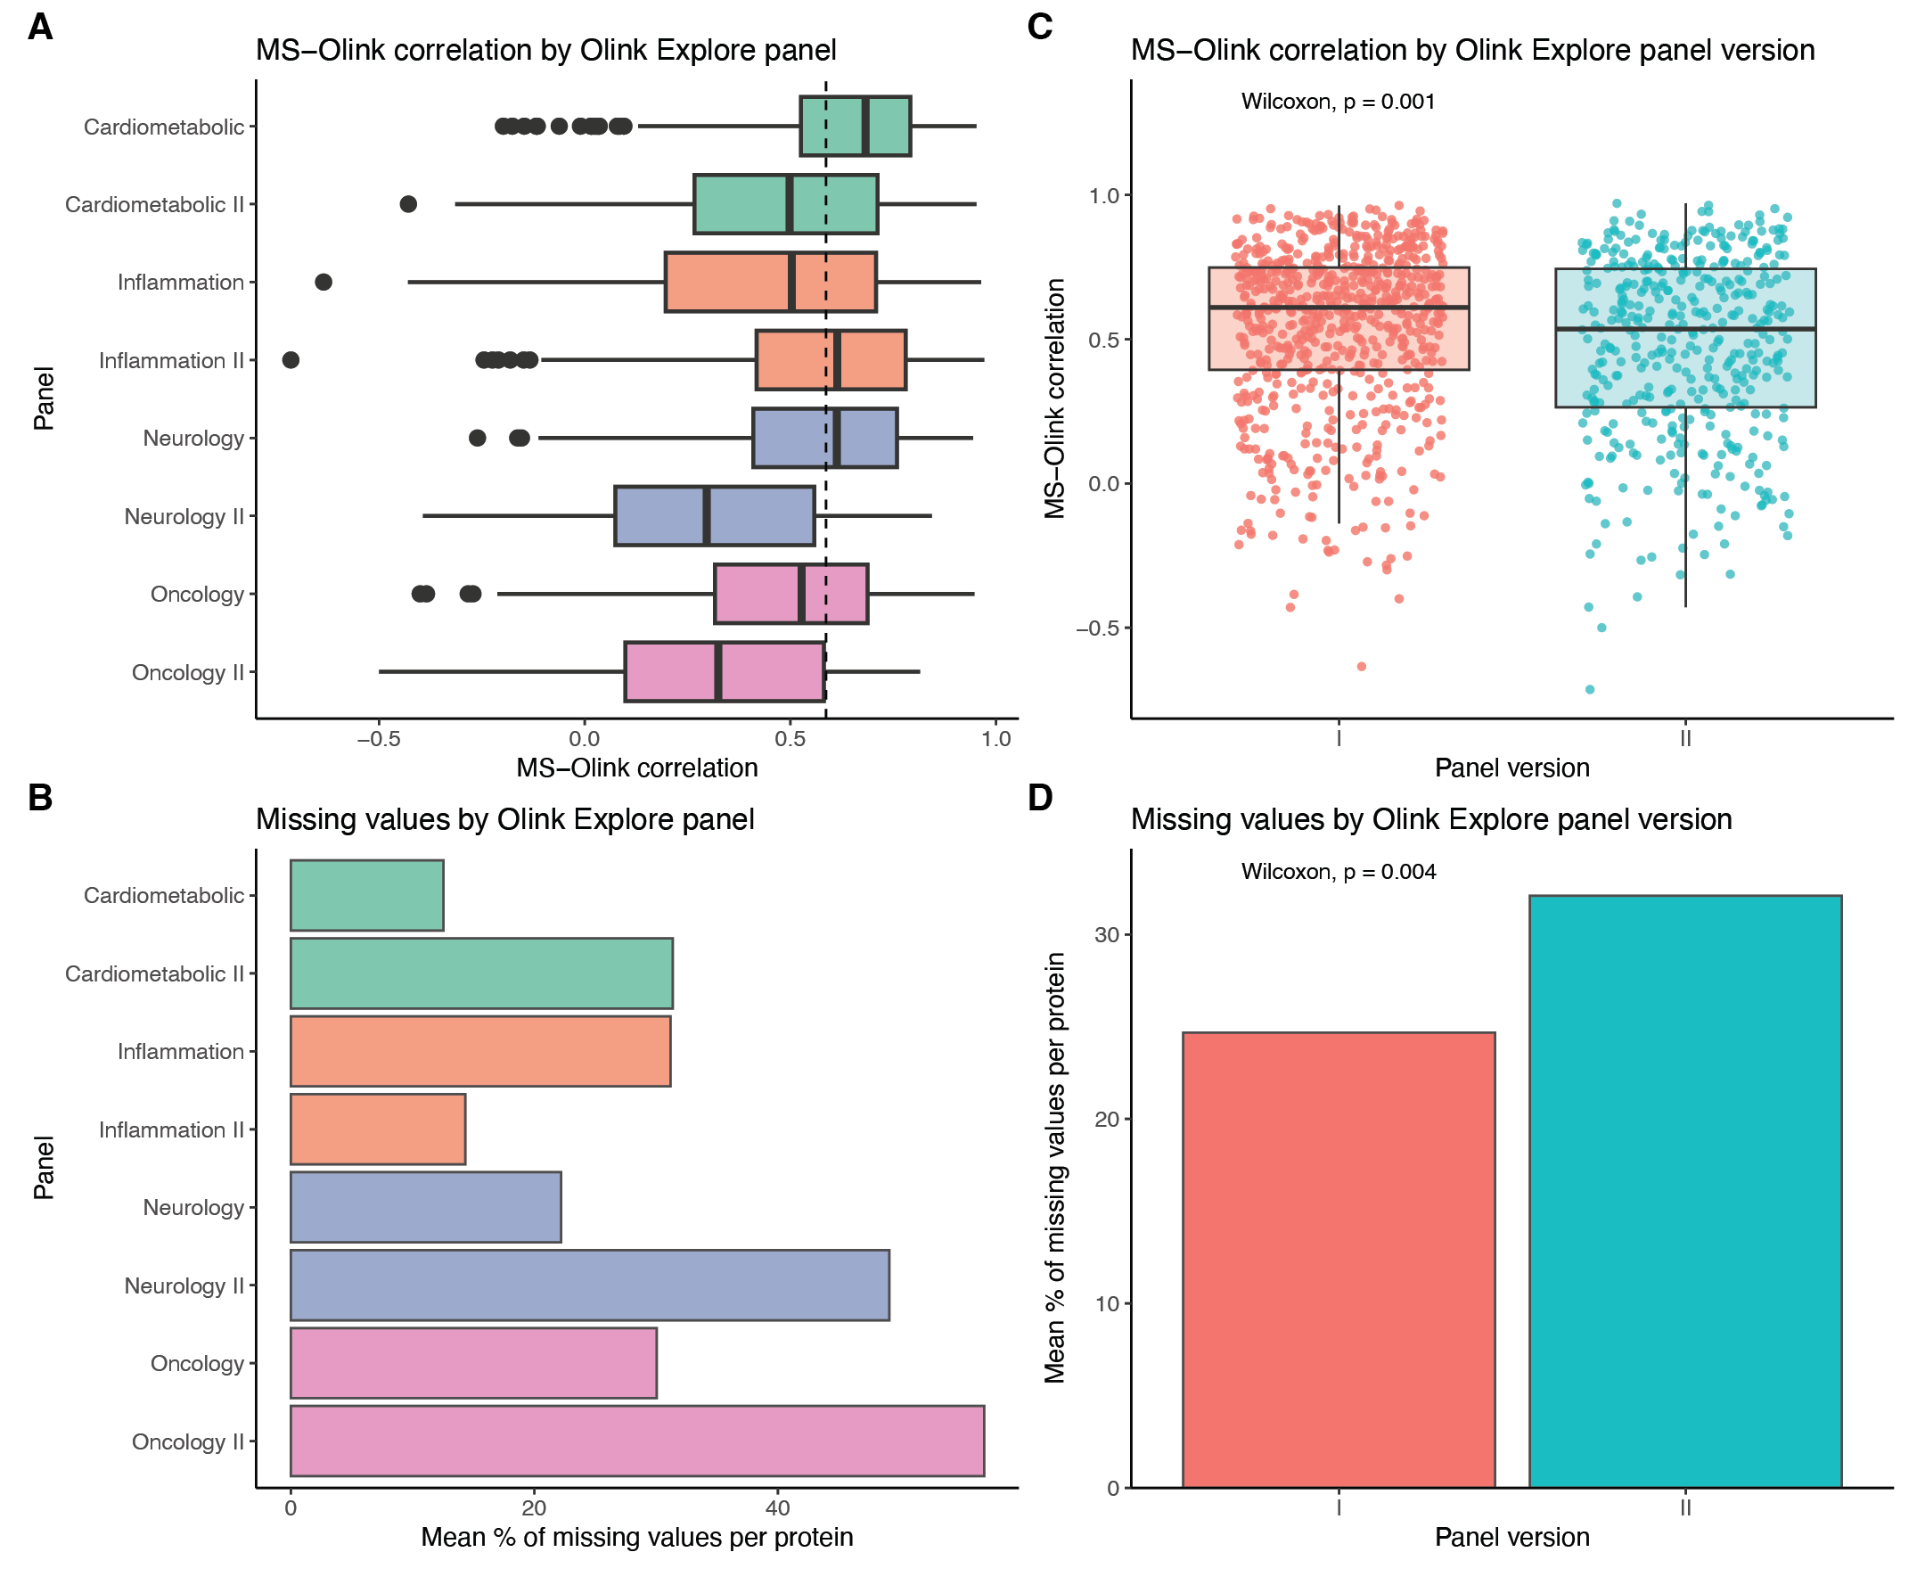
Figure S18. MS-Olink correlation and missing values by Olink Explore panels. (A) MS-Olink correlation for proteins grouped by Olink Explore panel. The dashed line indicates the median correlation across all proteins. (B) The mean proportion of missing values for proteins in each Olink Explore panel. (C) MS-Olink correlation for proteins grouped by the Olink panel version. Version I panels were also included in the earlier version of the Explore platform, the Olink Explore 1536, while version II panels were new to the Olink Explore 3072. (D) The mean proportion of missing values for proteins in each group of Explore panels.
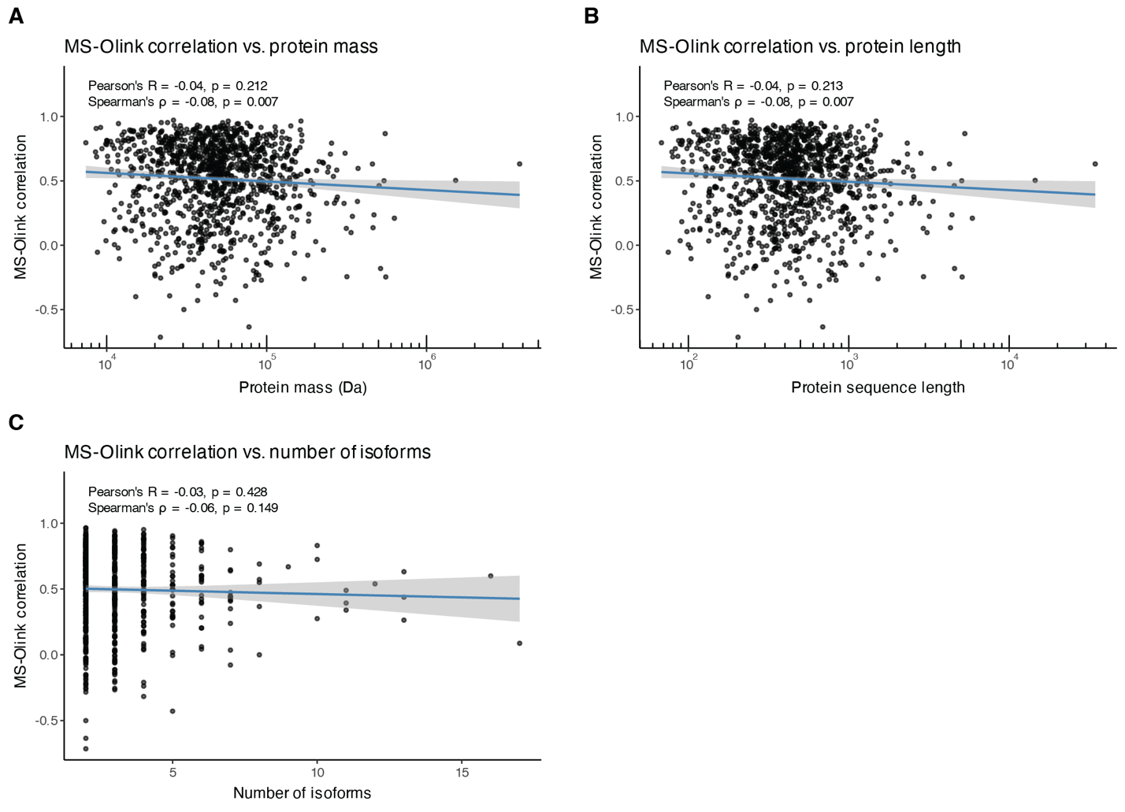

Figure S19. Relationship between protein properties and cross-platform correlations. MS-Olink correlation (y-axis) versus (A) protein mass, (B) protein sequence length, and (C) the number of existing isoforms reported in UniProt. Spearman’s and Pearson’s correlation coefficients are displayed on each plot, with a regression line indicating the trend.

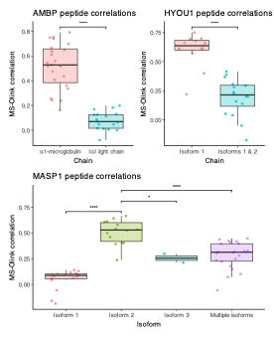
Figure S20. Peptide-Olink correlations across different protein sequence regions for select examples. Boxplots showing the MS-Olink correlation at the peptide level for different regions of the AMBP, HYOU1, and MASP1 protein sequences. For AMBP, correlations are shown for peptides mapping to the α1-Microglobulin (residues 20-203) and Inter-α-Trypsin Inhibitor Light Chain (IαI) regions (residues 206-352). For HYOU1, correlations are shown for peptides mapping to regions shared by isoforms 1 and 2 (residues 88-602) and the region unique to isoform 1 (residues 647-999). For MASP1, correlations are presented for peptides mapping uniquely to each isoform (UniProt IDs: P48740-1, P48740-2, and P48740-3), and peptides mapping to multiple isoforms (“Multiple isoforms”). Differences in correlation between categories were tested using two-sided Welch’s t-tests, and p-values were adjusted using the FDR method. ns = not significant, * = p < 0.05, ** = p < 0.01, *** = p < 0.001, **** = p < 0.0001.

Table S1. Detected proteins. Proteins measured and detected with HiRIEF LC-MS/MS and Olink Explore 3072. Proteins quantified (above the limit of detection [LOD]) in at least one sample were considered detected. The table also includes protein identifiers, Olink assay details, missing value frequencies, overlap between platforms, and overlap with the Human Protein Atlas (HPA) and the Plasma section of the PeptideAtlas (the Human Plasma Proteome Project, HPPP). The HPA Plasma proteins were defined as proteins with blood concentration data available in the HPA or proteins annotated as “Secreted to blood”. The reference plasma proteome was compiled by combining the HPA Plasma proteins and proteins from the HPPP.

Table S2. ORA of HPA annotations. Overrepresentation analysis (ORA) of HPA annotations comparing proteins detected by HiRIEF LC-MS/MS and Olink Explore 3072. The frequence of annotations in select HPA categories was compared using Fisher’s exact test, and overrepresentation of annotations was tested using a hypergeometric test, with all proteins detected by MS or Olink as the background (columns “Enr.pvalue”, “Enr.adj.p”, and “Enriched”).

Table S3. ORA of GO terms. ORA of Gene Ontology (GO) terms for proteins detected by HiRIEF LC-MS/MS and Olink Explore 3072. GeneRatio: proportion of target list proteins (MS or Olink proteins) associated with a specific GO term. BgRatio: proportion of background list proteins (MS and Olink proteins) associated with the GO term. Count: number of target list proteins associated with a specific GO term. foldEnr: fold enrichment calculated as GeneRatio/BgRatio.

Table S4. Coverage of FDA-approved plasma protein biomarkers. Comparison of FDA-approved plasma protein biomarkers, from a list compiled by Anderson (29), detected by HiRIEF LC-MS/MS and Olink Explore 3072.

Table S5. Technical CVs. Technical coefficients of variation (CVs) on repeated measurements for proteins measured by HiRIEF LC-MS/MS and Olink Explore 3072.

Table S6. DAA between females and males. Differential abundance analysis (DAA) comparing protein levels between females (N=37) and males (N=51) in the HiRIEF LC-MS/MS and Olink Explore 3072 datasets, performed with two-sided Welch’s t-tests on overlapping proteins with no missing values. P-values were adjusted for multiple testing with the false discovery rate (FDR) method.

Table S7. Cross-platform correlations and technical factors. Correlation of protein levels between HiRIEF LC-MS/MS and Olink Explore 3072, calculated for Olink data with <LOD values and QC warnings retained, as well as for Olink data with <LOD values and QC warnings set to NA (columns marked with “cleanData”). The table includes data on various technical factors, such as the proportion of missing values, number of peptide spectrum matches (PSMs) and peptides per protein in MS data, number of sample QC warnings per protein in Olink data, etc.

Table S8. Comparison to Olink-SomaScan correlations from previous studies. Comparison of cross-platform correlations between HiRIEF LC-MS/MS and Olink Explore 3072 with cross-platform correlations between Olink and SomaScan platforms from previous studies.

Table S9. Comparison to confidence tiers from Eldjarn et al. Comparison of cross-platform correlations between HiRIEF LC-MS/MS and Olink Explore 3072 from the current study with the confidence tiers defined by Eldjarn et al. (15). PAV: protein altering variant. eQTL: expression quantitative trait loci.

Table S10. Comparison to MS-Olink correlations from previous studies. Comparison of cross-platform correlations between HiRIEF LC-MS/MS and Olink Explore 3072 with cross-platform correlations between MS and Olink platforms from previous studies.

Table S11. Comparison to MS-SomaScan correlations from previous studies. Comparison of cross-platform correlations between HiRIEF LC-MS/MS and Olink Explore 3072 with cross-platform correlations between MS and SomaScan platforms from previous studies.

Table S12. GSEA on cross-platform correlations. Gene set enrichment analysis (GSEA) of HPA annotations on cross-platform correlations between HiRIEF LC-MS/MS and Olink Explore 3072. SetSize: number of analyzed proteins associated with a specific HPA annotation. NES: normalized enrichment score.

Table S13. ORA on cross-platform correlations. ORA of GO terms and HPA annotations for proteins with low and high cross-platform correlations between HiRIEF LC-MS/MS and Olink Explore 3072. The low correlation group was defined as proteins with a Spearman’s correlation coefficient < 0.3, while the high correlation group was defined as proteins with correlation > 0.7.

Table S14. Cross-platform correlations at the peptide level. Correlations between peptides quantified by HiRIEF LC-MS/MS and the corresponding Olink Explore 3072 assays.

Table S15. TMT labeling scheme. Indicates which TMT sets and TMT tags the MS samples were assigned to. Duplicate samples are highlighted. IS = internal standard.

Table S16. Gradient length for HiRIEF fractions.

Table S17. List of studies included in the comparison of cross-platform correlations. The table summarizes key information about each study, including the data source in the original publication, correlation method, how proteins were matched between platforms and studies (UniProt ID or Gene name), which MS, Olink, and SomaLogic platforms were used, as well as how data were pre-processed prior to calculating the cross-platform correlations. TMT = tandem mass tag. LOD = limit of detection. QC = quality control. CV = coefficient of variation.

