Supplementary materials
A high-quality assembly reveals genomic characteristics, phylogenetic status and causal genes for white feather of Indian peafowl
Shaojuan Liu^{1#}, Hao Chen^{3#}, Jing Ouyang³, Min Huang¹, Hui Zhang¹, Sumei Zheng¹, Suwang Xi², Hongbo Tang³, Yuren Gao³, Yanpeng Xiong³, Di Cheng², Kaifeng Chen², Bingbing Liu¹,Wanbo Li⁴, Xueming Yan^{3*}, Huirong Mao^{2*}, Jun Ren ^{1*}

Table of Contents
Supplementary Methods 1
Genome sequence 1
Illumina library preparation and sequencing 2
Mate pair libraries 3
Illumina sequencing 4
PacBio sequencing 5
10X Genomics sequencing 6
Genome annotation 7
Repeat annotation 7
Structure annotation 8
Homolog prediction 9
Ab initio prediction 10
RNA-seq data 11
Functional annotations 12
Non-coding RNA annotation 13
Supplementary Figures 14
Figure S1: Pipeline of the draft genome assembly of Indian blue peafowl 14
Figure S2: Workflow of the genome annotation of Indian blue peafowl 15
Figure S3: 17-kmer frequency distribution of peafowl genome 16
Figure S4: Divergence distribution of transposable element of peafowl genome using RepeatMasker software 17
Figure S5: Phylogenetic tree of 15 species constructed with IQ-tree 18
Figure S6: Phylogenetic tree of 15 species constructed with RAxML 19
Figure S7: EDNRB transcripts in the feather tissue of peafowl by IGV visualization 20
Supplementary Tables 21
Table S1: Statistics of genome assembly data of peafowl 21
Table S2: Summary of de novo genome assembly of peafowl 22
Table S3: Percentage of the bases contents of peafowl genome 23
Table S4: Statistics of paired-end reads mapping in peafowl genome 24
Table S5: Number of SNPs of peafowl genome 25
Table S6: Assembly assessment of completeness using BUSCOs 26
Table S7: Whole genome repeat sequences of Indian peafowl genome predicted by homologous alignment and de novo search 27
Table S8: Composition of repetitive sequences in peafowl genome 28
Table S9: Prediction of protein-coding genes for the peafowl genome 29
Table S10: Statistics of functional annotation of protein-coding genes in the peafowl genome assembly 30
Table S11: Statistics of non-coding RNAs in the assembly of peafowl 31
Table S20: Primer sequences of PMEL for RT-qPCR 32
References 33

Supplementary Methods
Genome sequence
Illumina library preparation and sequencing:
High molecular weight DNA was extracted from a single individual and used to make a 350 bp insert fragment libraries using the Illumina TruSeq Nano method, starting with 100 ng DNA. DNA was sheared to the relevant size using a Covaris M220 Focused-ultrasonicator (Covaris). The resulting fragmented DNA was purified using Agencourt AMPure XP beads (Beckman Coulter) and checked for size distribution on an Agilent 2100 Bioanalyzer (Agilent Genomics). Following the manufacturer’s protocol, fragments were end repaired, A-tailed and adapter ligated. Enrichment was achieved with eight rounds of PCR. Libraries were checked using a Qubit Fluorometer (Invitrogen) and a high sensitively chip on the Agilent Bioanalyzer.
Mate pair libraries
Mate pair libraries were made using the Nextera Mate Pair Sample Preparation Kit (Illumina) using the gel plus option. Following manufacturer’s protocol 4 µg of genomic DNA was tagmented. During this step, by use of a specially formulated mate pair transposome, the genomic DNA sample is simultaneously fragmented and tagged with a biotinylated mate pair junction adapter. In later steps, this biotin adapter served to facilitate purification of mate pair fragments. The DNA was cleaned on a Zymo DNA clean column (Zymo Research). The range of fragment sizes produced was checked using a DNA 12000 Bioanalyzer chip. Subsequently, the strand displacement reaction was performed and the DNA purified with AMPure XP beads. The resulting DNA fragments were size selected using a 0.75% cassette for the BluePippin (Sage Science) using two ranges: 2 Kb, 5 Kb and 10 Kb. DNA was recovered and ligated overnight at 30°C following the manufacturer’s protocol. After incubation and heat inactivation, exonuclease was added to remove DNA which hadn’t circularised. This DNA was then sheared using the Covaris M220 and purified using Streptavidin Magnetic Beads. The samples were subsequently end repaired, A-tailed and adapter ligated according to manufacturer’s instructions and enrichment was achieved with 10 rounds of PCR. Libraries were checked for quantity and quality using a Qubit assay and a high sensitivity Bioanalyzer chip.
The Qubit and Bioanalyzer QC information was used to pool the fragment and mate pair libraries into a single pool. The quality and quantity of the pool was assessed using a Qubit assay and the Agilent Bioanalyzer and subsequently by qPCR using the Illumina Library Quantification Kit (Kapa Biosystems) on a Roche Light Cycler LC480II (Roche Molecular Systems) according to manufacturer's instructions. The template DNA was denatured according to the protocol described in the Illumina cBot user guide and loaded at 10 pM and later 12 pM concentration. At last, the library was sequenced on Illumina NovaSeq 6000 platform and 150 bp paired-end reads were generated.
Illumina sequencing
Total genomic DNA was extracted from peripheral blood. Two paired-end genomic sequence libraries were constructed with 350 bp insert size, and sequencing was carried out on the Illumina NovaSeq 6000 platform according to the manufacturer’s instructions. The clean data were obtained by removing reads containing adapter, reads containing ploy-N and low quality reads from raw data using megablast v2.2.26 (Chen, Ye, Zhang, & Xu, 2015) with parameters ‘-v 1 -b 1 -e 1e-5 -m 8 -a 13’; the duplication_rm.v2 was used to remove the duplicated read pairs; the low-quality reads were filtered satisfying the following conditions: (1) reads with ≥ 10% unidentified nucleotides (N), (2) remove reads with adapters, (3) reads with > 20% bases having Phred quality < 5.
PacBio sequencing
Genomic DNA was sheared by a g-TUBE device (Covaris) with 20 kb settings. Sheared DNA was purified and concentrated with AmpureXP beads (Agencourt) and further used for Single-Molecule Real Time (SMRT) bell preparation according to manufacturer’s protocol (Pacific Biosciences, 20 kb template preparation using BluePippin size selection). Size selected and isolated SMRT bell fractions were purified using AmpureXP beads (Beckman Coulter, Inc.) and finally these purified SMRT bells were used for primer-and polymerase (P6) binding according to manufacturer’s binding calculator (Pacific Biosciences). DNA-Polymerase complexes were used for Magbead binding and loaded at 0.1nM on-plate concentration spending 285 SMRT cells. Single-molecule sequencing was done on a PacBio RS-II platform with C4 chemistry and yielded data filtered polymerase read base.
10X Genomics sequencing
An automated micro uidic system allows the combination of the functionalized gel beads and high molecular weight DNA (HMW gDNA) together with oil to form a ‘Gel bead in emulsion (GEM)’. Each GEM contains ~10 molecules of HMW gDNA and primers with unique barcodes and P5 sequencing adapters. After PCR amplification, P7 sequencing adapters are added for Illumina sequencing.
Genome annotation
Repeat annotation
A combined strategy based on homology alignment and de novo search to identify the whole genome repeats were applied in our repeat annotation pipeline. Tandem Repeat was extracted using TRF (Gant et al., 2017) (http://tandem.bu.edu/trf/trf.html) by ab initio prediction. The homolog prediction commonly used Repbase (Jurka et al., 2005) (http://www.girinst.org/repbase) database employing RepeatMasker (http://www.repeatmasker.org/) software (Tarailo-Graovac & Chen, 2009) and its in-house scripts (RepeatProteinMask) with default parameters to extracted repeat regions. And ab initio prediction built de novo repetitive elements database by LTR_FINDER (Xu & Wang, 2007) (http://tlife.fudan.edu.cn/ltr_finder/), RepeatScout (http://www.repeatmasker.org/), RepeatModeler (Flynn et al., 2020) (http://www.repeatmasker.org/RepeatModeler.html) with default parameters, then all repeat sequences with lengths > 100bp and gap ‘N’ less than 5% constituted the raw transposable element (TE) library. A custom library (a combination of Repbase and our de novo TE library which was processed by uclust to yield a non-redundant library) was supplied to RepeatMasker for DNA-level repeat identification.
Structure annotation
Structural annotation of the genome incorporates ab initio prediction, homologybased prediction and RNA-Seq assisted prediction, was used to annotate gene models. First, we built a non-redundant protein database of Gallus gallus, Meleagris gallopavo, Peking duck, Struthio camelus, Nipponia nippon, and Eastern Zhejiang white goose. Then the protein sequences were aligned to the genome by using TBlastN with an E-value cutoff by 1E-5 (Gertz, Yu, Agarwala, Schäffer, & Altschul, 2006). The blast hits were conjoined by solar. For each blast hit, Genewise was used to predict the exact gene structure in the corresponding genomic regions. Finally, RNA-seq data were mapped to genome using Tophat (version 2.0.8) (Trapnell, Pachter, & Salzberg, 2009). Then cufflinks (version 2.1.1) (Trapnell et al., 2012) (http://cufflinks.cbcb.umd.edu/) was used to assemble transcripts to gene models. We used the transcript information to revise the gene set.
Homolog prediction
Sequences of homologous proteins were downloaded from Ensembl/NCBI/others. Protein sequences were aligned to the genome using TblastN (v2.2.26; E-value ≤ 1e−5) (Gertz et al., 2006), and then the matching proteins were aligned to the homologous genome sequences for accurate spliced alignments with GeneWise (v2.4.1) software (Birney, Clamp, & Durbin, 2004) which was used to predict gene structure contained in each protein region.
Ab initio prediction
For gene predication based on ab initio, Augustus (v3.2.3) (Stanke et al., 2006), Geneid (v1.4), Genescan (v1.0), GlimmerHMM (v3.04) (Majoros, Pertea, & Salzberg, 2004) and SNAP (Korf, 2004) were used in our automated gene prediction pipeline.
RNA-seq data
Transcriptome reads assemblies were generated with Trinity (v2.1.1) (Grabherr et al., 2011) for the genome annotation. To optimize the genome annotation, the RNA-Seq reads from different tissues which were aligned to genome fasta using Hisat (v2.0.4) / TopHat (v2.0.11) (Trapnell et al., 2009) with default parameters to identify exons region and splice positions. The alignment results were then used as input for Stringtie (v1.3.3)/Cufflinks (v2.2.1) with default parameters for genome-based transcript assembly. The non-redundant reference gene set was generated by merging genes predicted by three methods with EvidenceModeler (EVM,v1.1.1) (Haas et al., 2008) using PASA (Program to Assemble Spliced Alignment) terminal exon support and including masked transposable elements as input into gene prediction. Individual families of interest were selected for further manual curation by relevant experts.
Functional annotations
Gene functions were assigned according to the best match by aligning the protein sequences to the Swiss-Prot (Bairoch & Apweiler, 2000) using Blastp (with a threshold of E-value ≤ 1e−5). The motifs and domains were annotated using InterProScan70 (Zdobnov & Apweiler, 2001) (v5.31) by searching against publicly available databases, including ProDom, PRINTS, Pfam, SMRT, PANTHER and PROSITE. The Gene Ontology (GO) IDs for each gene were assigned according to the corresponding InterPro entry. We predicted the proteins function by transferring annotations from the closest BLAST hit (E-value <10-5) in the Swissprot20 database and DIAMOND (v0.8.22) / BLAST hit (E-value <10-5) hit (E-value <10-5) in the NR20 database. We also mapped gene set to a KEGG pathway and identified the best match for each gene.
Non-coding RNA annotation
The tRNAs were predicted using the program tRNAscan-SE (Lowe & Eddy, 1997) (http://lowelab.ucsc.edu/tRNAscan-SE/). For rRNAs are highly conserved, we choose relative species’ rRNA sequence as references, predict rRNA sequences using BlastN at E-value of 1E-10. Other ncRNAs, including miRNAs and snRNAs were identified by searching against the Rfam database (Griffiths-Jones et al., 2005) with default parameters using the INFERNAL software (Zdobnov & Apweiler, 2001) (http://infernal.janelia.org/).

Supplementary Figures：
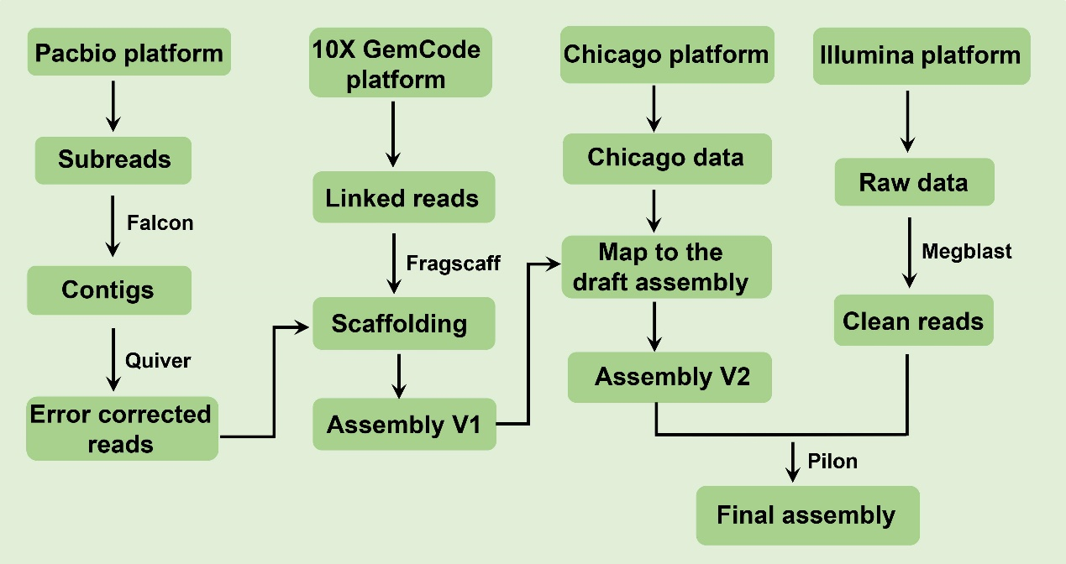
Supplementary Figure S1. Pipeline of the draft genome assembly of Indian blue peafowl.
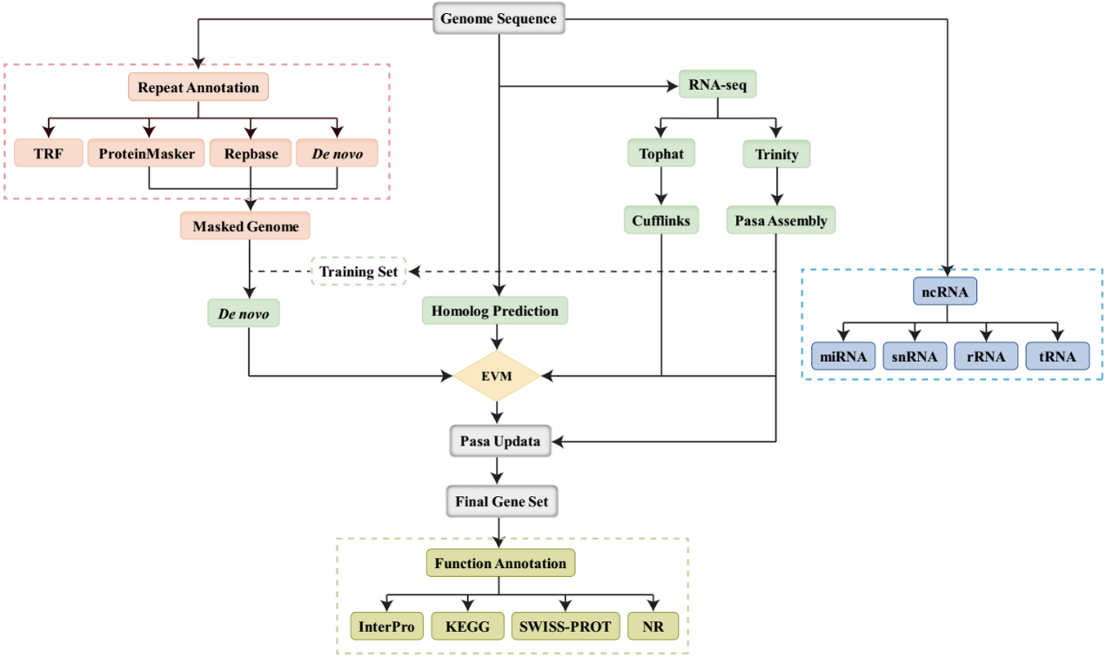
Supplementary Figure S2. Workflow of the genome annotation of Indian blue peafowl.

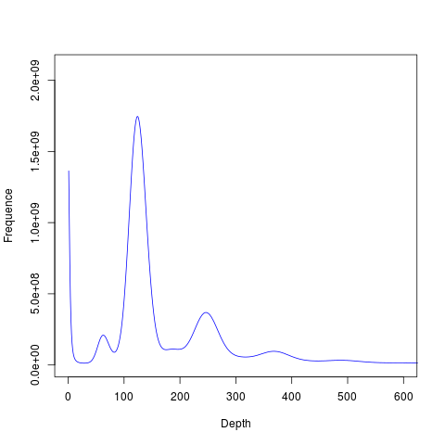
Supplementary Figure S3. 17-kmer frequency distribution of peafowl genome. The genome size of peafowl was estimated to be 1.05 Gb.

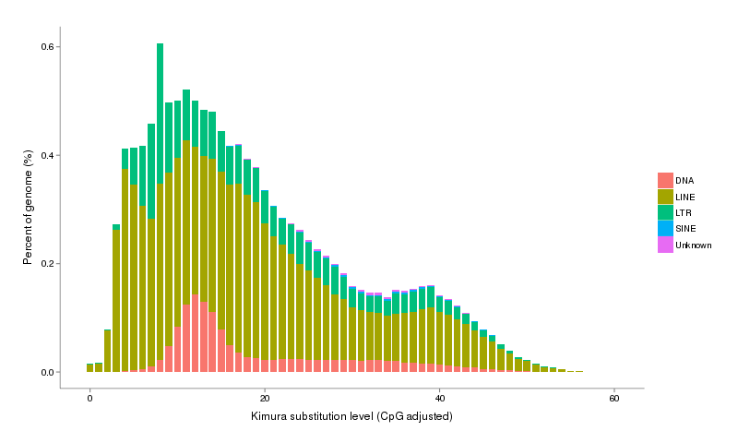
Supplementary Figure S4. Divergence distribution of transposable element of peafowl genome using RepeatMasker software.

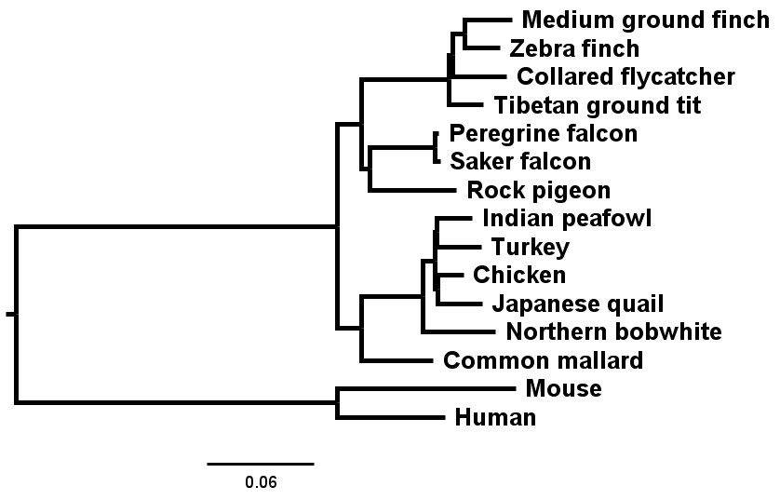
Supplementary Figure S5. Phylogenetic tree of 15 species constructed with IQ-tree. The tree was constructed by IQ-tree with 1000 bootstraps and JTT model based on the single-copy orthologs of 15 species. The result showed that peafowl was closely to turkey, and chicken was clustered with Japanese quail.

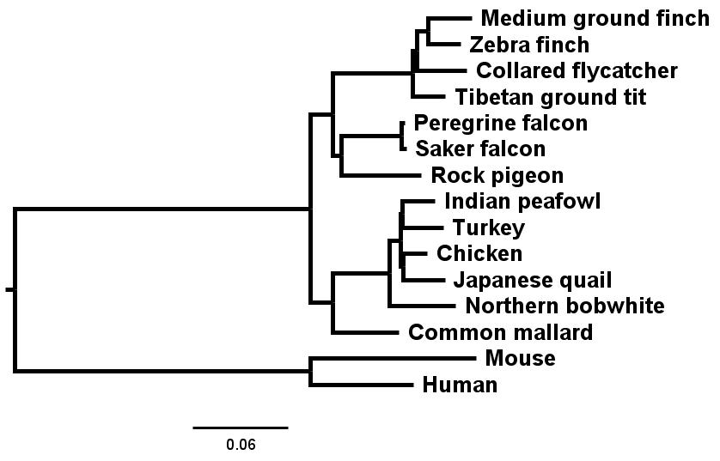
Supplementary Figure S6. Phylogenetic tree of 15 species constructed with RAxML. RAxML software was used to construct phylogenetic tree of 15 species with parameters “-m PROTGAMMALGX -f a” with bootstrap 1000. The position of peafowl among the Phasianidae birds was consistent with the result by IQ-tree that closer to turkey than chicken.

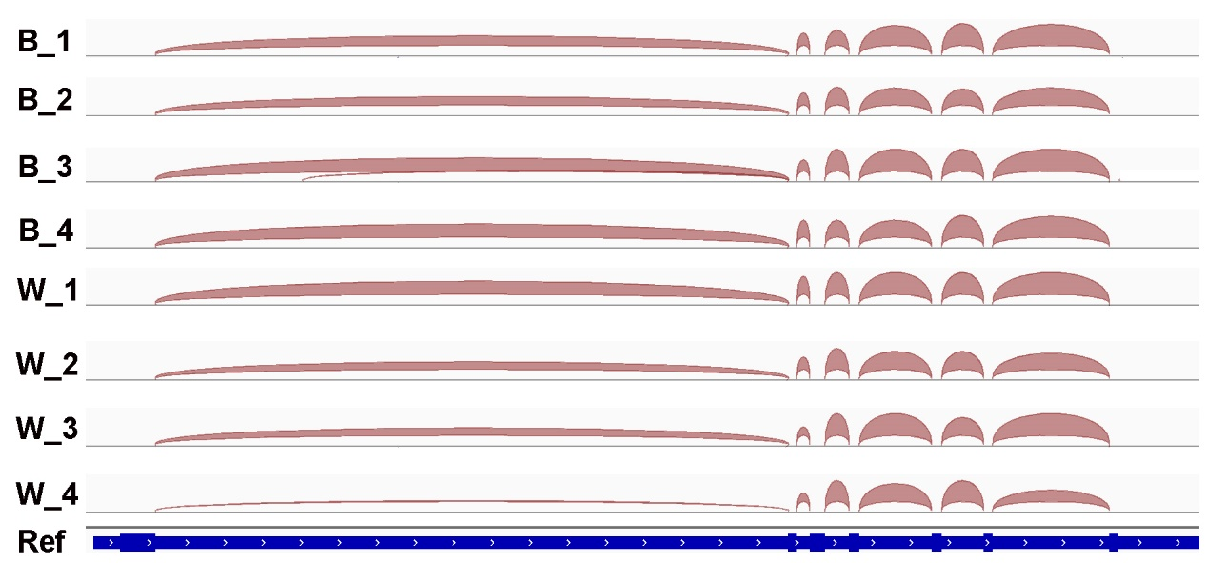
Supplementary Figure S7. EDNRB transcripts in the feather tissue of peafowl by IGV visualization. B: blue peafowl, W: white peafowl. The red arc represented the expressed abundance of genes. There was no difference in the mRNA expression of EDNRB between blue and white peafowl.

Supplementary Tables
Supplementary Table S1. Statistics of genome assembly data of peafowl.
Pair-end libraries | Insert size | Total data (G) | Read length (bp) | Sequence coverage ($×$)
Illumina reads | 350 | 164.03 | 150 | 154
Pacbio reads | 20 | 110.74 | - | 103
10X Genomics | - | 112.57 | - | 105
Total | - | 387.34 | - | 362

Supplementary Table S2. Summary of de novo genome assembly of peafowl.
Sample ID | Length |  | Number
Sample ID | Contig(bp) | Scaffold(bp) | Contig | Scaffold
Total | 1,043,649,651 | 1,046,718,946 | 1,198 | 726
Max | 23,772,621 | 38,857,732 | - | -
Number>=2000 | - | - | 1,158 | 686
N50 | 6,188,159 | 11,421,185 | 49 | 27
N60 | 4,400,165 | 7,915,652 | 69 | 38
N70 | 3,145,120 | 4,996,603 | 97 | 55
N80 | 1,836,661 | 3,704,366 | 141 | 79
N90 | 1,119,826 | 1,758,833 | 215 | 120

Supplementary Table S3. Percentage of the bases contents of peafowl genome.
 | Number (bp) | % of genome
A | 302,508,917 | 28.90
T | 302,518,685 | 28.90
C | 219,251,624 | 20.95
G | 219,370,425 | 20.96
N | 3,069,295 | 0.29
Total (bp) | 1,046,718,946 | 100
GC | 438,622,049 | 42.03
Note: GC content of the genome without N.

Supplementary Table S4. Statistics of paired-end reads mapping in peafowl genome.
 |  | Percentage
Reads | Mapping rate (%) | 98.05
Genome | Average sequencing depth | 137.11
Genome | Coverage (%) | 99.87
Genome | Coverage at least 4× (%) | 99.83
Genome | Coverage at least 10× (%) | 99.77
Genome | Coverage at least 20× (%) | 99.68

Supplementary Table S5. Number of SNPs of peafowl genome.
Items | Number | Percentage（%）
All SNP | 1,239,760 | 0.1199
Heterozygosis SNP | 1,237,532 | 0.1197
Homology SNP | 2,228 | 0.0002
Note: All SNP: All SNPs of genome, including heterozygosis SNP and homology SNP. The percentage of homozygous SNPs showed the correct rate of genome assembly.

Supplementary Table S6. Assembly assessment of completeness using BUSCOs.
BUSCO categories | Gene number | Percentage (%)
Complete BUSCOs | 2,519 | 97.4
Complete and Single-copy BUSCOs | 2,503 | 96.8
Complete and duplicated BUSCOs | 16 | 0.6
Fragmented BUSCOs | 44 | 1.7
Missing BUSCOs | 23 | 0.9

Supplementary Table S7. Whole genome repeat sequences of Indian peafowl genome predicted by homologous alignment and de novo search.
Type | Repeat Size (bp) | Percent (%)
TRF | 13,329,377 | 1.27
RepeatMasker | 147,823,121 | 14.12
RepeatProteinMask | 76,804,345 | 7.34
Total | 159,076,720 | 15.20
Note: Total is the result obtained by the above various methods, and the non-redundant result after removing the overlap between them.

Supplementary Table S8. Composition of repetitive sequences in peafowl genome.
TE type | Denovo+Repbase |  | TE Proteins |  | Combined TEs
TE type | Length (bp) | % in Genome | Length (bp) | % in Genome | Length (bp) | % in Genome
DNA | 5,877,448 | 0.56 | 4,388,989 | 0.42 | 7,373,107 | 0.70
LINE | 106,989,546 | 10.22 | 59,661,976 | 5.70 | 113,724,510 | 10.86
SINE | 63,844 | 0.01 | 0 | 0 | 63,844 | 0.01
LTR | 39,282,352 | 3.75 | 12,851,110 | 1.23 | 41,084,147 | 3.93
Unknown | 2,829,364 | 0.27 | 0 | 0 | 2,829,364 | 0.27
Total | 147,823,121 | 14.12 | 76,804,345 | 7.34 | 152,420,385 | 14.56
Note: Denovo+Repbase is a library predicted by RepeatModeler, RepeatScout, Piler and LTR_FINDER software combined with RepBase nucleotide library, using Uclust software to integrate according to the 80-80-80 principle, and then using RepeatMasker software to identify TEs; TE proteins are based on RepBase protein library, using RepeatProteinMask software to identify TEs; Combined TEs is the result of integrating the above two methods and removing redundancy. Unknown indicates that the repeat sequence can’t be classified by RepeatMasker.

Supplementary Table S9. Prediction of protein-coding genes for the peafowl genome.
Prediction Method | Gene set | Number | Average transcript length(bp) | Average CDS length(bp) | Average exons per gene | Average exon length(bp) | Average intron length(bp)
De novo | Augustus | 15,350 | 18,679.48 | 1,492.42 | 8.58 | 173.95 | 2,267.48
De novo | GlimmerHMM | 157,061 | 5,826.55 | 494.43 | 2.91 | 169.90 | 2,791.62
De novo | SNAP | 44,786 | 37,825.24 | 839.36 | 6.58 | 127.62 | 6,632.06
De novo | Geneid | 23,030 | 27,060.74 | 1,277.38 | 6.87 | 185.95 | 4,392.72
De novo | Genscan | 32,979 | 23,773.49 | 1,399.65 | 8.37 | 167.22 | 3,035.70
Homolog | African ostrich | 19,912 | 14,902.03 | 1,332.09 | 6.93 | 192.30 | 2,289.48
Homolog | Crested ibis | 27,835 | 11,207.12 | 1,041.79 | 5.58 | 186.67 | 2,219.06
Homolog | Peking duck | 21,801 | 14,382.25 | 1,274.25 | 6.72 | 189.48 | 2,289.68
Homolog | Red junglefowl | 21,304 | 13,813.28 | 1,228.22 | 6.62 | 185.45 | 2,238.17
Homolog | Turkey | 28,433 | 10,242.10 | 1,020.06 | 5.50 | 185.55 | 2,050.44
Homolog | Zedong white goose | 35,210 | 8,808.57 | 923.40 | 4.71 | 196.25 | 2,128.19
RNAseq | PASA | 89,720 | 12,240.46 | 985.89 | 5.72 | 172.30 | 2,383.49
RNAseq | Cufflinks | 53,708 | 29,459.41 | 4,405.71 | 9.76 | 451.38 | 2,859.82
EVM |  | 20,323 | 20,438.39 | 1,384.46 | 8.10 | 170.86 | 2,682.60
Pasa-update |  | 20,199 | 20,653.08 | 1,391.43 | 8.08 | 172.12 | 2,719.03
Final set |  | 19,465 | 21,046.08 | 1,408.58 | 8.24 | 171.01 | 2,713.61

Supplementary Table S10. Statistics of functional annotation of protein-coding genes in the peafowl genome assembly.
 | Number | Percent(%)
Total | 19,465 | -
Swissprot | 15,137 | 77.80
Nr | 15,741 | 80.90
KEGG | 14,137 | 72.60
InterPro | 14,416 | 74.1
GO | 10,347 | 53.2
Pfam | 13,146 | 67.5
Annotated | 15,766 | 81.00
Unannotated | 3,699 | 19.00

Supplementary Table S11. Statistics of non-coding RNAs in the assembly of peafowl.
Type |  | Copy number | Average length(bp) | Total length(bp) | % of genome
miRNA |  | 354 | 102.23 | 36,190 | 0.003457
tRNA |  | 308 | 76.22 | 23,477 | 0.002243
rRNA | rRNA | 151 | 151.53 | 22,881 | 0.002186
rRNA | 18S | 23 | 235.96 | 5,427 | 0.000518
rRNA | 28S | 105 | 142.03 | 14,913 | 0.001425
rRNA | 5.8S | 0 | 0 | 0 | 0
rRNA | 5S | 23 | 110.48 | 2,541 | 0.000243
snRNA | snRNA | 334 | 128.77 | 43,010 | 0.004109
snRNA | CD-box | 131 | 101.06 | 13,239 | 0.001265
snRNA | HACA-box | 81 | 144.16 | 11,677 | 0.001116
snRNA | splicing | 101 | 142.10 | 14,352 | 0.001371
Supplementary Table S12-S19 are displayed in excel files.

Supplementary Table S20. Primer sequences of PMEL for RT-qPCR.
Gene name | Forward Primer (5’ to 3’) | Reverse Primer (5’ to 3’)
PMEL | GGTGGTTTATCACTACCG | GTCGGTGATGCTGAACTG
β-actin | ACACGGTATTGTCACCAACT | TAACACCATCACCAGAGTCC
Note: β-actin is used as an internal reference gene.

References
Bairoch, A., & Apweiler, R. (2000). The SWISS-PROT protein sequence database and its supplement TrEMBL in 2000. Nucleic Acids Res, 28(1), 45-48. doi:10.1093/nar/28.1.45
Birney, E., Clamp, M., & Durbin, R. (2004). GeneWise and Genomewise. Genome Res, 14(5), 988-995. doi:10.1101/gr.1865504
Chen, Y., Ye, W., Zhang, Y., & Xu, Y. (2015). High speed BLASTN: an accelerated MegaBLAST search tool. Nucleic Acids Res, 43(16), 7762-7768. doi:10.1093/nar/gkv784
Flynn, J. M., Hubley, R., Goubert, C., Rosen, J., Clark, A. G., Feschotte, C., & Smit, A. F. (2020). RepeatModeler2 for automated genomic discovery of transposable element families. Proc Natl Acad Sci U S A, 117(17), 9451-9457. doi:10.1073/pnas.1921046117
Gant, T. W., Sauer, U. G., Zhang, S. D., Chorley, B. N., Hackermüller, J., Perdichizzi, S., . . . Poole, A. (2017). A generic Transcriptomics Reporting Framework (TRF) for 'omics data processing and analysis. Regul Toxicol Pharmacol, 91 Suppl 1(Suppl 1), S36-s45. doi:10.1016/j.yrtph.2017.11.001
Gertz, E. M., Yu, Y. K., Agarwala, R., Schäffer, A. A., & Altschul, S. F. (2006). Composition-based statistics and translated nucleotide searches: improving the TBLASTN module of BLAST. BMC Biol, 4, 41. doi:10.1186/1741-7007-4-41
Grabherr, M. G., Haas, B. J., Yassour, M., Levin, J. Z., Thompson, D. A., Amit, I., . . . Regev, A. (2011). Full-length transcriptome assembly from RNA-Seq data without a reference genome. Nat Biotechnol, 29(7), 644-652. doi:10.1038/nbt.1883
Griffiths-Jones, S., Moxon, S., Marshall, M., Khanna, A., Eddy, S. R., & Bateman, A. (2005). Rfam: annotating non-coding RNAs in complete genomes. Nucleic Acids Res, 33(Database issue), D121-124. doi:10.1093/nar/gki081
Haas, B. J., Salzberg, S. L., Zhu, W., Pertea, M., Allen, J. E., Orvis, J., . . . Wortman, J. R. (2008). Automated eukaryotic gene structure annotation using EVidenceModeler and the Program to Assemble Spliced Alignments. Genome biology, 9(1), R7. doi:10.1186/gb-2008-9-1-r7
Jurka, J., Kapitonov, V. V., Pavlicek, A., Klonowski, P., Kohany, O., & Walichiewicz, J. (2005). Repbase Update, a database of eukaryotic repetitive elements. Cytogenet Genome Res, 110(1-4), 462-467. doi:10.1159/000084979
Korf, I. (2004). Gene finding in novel genomes. BMC Bioinformatics, 5, 59. doi:10.1186/1471-2105-5-59
Lowe, T. M., & Eddy, S. R. (1997). tRNAscan-SE: a program for improved detection of transfer RNA genes in genomic sequence. Nucleic Acids Res, 25(5), 955-964. doi:10.1093/nar/25.5.955
Majoros, W. H., Pertea, M., & Salzberg, S. L. (2004). TigrScan and GlimmerHMM: two open source ab initio eukaryotic gene-finders. Bioinformatics (Oxford, England), 20(16), 2878-2879. doi:10.1093/bioinformatics/bth315
Stanke, M., Keller, O., Gunduz, I., Hayes, A., Waack, S., & Morgenstern, B. (2006). AUGUSTUS: ab initio prediction of alternative transcripts. Nucleic Acids Res, 34(Web Server issue), W435-439. doi:10.1093/nar/gkl200
Tarailo-Graovac, M., & Chen, N. (2009). Using RepeatMasker to identify repetitive elements in genomic sequences. Curr Protoc Bioinformatics, Chapter 4, Unit 4.10. doi:10.1002/0471250953.bi0410s25
Trapnell, C., Pachter, L., & Salzberg, S. L. (2009). TopHat: discovering splice junctions with RNA-Seq. Bioinformatics (Oxford, England), 25(9), 1105-1111. doi:10.1093/bioinformatics/btp120
Trapnell, C., Roberts, A., Goff, L., Pertea, G., Kim, D., Kelley, D. R., . . . Pachter, L. (2012). Differential gene and transcript expression analysis of RNA-seq experiments with TopHat and Cufflinks. Nat Protoc, 7(3), 562-578. doi:10.1038/nprot.2012.016
Xu, Z., & Wang, H. (2007). LTR_FINDER: an efficient tool for the prediction of full-length LTR retrotransposons. Nucleic Acids Res, 35(Web Server issue), W265-268. doi:10.1093/nar/gkm286
Zdobnov, E. M., & Apweiler, R. (2001). InterProScan--an integration platform for the signature-recognition methods in InterPro. Bioinformatics (Oxford, England), 17(9), 847-848. doi:10.1093/bioinformatics/17.9.847

