Table 1 Baseline data of the study population
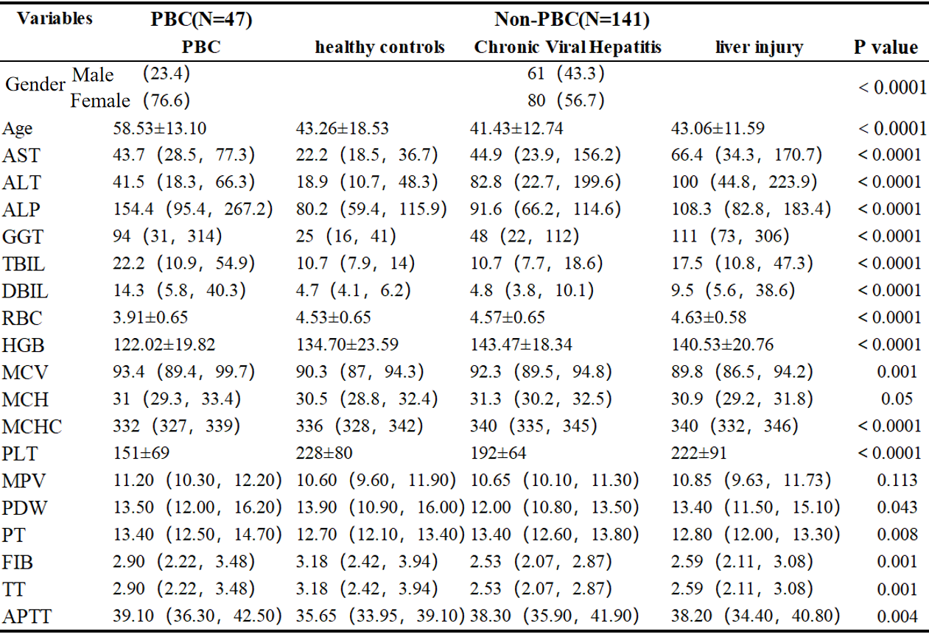

Table 2 Univariate logistic regression analysis for identification of factors associated with PBC
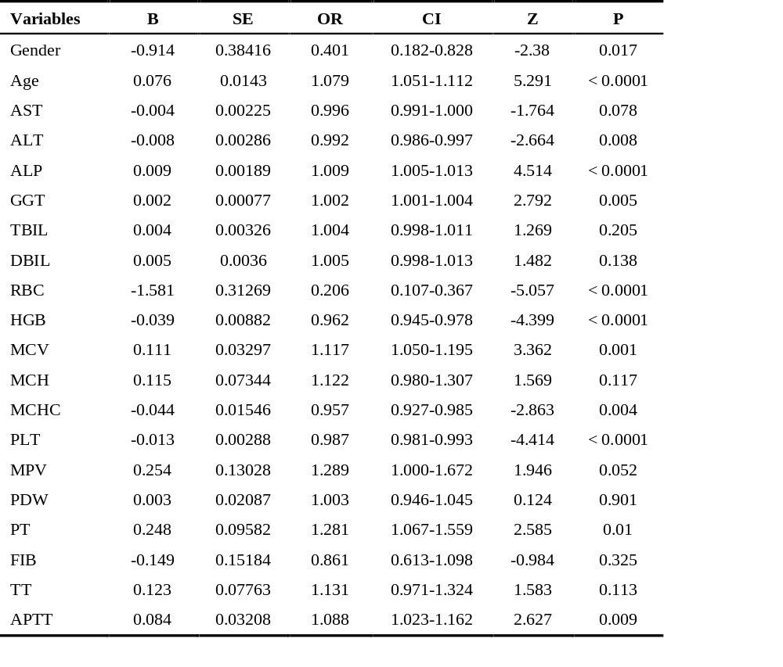
Table 3 Multivariate logistic regression analysis for identification of factors associated with PBC
