Impact of meteorological factors on influenza incidence in Wuxi from 2014 to 2019: a time series and comprehensive analysis
Menglan He^{1,#}, Yan Wang^{2,#}, Xinliang Ding^{2,#}, Yumeng Gao², Chao Shi^{1,2,*}
# These authors equally contributed to the article.
* Corresponding authors:
Chao Shi, E-mail: wxcdcshichao@126.com
¹ School of Public Health, Nanjing Medical University, Nanjing, China
² The Affiliated Wuxi Center for Disease Control and Prevention of Nanjing Medical University, Wuxi Center for Disease Control and Prevention, Wuxi, China

Supplementary materials
Search strategy
Quality assessment
Study characteristics
Supplementary Table
Supplementary Table 1 Spearman correlation between influenza cases and meteorological factors in Wuxi, 2014-2019
Supplementary Table 2 GCV Scores of Meteorological Factors and Influenza Incidence Risk Models for Different Lag Weeks
Supplementary Table 3 Subgroup Heterogeneity Test of Meteorological Factors
Supplementary Table 4 Basic Characteristics of Included Studies
Supplementary Table 5 Meta-regression analysis of influenza on temperature and relative humidity
Supplementary Table 6 Publication bias test of temperature and relative humidity

Supplementary Figure
Supplementary Fig. 1 Time distribution of weekly influenza and meteorological factors in Wuxi city, 2014-2019
Supplementary Fig. 2 Systematic search and study selection
Supplementary Fig. 3 Funnel plot of the association between temperature, relative humidity and influenza

References
Supplementary materials

This systematic review and meta-analysis were conducted following the Preferred Reporting Items for Systematic Reviews and Meta-Analyses (PRISMA) guidelines [1]. The study has been registered with PROSPERO under the registration number CRD42021284952.
Search strategy (Taking PubMed as an example)
#1 "Influenza, Human"[Mesh]
#2 Influenza[Title/Abstract]
#3 #1 OR #2
#4 ambient temperature[Title/Abstract] OR temperature[Title/Abstract]
#5 relative humidity[Title/Abstract] OR humidity[Title/Abstract]
#6 rainfall[Title/Abstract]) OR precipitation[Title/Abstract]
#7 air pressure[Title/Abstract]) OR atmospheric pressure[Title/Abstract]
#8 wind speed[Title/Abstract] OR wind velocity[Title/Abstract]
#9 sunshine[Title/Abstract]) OR sunshine duration[Title/Abstract]
#10 meteorology[Title/Abstract] OR climate[Title/Abstract]
#11 #4 OR #5 OR #6 OR #6 OR #8 OR #9 OR #10
#12 #3 AND #11

Quality assessment
The quality of the included studies was assessed using the research quality evaluation criteria recommended by the Agency for Healthcare Research and Quality (AHRQ), which consists of 11 items [2]. A score of 0 to 3 indicates low quality, 4 to 7 indicates medium quality, and 8 to 11 indicates high quality. The results are presented in Supplementary Table 4.
Study characteristics
Initially, 14,096 articles were identified. After removing duplicates and applying inclusion/exclusion criteria, 13 studies were selected. A data update in January 2025 added one more study, bringing the total to 14 studies for meta-analysis. The screening process is shown in Supplementary Fig. 2. Of these studies, 13 focused on temperature, 4 on relative humidity, 2 on precipitation, 1 on sunshine duration, and 1 on wind speed. The studies included 10 from subtropical regions, 2 from temperate regions, and 1 from tropical regions. Two studies targeted children, and 12 focused on the general population, with 2 including age stratification. Five studies analyzed different influenza subtypes. The studies were summarized for meta-analysis, with temperature effects categorized into cold, hot, and average to assess their role in influenza incidence. Subgroup analysis was performed based on population and regional climate to identify sources of heterogeneity.
Supplementary Table
Supplementary Table 1 Spearman correlation between influenza cases and meteorological factors in Wuxi, 2014-2019
Correlation | Cases | Pressure | Temperature | Relative humidity | Precipitation | Wind speed | Sunshine duration
Cases | 1
Pressure | 0.478* | 1
Temperature | -0.539* | -0.933* | 1
Relative humidity | -0.005 | -0.150* | 0.103 | 1
Precipitation | -0.040 | -0.297* | 0.183* | 0.617* | 1
Wind speed | -0.036 | -0.221* | 0.137* | -0.095 | 0.167* | 1
Sunshine duration | -0.117* | -0.093 | 0.188* | -0.754* | -0.542* | 0.066 | 1
*P < 0.05

Supplementary Table 2 GCV Scores of Meteorological Factors and Influenza Incidence Risk Models for Different Lag Weeks
Lag weeks | Pressure | Temperature | Relative humidity | Precipitation | Wind speed | Sunshine duration
Lag0 | 11.12556 | 11.22518 | 10.29512 | 11.30741 | 11.68140 | 10.67005
Lag1 | 11.38494 | 11.45404 | 11.74052 | 11.75474 | 11.71740 | 11.71375
Lag2 | 10.61353 | 10.23179 | 11.60400 | 11.72039 | 11.30681 | 11.65771

Supplementary Table 3 Subgroup Heterogeneity Test of Meteorological Factors
 | Sex | Age
Pressure | Q=0.02, P=0.8775 | Q=11.32, P=0.0101*
Temperature | Q=0.00, P=0.9475 | Q=10.14, P=0.0174*
Wind speed | Q=0.00, P=0.9616 | Q=1.37, P=0.7127
Relative humidity | Q=0.03, P=0.8736 | Q=3.15, P=0.3687
Precipitation | Q=0.27, P=0.6015 | Q=29.73, P<0.0001*
Sunshine duration | Q=0.00, P=0.9826 | Q=17.46, P=0.0006*
*P < 0.05

Supplementary Table 4 Basic Characteristics of Included Studies
First author  (year) | Published | Period | Location | Population | Age | Exposure | Study design | Statistical model | Climate group | Outcome | Quality scores
Liu et al[3] | 2019 | 2012-2017 | Wuxi,China | 1573 | All | T | Time series study | DLNM | Subtropical | Confirmed Cases | 6
Chen et al[4] | 2021 | 2004-2019 | China | 1986536 | ≤14 year  15-59 year  ≥60 year | T | Time series study | GAM | Subtropical and temperate | Confirmed Cases | 5
Jaakkola et al[5] | 2014 | 2004-2015 | Finland | 66 | All | T | Case-crossover study | Conditional logistic regression | Subtropical | Confirmed Cases | 9
Lau et al[6] | 2020 | 2014-2018 | Hangzhou, China | 20165 | All | PRCP、T、RH | Time series study | GAM, DLNM | Subtropical | Confirmed Cases | 7
Li et al[7] | 2022 | 2014-2017 | Wuhan, China | 12390 | All | T | Time series study | GAM, DLNM | Subtropical | Confirmed Cases | 6
Li et al[8] | 2020 | 2017-2019 | Shanghai, China | 29315 | 0-18 years | T | Time series study | DLNM | Subtropical | Confirmed Cases | 7
Ma et al[9] | 2022 | 2009-2015 | Shenzhen, China | 3330 | All | T、RH、WS | Time series study | GAM, DLNM | Subtropical | Confirmed Cases | 7
Ng et al[10] | 20222022 | 2014-2018 | Macau, China | 17104 | All | T、RH、SD | Time series study | DLNM | Subtropical | Confirmed Cases | 7
Wang et al[11] | 2022 | 2010-2019 | Lanzhou, China | 6701 | All | RH、T | Time series study | DLNM | Temperate | Confirmed Cases | 6
Wu et al[12] | 2021 | 2014-2019 | Hefei, China | 5238 | 0-4 year  5-17 year  ≥18 year | T | Time series study | GAM, DLNM | Subtropical | Confirmed Cases | 7
Xu et al[13] | 2013 | 2010-2018 | Brisbane, Australia | 2922 | 0-14 years | T | Time series study | Poisson log-linear regression | Subtropical | Confirmed Cases | 5
Soebiyanto et al[14] | 2014 | 2008-2013 | Guatemala、El Salvador and Panama | 6420 | All | T、PRCP | Time series study | Logistic regression | Tropical | Confirmed Cases | 6
Wafatsuma et al[15] | 2024 | 2014.3-2019.12 | Kawasaki, Japan | 181895 | All | T | Time series study | GLM、DLNM | Temperate | Confirmed Cases | 7
T, Temperature; PRCP, Precipitation; RH, Relative humidity; WS, Wind speed; SD, Sunshine duration; DLNM, Distributed Lag Non-Linear Model; GAM, Generalized Additive Model; GLM, Generalized Linear Model; NA, Not Available
Supplementary Table 5 Meta-regression analysis of influenza on temperature and relative humidity
Index | Effect | Factors | Estimate | se | zval | P value | ci.lb | ci.ub
Temperature | Cold effect | Population | -0.2374 | 0.0468 | -5.0748 | <0.0001* | -0.3290 | -0.1457
Temperature | Cold effect | Regional climate | -0.0410 | 0.0380 | -1.0567 | 0.2906 | -0.1145 | 0.0343
Temperature | Hot effect | Population | 0.1715 | 0.0806 | 2.1263 | 0.0335* | 0.0134 | 0.3295
Temperature | Hot effect | Regional climate | -0.0140 | 0.0669 | -0.2095 | 0.8341 | -0.1451 | 0.1170
Relative humidity | Low relative humidity | Population | 0.0001 | 0.0162 | 0.0066 | 0.9947 | -0.0316 | 0.0318
Relative humidity | Low relative humidity | Regional climate | -0.0469 | 0.0237 | -1.9787 | 0.0479* | -0.0933 | -0.0004
Relative humidity | High relative humidity | Population | 0.0032 | 0.0230 | 0.1383 | 0.8900 | -0.0420 | 0.0483
*P < 0.05

Supplementary Table 6 Publication bias test of temperature and relative humidity
Variables | Effect | n | Method | Statistics | P value
Ambient temperature | Cold effect | 10 | Egger’s test | -2.70 | 0.0270
Ambient temperature | Cold effect | 10 | Begg’s test | -1.34 | 0.1797
Ambient temperature | Hot effect | 10 | Egger’s test | 2.50 | 0.0369
Ambient temperature | Hot effect | 10 | Begg’s test | 0.80 | 0.4208
Ambient temperature | Mean effect | 5ª | Egger’s test | -1.53 | 0.2236
Ambient temperature | Mean effect | 5ª | Begg’s test | -0.49 | 0.6242
Relative humidity | Low effect | 8ª | Egger’s test | -2.43 | 0.0513
Relative humidity | Low effect | 8ª | Begg’s test | 0.00 | 1.0000
Relative humidity | High effect | 6ª | Egger’s test | 2.38 | 0.0756
Relative humidity | High effect | 6ª | Begg’s test | 1.69 | 0.0909
ª Since Egger’s and Begg’s tests are recommended to be conducted with more than 10 studies, the results for some groups that include fewer studies may be biased.

Supplementary Figure
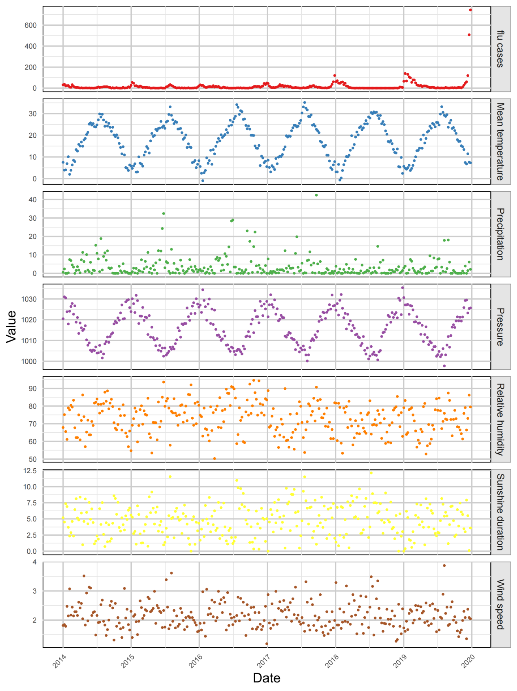
Supplementary Fig. 1 Time distribution of weekly influenza and meteorological factors in Wuxi city, 2014-2019
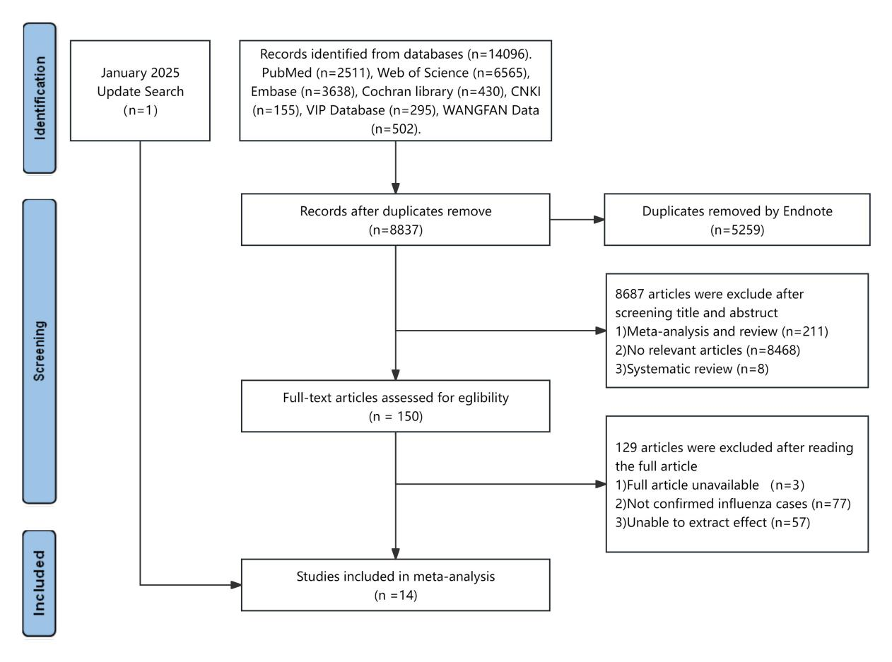
Supplementary Fig. 2 Systematic search and study selection

A
B
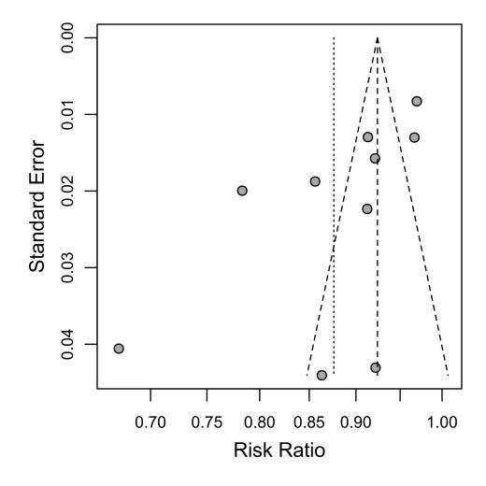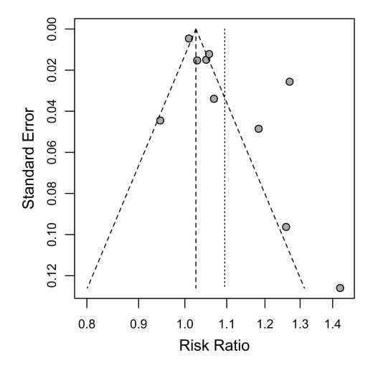
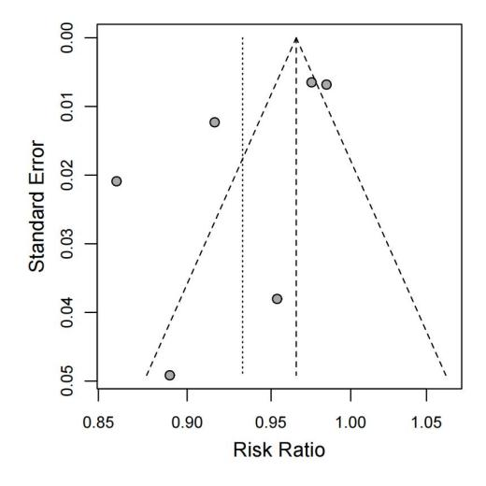
C
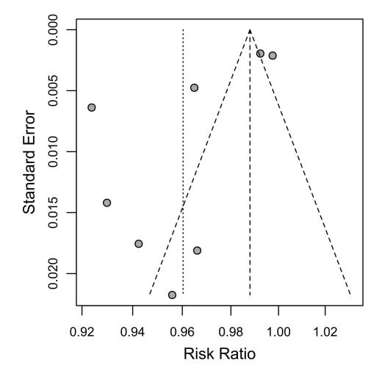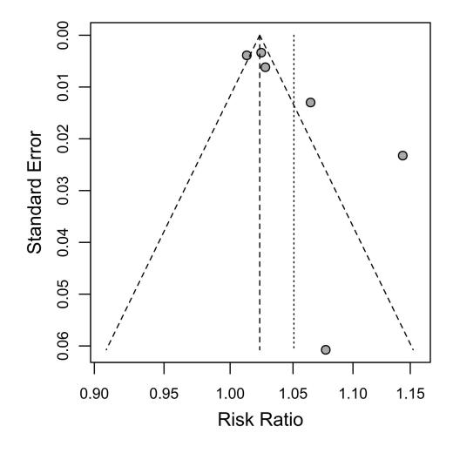
E
D
Supplementary Fig. 3 Funnel plot of the association between temperature, relative humidity and influenza. A for cold effect of temperature; B for hot effect of temperature; C for average effect of temperature; D for dry effect of relative humidity; E for wet effect of relative humidity
References:
1. Moher D, Liberati A, Tetzlaff J, Altman DG. Preferred reporting items for systematic reviews and meta-analyses: the PRISMA statement. PLoS Med. 2009;6(7):e1000097.
2. Huang T, Li C, Chen F, Xie D, Yang C, Chen Y, et al. Prevalence and risk factors of osteosarcopenia: a systematic review and meta-analysis. BMC Geriatr. 2023;23(1):369.
3. Liu J, Shi C, Zhang Q, Shi P. The effect of ambient temperature on the activity influenza like illness andlaboratory-confirmed influenza in Wuxi City. Chin J Dis Control Prev. 2019;23(11):1389-1393+1419.
4. Chen C, Zhang X, Jiang D, Yan D, Guan Z, Zhou Y, et al. Associations between Temperature and Influenza Activity: A National Time Series Study in China. Int J Environ Res Public Health. 2021;18(20):10846.
5. Jaakkola K, Saukkoriipi A, Jokelainen J, Juvonen R, Kauppila J, Vainio O, et al. Decline in temperature and humidity increases the occurrence of influenza in cold climate. Environ Health. 2014;13(1):22.
6. Lau SY, Cheng W, Yu Z, Mohammad KN, Wang MH, Zee BC, et al. Independent association between meteorological factors, PM2.5, and seasonal influenza activity in Hangzhou, Zhejiang province, China. Influenza Other Respir Viruses. 2021;15(4):513-520.
7. Li Y, Wu J, Hao J, Dou Q, Xiang H, Liu S. Short-term impact of ambient temperature on the incidence of influenza in Wuhan, China. Environ Sci Pollut Res Int. 2022;29(12):18116-18125.
8. Li Y, Ye X, Zhou J, Zhai F, Chen J. The association between the seasonality of pediatric pandemic influenza virus outbreak and ambient meteorological factors in Shanghai. Environmental Health. 2020;19(1).
9. Ma P, Tang X, Zhang L, Wang X, Wang W, Zhang X, et al. Influenza A and B outbreaks differed in their associations with climate conditions in Shenzhen, China. International Journal of Biometeorology. 2021;66(1):163-173.
10. Ng H, Li Y, Zhang T, Lu Y, Wong C, Ni J, et al. Association between multiple meteorological variables and seasonal influenza A and B virus transmission in Macau. Heliyon. 2022;8(11):e11820.
11. Wang J, Zhang L, Lei R, Li P, Li S. Effects and Interaction of Meteorological Parameters on Influenza Incidence During 2010-2019 in Lanzhou, China. Front Public Health. 2022;10:833710.
12. Wu Q, He J, Zhang W-Y, Zhao K-F, Jin J, Yu J-L, et al. The contrasting relationships of relative humidity with influenza A and B in a humid subtropical region. Environmental Science and Pollution Research. 2021;28(27):36828-36836.
13. Xu Z, Hu W, Williams G, Clements ACA, Kan H, Tong S. Air pollution, temperature and pediatric influenza in Brisbane, Australia. Environment International. 2013;59:384-388.
14. Soebiyanto RP, Clara W, Jara J, Castillo L, Sorto OR, Marinero S, et al. The role of temperature and humidity on seasonal influenza in tropical areas: Guatemala, El Salvador and Panama, 2008-2013. PLoS One. 2014;9(6):e100659.
15. Wagatsuma K. Effect of short-term ambient temperature exposure on influenza A and B incidence: a time-series analysis of daily surveillance data in Kawasaki City, Japan. IJID Reg. 2024;13:100479.

