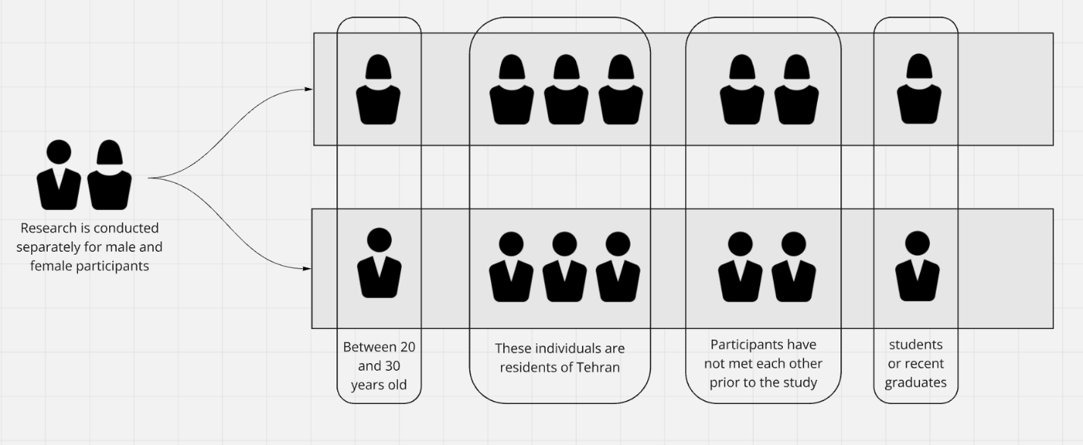
Chart 1: Factors influencing participant selection; source: author.
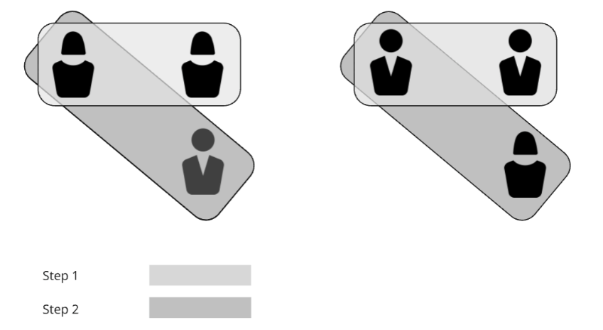
Chart 2: Stages of conducting the experiment based on different gender pairings; source: author.

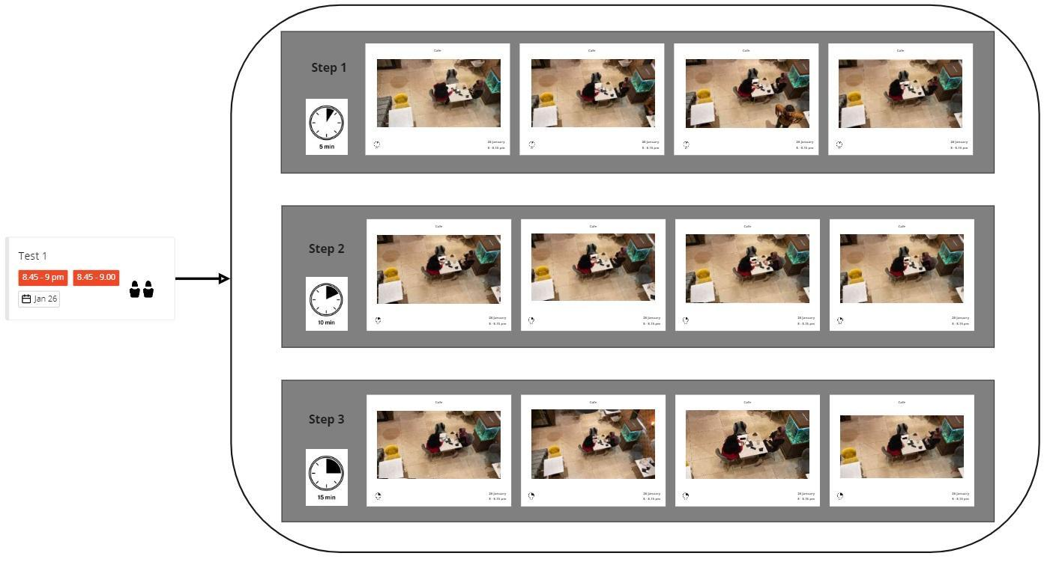
Charts 3: Timing and categorization of photographic data; source: author.

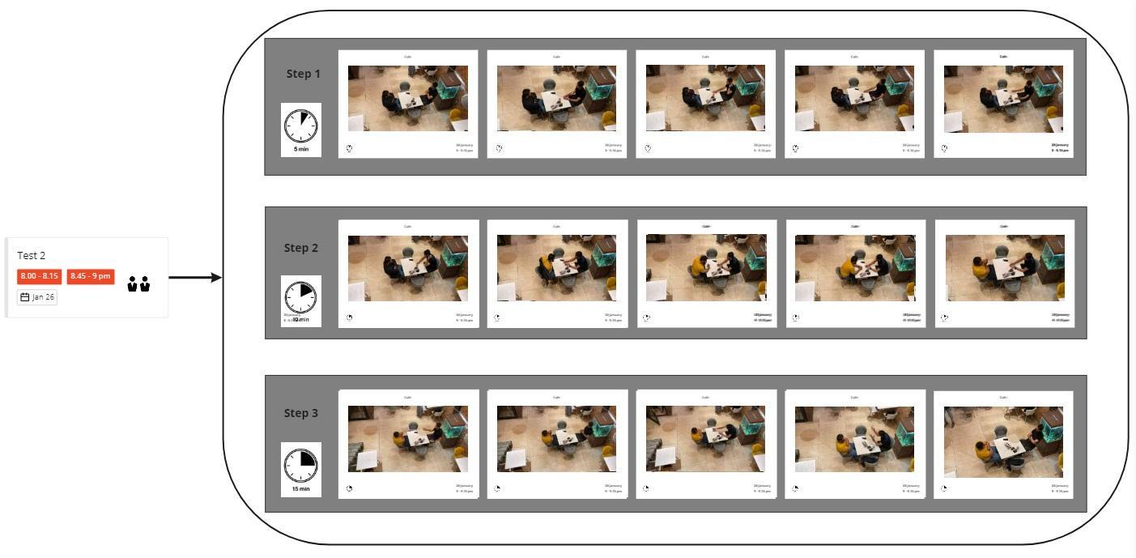
Charts 4: Timing and categorization of photographic data; source: author.

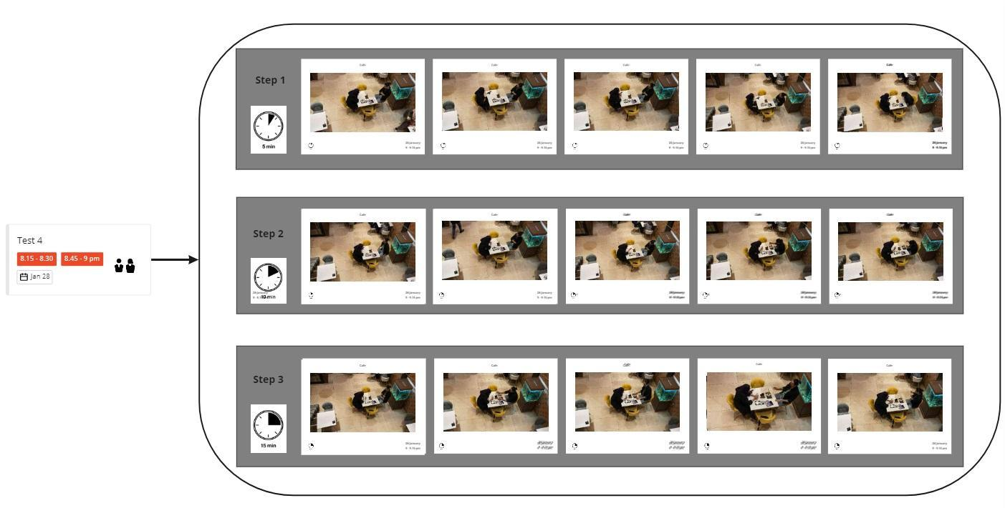
Charts 5: Timing and categorization of photographic data; source: author.

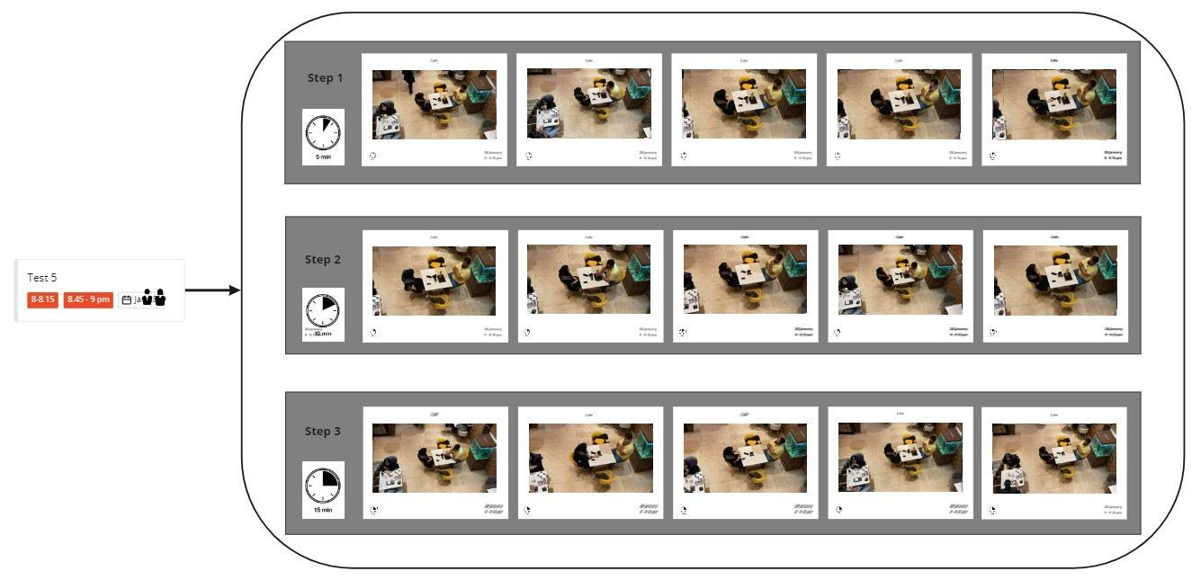
Charts 6: Timing and categorization of photographic data; source: author.
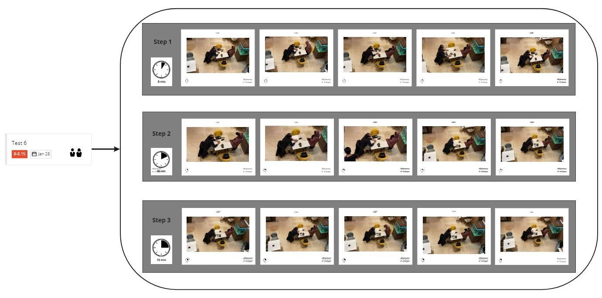

Charts 7: Timing and categorization of photographic data; source: author.

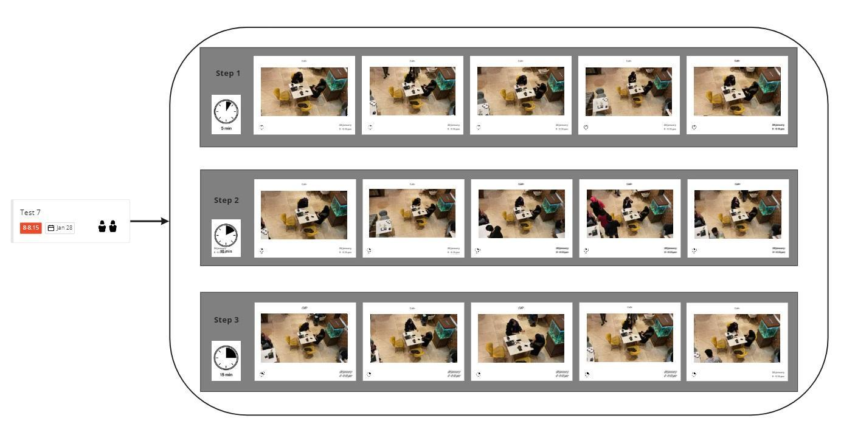

Charts 8: Timing and categorization of photographic data; source: author.

Effective Factors on Proxemic Behaviors | Observed Situations in Layout | Predicted Situations and Behaviors Between Same-Sex Individuals | Predicted Situations and Behaviors Between Opposite-Sex Individuals
Postural / Gender | In the designed experiment, most individuals were seated. | Both individuals usually sat facing each other with a slight tilt. | At the beginning of the conversation, individuals sat with a tilt and avoided direct facing.
Social / Antisocial Orientation | In same-sex interactions, individuals tended to sit at a specific angle, mostly facing each other. | During same-sex conversations, individuals maintained more direct orientation toward each other. | Opposite-sex participants tended to sit at angles or avoid direct body orientation toward each other.
Kinetic / Movements Factors | Considering the table size (80×80 cm), the distance between participants was relatively constant (either touching or almost touching the table edges). | In same-sex interactions, the distance was slightly reduced during the conversation (closer physical proximity). | Opposite-sex individuals maintained greater distance throughout the conversation (e.g., 2.0 distance — forearm length or further).
Tactile/Touch Code | Due to the structure of the experiment, no physical touch was expected between participants. | In same-sex interactions, no intentional physical contact occurred (case 5: incidental contact). | In opposite-sex interactions, no intentional physical contact occurred.
Visual Code | According to video analysis, eye contact in same-sex interactions was either macular (M) or occasionally peripheral (P). | In same-sex conversations, visual contact was generally macular and occasionally peripheral. | In opposite-sex conversations, visual contact was mostly peripheral and less direct.
Thermal Code | Due to the size of the table, participants' perception of body warmth was minimal or nonexistent. | Participants did not report feeling each other’s body warmth. | Participants did not report feeling each other’s body warmth.
Olfaction Code | Due to the set distance, the perception of each other’s scent was unlikely. | Participants did not report sensing the smell of others. | Participants did not report sensing the smell of others.
Voice Loudness | Using recording equipment, voice loudness was measured and remained relatively stable throughout the sessions. | Voice loudness remained stable across same-sex conversations. | Voice loudness remained stable across opposite-sex conversations.

Chart 9: Analysis of effective factors influencing proxemic behaviors in the experiment. Source: Author.

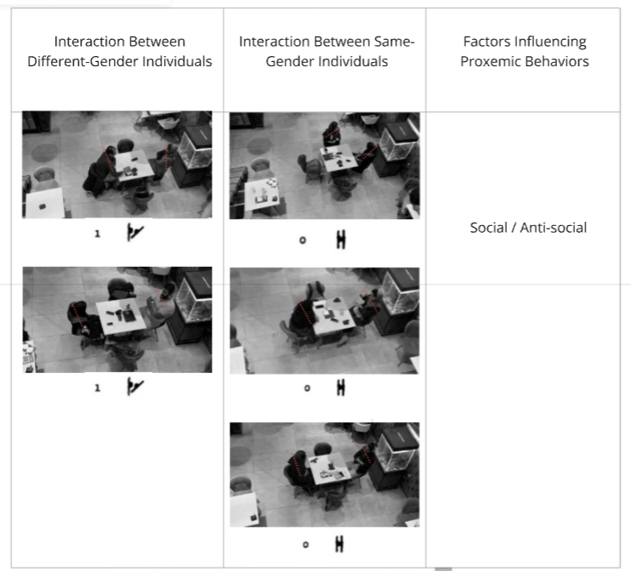
Chart 10: Analysis of social/antisocial orientation in interactions between same-sex and opposite-sex individuals. Source: Author.
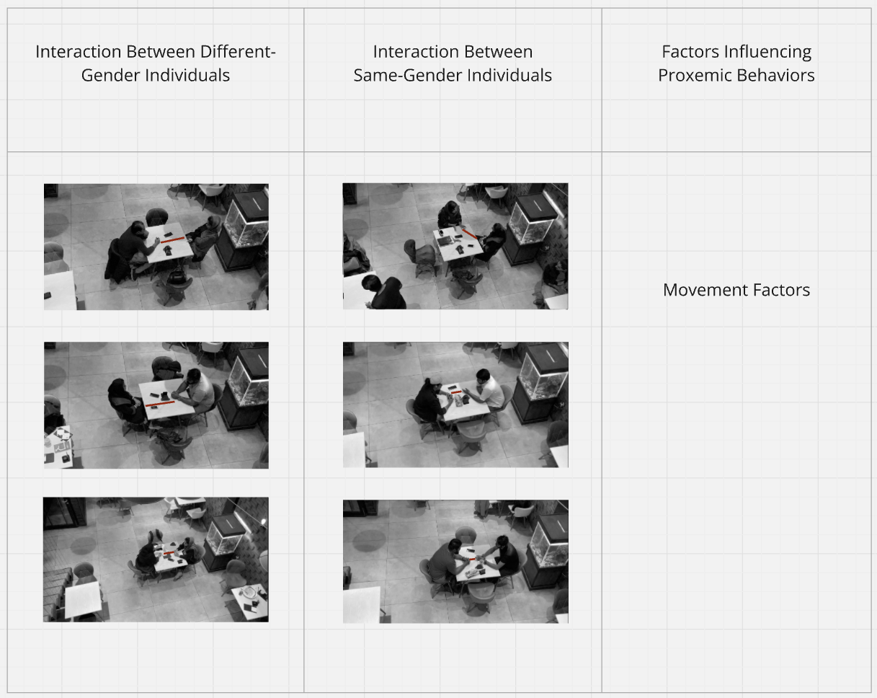
Chart 11: Analysis of kinetic/movement factors in interactions between same-sex and opposite-sex individuals. Source: Author.
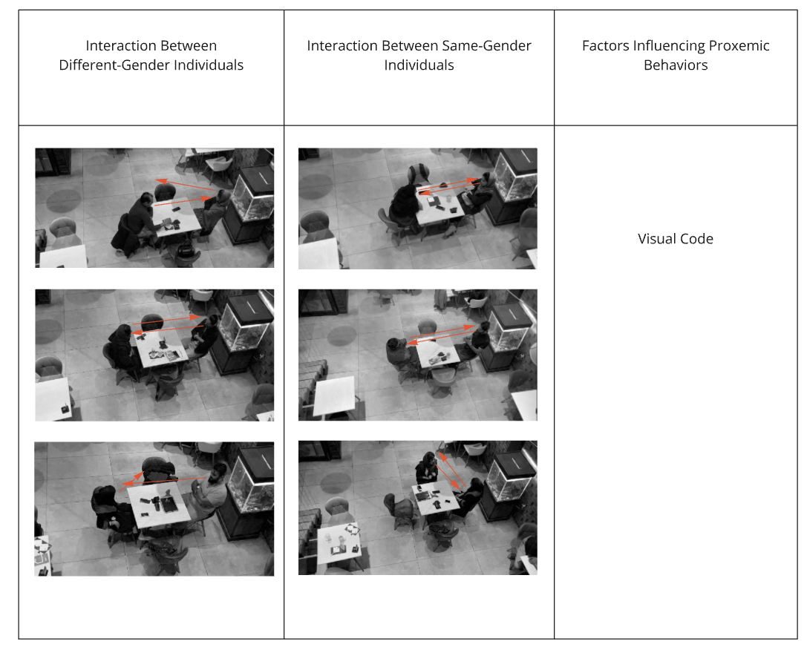
Chart 12: Analysis of visual communication factors in interactions between same-sex and opposite-sex individuals. Source: Author.

