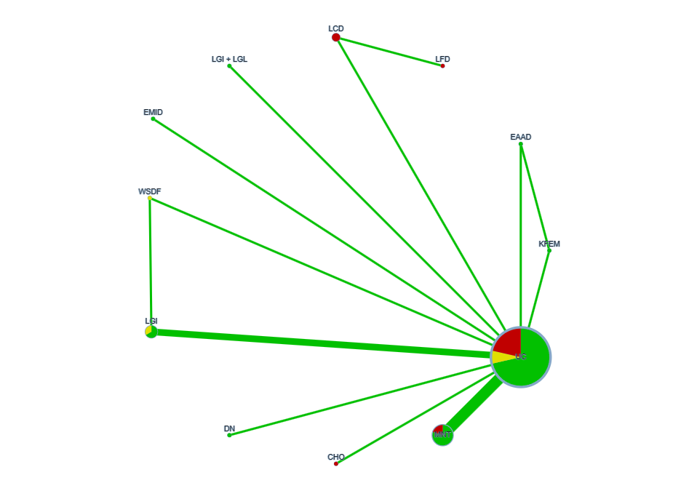
Figure1 Network meta-analysis evidence network diagram for HbAlc
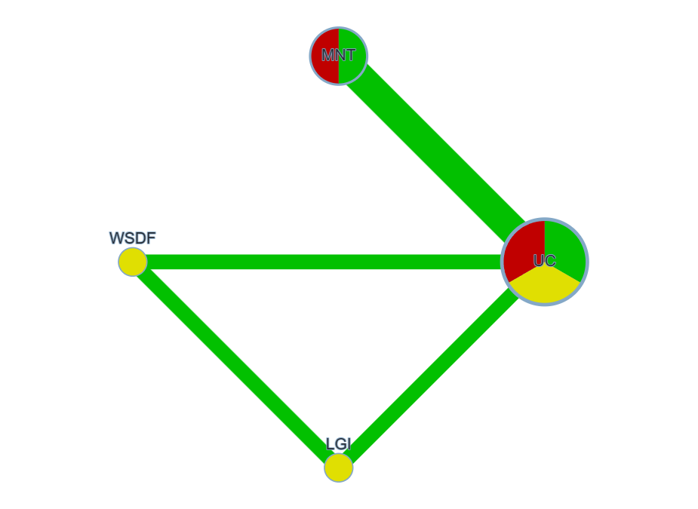
Figure2 Network meta-analysis evidence network diagram for HOMA-IR
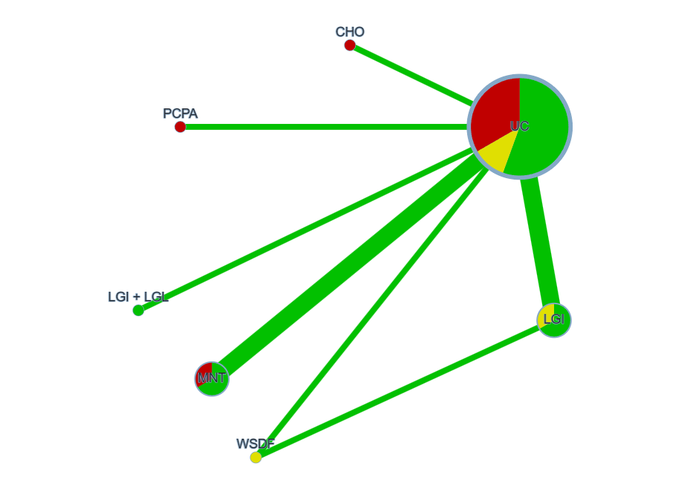

Figure3 Network meta-analysis evidence network diagram for TC
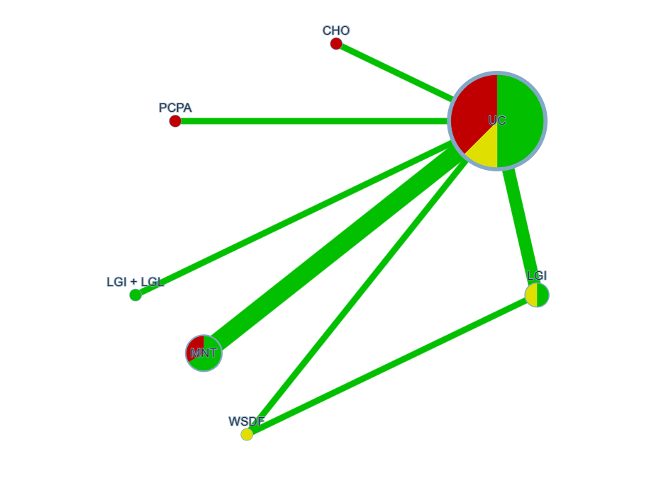
Figure4 Network meta-analysis evidence network diagram for TG
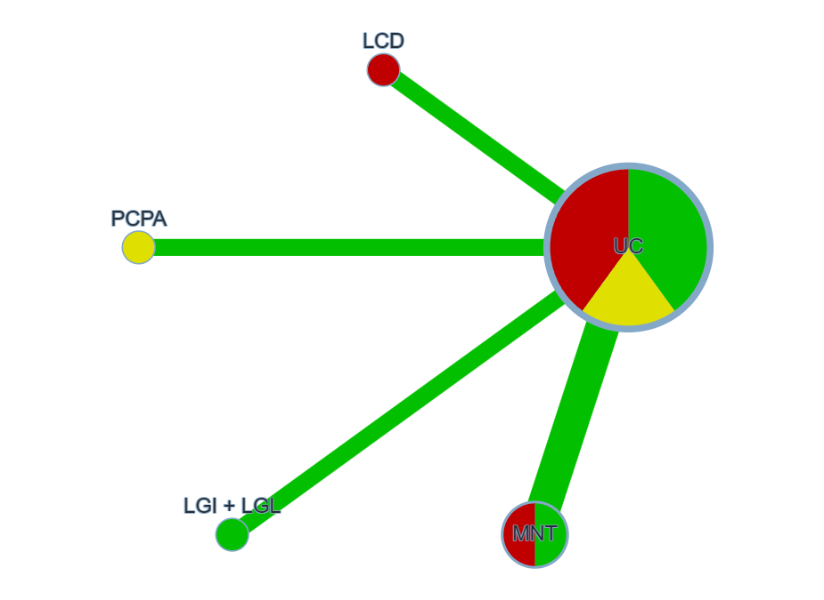

Figure5 Network meta-analysis evidence network diagram for BMI

Table
Stategy for searching literature in Pubmbed database

Serial Number | Search Strategy
#1 | Diet[Mesh]
#2 | Diet, Mediterranean[Mesh]
#3 | ((((((((((((((((((Diet[Text Word]) OR (Diets[Text Word])) OR (Food[Text Word])) OR (dietary[Text Word])) OR (eating pattern[Text Word])) OR (Mediterranean Diet[Text Word])) OR (Diets, Mediterranean[Text Word])) OR (Mediterranean Diets[Text Word])) OR (Diet, Mediterranean[Text Word])) OR (Mediterranean eating pattern[Text Word])) OR (Mediterranean-style diet[Text Word])) OR (medical nutrition intervention[Text Word])) OR (Low glycemic index diet[Text Word])) OR (Energy-restricted diet[Text Word])) OR (Dietary Approaches to Stop Hypertension, DASH[Text Word])) OR (Carbohydrate-restricted diet[Text Word])) OR (Fiber-enriched diet[Text Word])) OR (Low-fat diet[Text Word])) OR (Ethnic diet[Text Word])
#4 | #1 OR #2 OR #3
#5 | Diabetes Mellitus, Type 2[Mesh]
#6 | ((((((((((((((((((((((((((((((((((Diabetes Mellitus, Type 2[Title/Abstract]) OR (Diabetes Mellitus, Noninsulin-Dependent[Title/Abstract])) OR ("type 2 diabetes[Title/Abstract])) OR (diabetes type 2[Title/Abstract])) OR (diabetic[Title/Abstract])) OR (Diabetes Mellitus, Ketosis-Resistant[Title/Abstract])) OR (Diabetes Mellitus, Ketosis Resistant[Title/Abstract])) OR (Ketosis-Resistant Diabetes Mellitus[Title/Abstract])) OR (Diabetes Mellitus, Non Insulin Dependent[Title/Abstract])) OR (Diabetes Mellitus, Non-Insulin-Dependent[Title/Abstract])) OR (Non-Insulin-Dependent Diabetes Mellitus[Title/Abstract])) OR (Diabetes Mellitus, Stable[Title/Abstract])) OR (Stable Diabetes Mellitus[Title/Abstract])) OR (Diabetes Mellitus, Type II[Title/Abstract])) OR (NIDDM[Title/Abstract])) OR (Diabetes Mellitus, Noninsulin Dependent[Title/Abstract])) OR (Diabetes Mellitus, Maturity-Onset[Title/Abstract])) OR (Diabetes Mellitus, Maturity Onset[Title/Abstract])) OR (Maturity-Onset Diabetes Mellitus[Title/Abstract])) OR (Maturity Onset Diabetes Mellitus[Title/Abstract])) OR (MODY[Title/Abstract])) OR (Diabetes Mellitus, Slow-Onset[Title/Abstract])) OR (Diabetes Mellitus, Slow Onset[Title/Abstract])) OR (Slow-Onset Diabetes Mellitus[Title/Abstract])) OR (Type 2 Diabetes Mellitus[Title/Abstract])) OR (Noninsulin-Dependent Diabetes Mellitus[Title/Abstract])) OR (Noninsulin Dependent Diabetes Mellitus[Title/Abstract])) OR (Maturity-Onset Diabetes[Title/Abstract])) OR (Diabetes, Maturity-Onset[Title/Abstract])) OR (Maturity Onset Diabetes[Title/Abstract])) OR (Type 2 Diabetes[Title/Abstract])) OR (Diabetes, Type 2[Title/Abstract])) OR (Diabetes Mellitus, Adult-Onset[Title/Abstract])) OR (Adult-Onset Diabetes Mellitus[Title/Abstract])) OR (Diabetes Mellitus, Adult Onset[Title/Abstract])
#7 | #5 OR #6
#8 | ((((intervention[Title/Abstract]) OR (randomized controlled trial[Title/Abstract])) OR (randomized[Title/Abstract])) OR (RCT[Title/Abstract])) OR (placebo[Title/Abstract])
#9 | #4 AND #7 AND #8

Results of Traditional Meta-Analysis and Heterogeneity Test (SMD, 95%CI)
Outcome Indicator | Number of Included Studies |  | Sample Size |  |  | Heterogeneity Test |  |  | Traditional Meta-Analysis Results
Outcome Indicator | Number of Included Studies | Intervention Comparison | T | C |  | I² | P | Model | SMD | 95%CI | P
FPG | 10 | ②⑥⑦⑧⑨⑫⑬VS① | 494 | 432 |  | 88.3% | 0.000 | Random | -0.75 | (-0.88~-0.61) | 0.000
2hPG | 8 | ②⑥⑧⑨⑫VS① | 329 | 394 |  | 78.5% | 0.000 | Random | -0.62 | (-0.76~-0.47) | 0.000
HbAlc | 12 | ②④⑤⑥⑦⑧⑨⑩⑫VS① | 649 | 646 |  | 80.4% | 0.000 | Random | -0.45 | (-0.45~-0.33) | 0.000
TC | 8 | ⑥⑦⑨⑫⑬VS① | 392 | 405 |  | 93.5% | 0.000 | Random | -0.39 | (-0.54~-0.25) | 0.000
TG | 7 | ⑥⑦⑨⑫⑬VS① | 330 | 326 |  | 82.8% | 0.000 | Random | -0.59 | (-0.75~-0.43) | 0.000
BMI | 5 | ②⑥⑫⑬VS① | 259 | 244 |  | 61.8% | 0.002 | Random | -0.28 | (-0.45~-0.10) | 0.033
Outcome Indicators ①conventional diabetes diet ②low-carb diet ③low-fat diet④East Asian alternative diet⑤Korean food exchange model⑥MNT⑦carbohydrate counting⑧digital dietary patterns ⑨LGI diet⑩multi-factor Mediterranean diet intervention ⑪water-soluble dietary fiber intervention ⑫LGI+LGL⑬PCPA dietary intervention

HbAlc、HOMA-IR、BMI league table (MD, 95% CI)

Items (MD, 95% CI) | Digital Nutrition-Based Dietary Model | Personalized Medical Nutrition Therapy (MNT) | Low-Glycemic Index and Load Intervention | Carbohydrate Counting | Low-Glycemic Index (LGI) Dietary Intervention | Water-Soluble Dietary Fiber Intervention
1.HbAlc league table
Routine Diabetes Dietary Intervention | -1.06 (-2.11,-0.01) | -0.74 (-1.28,-0.19) | - | - | - | -
Korean Food Exchange Model | -1.68 (-3.16,-0.20) | -1.36 (-2.52,-0.19) | - | - | - | -
East Asian Alternative Dietary Model | -2.13 (-3.64,-0.62) | -1.81 (-3.02,-0.60) | -1.79 (-3.31,-0.27) | -1.77 (-3.32,-0.22) | -1.61 (-2.88,-0.33)
2.HOMA-IR league table
Personalized Medical Nutrition Therapy (MNT) | - | - | - | - | -8.04 (-15.07,-1.00)
Routine Diabetes Dietary Intervention | - | - | - | - | -10.13 (-15.96,-4.30) | -6.12 (-12.14,-0.10)
3.BMI league table
Low-Carbohydrate Dietary Intervention | - | - | -2.03 (-3.57,-0.49) | - | - | -
Personalized Medical Nutrition Therapy (MNT) | - | - | -2.41 (-3.88,-0.95) | - | - | -
PCPA Dietary Intervention | - | - | -2.66 (-4.58,-0.74) | - | - | -
Routine Diabetes Dietary Intervention | - | - | -2.73 (-4.03,-1.43) | - | - | -

