Fine-Tuning EMS Treatments to Produce Large Sorghum Mutant Populations for FIND-IT
Patrick J Mason^{1,5}, Anko Blaakmeer², Agnelo Furtado¹, Peter Stuart³, Rajesh Nomula¹, Pai Rosager Pedas², Søren Knudsen², Birger Lindberg Møller^{4,5}, Birgitte Skadhauge², Robert J Henry^{1,5}
Supplementary File 1:

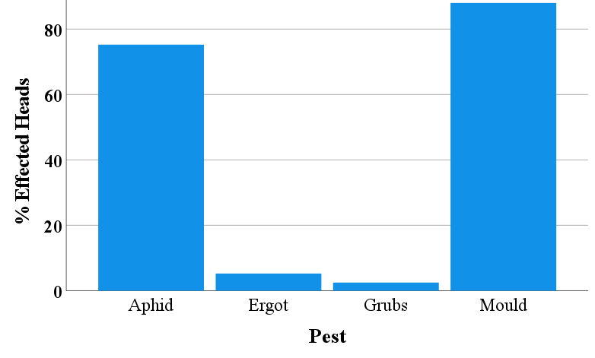

Supplementary File Figure S1. Pest incidence i.e. herbivore (aphid, grubs) and pest (mould, ergot) burden on M₁ S. bicolor panicles, in each EMS treatment group (presented as a percentage) (n=400).
Supplementary File Figure S2. % of EMS type variants, characterised by G/C > A/T single nucleotide transition, throughout the whole genome. The other category is all other single nucleotide polymorphisms (SNP) combinations combined. All detected control variants were used to remove all detected background variants from EMS treatment samples of 0.05, 0.15 and 0.25.
Supplementary File 1 Figure S3. % of EMS type variants, characterised by G/C > A/T single nucleotide transition, within the coding region. The other category is all other single nucleotide polymorphisms (SNP) combinations combined. All detected control variants were used to remove all detected background variants from EMS treatment samples of 0.05, 0.15 and 0.25.
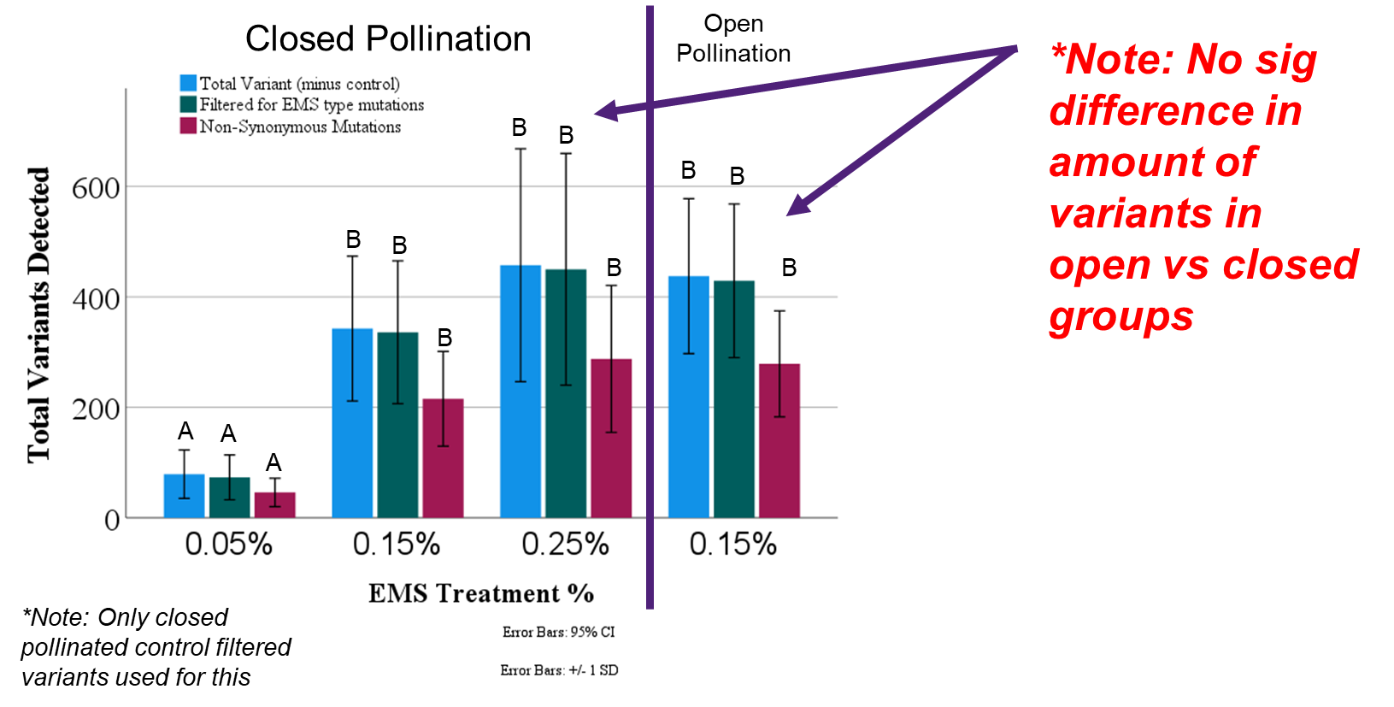
Supplementary File 1 Figure S4. Total variants detected in the coding region of all closed pollination (bagged seed heads) treatment groups vs. the 0.15% treatment group that was left as to open pollinate (unbagged seed head). All detected control variants were used to remove all detected background variants from EMS treatment samples of 0.05, 0.15 and 0.25% concentration. Capitalised letters above bars indicate significant difference groupings as calculated by a Tukey’s T-test at a p-value of 0.05.

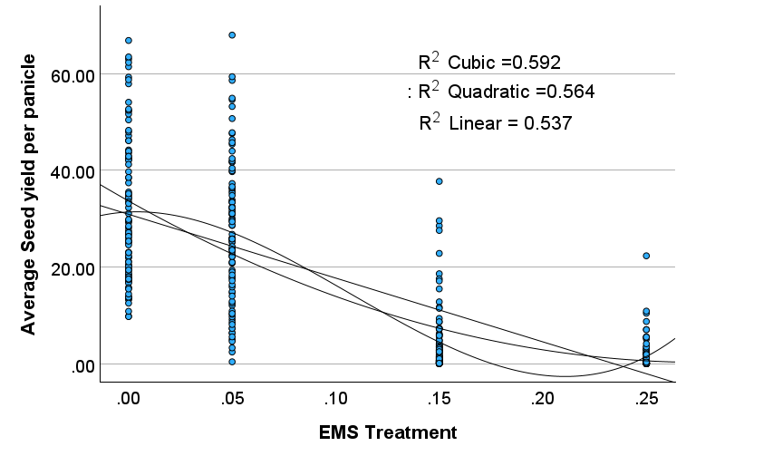
Supplementary File 1 Figure S5. Comparison of linear, quadratic, and cubic regression fits for the relationship between EMS treatment and Seed yield per panicle. The quadratic fit was selected on the basis of R² and biological plausibility, avoiding the unrealistic increase predicted by the cubic model at EMS levels between 0 and 0.05.
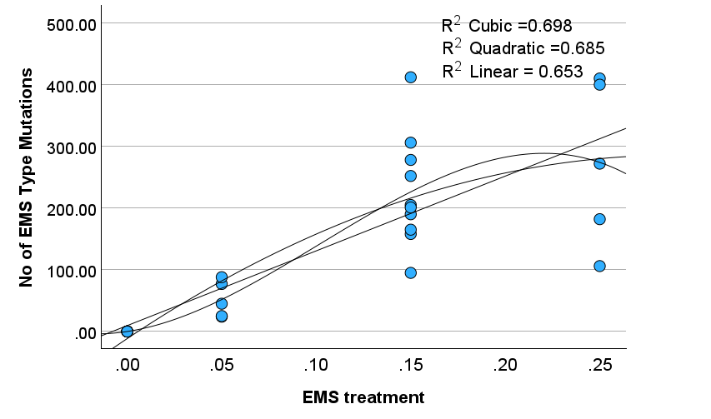
Supplementary File 1 Figure S6. Comparison of linear, quadratic, and cubic regression fits for the relationship between EMS treatment and EMS‐type mutations. The quadratic fit was selected on the basis of R² and biological plausibility, avoiding the unrealistic decline predicted by the cubic model at higher EMS levels.
A quadratic (polynomial) regression was chosen as the most representative line based on both R² value and visual assessment for both figures 5 and 6. Although the cubic model yielded a marginally higher R², its downward turn at higher EMS doses (Figure 6) and upturn between 0 and 0.05 (Figure 5) is biologically implausible (it is unlikely that the number of EMS‐type mutations would decrease and seed yield would increase respectively). In addition, saturating (plateau‐like) functions such as Michaelis–Menten are not suitable here because the low number of EMS concentrations would poorly anchor the curve and risk overfitting.

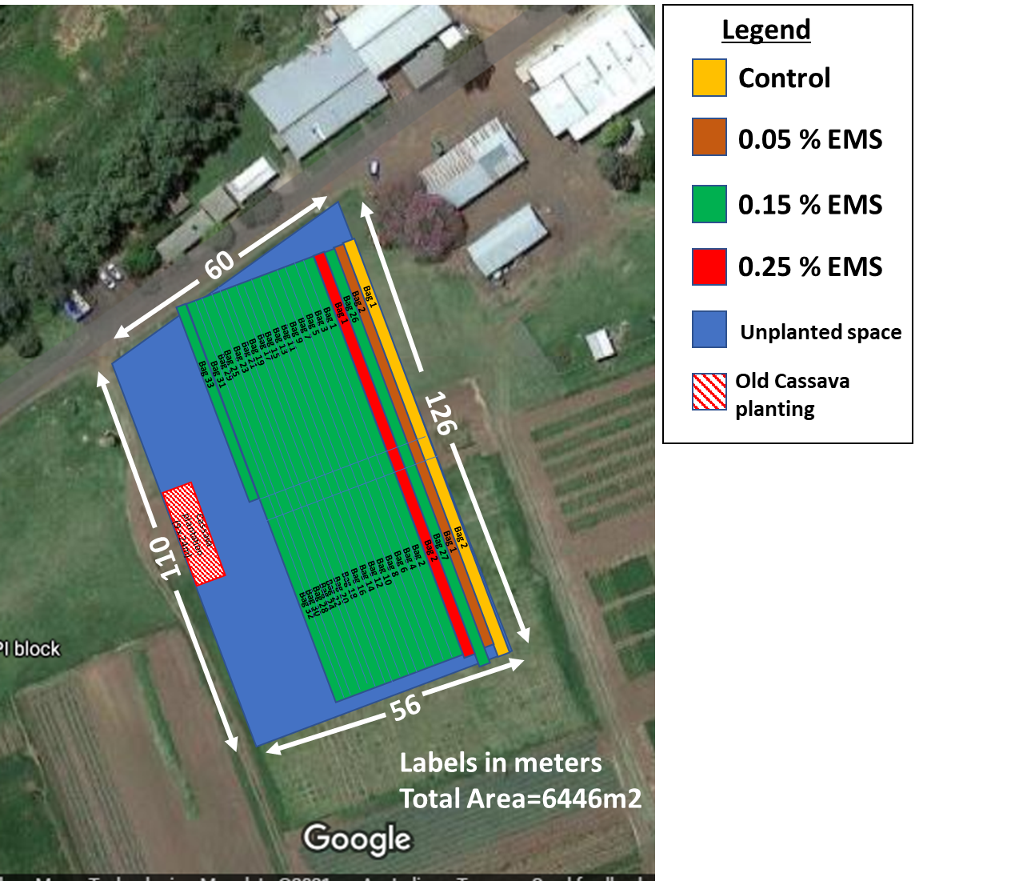
Supplementary File 1 Figure S7. Field layout of Sorghum bicolor ethyl methanesulphonate trial at the Crop Research Unit at the University of Queensland, Gatton Campus. Each colour indicates area that contains plants treated with different rates of EMS. Yellow indicates the control run, brown indicates 0.05 EMS treated seed, green indicates 0.15 EMS treated seed, and red indicates 0.25 EMS treated seed. Each bag represents an allotment of 1000 seeds treated with EMS (or control), which was planted in a run which contained 2 rows at a spacing of 0.75m. Note: The area beyond the first 4 runs is 0.15% EMS treated seed which was used to create a larger population of mutants, this area was not a part of the experiment.

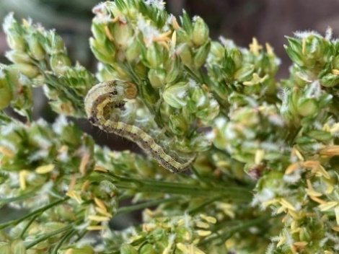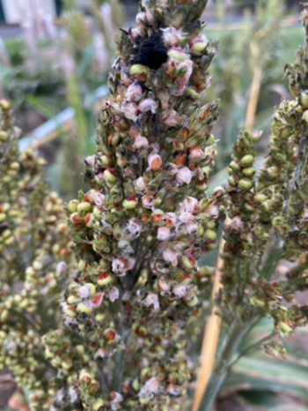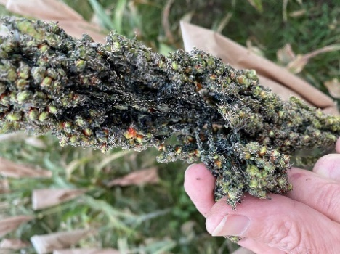
c
b
a
Supplementary File 1 Figures S8a, b and c. Pests observed within Sorghum trial on the 5th of May, 2021. a) Heliothis grub, b) Ergot and c) Aphid and some mould.
Observations of seed-set (%) in each treatment group were made prior to harvest (Figures S11a and b). Seed yield (per panicle) was calculated by measuring the mass of seed collected (g) from individual panicles following harvest and threshing.
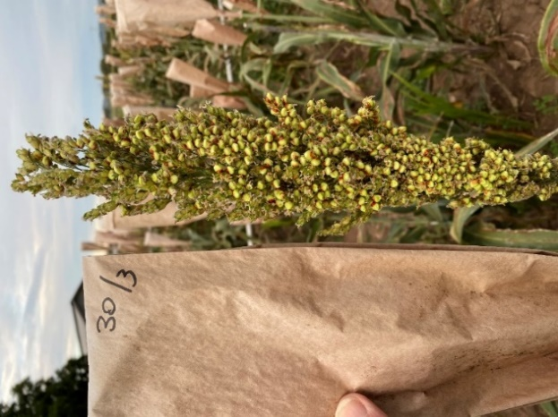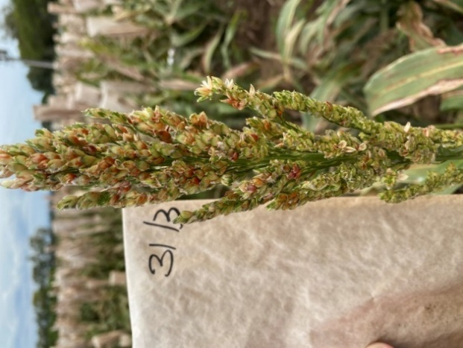
a
b
Supplementary File 1 Figures S9a and b. Level of seedset observed in two different seed heads within Sorghum trial on the 5th of May, 2021. a) 80% seedset (control treatment) and b) 2% seedset in 0.15% EMS treatment.

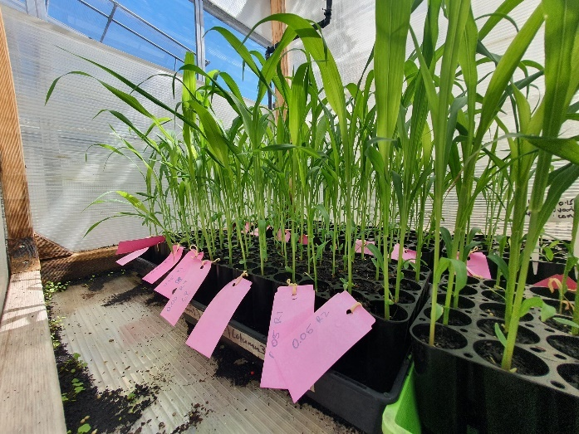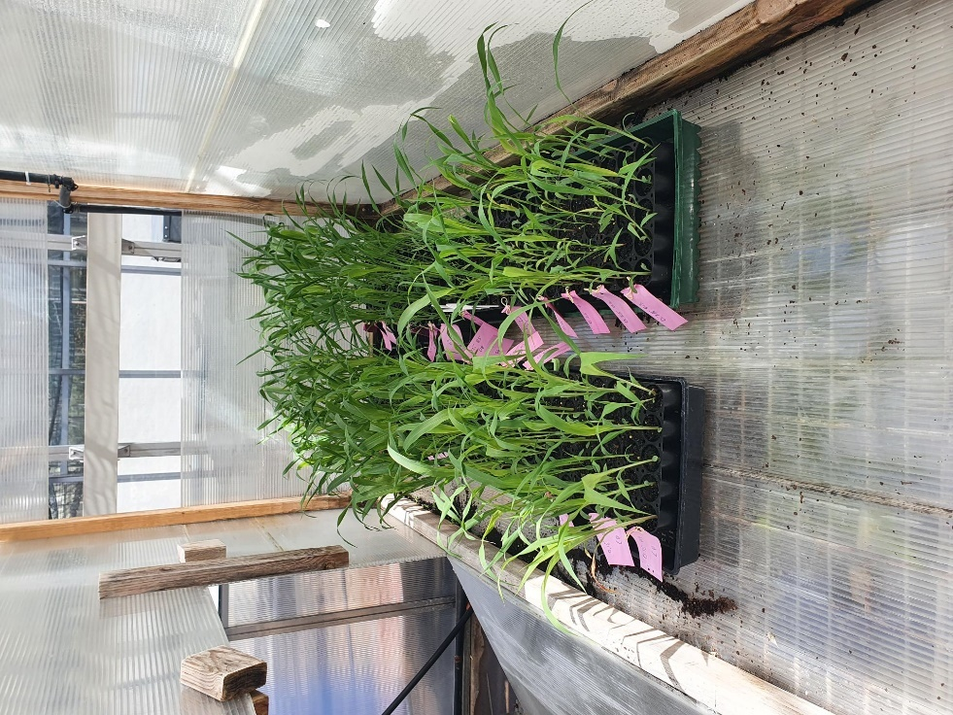
a
b
Supplementary File 1 Figures S10a and b. 2-week-old M1 sorghum plants grown in glasshouse at the University of Queensland, St Lucia Campus in September 2021. Note: Individual plants were collected for each sequencing replicate.

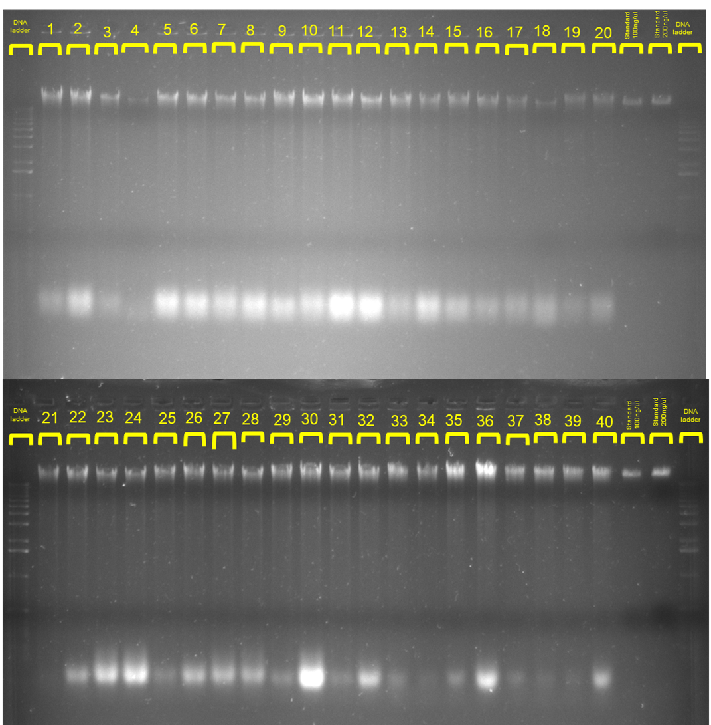
Supplementary File 1 Figure S11. Gel electrophoresis for all 40 DNA samples, to check DNA sample quality prior to Illumina Sequencing.

Supplementary File 1 Table S1. Summary quality control check for all 40 Sorghum bicolor samples
 | Gel Results |  |  |  |  | Nanodrop Results
Sample No. | Estimated DNA concentration (ng/ul) | Total DNA (ug) | Total eluant (ul) | Visible Contaminants in Gel | Amount of Degraded DNA | 260/230 | 260/280
1 | 600 | 39 | 65 | Maybe DNA | Low | 1.83 | 2.08
2 | 600 | 39 | 65 | Maybe DNA | Low/Moderate | 2 | 2.15
3 | 400 | 26 | 65 | Maybe DNA | Low | 1.93 | 2.09
4 | 40 | 3.6 | 90 | None | None | 2.15 | 2.13
5 | 600 | 39 | 65 | Maybe DNA | Moderate | 1.99 | 2.06
6 | 600 | 39 | 65 | Maybe DNA | Moderate | 2.06 | 2.15
7 | 500 | 32.5 | 65 | Maybe DNA | Moderate | 2.03 | 2.13
8 | 500 | 32.5 | 65 | Maybe DNA | Moderate | 2.22 | 2.2
9 | 600 | 39 | 65 | Maybe DNA | Low/Moderate | 1.98 | 2.04
10 | 600 | 39 | 65 | Maybe DNA | Moderate | 2.11 | 2.18
11 | 600 | 39 | 65 | Maybe DNA | High | 2.03 | 2.12
12 | 550 | 35.75 | 65 | Maybe DNA | High | 2.07 | 2.07
13 | 550 | 35.75 | 65 | Maybe DNA | Low | 1.88 | 2.02
14 | 500 | 32.5 | 65 | Maybe DNA | Moderate | 2.06 | 2.06
15 | 450 | 29.25 | 65 | Maybe DNA | Low/Moderate | 2.06 | 2.10
16 | 400 | 26 | 65 | Maybe DNA | Low | 2.07 | 2.07
17 | 400 | 26 | 65 | Maybe DNA | Low | 2.06 | 1.97
18 | 80 | 7.2 | 90 | Maybe DNA | Low | 2.14 | 2.12
19 | 400 | 26 | 65 | Maybe DNA | Low | 1.94 | 2.12
20 | 400 | 26 | 65 | None | None | 1.98 | 2
21 | 400 | 26 | 65 | None | None | 2.15 | 2.16
22 | 600 | 39 | 65 | Maybe DNA | Low | 2.14 | 2.14
23 | 450 | 29.25 | 65 | Maybe DNA | High | 2.10 | 2.11
24 | 450 | 29.25 | 65 | Maybe DNA | High | 2.14 | 2.11
25 | 500 | 32.5 | 65 | None | None | 2.07 | 2.10
26 | 600 | 39 | 65 | Maybe DNA | Low/Moderate | 2.19 | 2.13
27 | 600 | 39 | 65 | Maybe DNA | Low/Moderate | 2.17 | 2.09
28 | 600 | 39 | 65 | Maybe DNA | Low/Moderate | 2.10 | 2.07
29 | 700 | 45.5 | 65 | Maybe DNA | Low | 2.21 | 2.04
30 | 700 | 45.5 | 65 | Maybe DNA | High | 2.06 | 1.97
31 | 650 | 42.25 | 65 | Maybe DNA | Low | 2.06 | 1.95
32 | 650 | 42.25 | 65 | Maybe DNA | Moderate | 2.11 | 2.01
33 | 700 | 45.5 | 65 | Maybe DNA | Low | 2.30 | 2.07
34 | 450 | 29.25 | 65 | None | None | 1.98 | 1.92
35 | 800 | 52 | 65 | Maybe DNA | Low | 1.83 | 1.78
36 | 800 | 52 | 65 | Maybe DNA | Moderate | 2.24 | 2.03
37 | 450 | 29.25 | 65 | Maybe DNA | Low | 1.98 | 1.92
38 | 450 | 29.25 | 65 | Maybe DNA | Low | 2.03 | 1.96
39 | 450 | 29.25 | 65 | Maybe DNA | Low | 1.99 | 1.94
40 | 450 | 29.25 | 65 | Maybe DNA | Low/Moderate | 1.96 | 1.92

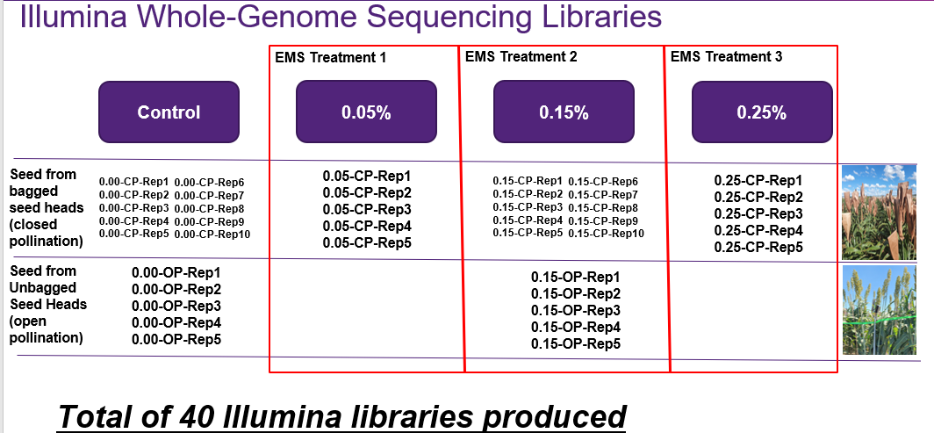
Supplementary File 1 Figure S12. Overview of each Illumina sequence library produced for this project and their corresponding treatments.

Supplementary File 1 Table S2. Table of quality attributes of RAW and 0.01 trimmed Illumina whole genome sequences for the 40 Sorghum bicolor libraries.
 | RAW Illumina Reads |  |  | 0.01 Trim
Ramaciotti Sub I.D. | RAW # reads | Estimated Coverage (x) |  | 0.01 # paired reads |  | 0.01 # orphaned reads | % Loss 0.01 reads | Estimated Coverage (x)
Sorg001 | 87,481,442 | 18.4193818 |  | 63,152,482 |  | 10,279,535 | 16.05989188 | 14.08139308
Sorg002 | 133,502,190 | 28.09356451 |  | 102,726,728 |  | 12,858,213 | 13.42094014 | 22.46276543
Sorg003 | 169,633,948 | 35.69706433 |  | 127,570,280 |  | 17,512,420 | 14.47307469 | 28.03736917
Sorg004 | 84,960,652 | 17.87849289 |  | 64,697,024 |  | 8,350,338 | 14.02212638 | 14.10663631
Sorg005 | 138,068,002 | 29.06828956 |  | 106,907,142 |  | 13,144,472 | 13.04892353 | 23.32427579
Sorg006 | 134,680,034 | 28.3587442 |  | 100,058,674 |  | 14,581,179 | 14.87984552 | 22.13263956
Sorg007 | 131,285,850 | 27.63830188 |  | 98,974,108 |  | 13,210,760 | 14.54915515 | 21.59493284
Sorg008 | 128,788,940 | 27.12426256 |  | 96,911,618 |  | 13,156,467 | 14.53607352 | 21.28805592
Sorg009 | 90,734,990 | 19.09582371 |  | 66,403,816 |  | 10,195,846 | 15.57869572 | 14.75053635
Sorg010 | 130,970,674 | 27.56958969 |  | 101,041,684 |  | 12,540,328 | 13.27675996 | 22.04710162
Sorg011 | 122,745,392 | 25.85519956 |  | 94,892,172 |  | 11,661,552 | 13.19126342 | 20.72014919
Sorg012 | 118,033,656 | 24.86084188 |  | 90,284,768 |  | 11,577,682 | 13.7005042 | 19.67972817
Sorg013 | 88,069,136 | 18.55140323 |  | 68,856,808 |  | 8,023,832 | 12.7042191 | 14.94457478
Sorg014 | 131,219,280 | 27.62609085 |  | 98,429,898 |  | 13,778,094 | 14.48818192 | 21.68791074
Sorg015 | 152,320,376 | 32.07283347 |  | 114,250,418 |  | 15,904,829 | 14.55165066 | 25.16024875
Sorg016 | 115,732,698 | 24.36924949 |  | 87,135,654 |  | 11,862,230 | 14.4598841 | 19.14142172
Sorg017 | 112,185,838 | 23.62188556 |  | 81,923,946 |  | 12,842,075 | 15.52764352 | 18.22804688
Sorg018 | 95,334,226 | 20.07425304 |  | 69,725,214 |  | 10,700,205 | 15.63846231 | 15.4727065
Sorg019 | 66,909,552 | 14.07022743 |  | 54,825,420 |  | 5,055,861 | 10.50413699 | 11.74824021
Sorg020 | 110,168,438 | 23.187968 |  | 89,703,114 |  | 8,486,578 | 10.87311958 | 19.22144007
Sorg021 | 135,223,832 | 28.48186808 |  | 101,574,354 |  | 13,965,265 | 14.55676319 | 22.29840142
Sorg022 | 120,943,028 | 25.479197 |  | 95,659,416 |  | 10,564,013 | 12.17068833 | 20.7197393
Sorg023 | 152,053,472 | 32.01558834 |  | 119,273,610 |  | 13,682,483 | 12.55964678 | 25.88414856
Sorg024 | 105,650,752 | 22.23885611 |  | 82,114,152 |  | 9,840,874 | 12.9632073 | 17.85690883
Sorg025 | 95,641,750 | 20.13299278 |  | 74,851,558 |  | 8,655,468 | 12.68768503 | 16.26869868
Sorg026 | 126,725,690 | 26.67409128 |  | 99,726,092 |  | 11,224,008 | 12.44861243 | 21.61102402
Sorg027 | 109,176,116 | 22.96174065 |  | 89,254,140 |  | 8,291,926 | 10.65255884 | 19.07617785
Sorg028 | 94,260,786 | 19.83693997 |  | 71,581,080 |  | 9,468,180 | 14.01593023 | 15.6924477
Sorg029 | 99,500,472 | 20.94336447 |  | 77,139,268 |  | 9,367,832 | 13.05860338 | 16.84810373
Sorg030 | 100,049,454 | 21.04963699 |  | 79,302,682 |  | 8,753,101 | 11.98774258 | 17.19921292
Sorg031 | 111,839,196 | 23.53893033 |  | 89,217,596 |  | 9,383,535 | 11.83669543 | 19.25474983
Sorg032 | 154,418,922 | 32.49055131 |  | 122,373,618 |  | 13,336,696 | 12.11548932 | 26.52893268
Sorg033 | 84,905,616 | 17.87534068 |  | 68,779,180 |  | 6,687,532 | 11.11693719 | 14.76460117
Sorg034 | 107,242,878 | 22.58140735 |  | 82,138,810 |  | 10,538,604 | 13.58175412 | 18.01670579
Sorg035 | 93,234,308 | 19.63070603 |  | 72,410,232 |  | 8,676,407 | 13.02918342 | 15.7392899
Sorg036 | 126,819,136 | 26.70745725 |  | 96,841,790 |  | 12,463,963 | 13.80973215 | 21.18430824
Sorg037 | 112,564,304 | 23.71119021 |  | 77,960,940 |  | 14,380,324 | 17.96576648 | 17.5418786
Sorg038 | 114,305,030 | 24.0727347 |  | 88,851,418 |  | 10,598,730 | 12.99582529 | 19.35264794
Sorg039 | 131,325,142 | 27.65564563 |  | 97,750,434 |  | 14,343,428 | 14.64401995 | 21.69612622
Sorg040 | 101,637,676 | 21.39560599 |  | 79,533,832 |  | 9,223,267 | 12.67303377 | 17.30431
Total Illumina Reads | 4,620,342,874 | Average Coverage | 24.31768282 | Total Illumina Reads | 4,620,342,874 |  | Average Coverage | 19.36671466

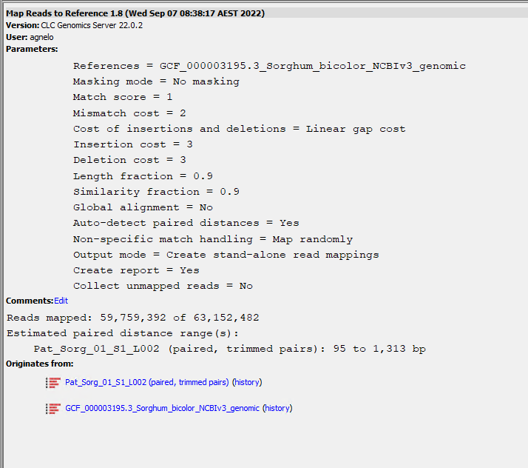
Supplementary File 1 Figure S13. Parameters used within Mapping Reads to Reference tool for all 40 Sorghum bicolor whole genome Illumina libraries using CLC genomics workbench 22.0.2.
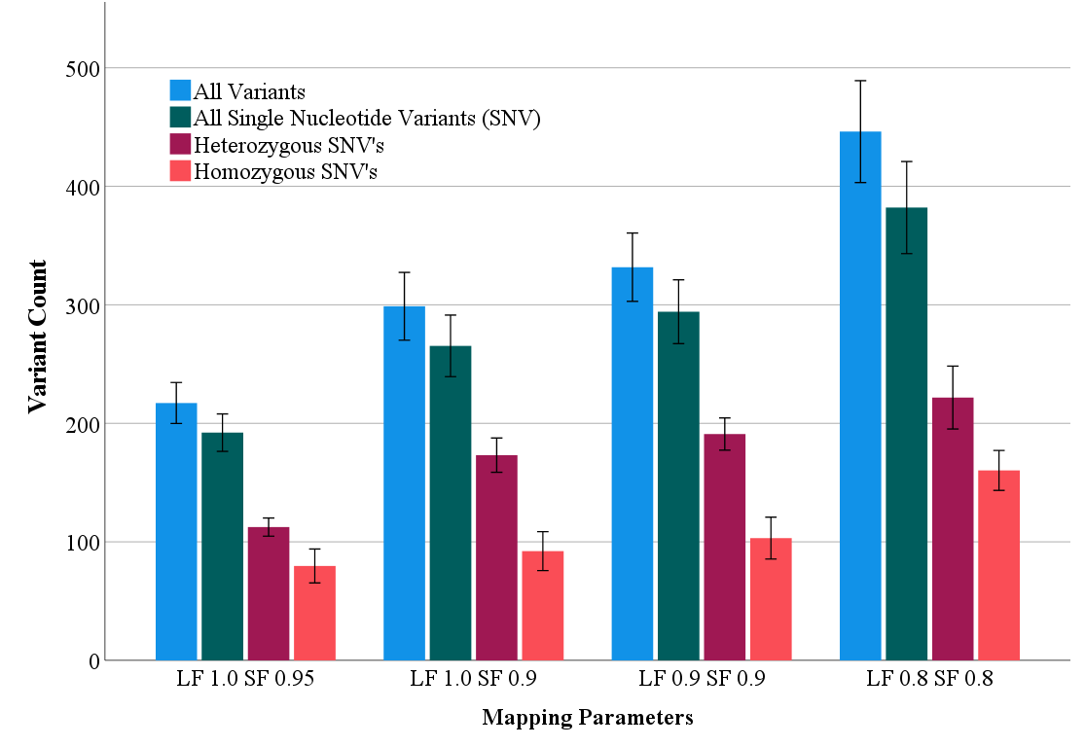
Supplementary File 1 Figure S14. Quality trimmed Illumina reads from all control samples (n=10) variant calling when subjected to different mapping parameters. “SF” stands for similarity fraction and “LF” stands for length fraction.
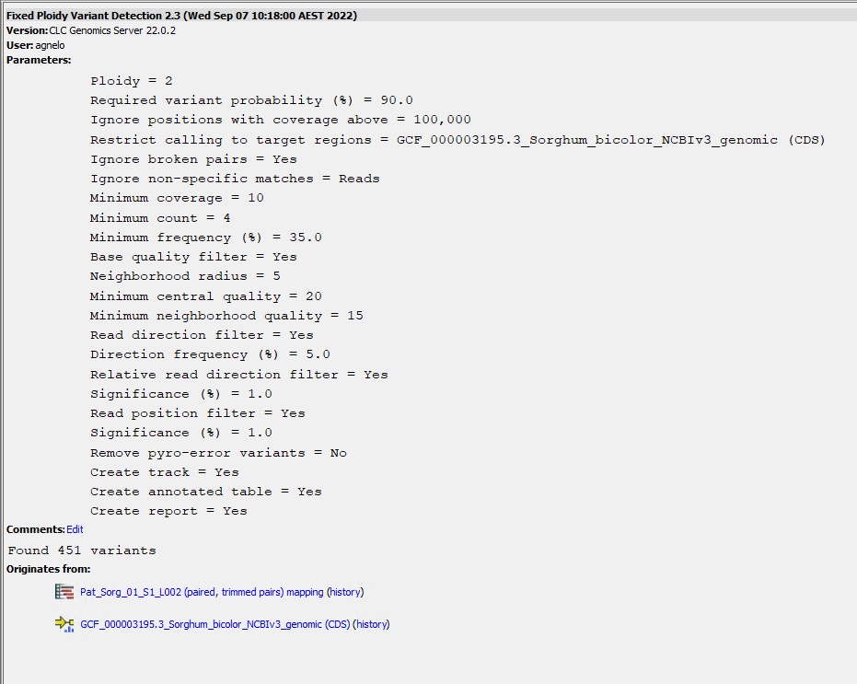
Supplementary File 1 Figure S15. Parameters used within Fixed ploidy Variant detection tool for all 40 Sorghum bicolor whole genome Illumina libraries using CLC genomics workbench 22.0.2.
To remove background variants from the analysis that were already present in the BTx623 genotype prior to EMS treatment, the 10 x control samples (Illumina libraries 1-5 and 36-40) were used to create a database file of background variants. The background variant database was created using the merge variant track function, which added all unique and common variants found in the controls (Figures S18 and S19) which shows the effect of adding control libraries and the total background variant count.
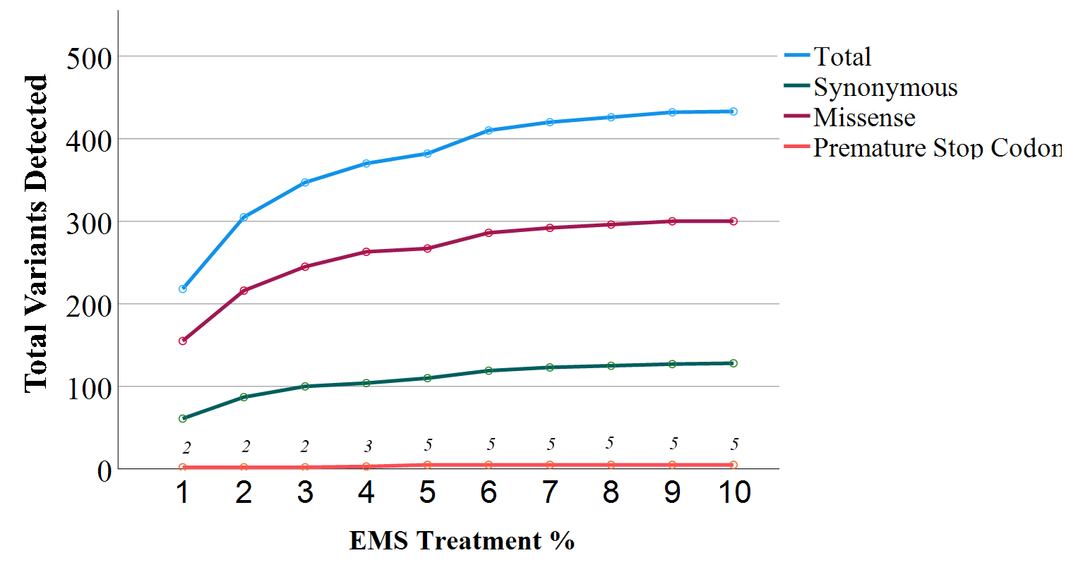
Supplementary File 1 Figure S16. Figure of background variant counts detected within the coding region as affected by the number of control samples used within the background variant database. Values are derived from Parameters used within Fixed ploidy Variant detection tool for all 40 Sorghum bicolor whole genome Illumina libraries using CLC genomics workbench 22.0.2. Mutants annotated using the USC variant annotation integrator, which allowed the determination of synonymous, missense and premature stop codon inducing variants.

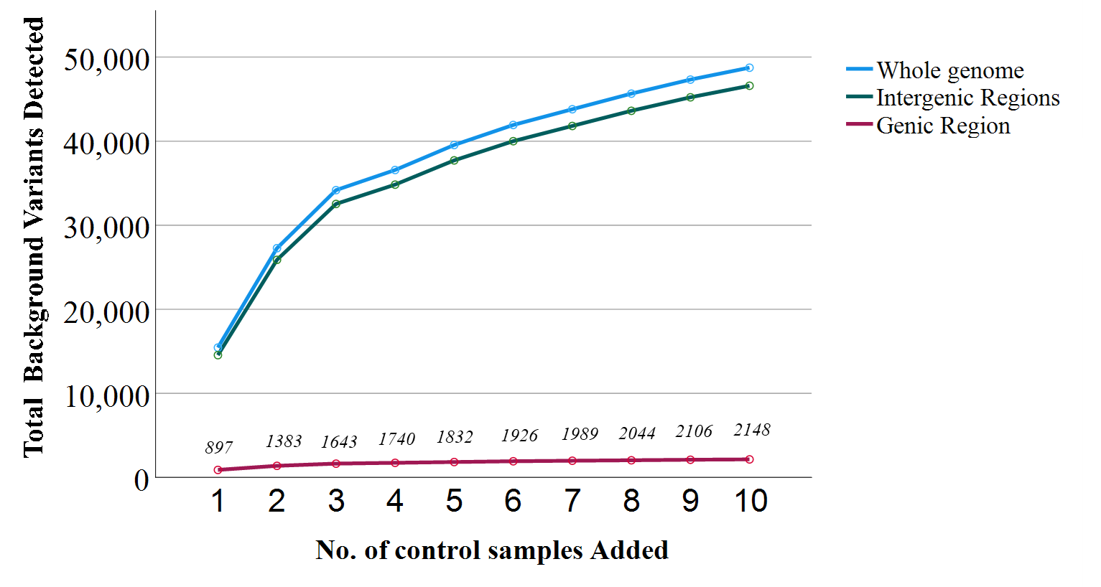
Supplementary File 1 Figure S17. Figure of background variant counts detected within the coding region as affected by the number of control samples used within the background variant database. Values are derived from Parameters used within Fixed ploidy Variant detection tool for all 40 Sorghum bicolor whole genome Illumina libraries using CLC genomics workbench 22.0.2. Mutants annotated using the USC variant annotation integrator. This allowed the determination of variants in specific genome regions i.e. genic vs. intergenic regions.

