1H-NMR spectrum of MBI

¹³C-NMR spectrum of MBI

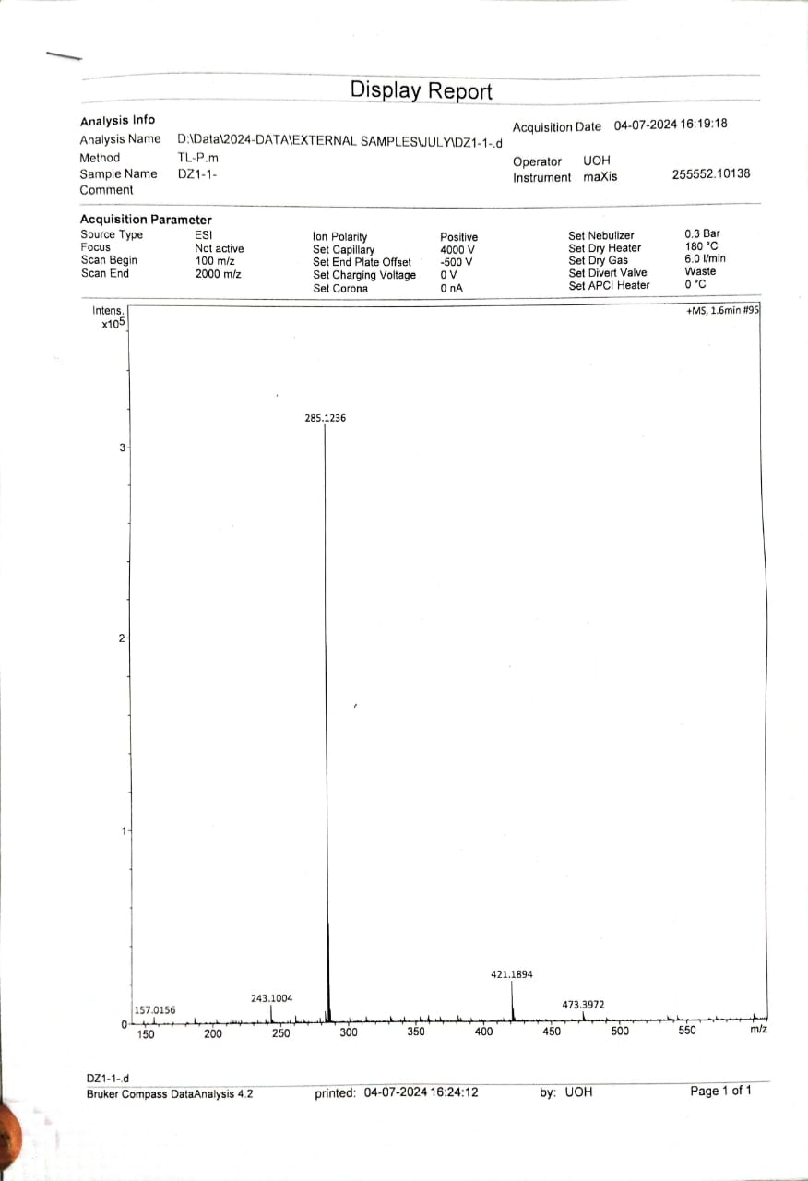

ESI spectrum of MBI

