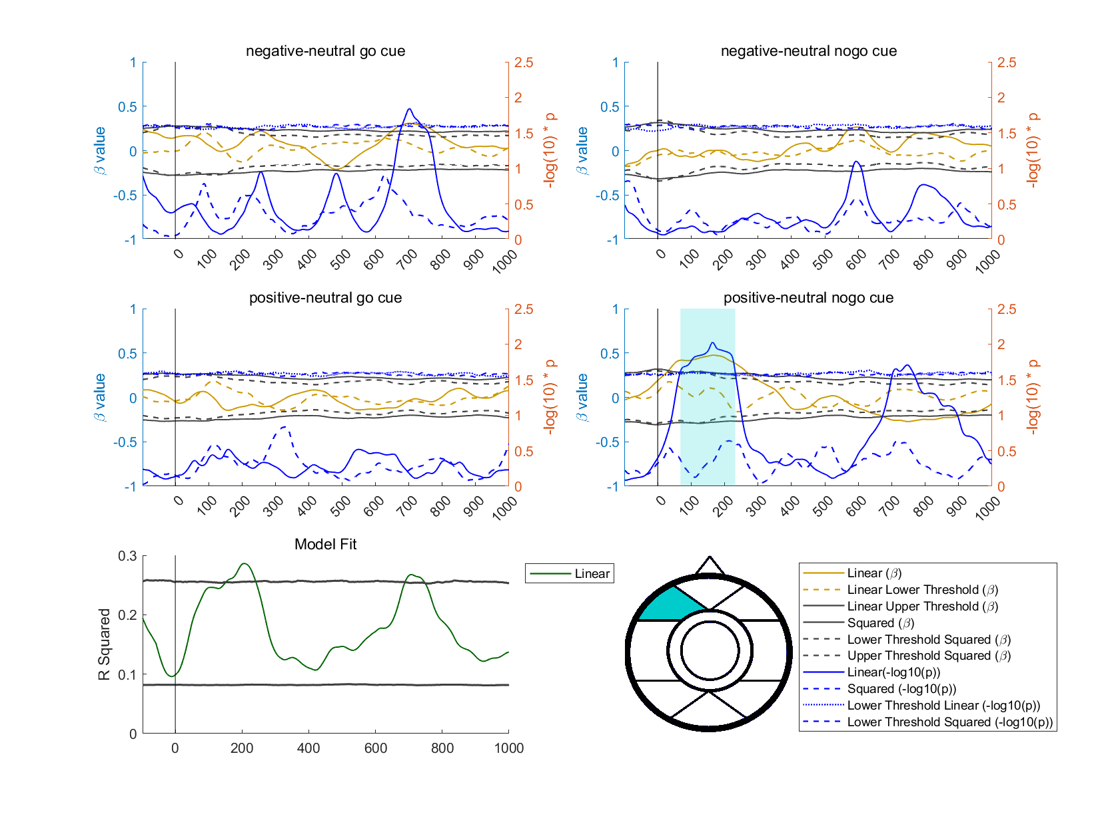
Figure 1 Association between affective instable symptoms and ERP activity at the frontal left lateral ROI upon different cues
Note: Top four panels focuses on different cues. Significant periods of ERP activity correlating with symptoms are indicated by colored vertical bars in each panel, determined by regression analysis. Colored horizontal lines indicate linear association with yellow solid lines, curvilinear association with yellow dashed lines, upper and lower threshold for the association with dark solid and dashed lines separately, and the statistical p values for these associations with blue solid and dashed lines separately. The dot and short-dash blue lines show critical thresholds for statistical significance. Statistical significance was assessed using a maximum statistical approach, with benchmarks established from 7,000 null models to ensure robust findings. The model fit for all the linear effects were separately plotted at the bottom left panel. Thess p-values was log transformed so that higher values trended towards statistical significance: where p = 0.05, -log10(p) = 1.30; where p = 0.01, -log10(p) = 2; where p = .001, -log10(p) = 3.
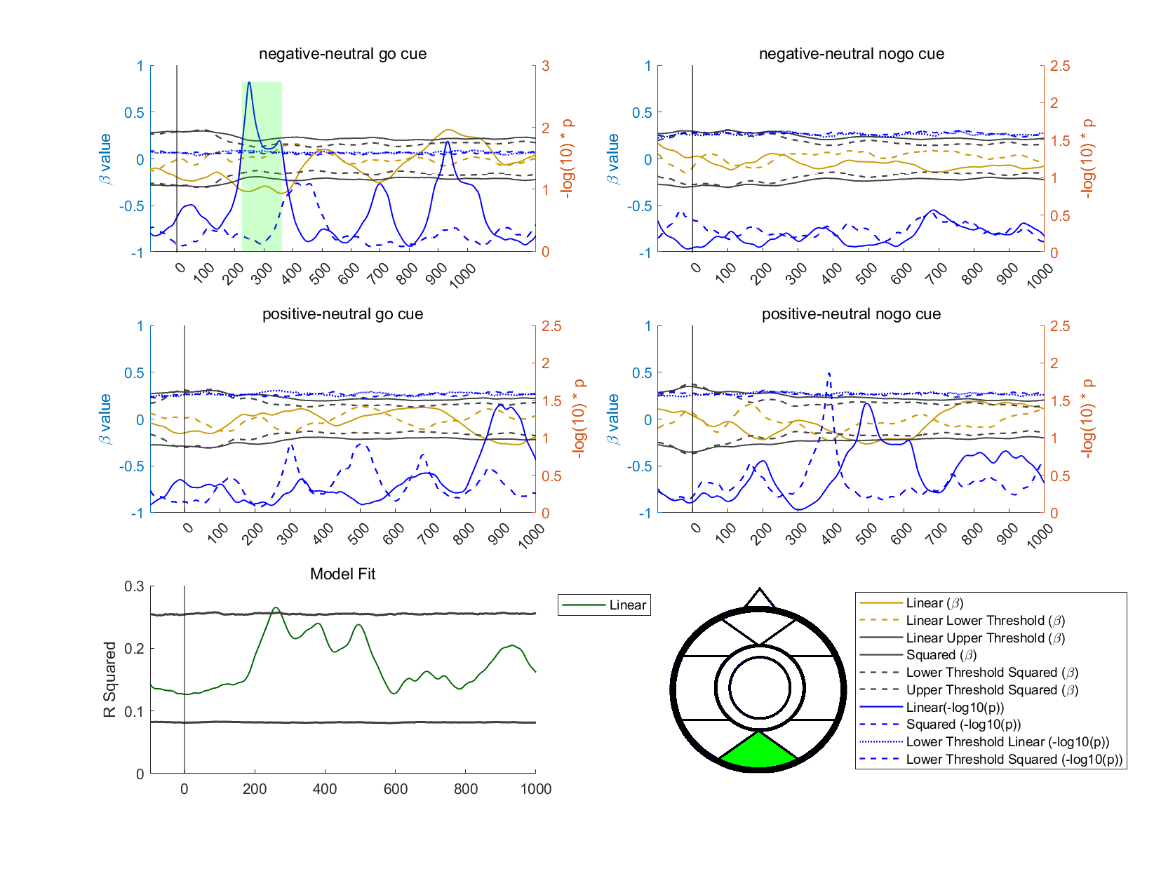
Figure 2 Association between affective instability and ERP activity at the posterior middle ROI upon different cues
Note: The designation of each component is akin to that of Figure 1.
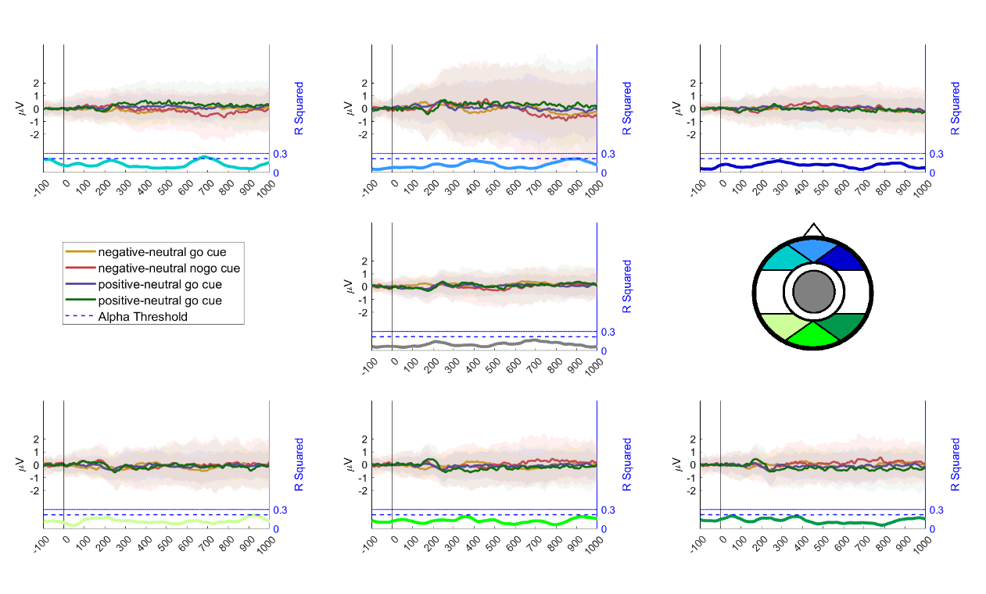
Figure 3 The average contrasting waves in response to go and nogo cues under different emotional conditions (negative vs. neutral and positive vs. neutral) and their associations with negative sociality
Note: each panel represents a scalp ROI, with the lighter region surrounding the ERP amplitudes indicating the standard deviation. The colored vertical bars indicate periods when the amplitudes of waves were significantly associated with symptoms, based on R² values exceeding the top 97.5 percentile of all null model R² values. The R² value at each time point is shown at the bottom of each ROI panel, with the color corresponding to the scalp ROI. The dashed blue line represents the critical R² threshold based on the distribution.

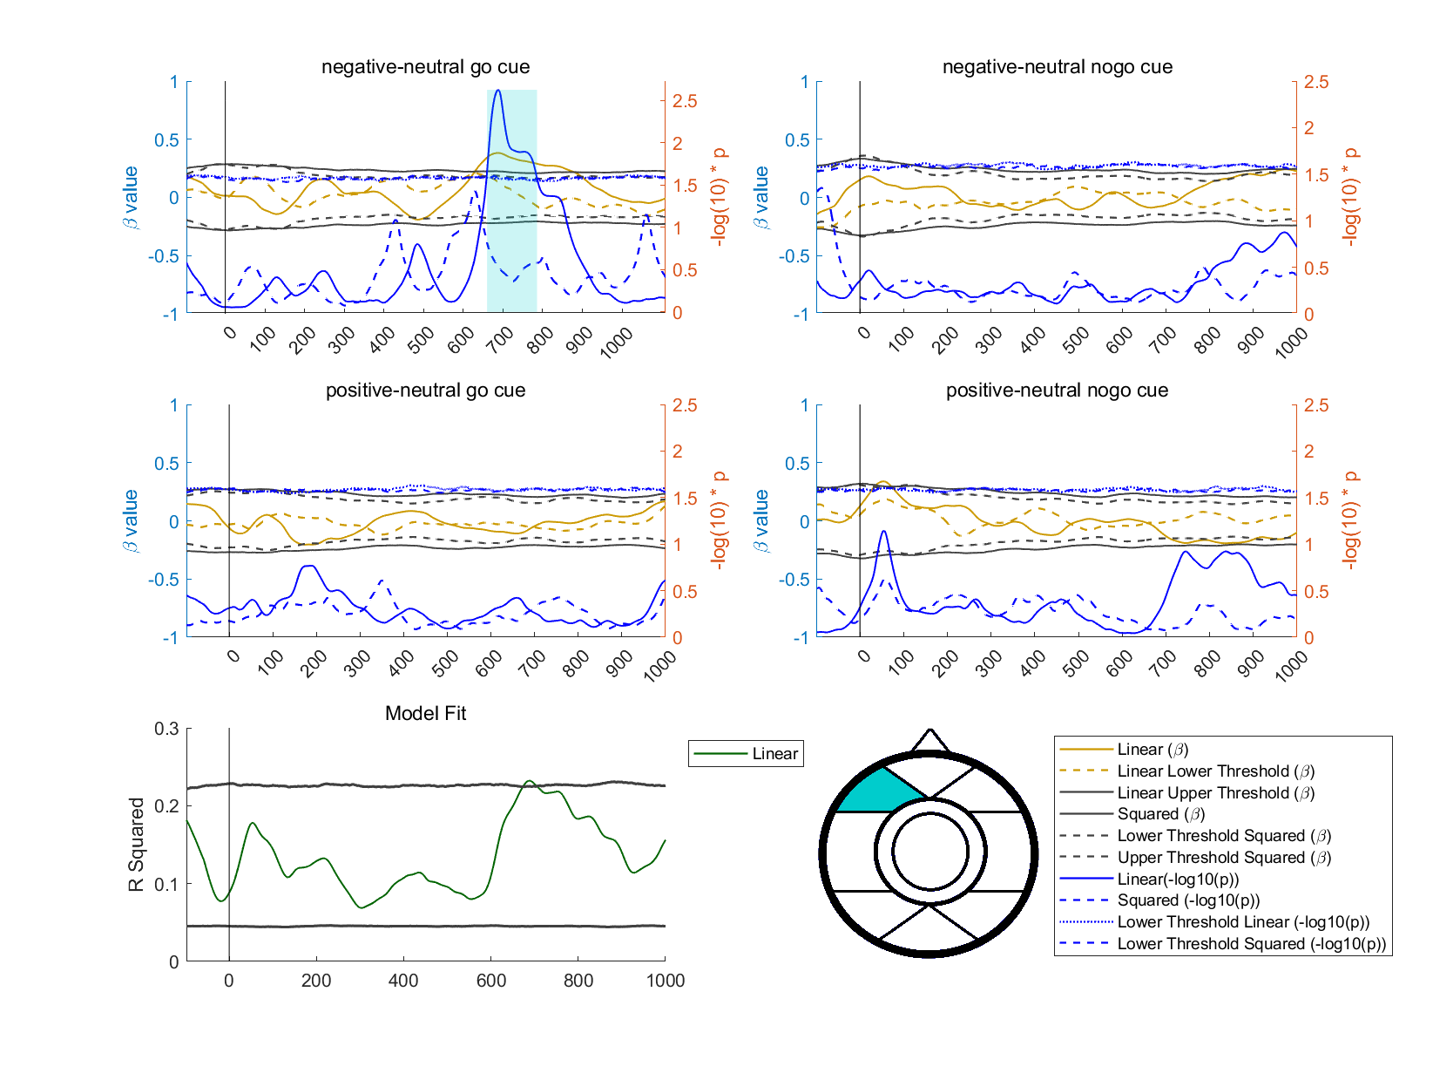
Figure 4 Association between affective self-harm and ERP activity at the the frontal left lateral ROI upon different cues
Note: The designation of each component is akin to that of Figure 1.

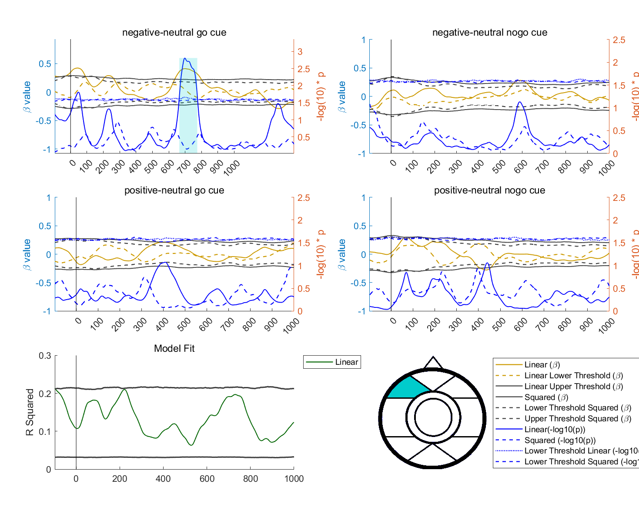
Figure 5 Association between affective self-identity and ERP activity at the the frontal left lateral ROI upon different cues
Note: The designation of each component is akin to that of Figure 1.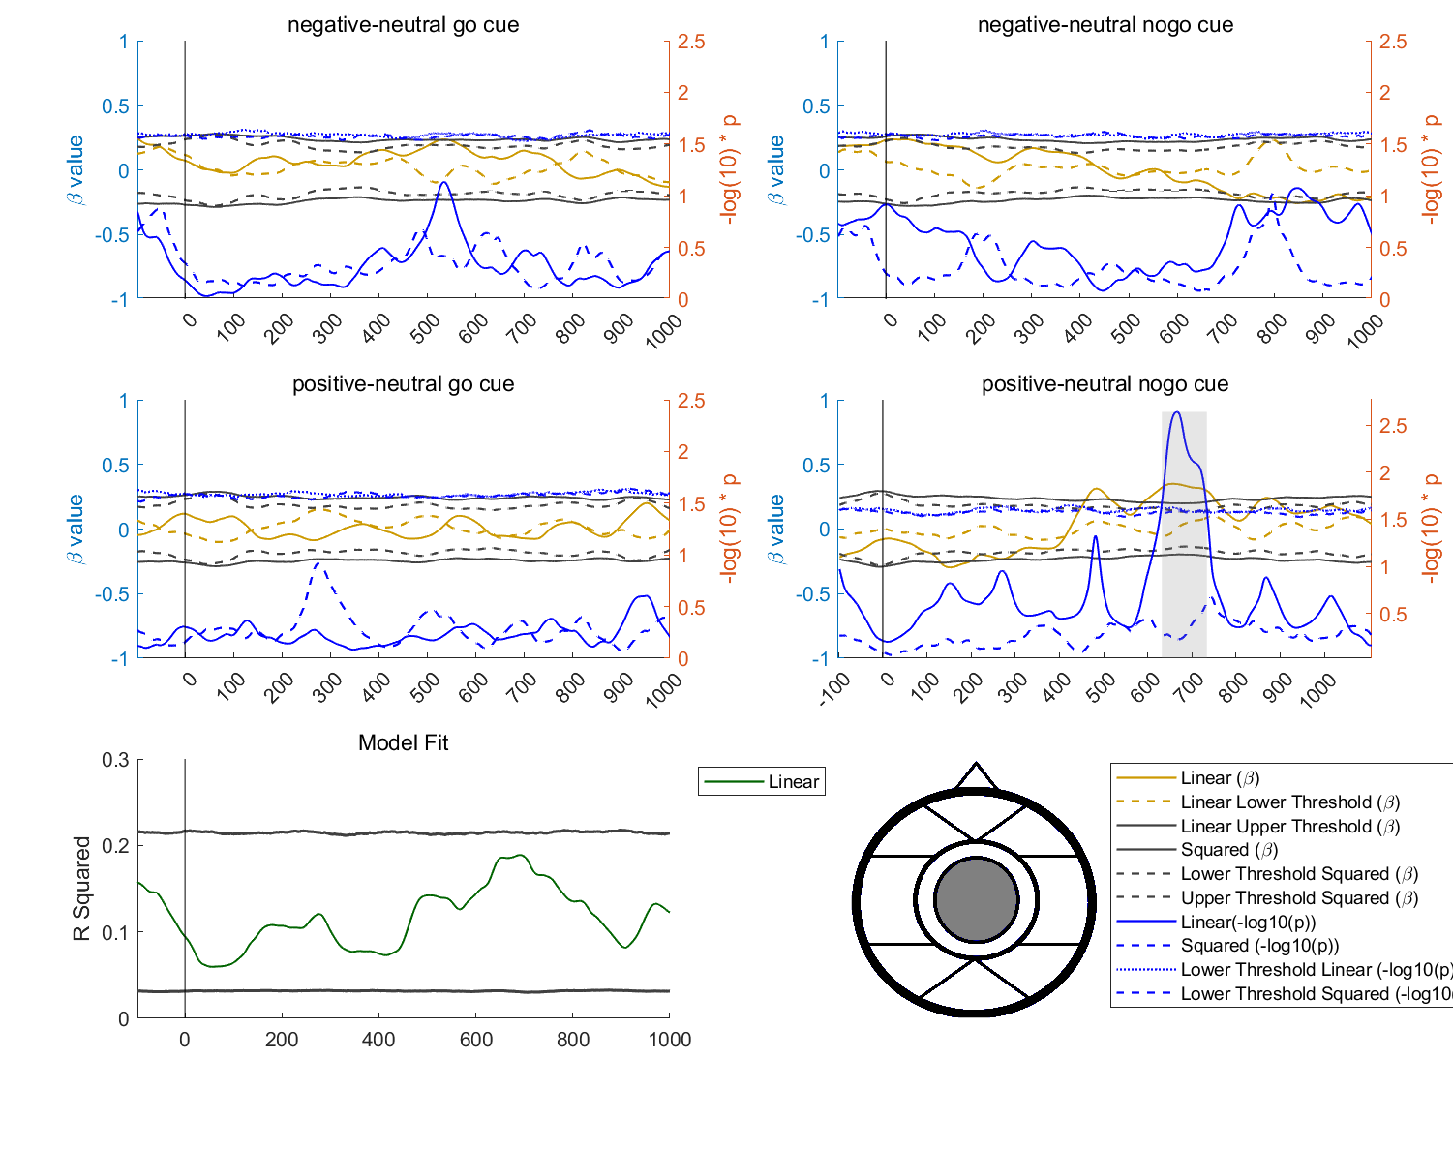
Figure 6 Association between self-identity and ERP activity at the the frontal left lateral ROI upon different cues
Note: The designation of each component is akin to that of Figure 1.

