Table S1. Oligos used for the establishment of KO cell lines
Primer | sense（5′-3′） | antisense（5′-3′）
TMEM259-gRNA1 | caccgGGTCGCGCACGTTGATGAG | aaacCTCATCAACGTGCGCGACCc
TMEM259-gRNA2 | caccgGAACTCGAAGAGACGGCGGA | aaacTCCGCCGTCTCTTCGAGTTCc
FAM134B-gRNA1 | caccgGCTTCCAGCTCAGCAGCTCGT | aaacACGAGCTGCTGAGCTGGAAGCc
FAM134B-gRNA2 | caccgGCAATACAGTGGCTGAGCCT | aaacAGGCTCAGCCACTGTATTGCc
RTN3-gRNA1 | caccgGAGGCTGGCTCCCTAACACA | aaacTGTGTTAGGGAGCCAGCCTCc
RTN3-gRNA2 | caccgGGAGATGGAATGGGACTGAG | aaacCTCAGTCCCATTCCATCTCCc
ATL3-gRNA1 | caccgGCCACCACCACATCAAGATCT | aaacAGATCTTGATGTGGTGGTGGCc
ATL3-gRNA2 | caccgGTGGTCCTGCAAGAGGATGC | aaacGCATCCTCTTGCAGGACCACc
SEC62-gRNA1 | caccgGAAGCTTTATTTACAACCA | aaacTGGTTGTAAATAAAGCTTCc
SEC62-gRNA2 | caccgGAACCCGGTGACCCATCATAT | aaacATATGATGGGTCACCGGGTTCc
CCPG1-gRNA1 | caccgAGAAACTGCTTATCCAGCTT | aaacAAGCTGGATAAGCAGTTTCTc
CCPG1-gRNA2 | caccgGTCTAACTTAGGTGGCTCAA | aaacTTGAGCCACCTAAGTTAGACc
TEX264-gRNA1 | caccgGTGATAAGTGCCGATGTGCCG | aaacCGGCACATCGGCACTTATCACc
TEX264-gRNA2 | caccgGTGGCCTTTGCCGGGTACTCA | aaacTGAGTACCCGGCAAAGGCCACc
MAN1B1-gRNA1 | caccgCAAATCCACCCGTCTTACC | aaacGGTAAGACGGGTGGATTTGc
MAN1B1-gRNA2 | caccgAAATCTCAGGTAAGTTCTC | aaacGAGAACTTACCTGAGATTTc
EDEM2-gRNA1 | caccgTGCTCATCTGCTCTCCAAGA | aaacTCTTGGAGAGCAGATGAGCAc
EDEM2-gRNA2 | caccgCCTGAGAATGGCTGAGGAGG | aaacCCTCCTCAGCCATTCTCAGGc
SEC61B-gRNA1 | caccgACCCCCAGTGGCACTAACGT | aaacACGTTAGTGCCACTGGGGGTc
SEC61B-gRNA2 | caccgGCGCTCTCCCAGCAAAGCAG | aaacCTGCTTTGCTGGGAGAGCGCc

Fig. S1. MAN1B1 does not engage with known ER-phagy receptors.
(A) Indicated ER-phagy receptor genes were knocked out in HEK293T cells by CRISPR/Cas9, and their expression was confirmed by WB. (B) Class I fusion proteins were expressed with MAN1B1 in HKE293T WT and indicated ER-phagy receptor KO cell lines, and their expression was determined by WB. (C) Class I fusion and VSV-G proteins were expressed with MAN1B1 in HKE293T WT and FAM134C-KO cells, and their expression was determined by WB.
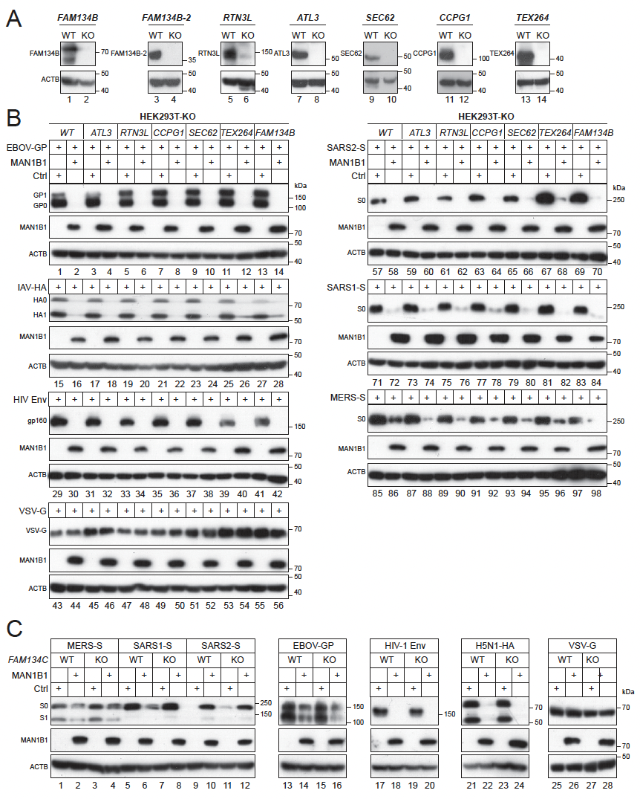
Fig. S2. MAN1B1 and Membralin act independently of the SEC61 translocon.
(A) Class I fusion proteins were expressed with MAN1B1 or TMEM259 in HEK293T cells in the presence of SEC61A siRNAs or a control siRNA, and their expression was determined by WB. (B) SEC61B was knocked out in HEK293T cells, and two KO clones (B3, B6) were confirmed by WB. (C) Class I fusion proteins were expressed with MAN1B1 or Membralin in HEK293T WT or SEC61B-KO (B3) cells, and their expression was determined by WB.
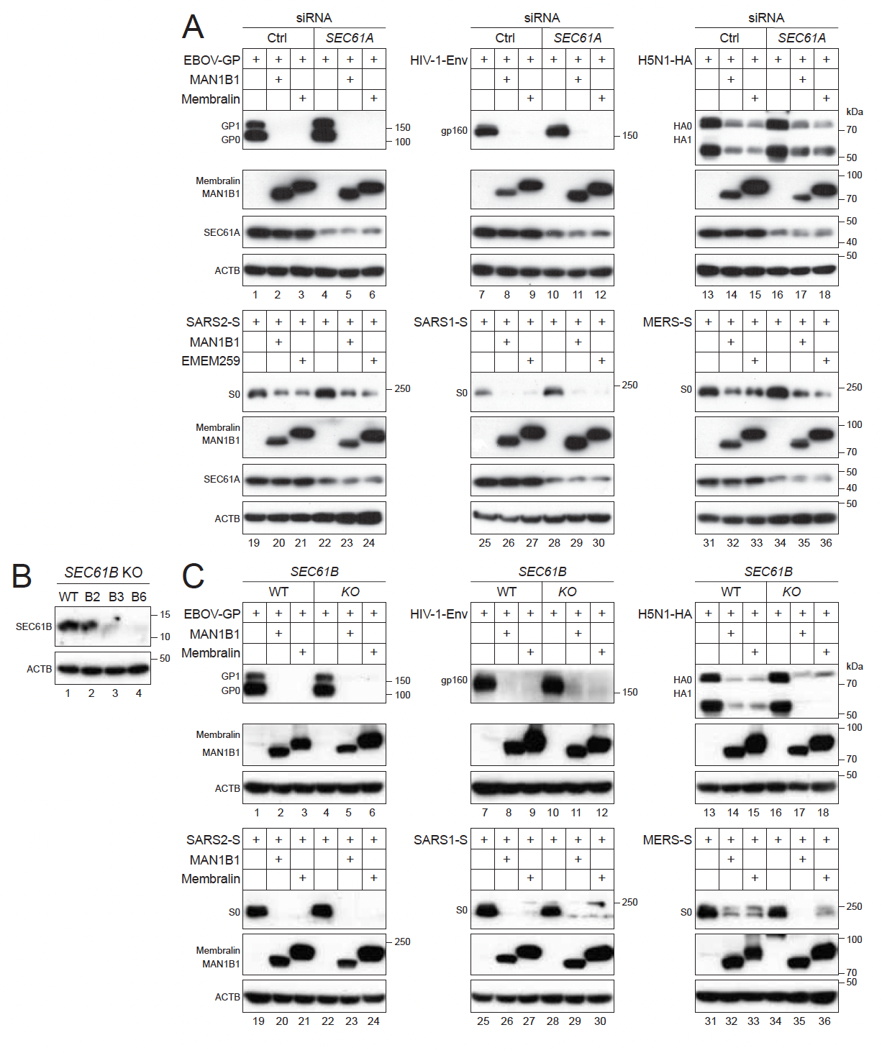
Fig. S3. Detection of SARS2-S and Membralin trafficking to lysosomes by live-cell imaging.
SARS2-S-GFP, LAMP1-mCherry, and Membralin-BFP were expressed in HEK293T cells in the absence or presence of ectopic MAN1B1. Images were captured by Airyscan super-resolution microscopy every 5 min for 12.8 or 23.3 hours. Scale bar, 5 μm.

MAN1B1 (-)
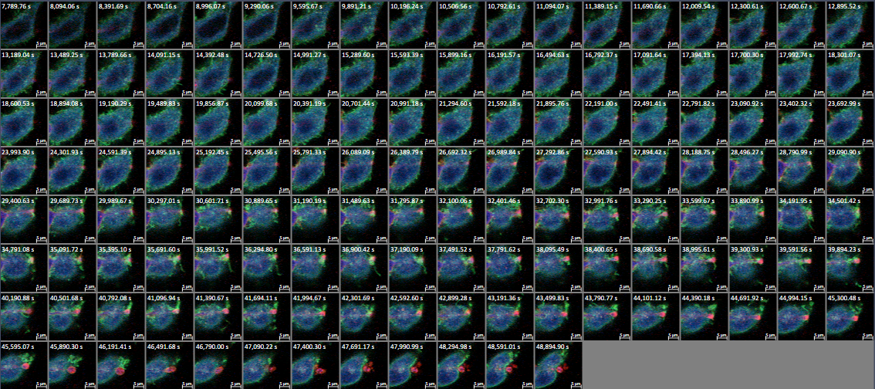
MAN1B1 (+)
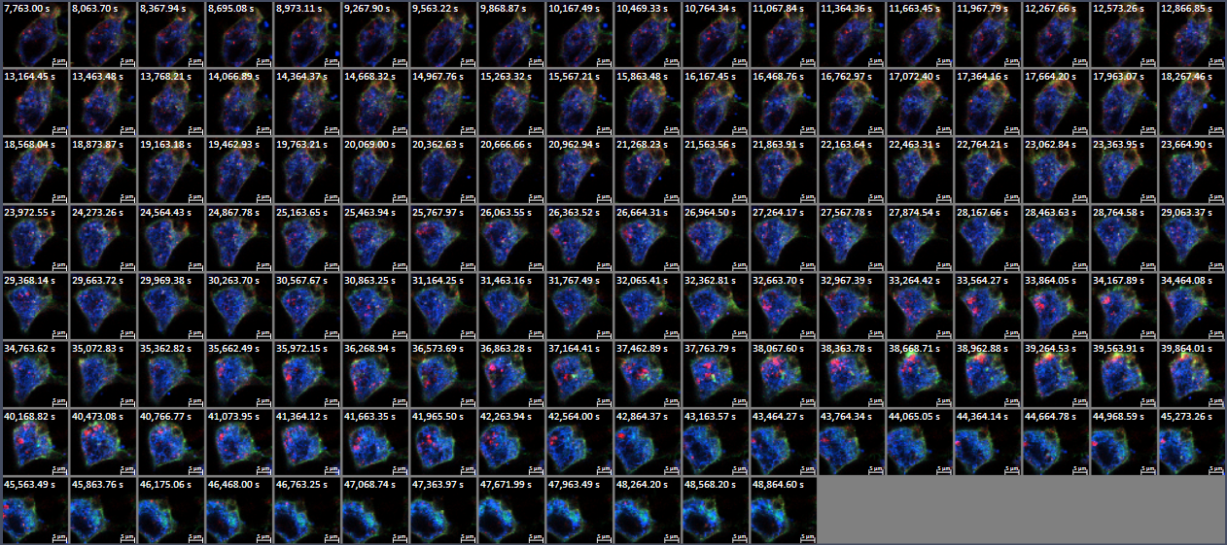

Fig. S4. MAN1B1 does not engage with well-known ER-phagy receptors to degrade misfolded proteins and aggregates.
Indicated misfolded proteins were expressed with MAN1B1 in HEK293T WT and indicated KO cells. Protein expression was determined by WB.
