INTELLIGENT PACKAGING SOLUTIONS FOR FISH AND MEAT PRODUCTS: VOLATILE GAS DETECTION VIA GC-MS, MICROBIAL ANALYSIS AND COLORIMETRIC MONITORING
Table A.1 Limit of detection with (TVB-N gases) at accelerated storage condition.
Type of standard | Concentration | Mean R | Mean G | Mean B | Std R | Std G | Std B | ΔRGB
NH₃ | 0 | 204.66 | 41 | 96 | 4.49 | 16.26 | 8.6 | 0
NH₃ | 0.001 | 190.66 | 109.66 | 133.33 | 5.24 | 1.24 | 2.62 | 78.15193**
NH₃ | 0.01 | 179 | 137 | 146 | 6.37 | 6.48 | 5.71 | 108.8667***
NH₃ | 0.1 | 206.66 | 146.66 | 145.66 | 11.95 | 8.49 | 8.49 | 117.8395***
NH₃ | 1 | 174 | 111 | 102.33 | 4.08 | 2.16 | 4.18 | 72.23313**
TMA | 0 | 204.66 | 41 | 96 | 4.49 | 16.26 | 8.6 | 0
TMA | 0.001 | 180 | 120 | 132.33 | 3.55 | 6.16 | 5.43 | 90.38243**
TMA | 0.01 | 212.33 | 179.66 | 182 | 3.09 | 2.86 | 2.94 | 163.3445***
TMA | 0.1 | 137.66 | 85.66 | 90.33 | 7.31 | 7.31 | 6.84 | 80.71967
TMA | 1 | 161 | 126.66 | 104.66 | 0 | 3.29 | 1.24 | 96.53407
DMA | 0 | 204.66 | 41 | 96 | 4.49 | 16.26 | 8.6 | 0
DMA | 0.001 | 123 | 18.66 | 40.66 | 2.82 | 7.84 | 7.84 | 101.1432***
DMA | 0.01 | 106 | 7.66 | 68.33 | 8.48 | 4.71 | 4.92 | 107.7543***
DMA | 0.1 | 88.66 | 80.33 | 68.33 | 6.01 | 6.54 | 4.92 | 125.5726***
DMA | 1 | 80 | 64.66 | 33 | 9.41 | 8.57 | 9.27 | 141.6648***
All values were expressed as mean ± standard deviation (n = 3).
Level of significance codes: P-value<0.01 ***, P-value<0.05 **, P-value <0.1 *

A.2 Freshness control in room temperature with gas tube detector
At refrigerated temperatures (0 till 4 º C), fish typically remain fresh for several days, and ammonia production is minimal. According to several measurement, no color change was observed in gas detector tubes regarding presence of ammonia for 8 hours. Suggesting that the fish is fresh. At room temperature, spoilage occurs much more rapidly. Ammonia levels can easily increase within a few hours, depending on the initial freshness of the fish and microbial load. With increasing weights from 50 g to 200 g, the data illustrates a clear trend: larger sample sizes lead to higher ammonia concentrations over time. This can be attributed to a larger amount of organic material being decomposed, resulting in more generated ammonia. As temperatures increase and sample weights increase, spoilage accelerates, leading to faster ammonia production. The room temperature condition exacerbates this issue, making it unsuitable for preserving fish freshness. The measurements indicate that regular monitoring of ammonia levels could serve as an effective method for assessing fish freshness and ensuring product safety.
For the 50 g sample, ammonia levels increased gradually over time. The concentration reached its highest point (310 ppm) at the 8-hour mark, indicating ongoing spoilage. The concentrations fluctuate slightly, suggesting a relatively stable gradual increase. For the 100 g sample, the ammonia levels start higher and exhibit a more consistent increase, suggesting a greater rate of decomposition due to potentially higher microbes while the initial readings in the first hour were low (0 ppm for 50 g and 15 ppm for 100 g), which is typical as spoilage has not yet initiated within that timeframe. By the end of 8 hours, both samples were within ppm values that could indicate spoilage, particularly the 100 g sample, which is approaching levels where quality could be considered unacceptable. By the 8-hour mark, the concentration reached 390 ppm. The results confirm that storage at room temperature accelerates spoilage in fish. Ammonia levels increase significantly over time, indicating that fish should be stored at lower temperatures to maintain freshness. The methodology of using an ammonia detector provides a practical means of monitoring fish freshness. However, the initial ammonia concentrations were below detection limits, suggesting that the fish could still be relatively fresh immediately after storage began.
Table A.2 The measurement data is derived from the ammonia produced during 8 hours of storage at room temperature for various fish sample weights.
 | Duration (hour)
 | 1 | 2 | 3 | 4 | 5 | 6 | 7 | 8
*Sample weight (g) | Tube reading (ppm)
50 | 0 | 20 | 150 | 200 | 250 | 290 | 300 | 310
100 | 15 | 75 | 200 | 250 | 300 | 350 | 370 | 390
200 | 20 | 100 | 300 | 350 | 400 | 450 | 500 | 550
 | NH₃ concentration (ppm)
50 | 0 | 10 | 50 | 50 | 50 | 48.33 | 42.85 | 38.75
100 | **NA | 37.5 | 66.66 | 62.5 | 60 | 58.33 | 52.85 | 48.75
200 | 20 | 50 | 100 | 87.5 | 80 | 75 | 71.42 | 68.72
*Weigh sample standard deviation ± 5 gr
**Measuring range (20 º C, 1013 hPa): for 1 hour the acceptable measuring range 20 to 1500 ppm NH₃

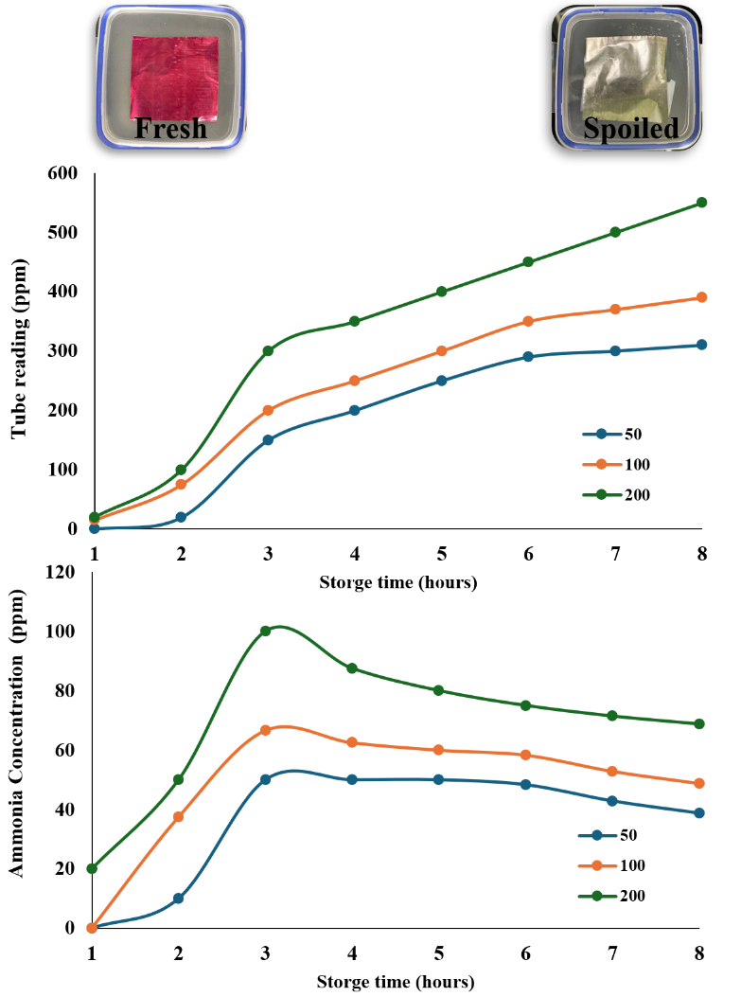
Figure A.1 The trend shows an increase in ammonia and then decrease it during 8 hours of fish storage at room temperature.

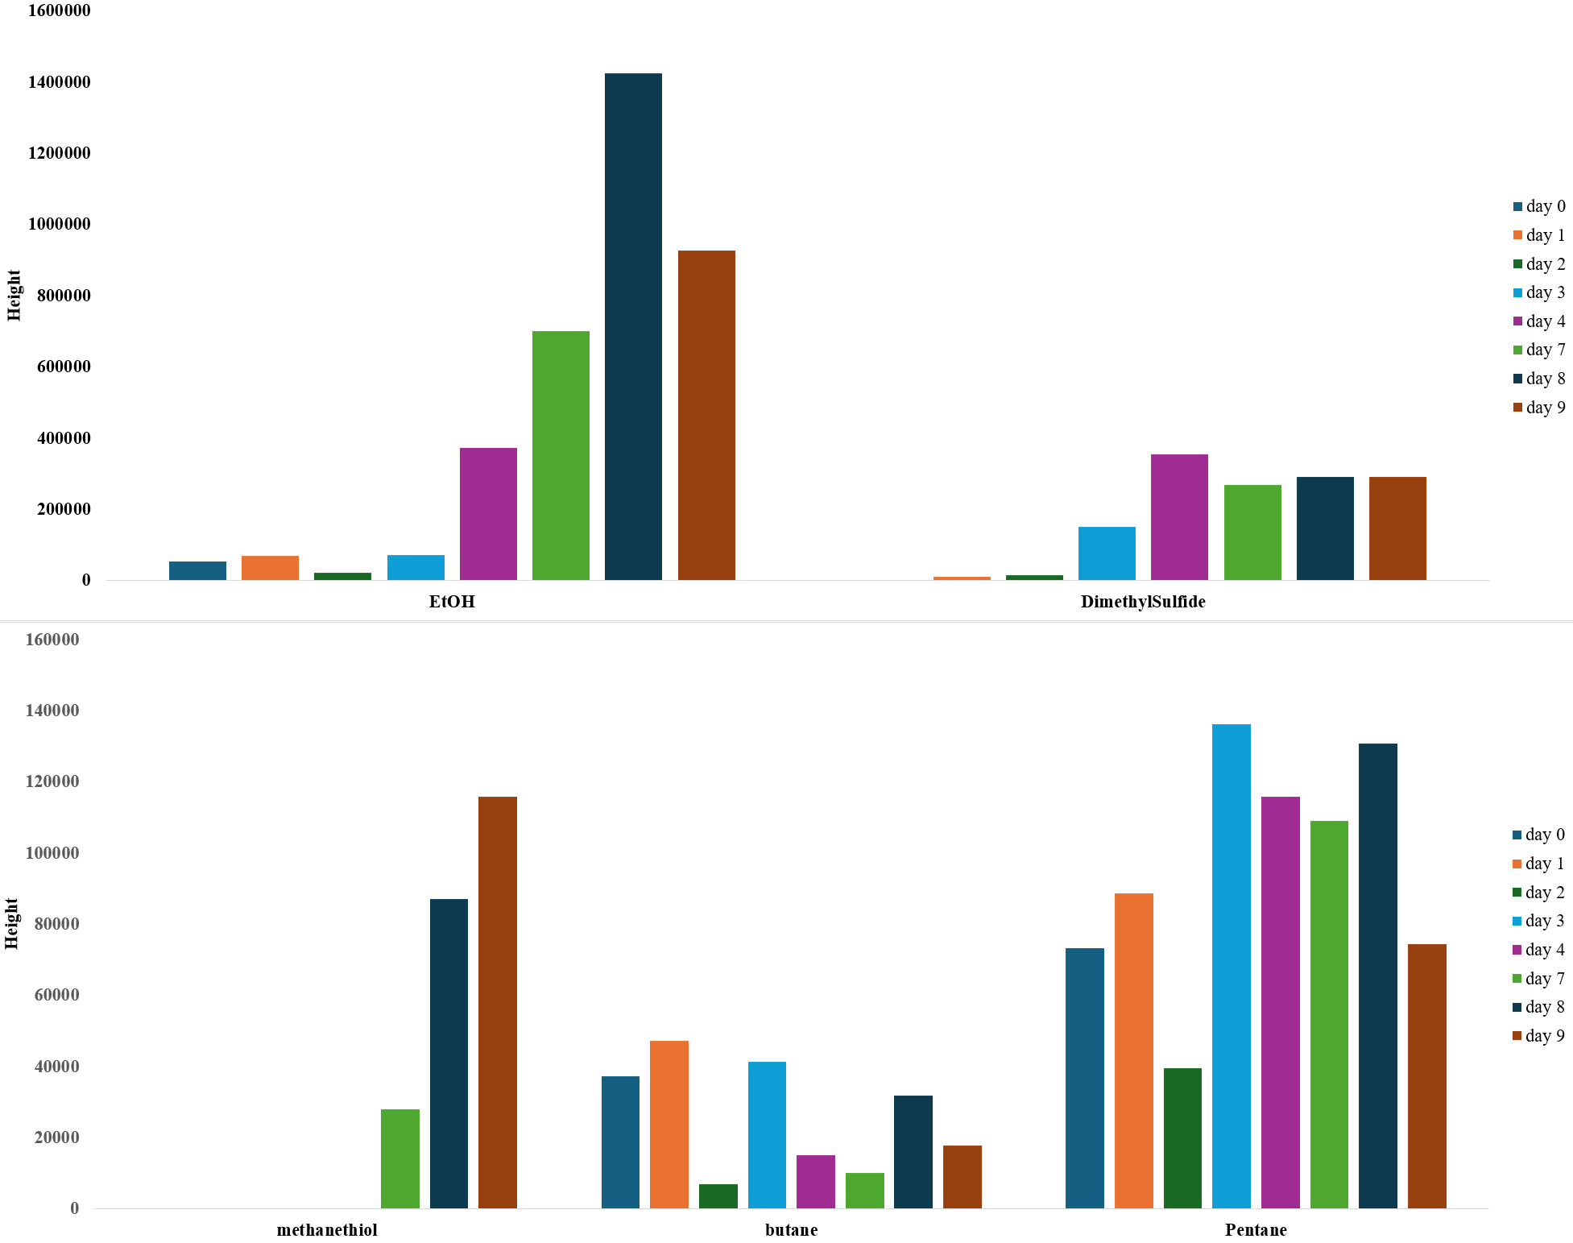
Figure A.2 Trends in the signal intensities of untargeted analytes over 9-day storage in the fridge (scan mode acquisition).

A.3 Species-Specific Analysis
The method performance for headspace GC-MS analysis was evaluated using several quality control criteria, focusing on the relative abundance of ammonia and trimethylamine in various fish samples. The issue of varying signals depending on the type of fish used was found; different fish types yielded different detectable compounds. The second experiment which performed, simultaneously with TVC and monitoring color change of sensor, with spiked fish resulted in better detection than the first, but issues with the experimental setup might continue affecting results. A comparative analysis was conducted on two fish types, pangasius and haddock. In pangasius fillets, the concentration of ammonia was found to be significantly higher compared to haddock. Conversely, haddock samples exhibited sharper and more distinct peaks for TMA, making it easier to quantify. Notably, pangasius fillets typically contain lower levels of TMAO compared to haddock, with the marine species generally exhibiting higher concentrations of TMAO. These findings highlight the differing spoilage characteristics between freshwater (pangasius) and marine (haddock) fish, further informing quality assessment and shelf-life determination. Therefore, fluctuations in fish quality based on seasons might influence experimental outcomes.

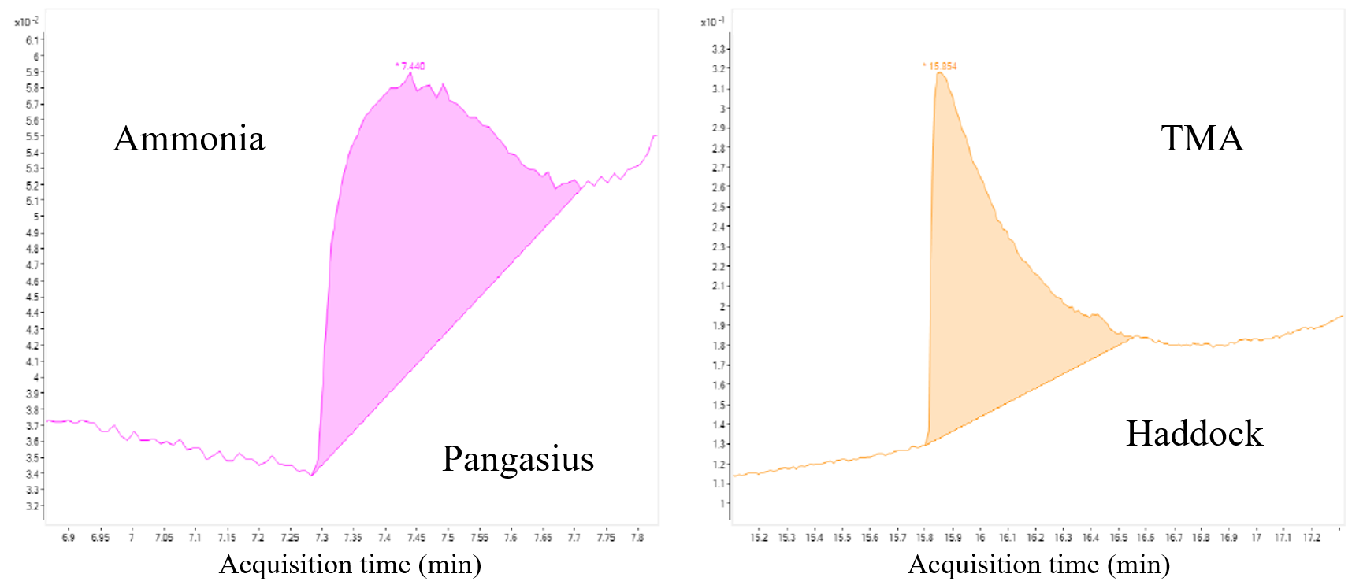
Figure A.3 Zoomed SIM chromatograms of spoiled fish samples allowing for detection of ammonia and TMA.
Some species appear to be released to the headspace after several storage days at both temperatures and could be detected by Scan mode injections. Figure A.4 shows that ethanol and butane were identified by database search after 7 days. They could potentially be quantified by injecting their corresponding standards.
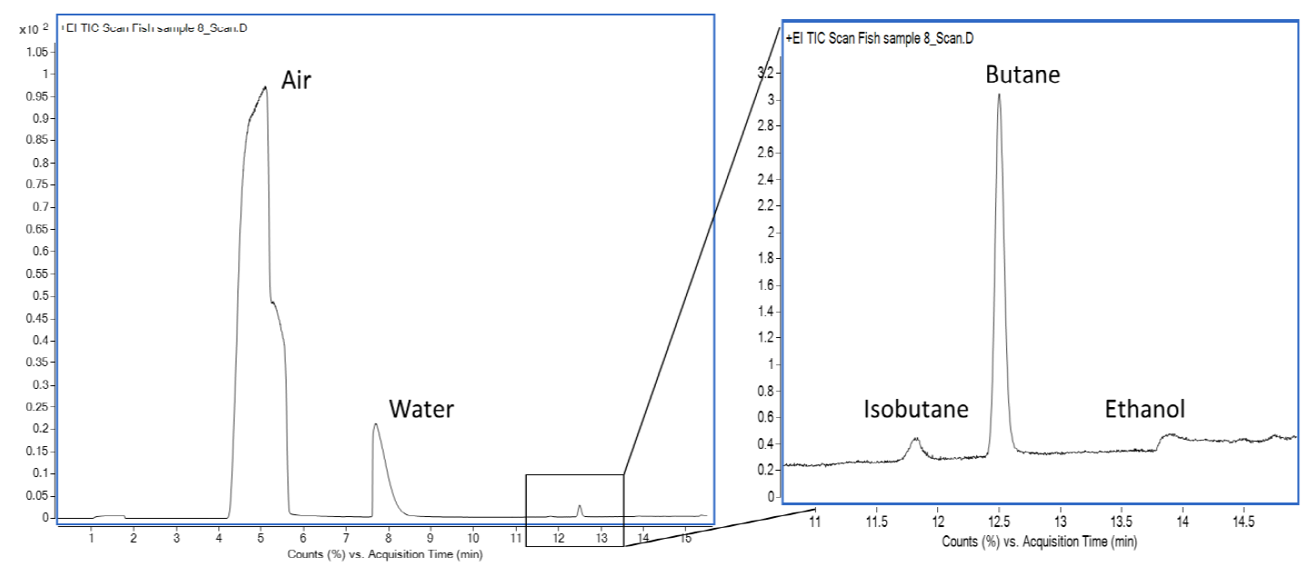
Figure A.4 Zoomed Scan chromatograms of untargeted species identified using NIST database comparison.

A.4 Performance Assessment of Colorimetric Sensing for TMA: Correlation with GC-MS Results
In this study, we compared the performance of our colorimetric sensor for detecting TMA with the established method of GC-MS. 4 samples were exposed to 100 µL TMA with different dilutions (0.001,0.01,0.1 and 1 M) at 25 ºC for 30 min. The colorimetric sensor demonstrated a LOD of 0.01 M for 100 µL of TMA, while GC-MS achieved a lower instrumental LOD of 0.001 M for the same amount of TMA. The samples exposed to concentrations higher than 0.001 M exhibited ΔE higher than 30.
Although the GC-MS method exhibits higher sensitivity, developed colorimetric sensor's performance is significant when considering practical applications in seafood freshness monitoring. The correlation analysis between the two methods revealed a strong relationship, indicating that the colorimetric sensor can reliably detect TMA concentrations in a manner consistent with GC-MS results. To validate the effectiveness of the colorimetric sensor, we conducted repeatability and reproducibility tests, which showed consistent results across multiple trials.
The sensor's RGB values were recorded before exposure to TMA and after each subsequent acid treatment for recovery. The initial RGB values were (132, 8, 52), which changed to (176, 132, 142) after the first TMA exposure. Following the first acid treatment, the values returned to (135, 7, 47), indicating a significant change in colorimetric response. Subsequent cycles of TMA exposure and acid recovery yielded RGB values of (179, 138, 148) and (149, 34, 65), respectively, demonstrating the sensor's responsiveness to TMA concentrations. The analysis of delta RGB values revealed substantial changes, with recovery percentages indicating a high degree of sensitivity, particularly in the G channel, which showed a recovery rate of 1650%. These findings suggest that the colorimetric sensor is highly effective in detecting TMA levels, with the ability to return to baseline values after acid treatment and can offer advantages such as cost-effectiveness and ease of use. In scenarios where rapid monitoring is essential, the colorimetric sensor provides a practical alternative to GC-MS, making it a valuable tool for assessing seafood freshness.

