SUPPLEMENTAL INFORMATION

Supplemental Table 1. Shade use by monarchs across the 5 surveyed regions in 2017-2019 in which monarch immatures were present in at least one year.

 | χ² | df | P
Monarch Eggs
Shade | 11.6 | 1 | <0.001 ***
Region | 86.8 | 4 | <0.001 ***
Year | 26.8 | 2 | <0.001 ***
Shade x Region | 9.4 | 4 | 0.050
Region x Year | 36.6 | 8 | <0.001 ***
All immature stages
Shade | 16.7 | 1 | <0.001 ***
Region | 129.6 | 4 | <0.001 ***
Year | 54.9 | 2 | <0.001 ***
Shade x Region | 10.3 | 4 | 0.036 *
Region x Year | 49.3 | 8 | <0.001 ***

*** indicates p<0.001, ** p<0.01, * p < 0.05, + p < 0.1

Supplemental Table 2. Influence of shade and milkweed species on survival to pupa and development time from 2nd instar to pupa in experimental study at Umatilla NWR in 2023.
 | χ² | df | P
Survival to pupae
Milkweed Species | 23.06 | 1 | <0.001***
Shade | 0.012 | 1 | 0.913
Milkweed x Shade | 4.83 | 1 | 0.028*
Development time (days,
pupal stage)
Milkweed Species | 37.44 | 1 | <0.001 ***
Shade | 46.87 | 1 | <0.001 ***
Milkweed x Shade | 6.75 | 1 | 0.009**

Supplemental Figure S1 Shaded vs full sun habitat at Umatilla NWR (photos by Sarah Lane)
From left to right – narrow-leaved milkweed in shade, showy milkweed in shade, narrow -leaved milkweed in sun, showy milkweed in sun

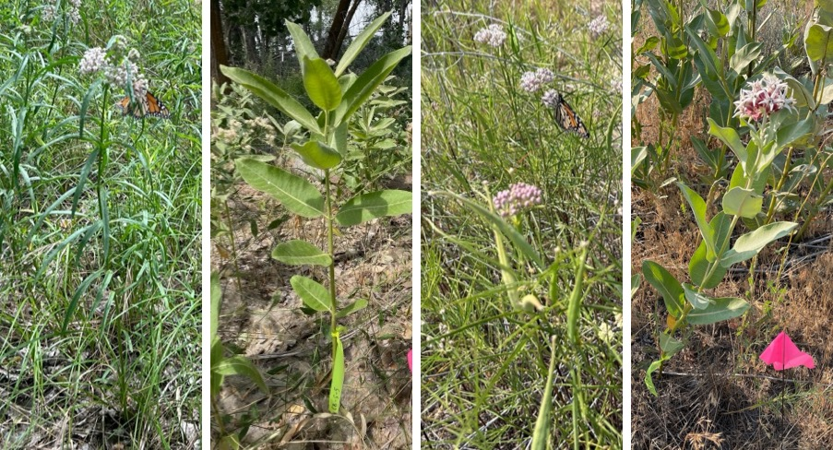

Supplemental Figure S2 Available shade in surveyed plots. Yellow = full sun; light green = up to 50% cover; dark green = 50-90% cover; brown = 100% cover (tall canopy but open understory with milkweeds)
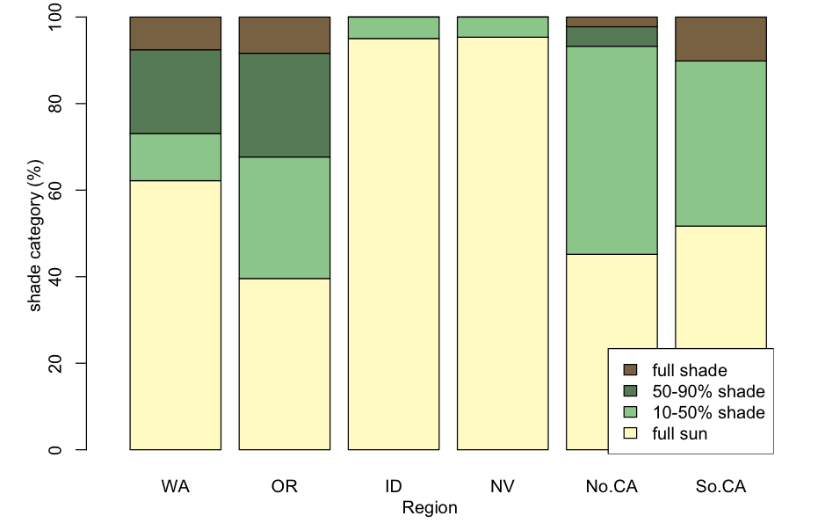

Supplemental Figure S3. Enclosures in sun and shade environments. Enclosures in the narrow-leaved-shade, showy-shade, and showy-sun treatments were 61 cm diameter cylindrical cages placed over clusters of milkweed stems (at least 3 stems of showy milkweed and 7 stems of narrow-leaved milkweed) and were 122 cm tall. Due to the growth form of narrow-leaved milkweed in full sun, to include enough plants to support the larvae in narrow leaved sun treatments, we used 91 x 152 cm rectangular enclosures that were 91 cm tall

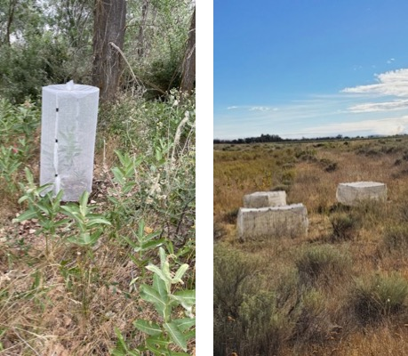

Supplemental Methods
At sites with abundant milkweed, transects were selected in optimal breeding locations. In 2017, transects were 50 m long x 30 cm wide and we recorded milkweed, and monarch counts in 5 m intervals to facilitate repeated search of the same milkweed stems in each survey. Sites included a totally of 50 – 2000 milkweed stems per survey, depending on milkweed species and density. In 2018, transects at some sites in Oregon and Washington were replaced with 2 m x 2 m plots, and these plots were surveyed instead of transects to ensure repeatability in 2018 and 2019. In addition, due to non-systematic surveys at Washington sites in 2017 and absence of immature monarchs in 2018 and 2019, we excluded some Washington sites from parts of our analyses.

